Name: Deep Vaviya
Class:TY-4
Roll no: 72
PRN:124BTCM2011
Batch C

Experiment No - 05

Title: Implement Database as a Service on SQL/NOSQL databases like AWS RDS/ Microsoft Azure

Learning Outcome: Apply Database as a Service (DBaaS) concepts by deploying and managing SQL/NoSQL databases using platforms like AWS RDS and Microsoft Azure

Theory:
AWS RDS is Amazon’s DBaaS platform for managing relational databases. It supports MySQL, PostgreSQL, SQL Server, and others. Users can configure DB instances, monitor performance, enable automatic backups, and scale resources based on workload.Database as a Service (DBaaS) is a cloud-based service model that allows users to access and manage databases without needing to handle the underlying hardware, infrastructure, or software maintenance. It abstracts the complexity of database setup, scaling, and security, providing a simplified, on-demand experience for developers, administrators, and organizations. DBaaS platforms like Amazon Web Services (AWS) RDS offer managed database environments that support several database engines including MySQL, PostgreSQL, Oracle, and SQL Server.
AWS RDS is particularly useful for hosting SQL databases like MySQL or PostgreSQL, where data is structured and relationships are clearly defined. Once a database instance is launched on AWS RDS, users can connect to it using standard SQL clients such as SQL Workbench, MySQL Workbench, or command-line tools. Through these clients, one can perform typical operations like creating tables, inserting records, querying data, and more. Moreover, users can configure RDS to perform regular snapshots and set up multi-AZ (availability zone) replication for high availability and fault tolerance.

Procedure: Step-wise explanation with screen shots

Step 01: Search Aurora and RDS
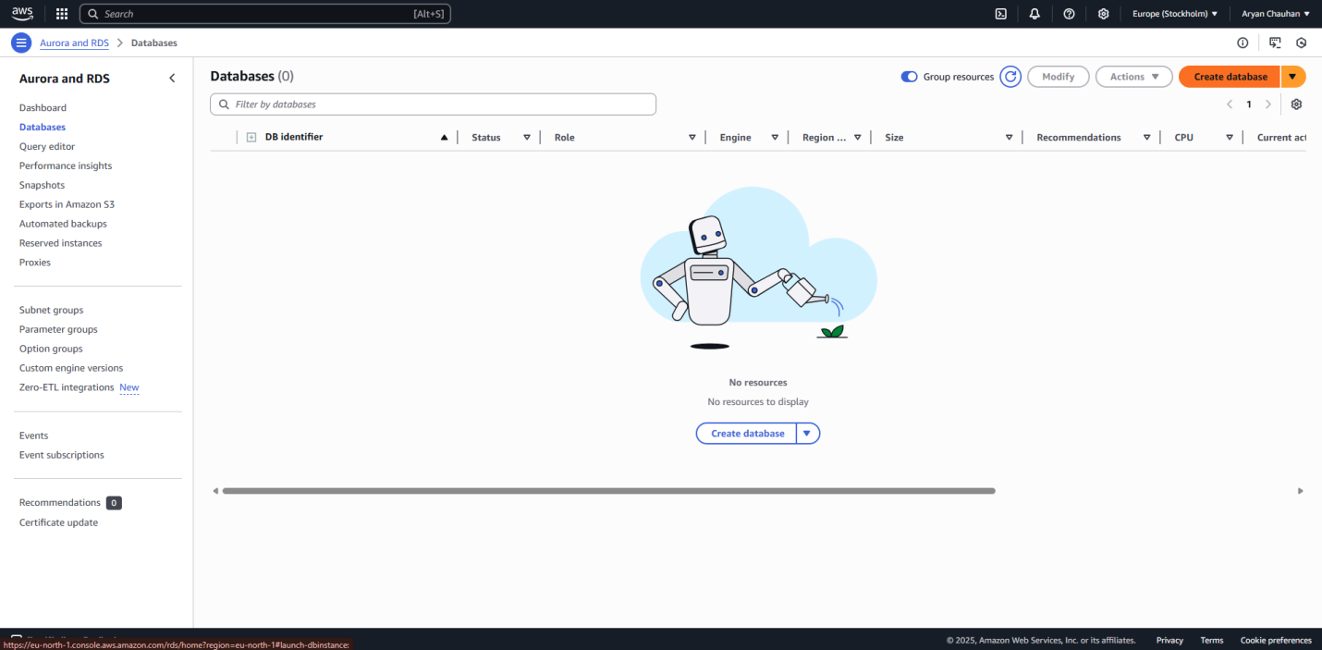

Step 02:Select MySql
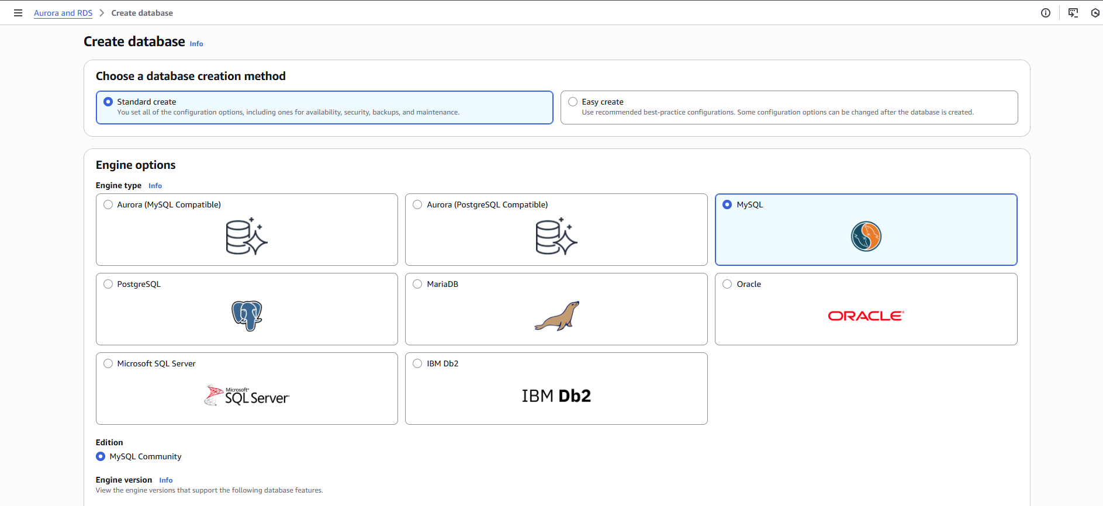

Step 03: In Templates select Free Tier
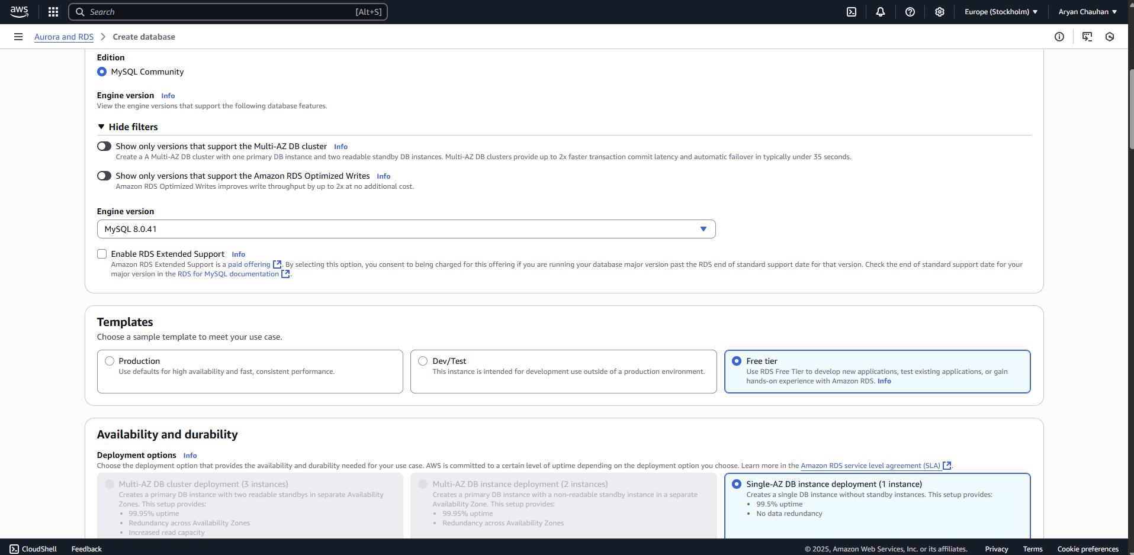

Step 04:Make a Data Instance Identifier and Keep A Master Name
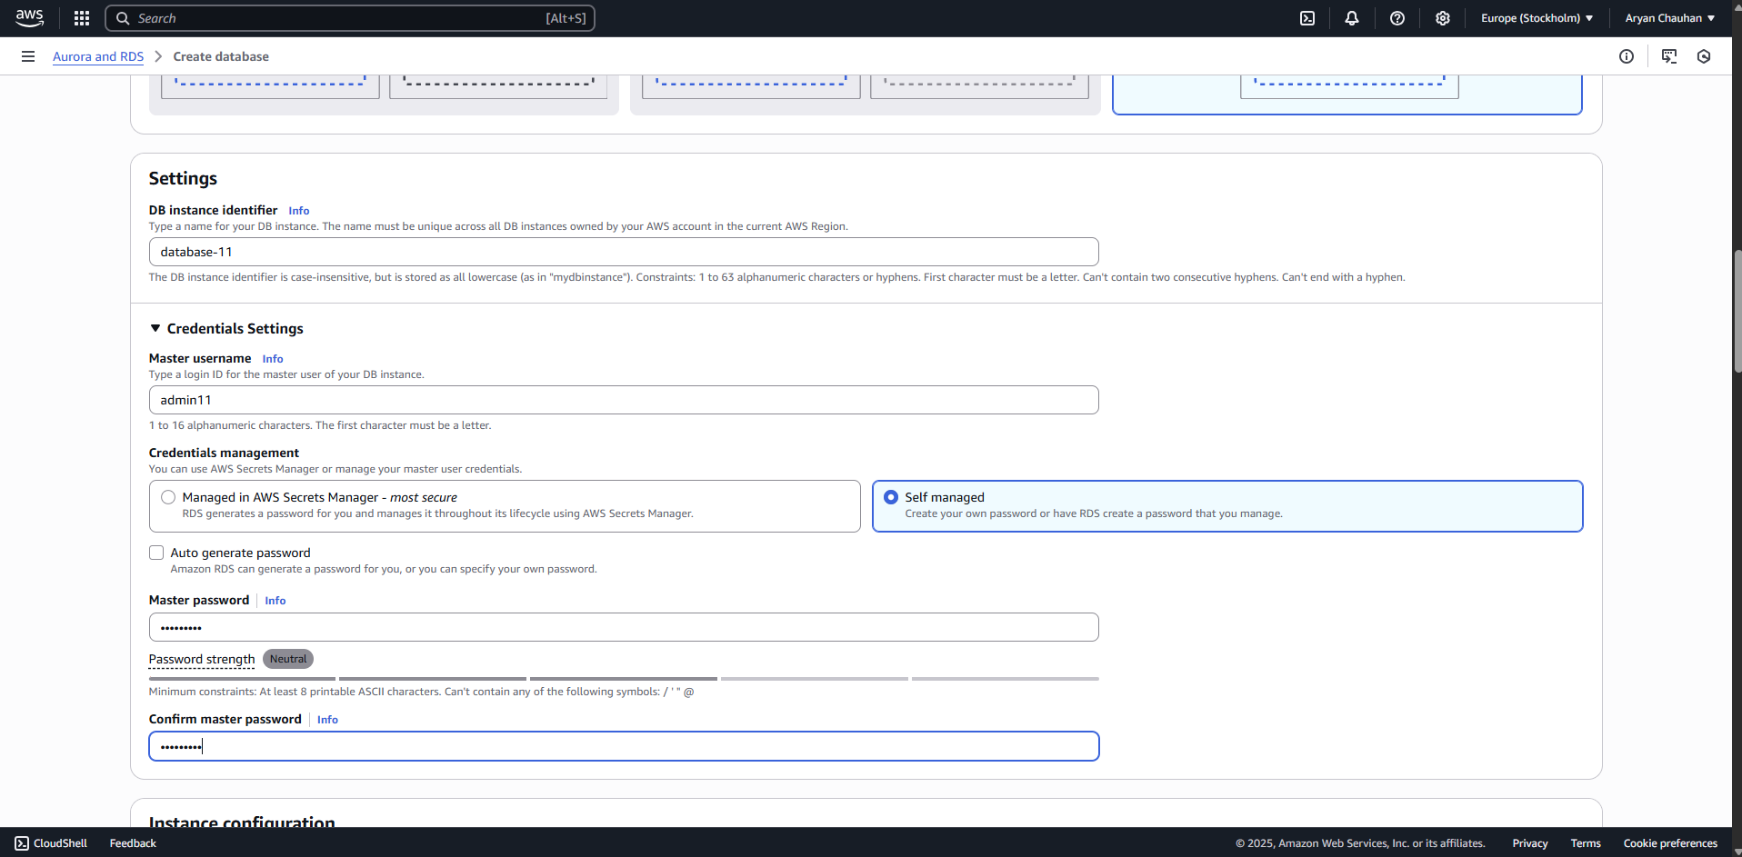

Step 05:Keep a master password
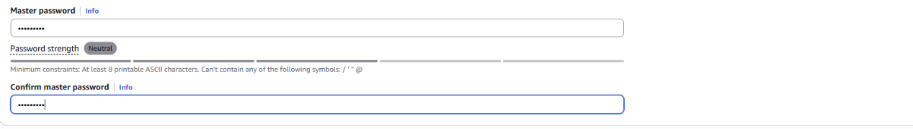

Step 06:In Instance Configuration select db.t3.micro and keep allocated storage to 20
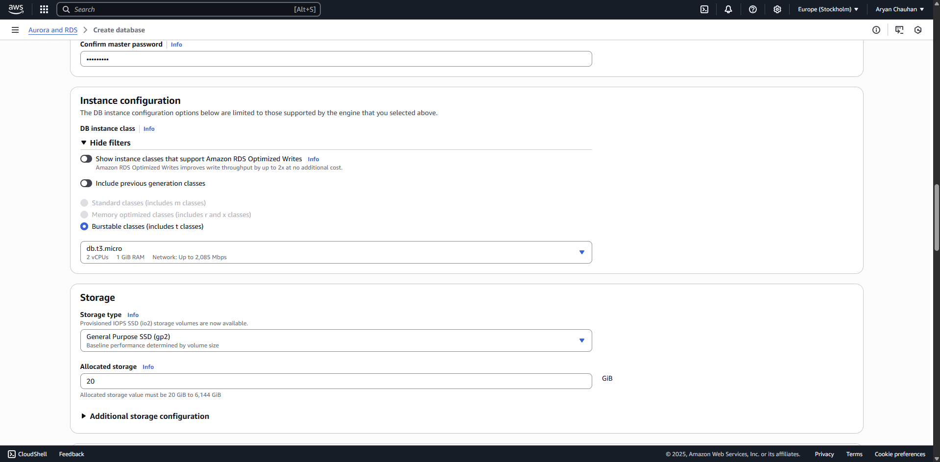

Step 07:Keep the connectivity Untouched and Give the public access
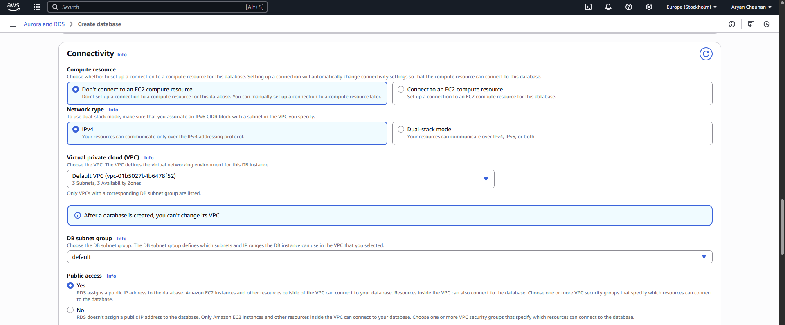

Step 08: Create new VPC Security Group name
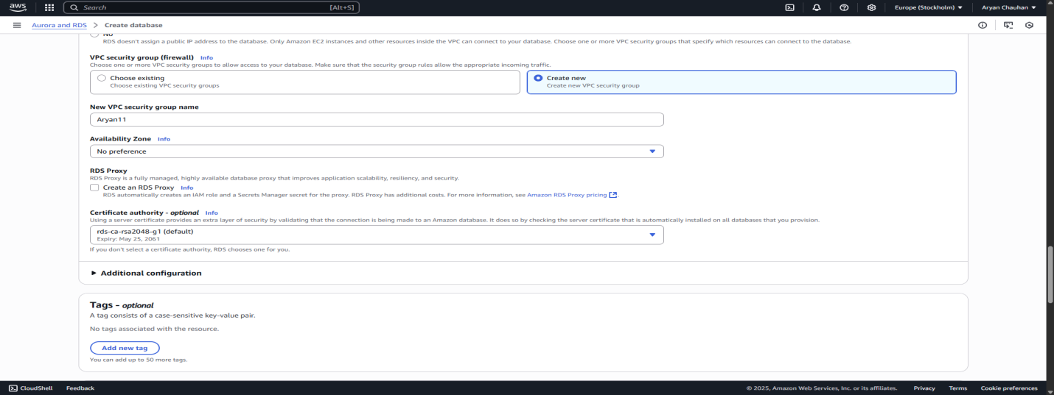

Step 09:Do not change anything in database configuration
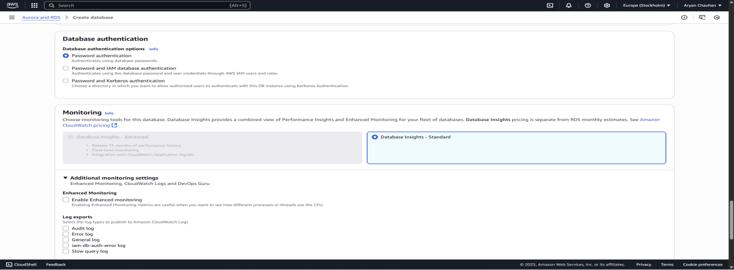

Step 10:Click on create Database
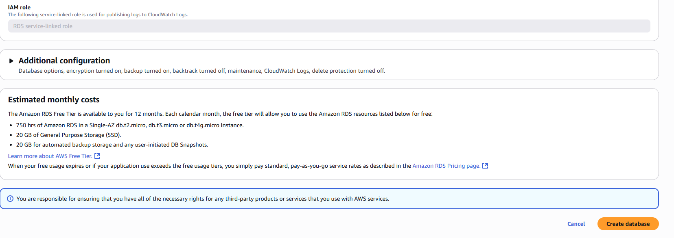
Step 11:Database Created
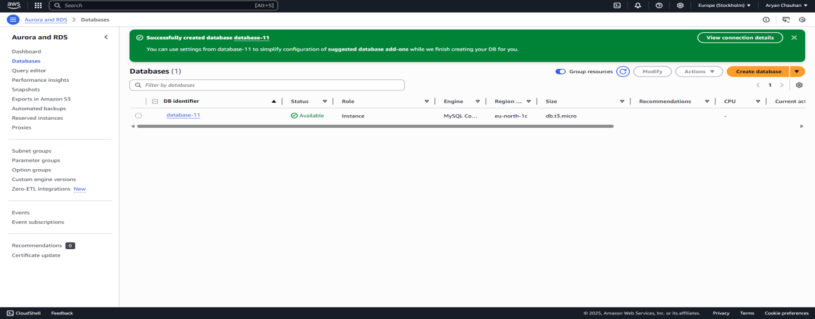

Step 12:Copy the endpoint address
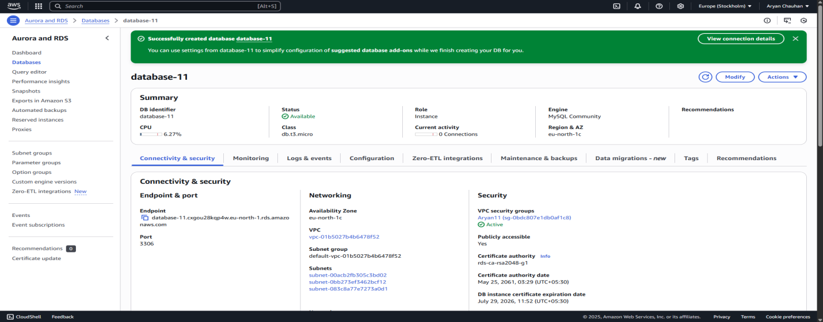

Step 13: Click on + sign and create a workbench
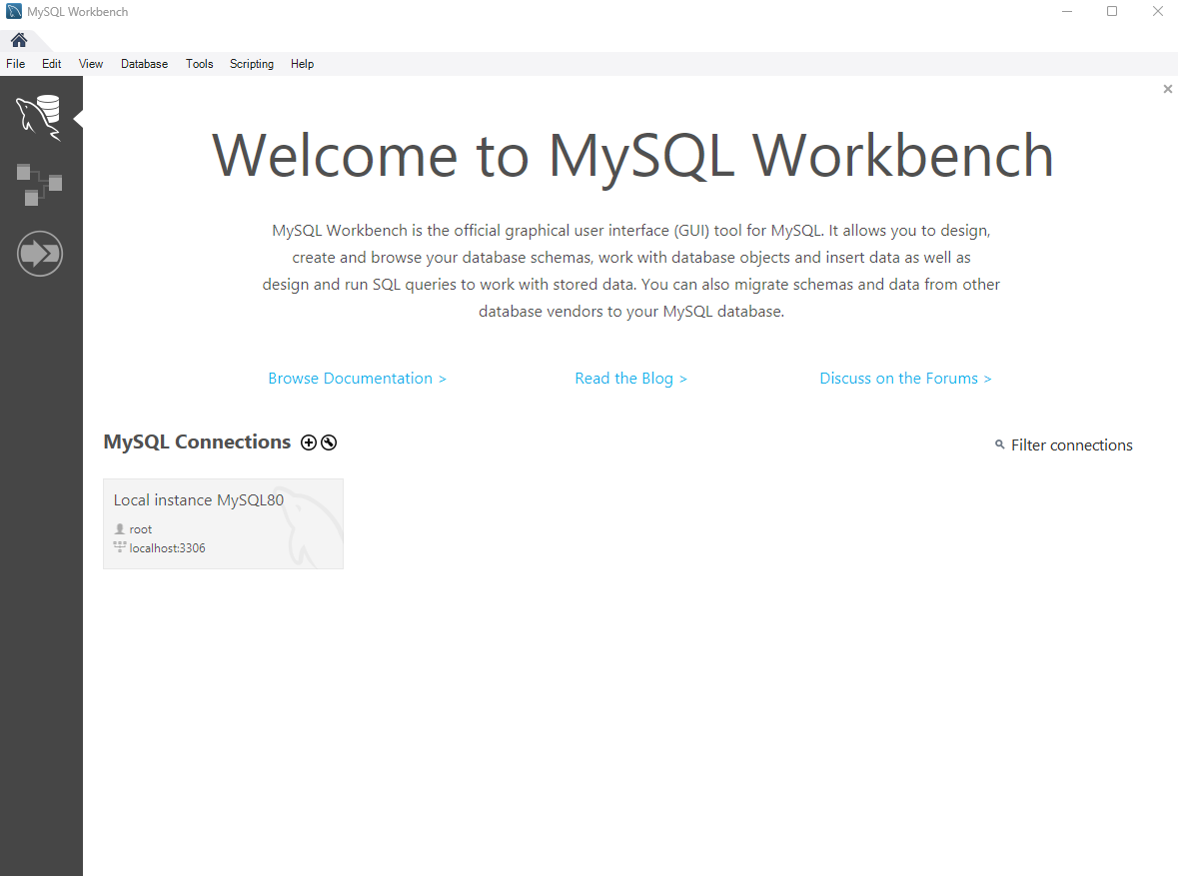
Step 14:Fill your connection name and put the copied Endpoint address on host name
And keep username same as the one kept previously
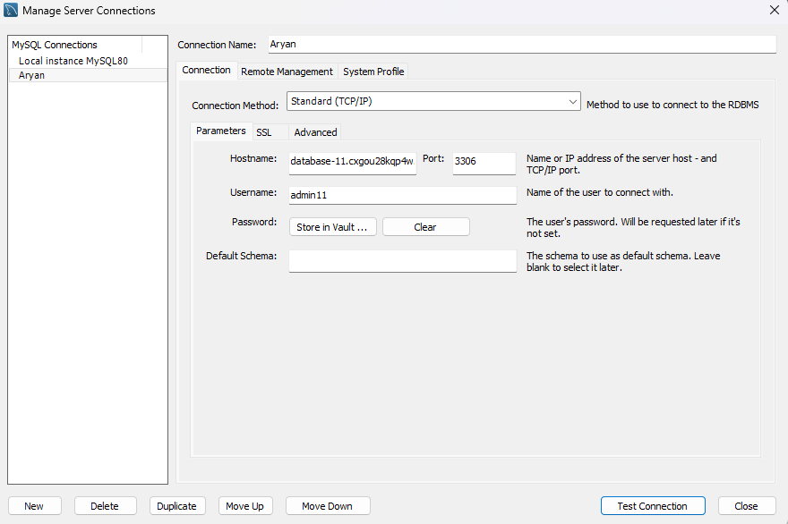

Step 15:Final SQL Output made using aws
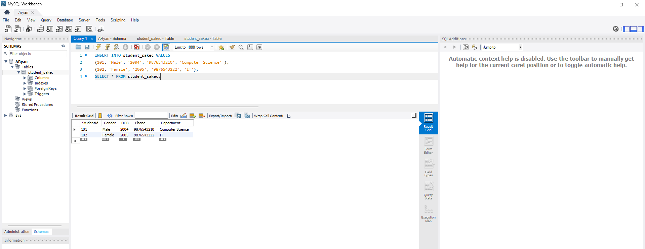

Conclusion:
Deploying an SQL database on AWS RDS allows students to gain practical experience in real-world cloud-based database management. They learn how to configure instances, connect external SQL clients like MySQL Workbench, execute SQL queries, and monitor performance in a live environment. It also introduces them to key cloud concepts such as VPC (Virtual Private Cloud), security group configuration, and endpoint management, which are crucial in understanding the complete cloud ecosystem.

