Name: Deep Vaviya
Class:TY-4
Roll no: 72
PRN:124BTCM2011
Batch C

Experiment No - 06

Title: Implement Lambda function in AWS

Learning Outcome: Apply Lambda function to create trigger events using platforms like AWS

Theory:
AWS Lambda:
It is a serverless computing service that enables the execution of code without the need to provision or manage servers. It operates in an event-driven manner, where code is executed in response to specific triggers, and AWS automatically manages infrastructure, scaling, and availability. Lambda functions are stateless and can scale automatically based on demand, with charges applied only for the number of requests and the execution duration.
Lambda Function and Event notifications on s3:
When an S3 event occurs, it can be configured to send an event notification to Lambda. This event is delivered as a JSON payload containing details such as the bucket name, object key, event type, and time of occurrence. Lambda functions can then process this information to perform various automated actions. For the Lambda function to access and process S3 objects, an IAM execution role with the necessary permissions must be assigned.
When an event like file upload or deletion happens in S3, it can trigger a Lambda function. The event details are sent to Lambda in JSON format, containing information like bucket name, file key, and event type.
Characteristics:
- Automated processing: No manual intervention required.
- Customizable triggers: Object created, deleted, or restored events.
- Real-time execution: Code runs immediately after an event.
- Supports multiple workflows: Can be connected with databases, APIs, or other AWS services.

Procedure: Step-wise explanation with screen shots
Step 01:Create A S3 Bucket
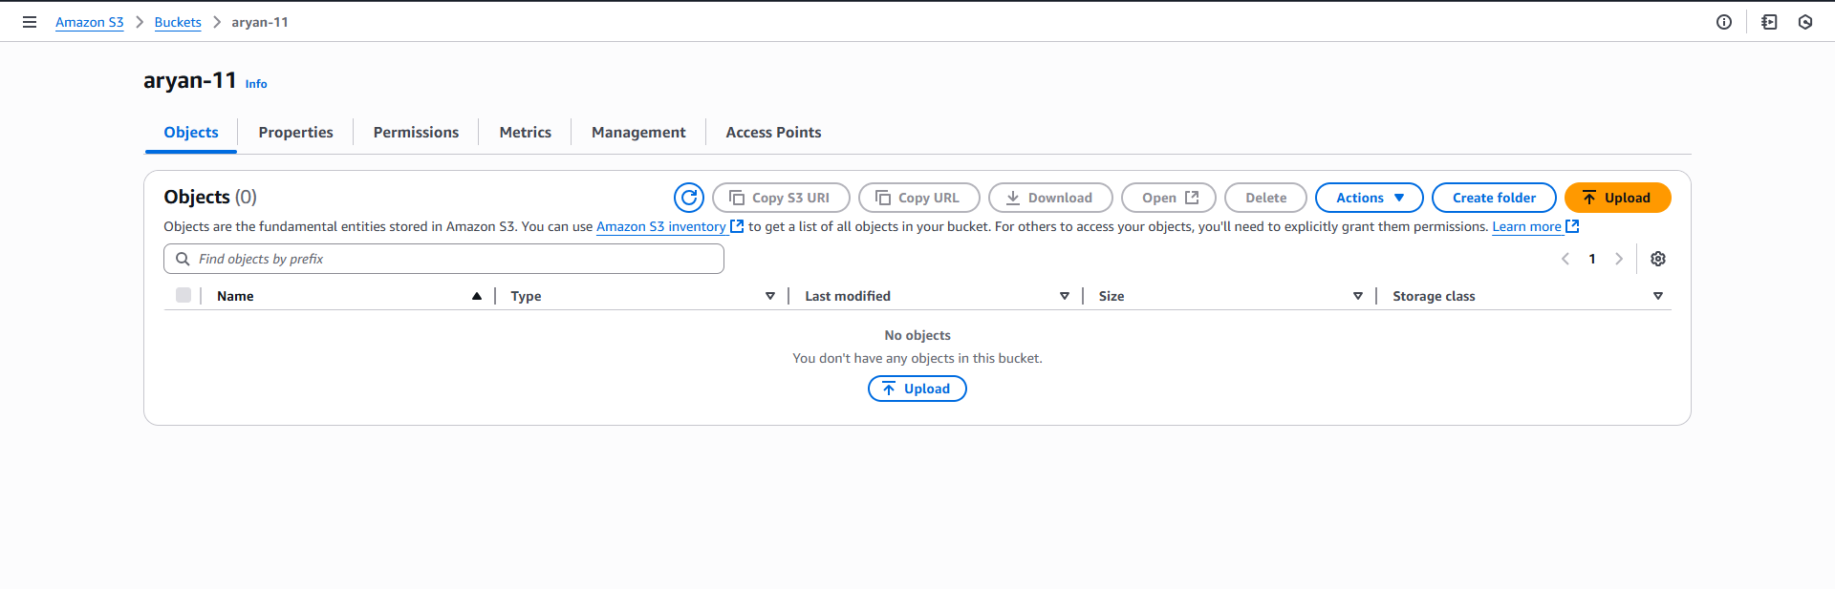
Step 02:Create A Lamda Function
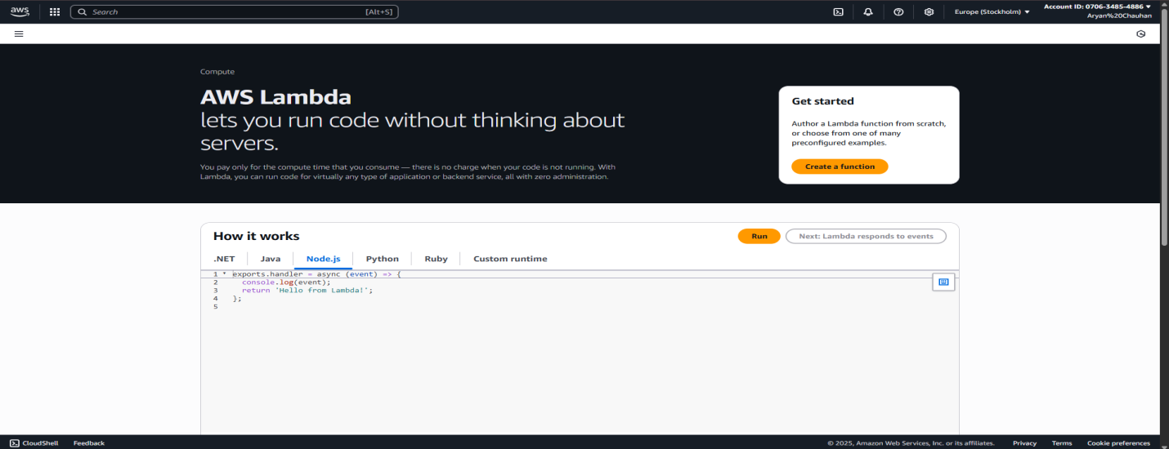

Step 03: Create Function name and Select Language
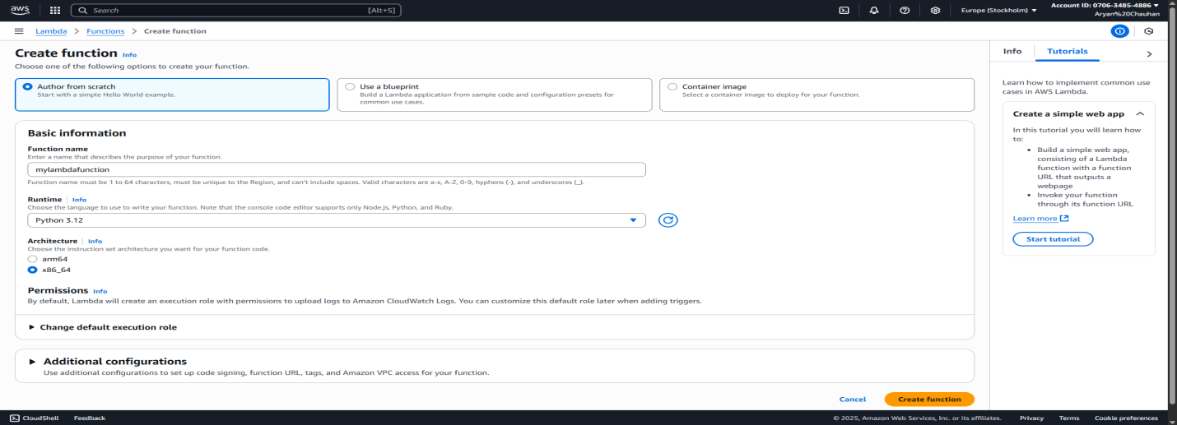

Step 04:Change Default Execution Role
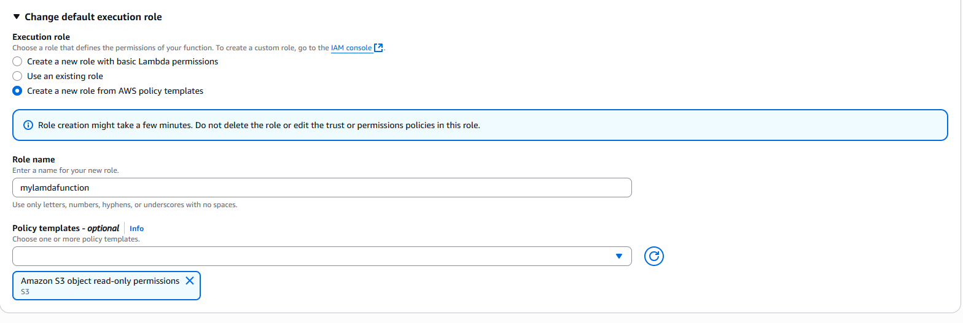

Step 06: Function Successfully Created
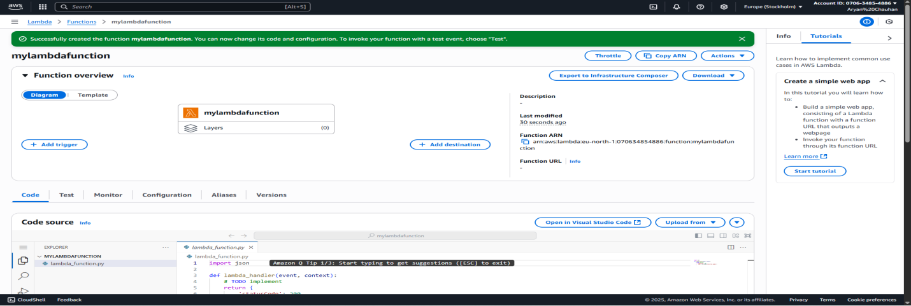

Step 07:Upload the code
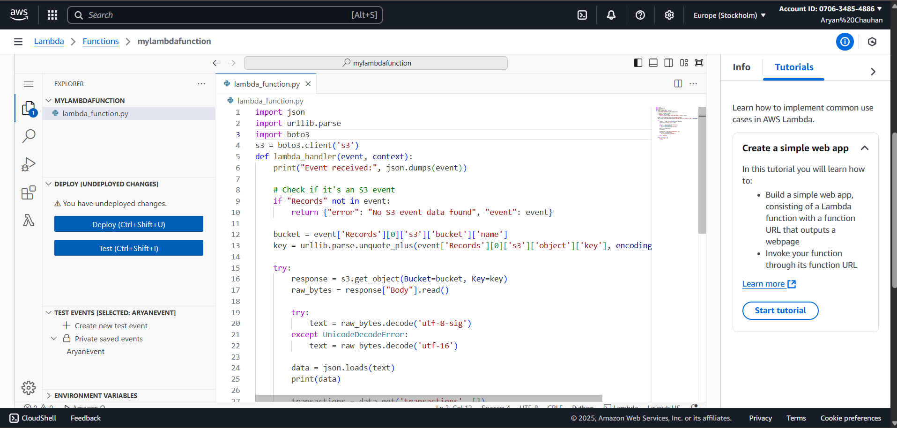
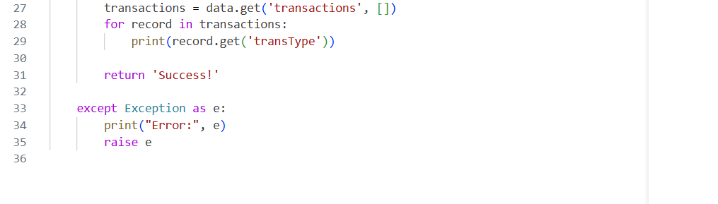
Step 08:Deploy the function (whenever you update the code)
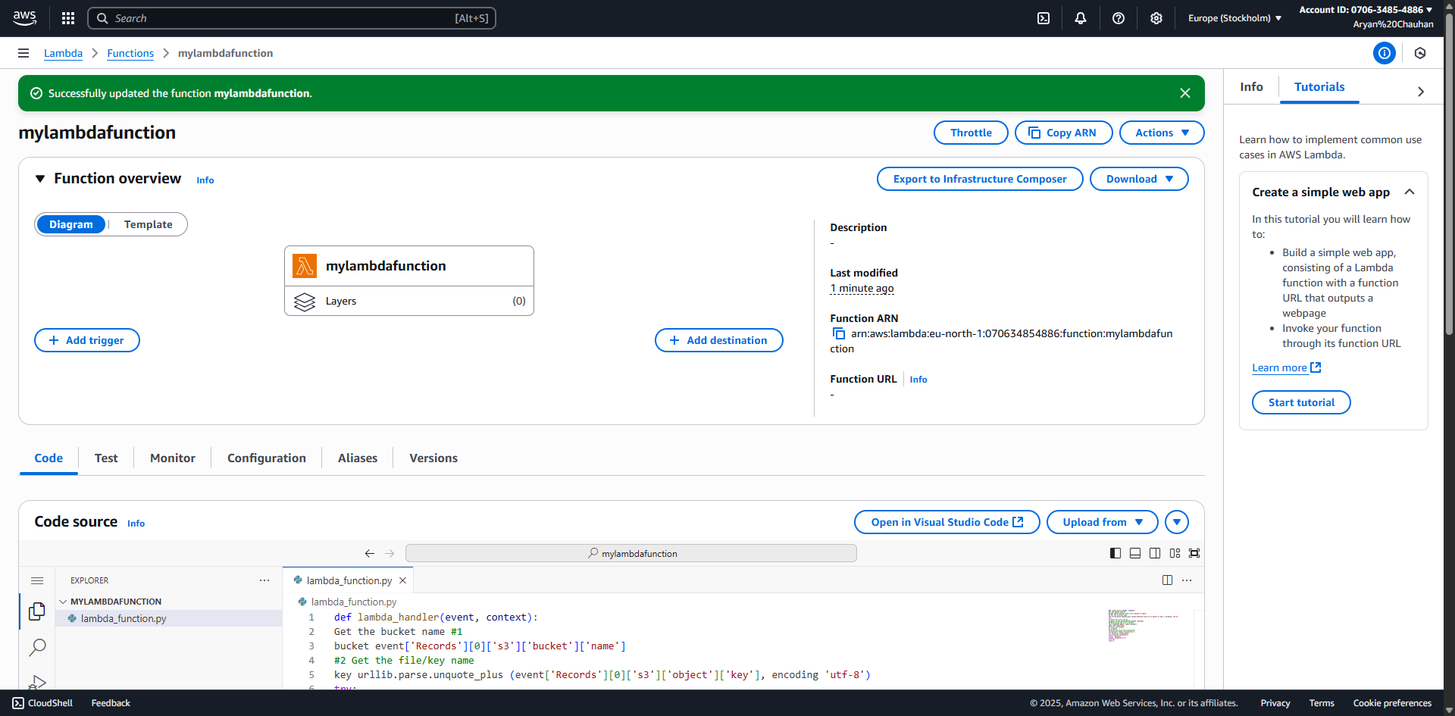

Step 09:Add A trigger
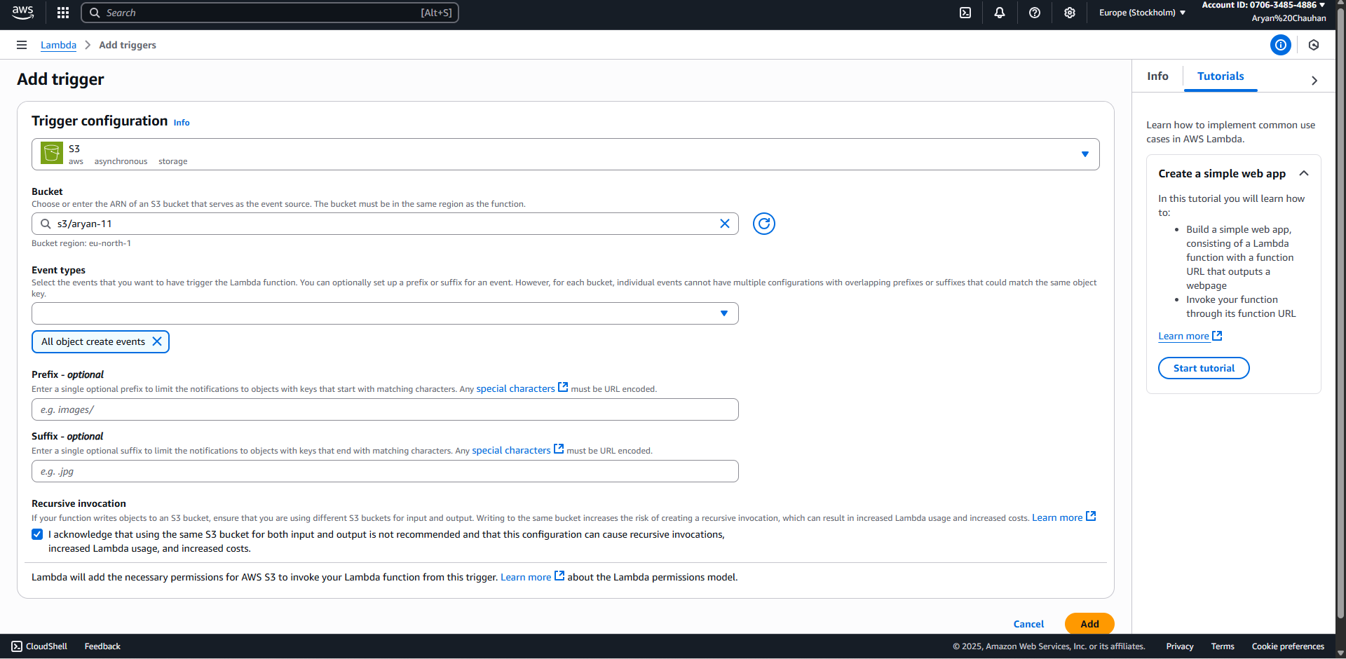

Step 10:Successfully Added the Trigger
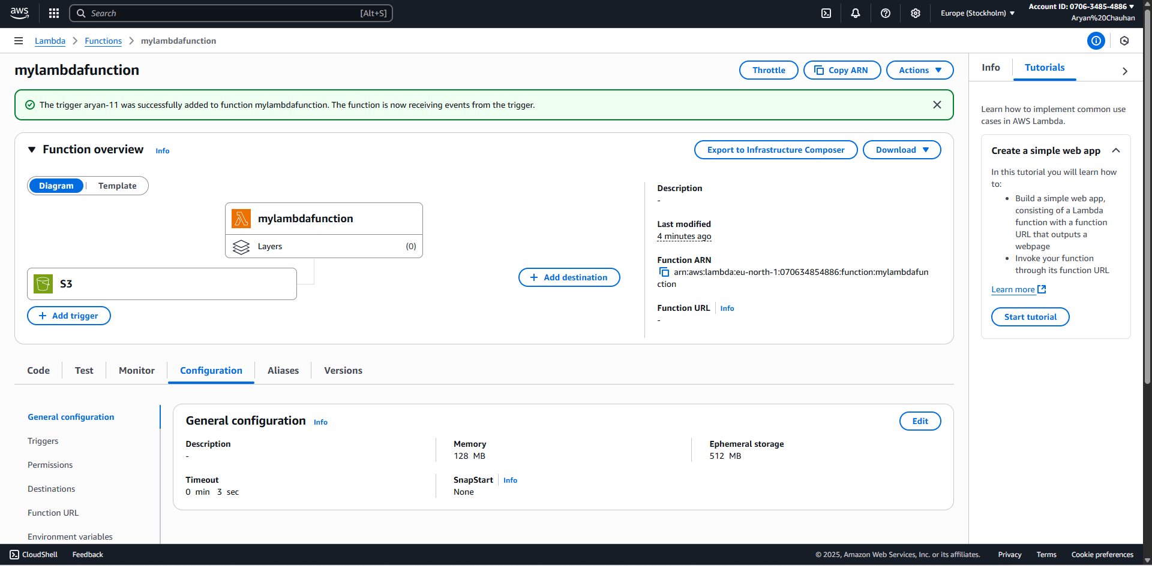

Step 11:Go back to s3(else open s3 in new tab) and make changes in properties and upload an Image
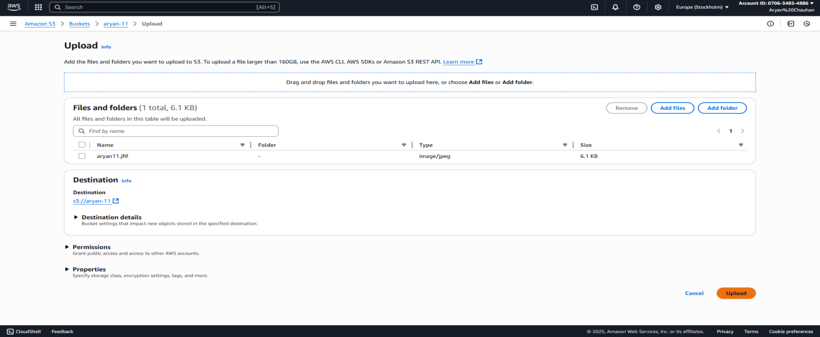
Step 12:Successfully Uploaded 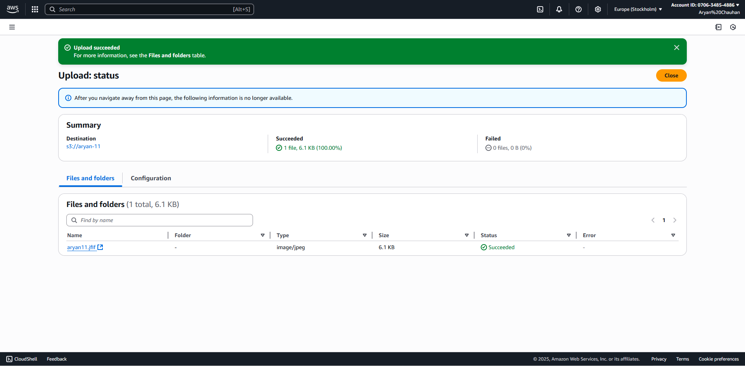

Step 13:Check the cloudwatch Metrics
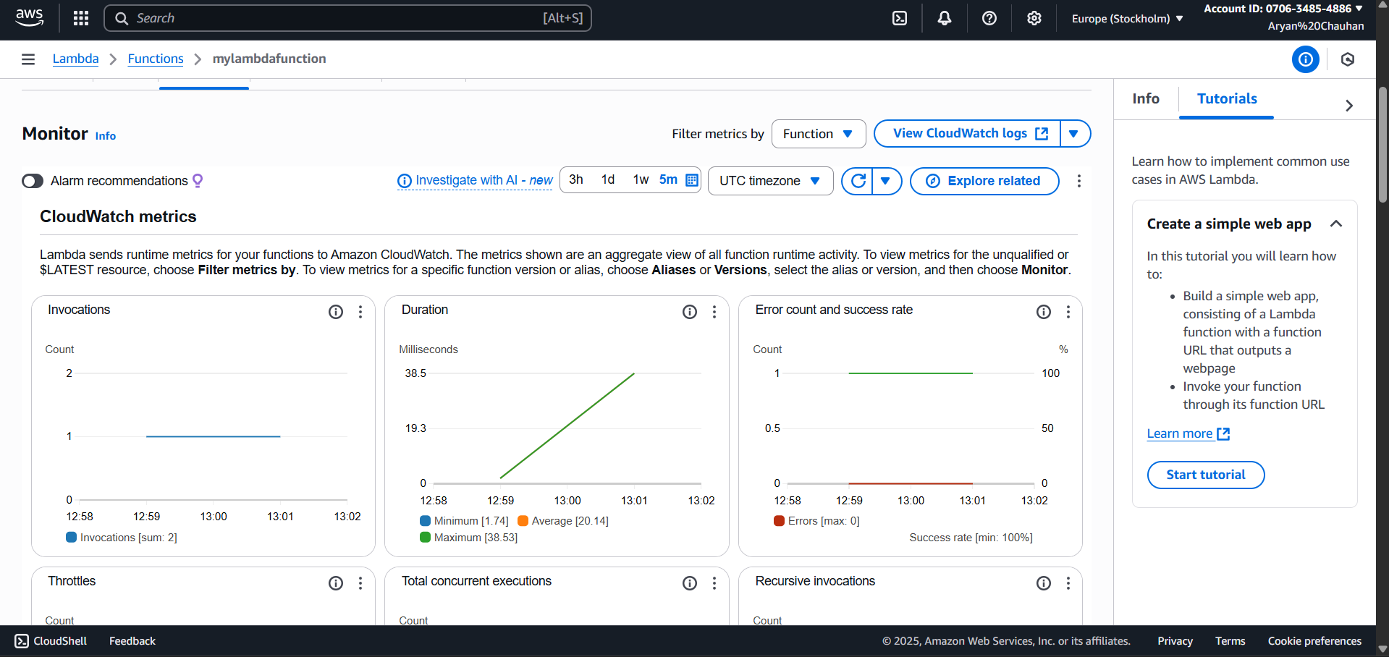

Step 14:View CloudWatch Logs
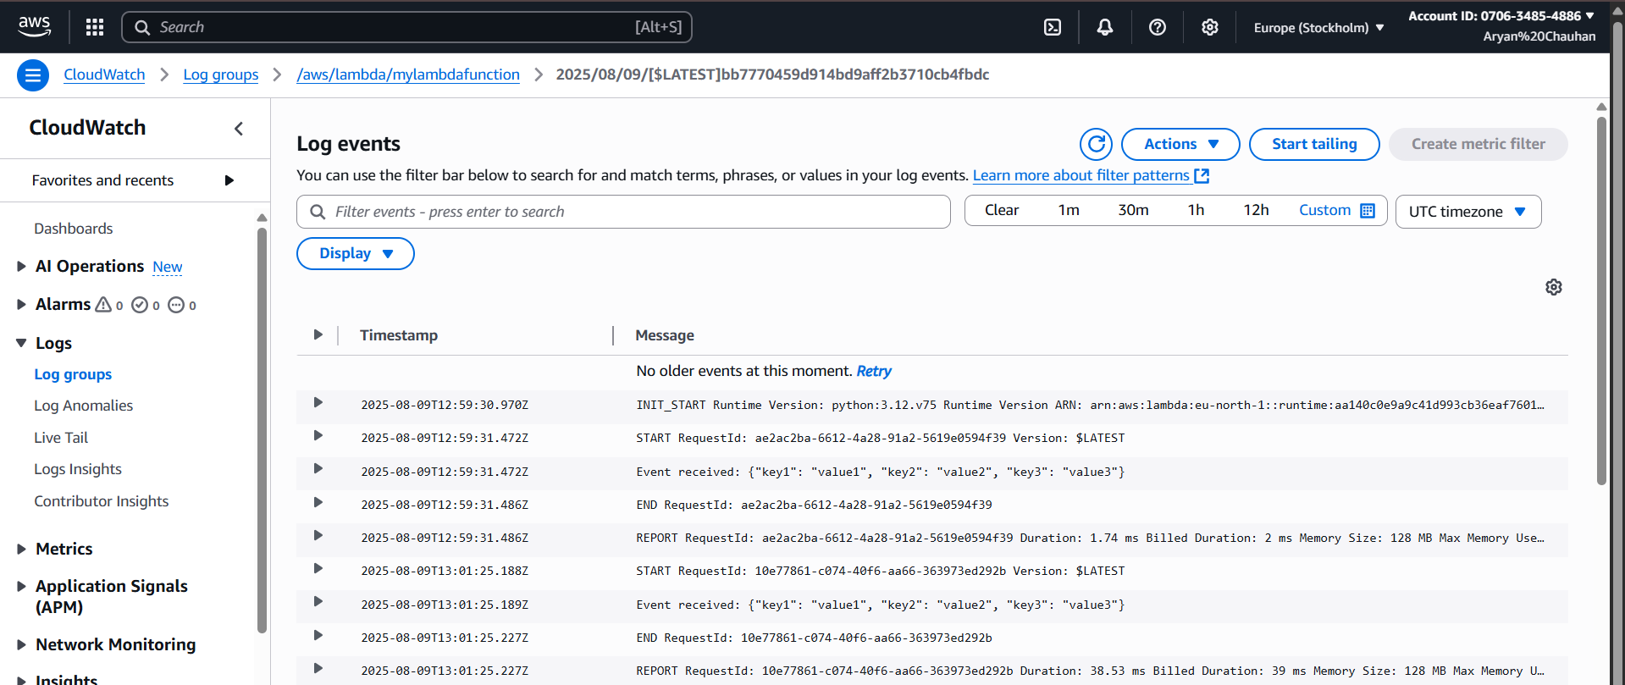

Conclusion:
Through this experiment, the implementation of an AWS Lambda function with a trigger from an Amazon S3 bucket was successfully achieved. The process involved configuring an event notification in S3 so that file uploads automatically invoked the Lambda function. This provided an understanding of the structure of S3 event payloads, methods to extract bucket names and object keys from the event, and techniques to read file contents from S3 within the Lambda environment. The experiment also enhanced knowledge of AWS services such as, boto3 , and JSON data handling in Python. Additionally, experience was gained in debugging Lambda functions using CloudWatch logs and managing different file encodings and event formats.

