Name: Deep Vaviya
Class:TY-4
Roll no:72
PRN:124BTCM2011
Batch C

Experiment No 7 : AWS Elastic Load Balancing

Title: Implement cloud-based Elastic Load Balancing as a Service on AWS

Learning Outcome: Apply Load balancing using platforms like AWS

Theory:
AWS Elastic Load Balancing is a managed service that automatically distributes incoming application traffic across multiple healthy compute resources, such as EC2 instances, to ensure high availability and scalability. By acting as a single point of entry, the load balancer prevents any single backend resource from becoming overwhelmed and automatically handles fluctuations in traffic demand. This distribution happens across multiple Availability Zones (AZs), effectively providing fault tolerance by isolating the application from failure in a single zone or instance.

There are four main types of load balancers available under AWS Elastic Load Balancing (ELB).
- Application Load Balancer (ALB): Layer 7 (HTTP/HTTPS) routing based on content (paths, hostnames).
- Network Load Balancer (NLB): Layer 4 (TCP/UDP/TLS) high-performance, ultra-low latency load balancing, supporting static IPs.
- Gateway Load Balancer (GWLB): Layer 3/4 used for deploying and scaling virtual network appliances (like firewalls or Intrusion Detection Systems) as a service.
- Classic Load Balancer (CLB): The legacy load balancer. It operates at both Layer 4 and Layer 7 but is no longer recommended by AWS for new applications.

The load balancer relies on Listeners to check for client connection requests and routes this traffic to Target Groups, which are logical groupings of your backend servers. Crucially, the system employs continuous Health Checks to monitor these targets, only forwarding traffic to targets that are confirmed to be operational.

Procedure: Step-wise explanation with screen shots

STEP 01:CREATE TWO INSTANCES
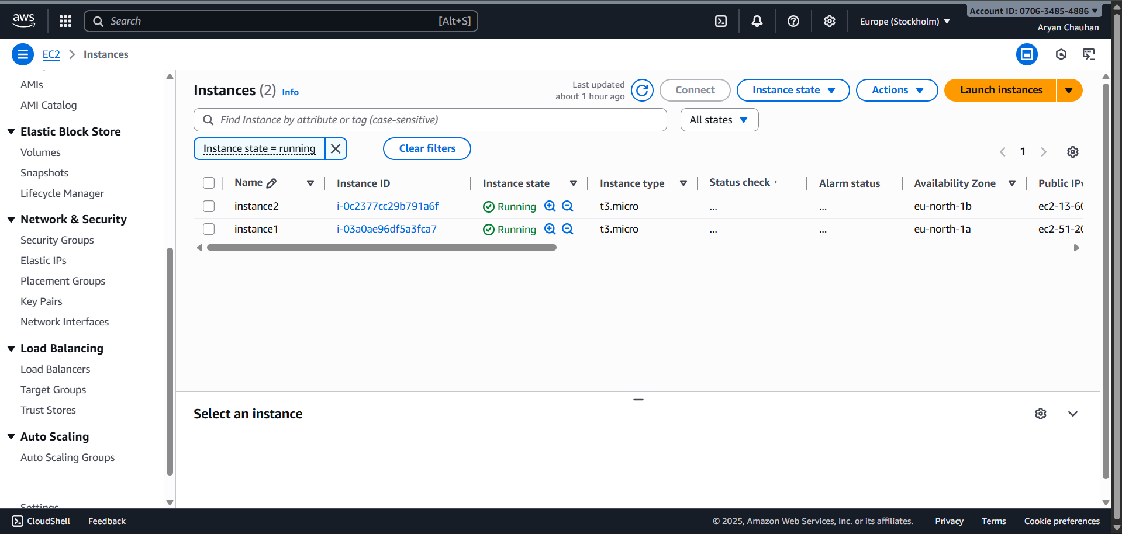

STEP 02: CREATE APPLICATION LOAD BALANCER
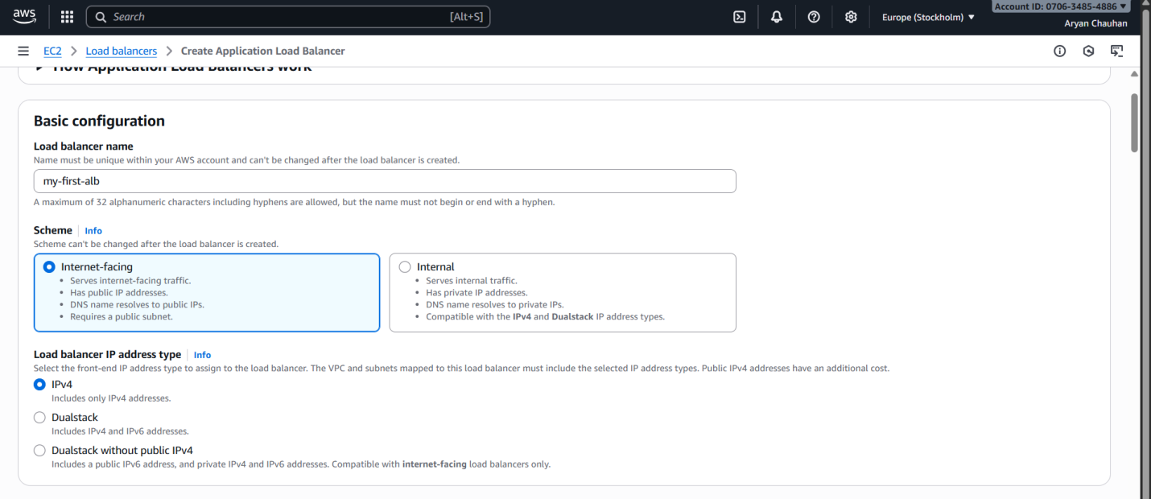
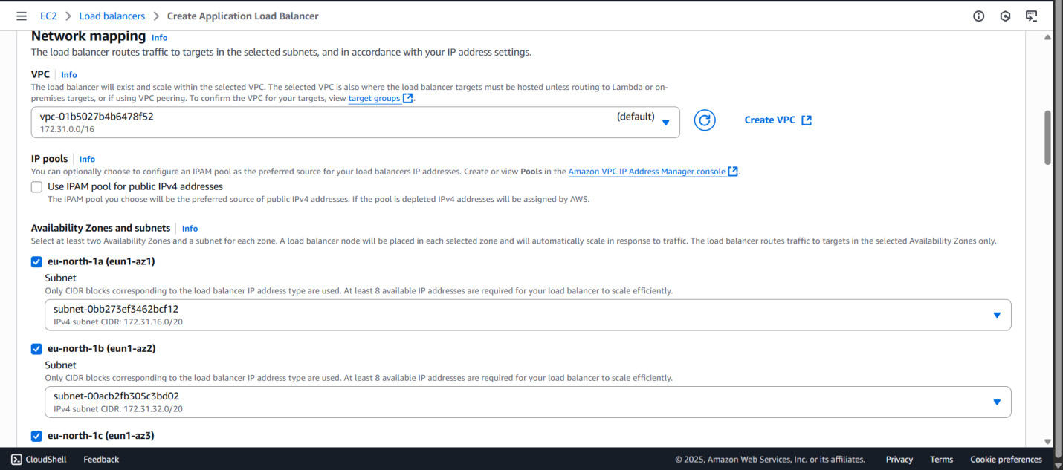
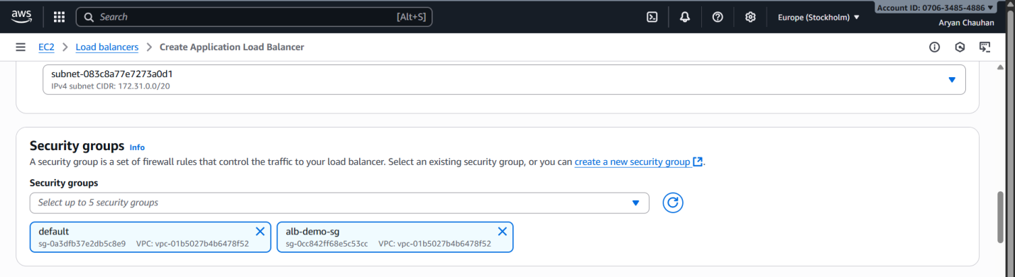

STEP 03 : CREATING SECURITY GROUP
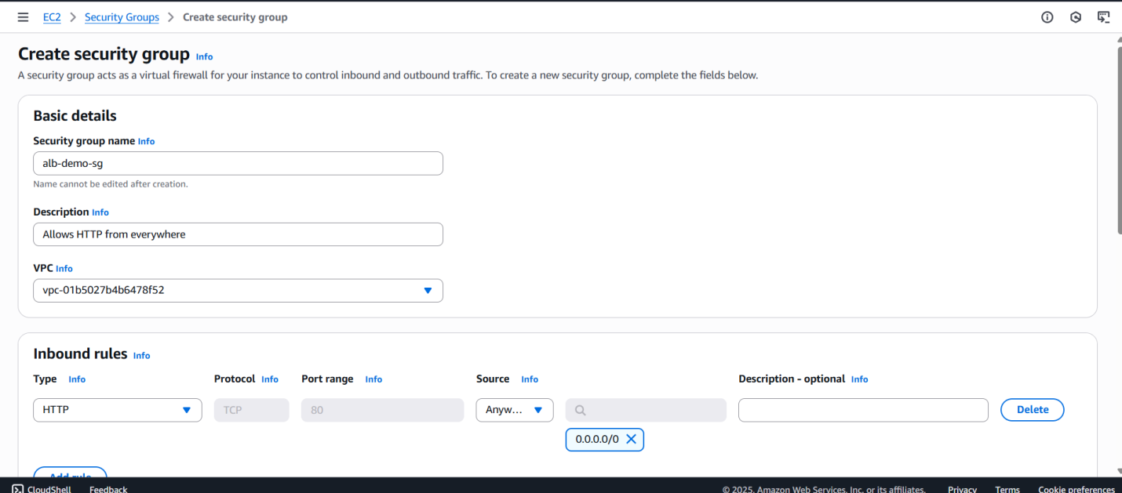

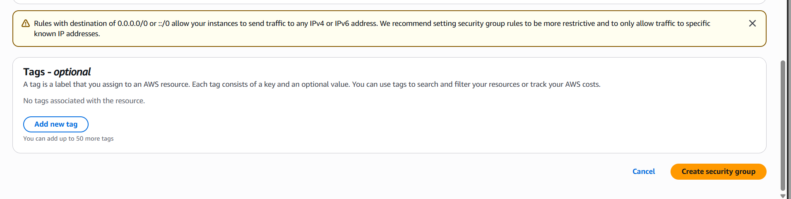

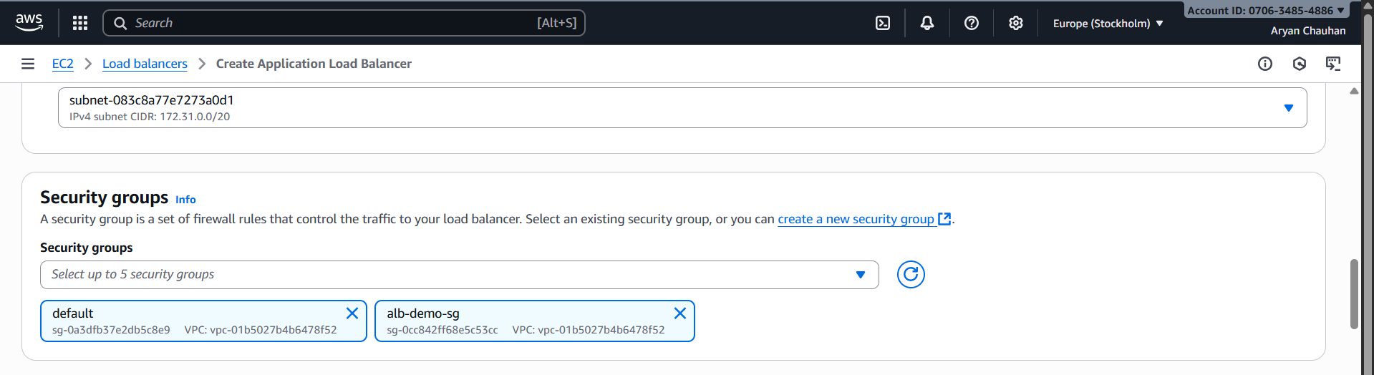

STEP 04:CREATE A TARGET GROUP
Choose Instance :
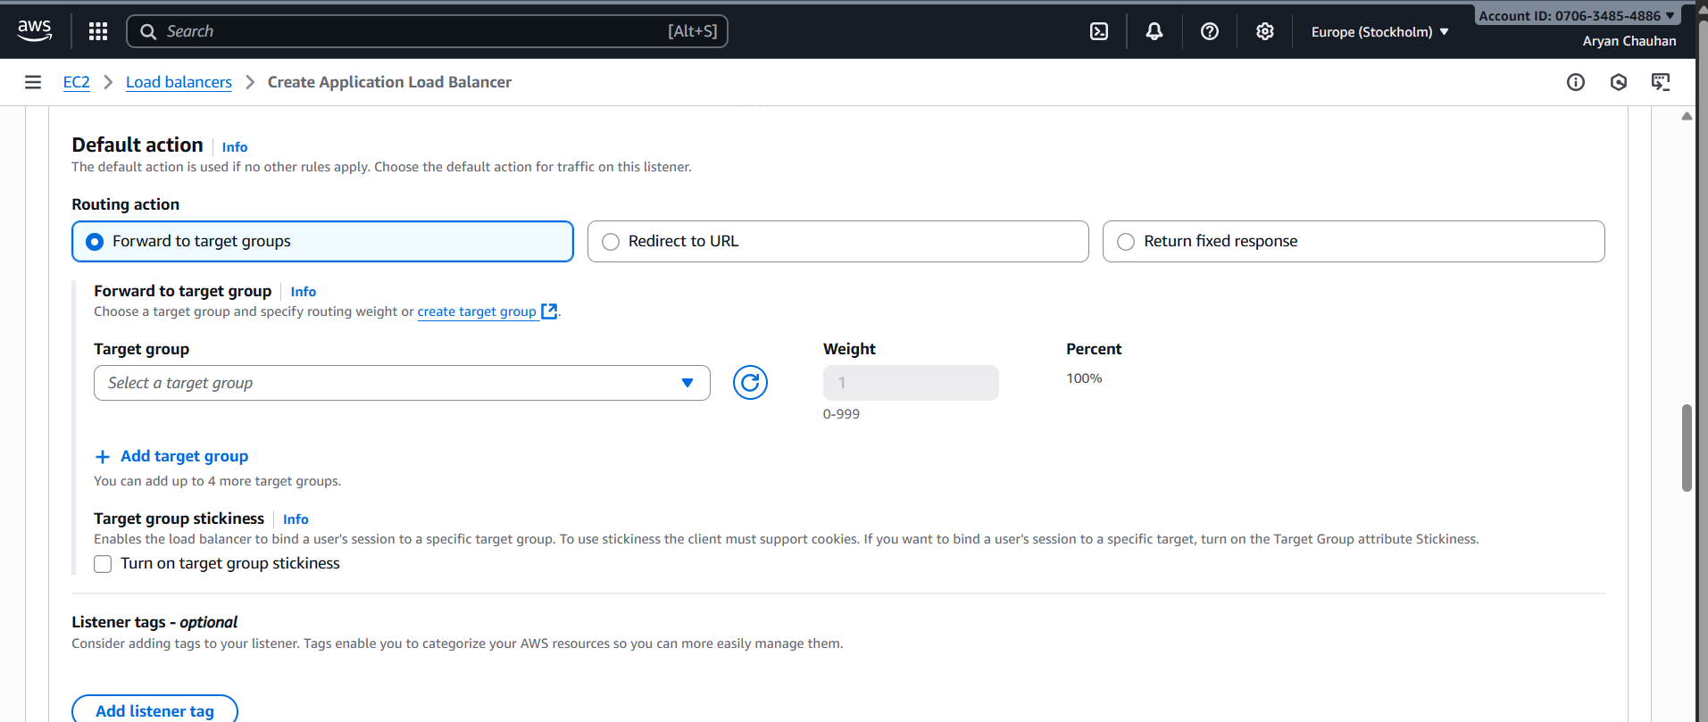

Make a target group name
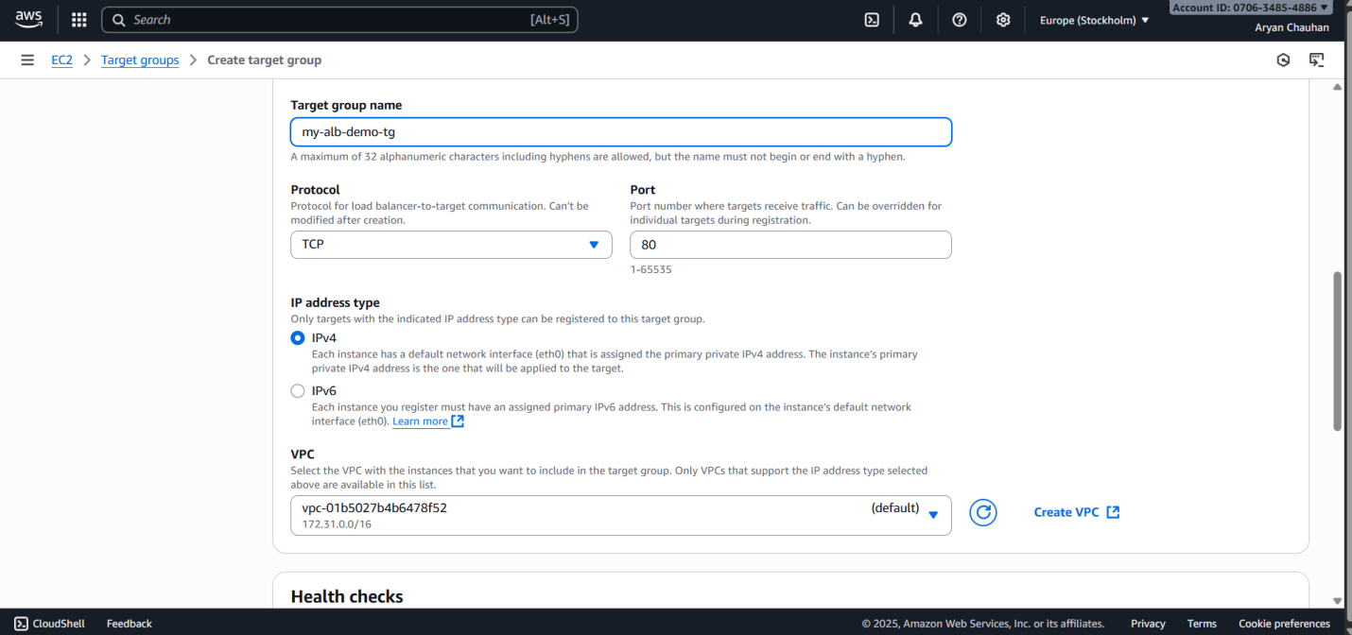

Choose The two instances Running :
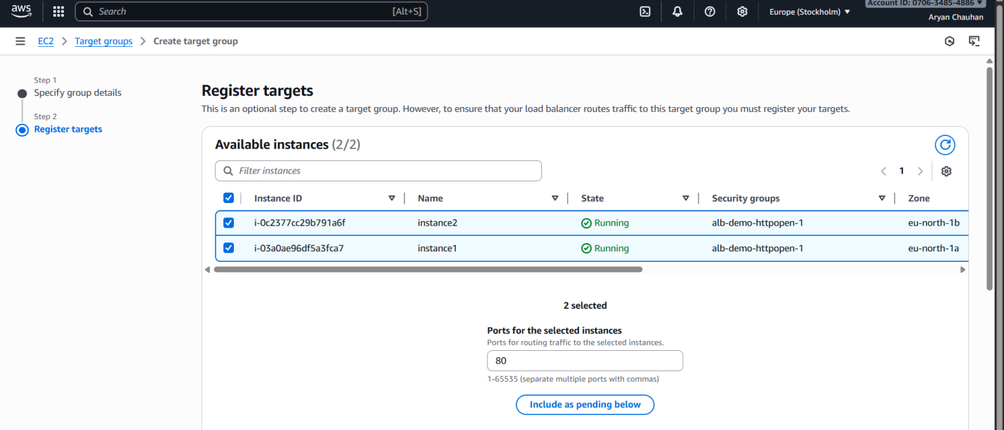

Include the instances pending below & Click on create Target Group :
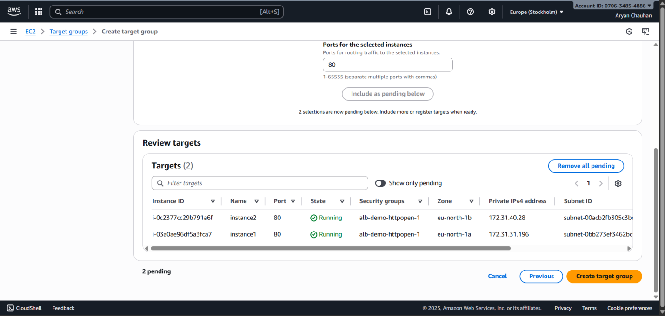

Target Group created Successfully:
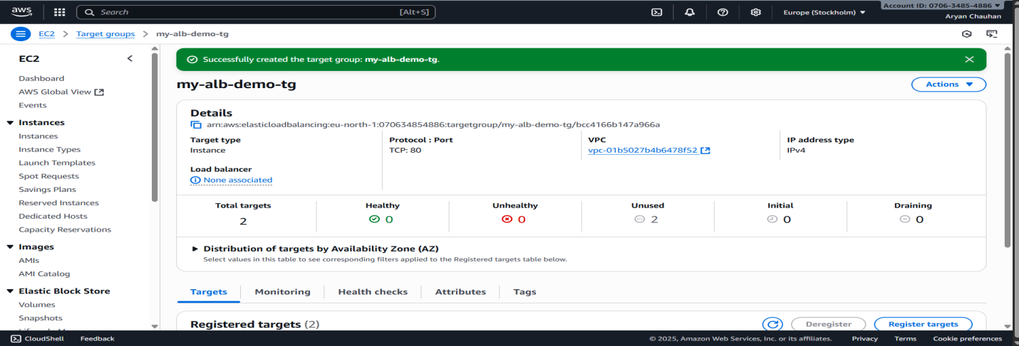

Target Group Added:
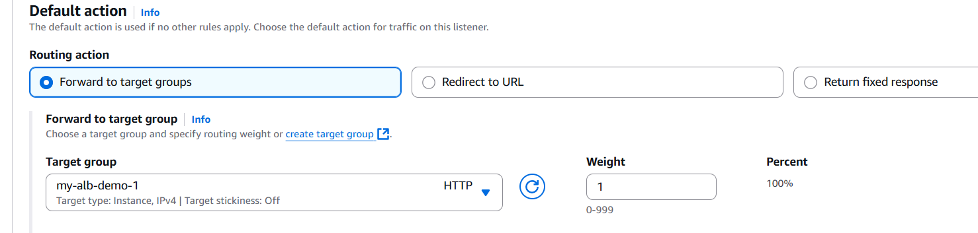

STEP 05 :LOAD BALANCERS CREATED
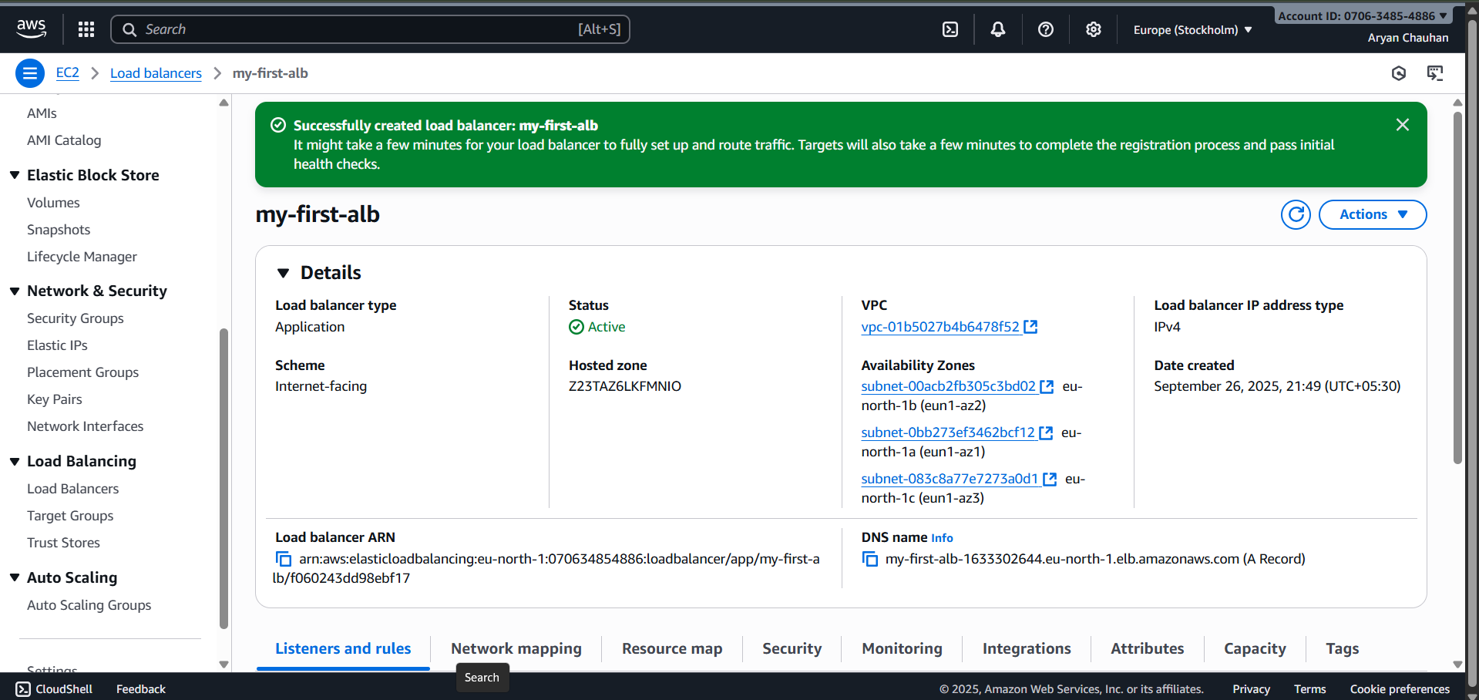

Two instances can run simultaneously Reducing Load on one
Instance 1

Instance 2

Conclusion: Implementing an AWS Elastic Load Balancer (often an ALB for a web application) demonstrates how to create a highly available and scalable architecture. The experiment will involve setting up a load balancer across at least two AZs, defining a listener (e.g., HTTP), configuring a target group with EC2 instances or containers, and establishing health checks. Successful completion proves the ability to apply cloud-based Load Balancing as a Service to effectively manage and distribute application traffic

