Name: Deep Vaviya
Class:TY-4
Roll no: 72
PRN:124BTCM2011
Batch C

Exp 8 : Auto Scaling Group

Title: Design Auto Scaling Group

Learning Outcome: Apply Load balancing with an auto scaling group using platforms like AWS.

Theory:
Auto Scaling is an essential cloud feature that automatically adjusts the compute capacity of your application to maintain performance and optimize costs. It works by ensuring you have the right number of Amazon EC2 instances available to handle the load.An ASG acts as an abstract container for EC2 instances, maintaining a minimum number of healthy servers.
- Desired Capacity: The number of instances the group tries to maintain under normal conditions.
- Minimum Capacity: The smallest number of instances allowed, ensuring a baseline level of service and fault tolerance.
- Maximum Capacity: The ceiling for the number of instances, preventing runaway costs during unexpected traffic spikes.
- Launch Template: This is the blueprint (AMI, instance type, security group) the ASG uses to launch new EC2 instances when scaling out.

When combined with Elastic Load Balancing (ELB), Auto Scaling becomes even more powerful:
● The Load Balancer evenly distributes incoming traffic across all active EC2 instances. ● The Auto Scaling Group ensures there are always enough healthy instances behind the Load Balancer.
● Together, they create a highly available, fault-tolerant, and scalable environment without manual intervention

Benefits of using this service :
1. Improved application availability.
2. Automatic scaling during traffic spikes or drops.
3. Cost optimization by running only the required resources.
4. Fault tolerance through health checks and automatic instance replacement.

Procedure: Step-wise explanation with screen shots

Step01:Create a Auto-Scaling Group
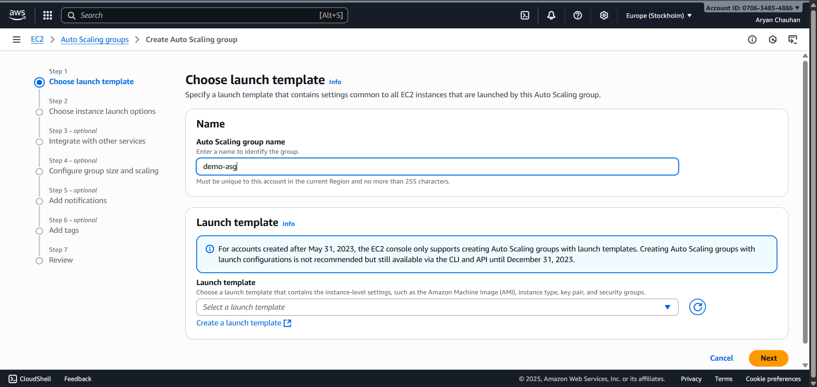
Step 02:Create Launch Template
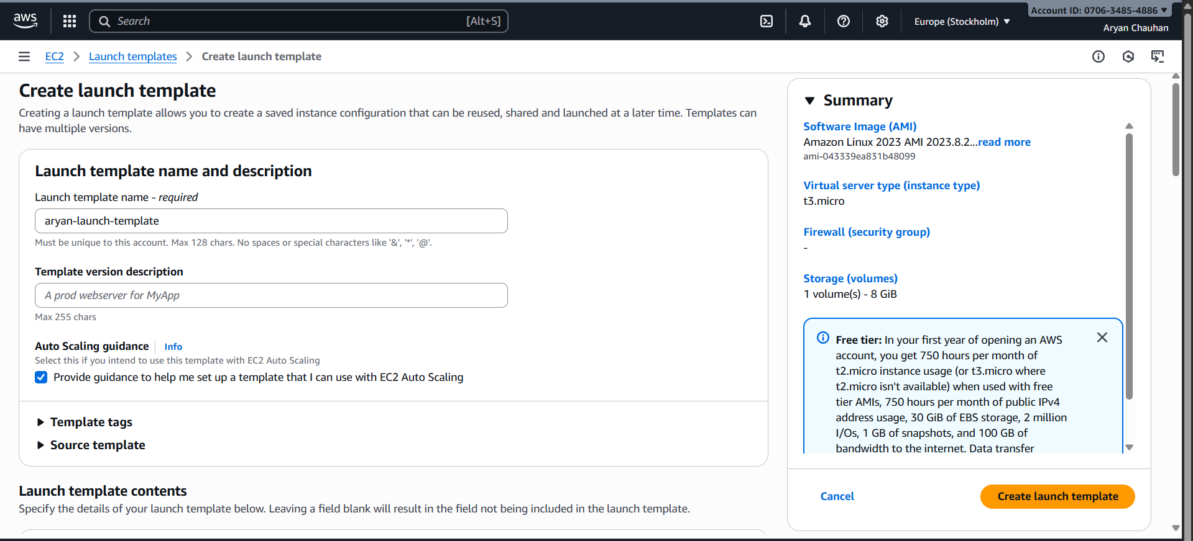

Step 03:In Quick Start Select Linux and Instance Type as t3.micro
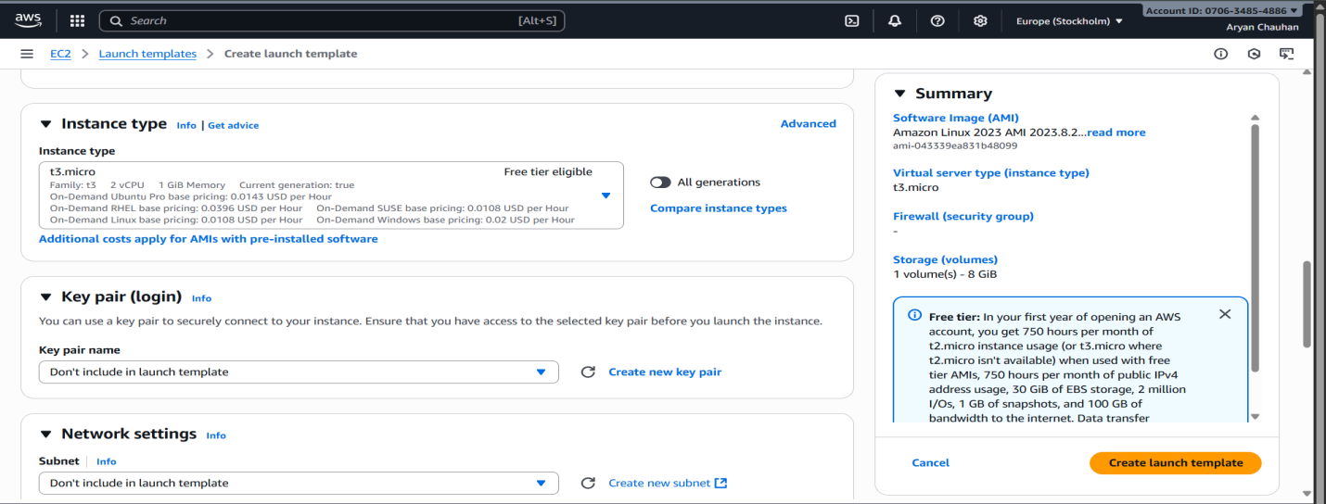
Step 04:Put the Existing Security Group
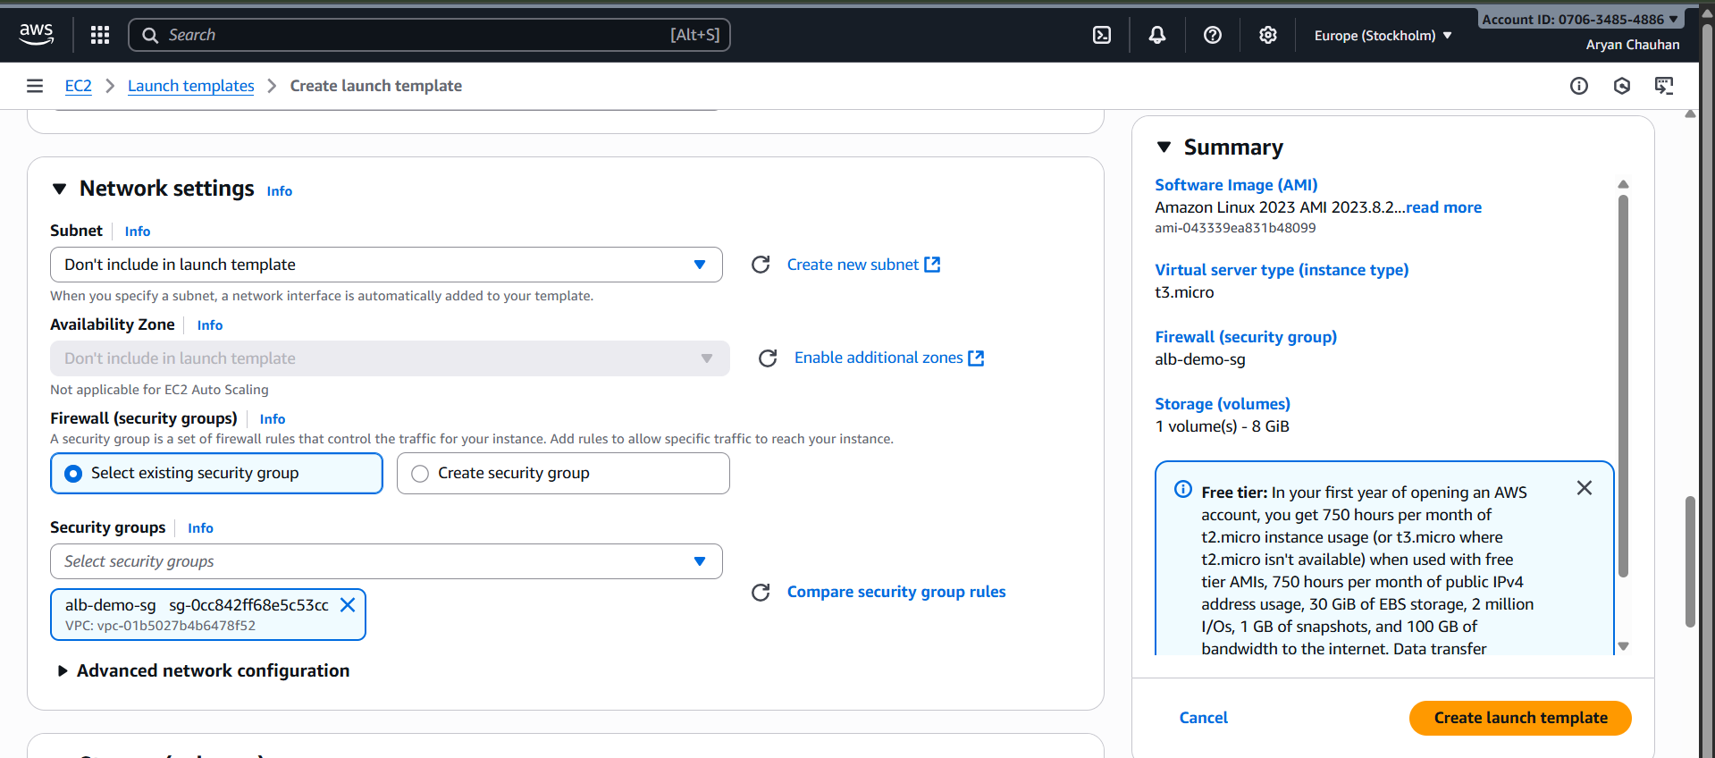
Step 05:Put the code infuser data and Launch Template
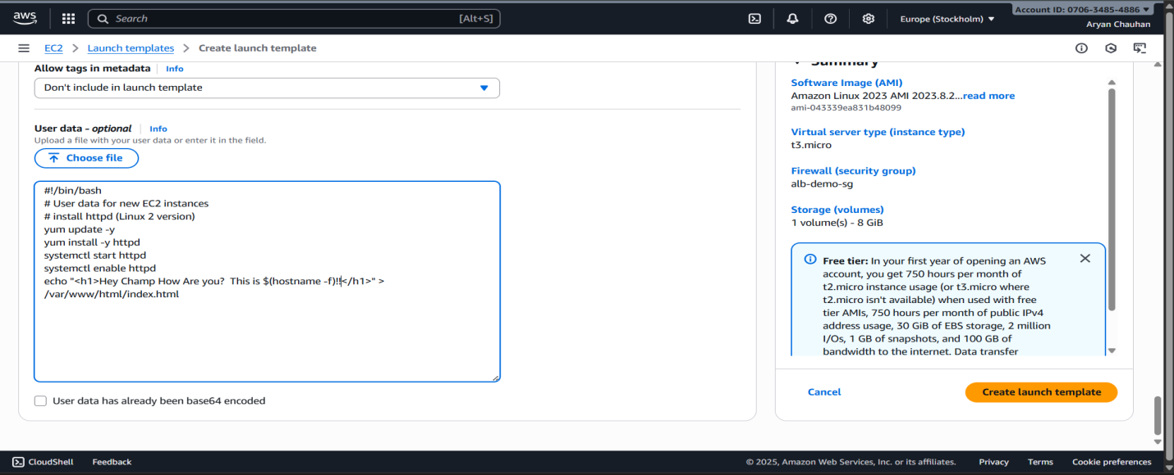

Step 06:The newly launched Template is Available
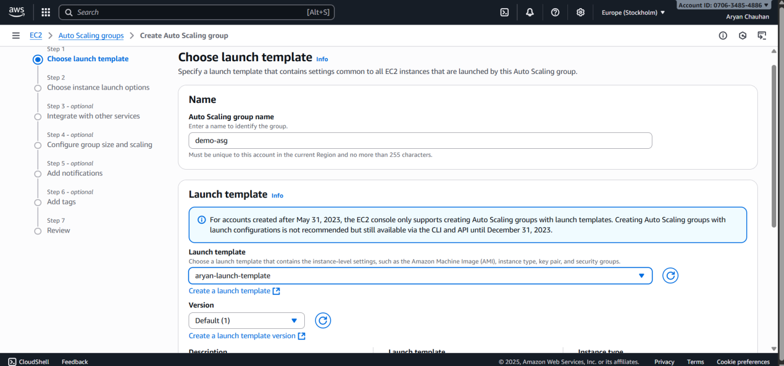
Step 07:In Instance Launch Options Choose Choose all three availability zones and subnets
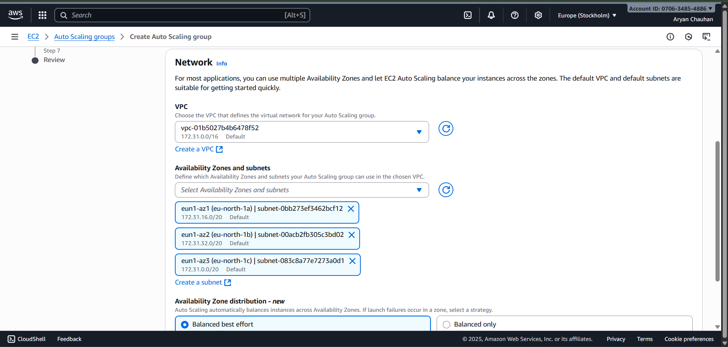

Step 08:Attach to Existing load balancer

Step 09:Turn on Amazon EBS health Check
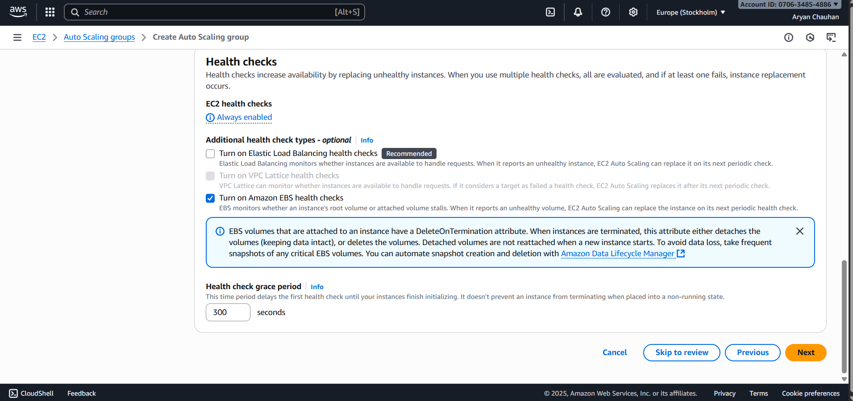
Step 10:Configuration of group Size and Scaling
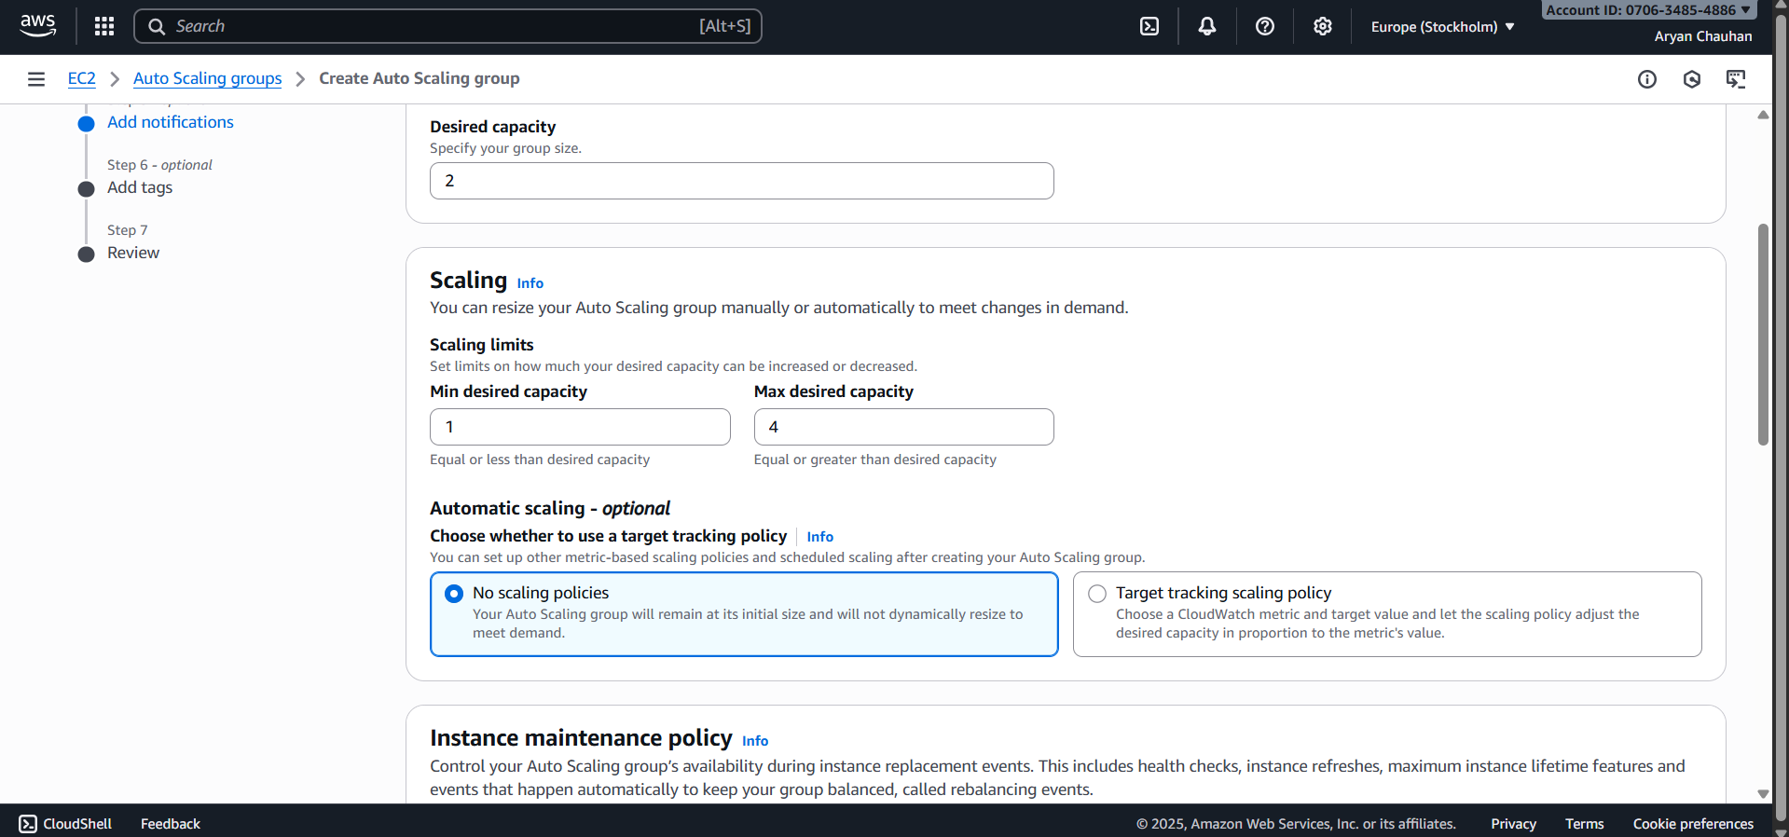
Step 11:Auto Scaling Group Created
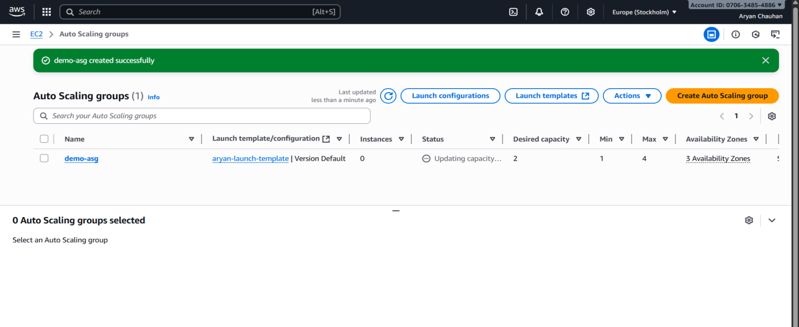
Step 12:Check the Instances
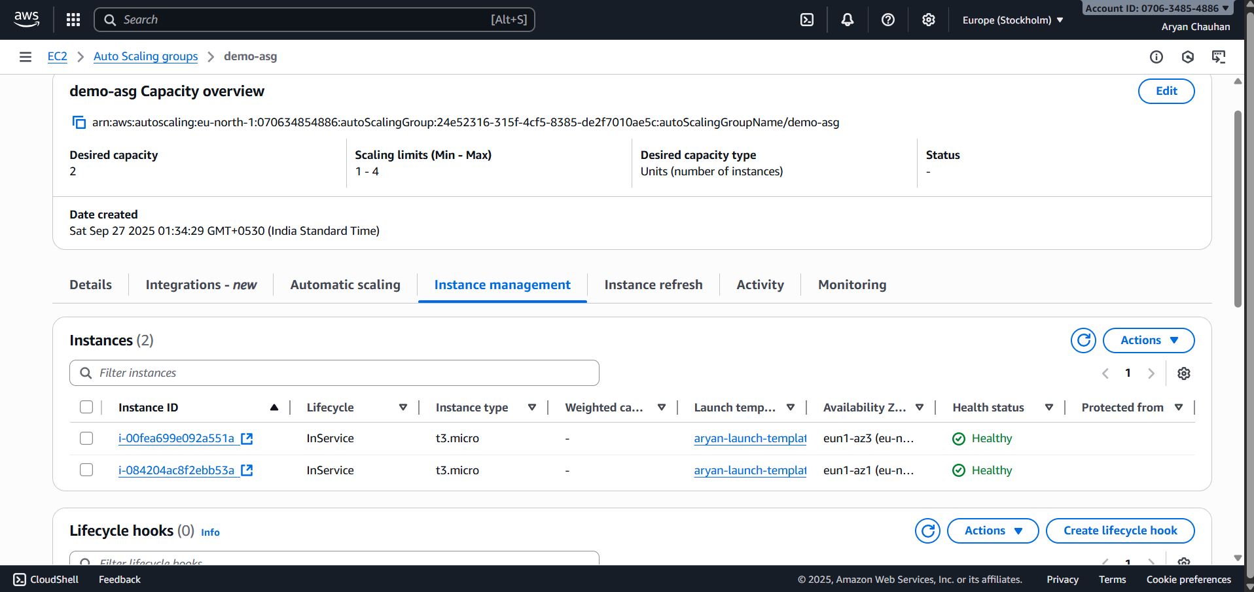
Step 13:Check History
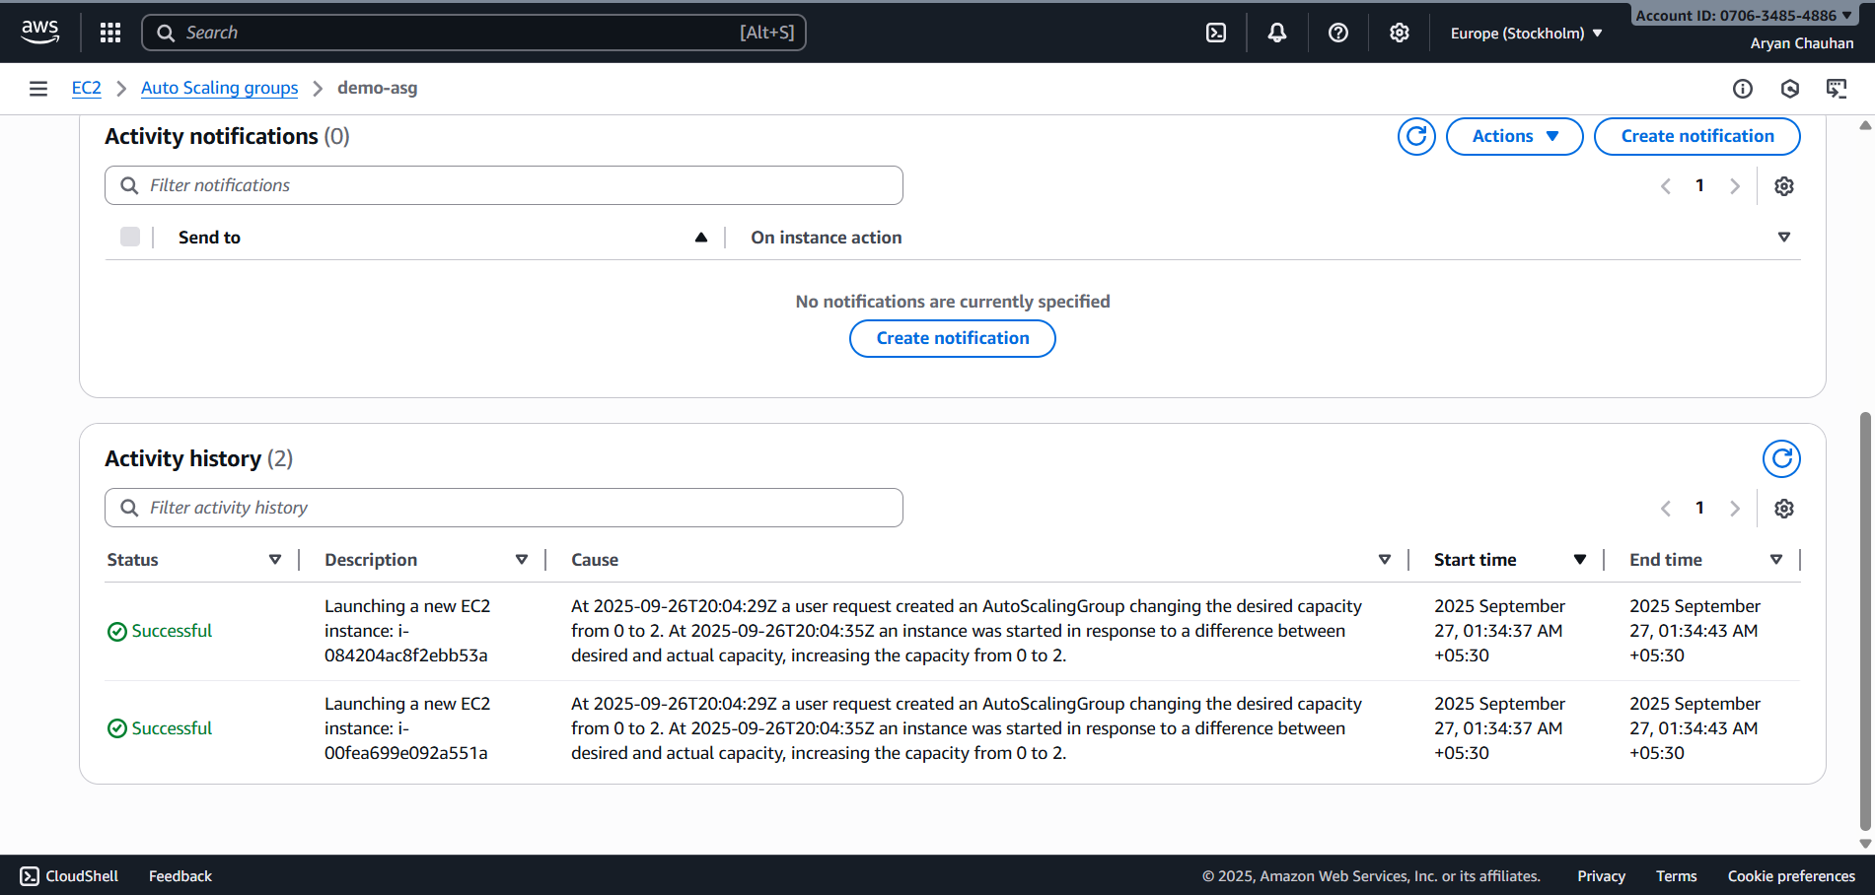
Step 14:After terminating one Instance the Results are as Follows
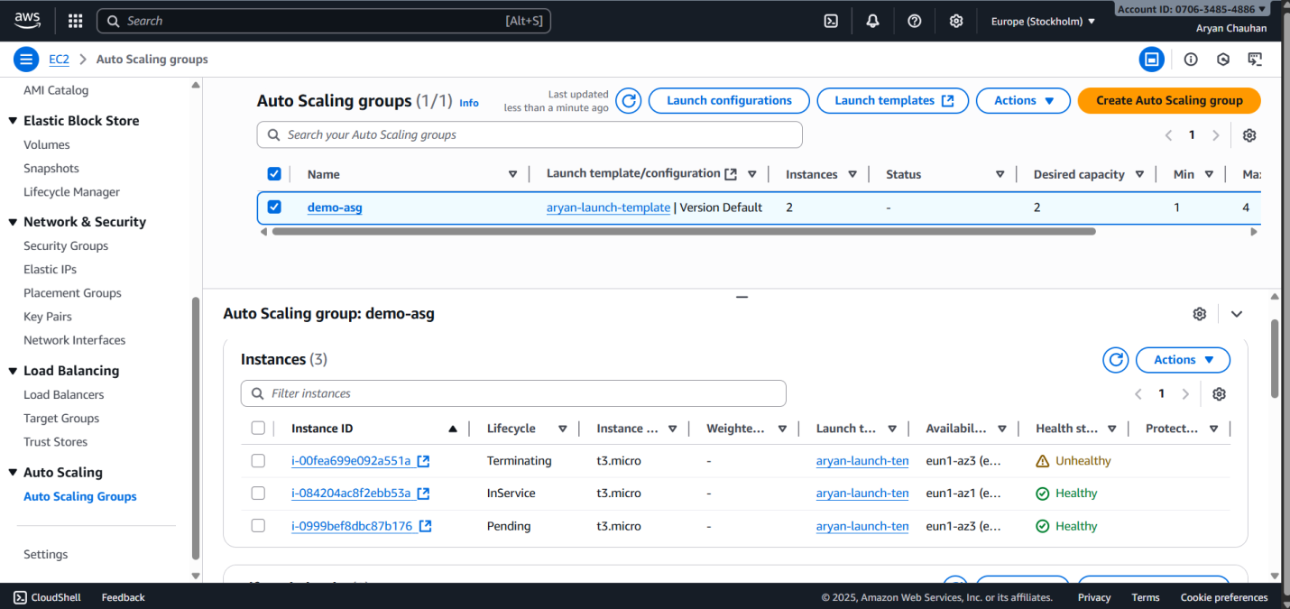
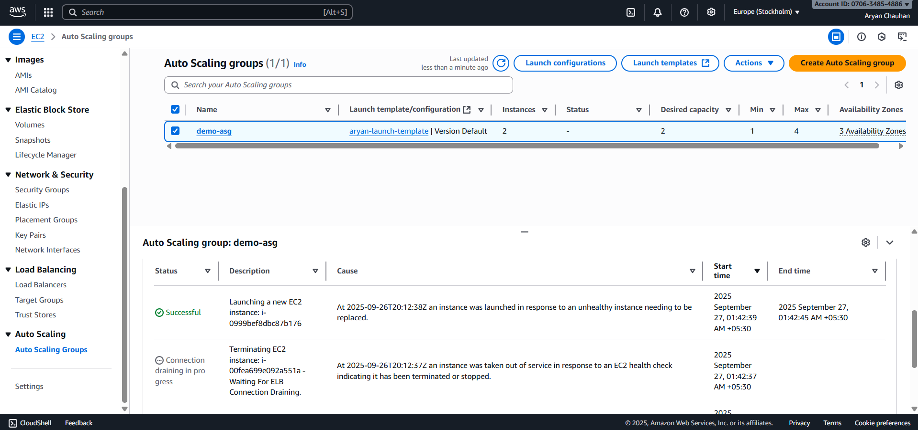

Conclusion:
The primary learning outcome involved building a system using the Elastic Load Balancer (ELB) and the Auto Scaling Group (ASG). The Application Load Balancer (ALB) provides entry, distributing client traffic across instances in multiple Availability Zones. This arrangement confirms system availability. We confirmed the ASG's ability to act, detecting unhealthy instances via ELB checks and initiating replacements to maintain service. Through Target Tracking Scaling Policies, the system adjusted capacity, scaling out to handle load and scaling in when demand dropped. This process ensures application performance during usage and confirms cost efficiency by preventing resource over-provisioning.

