Name: Deep Vaviya
Class:TY-4
Roll no: 72
PRN:124BTCM2011
Batch C

Experiment 09: AWS IAM

Title: Configure user roles, permissions and policies with Identity and Access Management

Learning Outcome: Create IAM roles using platforms like AWS

Theory:Identity and Access Management (IAM) is a security framework that defines who (identity) can access what (resources) under which conditions (policies). It ensures that the right individuals and services have the appropriate level of access to cloud resources.In AWS, IAM is a global service that allows administrators to manage access to AWS services and resources securely. The main components are:
- IAM Users:These represent individual people or applications that interact with AWS services. Each user has unique security credentials (access key, secret key, or password).
- IAM Groups:A collection of users that share common permissions. For example, you can create a “Developers” group and assign the same permissions to all users in it.
- IAM Roles: Roles are temporary sets of permissions that can be assumed by users, services, or applications. Unlike users, roles do not have permanent credentials. They are commonly used for cross-account access or allowing AWS services (like EC2, Lambda) to perform actions on behalf of the user.
- IAM Policies: Policies are JSON-based documents that define permissions. They specify what actions are allowed or denied on which resources. Policies can be attached to users, groups, or roles.
- Permissions:The actual rights granted to a user, group, or role. Permissions come from the policies attached. They decide whether the request is allowed or denied when accessing AWS resources.
Importance of IAM:
- Provides fine-grained access control.
- Enhances security by following the principle of least privilege.
- Enables centralized management of access.
- Supports compliance with security standards.
Procedure: Step-wise explanation with screen shots
LAMBDA TO S3 ACCESS USING IAM
Step 01: Create an IAM Role- Select AWS Service as Trusted Identity and select Lambda use case
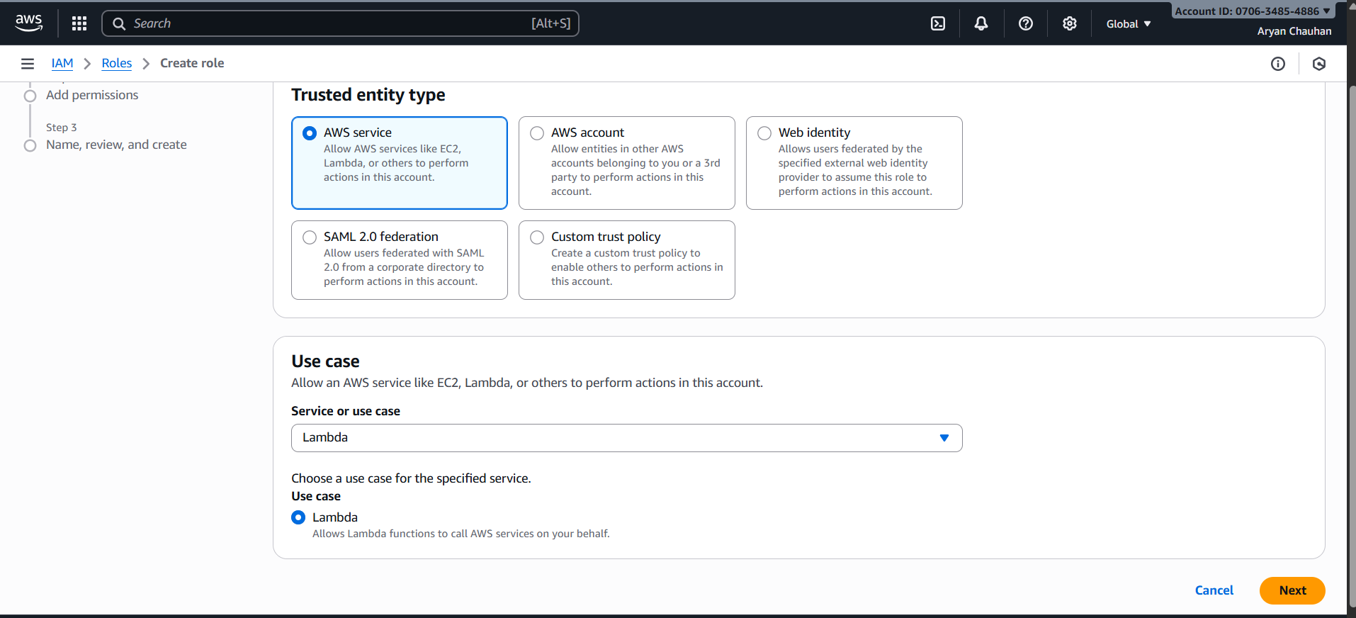

Step 02: Put Up the Role name
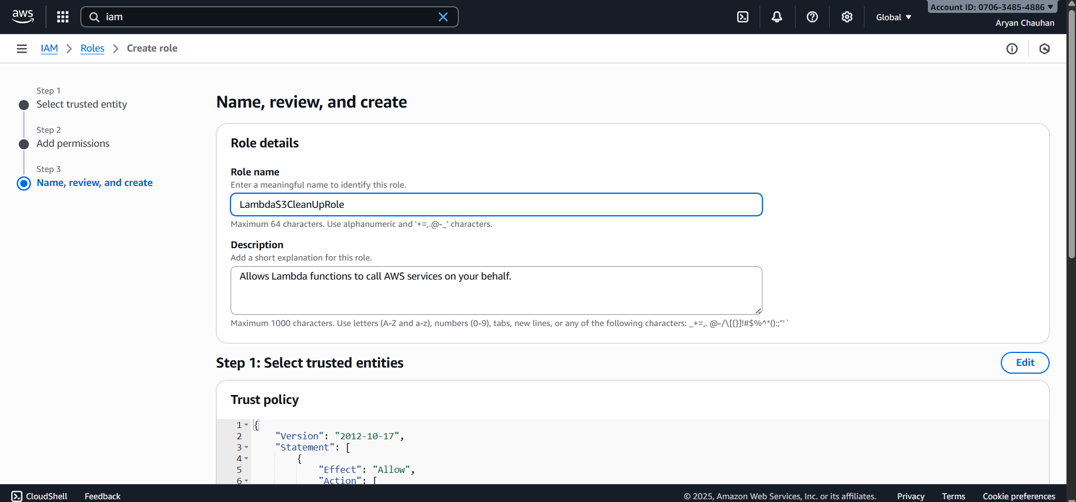

Step 03:Add tags and Create Role
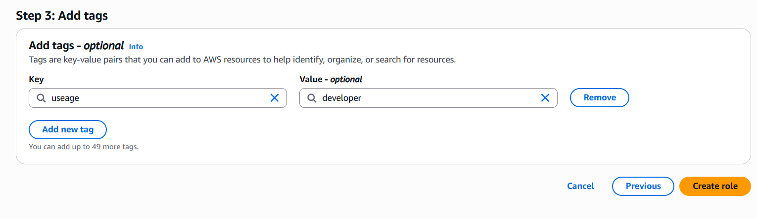

Step 04:Create IAM Policy and Select S3
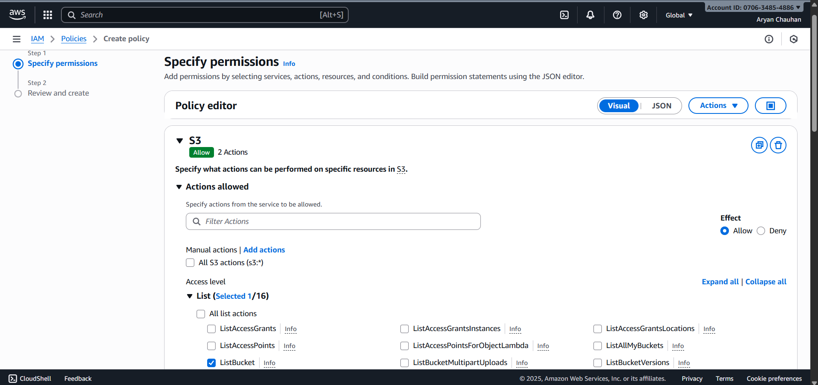
Step 05:Select the Below two Actions
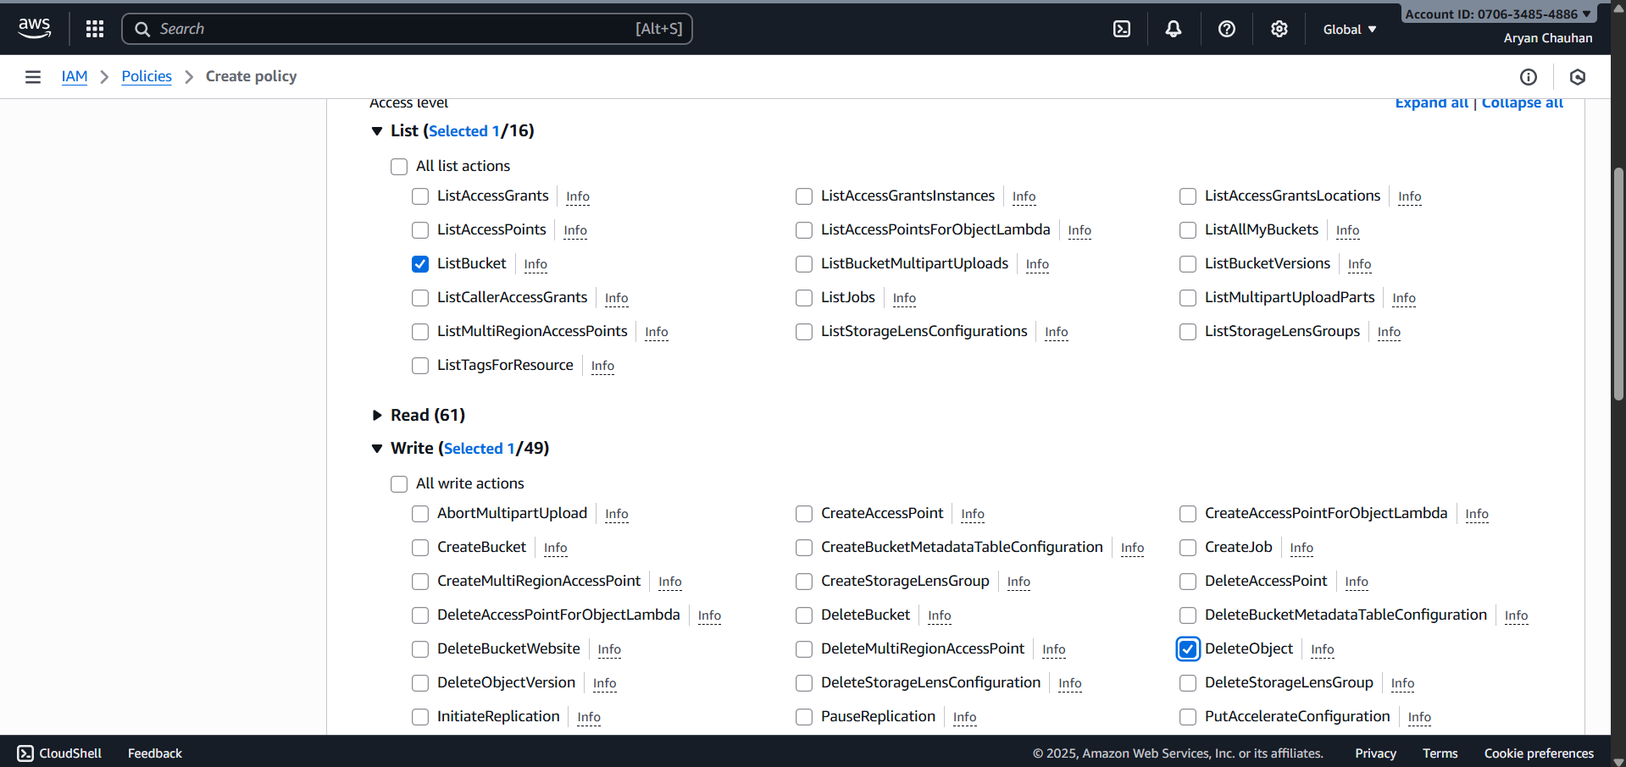
Step 05:Create S3 Bucket
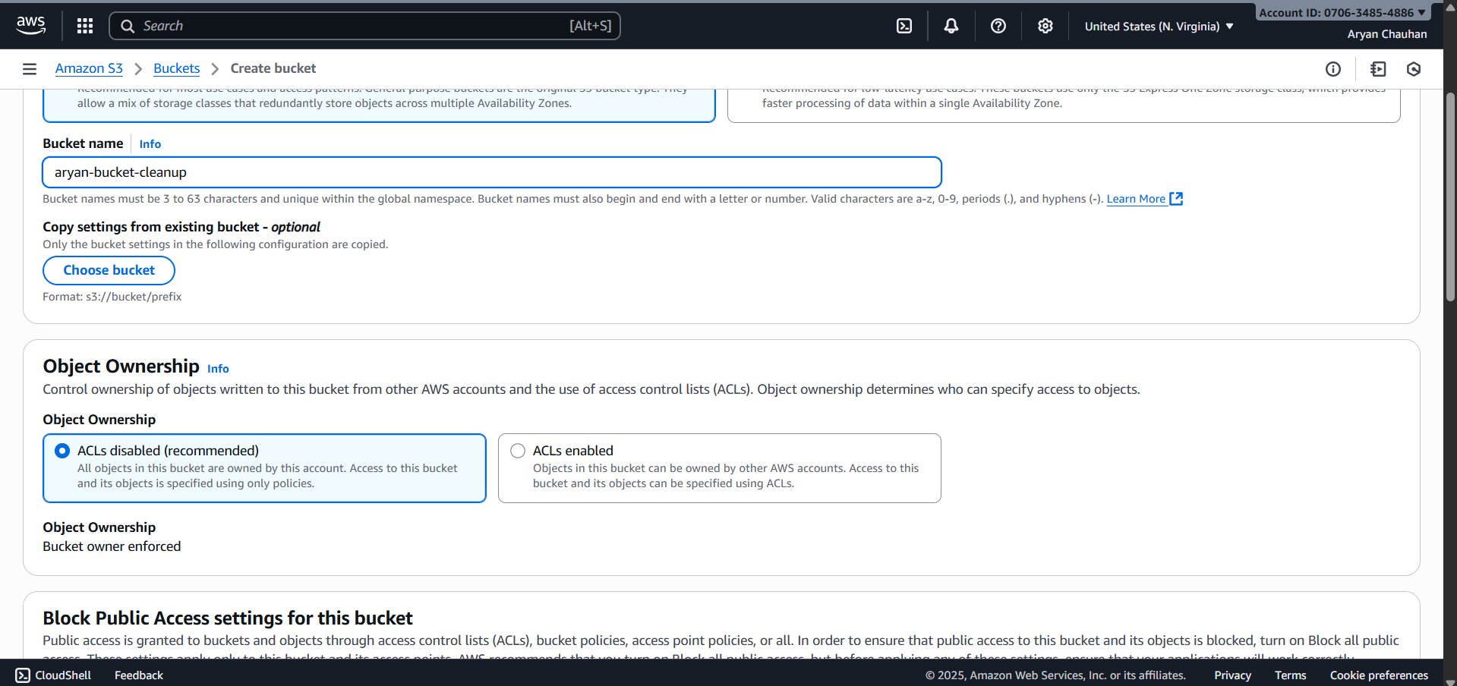

Step 06:Add ARN in the IAM Policies
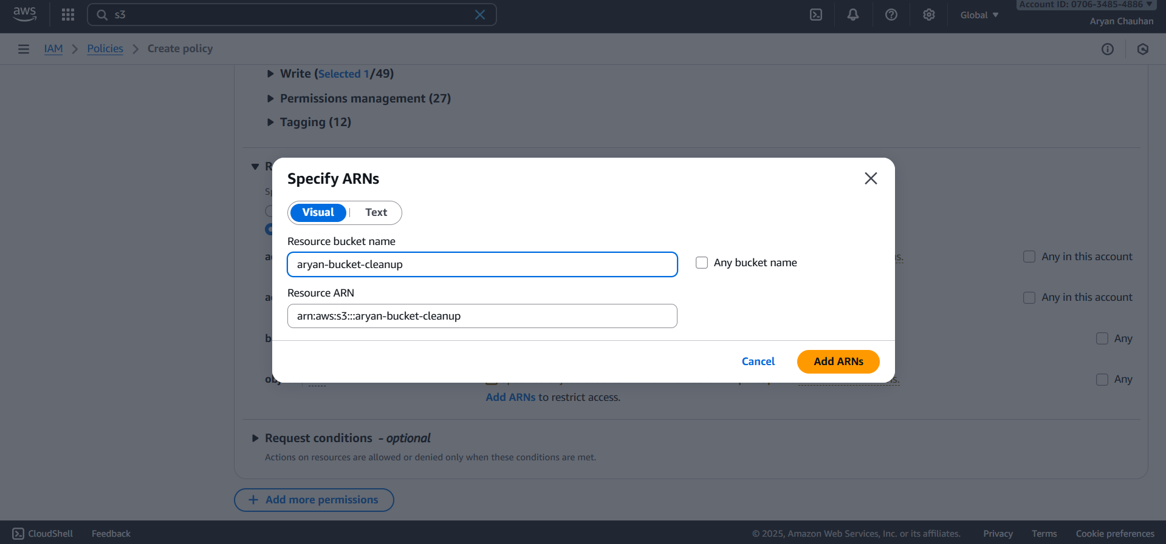
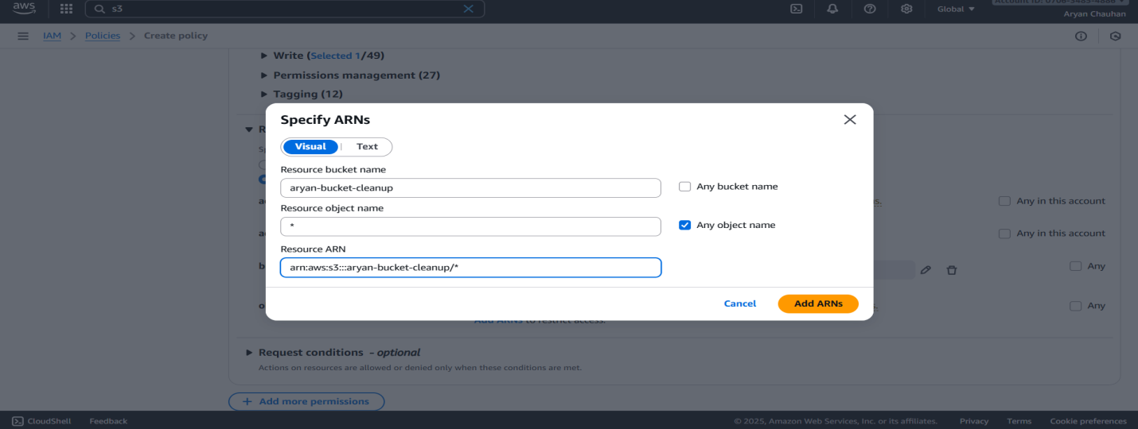

Step 07:In JSON Section update your code
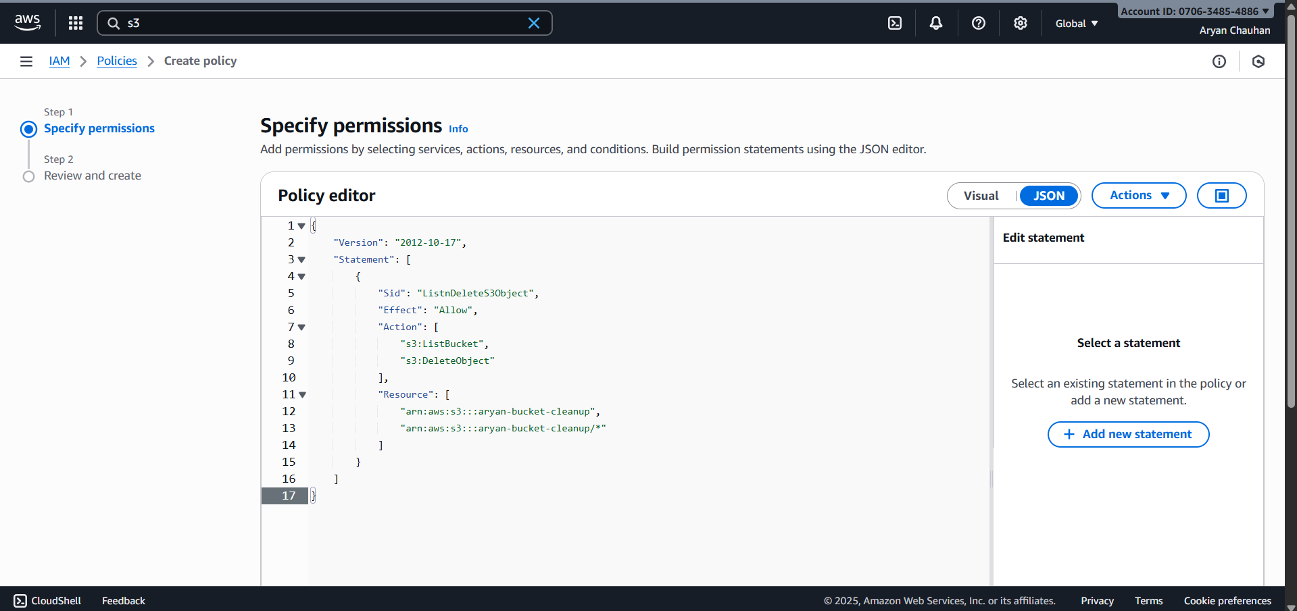

Step 08:Update the Policy name and Create Policy
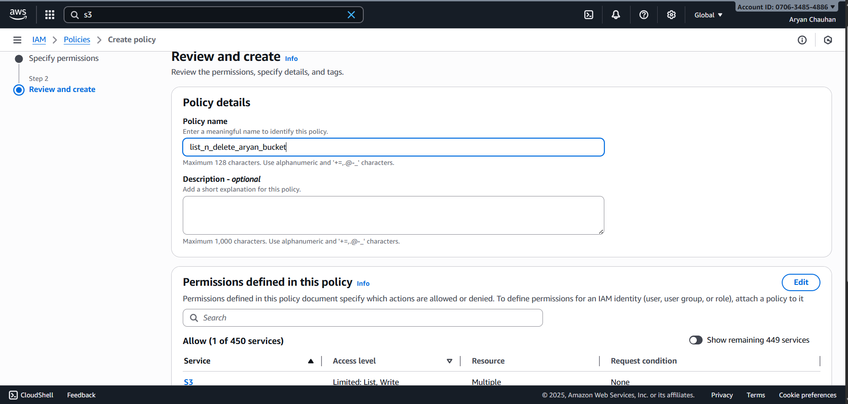
Step 09:In custom policies we can se our newly made policy

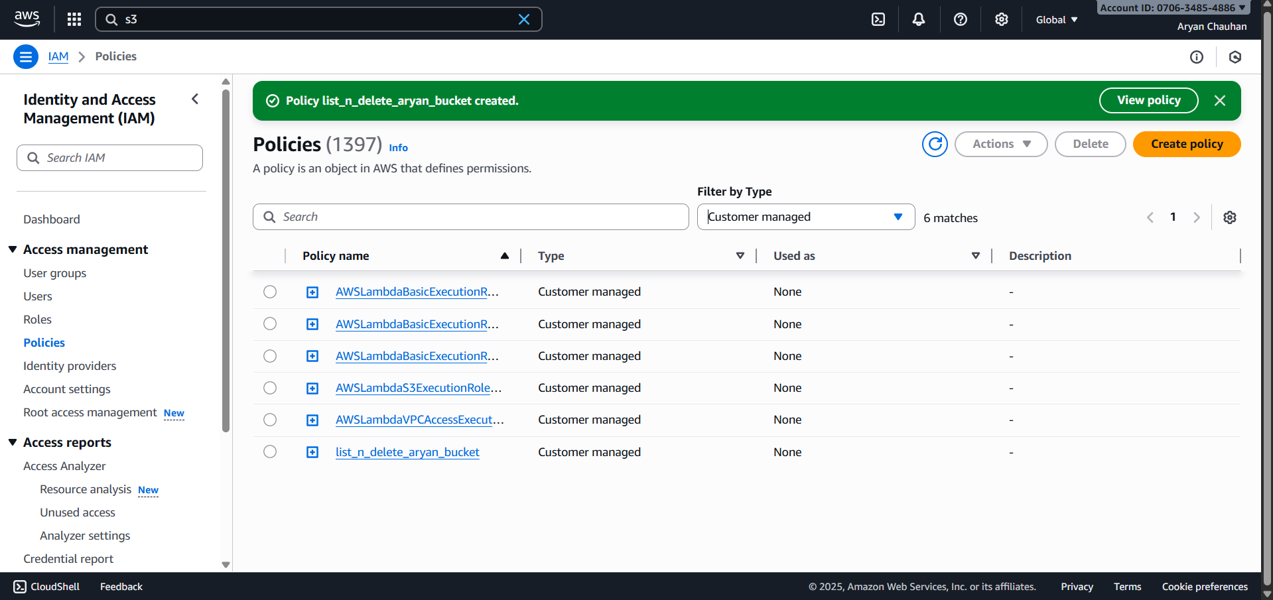

Step 10:In IAM role attach policy which you made

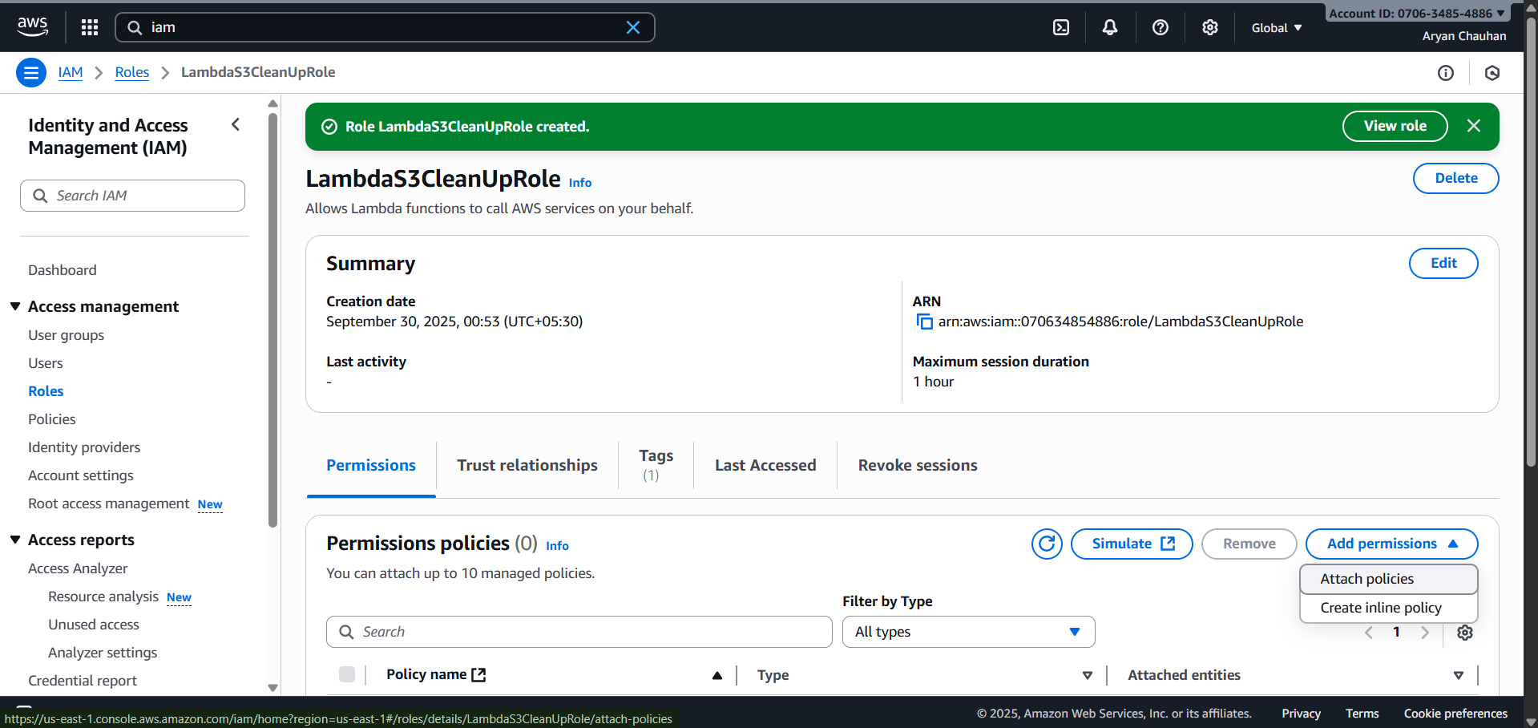

Step 11: Click on your policy and then add permissions
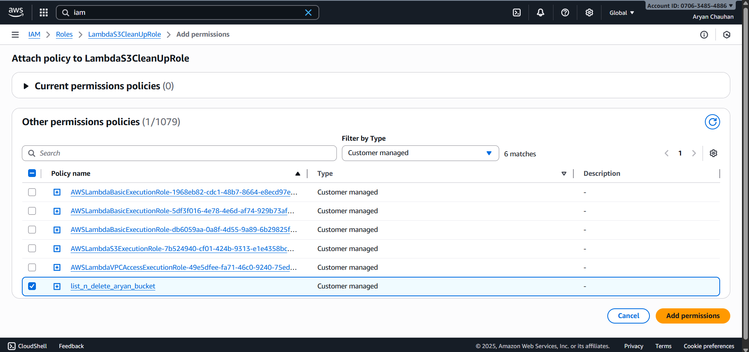Step 12:Policy Successfully Attached after which we can repeat same steps for Lambda Function
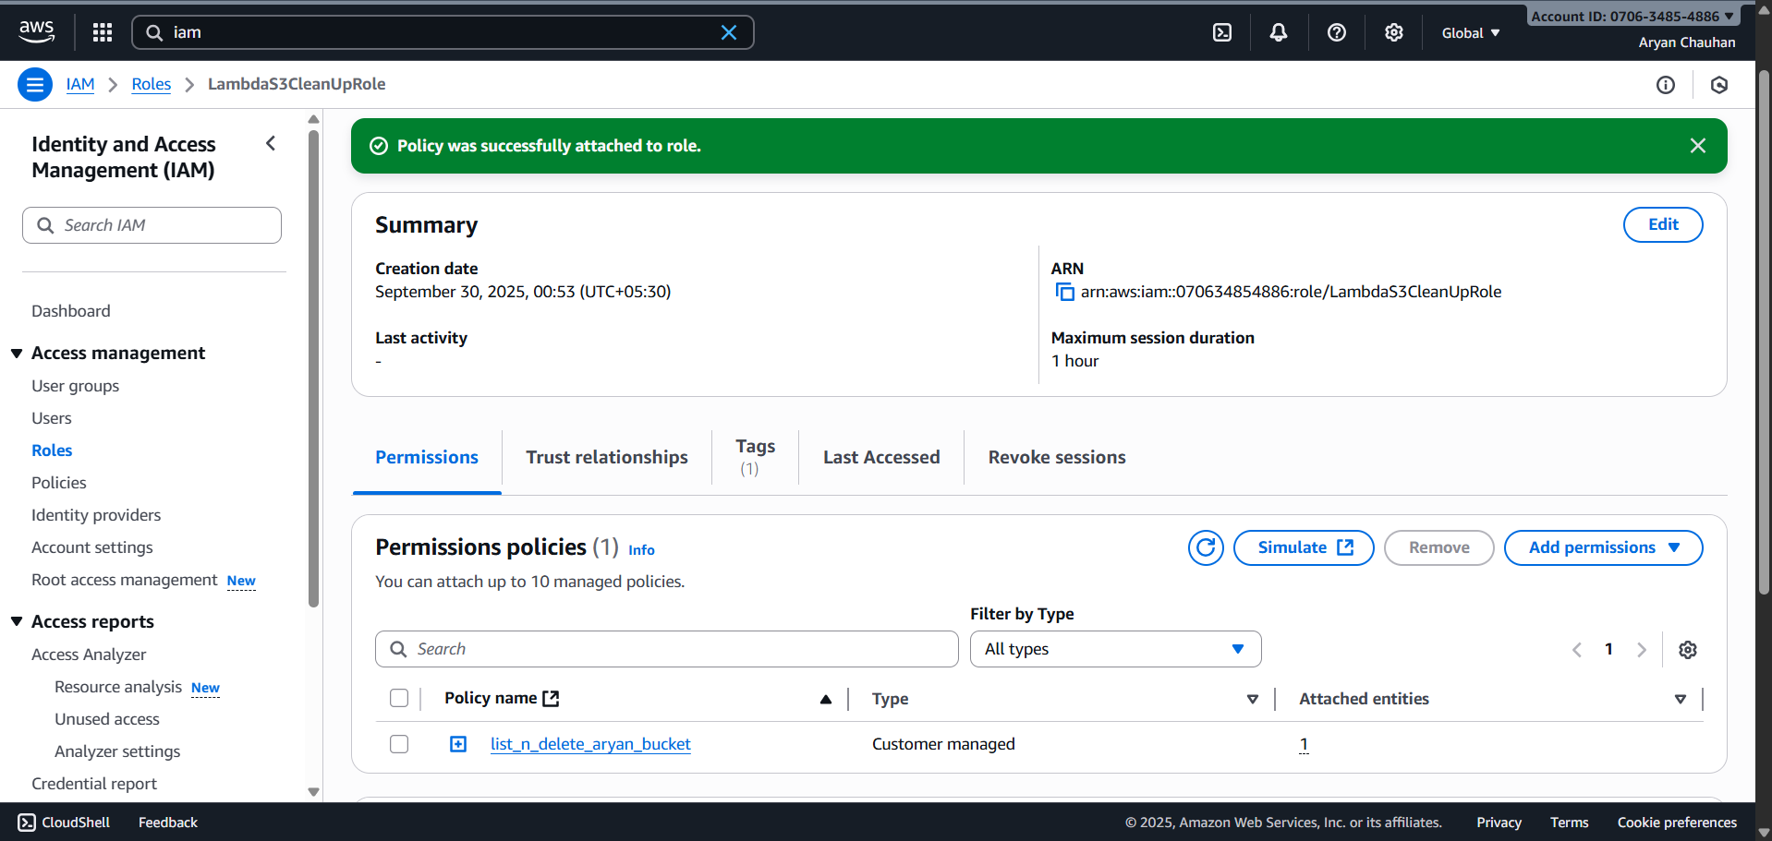

Conclusion:
We can state that IAM Roles provide a secure way for AWS services, such as Lambda, to temporarily assume permissions needed to perform specific tasks. Roles differ from users in that they do not have permanent credentials but instead offer temporary access that can be assumed by services or other entities. Creating a role involves specifying the trusted entity (e.g., a Lambda service), attaching appropriate permissions via policies, and then associating the role with the service. This approach avoids embedding sensitive credentials in functions and enables scalability, security, and cross-account access. IAM Roles are essential for automation and secure short-term access in AWS environments. This method is a best practice for granting permissions to services while maintaining security and minimizing risk.

