Steps:
- Please Download updated Mozilla Firefox Browser https://www.mozilla.org/en-US/firefox/new/ and install it.And Restart your system
- Open Mozilla Firefox Browser .Click on Application Menu as show on Pic(1) and click Settings as show on Pic(2)
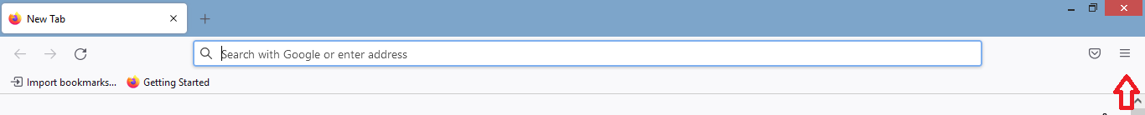
Pic(1)
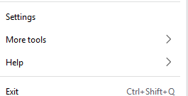
Pic(2)

- Click Privacy & Security as show on Pic(3).

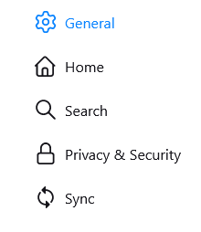
Pic(3)
- Click Permissions section as show on Pic(4)
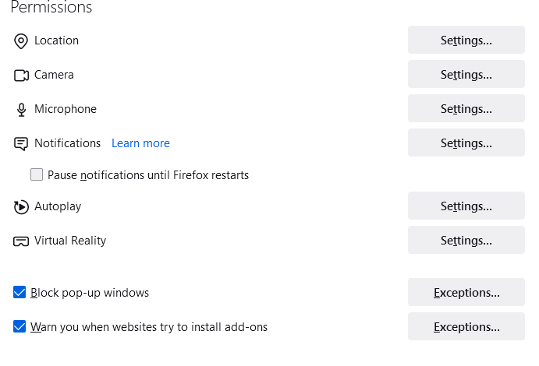
Pic(4)
- Uncheck Block pop-up windows .
- Relogin https://aishe.gov.in/ in Mozilla Firefox Browser.
- If you get Pic (5) type of issue. Please click on Advance button and Accept it.
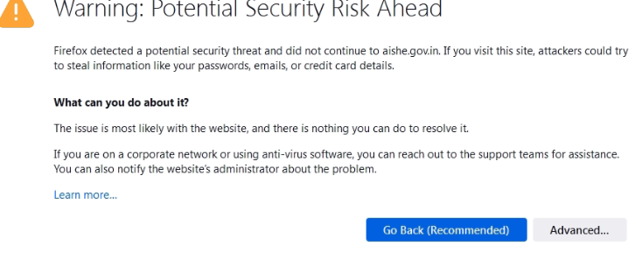
Pic (5)
- If you getting again Pic(5) type of issue. Please click on Advance button and Accept it.
- If issue not solved update your Windows.

