PRACTICAL-6:
CODE (SERVER)
#include <stdio.h>
#include <stdlib.h>
#include <string.h>
#include <unistd.h>
#include <fcntl.h>

#define FIFO1 "client_to_server"
#define FIFO2 "server_to_client"

int main()
{
char message[100];
char response[150];

printf("Client started.\n");

while (1)
{
printf("Enter message: ");
fgets(message, sizeof(message), stdin);

message[strcspn(message, "\n")] = '\0';

int fd1 = open(FIFO1, O_WRONLY);

write(fd1, message, strlen(message) + 1);
close(fd1);

int fd2 = open(FIFO2, O_RDONLY);

read(fd2, response, sizeof(response));
close(fd2);

printf("Server: %s\n", response);

if (strcmp(message, "exit") == 0)
break;
}

return 0;
}
Code(Clinet)
#include <stdio.h>
#include <stdlib.h>
#include <string.h>
#include <unistd.h>
#include <fcntl.h>
#include <sys/stat.h>

#define FIFO1 "client_to_server"
#define FIFO2 "server_to_client"

int main()
{
char buffer[100];

// Create named pipes
mkfifo(FIFO1, 0666);
mkfifo(FIFO2, 0666);

printf("Server started. Waiting for client...\n");

while (1)
{
// Open FIFO for reading
int fd1 = open(FIFO1, O_RDONLY);

read(fd1, buffer, sizeof(buffer));
close(fd1);

printf("Client: %s\n", buffer);

// Process message
char response[150];

if (strcmp(buffer, "exit") == 0)
{
strcpy(response, "Server shutting down...");
}
else
{
sprintf(response, "Server processed: %s", buffer);
}

// Send response
int fd2 = open(FIFO2, O_WRONLY);

write(fd2, response, strlen(response) + 1);
close(fd2);

if (strcmp(buffer, "exit") == 0)
break;
}

unlink(FIFO1);
unlink(FIFO2);

return 0;
}
OUT PUT(SERVER)
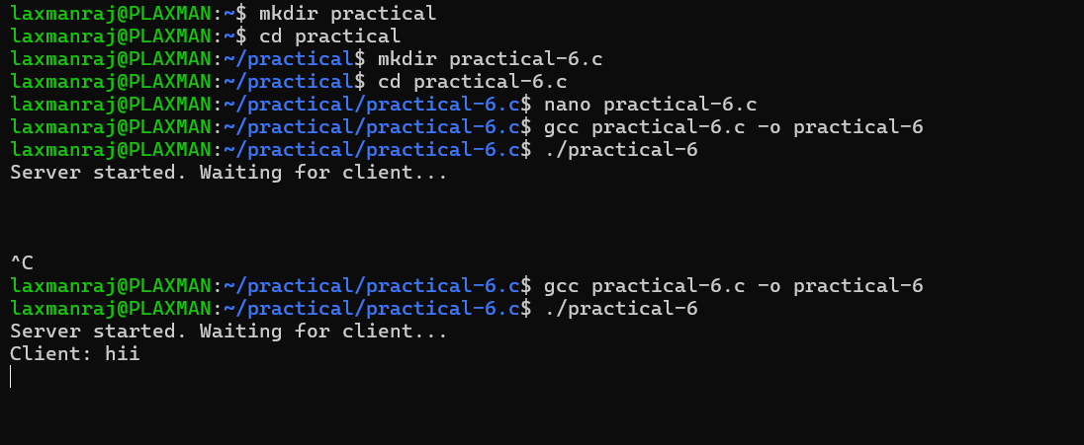
OUTPUT(CLINET)
