Assignment – 2

# Question2 : Create Web API for scraping country data in JSON format.

# Answer:

# GitHub Link: <https://github.com/laxmanrao23/Backend-Assignment.git>

Steps:

Step1 : Create a Template (HTML)

Step2 : List the country name

Step3: enter any country name

Step4: scrap data in views

Step5: save the scraped data in JSON file

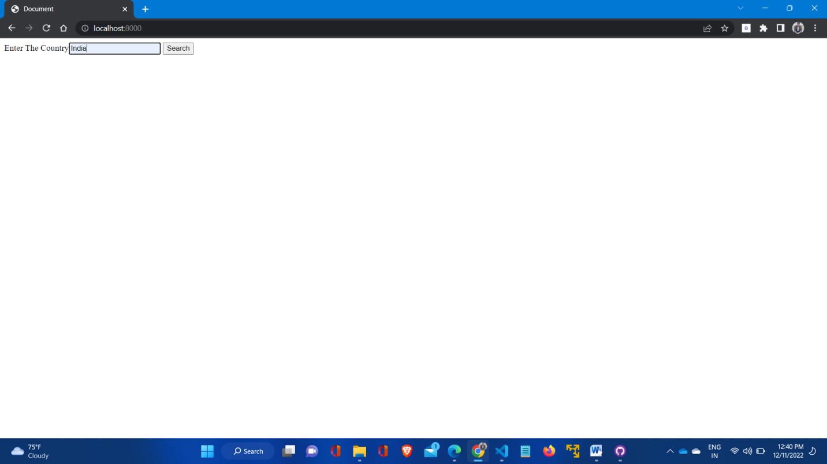

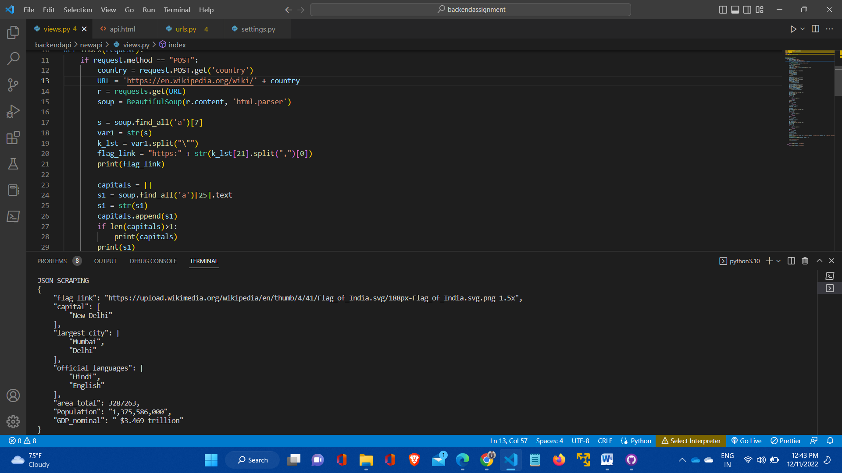

# GitHub Link: <https://github.com/laxmanrao23/Backend-Assignment.git>