BOOKFLOW MONGODB LAB – EXPERIMENT 3
Step 1 – Start MongoDB Shell
Main thing done: Opened MongoDB Shell (mongosh) and connected to the local MongoDB server.
Result: MongoDB 8.3.8 and Mongosh 2.10.0 were successfully connected on localhost:27017.
Screenshot 1
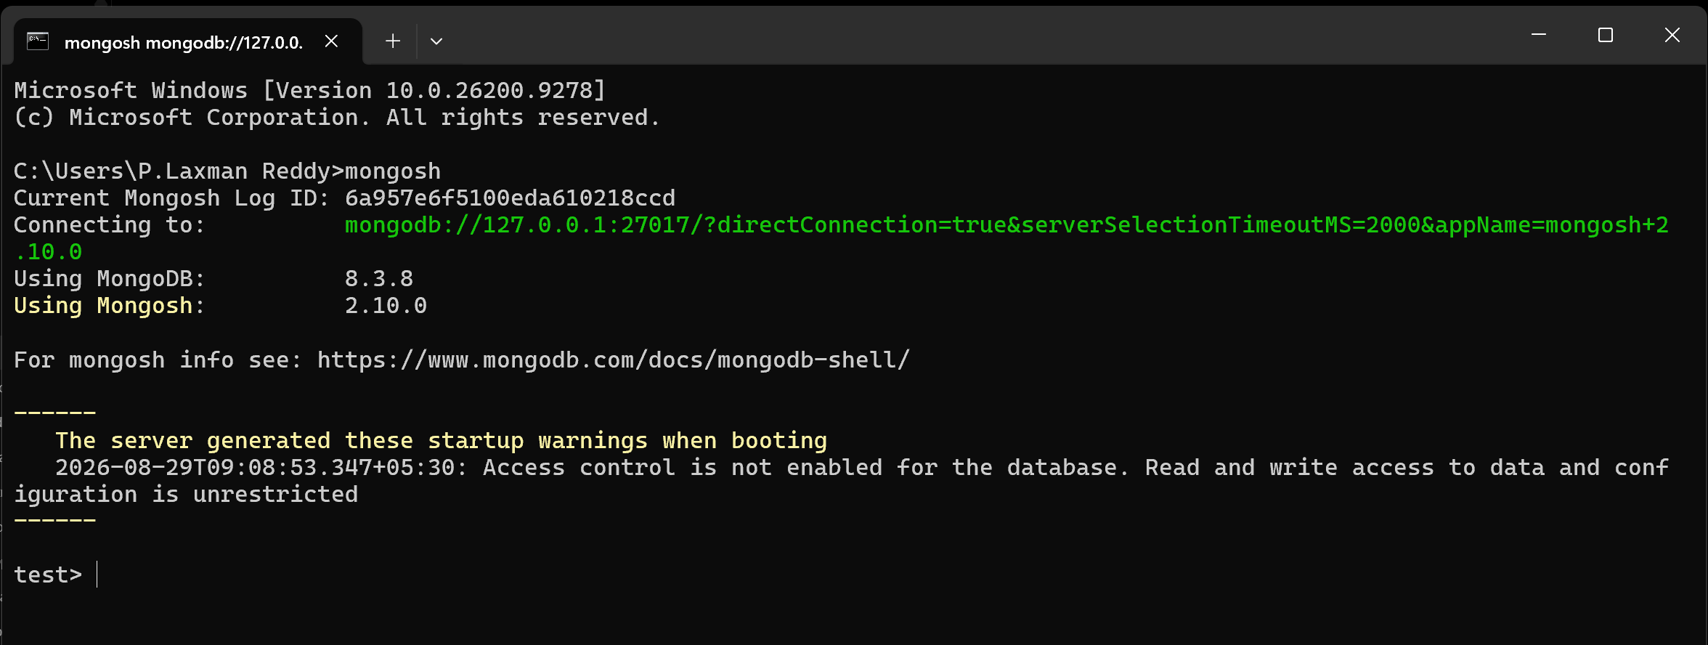
Step 2 – Create and Select the BookFlow Database
Main thing done: Switched from the test database to the bookflow database and verified the active database using db.
Result: The active database displayed as bookflow.
Screenshot 2
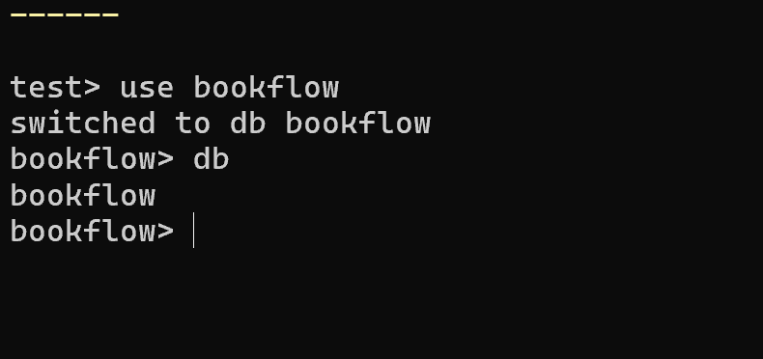

Step 3 – Insert the First Book Document
Main thing done: Inserted the first BookFlow document, The Silent Algorithm, with author, genre, year, formats, specifications, rating, and embedded reviews.
Result: The insert operation returned acknowledged: true.
Screenshot 3
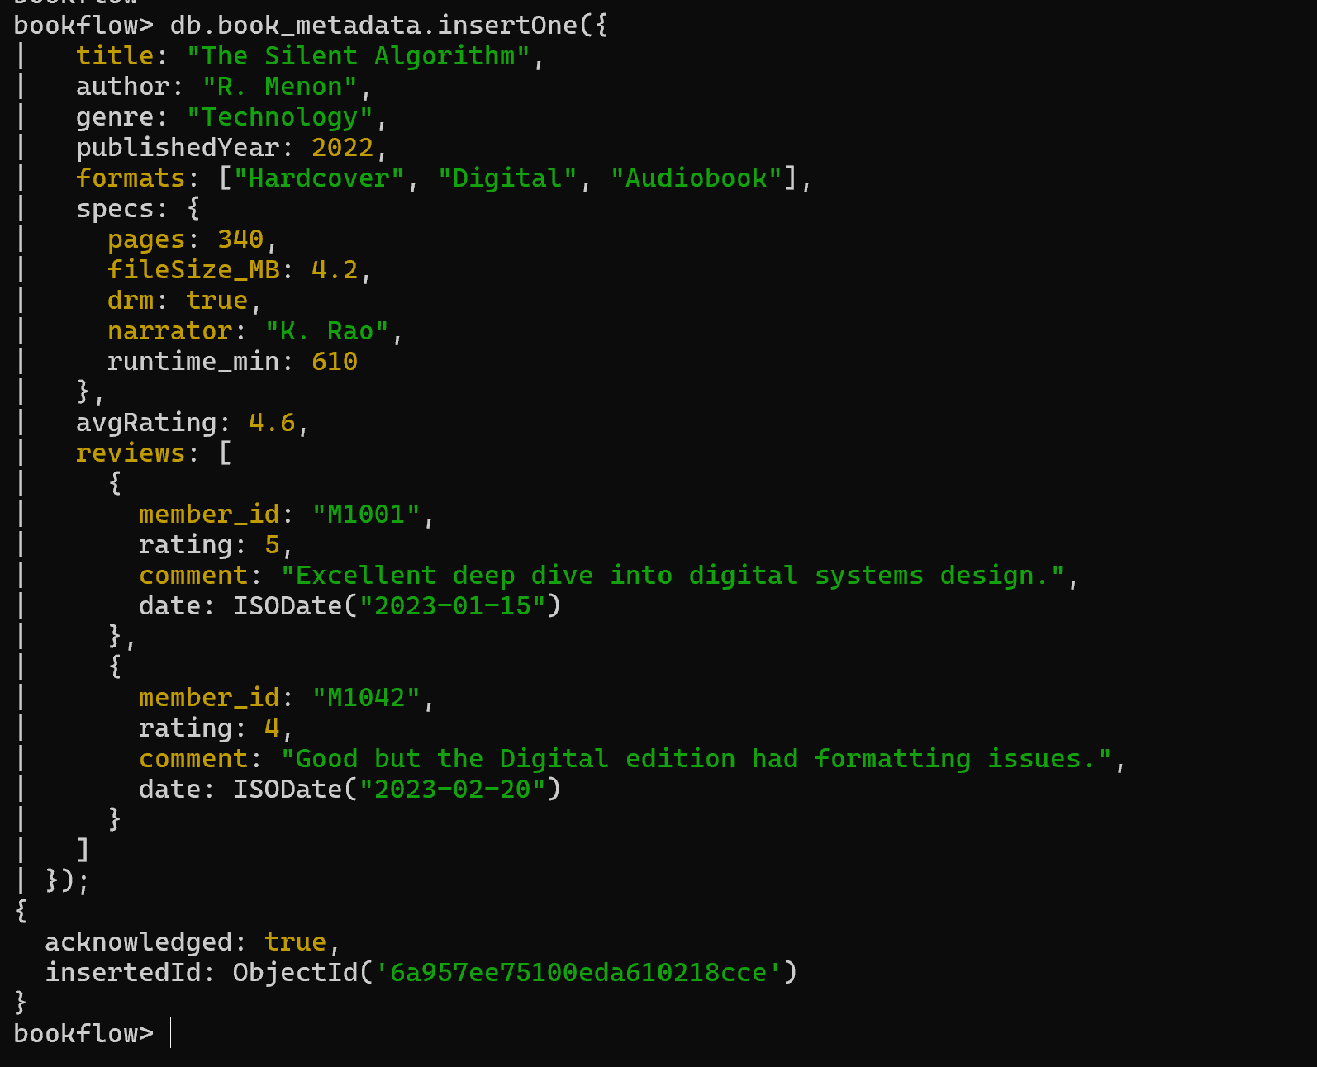
Step 4 – Insert the Remaining Three Book Documents
Main thing done: Inserted Ocean of Code, Whispers of Yesterday, and Quantum Horizons using insertMany().
Result: The insertMany operation returned acknowledged: true and inserted three document IDs.
Screenshot 4
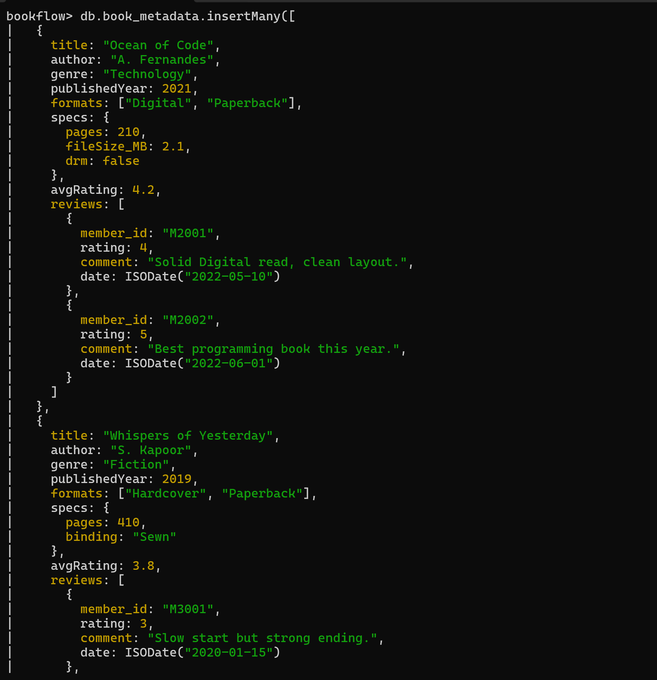

Screenshot 5
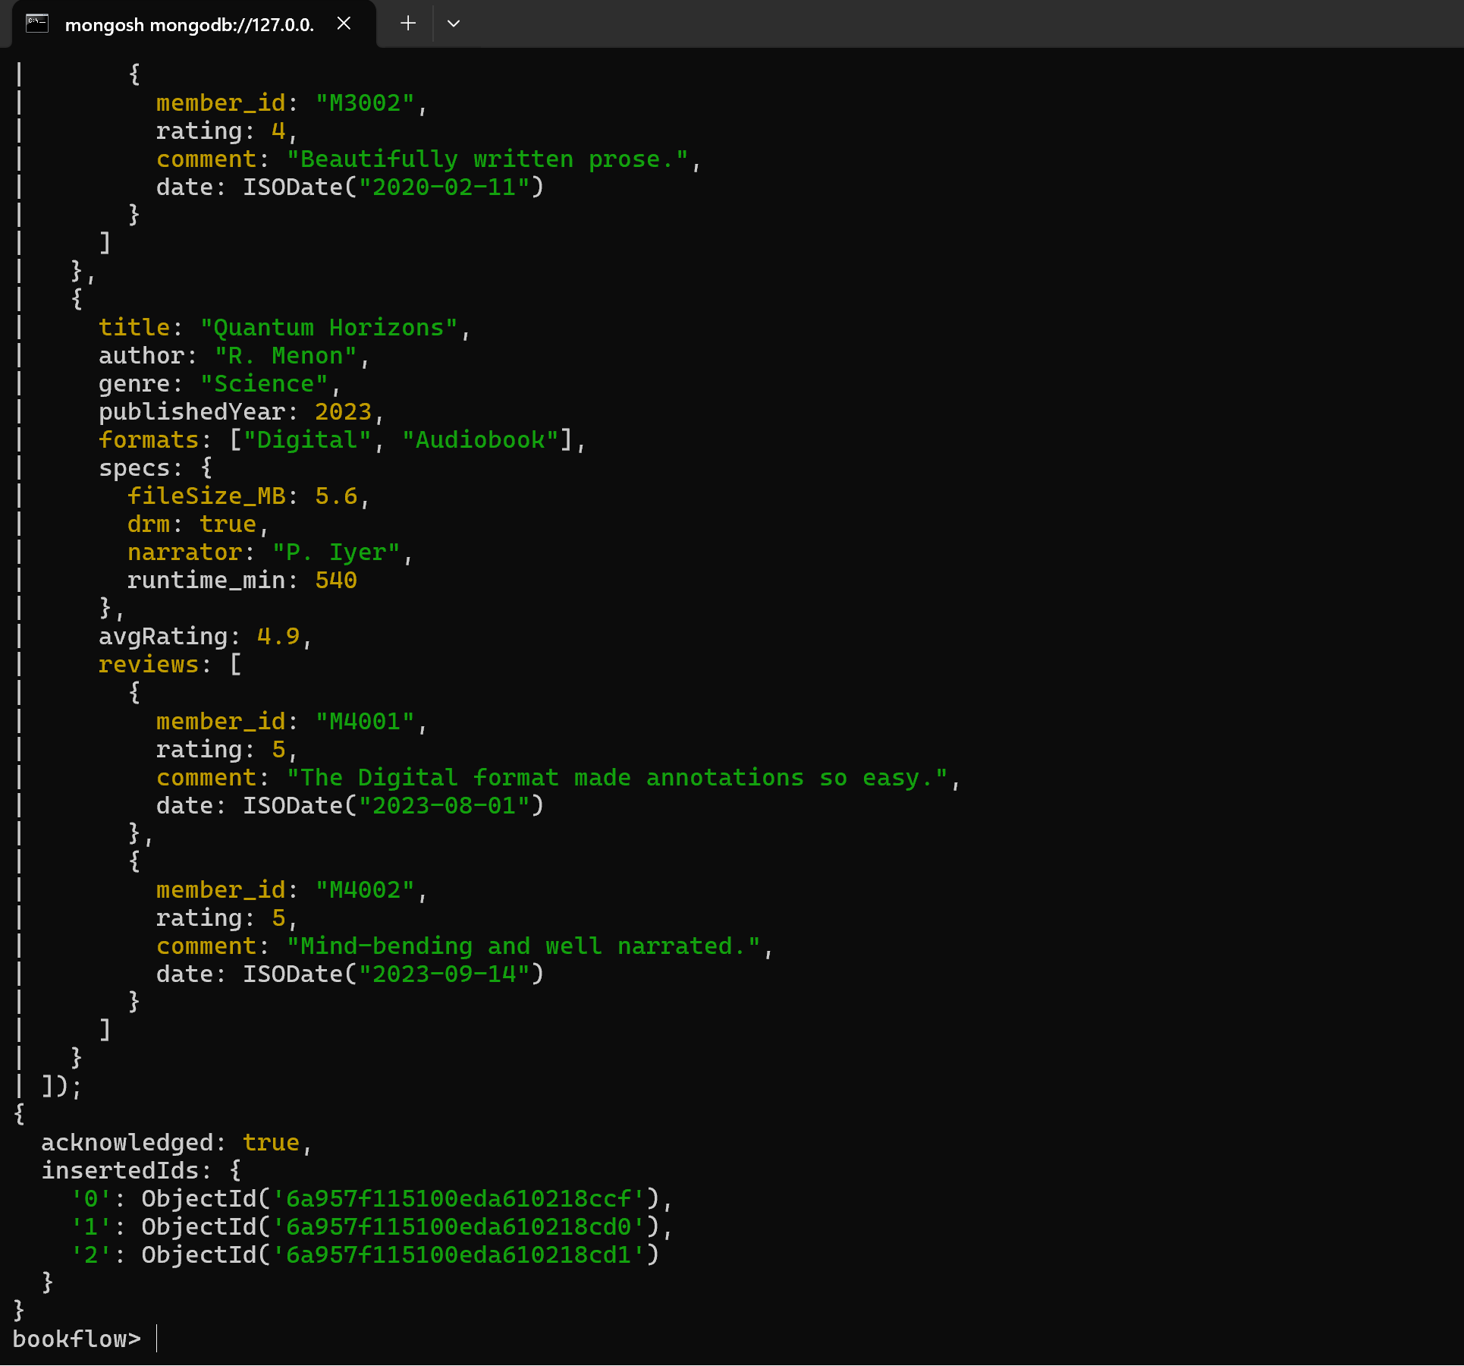

Step 5 – Verify All Book Documents
Main thing done: Used db.book_metadata.find().pretty() to display the stored BookFlow documents.
Result: The four book documents were displayed successfully.
Screenshot 6
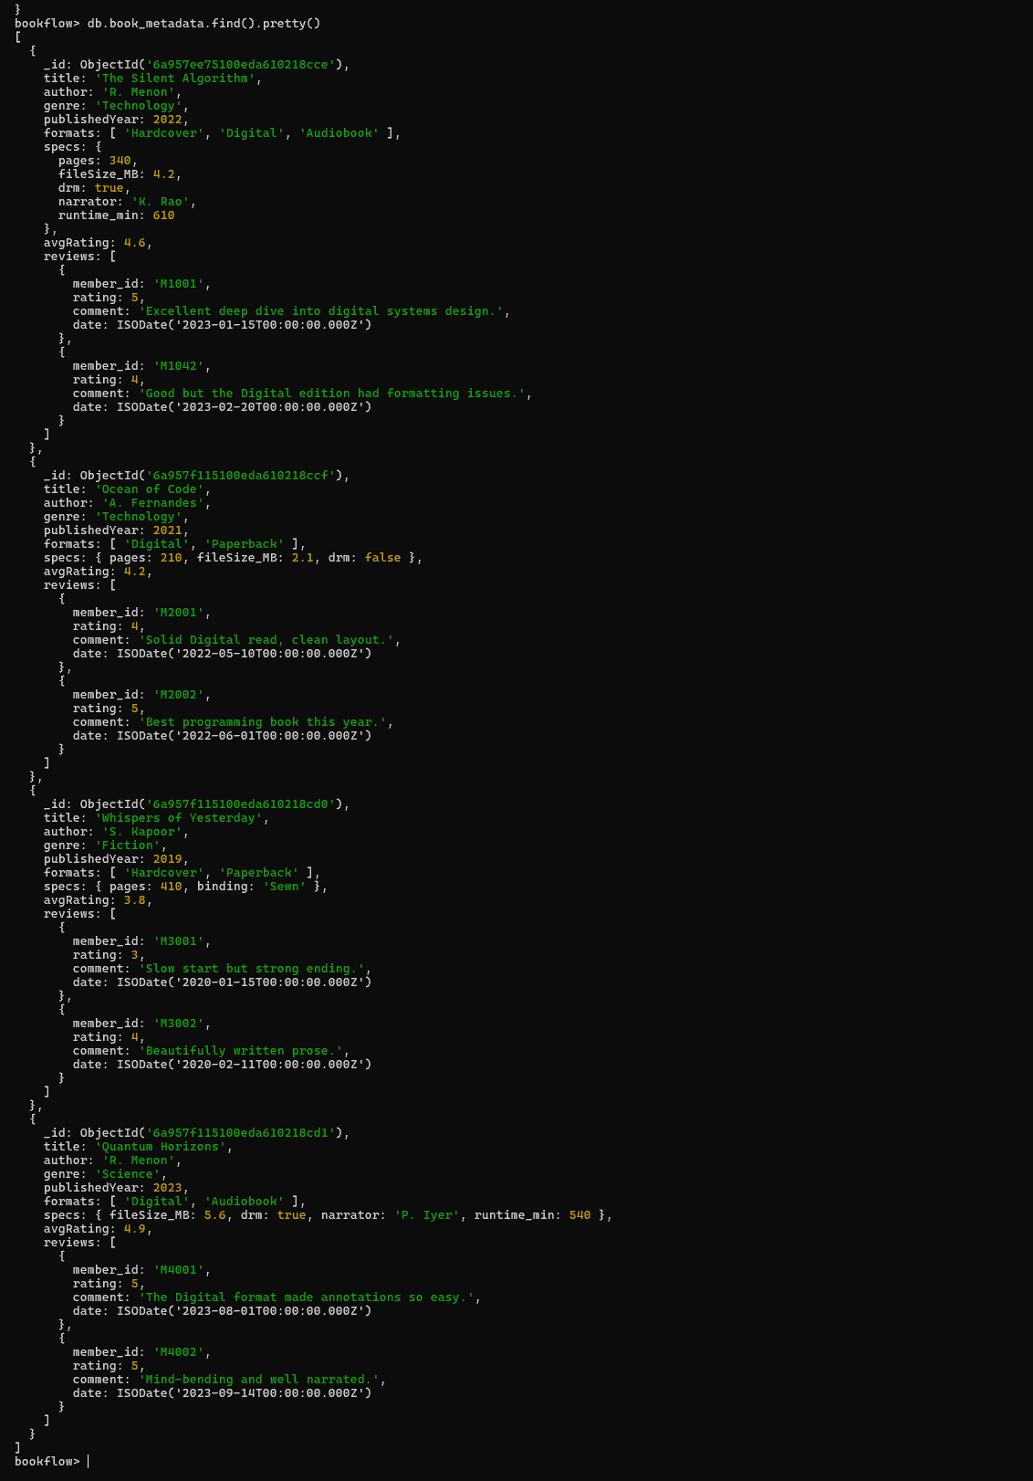
Step 6 – Advanced Query: $gt
Main thing done: Queried books whose avgRating is greater than 4.
Result: The query returned The Silent Algorithm (4.6), Ocean of Code (4.2), and Quantum Horizons (4.9).
Screenshot 7
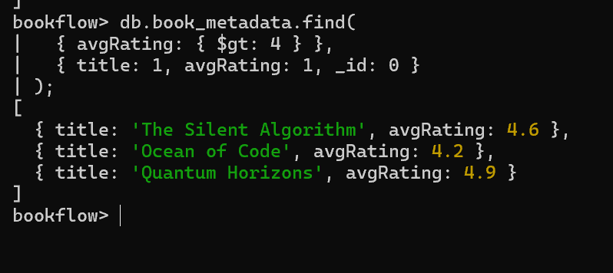
Step 7 – Advanced Query: $in
Main thing done: Queried books whose formats contain Digital or Audiobook using $in.
Result: The query returned the three books containing one or both of those formats.
Screenshot 8
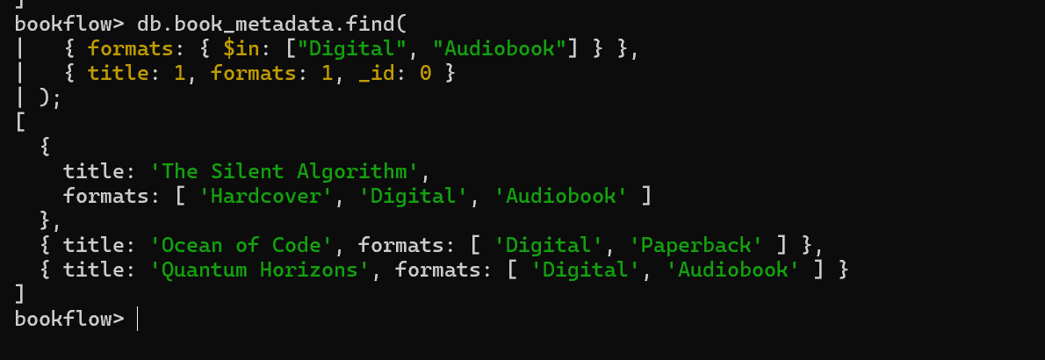

Step 8 – Combined Query: $gt + $in
Main thing done: Combined the rating and format conditions to find books rated above 4 and available in Digital format.
Result: The query returned The Silent Algorithm, Ocean of Code, and Quantum Horizons.
Screenshot 9
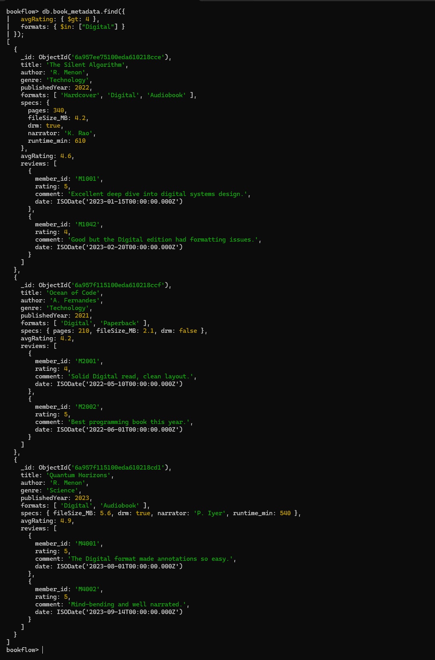

Step 9 – Regex Query on Formats
Main thing done: Used a case-insensitive regular expression to search the formats field for Digital.
Result: The query returned the three books with Digital format.
Screenshot 10
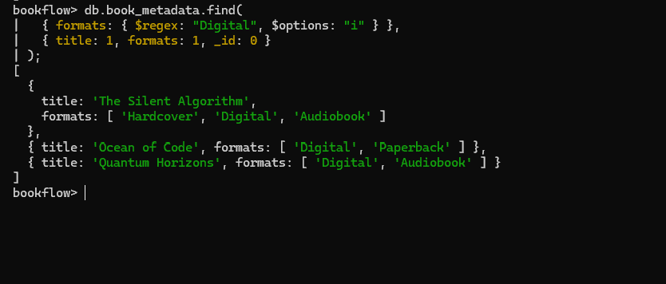

Step 10 – Regex Query on Nested Review Comments
Main thing done: Used a regular expression on reviews.comment to find review comments containing Digital.
Result: Matching review documents were returned for the relevant books.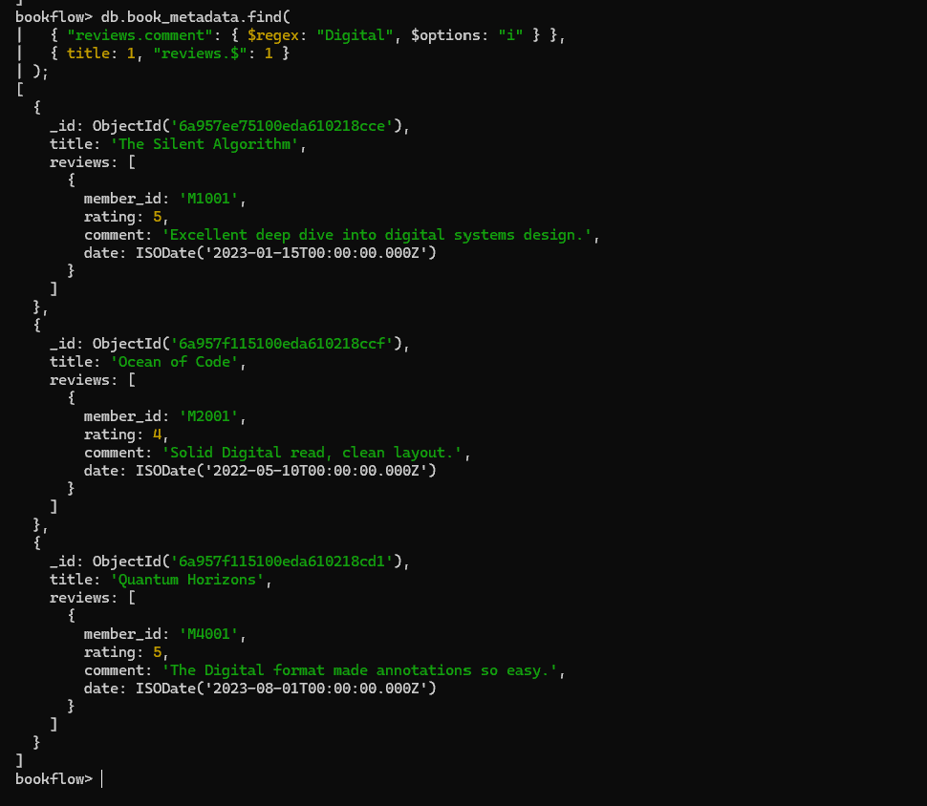

Step 11 – Aggregation Pipeline
Main thing done: Built an aggregation pipeline using $match, $unwind, $group, $sort, and $project to calculate average review ratings for books published after 2020.
Result: The report was sorted by average review rating, with Quantum Horizons at 5.0 followed by The Silent Algorithm and Ocean of Code at 4.5.
Screenshot 12
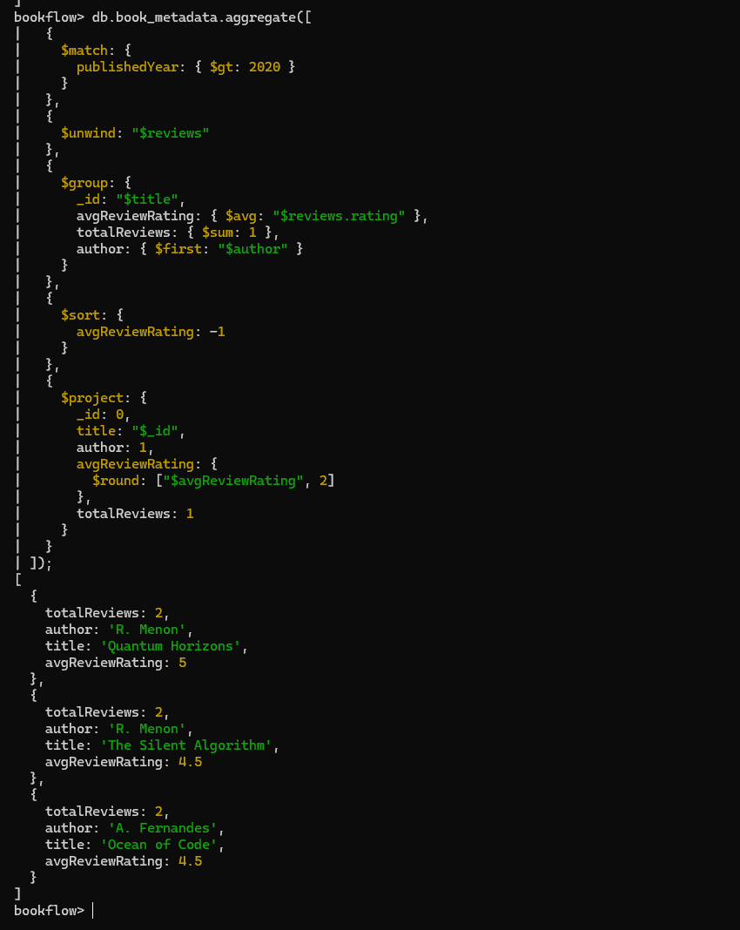

Step 12 – Create a Text Index
Main thing done: Created a text index on reviews.comment.
Result: MongoDB created the index named reviews.comment_text.
Screenshot 13
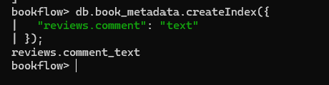
Step 13 – Perform Text Search
Main thing done: Used $text with $search: Digital and textScore sorting to search review comments.
Result: The search returned matching books with relevance scores.
Screenshot 14
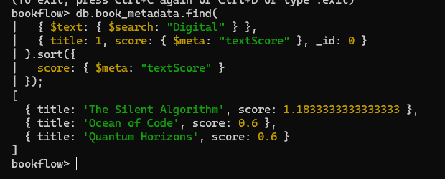

Step 14 – Explain the Text Search
Main thing done: Ran explain("executionStats") for the text search to verify index usage.
Result: The execution plan showed TEXT_MATCH and the reviews.comment_text text index; the detailed plan also showed an IXSCAN input stage.
Screenshot 15
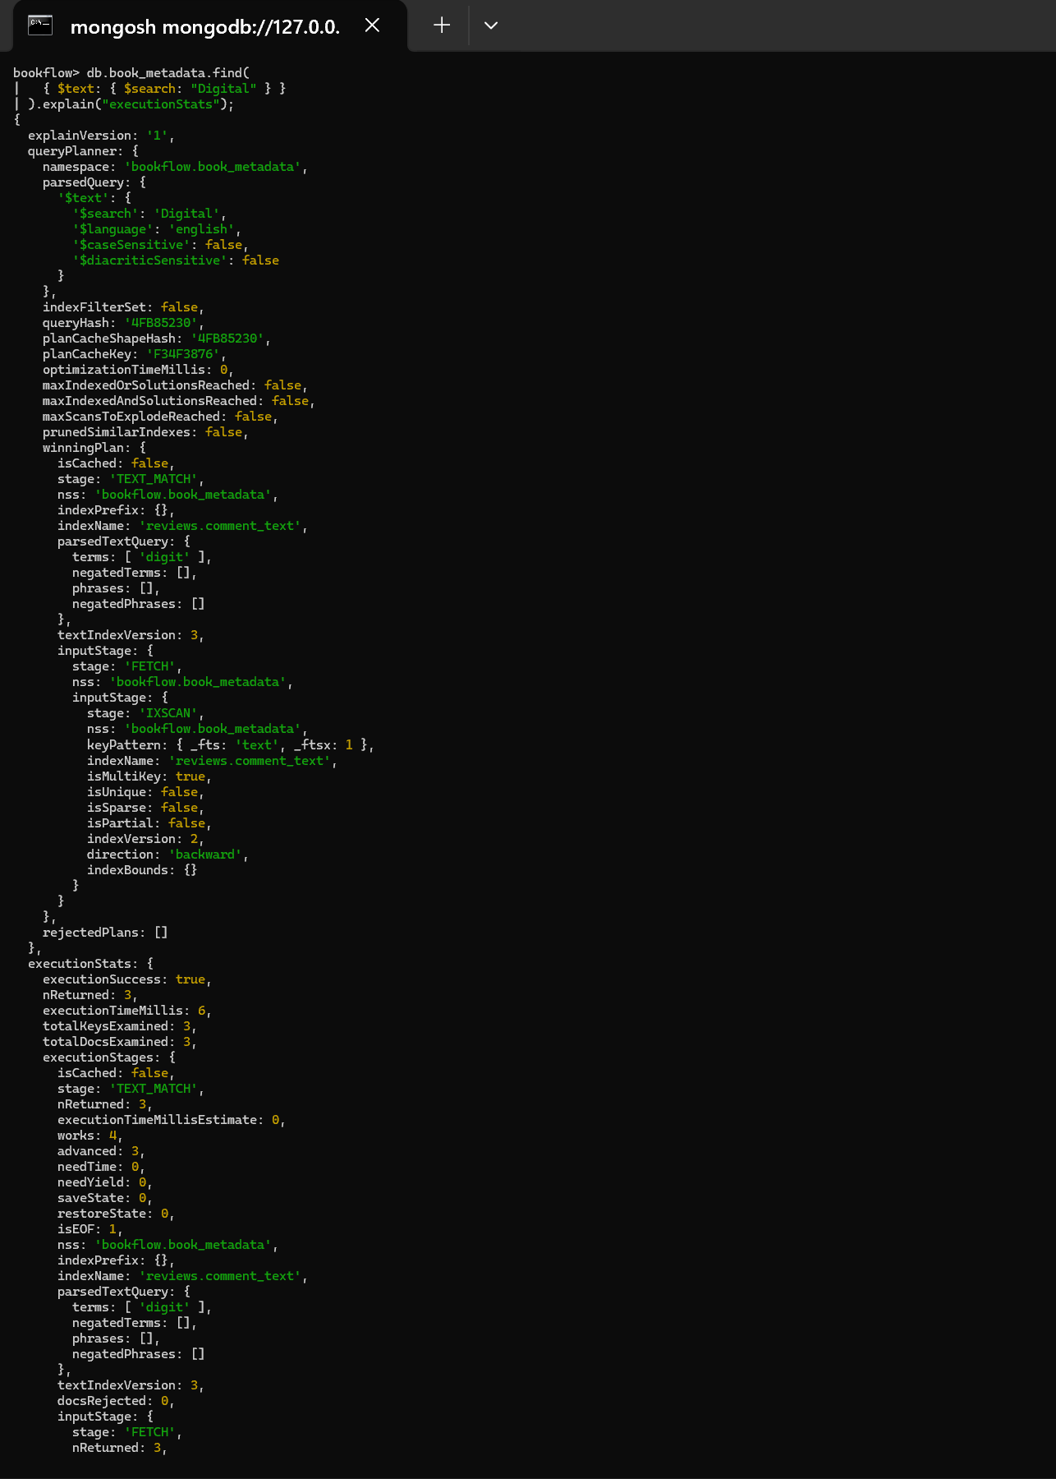

Screenshot 16
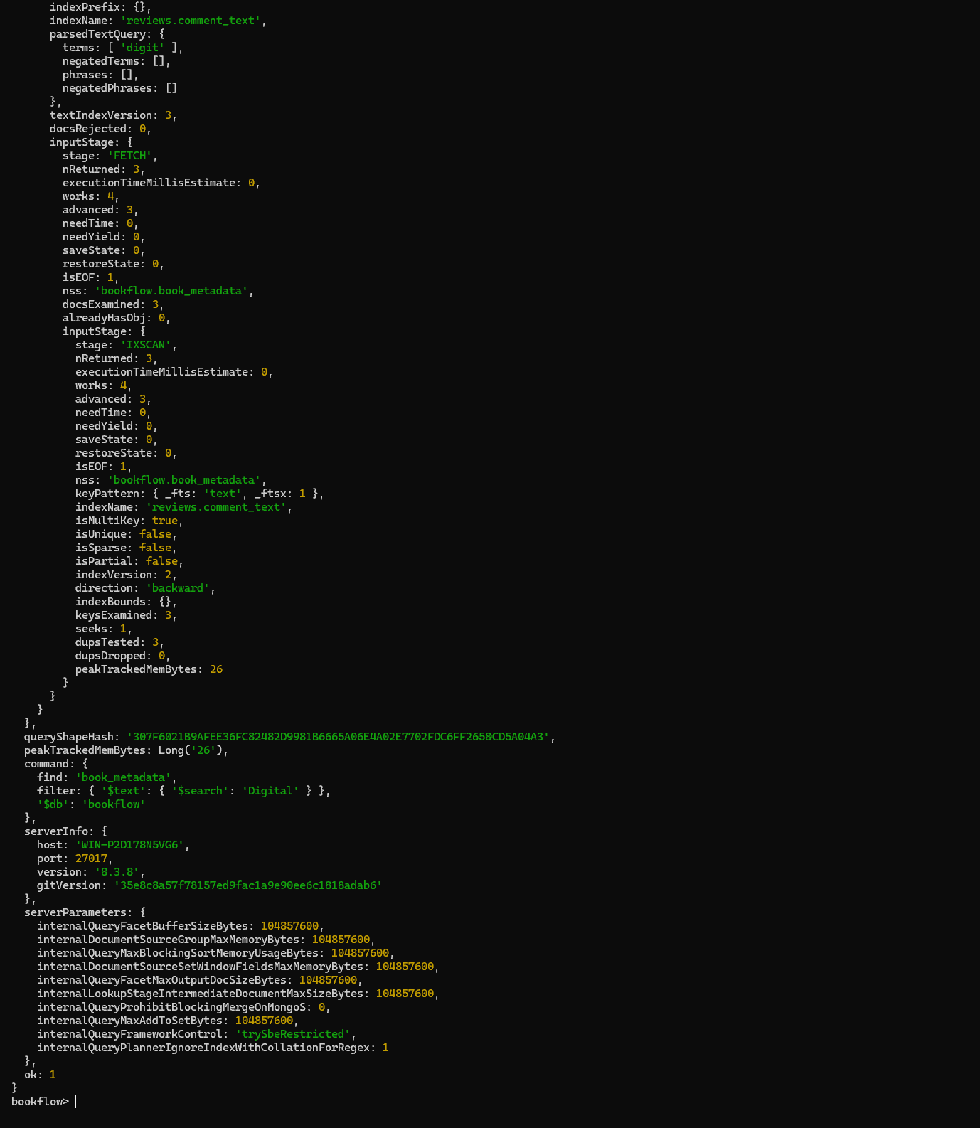

Step 15 – Explain the Regex Search
Main thing done: Ran explain("executionStats") for the nested regex query on reviews.comment.
Result: The winning plan showed COLLSCAN, demonstrating a collection scan for this regex query.
Screenshot 17
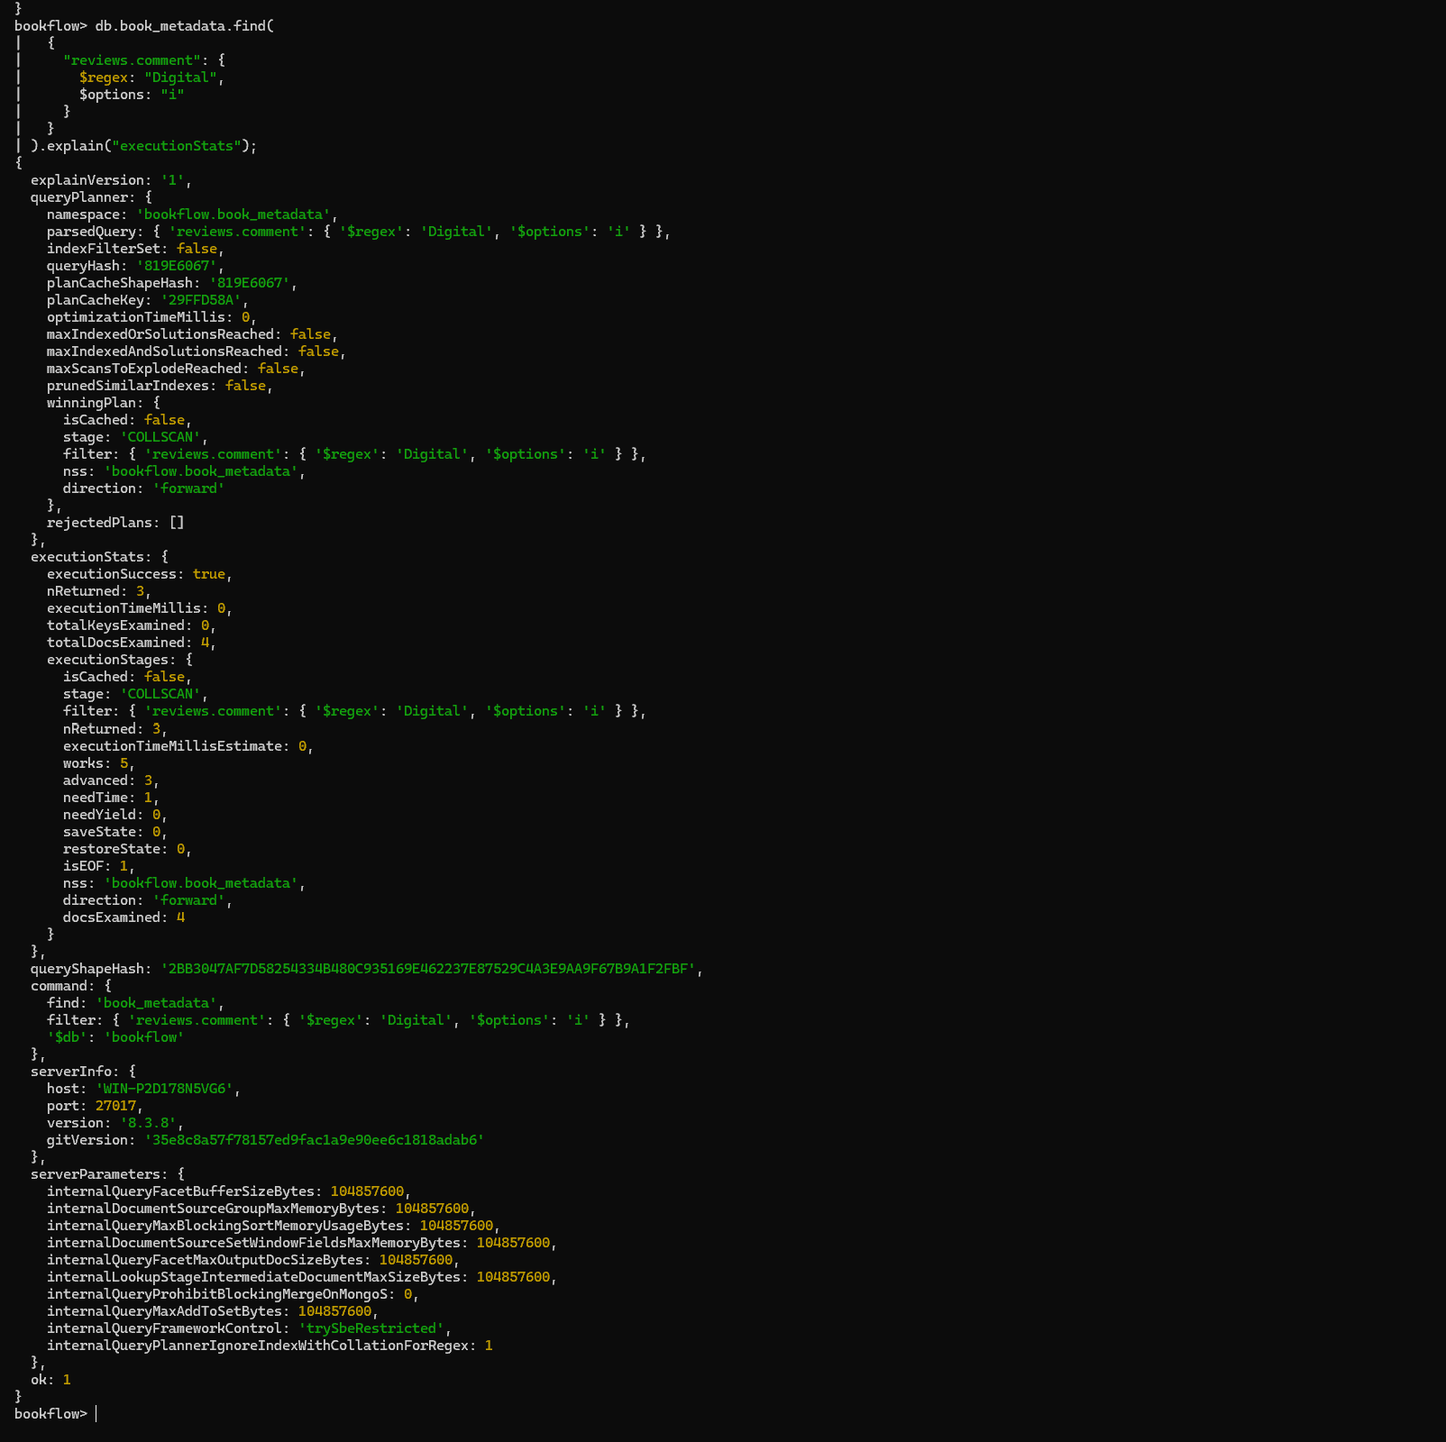

Step 16 – Create Supporting Indexes
Main thing done: Created indexes on formats and avgRating to support efficient queries.
Result: MongoDB created formats_1 and avgRating_-1.
Screenshot 18
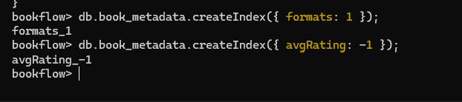
Step 17 – Verify avgRating Index Usage
Main thing done: Ran explain("executionStats") for avgRating > 4 to verify the supporting index.
Result: The winning plan used IXSCAN with the avgRating_-1 index.
Screenshot 19
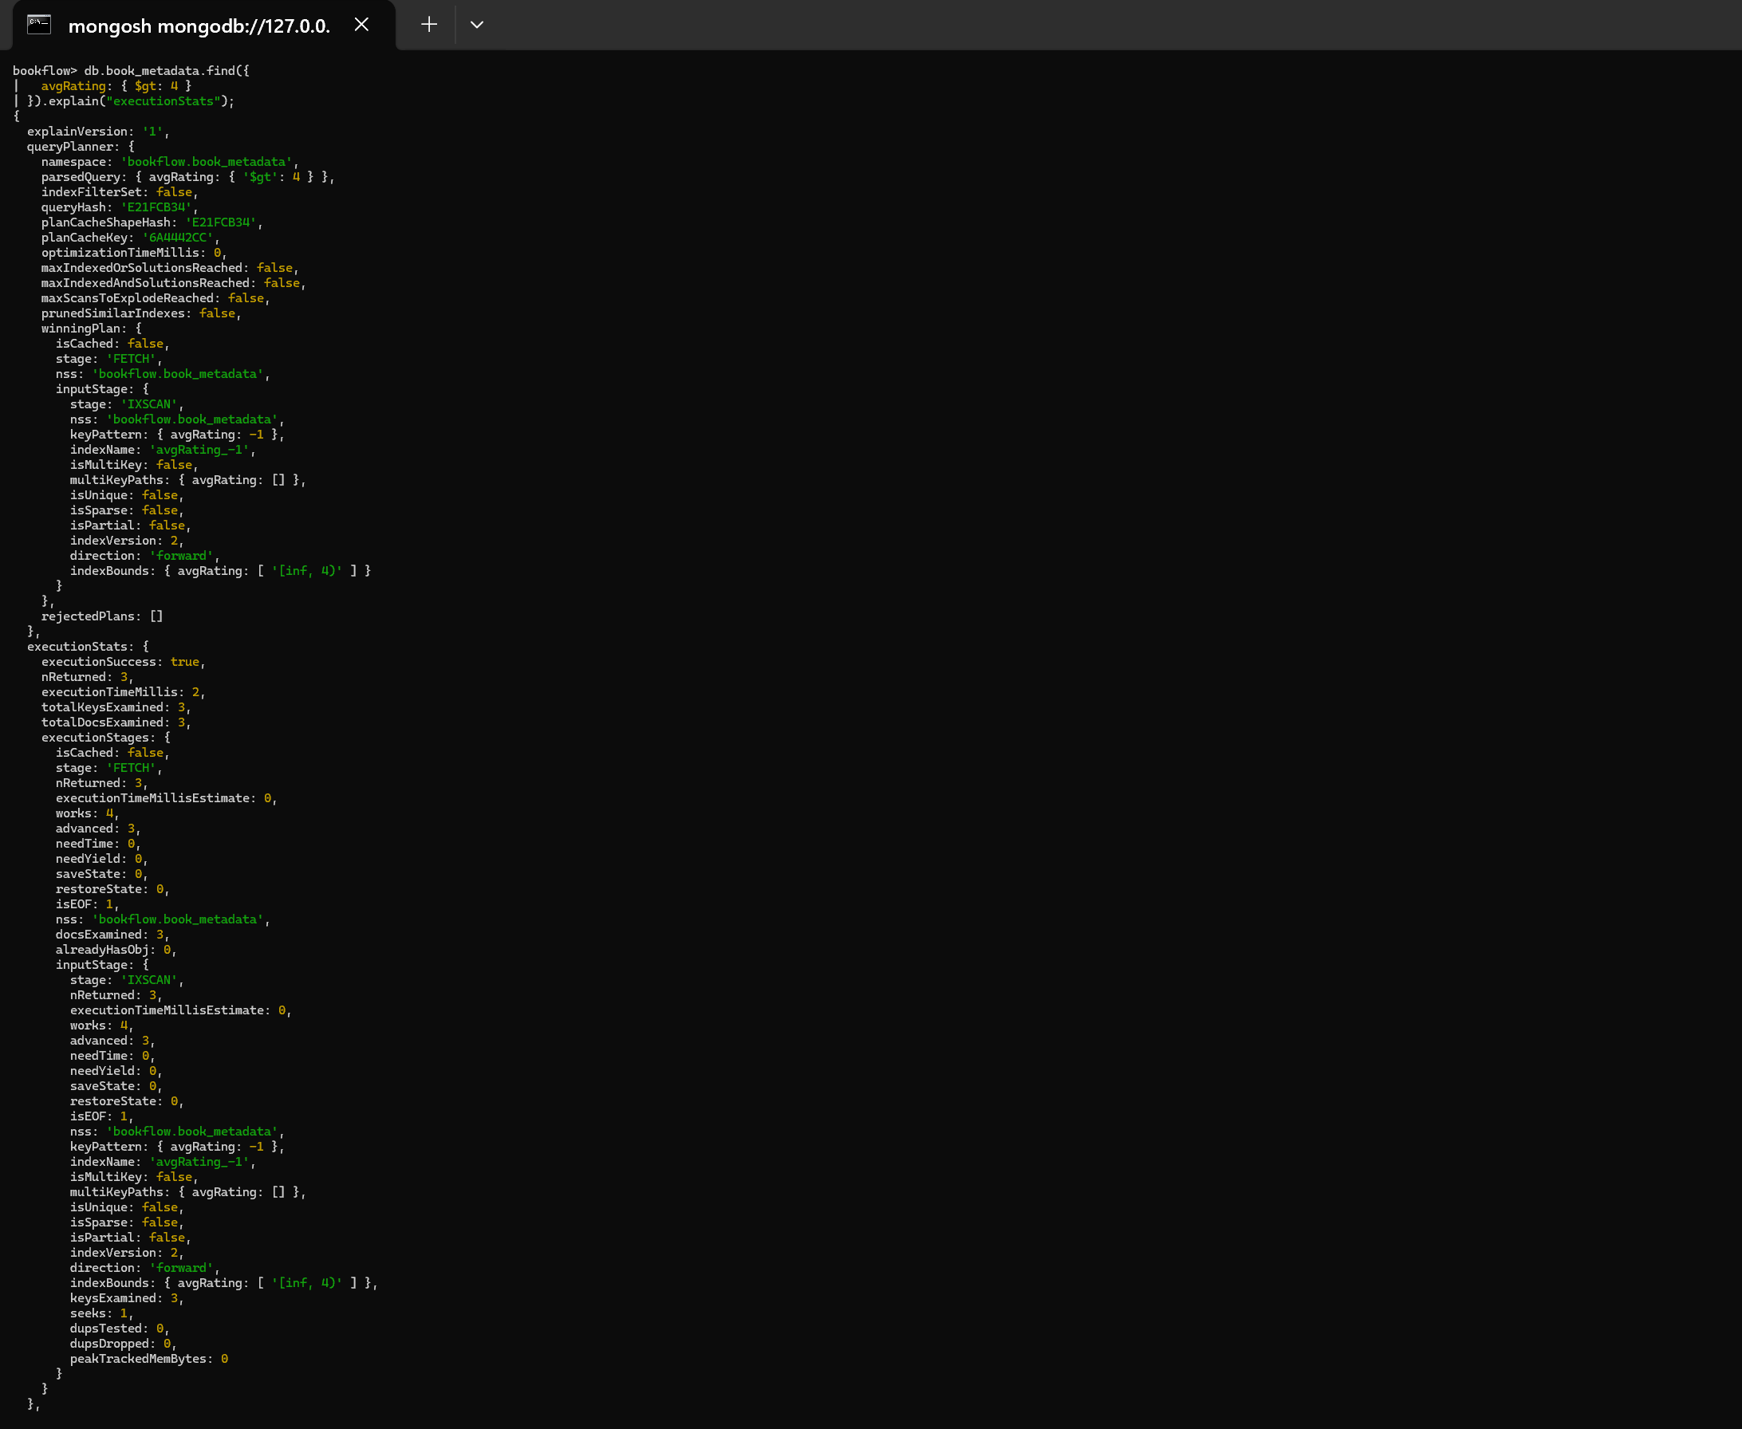
Screenshot 20
