SPLITMASTER
PROJECT DESIGN DOCUMENT
Expense Splitting and Settlement Management System

1. Project Overview
SplitMaster is an expense-splitting system designed to manage users, groups, shared expenses, individual expense shares, and settlements between users. The database is organized so that expenses can be associated with a group and a user who paid the expense, while expense_members stores how the expense is shared among users.

2. Objectives
- Store and manage user information.
- Create and manage expense groups.
- Record expenses and identify the user who paid each expense.
- Store each member's share of an expense.
- Record settlements between users.
- Maintain relationships between users, groups, expenses, and settlements using foreign keys.

3. System Architecture
The overall logical flow of the system is:
User / Client
↓
SplitMaster Application
↓
Database Operations
↓
MySQL Database
↓
users | groups_master | expenses | expense_members | settlements

4. Entity Relationship (ER) Design
The following ER diagram represents the database design used by SplitMaster. It shows the five main tables and their relationships.
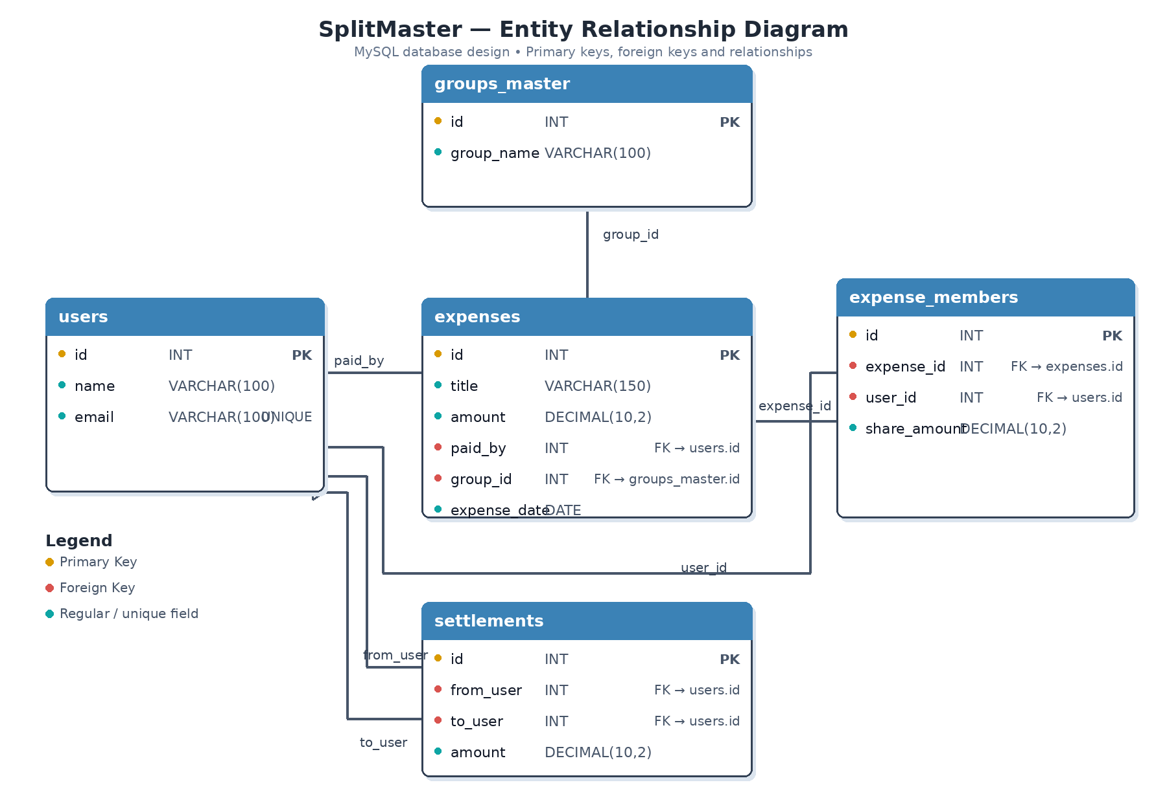

5. Database Tables

users
Field | Data Type | Purpose / Relationship
id | INT | Primary Key
name | VARCHAR(100) | User name
email | VARCHAR(100) | Unique email

groups_master
Field | Data Type | Purpose / Relationship
id | INT | Primary Key
group_name | VARCHAR(100) | Group name

expenses
Field | Data Type | Purpose / Relationship
id | INT | Primary Key
title | VARCHAR(150) | Expense title
amount | DECIMAL(10,2) | Total expense amount
paid_by | INT | Foreign Key → users.id
group_id | INT | Foreign Key → groups_master.id
expense_date | DATE | Expense date

expense_members
Field | Data Type | Purpose / Relationship
id | INT | Primary Key
expense_id | INT | Foreign Key → expenses.id
user_id | INT | Foreign Key → users.id
share_amount | DECIMAL(10,2) | Member's share

settlements
Field | Data Type | Purpose / Relationship
id | INT | Primary Key
from_user | INT | Foreign Key → users.id
to_user | INT | Foreign Key → users.id
amount | DECIMAL(10,2) | Settlement amount

6. Relationships
- users → expenses: one user can pay many expenses through expenses.paid_by.
- groups_master → expenses: one group can contain many expenses through expenses.group_id.
- expenses → expense_members: one expense can have multiple members through expense_members.expense_id.
- users → expense_members: one user can participate in multiple expenses through expense_members.user_id.
- users → settlements: users can appear as both the sender (from_user) and receiver (to_user) of settlements.

7. Expense Management Flow
- User is stored in the users table.
- A group is created in groups_master.
- An expense is recorded in expenses with its title, amount, payer, group and date.
- The participants and their individual shares are stored in expense_members.
- When money is owed between users, the settlement is recorded in settlements.
- The foreign-key relationships keep the records connected.

8. User Interface Design
The SplitMaster interface can be organized into the following functional areas:
- Dashboard – summary of groups, expenses and balances.
- Users – add and manage users.
- Groups – create and manage expense groups.
- Add Expense – enter expense title, amount, payer, group and date.
- Expense Members – assign participants and their share amounts.
- Settlements – record payments between users.
- History – view stored expenses and settlements.

9. Technology Stack
- Frontend: HTML / CSS / JavaScript (as applicable to the project implementation).
- Database: MySQL.
- Database design: Relational tables with primary and foreign keys.
- Project name: SplitMaster.

10. Database Integrity
The database uses primary keys to uniquely identify records and foreign keys to maintain relationships between tables. The expense_members table uses ON DELETE CASCADE for its expense_id and user_id references, so dependent membership records can be removed when the referenced record is deleted.

11. Sample Data
The provided database script contains sample users Laxman, Arjun, Neha and Rahul, and groups Goa Trip, Flat 4B and Friends.

12. Conclusion
The SplitMaster design provides a relational structure for managing shared expenses and settlements. The five-table design separates users, groups, expenses, expense participation and settlements while maintaining their relationships through foreign keys.

