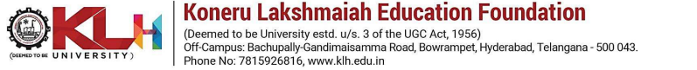
STUDENT CASE STUDY EXECUTION REPORT
Department | FED
Subject | DSA-2
Academic Year | I-III Semester(2025-26)
Faculty Name | Dr Balaiah
Student Name | P. Laxman Reddy
Roll Number | 2520030097
Branch | CSE
Course Outcome | CO-4

Case Study Topic: Chennai Metro Fare Optimisation using Multi-Criteria Dijkstra's Algorithm
In this case study, we implemented Dijkstra's Algorithm to determine the minimum-fare route from Alandur (ALD) to Wimco Nagar Depot (WMN) in the Chennai Metro network. The metro network was modeled as a weighted graph where each edge contained both fare and travel time. The algorithm first identified the cheapest path and then applied a lexicographic comparison to use travel time as a tiebreaker whenever multiple routes had the same fare. We traced the priority queue operations, verified the cumulative fare of the selected route, and analyzed how the tie-breaking strategy affected route selection. Finally, we discussed the concept of Pareto-optimal routing and the Multi-Objective Shortest Path (MOSP) algorithm for handling multiple optimization criteria in real-world navigation systems.
Implementation Details
- Represented the Chennai Metro network as a weighted graph with fare and travel time on each edge.
- Initialized Dijkstra's Algorithm from the source station Alandur (ALD).
- Used a priority queue (min-heap) to select the station with the minimum fare.
- Calculated the minimum fare to every reachable station through edge relaxation.
- Applied lexicographic comparison to use travel time as a tiebreaker when fares were equal.
- Updated the fare, travel time, and predecessor information whenever a better route was found.
- Determined the optimal path from ALD to WMN based on the fare-first, time-second criteria.
- Verified the cumulative fare and total travel time of the selected route.
- Compared the multi-criteria approach with running Dijkstra separately for fare and time.
- Analyzed the algorithm's efficiency and its suitability for real-world metro route optimization.
Result: Screenshots / Output
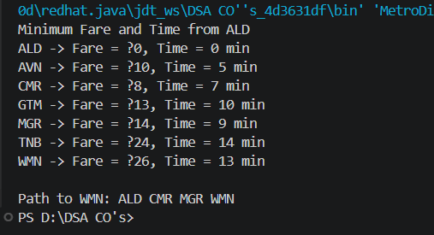
Time Complexity
- Priority Queue Operations: O((V + E) log V)
- Edge Relaxation: O(E log V)
- Shortest Path Computation: O((V + E) log V)
- Path Reconstruction: O(V)
Compared to running Dijkstra separately for fare and time, the multi-criteria Dijkstra algorithm is more correct because it optimizes both fare and travel time simultaneously using lexicographic ordering, ensuring the cheapest route is always chosen while using travel time as the tiebreaker.

- GitHub Link:

Student Signature | Faculty Signature

