OSSP – WEEK-1 –PRACTICAL
To Develop a c program that demonstrates how a Linux O.S executes a command entered by the user using fork(),exec(), and wait() system cells.

Step 1: Open UBUNTU terminal
You will get something like:
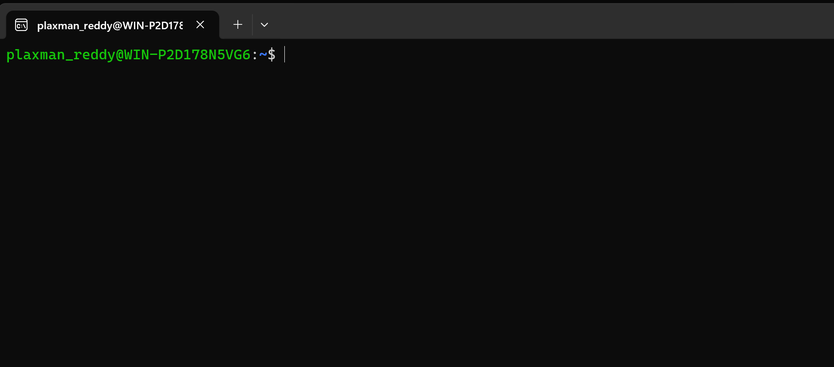

Step 2: Create the C file
Type: nano process.c
Press Enter.
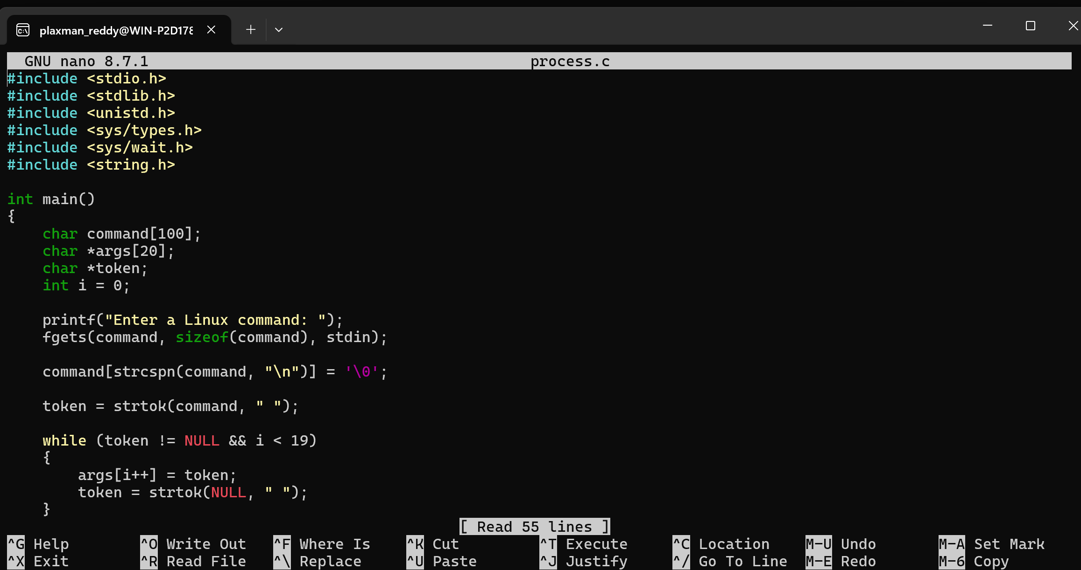

Step 3: Paste the program
Paste the complete C program into nano.
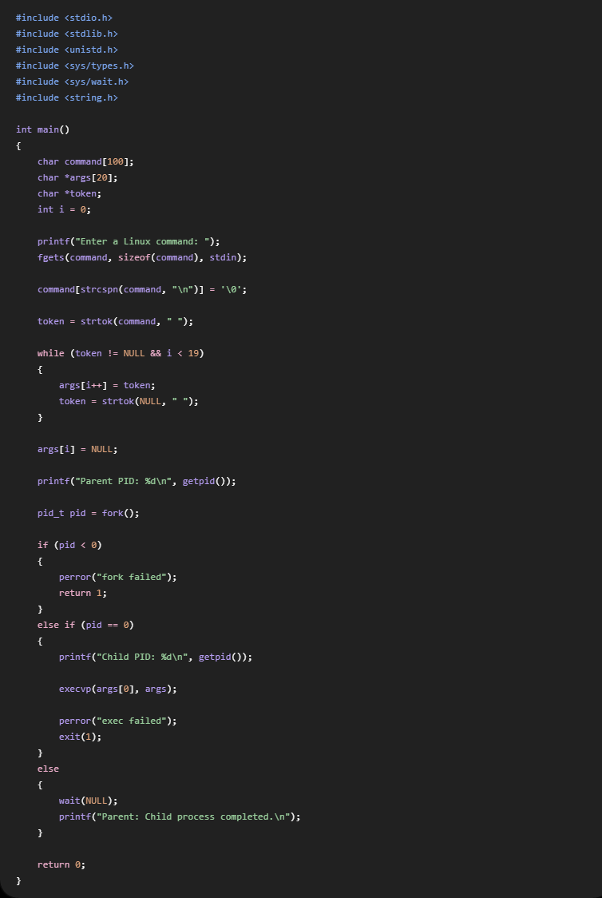
Then press:
Ctrl + O
You will see:
File Name to Write: process.c
Press Enter.
Then press:
Ctrl + X
You are back at the terminal.

Step 4: Compile the program
Type:
gcc process.c -o process
Press Enter.
If there is no error message, compilation was successful.

Step 5: Run the program
Type:
./process
You will see:
Enter a Linux command:

Step 6: Enter a command
For the first demonstration, type:
ls
Press Enter.
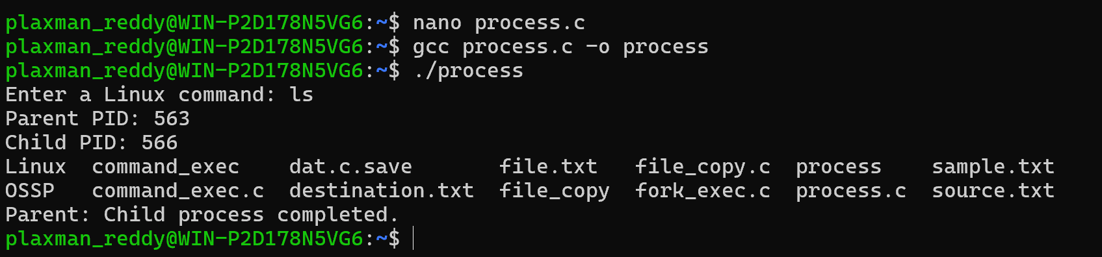
Parent: Child process completed.

What happened?
./process
|
v
Parent process
|
fork()
/ \
/ \
Parent Child
| |
wait() execvp()
| |
| ls
\ /
\ /
\ /
Child finishes

Step 7: Try another command
Run again:
./process
Enter:
Pwd
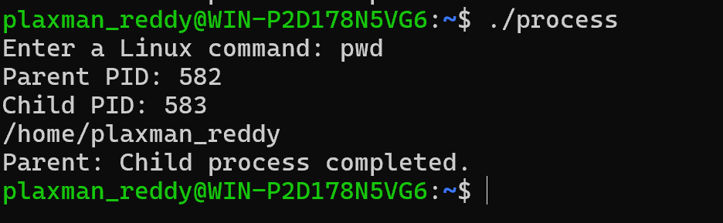

Step 8: Try ls -l
Run:
./process
Enter:
ls -l
This demonstrates that your program can accept command + arguments.
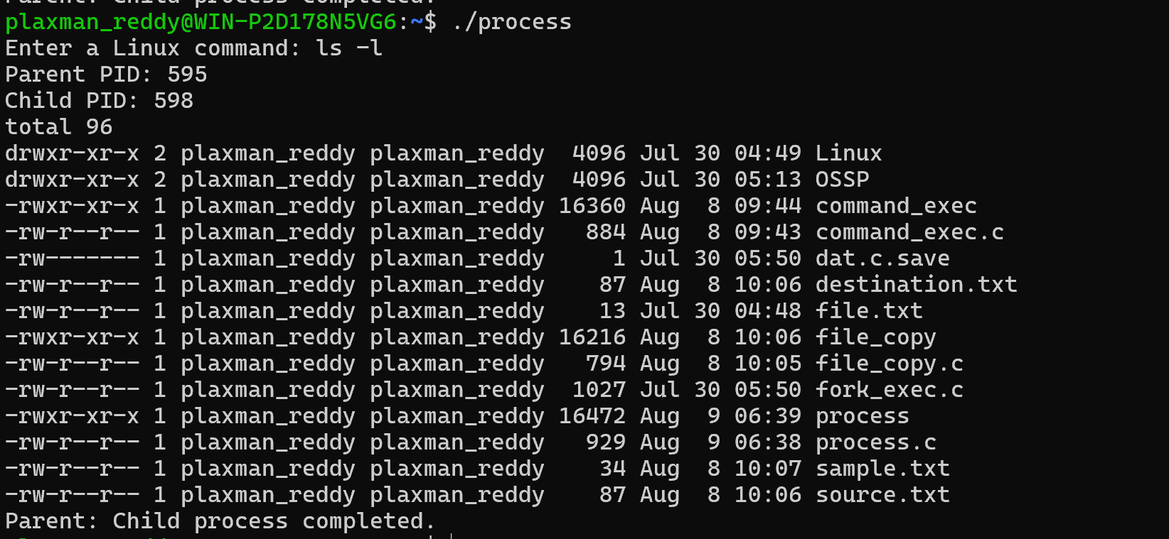

Step 9: Try uname
Run:
./process
Enter:
Uname
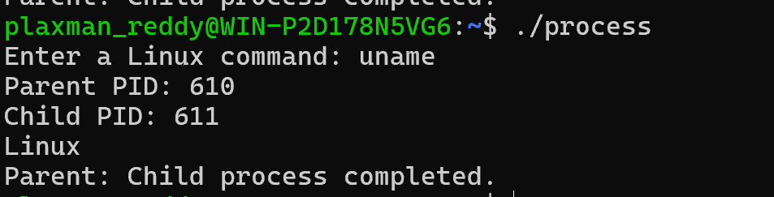

Step 10: strace — useful for demonstration
Since this practical is about showing how Linux executes processes, you can also demonstrate it with strace.
First install it if necessary:
sudo apt install strace
Then:
strace ./process
When it asks for the command, enter:
ls
You'll see many system calls such as:
fork()
execve()
wait4()
This is useful to show your faculty because it gives evidence of the system calls being used.
For the record:
strace is a Linux utility used to trace system calls and signals made by a process. It can be used to observe calls such as fork(), execve(), and wait4() during process creation and command execution.

LINUX HARDWARE & OS SERVICES
Now they asked us to investigate:
uname
lscpu
lsblk
ps
top
and prepare a report explaining how Linux abstracts:
- CPU
- Memory
- Storage
- I/O devices

1. uname

Command
uname -a

2. lscpu

Command
lscpu

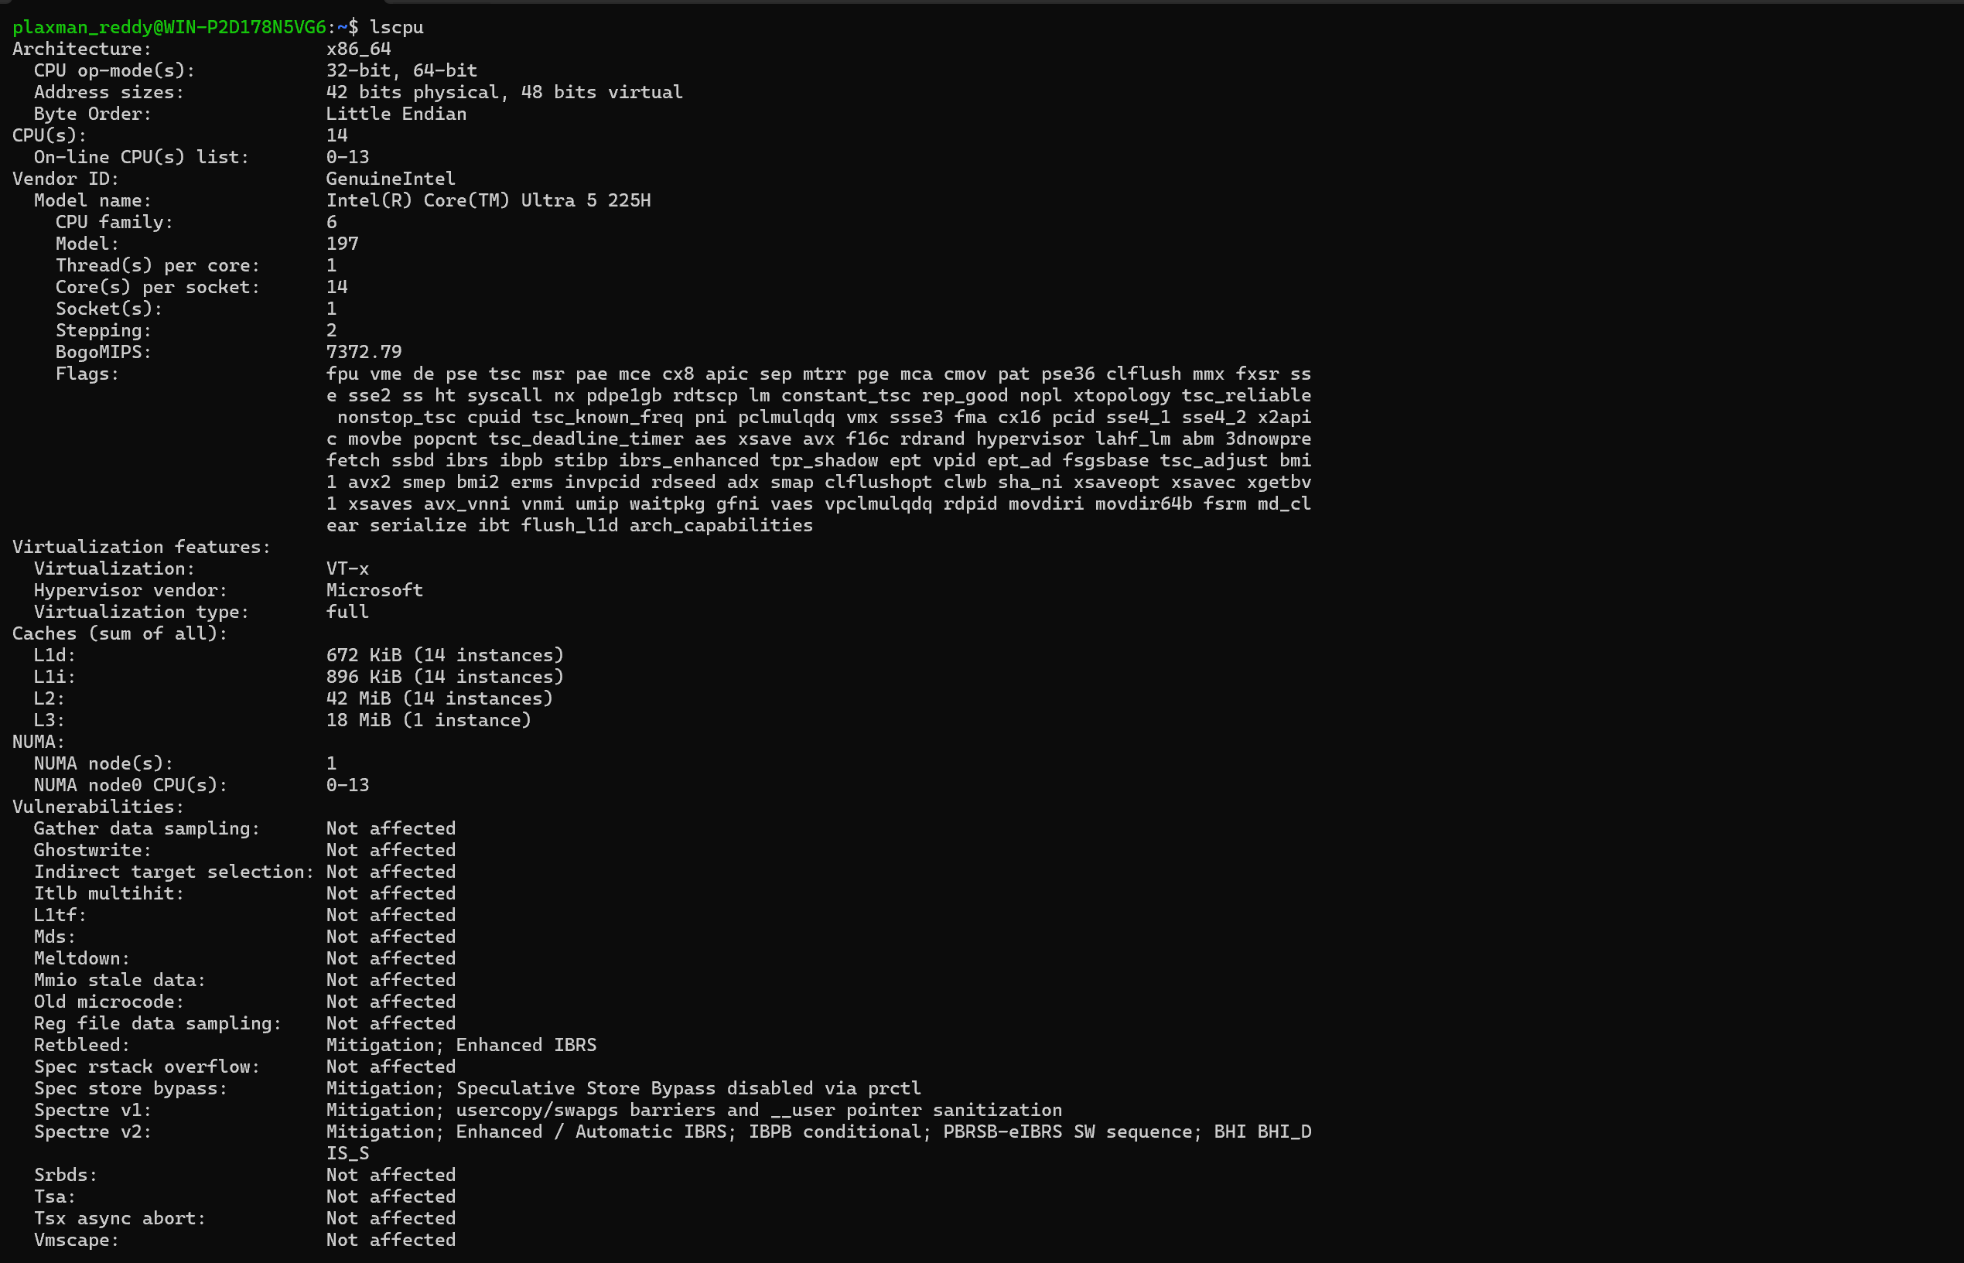3. lsblk

Command
Lsblk
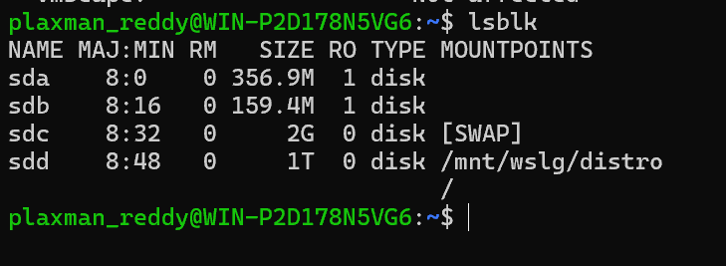

4. ps

Command
Ps

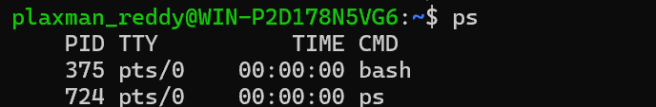

5. top

Command
top
To exit top, press: q
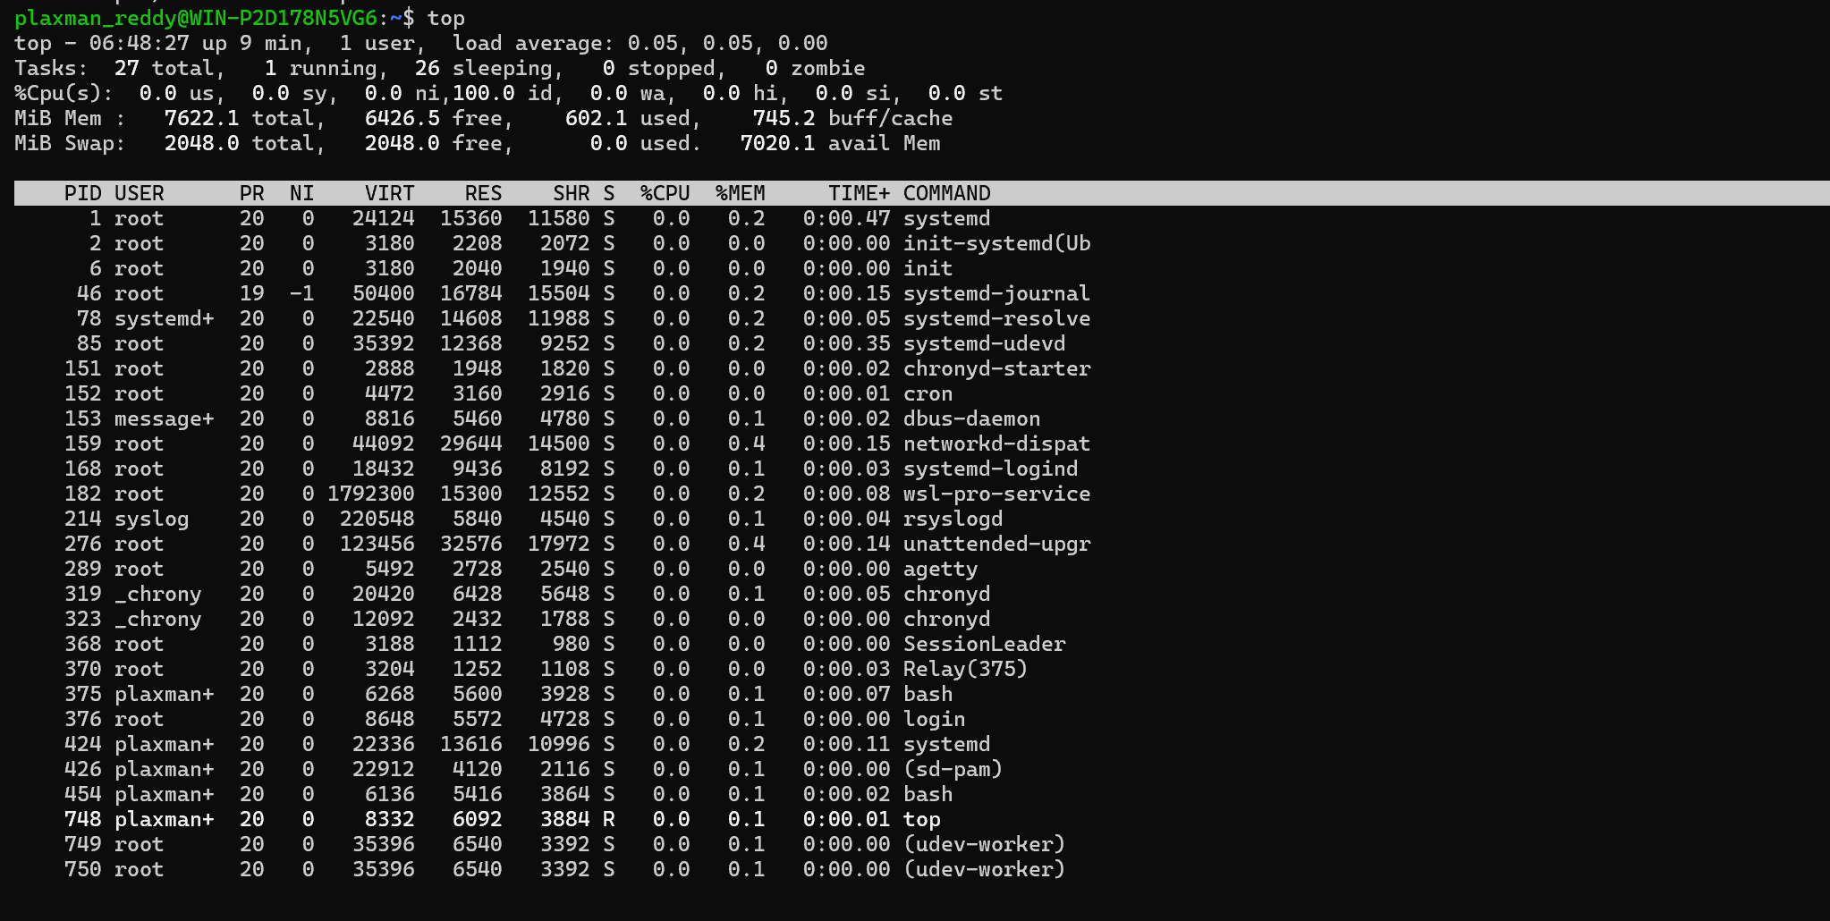
Important: top does not finish by itself. It continuously monitors the system until you press q.

