Assumptions:

- I have secured only few APIs, but we can secure all the API by just removing the entries from the WebSecurityConfig file.
This is applicable to all the microservices. Please try to access secure one to validate the authentication.
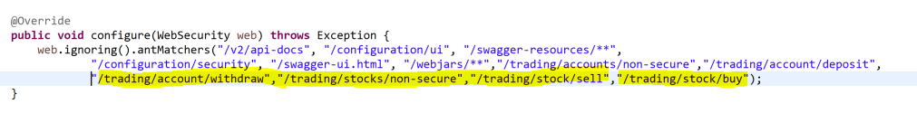

- Please refer H2 database console for database schema design.
- Please refer readme.md file for more details.
- AXON server need to be started.

