Microservices Workshop - Assignment 2021
To develop an online stock trading application, I have identified below microservices.
- Eureka Service Discovery
This microservice will provide the service registry and discovery server. Client microservice registers with Eureka it provides metadata such as host, port, and health indicator thus allowing for other microservices to discover it. The discovery server expects a regular heartbeat message from each microservice instance.

eureka-service-discovery.
- Application URL: http://localhost:6060/
- For more details around configuration and other info, please refer below files inside application.
    - Application.yml file
    - readme.md file

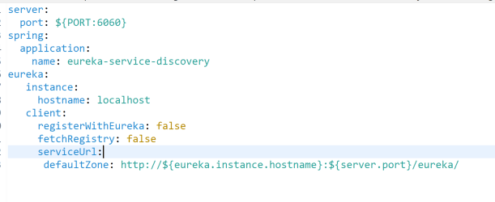
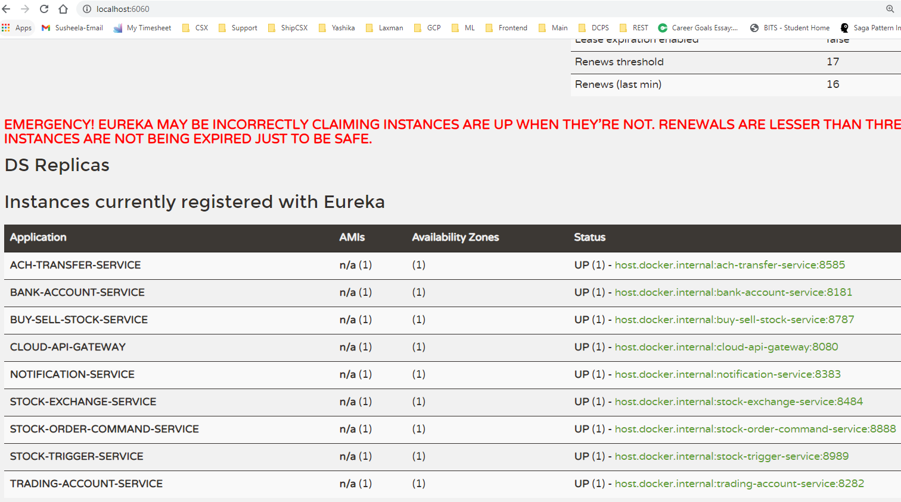

- ACH (Automated Clearing House) Transfer Service
This microservice is used to move money between bank accounts like from trading account to bank account and vice versa.

ach-transfer-service.
- Application URL: http://localhost:8585/
- SWAGGER UI URL: http://localhost:8585/swagger-ui.html
- H2 Database Console for Schema Reference: http://localhost:8585/h2-console
- H2 Database URL: jdbc:h2:mem:ach-nagp-db
- H2 Database Username: sa
- H2 Database Password: password
- Authentication Username/password: Laxman/nagarro
- For more details around configuration and other info, please refer below files inside application.
    - Application.yml file
    - readme.md file
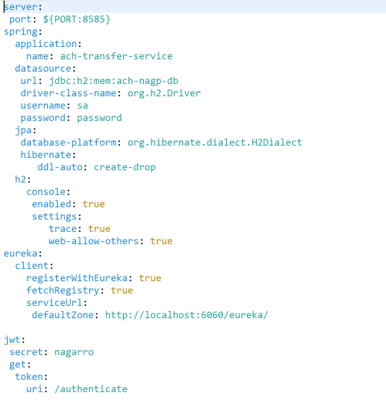
For Database design, please refer H2 database console.
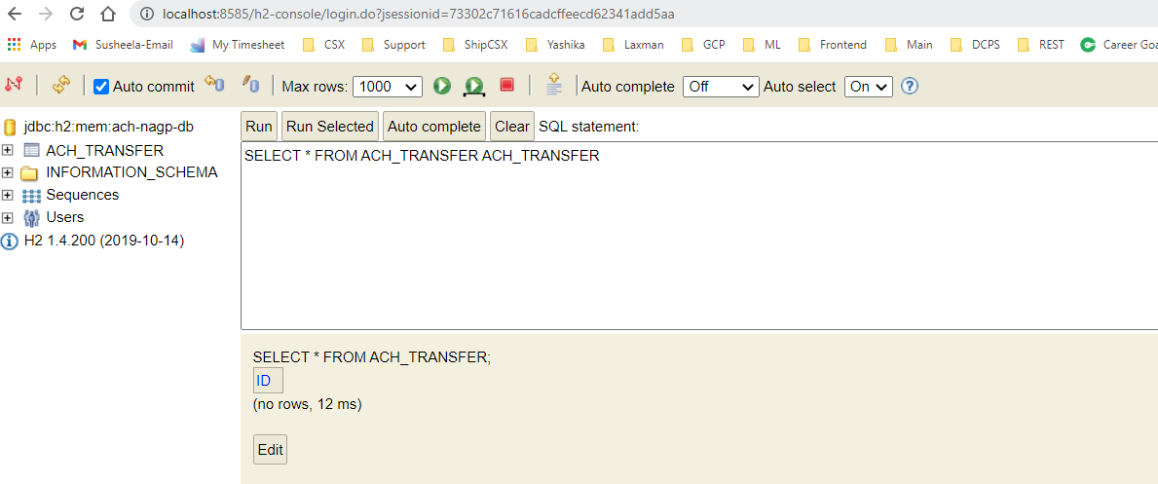
- Bank Account Service
This microservice is used to handle bank accounts and transactions.
bank-account-service
- Application URL: http://localhost:8181/
- SWAGGER UI URL: http://localhost:8181/swagger-ui.html
- H2 Database Console for Schema Reference: http://localhost:8181/h2-console
- H2 Database URL: jdbc:h2:mem:bank-nagp-db
- H2 Database Username: sa
- H2 Database Password: password
- Authentication Username/password: Laxman/nagarro
- For more details around configuration and other info, please refer below files inside application.
    - Application.yml file
    - readme.md file
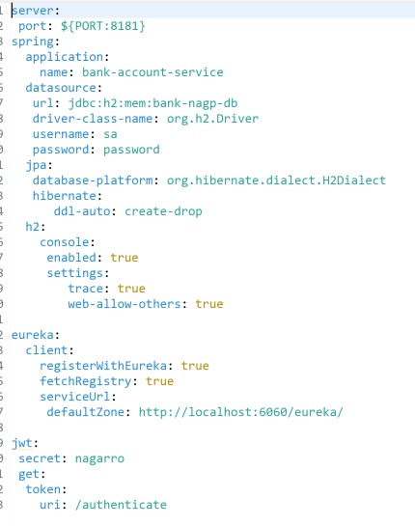
For database design, please refer H2 console.
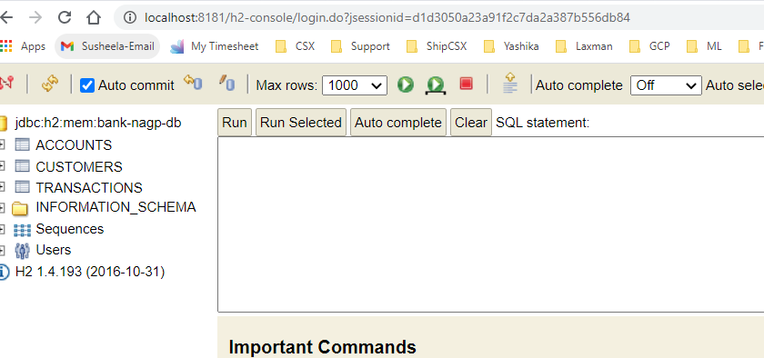
- Trading Account Service
This microservice is used to handle accounts/ transactions and buy/sell stocks.

trading-account-service
- Application URL: http://localhost:8282/
- SWAGGER UI URL: http://localhost:8282/swagger-ui.html
- H2 Database Console for Schema Reference: http://localhost:8282/h2-console
- H2 Database URL: jdbc:h2:mem:trading-nagp-db
- H2 Database Username: sa
- H2 Database Password: password
- Authentication Username/password: Laxman/nagarro

- For more details around configuration and other info, please refer below files inside application.
    - Application.yml file
    - readme.md file
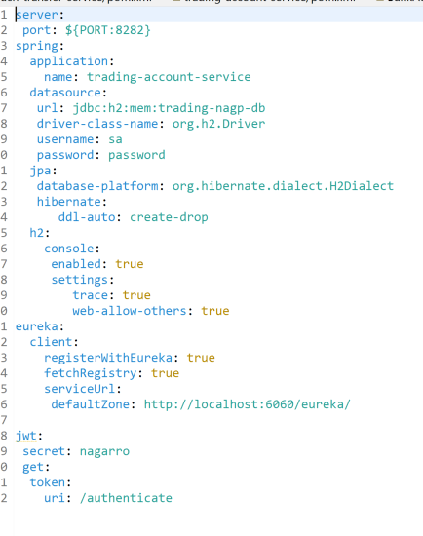
For database design, please refer H2 console.
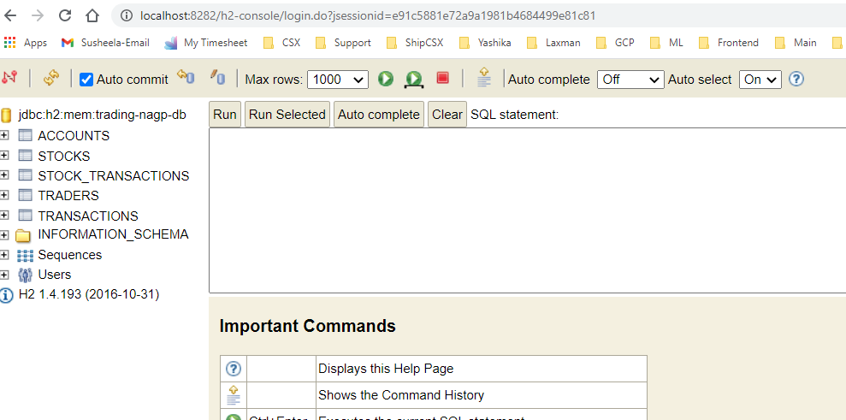

- Stock Exchange Service
This microservice is used to handle stocks and live prices of stocks.

stock-exchange-service
- Application URL: http://localhost:8484/
- SWAGGER UI URL: http://localhost:8484/swagger-ui.html
- H2 Database Console for Schema Reference: http://localhost:8484/h2-console
- H2 Database URL: jdbc:h2:mem:stock-exchange-nagp-db
- H2 Database Username: sa
- H2 Database Password: password
- Authentication Username/password: Laxman/nagarro

- For more details around configuration and other info, please refer below files inside application.
    - Application.yml file
    - readme.md file
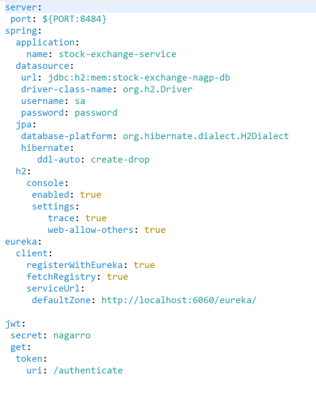
For database design, please refer H2 console.
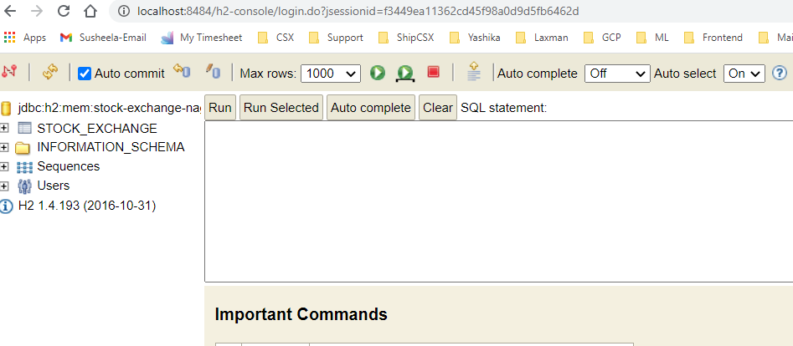

- Notification Service
This microservice is used to send email notifications to stakeholders.
notification-service
- Application URL: http://localhost:8383/
- SWAGGER UI URL: http://localhost:8383/swagger-ui.html
- For more details around configuration and other info, please refer below files inside application.
      - Application.yml file
      - readme.md file
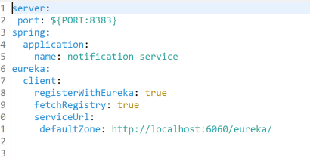
7. Cloud API Gateway
This microservice is used as API gateway that sits between a client and a collection of backend services. An API gateway acts as a reverse proxy to accept all application programming interface (API) calls, aggregate the various services required to fulfill them, and return the appropriate result.
cloud-api-gateway
- Application URL: http://localhost:8080/
- For more details around configuration and other info, please refer below files inside application.
          - Application.yml file
          - readme.md file
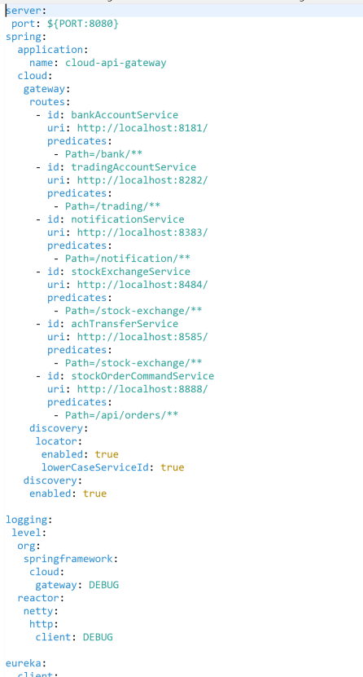
Implemented Saga pattern using AXON to support the feature of automatically buy/sell certain stock holdings when they are reach a set threshold price.
- Stock Order command Service
This microservice is used to create an order to set the trigger to automatically buy and sell the stocks.

stock-order-command-service
- Application URL: http://localhost:8888/

- SWAGGER UI URL: http://localhost:8888/swagger-ui.html
- H2 Database Console for Schema Reference: http://localhost:8888/h2-console
- H2 Database URL: jdbc:h2:mem:stock-order-command-nagp-db
- H2 Database Username: sa
- H2 Database Password: password

- For more details around configuration and other info, please refer below files inside application.
          - Application.yml file
          - readme.md file
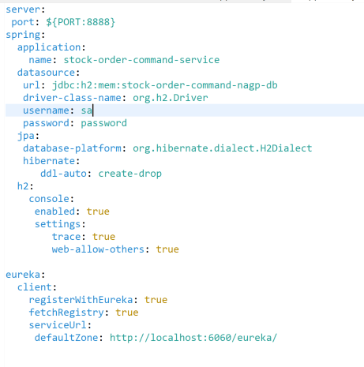

- Stock Trigger Service.
This microservice is used to set the trigger to buy and sell the stocks.

stock-trigger-service
- Application URL: http://localhost:8989/
- SWAGGER UI URL: http://localhost:8989/swagger-ui.html
- H2 Database Console for Schema Reference: http://localhost:8989/h2-console
- H2 Database URL: jdbc:h2:mem:stock-trigger-nagp-db
- H2 Database Username: sa
- H2 Database Password: password

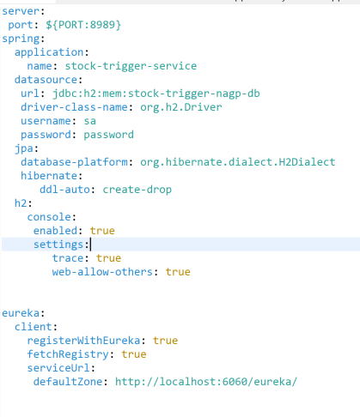
For database design, please refer H2 console.
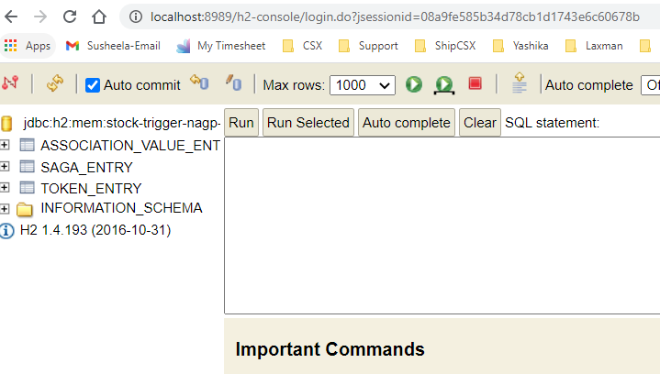

- Buy sell stock Service.
This microservice is used to actually buy and sell stocks when notified buy stock trigger service.

buy-sell-stock-service.

- Application URL: http://localhost:8787/
- SWAGGER UI URL: http://localhost:8787/swagger-ui.html
- H2 Database Console for Schema Reference: http://localhost:8787/h2-console
- H2 Database URL: jdbc:h2:mem:buy-sell-stock-nagp-db
- H2 Database Username: sa
- H2 Database Password: password
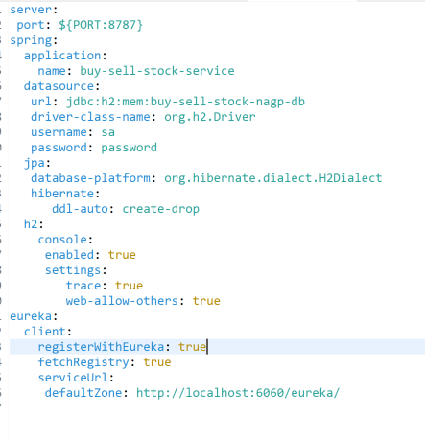
For database design, please refer H2 console.
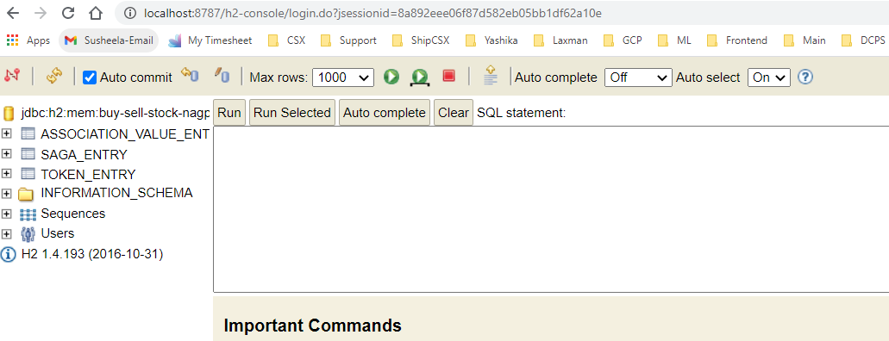

AXON Server
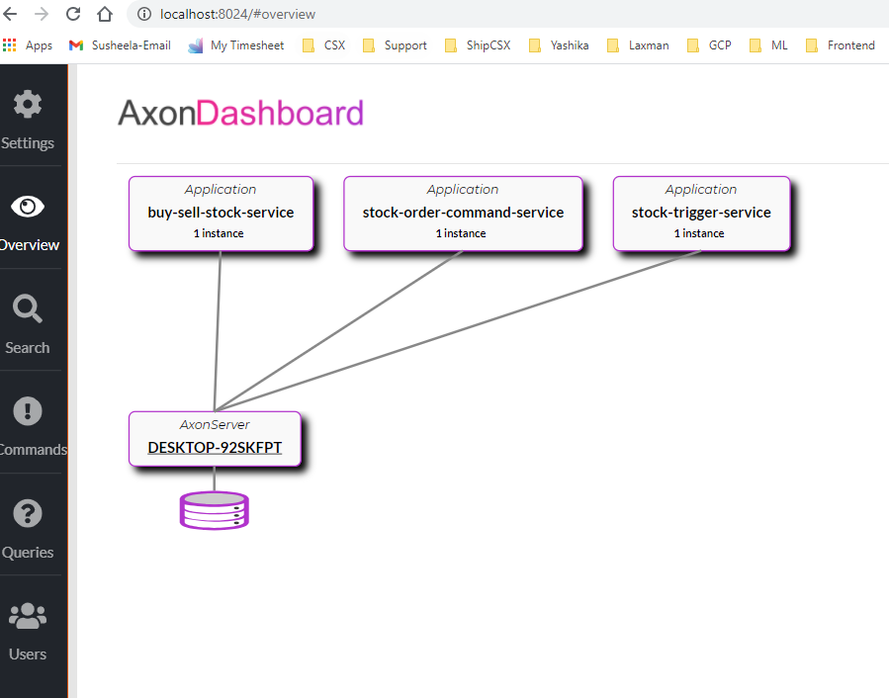
Bank db
Ach db
System Diagram.

Cloud api gateway
Bank account service
Ach transfer service

Stock db
client
Stock exchange service
Trading account service

Trading db
Notification service

Eureka service discovery.

Saga implementation with AXON
Create stock trigger command
db
STATUS UPDATE
ORDER SERVICE
Stock Trigger Service

ORDER MANAGEMENT SAGA
Stock trigger created event
Create buy sell stock command
ORDER DATA

Buy sell event
Buy Sell Stock Service

db

