**PROGRAM (1).**

**INPUT**

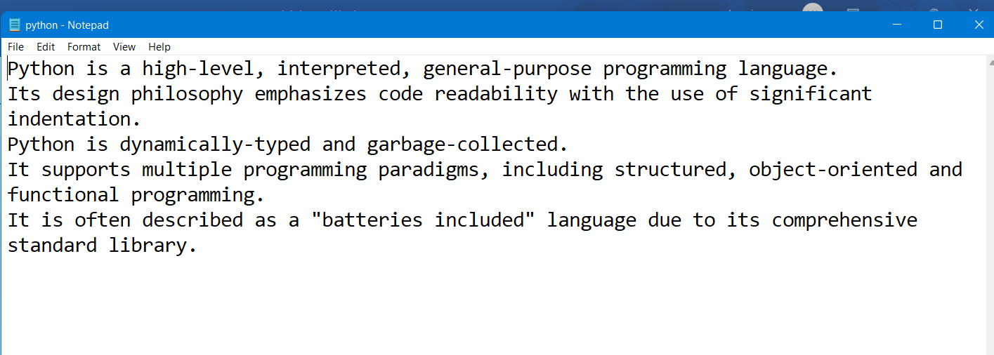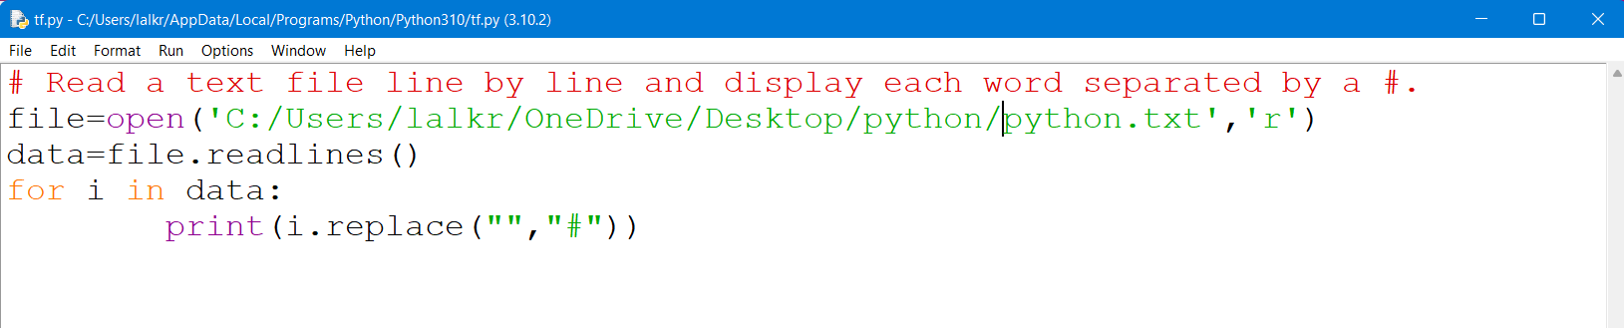

**OUTPUT** 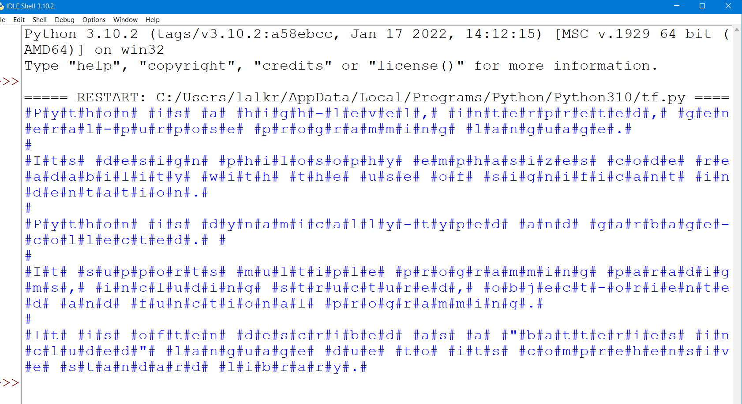

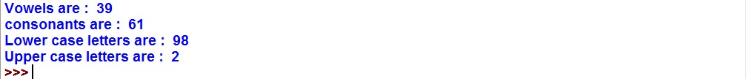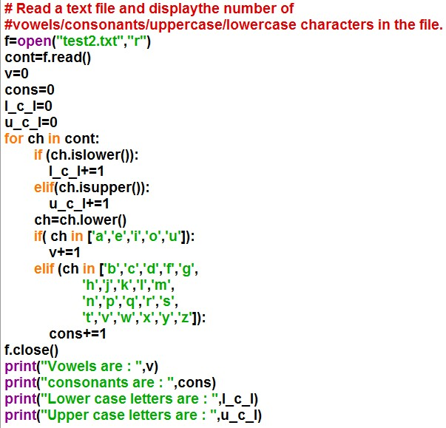

**OUTPUT OF PROGRAM (2).**

**INPUT OF PROGRAM (3**

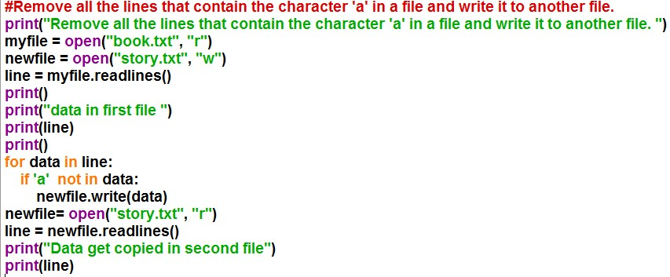

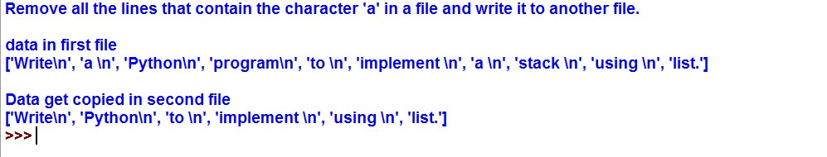**OUTPUT OF PROGRAM (3).**

**INPUT OF PROGRAM (4**

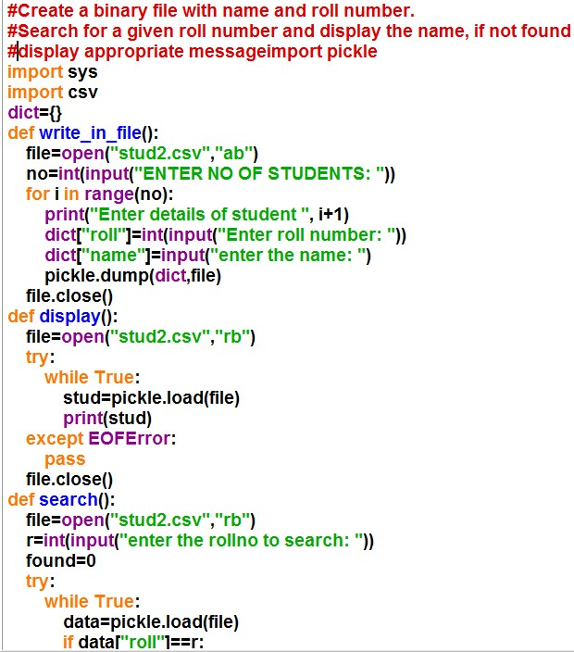

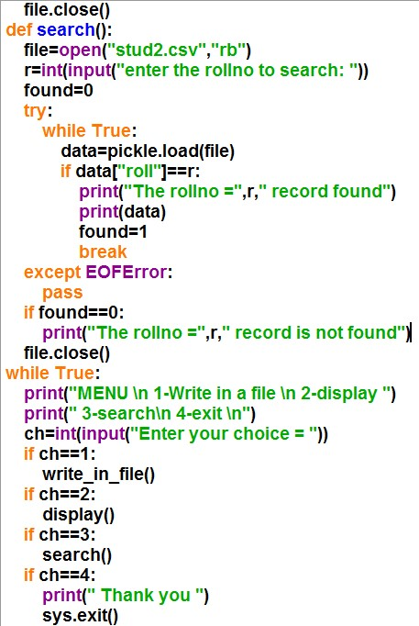

**OUTPUT OF PROGRAM (4).**

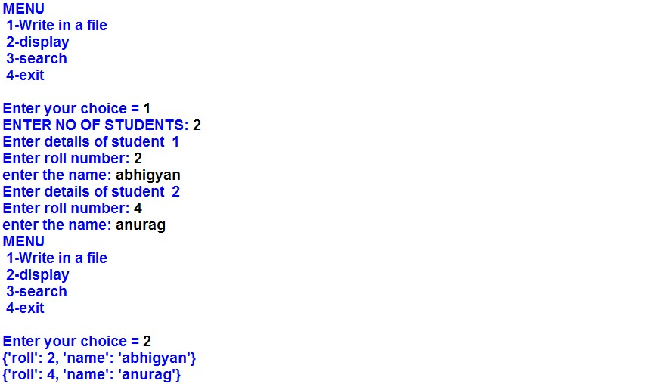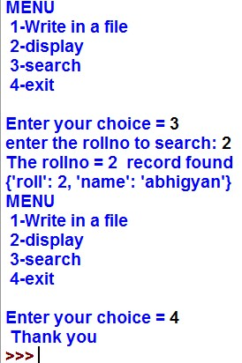

**INPUT OF PROGRAM (5).**

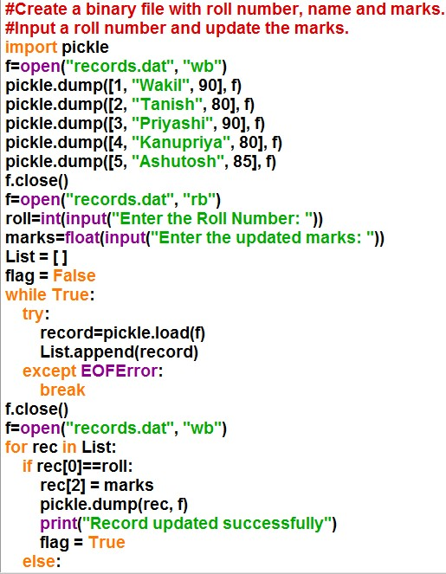

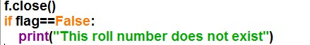

**OUTPUT OF PROGRAM (5).**

**INPUT OF PROGRAM (6).**

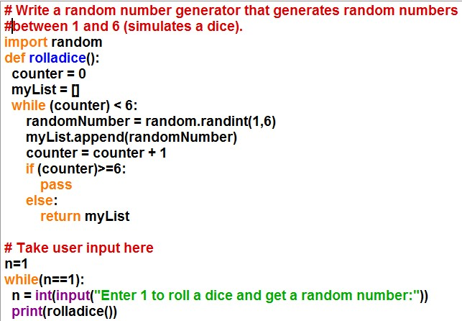

**OUTPUT OF PROGRAM (6).**

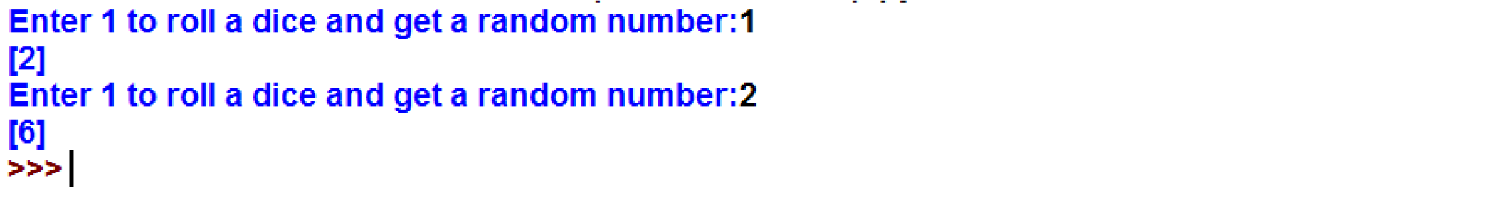**INPUT OF PROGRAM (7).**

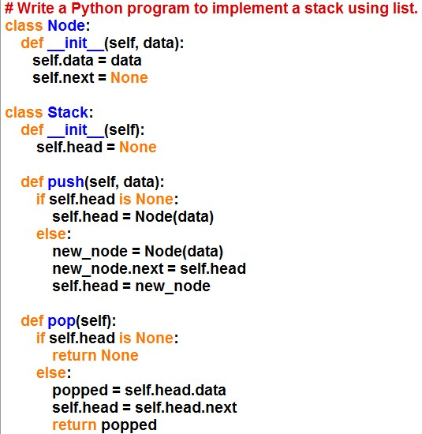

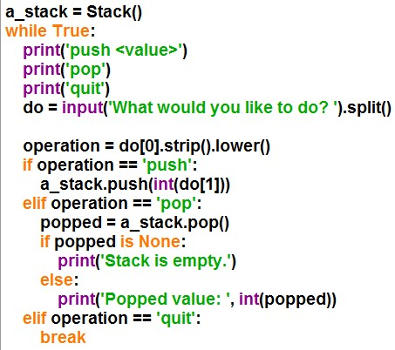

**OUTPUT OF PROGRAM (7).**

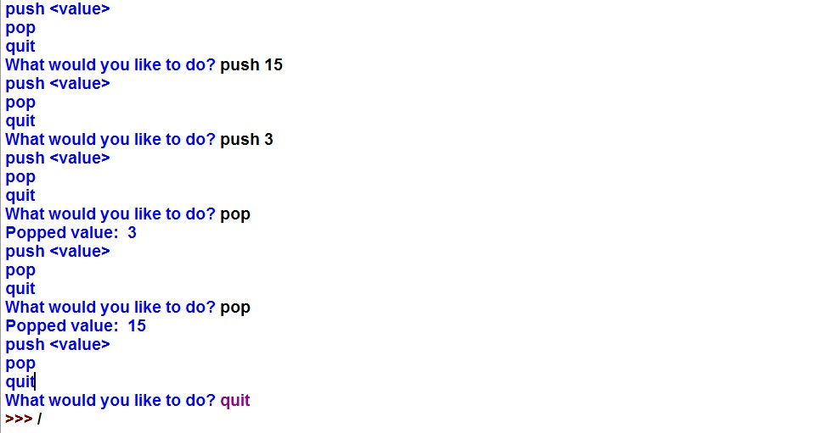

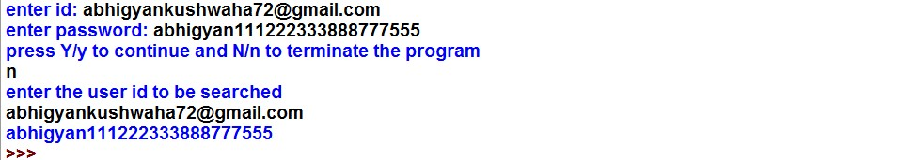**INPUT OF PROGRAM (8).**

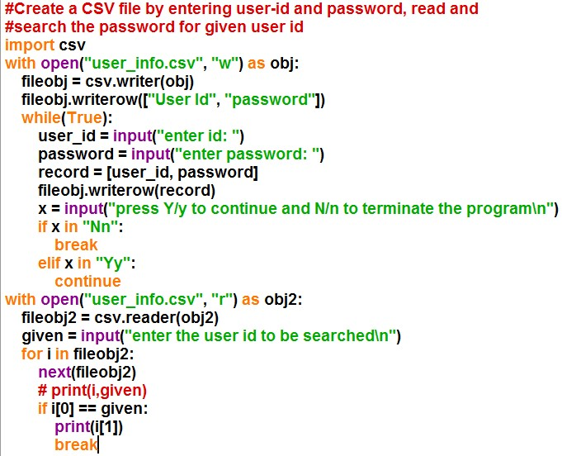

**OUTPUT OF PROGRAM (8).**

**PROGRAM 9(A).**

**INPUT**

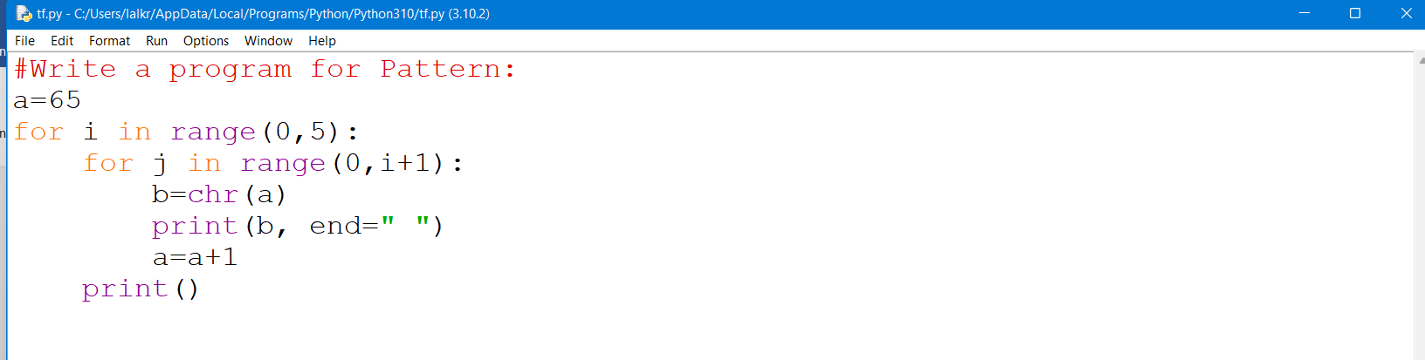

**OUTPUT**

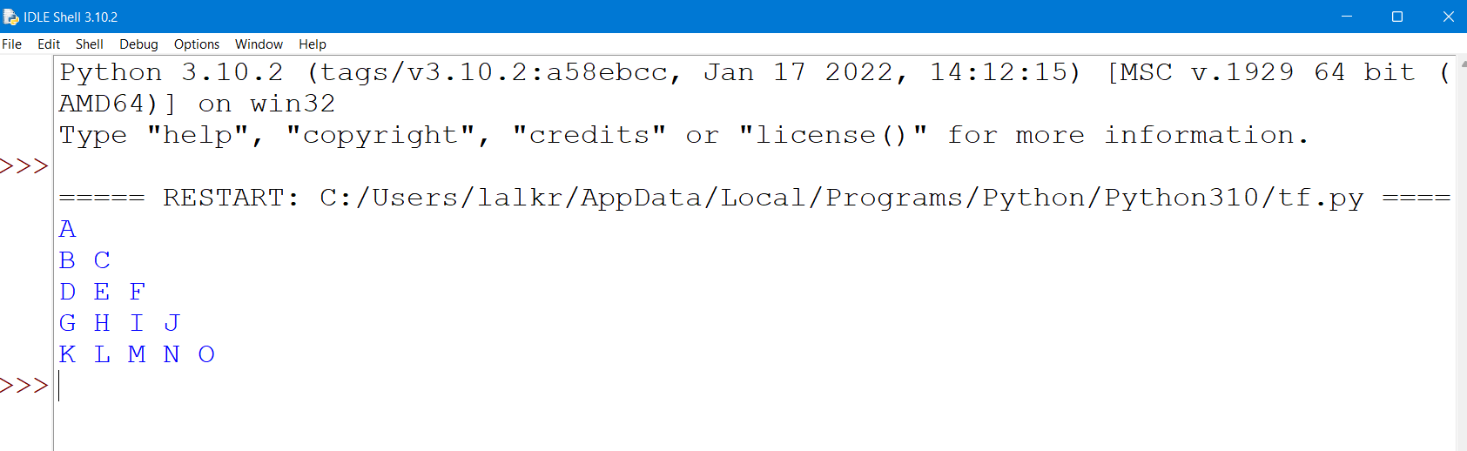

**PROGRAM 9(B).**

**INPUT**

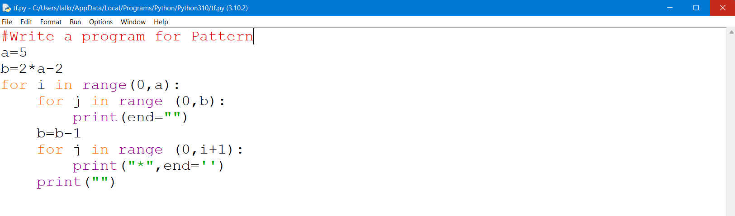

**OUTPUT**

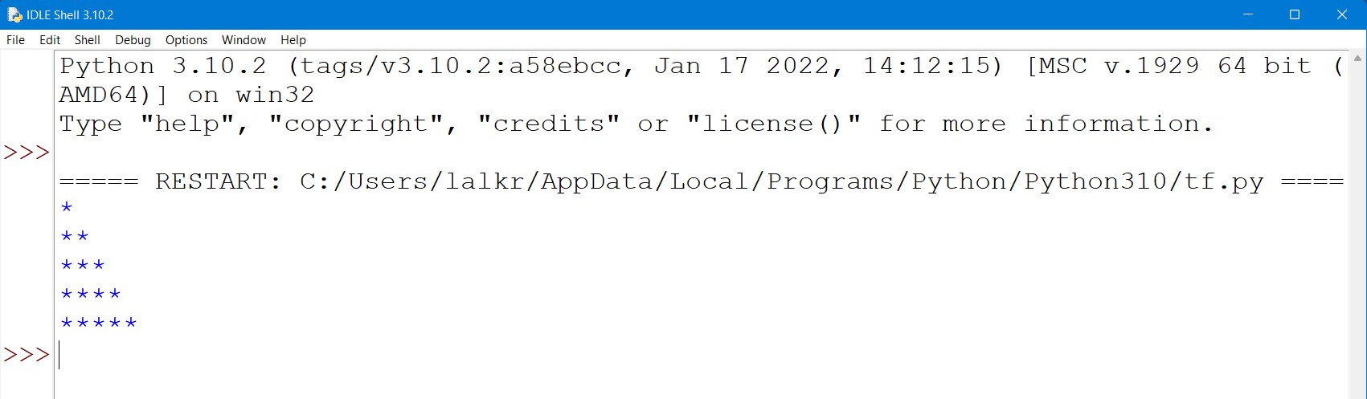

**PROGRAM 9(C).**

**INPUT**

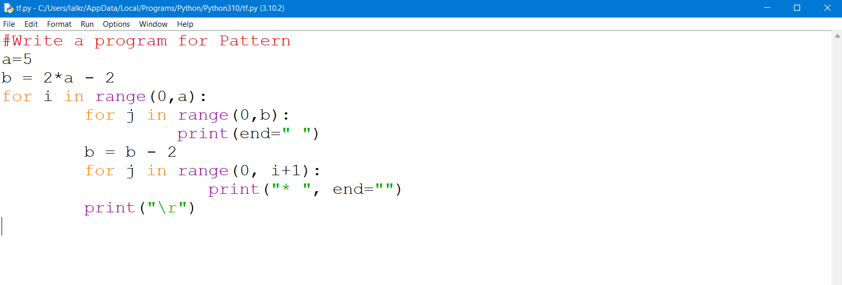

**OUTPUT**

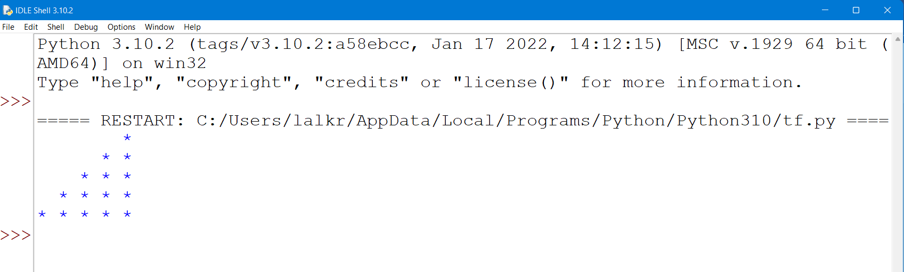

**PROGRAM 9(D).**

**INPUT**

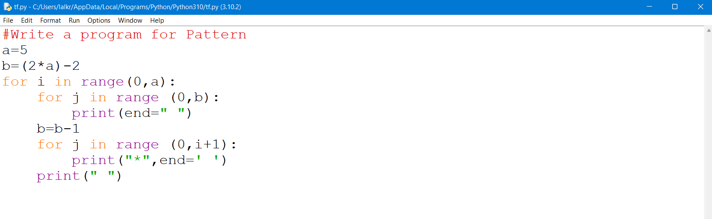

**OUTPUT**

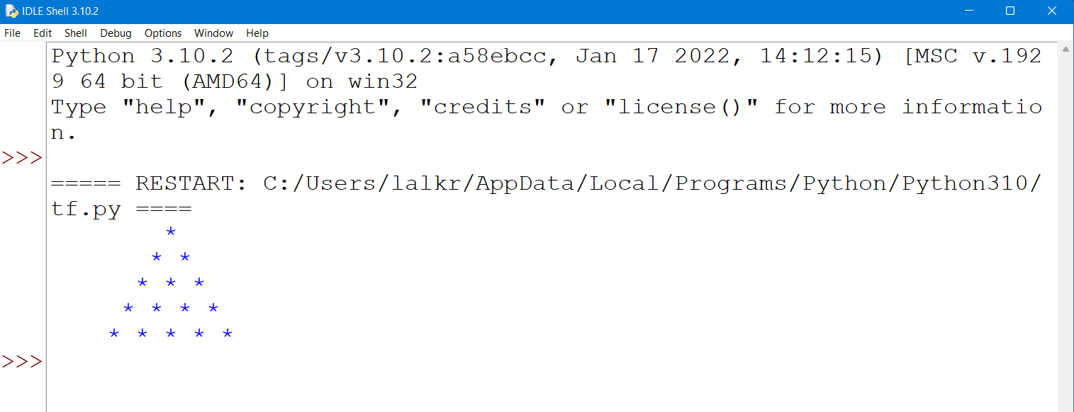

**PROGRAM 9(E).**

**INPUT**

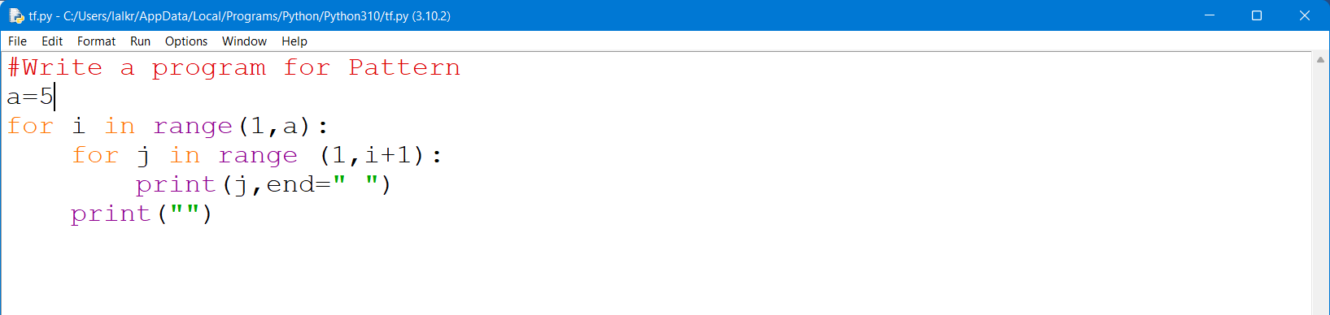

**OUTPUT**

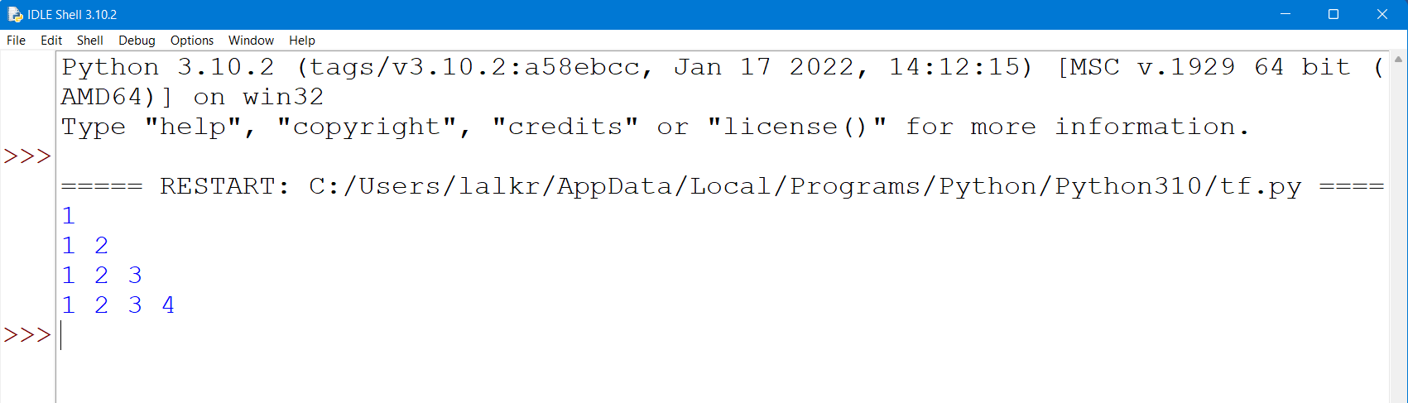

**PROGRAM 9(F).**

**INPUT**

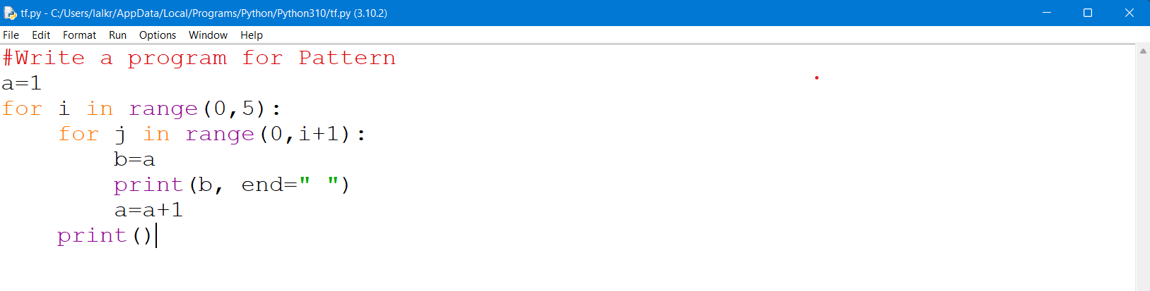

**OUTPUT**

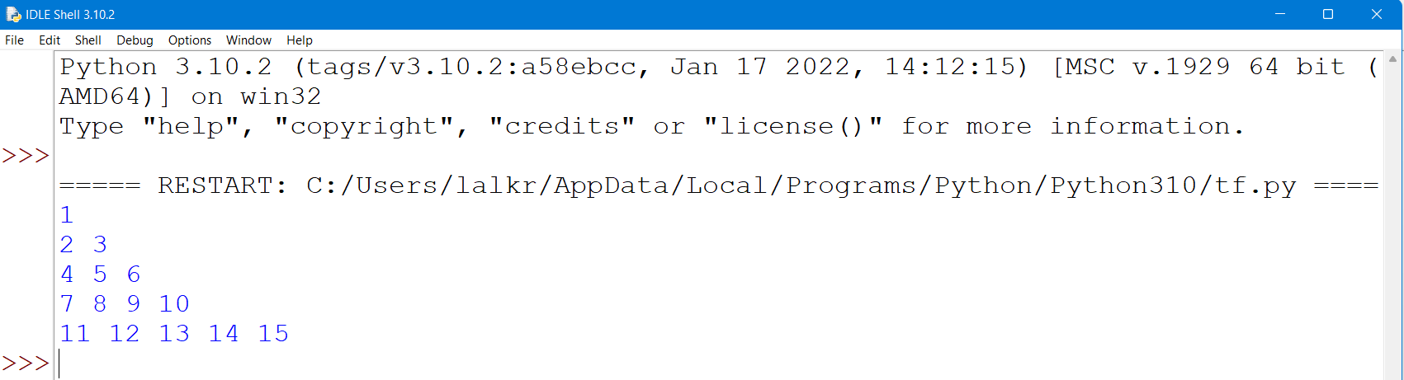

**PROGRAM 9(G).**

**INPUT**

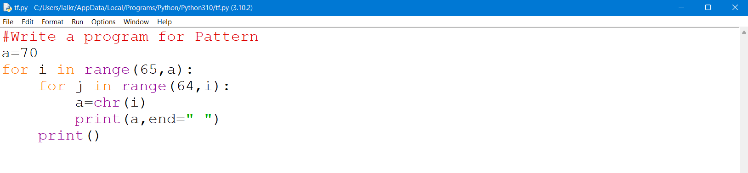

**OUTPUT**

