Data structures and Algorithms Lab
Assignment 1
Experiment 1: To Demonstrate the Use of Array, Structure, Union
and Dynamic Memory Allocation

Instruction: Make a pdf file of the program code in C/C++ and its output.
Name: Laxmi Devi
SAP ID: 590023896
Batch: 40
Link of your GitHub Account: https://github.com/laxmi1607/Laxmi_590023896_DSA_2026.git
Course: B.Tech. CSE (Sem II)
Subject: DSA Lab
Date: 03 February 2026
Note: Do all the implementations in C programming.
- Write a C program to dynamically allocate memory for an array, display elements, and properly free allocated memory before program termination.

CODE:
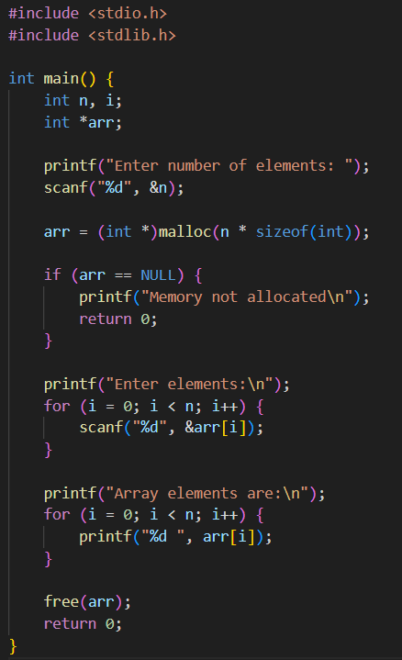

OUTPUT:
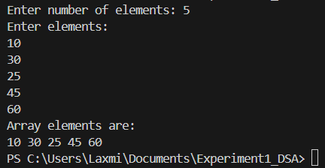

- Write a C program to dynamically allocate memory for an array of N integers and perform insertion, display, sum, and average operations.

CODE:
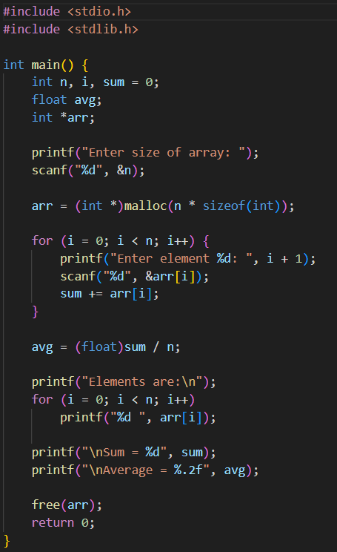

OUTPUT:
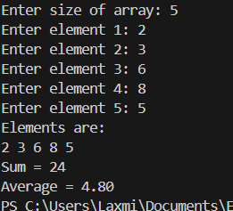

- Write a C program to dynamically allocate an array and find the largest and smallest element.

CODE:
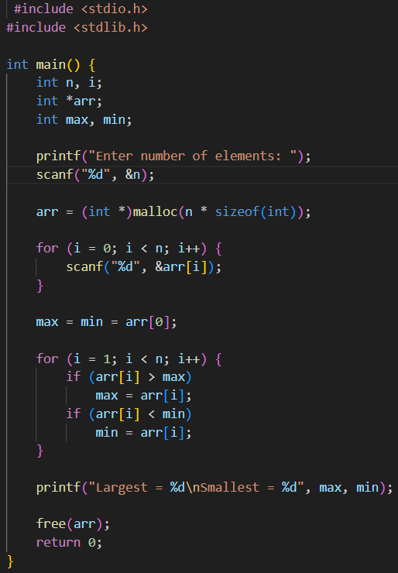

OUTPUT:
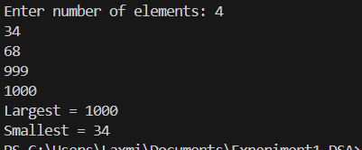

- Write a C program to dynamically allocate memory for a 2D matrix and perform matrix addition and subtraction.

CODE:
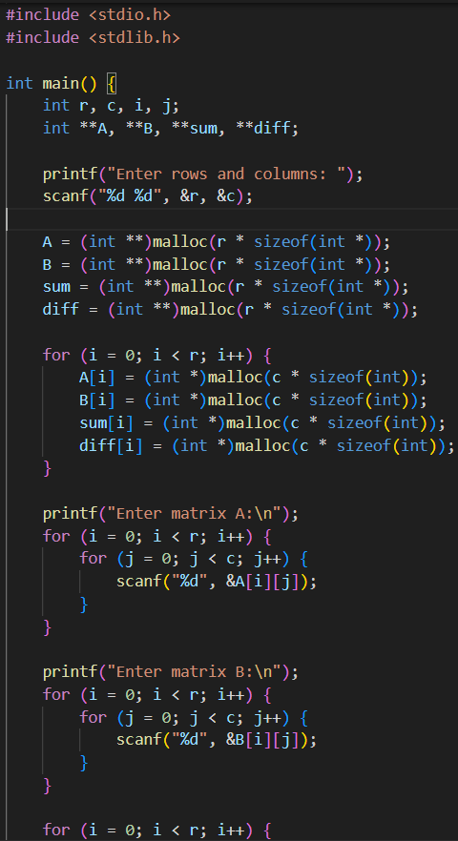
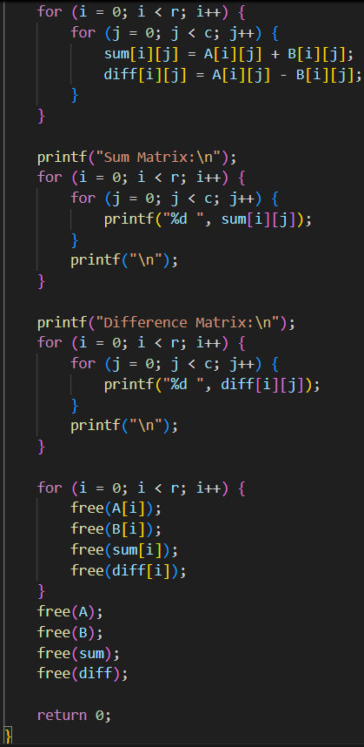
OUTPUT:
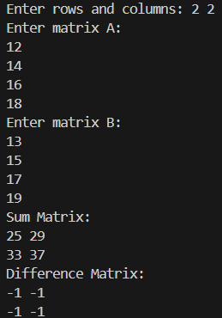

- Write a C program using structure and dynamic memory allocation to store and display student details such as roll number, name, and marks.

CODE:
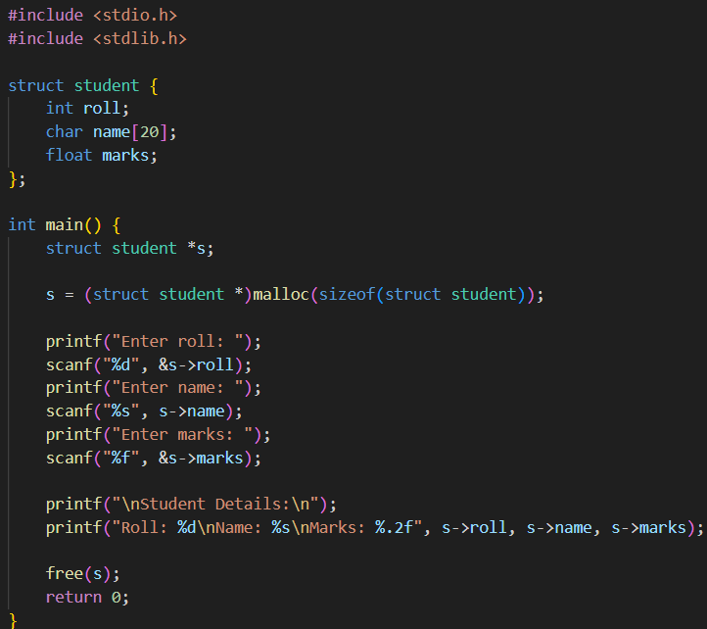
OUTPUT:
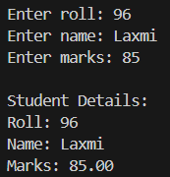
- Write a C program using array of structures with dynamic memory allocation to store employee details and find the employee with the highest salary.

CODE:
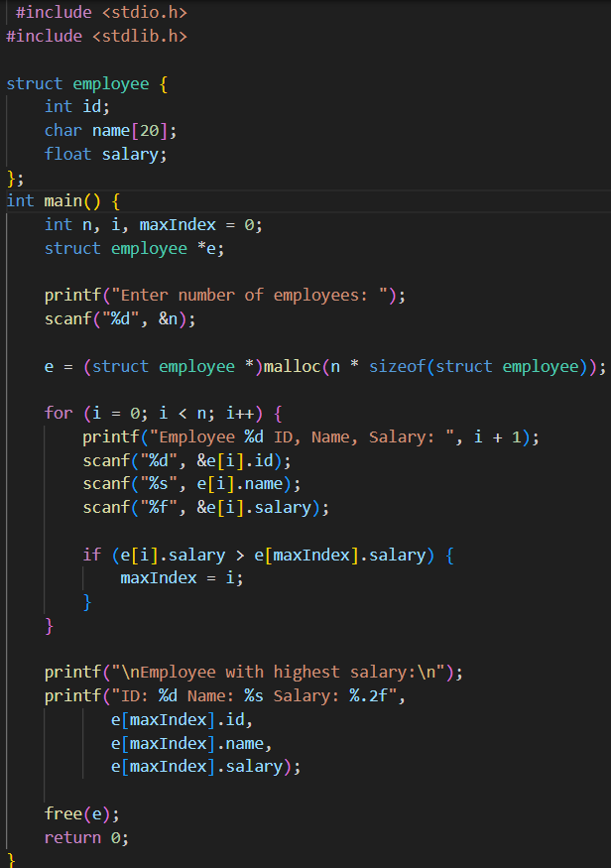

OUTPUT:
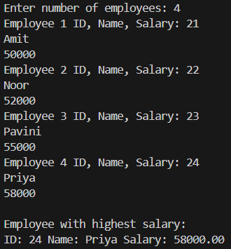

- Write a menu-driven C program using structure and dynamic memory allocation to add, display, delete records and free memory before exit.

CODE:
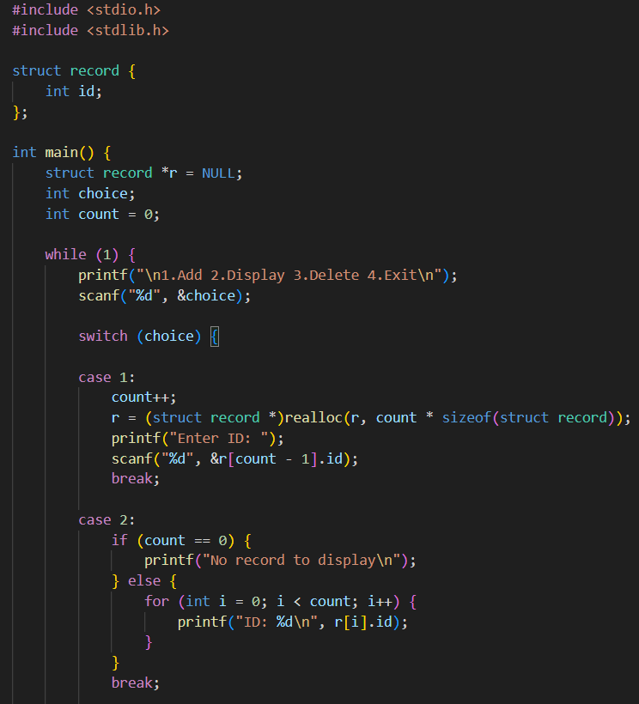
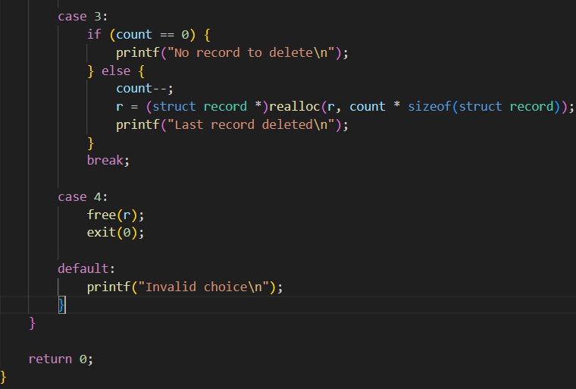

OUTPUT:
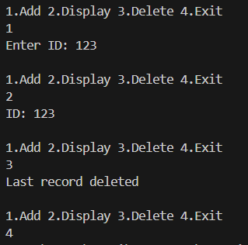

- Write a C program to demonstrate the use of union by storing integer, float, and character data and explain memory sharing.

CODE:
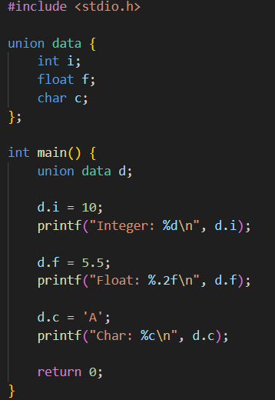
OUTPUT:
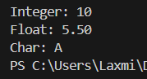

- Write a C program to show the difference in memory allocation between structure and union using sizeof().

CODE:
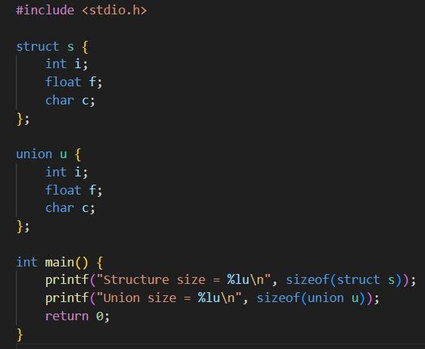

OUTPUT:
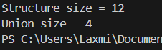

- Write a C program using structure and dynamic memory allocation to sort student record based on marks.
CODE:
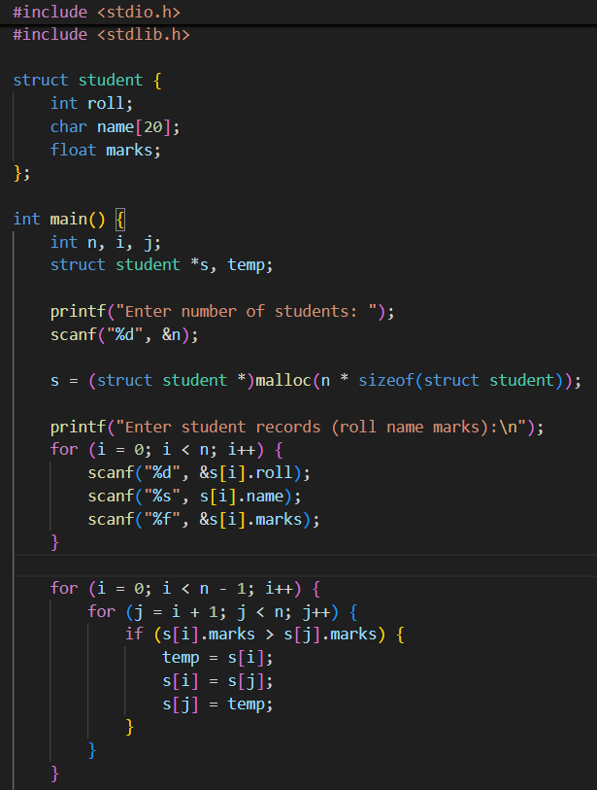
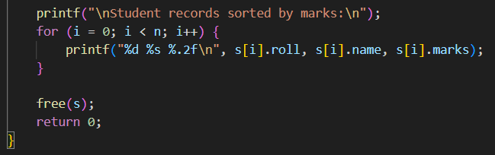

OUTPUT:
