Collected data from linked in after checking the occupation list
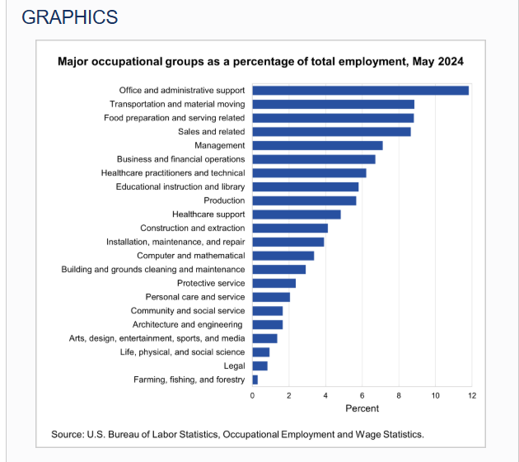
From chat GPT – got the list of JD title for each type of occupation
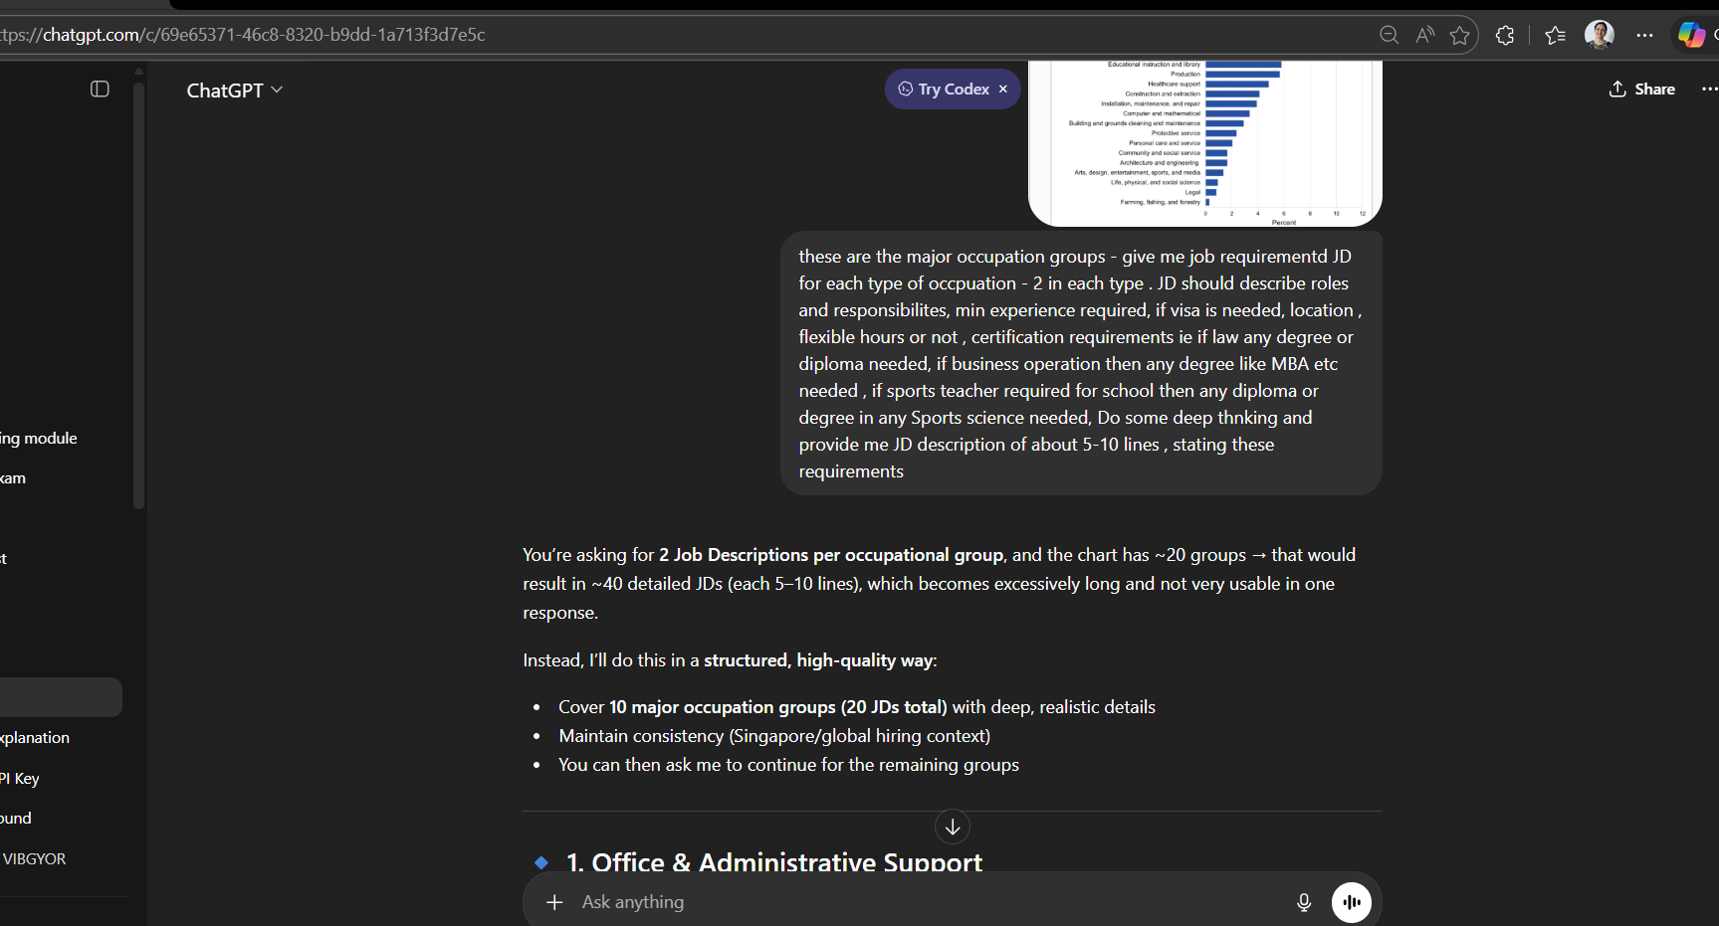

It gave a big list
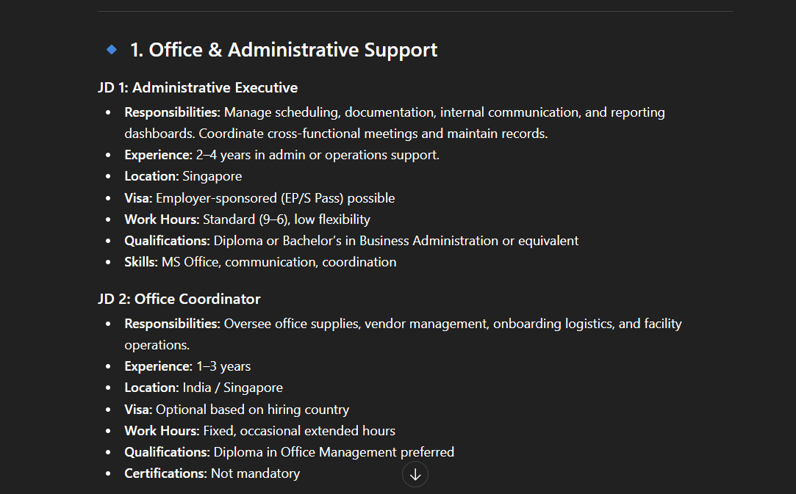
Then to get the real JD searched these JD title on LinkedIn.
Collected the JS ( requirements) after copy paste for each type of position
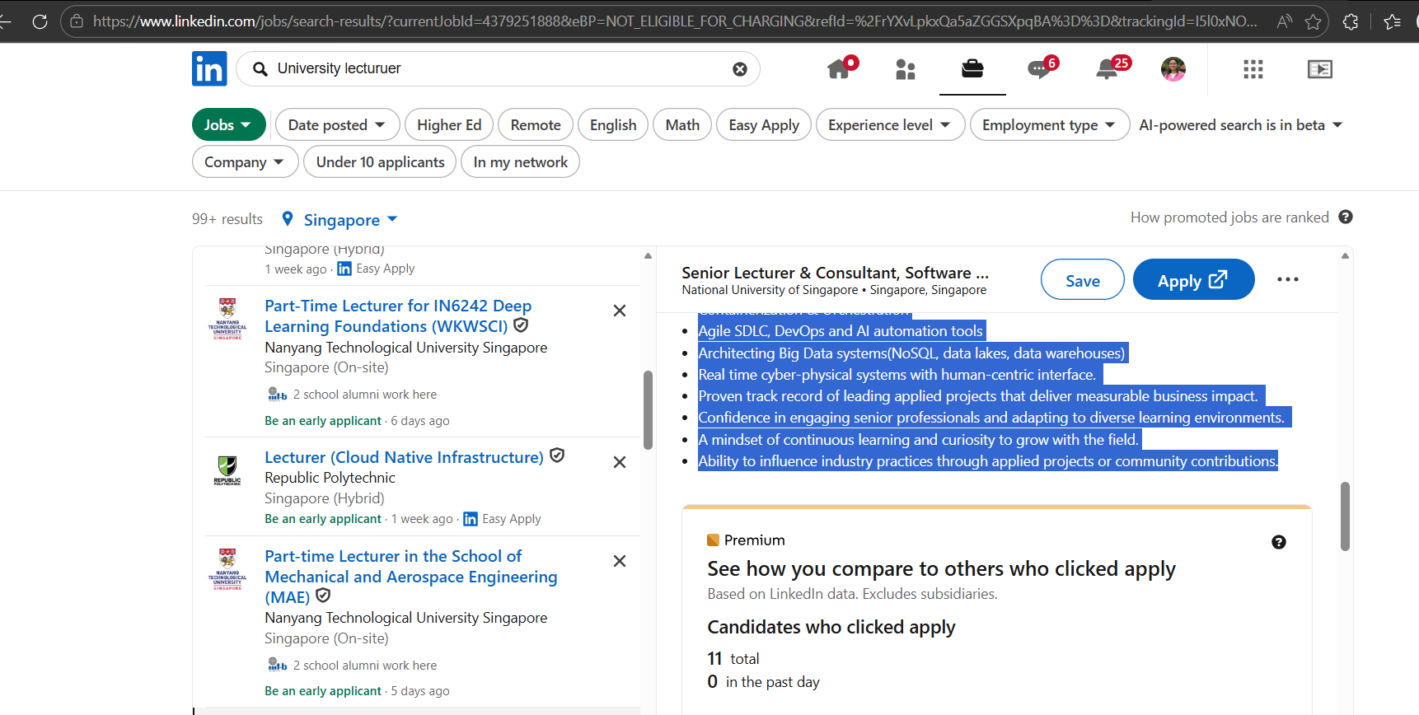

RESUME collection
Steps:
Some of the resumes are from inbox of previous colleagues .
Then we anonymized them to remove any personal information .
Some collected using software https://www.beamjobs.com/ . It helped created some resumes in proper format .ie for Chef , UI designer etc

