Project Proposal

RecruitIQ.ai

Intelligent CV Recommendation and Candidate shortlisting System

Table of Contents
- Project Overview
- Objectives
- Key Features
- Scope & Deliverables
- Full System Architecture
- Timeline & Milestones
- Stakeholders & Roles
- Additional Notes
- Summary

1. Project Overview
RecruitIQ.ai is an innovative recruitment assistant designed to transform the candidate screening process by leveraging Large Language Models (LLMs) and Retrieval-Augmented Generation (RAG). By automating the analysis of CVs and matching candidates against job descriptions, RecruitIQ.ai streamlines recruitment workflows, providing HR teams with consistent, fair, and data-driven candidate rankings supported by explainable reasoning.
This project addresses the persistent challenges faced by organizations during hiring, including the overwhelming volume of applications, inefficient manual resume screening, inconsistent candidate evaluation, and unconscious human biases. Given the rapid advancements in artificial intelligence and natural language processing, now is an opportune moment to harness these technologies to enhance recruitment effectiveness and fairness.
The proposed AI-assisted CV recommendation system integrates multiple AI paradigms:
- rule-based expert systems for automated hiring decisions
- optimization algorithms to prioritize candidate screening
- data mining techniques for knowledge discovery from resumes
- cognitive components including knowledge representation and natural language explanation
This hybrid design enables the system to perform intelligent candidate ranking, reasoning, and explainable hiring recommendations.

2. Objectives
- Automate Resume Screening: Minimize the manual effort required in reviewing candidate CVs.
- Semantic Matching of CVs and Job Descriptions: Use NLP and LLM techniques to understand and compare qualifications contextually.
- Generate Candidate Rankings: Automatically rank applicants based on their skills, experience, and relevance to job requirements.
- Provide Explainable Recommendations: Deliver transparent insights by highlighting resume evidence supporting rankings.
- Enable Natural Language Interaction: Allow HR users to query candidate data conversationally for efficient information retrieval.
- Build a Scalable Cloud-Based Platform: Deploy on cloud infrastructure to ensure reliability, responsiveness, and scalability.

3. Key Features

3.1 Decision Automation (Rule-Based Scoring Engine)
The system evaluates each candidate using explicit recruiter-style rules rather than only machine learning predictions. Each candidate receives a composite score (0–100) calculated from weighted criteria such as skills match, experience level, education, certifications, and job role relevance.

3.2 Knowledge-Based Reasoning (Expert System)
In the proposed CV recommendation system, recruiter expertise and hiring rules are encoded into a knowledge base that supports automated reasoning about candidate suitability.
Knowledge Base
The knowledge base contains domain knowledge used during candidate evaluation, such as:
- technology relationships (e.g., Spring Boot related to Java backend development)
- job role requirements
- visa eligibility constraints
- recruiter evaluation heuristics
This knowledge enables the system to infer candidate suitability even when explicit keywords are missing.
Reasoning Capability
The system performs reasoning using predefined rules and inferred knowledge relationships.
Example reasoning:
If a candidate worked on Kafka-based streaming systems, the system can infer suitability for roles requiring real-time data processing.

3.3 Semantic Matching (NLP Embeddings)
Traditional keyword matching fails when candidates describe skills differently. The system uses semantic embeddings to understand contextual similarity between job descriptions and resumes. For example, 'Python Developer' and 'Software Engineer (Python)' can be recognized as equivalent roles.

3.4 LLM-Based Explanation Engine
The system generates natural language explanations describing why candidates were ranked in a particular order. Example:
“This candidate scored 87/100 because they possess 6 years of relevant experience, match 8 out of 10 required skills, and hold a Master's degree aligned with the role.”

3.5 Business Resource Optimization
Recruiters have limited time to review candidates. This module optimizes which candidates should be reviewed first.

3.5.1 Informed Search (A* Ranking)
Candidate ranking is treated as a search problem. The heuristic function uses the composite candidate score to guide ranking. This allows efficient prioritization and near‑optimal candidate ordering.

3.5.2 Genetic Algorithm for Weight Optimization
Instead of manually choosing scoring weights, a genetic algorithm optimizes them based on historical data or recruiter feedback.

3.5.3 Multi‑Objective Optimization (NSGA‑II)
Recruiters often balance multiple objectives such as skill match, experience, and candidate diversity. NSGA‑II generates a Pareto‑optimal set of candidates.

4. Scope & Deliverables
- Resume Upload Interface (React web portal supporting PDF and DOCX uploads)
- Backend Processing APIs built using FastAPI
- AI-Powered Candidate Ranking Engine using semantic embeddings and similarity scoring
- Conversational AI Interface enabling natural language queries
- Explainability features presenting reasoning behind candidate rankings
- Cloud deployment using Microsoft Azure with ChromaDB and Azure Blob Storage

5. Full System Architecture
This diagram illustrates the processing pipeline of RecruitIQ.ai, showing how resumes and job descriptions flow through the NLP parsing layer, hybrid scoring engine, optimization modules, and explanation engine before reaching the recruiter dashboard.
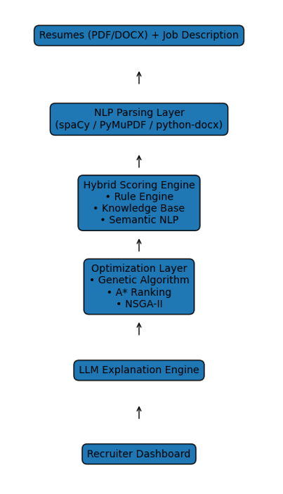

6. Timeline & Milestones
- Week 1: Requirements gathering and system architecture design
- Week 2: Document upload interface and resume parsing APIs
- Week 3–4: Embedding generation, semantic matching, and ranking algorithms
- Week 5–6: Conversational AI interface and explanation modules
- Week 7: Cloud deployment and system testing

7. Stakeholders & Roles
Project Team (LaSSMart – NUS Institute of Systems Science MTech AI Systems):
Responsible for system design, development, and testing.
Team composition :
Stalin- A454545
Sangeeta – A54545
Esshwaran – A2328302
Lakshmi Barthwal Chamoli – A232323
HR Users / Recruiters: Primary users benefiting from automated candidate screening.
Institutional Advisors: Provide academic and industry guidance.

8. Additional Notes
Tech Stack - FastAPI backend, React frontend, LangChain orchestration, and vector databases.
Risks: Resume format inconsistencies, data privacy concerns, and bias mitigation.
Future Extensions: AI interview assistants, multilingual resume analysis, bias detection, and enterprise HR system integrations.

9. Summary
RecruitIQ.ai aims to revolutionize recruitment through AI‑driven resume screening, semantic candidate matching, explainable ranking, and natural language interaction. The platform reduces manual effort while improving fairness and hiring efficiency.

