PROJECT PROPOSAL

Date of proposal:15-Sep-2026
Project Title: Video2Knowledge: A Multimodal Pattern Recognition Framework for Screen Activity Understanding and Knowledge Extraction.
Group ID (As Enrolled in Canvas Class Groups): Practice Project Group (PT& Stackable) 21
Group Members (name, Student ID):
1. Lakshmi Barthwal Chamoli (A0340664E)
2. Yuan Zilin (A0283899Y)
3. Stalin Sagayaraj (A0340115X)
4. Muthaiah Muneeswaran (A0019650J)

Sponsor/Client: (Company Name, Address and Contact Name, Email, if any)
Academic Project — NUS M.Tech in Artificial Intelligence Systems, Pattern Recognition Systems Module (Semester 2, 2026)

Background:
Organizations increasingly use screen recordings to capture software engineering and computer operational activities such as application usage, development tasks, deployments, CI/CD execution, infrastructure operations, and troubleshooting sessions. These recordings contain valuable operational knowledge but are difficult to search, analyze, and reuse because the information is embedded within visual interfaces, terminal windows, commands, logs, application states, and sequences of user interactions.
Existing techniques such as OCR, UI/object detection, and visual feature extraction can capture individual pieces of information from screen recordings, but these signals alone may not reliably determine the actual activity, execution state, outcome, or broader workflow being performed. Manual conversion of lengthy screen recordings into structured SOPs, runbooks, and training material is time-consuming and difficult to maintain.
Video2Knowledge addresses this challenge through multimodal pattern recognition that combines visual, OCR/text, UI/application, command/log, interaction, and temporal evidence to recognize activities and reconstruct higher-level workflows from screen recordings.
Aim:
The aim of Video2Knowledge is to develop and evaluate a multimodal pattern-recognition framework that recognizes software and computer operational activities from screen recordings by combining visual, OCR/text, UI/application, command/log, interaction, and temporal evidence. The recognized activities will subsequently be analyzed as temporal sequences to identify higher-level workflows and generate reusable structured knowledge such as SOPs and runbooks.
Objectives
- Develop a robust pipeline for processing screen-recorded software and computer operational activities.
- Extract multimodal visual, OCR/text, UI/application, command/log, interaction, and temporal features.
- Establish reliable activity labels using available dataset annotations, systematic label mapping, confidence assessment, and human validation where required.
- Compare classical ML and deep-learning approaches for operational activity recognition.
- Evaluate voting, stacking, and multimodal late-fusion techniques.
- Analyze sequences of recognized activities using temporal models to identify higher-level workflow patterns.
- Evaluate model effectiveness using quantitative metrics, cross-validation, confusion matrices, feature analysis, and multimodal ablation studies.
- Transform recognized workflows into structured SOPs, runbooks, and searchable reusable knowledge.
Project Descriptions:
Problem Statement:
A major challenge is that individual visual or textual observations do not provide sufficient context to determine the actual activity being performed. For example, OCR may identify a command displayed in a terminal, but it cannot by itself determine whether the command was merely typed, actually executed, or executed successfully or unsuccessfully. Similarly, identifying an application or UI element does not necessarily indicate the user's activity or its outcome. The temporal relationship between successive activities is also essential for recognizing a higher-level workflow.
Therefore, the core pattern-recognition challenge is to combine visual, OCR/text, UI/application, command/log, interaction, and temporal evidence to reliably recognize operational activities and their outcomes, and subsequently model sequences of recognized activities to identify higher-level workflow patterns.

This project addresses this problem through Video2Knowledge, a multimodal pattern-recognition system that transforms unstructured screen recordings into structured activity and workflow knowledge, which can subsequently be used to generate reusable documentation and organizational knowledge.
High Level:
Automatically capture and reconstruct how an engineer performs a technical operation, and convert the screen recording into a validated, step-by-step workflow that another engineer can reuse.
Illustrative target use case: DevOps / Production Deployment Knowledge Capture
Imagine a senior engineer performs a production deployment and records their screen.
Potential Applications:
The primary focus of the project is activity and workflow recognition from software/computer screen recordings. The recognized workflows can subsequently support applications such as the following:
Use case | What the engineer does | What Video2Knowledge produces | Value
1. Deployment Runbook Generation | Performs application deployment | Step-by-step deployment SOP | Reuse deployment knowledge
2. Debugging Knowledge Capture | Reproduces and fixes a software bug | Debugging procedure + commands + outcome | Captures expert debugging techniques
3. Developer Onboarding | Senior engineer demonstrates development process | Interactive onboarding guide | New engineers learn faster
4. SOP / Runbook Maintenance | Engineer performs an existing procedure differently | Updated workflow/documentation | Keeps operational documentation current
5. Audit & Compliance Evidence | Performs controlled operational activity | Timestamped activity trail | Easier audit evidence and process verification
6. Technical Training Material | Engineer demonstrates a task | Automatically generated tutorial | Reduces manual content creation

Proposed Solution:
Video2Knowledge proposes an AI-powered multimodal system that converts recorded software operational screen activities into structured, reusable workflow knowledge and documentation.
The proposed solution combines video processing, multimodal evidence extraction, feature representation, pattern recognition, ensemble learning, and temporal workflow analysis.
Solution flow:
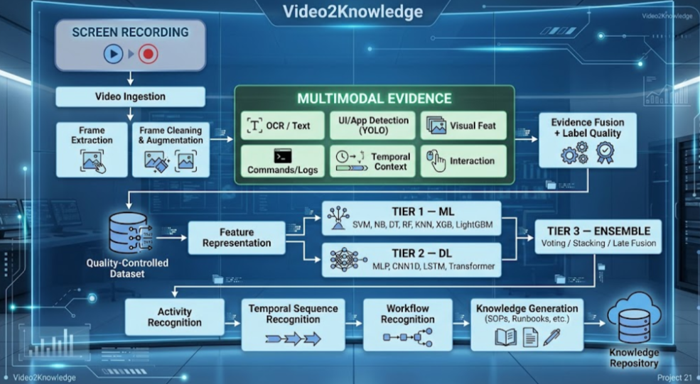
Figure 1.
The proposed Video2Knowledge system will automatically transform screen recordings of software operational activities into structured and reusable workflow knowledge.
The system will process recorded videos through frame extraction, cleaning, augmentation, multimodal evidence extraction, evidence fusion, and label validation. Visual, OCR/text, UI/application, command/log, interaction, and temporal evidence will be used to construct multimodal feature representations. A three-tier classification architecture will then evaluate classical machine-learning models, deep-learning models, and ensemble/fusion approaches for software operational activity recognition. Recognized activities will subsequently be analyzed as temporal sequences to identify higher-level workflows such as software development, debugging, deployment, and other computer operational processes. DevOps and software engineering knowledge capture represent important target applications of the proposed framework. Finally, the recognized workflows will be transformed into structured SOPs, runbooks, and searchable organizational knowledge, enabling other engineers to reuse established technical procedures without relying solely on lengthy screen recordings
Technology Stack:
Stack:Layer | Technology | Purpose
Programming Language | Python | Core AI/ML pipeline and backend
Video Processing | OpenCV | Video ingestion, frame extraction, preprocessing
OCR | Tesseract / EasyOCR | Extract text, commands, logs and UI text
UI/Object Detection | YOLO | Detect applications, UI elements and screen objects
Data Augmentation | Albumentations / OpenCV | Brightness, contrast, crop, noise, blur, compression, layout variations
Feature Engineering | NumPy, Pandas, scikit-learn | Feature extraction, encoding, scaling and dataset preparation
Classical ML — Tier 1 | scikit-learn | SVM, Naive Bayes, Decision Tree, Random Forest, KNN
Boosting — Tier 1 | XGBoost, LightGBM | Gradient-boosting classifiers
Deep Learning — Tier 2 | PyTorch | MLP, CNN1D, LSTM and Transformer
Ensemble — Tier 3 | scikit-learn / PyTorch | Voting, stacking and late fusion
Experiment Tracking | MLflow | Track models, parameters, metrics and experiments
Backend/API | FastAPI | Upload videos, trigger processing, retrieve predictions/results
Database | PostgreSQL | Store video metadata, activities, workflows and generated knowledge
Vector Search | pgvector | Semantic search over generated knowledge/documentation
Knowledge Generation | LLM API / local LLM | Convert recognized workflows into SOPs/runbooks
Frontend | React | Dashboard for workflows, predictions and documentation
Containerization | Docker | Package application and ML services
Version Control | Git + GitHub | Source code and collaboration

Team Responsibilities:
Member | Role |  | Scope
Lakshmi Barthwal Chamoli | Infrastructure + Data + CI/CD |  | AWS infrastructure, video upload, OCR, SVM, Naive Bayes, temporal sequence dataset preparation/evaluation and workflow-sequence analysis.
Yuan Zilin | Frontend + UI/UX |  | React dashboard, workflow visualization, ground truth dataset collection, evaluation, MLP, CNN1D, Voting
Stalin Sagayaraj | Preprocessing + Feature Extraction | Docker, video ingestion, YOLO, LSTM/Transformer model development
Muthaiah Muneeswaran | Backend + Pattern Recognition | FastAPI, multi-tier classifier, Decision Tree, Random Forest, Multimodal Late Fusion, CI/CD, monitoring

Pattern Recognition Techniques Coverage:

1. Classical / Statistical Pattern Recognition
These are the techniques represented in Tier 1:
- SVM — Support Vector Machine
- Naive Bayes
- Decision Tree
- Random Forest
- KNN — K-Nearest Neighbours
- XGBoost
- LightGBM

2. Neural / Deep Learning Pattern Recognition
Tier 2 contains:
- MLP — Multilayer Perceptron
- CNN1D — One-Dimensional Convolutional Neural Network
- LSTM — Long Short-Term Memory
- Transformer

Technique | Particularly useful for
MLP | Non-linear relationships among engineered features
CNN1D | CNN1D is applied to sequential multimodal feature representations rather than directly to raw video frames.
LSTM | Temporal dependencies and activity sequences
Transformer | Long-range relationships and sequence context

3. Ensemble Pattern Recognition
Tier 3 uses:
- Voting
  - Hard voting
  - Soft voting
- Stacking
  - Base classifiers → Meta-learner
- Multimodal Late Fusion
  - Combine predictions/representations from different modalities

4. Pattern Recognition for Temporal Sequences
We have
Frame → Activity
but ultimately want:
Activity₁ → Activity₂ → Activity₃ → ... → Activityₙ
↓
Workflow Pattern
LSTM and Transformer are used to model temporal dependencies and sequence context for workflow recognition.
Overall Pattern Recognition landscape is:
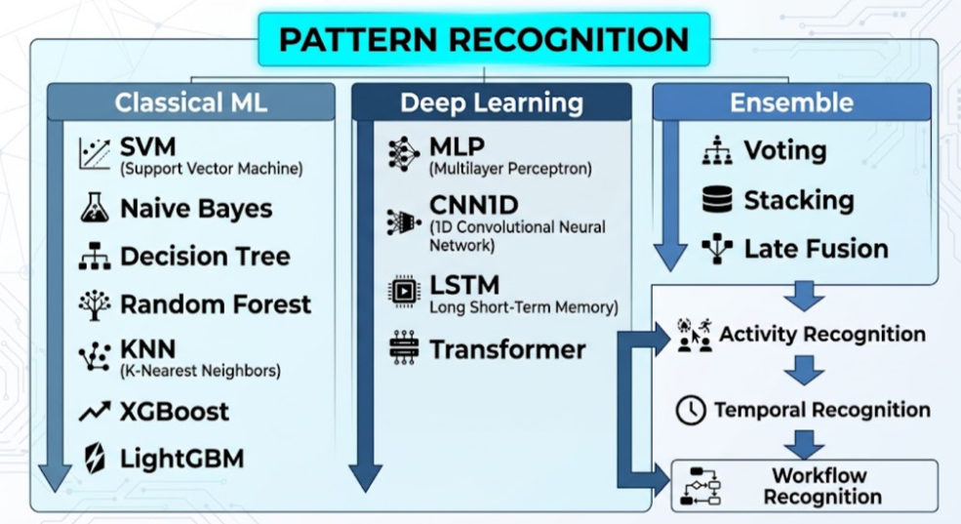
Figure 2.
OCR, YOLO/UI detection, feature extraction, and LLM generation are supporting technologies—not themselves the main pattern-recognition techniques being evaluated in your classifier comparison.

Expected Deliverables
- Screen Video Processing Pipeline – video ingestion, frame extraction, cleaning, and data augmentation.
- Multimodal Evidence Extraction – visual, OCR/text, UI/application, command/log, interaction, and temporal evidence.
- Quality-Controlled Dataset – dataset annotation mapping, confidence checking, and human-in-the-loop validation where required.
- Feature Representation Pipeline – representation and integration of visual, OCR/text, UI/application, command/log, interaction, and temporal features.
- Multi-Tier Pattern Recognition Models – Tier 1 classical ML, Tier 2 deep learning, and Tier 3 ensemble/fusion models.
- Model Evaluation – accuracy, macro- and weighted-averaged precision, recall, and F1-score, per-class metrics, confusion matrices, multiclass ROC-AUC where applicable, cross-validation, feature importance/interpretability where supported, and multimodal ablation studies.
- Temporal Workflow Recognition – identification of higher-level workflows from sequences of recognized activities.
- Automated Knowledge Generation – generation of SOPs, runbooks, troubleshooting guides, and workflow summaries.
- Knowledge Repository / Dashboard – searchable workflows, activities, timestamps, and generated documentation.
- Final Project Artifacts – source code, dataset documentation, trained models, project report, presentation, README, and demonstration video.
- To prevent data leakage, dataset splitting and cross-validation will be performed at the task/video level rather than at the individual frame or segment level, ensuring that observations originating from the same recording do not appear across training and evaluation partitions.
Source:
ServiceNow VideoCUA, part of CUA-Suite (MIT license) — expert human demonstrations of desktop tasks, recorded as continuous 30 fps video with millisecond-level action logs. This project uses a locally prepared subset of 70 of the 87 applications: 7,021 tasks, 6,991 videos, 50,651 logged action segments, and approximately 26 hours of interaction time (48 GB).
Automatic labelling: Task-level labels come from mapping each application to a broader activity category, such as software development, document editing, or web browsing. Segment-level labels come directly from the action logs, grouped into four interaction types: pointer movement, click, keyboard input, and drag. Each task's natural-language instruction and logged action sequence provide reference information for evaluating generated workflow summaries/SOPs and retrieval.
Level 1 — Interaction Evidence
Examples:
Pointer movement / Click / Keyboard input / Drag
These are observable interaction signals.
↓
Level 2 — Activity Recognition
Use multimodal evidence:
Visual + OCR/Text + UI/Application + Command/Log + Interaction + Temporal
to recognize the activity/task category.
↓
Level 3 — Workflow Recognition
Recognized activity sequence:
Activity₁ → Activity₂ → Activity₃ → ... → Activityₙ
↓
Workflow Pattern
Level 1 interaction annotations are used as one source of multimodal evidence. The primary classification task is Level 2 activity recognition, while Level 3 evaluates temporal workflow recognition.
Multimodal ablation studies will compare individual and combined evidence modalities— for example, visual-only, OCR/text-only, UI/application-only, command/log-only, interaction-only, and progressively fused multimodal representations —to quantify the contribution of each modality to recognition performance.

Data Set:
CUA-Suite: Massive Human-annotated Video Demonstrations for Computer-Use Agents

Research Question–Experiment Mapping:
RQ1: How do classical machine-learning and deep-learning approaches compare in recognizing software/computer operational activities from multimodal screen-recording features?
RQ2: Does multimodal fusion of visual, OCR/text, UI/application, command/log, interaction, and temporal evidence improve activity-recognition performance compared with individual modalities?
RQ3: To what extent can temporal sequence models such as LSTM and Transformer identify higher-level workflow patterns from sequences of recognized activities?

RQ1 → Tier 1 vs Tier 2
RQ2 → Tier 3 / Late Fusion / Ablation
RQ3 → Temporal Workflow Recognition

Acknowledgement:
Figures 1 and 2: Video2Knowledge system architecture and pattern-recognition landscape diagrams, created by the project team with generative-AI assistance.

