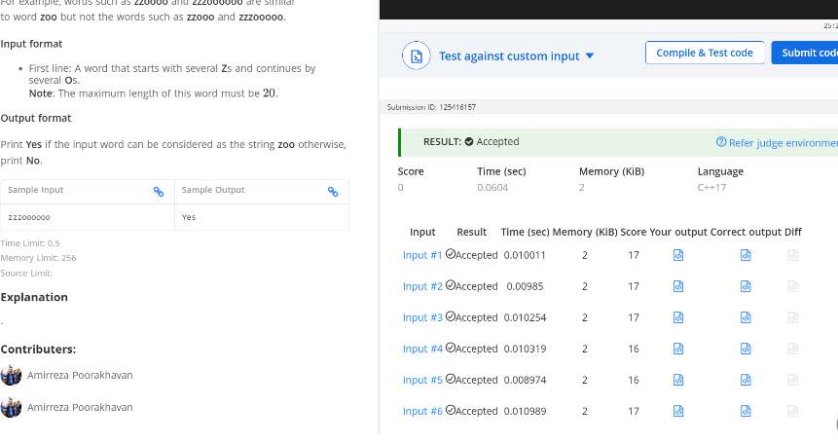
Q- Zoos
#include <iostream>
using namespace std;
int main() {
string word ;
int i;
int x=0;
int y=0;
getline(cin,word);
for(i=0;i<word.length();i++){
if (word[i]=='z'){
x++;}
if(word[i]=='o'){
y++; } }
if (2*x==y)
cout<<"Yes";
else {cout<<"No";}
return 0;
}

