Laxmi Gaudel Subedi

Info 5717(001)

Fall-2019

**Assignment-1**

URL of github repo:

https://github.com/laxmi48/http-localhost-8889-notebooks-GaudelSubedii_assignment-one-code.ipynb.git

Link to jupyter notebook :

http://localhost:8889/notebooks/GaudelSubedii_assignment-one-code.ipynb

**Question (1)**

2. screenshots of successfully python environment configuration

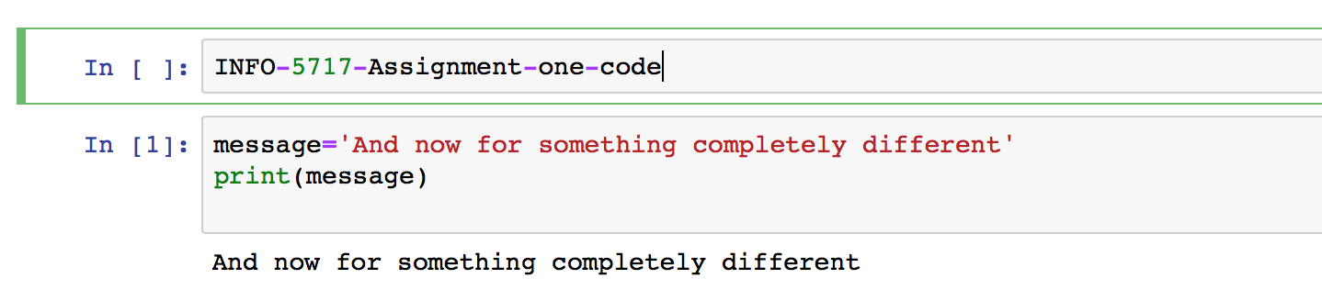

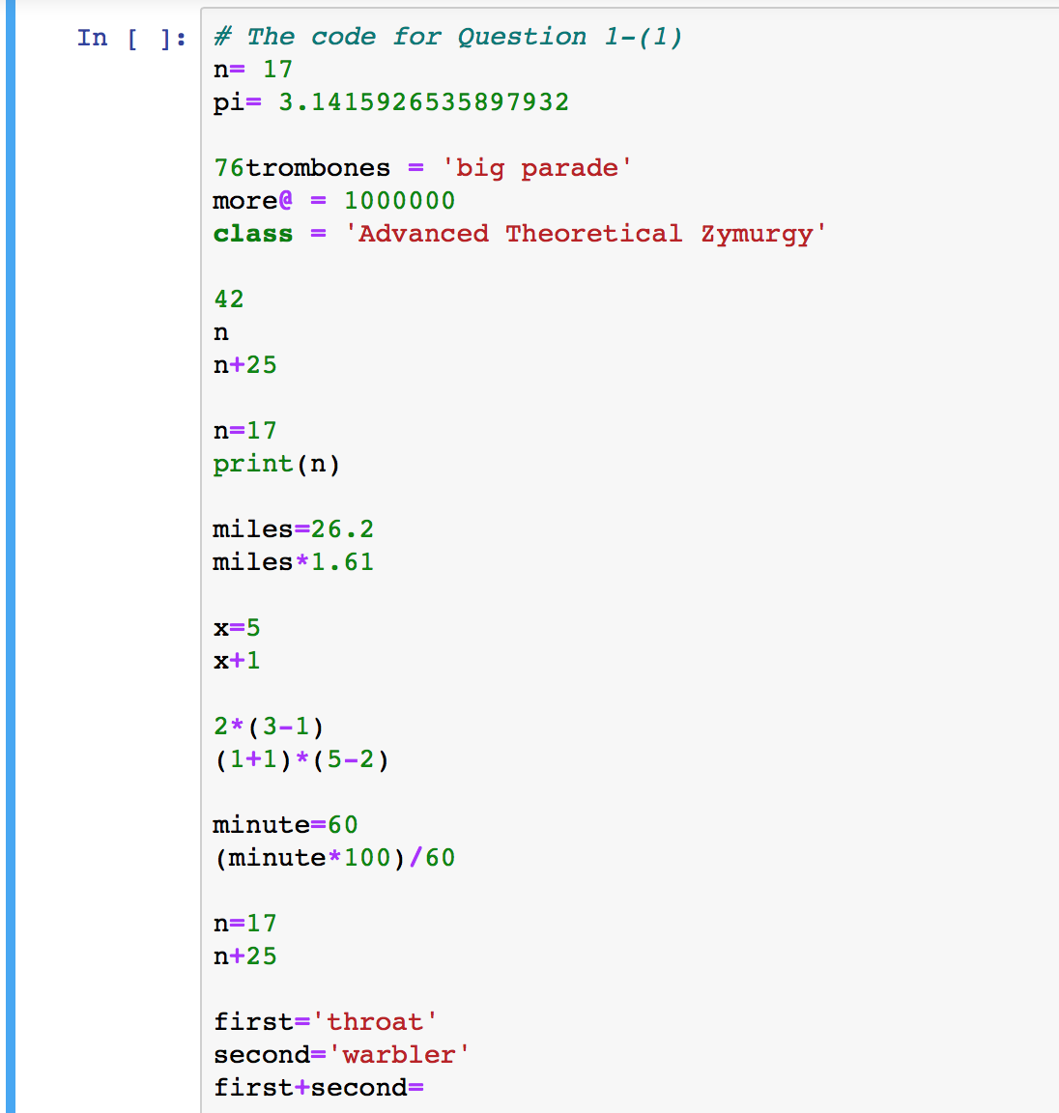

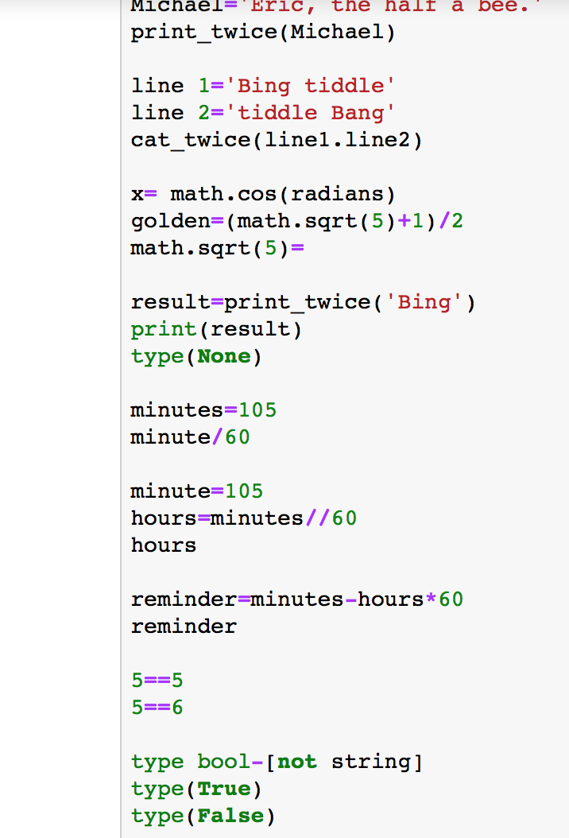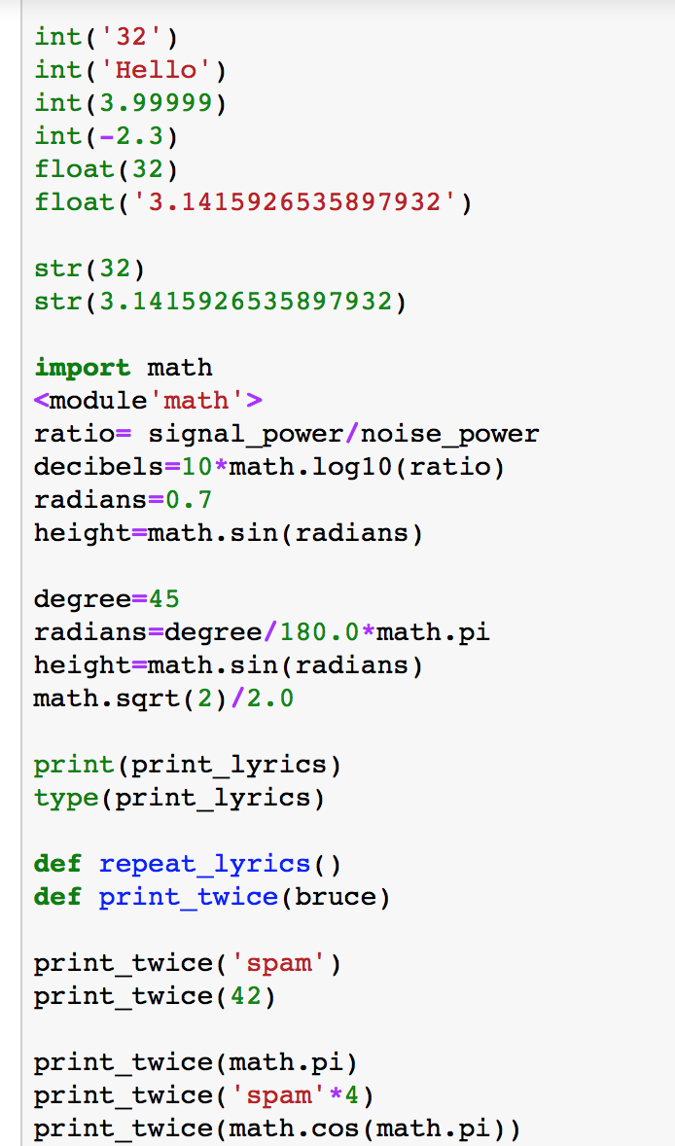



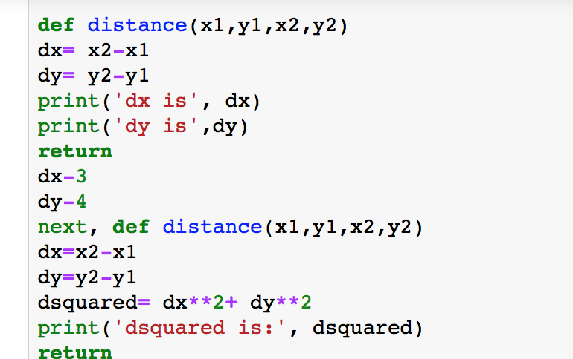

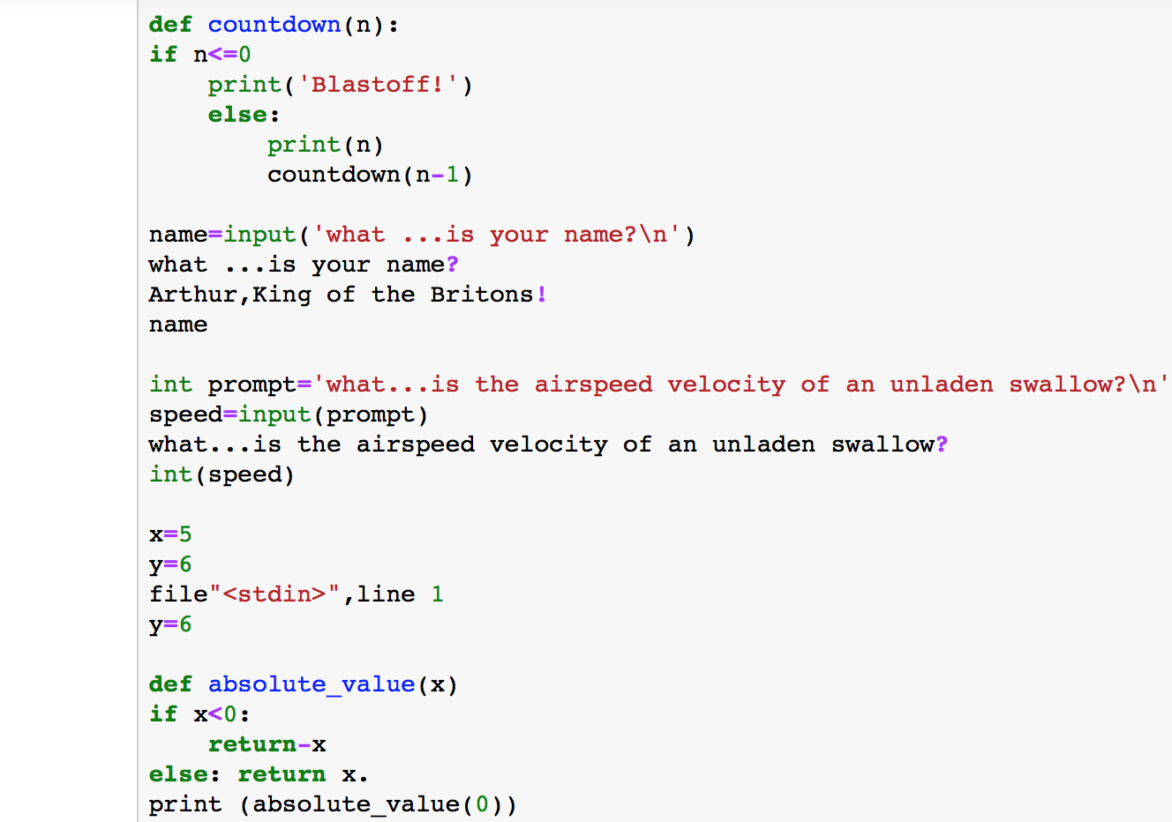



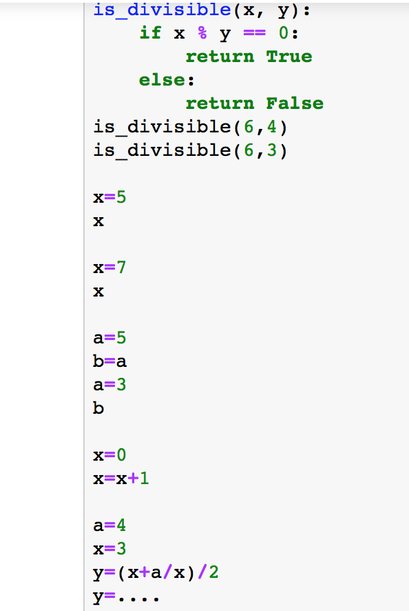

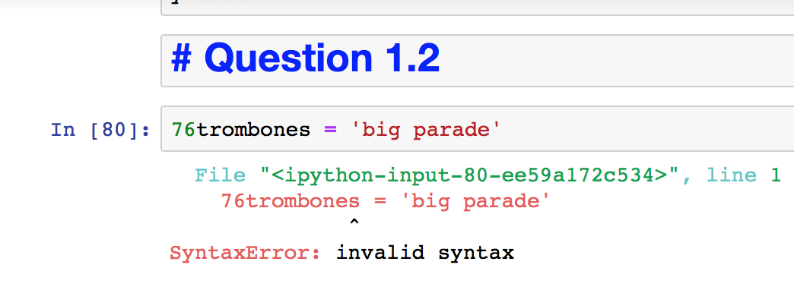

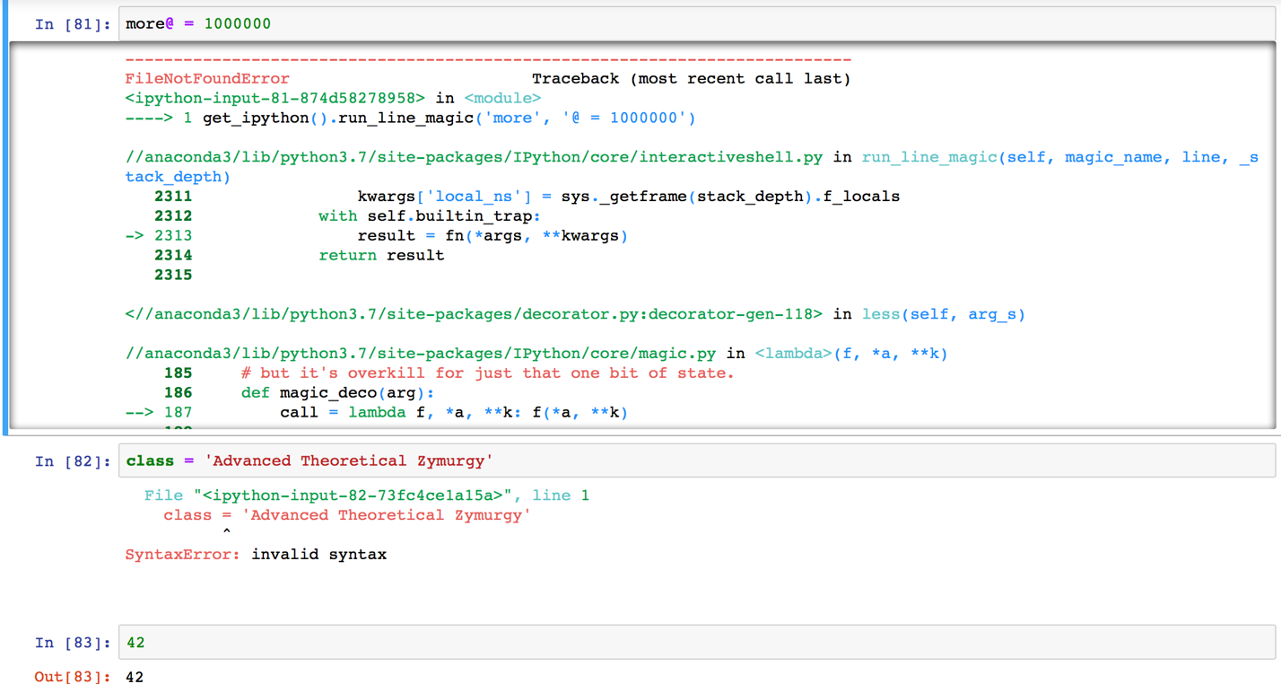

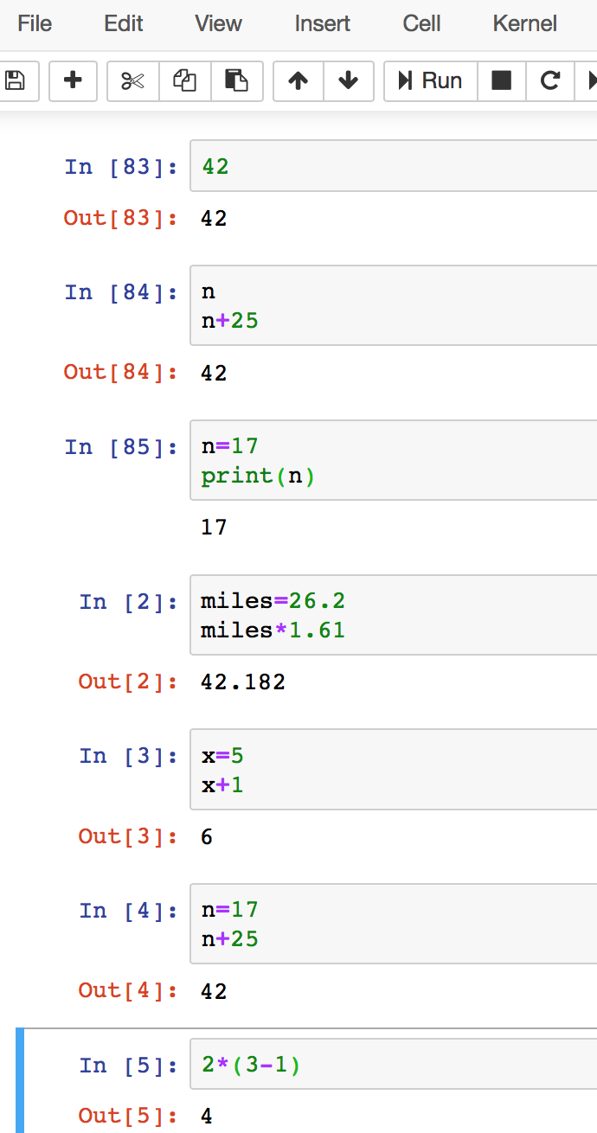

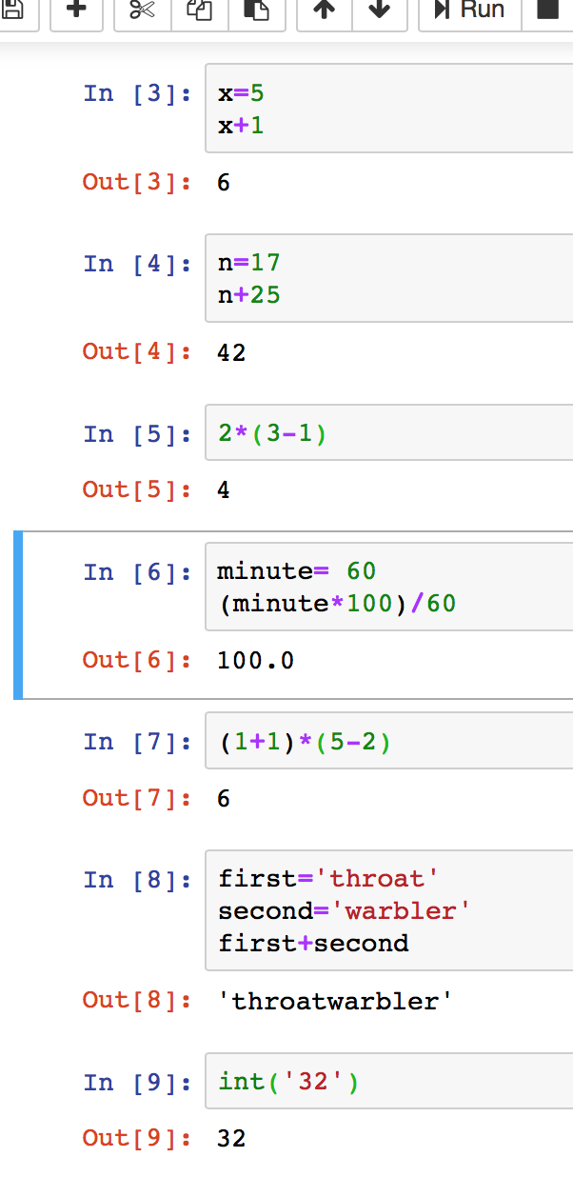

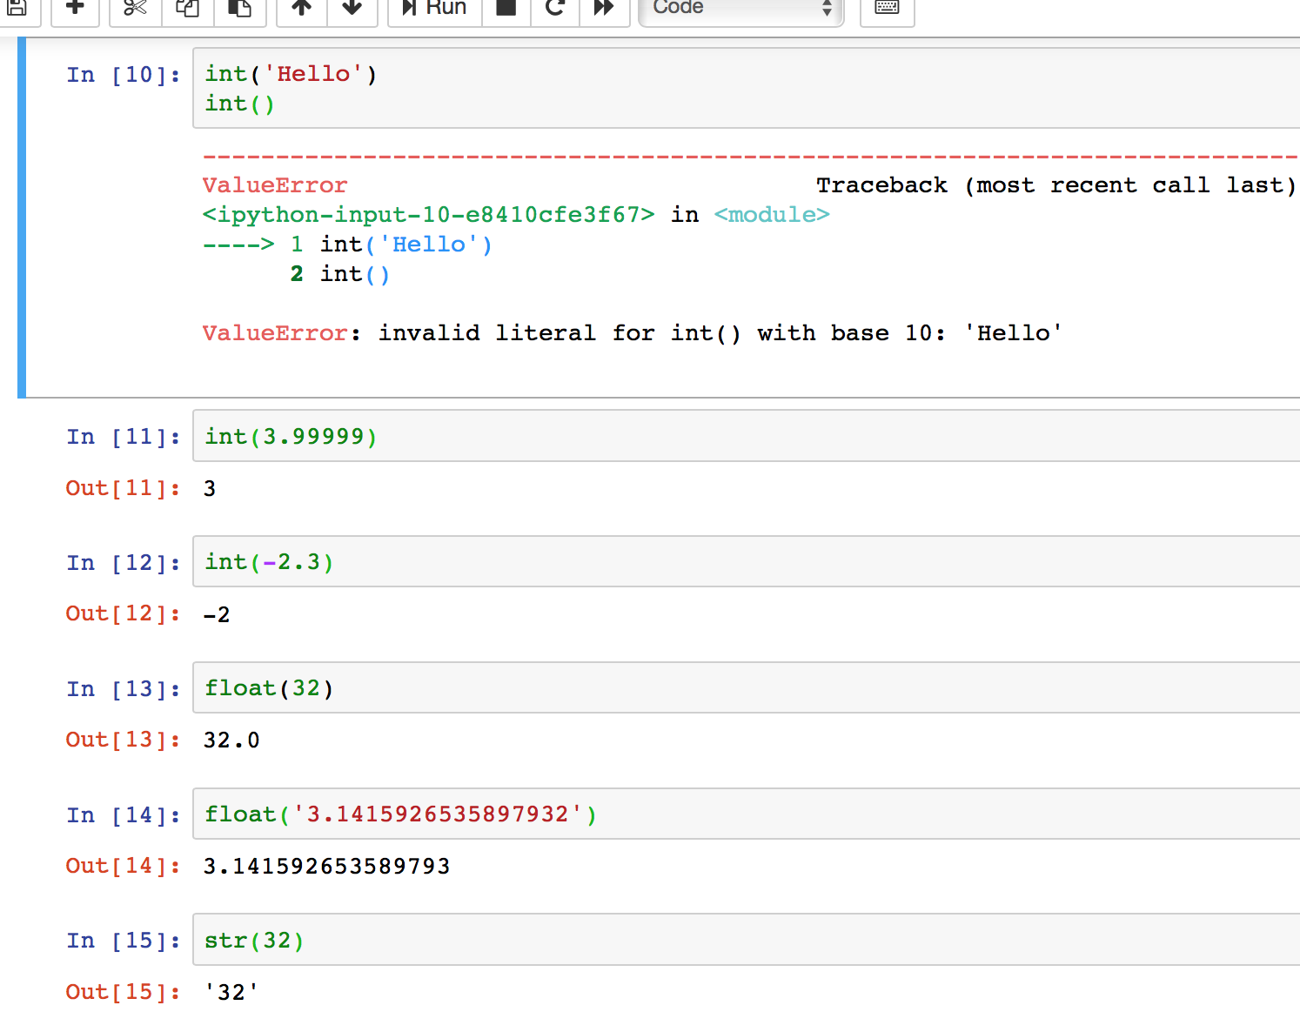

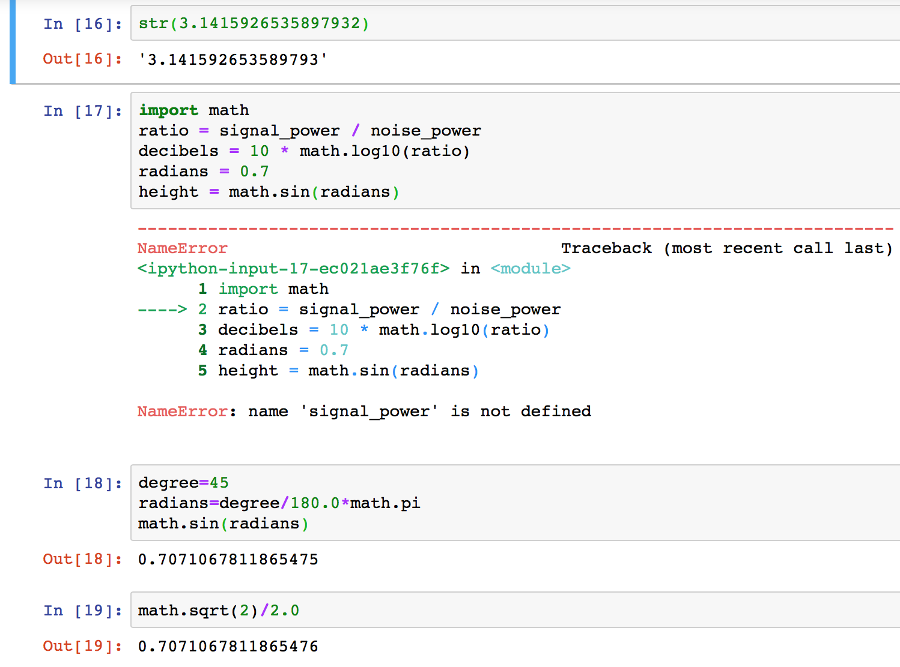

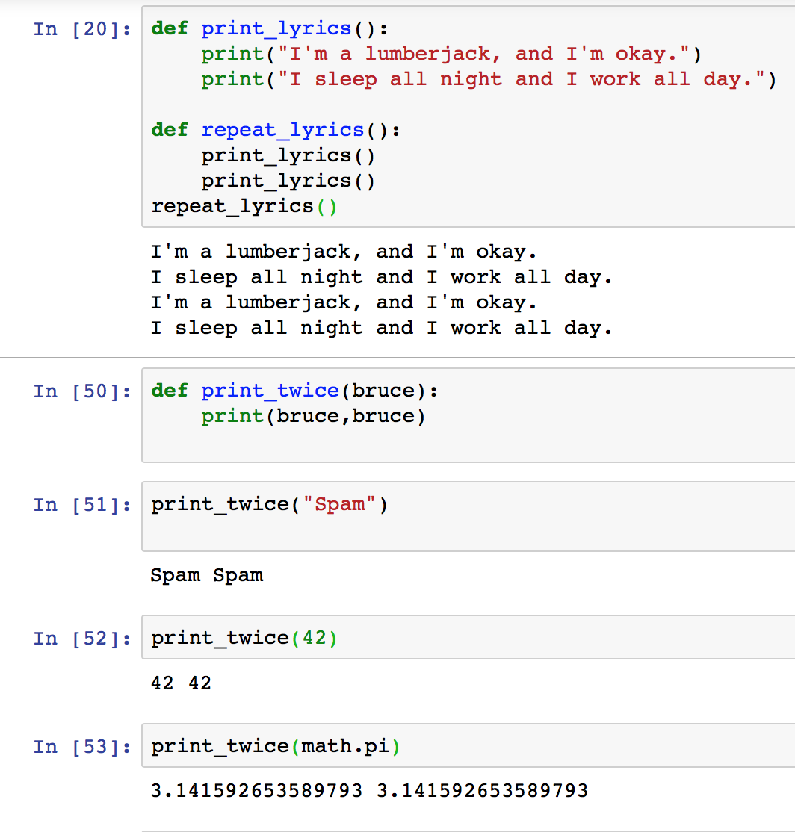

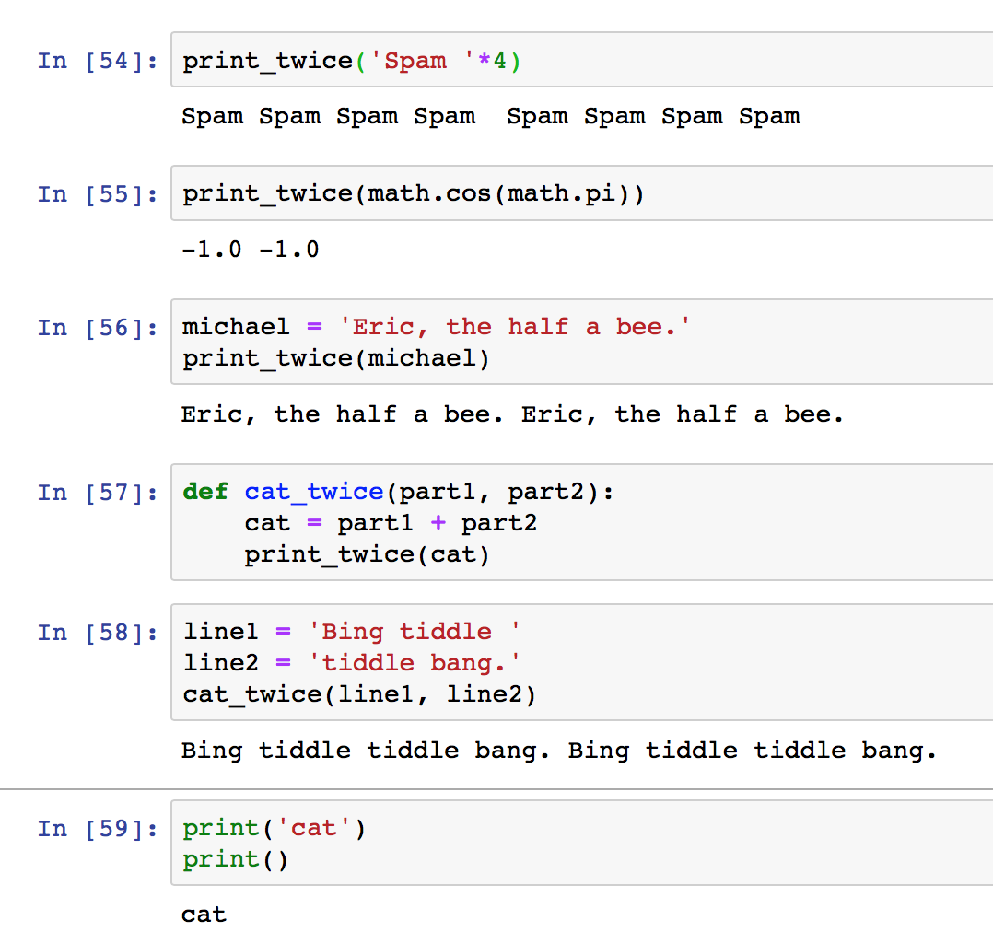

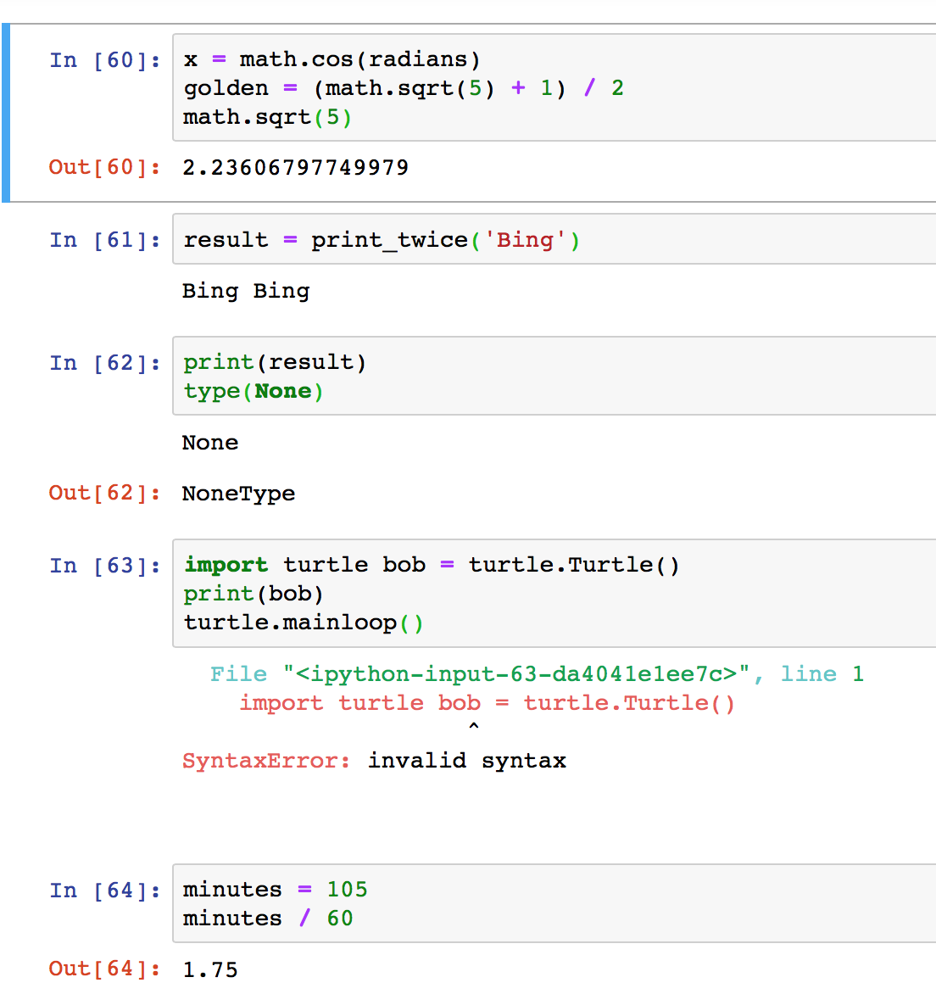

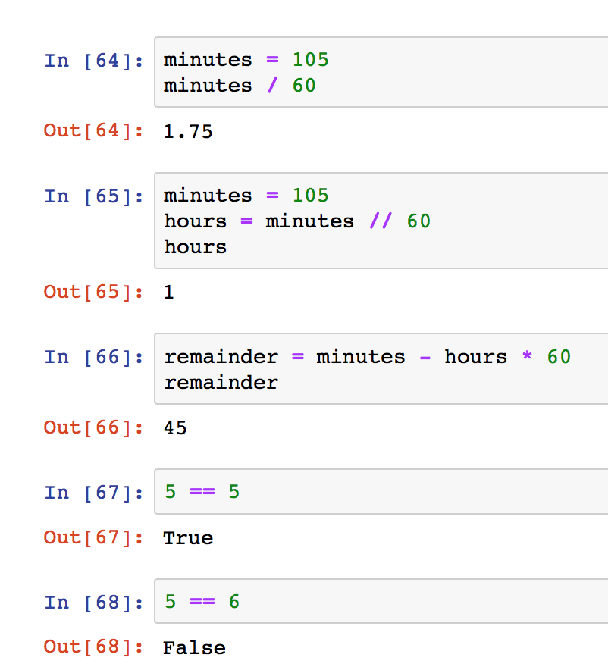

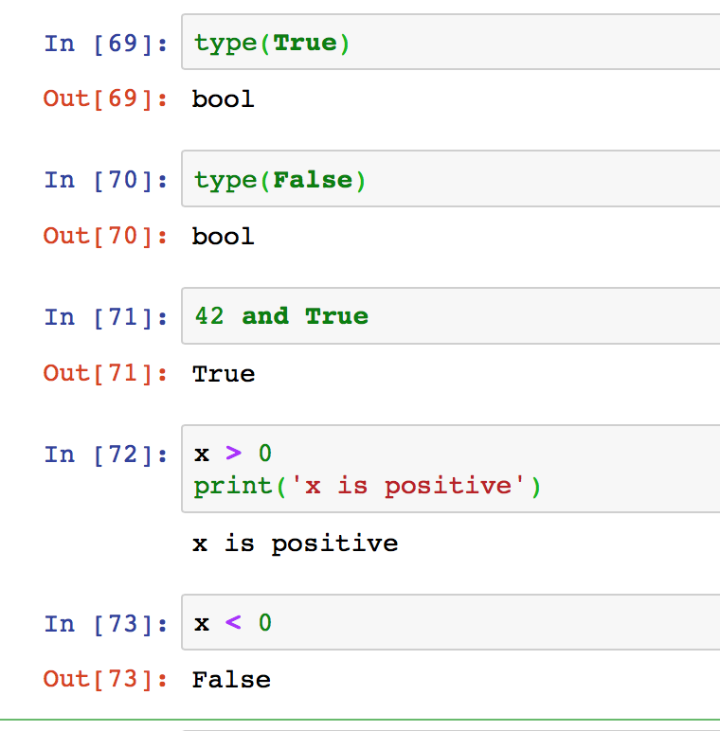

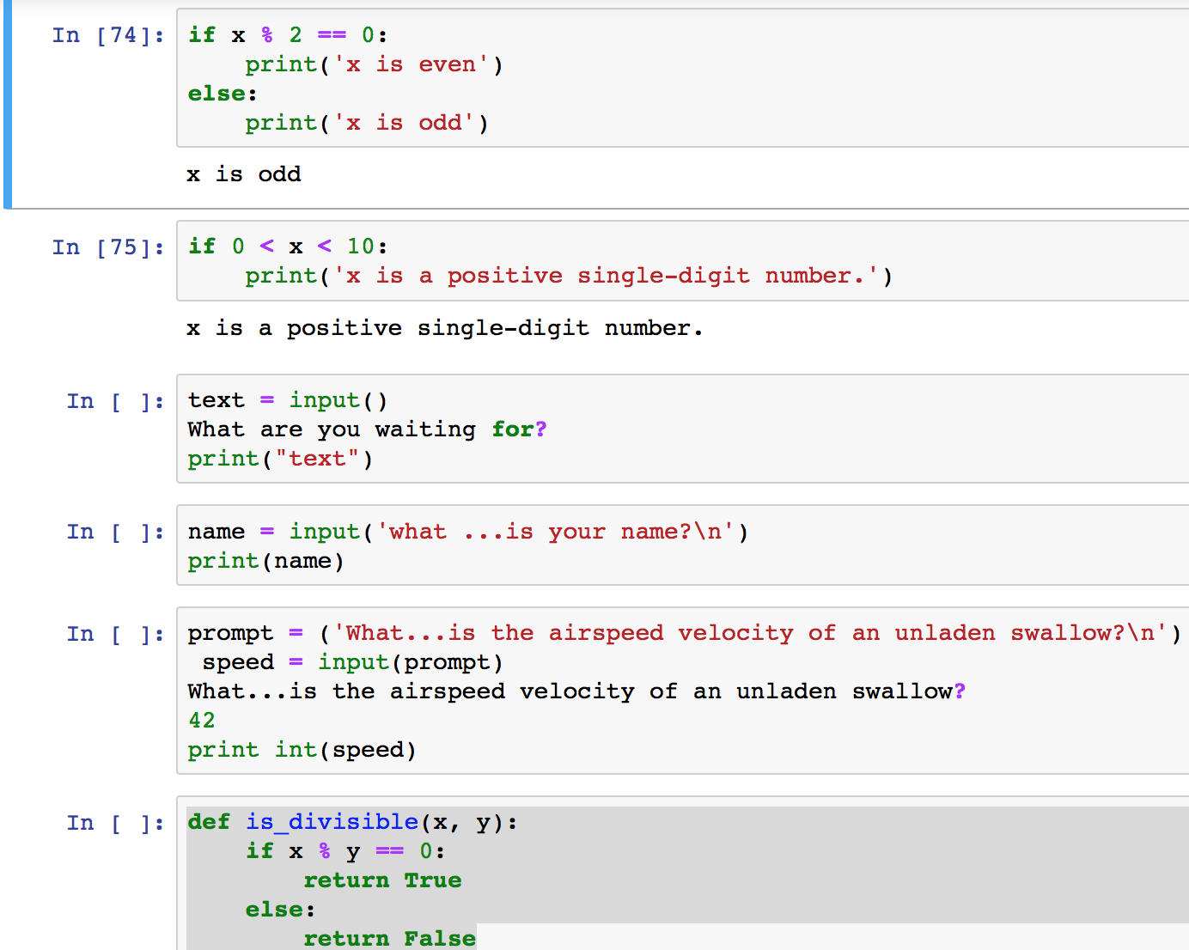

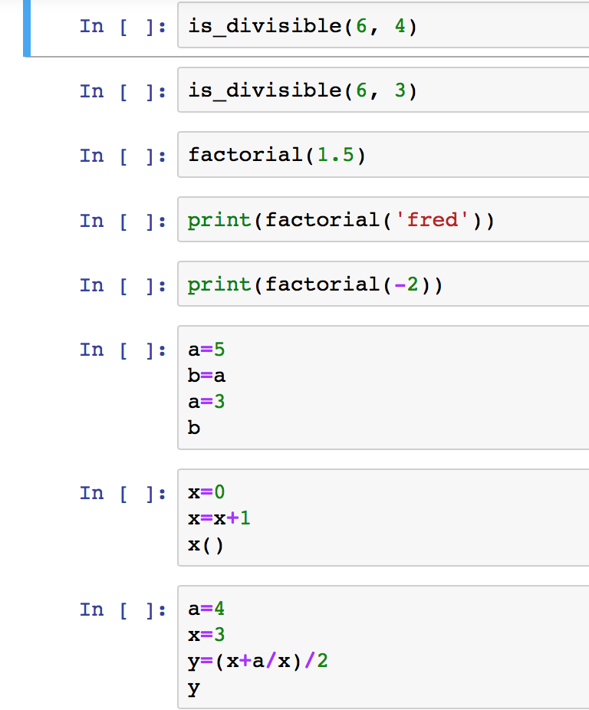

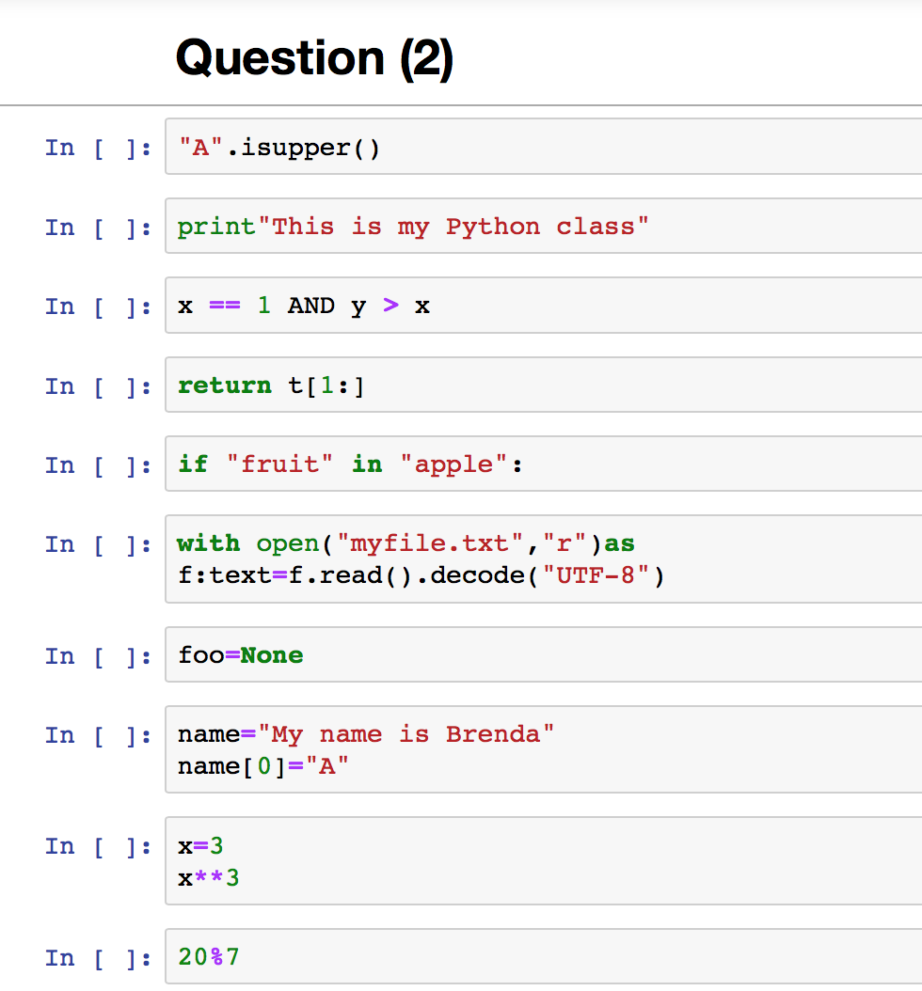

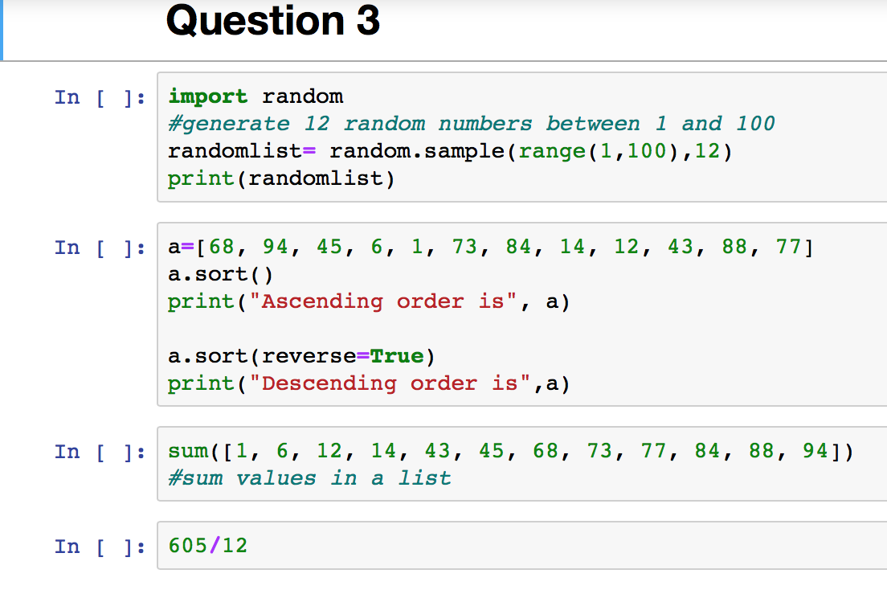

**Question (1)**

URL for the question 1

https://github.com/laxmi48/http-localhost-8889-notebooks-GaudelSubedii_assignment-one-code.ipynb.git

**Question (2)**

1. "A".isupper()- VALID .A is in upper case in the string.
2. Print "This is my Python class" -Invalid. Because parenthesis should be written in between the sentence like(“This is my Python class").
3. x == 1 AND y > x -Invalid statement. Value of "Y" is not defined .
4. return t[1:]- Invalid. The syntax return is an outside function.
5. if "fruit" in "apple":- Invalid. Syntax is not valid
6. with open("myfile.txt", "r") as f: text = f. read ().decode("UTF-8")- Invalid, because there is no such file or directory: ‘myfile.txt’
7. foo == None- Invalid. ‘foo’ is not defined here.
8. name = "My name is Brenda"

name[0] = "A" -Invalid. Because ‘str’ object doesn’t support item assignment.

1. x = 3

x**3-Valid .The exponentiation has the next highest precedence.

1. 20%7- Valid. It is a string like.