CHECKING FILES:
- Open command prompt by pressing windows + r then type cmd in it .
- Check java –version in cmd prompt, if not present then install java (above 21 bits)
- Check python –version in cmd prompt, if not present then install python (python 3.11.9)
- Download meatbase.jar file from the metabase website

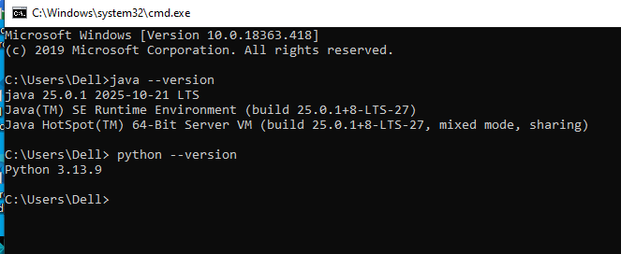

METABASE FILE RUNNING:
- After downloading meatbase.jar file -paste in the “d-drive”
- Type cmd in the d drive
- Then next type the “java -jar meatbase.jar” in the cmd prompt to run the meatbase file.
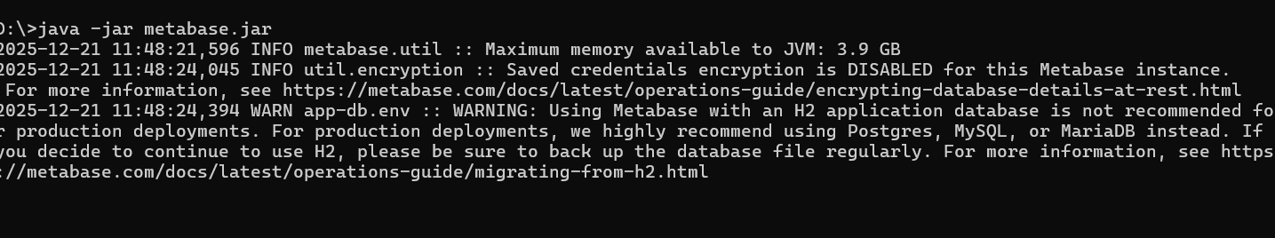
- Then open chrome type “localhost:3000” in the url

- Then one window will display

(AS SHOWN IN BELOW)

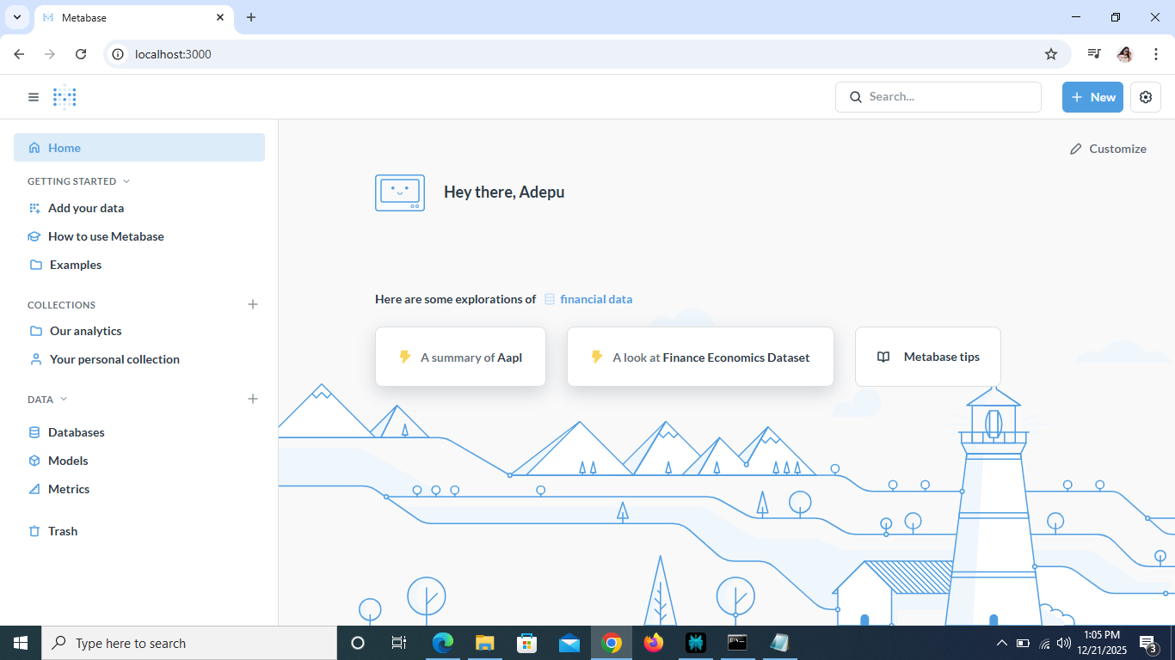

OPEN CHROME WEBSITE:
- GO TO CHROME
- THEN TYPE THE TITLE BY ADDING [FROM KAGGLE] at last
(ex:- Institutional Financial Health Monitoring & Predictive Budgeting System From Kaggle )
- Then Select Any link

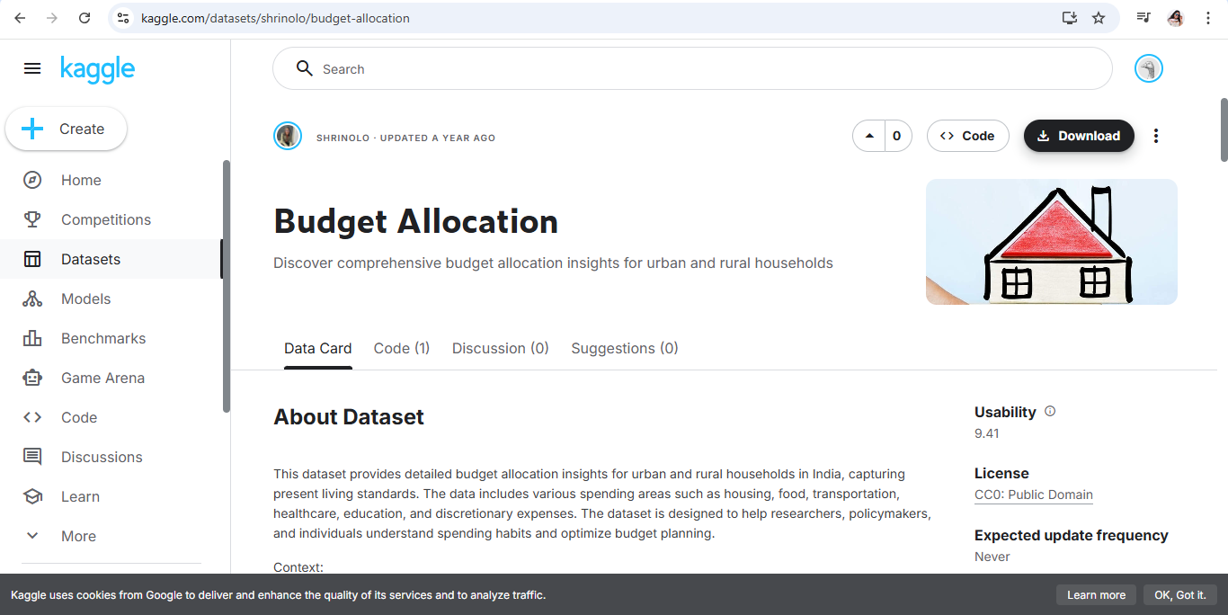
NOTE:- [MAKE SURE THAT USABILITY SHOULD BE ABOVE 8]
- Select DOWNLOAD (AS A ZIP FILE)
- Then extract the zip file in the file manager.
- BY SELECTING THE EXTRACT FILES..

- After completion of extracting the zip file then copy the file path .

(ex:- C:\Users\Dell\Downloads\archive (2))
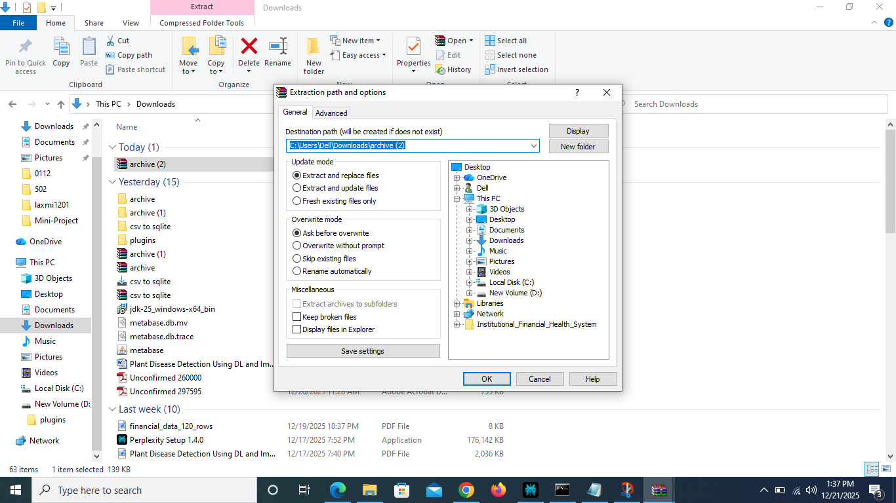
OPEN CSV FILE:
Open “CSV to SQLite Converter”
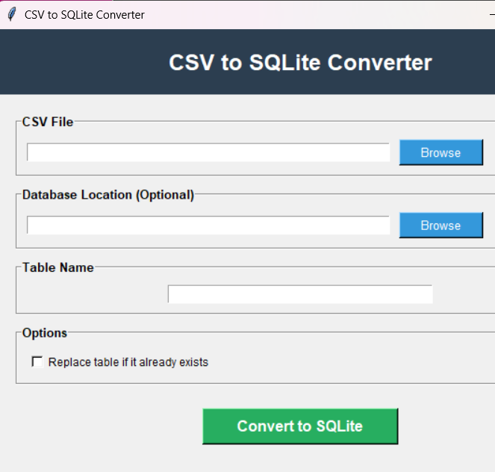

- Paste the above selected path in the CSV file
(ex:- C:\Users\Dell\Downloads\archive (2))

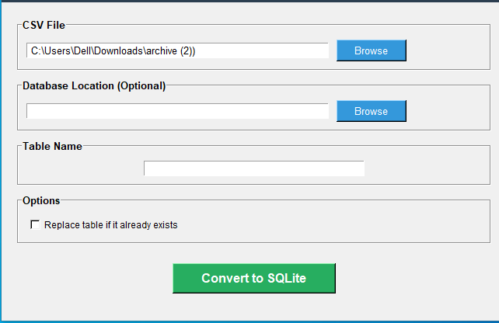

- CLICK THE BROWSE button
- THEN ONE PATH WILL ADDED TO THE ABOVE PATH into CSV FILE
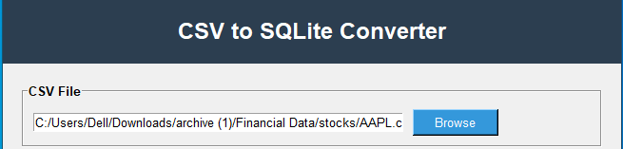
- Click convert to SQLITE
- (MESSAGE LIKE DATABASE CREATED SUCCESSFULLY)
- THEN SELECT THE DATABASE LOCATION
- THEN COPY the path of DB location
(ex- C:/Users/Dell/Downloads/archive (1)/Financial Data/stocks\database.db)

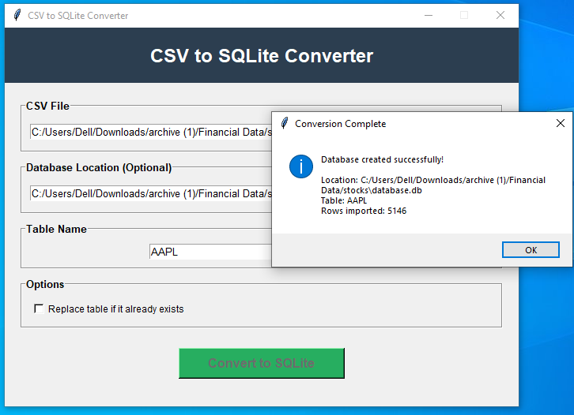

OPEN Chrome website:
- Go To Chrome
- Type in the URL below command
- http://localhost:3000/
- Then the Screen will display....
- THEN It opens the Apache Superset.
- Select the DATABASE..
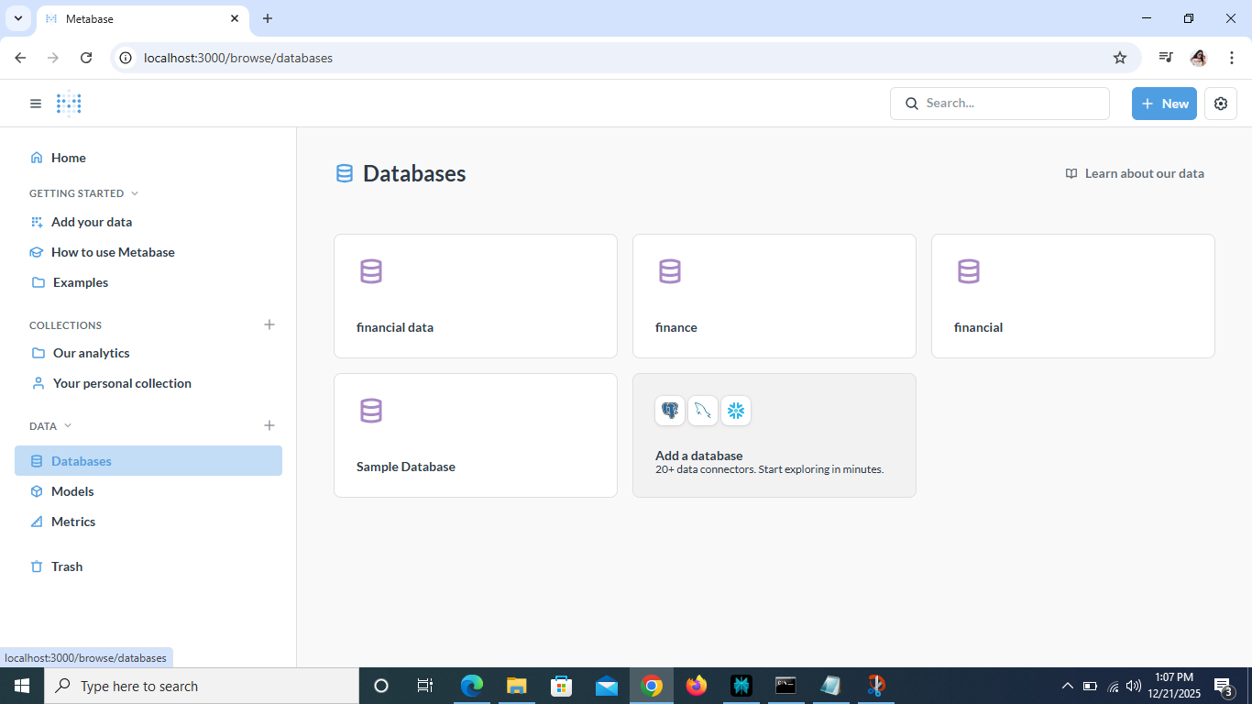
- Then CLICK Add the database
- THEN A window will Display FOR ADDING the DATABASE
- Give the DATABASE TYPE (SQLITE)
- THEN TYPE DISPLAY NAME (as you like)
(ex:- budget allocation)
- THEN FILE NAME
(as we copied above)
- (PASTE THE ABOVE COPIED FILE NAME ABOVE IN THE CVS TO SQLITE CONVERTER)
(ex:- C:/Users/Dell/Downloads/archive (1)/Financial Data/stocks\database.db)
- THEN CLICK SAVE
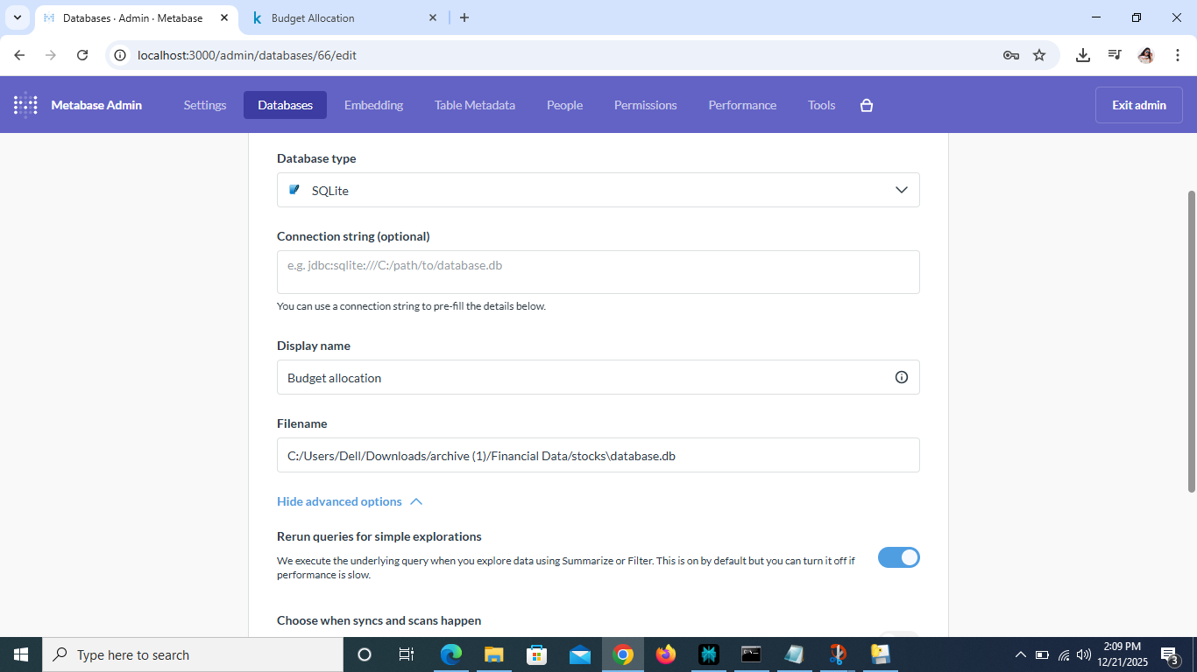

- THEN IT WILL DISPLAY THE WINDOW..
(As shown in the below)

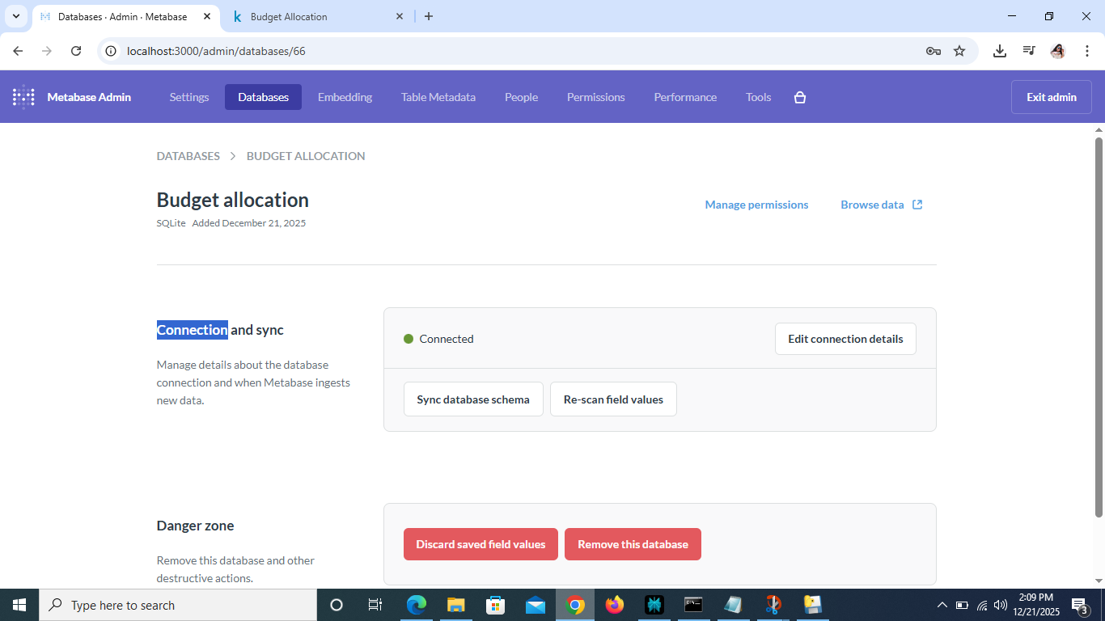

- THEN CLICK BROWSE DATA
- THEN SELECT the DATABASE
(ex:- Aapl )
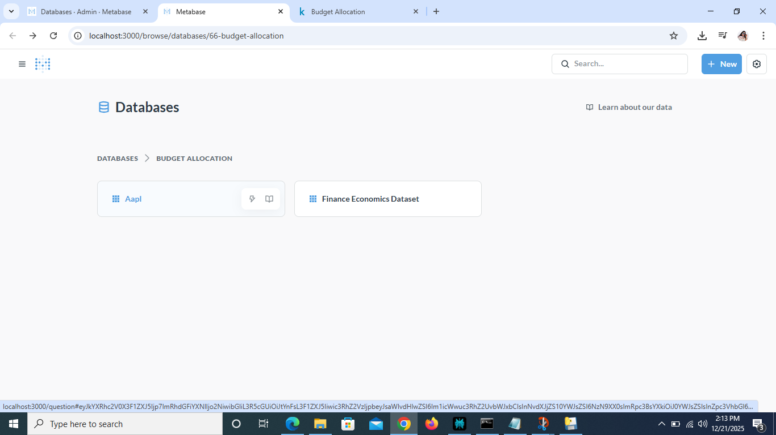

  - Then click on Aapl
  - Then select the visualization
  - Select the visualizations as you want.
  - Then select the ok
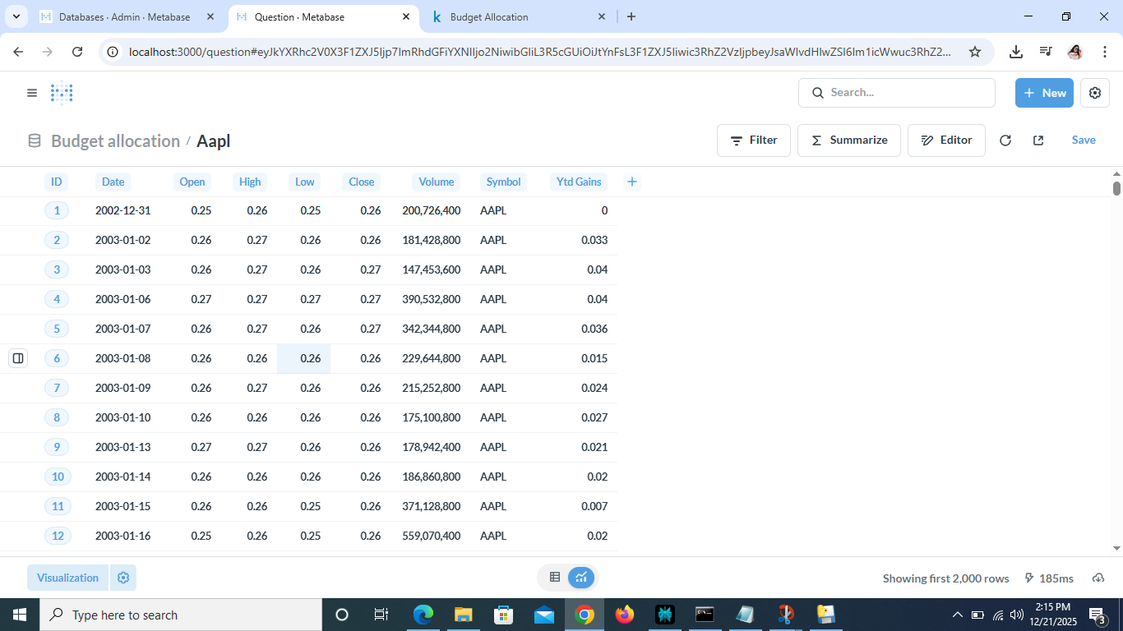

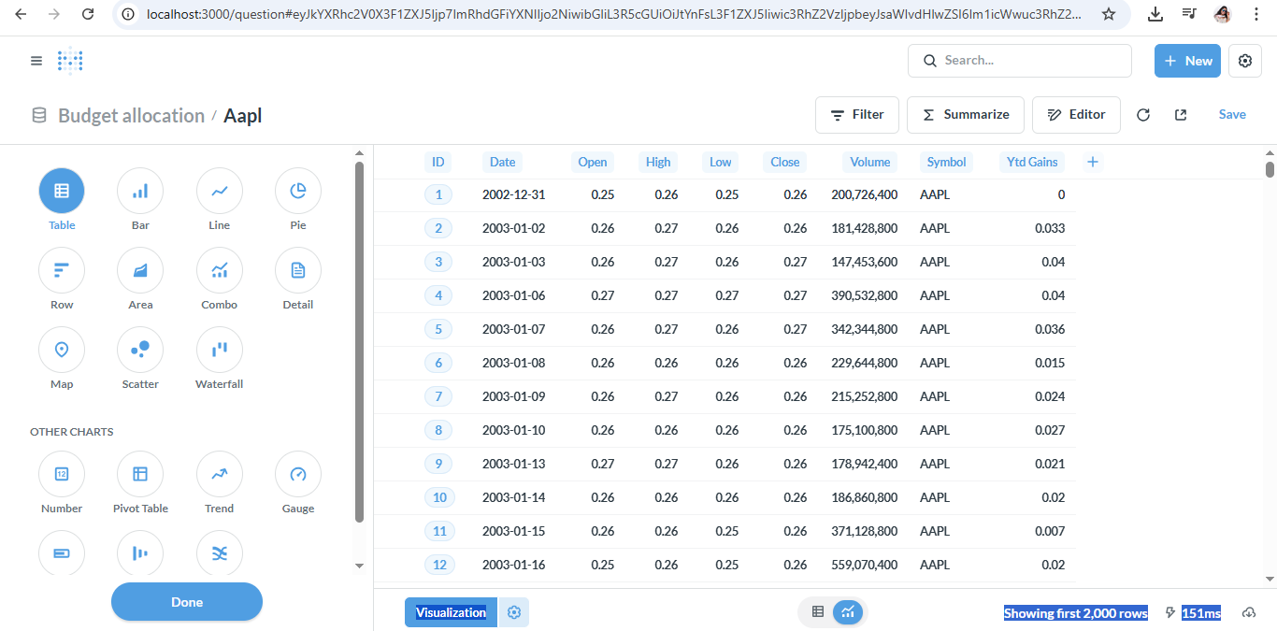
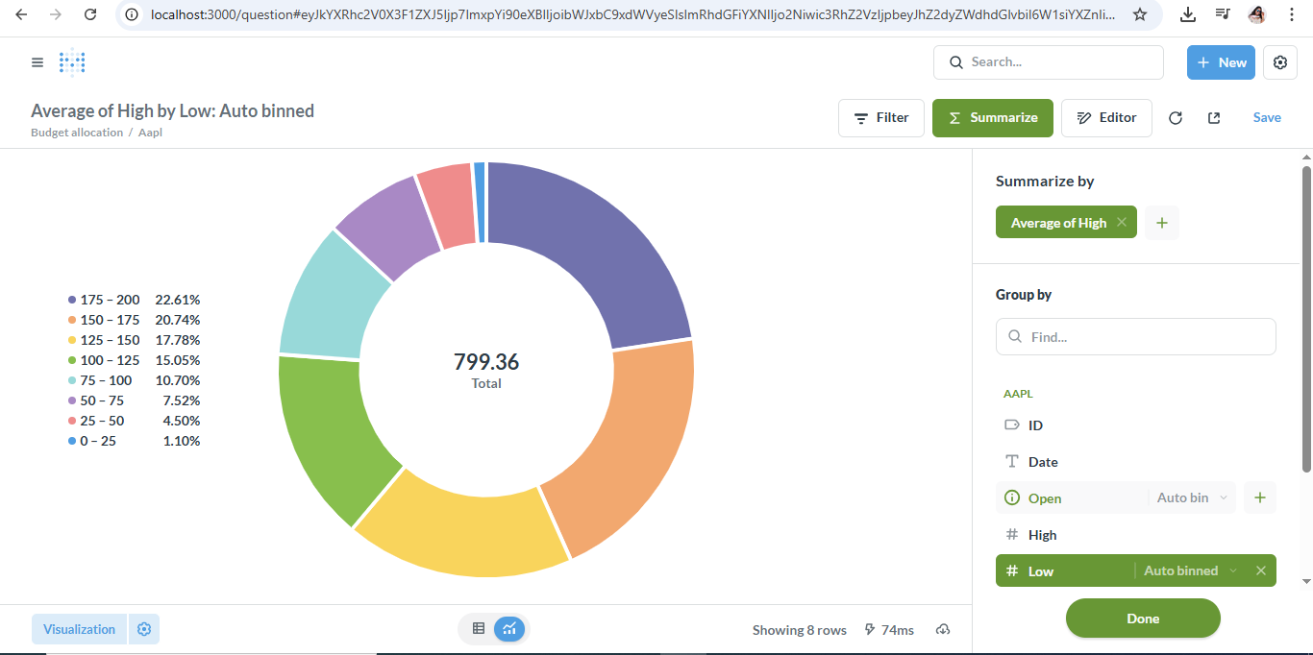

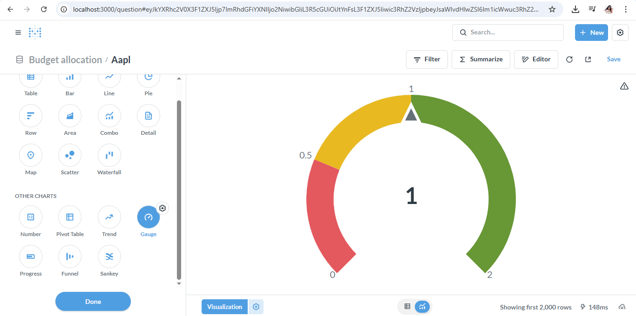

NOTE:- PERFORM ANY OPERATIONS (like visualizations) AS YOU WANT..

