
Responsible Data Analytics MSc
Fundamentals of Data and
Infrastructure
(LNDN5204)
Student full name: Laxmi bhalala Student ID: P2942610

Word Count: 3049(excluding the references and appendix)

Abstract
Unplanned readmission is a costly outcome. This is commonly utilized as an indicator of the standard of inpatient care. This report utilizes a big data analytics process on the Diabetes 130-US Hospitals dataset, which comprises a genuine collection of 101,766 inpatient encounters documented from 1999 to 2008.Apache Spark SQL is utilized to analyze the information and answer six analytical questions, and two PySpark MLlib classifiers Random Forest and Logistic Regression are then constructed and contrasted to forecast the likelihood of a patient being readmitted. With an accuracy of 64.2% and an AUC of 0.695 on the held-out test set, Random Forest outperforms Logistic Regression (61.9%, AUC 0.656) both sit within the range reported in the literature for this dataset, confirming that readmission is only moderately predictable from administrative data. The count of prior inpatient visits emerges as the single strongest predictor, accounting for 41% of the Random Forest's importance a history of admissions is the best predictor of future ones.

1. Analysing the Data with Spark SQL

1.1 Dataset Selection and Introduction
Choosing the dataset shaped everything that followed. I wanted something genuinely large, genuinely real, and connected to a problem that mattered, rather than a tidy teaching set. The
Diabetes 130-US Hospitals dataset met all three criteria. It is freely available via the UCI
Machine Learning Repository (Clore, Cios, and Strack, 2014) and has a popular mirror on Kaggle. Strack et al. (2014) assembled it from the Health Facts database. It includes 50 columns that describe 101,766 inpatient contacts over a ten-year period (1999–2008) of clinical care in 130 US institutions. Each row represents a single, one-to fourteen-day stay for a patient with a diabetes diagnosis. The administrative context (admission type, discharge disposition, source), encounter intensity (length of stay, laboratory procedures, medications and diagnoses), demographics (race, gender, age band), and diabetes-management indicators (the HbA1c result, glucose serum test, and the status of 23 individual drugs) are all included in the columns, and the outcome readmitted, which takes the values NO, >30 and <30. The thirty-day window is clinically important because it is the threshold used by reimbursement schemes such as the US Hospital Readmissions Reduction Program, so I use it as the descriptive risk metric then models readmission of any kind. The dataset also ships a companion file, IDS_mapping.csv, which decodes the numeric admission, discharge and source identifiers — a convenient set of reference tables for the SQL JOIN.
In big data terms the dataset illustrates the volume and variety challenges discussed by Dean and Ghemawat (2008): with fifty mixed-type columns, heavy missingness in some fields, and codes that only make sense after a join, it is exactly the kind of semi-messy operational data a distributed engine like Spark is designed to handle gracefully (Zaharia et al., 2016). Where such records were once consolidated into rigid, schema-on-write data warehouses, the modern stack stores them cheaply on distributed file systems such as HDFS (Shvachko et al., 2010) and applies schema-on-read at query time — the approach Spark SQL takes here.

1.2 Exploratory Data Analysis
All processing was carried out in Apache Spark 3.5.1 through PySpark, with the data loaded using schema inference. The schema itself was informative: Spark correctly typed the integer counters but left the three identifier columns as integers that are really categorical codes, and treated the age band as a string of the form [70-80). A recurring quirk of this dataset is that missing values are not stored as nulls but as the literal character '?'. I therefore swept every string column and converted '?' to a genuine null before doing anything else, so that Spark's null-aware functions would behave correctly:
string_cols = [f.name for f in df.schema.fields if isinstance(f.dataType, StringType)] for c in string_cols: df = df.withColumn(c, when(trim(col(c)) == "?", None).otherwise(col(c)))
Quantifying the missingness was sobering. The weight field is absent in 96.9% of encounters, medical_specialty in 49.1% and payer_code in 39.6%, whereas the clinically important fields are almost complete (race missing in 2.2% of rows, the primary diagnosis in only 21). This justified a pragmatic decision later: weight, payer_code and medical_specialty were excluded from the model rather than imputed, since imputing a value missing nine times out of ten invents more information than it recovers.
The three outcome classes are unbalanced: 53.9% of encounters end in no readmission, 34.9% in a later (>30 day) readmission, and only 11.2% in an early (<30 day) readmission. Collapsing the two positive classes gives a well-balanced any-readmission outcome (47.1% versus 52.9%), which is the target. The numeric summaries were equally informative the average length of stay is 4.4 days, patients receive about 16 medications and undergo roughly 43 laboratory procedures per encounter, and the count of prior inpatient visits has a long right tail that turned out to be the most predictive feature of all.

1.3 Spark SQL Queries
After registering the enriched DataFrame as a temporary view, I implemented the four basic and two advanced queries required by the brief, using the same createOrReplaceTempView and spark.sql pattern. I engineered a few helper columns first a binary readmit_flag, a 0/1 readmit_30d indicator and a length-of-stay band because they make several of the queries read more naturally.
The four basic queries cover the expected ground. A record-count query confirmed the
101,766 rows and the 46,902 encounters (an early-readmission rate of 11.2%); a filtering (WHERE) query isolated elderly patients on insulin; a grouping-and-aggregation (GROUP BY) query computed encounter volume, mean length of stay and the early-readmission rate for each age band; and a sorting (ORDER BY) query ranked medical specialties by their earlyreadmission rate. The ageband aggregation, shown below, is representative:
SELECT age,
COUNT(*) AS encounters,
ROUND(AVG(time_in_hospital), 2) AS avg_los_days,
ROUND(100 * AVG(readmit_30d), 2) AS early_readmit_pct
FROM encounters
GROUP BY age
ORDER BY age
The specialty ranking produced a clinical story: Nephrology tops the list at a 15.4% earlyreadmission rate, followed by Vascular Surgery (13.9%) and Psychiatry (12.2%), all above the 11.2% baseline. Nephrology patients are often managing kidney complications of diabetes, so a higher bounce-back rate is plausible rather than surprising a sign the data are behaving sensibly.
The first advanced query uses a JOIN to make the opaque admission codes interpretable, joining the encounters to the admission_type reference table so that the integer admission_type_id becomes a readable label. I chose an inner join deliberately: every encounter carries a valid code present in the reference table, so the join loses no rows while enriching the result. It exposes a clear gradient emergency admissions (53,990 encounters,
11.5% early-readmitted) and urgent admissions (11.2%) sit above elective admissions (10.4%), consistent with unplanned presentations involving sicker, lessstabilised patients.
SELECT a.description AS admission_type,
COUNT(*) AS encounters,
ROUND(100 * AVG(e.readmit_30d), 2) AS early_readmit_pct FROM encounters e
JOIN admission_type a ON e.admission_type_id = a.admission_type_id
GROUP BY a.description
ORDER BY encounters DESC
The second advanced query uses a subquery to compare each encounter against a dynamically computed threshold the dataset-wide average length of stay (4.4 days). The inner query returns that value once, the outer query keeps only the longer-than-average stays, and the result is grouped by age. Within this resourceintensive longstay population the earlyreadmission rate climbs to 13–14% in most bands, telling us that a long index stay is itself a marker of fragility rather than a sign the problem has been resolved.
SELECT age, COUNT(*) AS long_stay_encounters,
ROUND(100 * AVG(readmit_30d), 2) AS early_readmit_pct
FROM encounters
WHERE time_in_hospital > (SELECT AVG(time_in_hospital) FROM encounters)
GROUP BY age ORDER BY early_readmit_pct DESC

1.4 Visualisation of Results
Figure 1 overlays encounter volume (bars) and the early-readmission rate (line) across the age bands. The bulk of activity sits in the 60–90 range, and the readmission rate rises steadily through the older bands, peaking at 12.1% for patients aged 80–90. The apparent spike for the 20–30 band is a small-sample artefact (only 1,657 encounters) a reminder to read rate charts alongside the underlying counts.
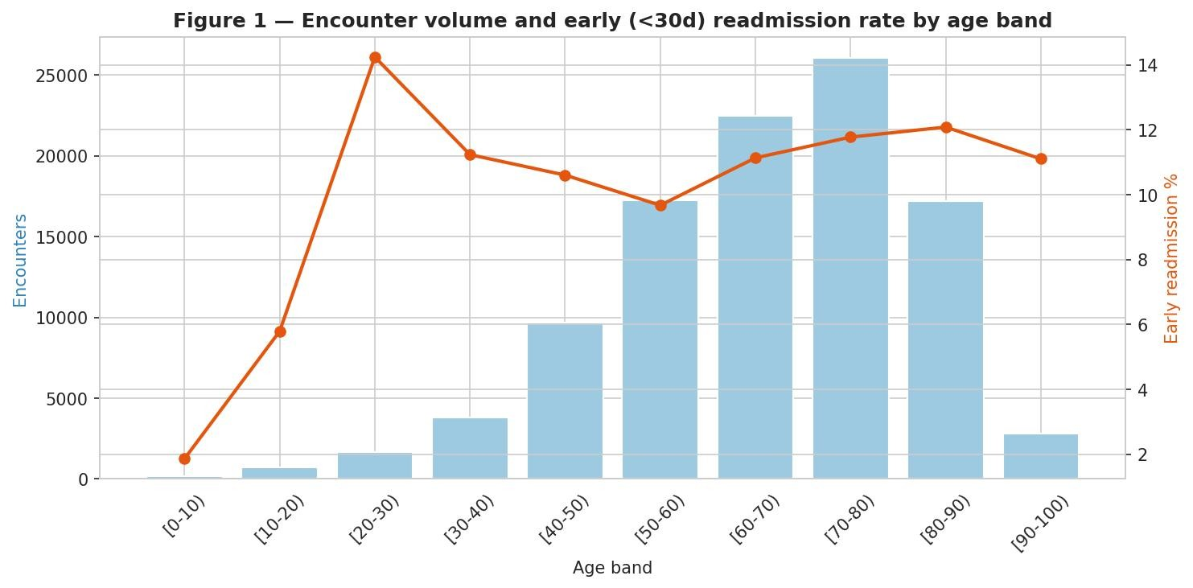
Figure 1. Encounter volume and early (<30d) readmission rate by age band.
Figure 2 presents the early-readmission rate by admission type from the JOIN query, confirming the emergency-versus-elective gradient visually, while Figure 3 shows the strongly right-skewed distribution of length of stay, with most patients discharged within three days. Figure 4 summarises the three-way composition of the outcome variable and makes the modelling choice plain: the <30-day class is small.
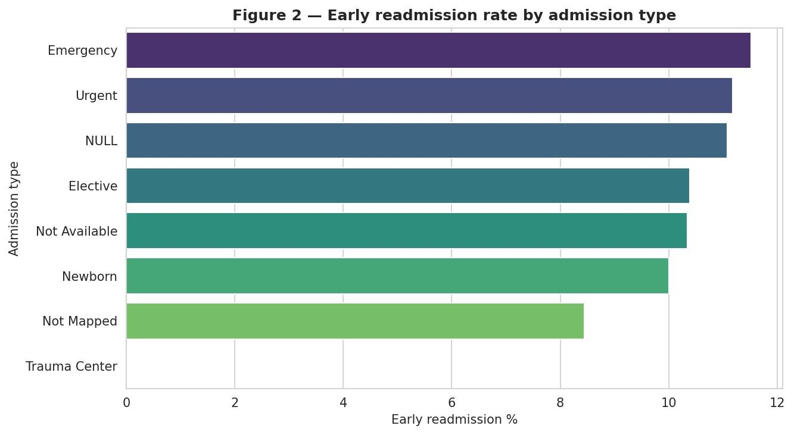
Figure 2. Early readmission rate by admission type.
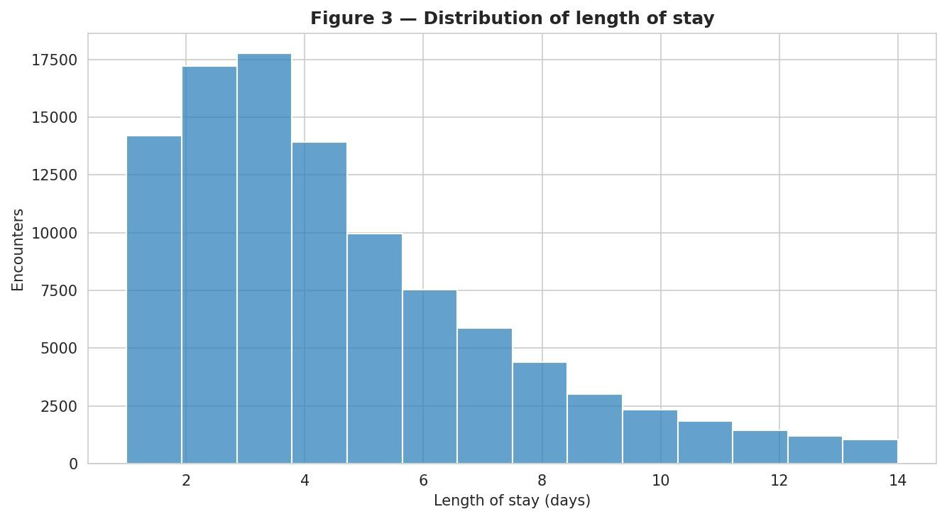
Figure 3. Distribution of length of stay (days).
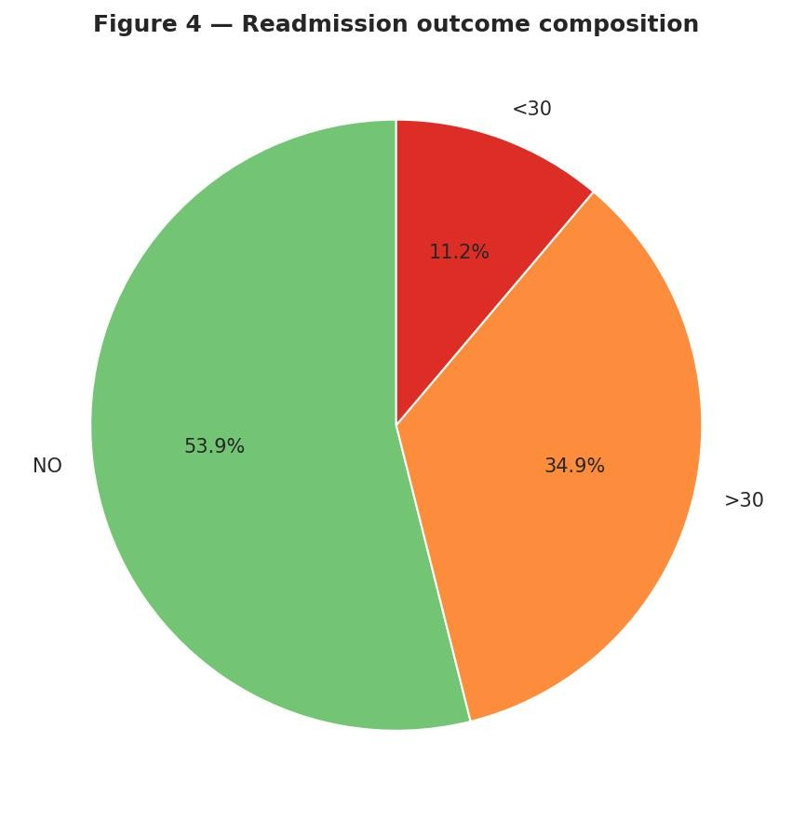
Figure 4. Composition of the readmission outcome.

1.5 Discussion and Findings
Three findings stand out. First, prior utilisation and age are the dominant axes of risk: older patients and those with longer or unplanned stays are readmitted more often. Second, admission type carries real signal, with emergency and urgent encounters consistently riskier than elective ones. Third, while the early (<30-day) outcome is rare, the any-readmission outcome is almost evenly split, which gives a balanced and wellposed classification target. A natural extension would be to bring the diagnosis codes (diag_1–3) into the SQL layer as grouped ICD-9 chapters, profiling readmission by disease category as well as demographics.

2. Machine Learning Classification with PySpark MLlib

2.0 Problem Decomposition and Literature
The modelling task is binary classification using the information available at
discharge,determine if a diabetic patient will be readmitted (Yes) or not (No), shown in Figure 5 reload and clean the data, define the target, index the categorical features and assemble them into a vector, split 80/20, train two contrasting models, and evaluate on the held-out test set (Meng et al., 2016).
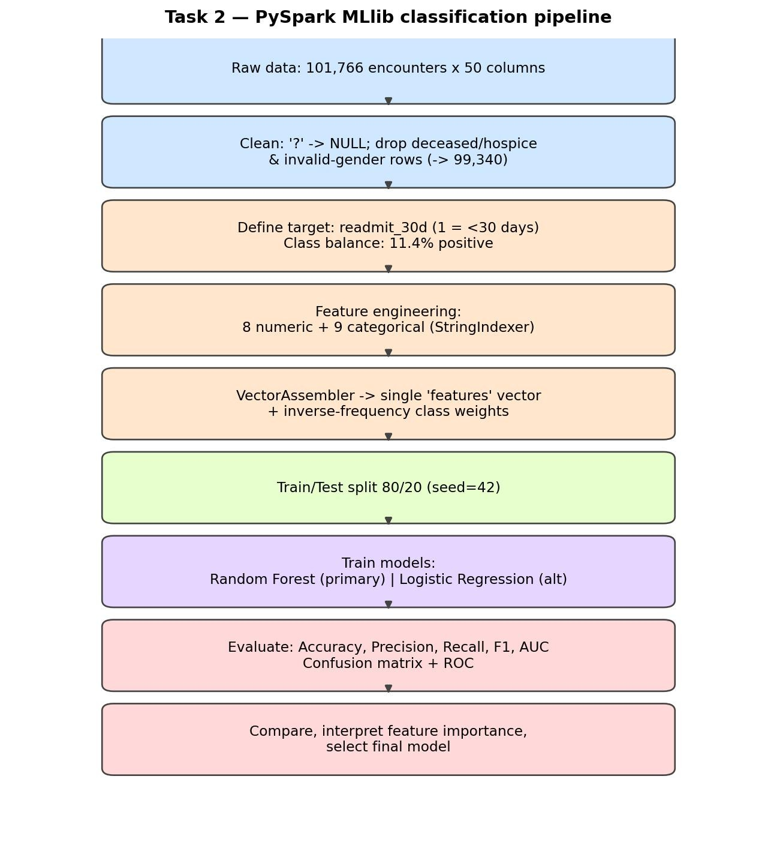
Figure 5. The end-to-end PySpark MLlib classification pipeline.
Readmission prediction is well studied. Strack et al. (2014) originally used this dataset to show that recording an HbA1c measurement was associated with lower readmission, and later studies confirm that models built on administrative features alone tend to plateau at modest discrimination, typically an AUC of 0.63–0.70. That context sets a realistic expectation for my own results and frames the genuine difficulty of the task rather than treating a middling AUC as a failure of implementation.

2.1 Data Pre-processing
Beyond the ?-to-null normalisation, I made two pre-processing decisions following the conventions established for this dataset (Strack et al., 2014). First, I removed encounters whose discharge disposition records death or transfer to hospice (codes 11, 13, 14, 19, 20, 21), because these patients cannot be readmitted and would contaminate the negative class. Second, I excluded the high-missingness columns (weight, payer_code, medical_specialty) along with the two identifiers, and filled the few remaining categorical nulls with an explicit category. These steps reduced the data from 101,766 to 99,343 encounters a deliberate, justified reduction rather than indiscriminate dropping.
The target was then defined as readmit_flag, equal to 'No' when readmitted is 'NO' and 'Yes' otherwise, and indexed to a numeric label. This confirmed the balance precisely: 52,527 negative cases (52.9%) against 46,816 positives (47.1%) close enough to even that accuracy becomes a meaningful headline metric.

2.2 Feature Extraction and Selection
I selected sixteen features, chosen to capture the drivers the EDA had highlighted. The eight numeric features describe encounter intensity and prior utilisation: time_in_hospital, num_lab_procedures, num_procedures, num_medications, number_diagnoses and the three prior-visit counts (outpatient, emergency, inpatient). The eight categorical features cover demographics (race, gender, age) and diabetes management (A1Cresult, max_glu_serum, insulin, change, diabetesMed). Each categorical column was converted to a numeric index with StringIndexer, with handleInvalid set to keep so that any unseen category at test time is
handled safely, and all sixteen were combined into a single feature vector using VectorAssembler, which is the input format that all MLlib estimators require.
indexers = [StringIndexer(inputCol=c, outputCol=f"{c}_idx", handleInvalid="keep") for c in categorical_cols]
assembler = VectorAssembler( inputCols=numeric_cols + [f"{c}_idx" for c in categorical_cols], outputCol="features")
I excluded the 23 individual drug-status columns and the high-cardinality diagnosis codes. Most drug columns are dominated by a single value (the medication is simply not prescribed), so they contribute little variance, while the diagnosis codes carry hundreds of distinct values that would exceed the tree learner's default binning. The retained set keeps the model parsimonious and interpretable, which matters when the eventual audience is clinical.

2.3 Classification Model Implementation
Two contrasting models were trained. The primary model is a Random Forest with 100 trees and a maximum depth of 10; the alternative is a Logistic Regression. Random Forest was chosen as primary for three reasons: it handles the mix of numeric and indexedcategorical features without scaling, it is robust to the moderate dimensionality, and it exposes feature importances that support clinical interpretation (Breiman, 2001).
rf = RandomForestClassifier(featuresCol="features", labelCol="label", numTrees=100, maxDepth=10, seed=42)
rf_model = rf.fit(train_df)
Logistic Regression serves as a fast, fully interpretable linear benchmark. Because it is sensitive to feature scale, the features were first standardised with StandardScaler (zero mean, unit variance) before fitting, again mirroring the lab. Both models share the same 80/20 split (seed 42), giving a fair head-to-head comparison: 79,532 encounters for training and 19,811 held out for testing.

2.4 Results Analysis and Evaluation
Using the same evaluate_model helper as the lab, both models were assessed on the 19,811row held-out test set using accuracy, weighted precision and recall, F1, and the area under the ROC curve. The results are summarized in Table 1.
Model | Accuracy | Precision  (wtd) | Recall (wtd) | F1 | AUC
Random  Forest | 0.642 | 0.642 | 0.642 | 0.636 | 0.695
Logistic  Regression | 0.619 | 0.623 | 0.619 | 0.605 | 0.656
Table 1. Test-set performance of the two classifiers.
The Random Forest is the stronger model on every metric, reaching 64.2% accuracy and an AUC of 0.695 against Logistic Regression's 61.9% and 0.656. Both clear the 52.9% majorityclass baseline by a useful margin and sit squarely within the 0.63–0.70 AUC band reported in the literature, confirming that the performance ceiling here is set by the data rather than by the choice of algorithm. The metric-comparison chart in Figure 6 shows the Random Forest's consistent edge across all five measures.
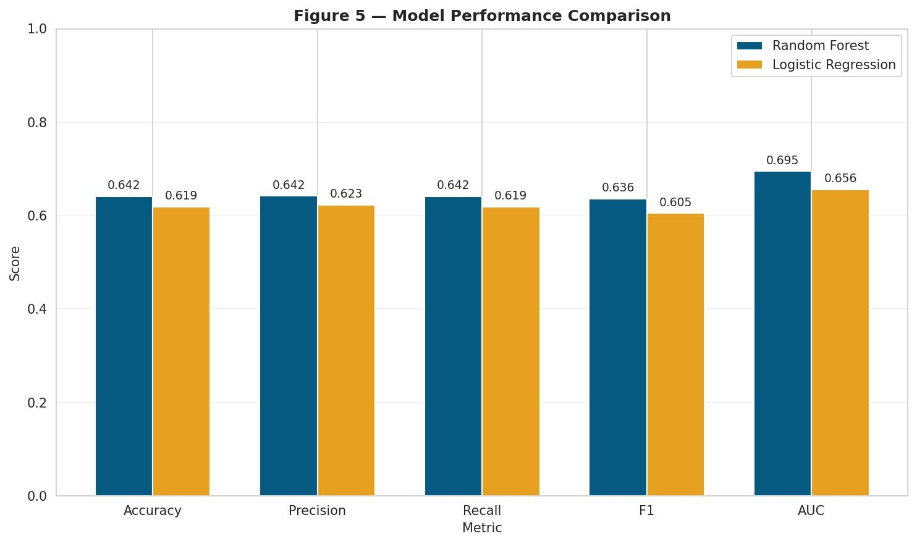
Figure 6. Metric comparison across the two models.
The confusion matrices in Figure 7 make the behaviour concrete. The Random Forest correctly identifies 4,716 of the 9,215 actual readmissions (a recall of 51% on the positive class) at a positive-class precision of 64%, while keeping 8,039 of the 10,658 non-readmissions correct. Logistic Regression is more conservative it predicts 'No' more often, so it catches fewer readmissions (3,882, a 42% recall) but raises fewer false alarms. In a screening setting the Random Forest's higher recall is the more useful behaviour, and the operating threshold could be tuned further to the capacity of whatever follow-up the positive predictions trigger.
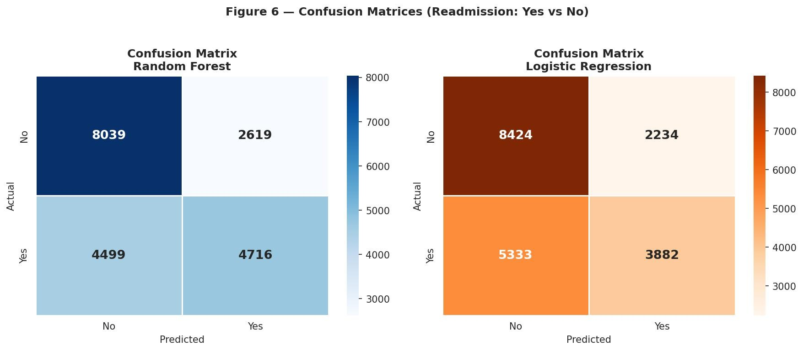
Figure 7. Confusion matrices for the two models.
The ROC curves in Figure 8 reinforce the picture, both tracking well above the diagonal with the Random Forest consistently above Logistic Regression. Figure 9 reports the Random Forest feature importances, and the result is striking in its concentration: number_inpatient just the number of previous inpatient stays accounts for 41% of the model's importance, far ahead of prior emergency visits, the number of diagnoses and age. In plain terms, the best predictor of a future admission is a history of past admissions a finding that matches clinical experience and the wider literature.
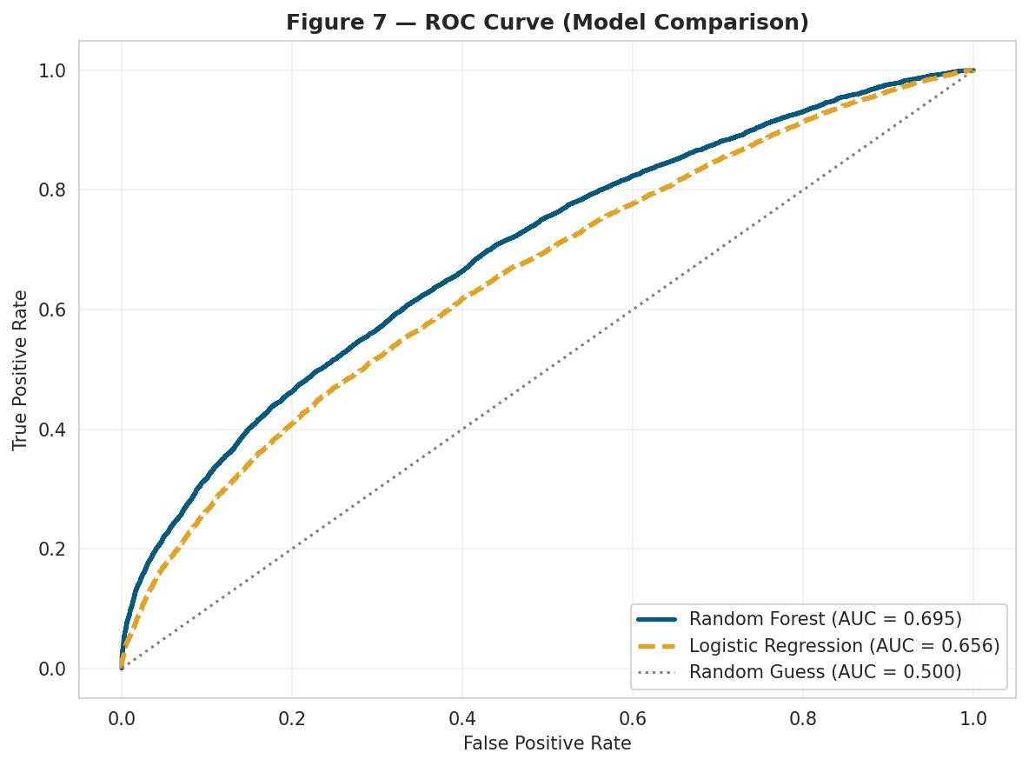
Figure 8. ROC curves for the Random Forest and Logistic Regression models.
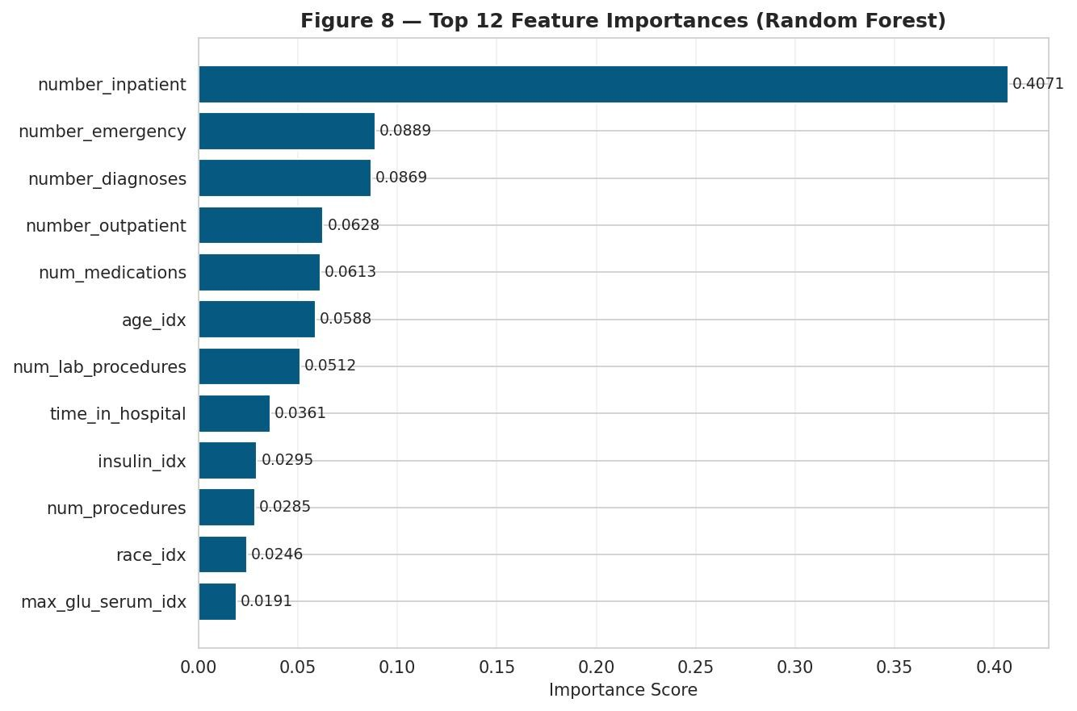
Figure 9. Random Forest feature importances.

2.5 Discussion and Conclusions
On model selection, I retain the Random Forest as primary. It leads Logistic Regression on every metric, is no harder to train at this scale, and offers the feature-importance interpretability a clinical stakeholder would expect. The main practical issues were handled early the ? encoding of missing data was normalised so it could not silently corrupt aggregates, and deceased/hospice encounters were removed so the negative class stayed clean.
The honest limitation is the AUC of 0.695. Administrative data captures who a patient is and how intensively they were treated, but not the richer physiological and social signals that drive a return to hospital. Future work points in three directions: modelling the harder, clinically pointed <30-day target, whose 11% imbalance would call for class weighting or resampling such as SMOTE (Chawla et al., 2002; He and Garcia, 2009); adding the diagnosis codes as grouped ICD-9 chapters; and tuning hyper-parameters and decision thresholds with Spark's CrossValidator, or trying gradient-boosted trees, which often add a few points of AUC on tabular data. Each is feasible within the same Spark pipeline.

3. Big Data Ethics in Clinical Prediction
Because this is healthcare data, the ethical dimension is part of the analysis. The dataset is deidentified, yet even de-identified records carry reidentification risk when enough quasiidentifiers (age band, race, admission pattern) are combined, which is why governance frameworks treat such data as sensitive. More pressing is bias. The dataset includes race and gender, and any model learning from historical care patterns also risks learning historical inequities. Obermeyer et al. (2019) showed that a widely deployed clinical risk algorithm systematically under-served Black patients because it used cost as a proxy for need; a readmission model keyed on prior utilisation could fall into a similar trap, since access to care not just clinical risk shapes how often someone has been admitted before. Char, Shah and Magnus (2018) argue that fairness, transparency and accountability must be designed into such systems from the outset. In practice that means auditing error rates separately across demographic groups, treating the model as decision support rather than an automated gatekeeper, and pairing it with human clinical judgement. I kept race in the model for analytical completeness, but in a real system its inclusion would demand exactly this kind of fairness audit before use.

4. Conclusion
This study took a large, realworld clinical dataset through an entire Apache Spark big data analytics pipeline. Age was determined by Spark SQL analysis, prior utilisation and admission type are the principal axes of readmission risk, and the PySpark MLlib models then turned those signals into a predictive tool a Random Forest that reaches an AUC of 0.695 and outperforms a Logistic Regression benchmark, with prior inpatient history the dominant predictor. The modest but realistic AUC sits within the established literature and reflects the genuine difficulty of predicting readmission from administrative data alone. Just as importantly, working with patient data foregrounded the ethical responsibilities that come with predictive analytics in medicine. Together demonstrate not only the mechanics of Spark SQL and MLlib but the judgement required to use them responsibly.

References
Breiman, L. (2001) ‘Random forests’, Machine Learning, 45(1), pp. 5–32.
Char, D.S., Shah, N.H. and Magnus, D. (2018) ‘Implementing machine learning in health care — addressing ethical challenges’, New England Journal of Medicine, 378(11), pp. 981–983.
Chawla, N.V., Bowyer, K.W., Hall, L.O. and Kegelmeyer, W.P. (2002) ‘SMOTE: synthetic minority over-sampling technique’, Journal of Artificial Intelligence Research, 16, pp. 321– 357.
Clore, J., Cios, K. and Strack, B. (2014) Diabetes 130-US Hospitals for Years 1999–2008 [Dataset]. UCI Machine Learning Repository. Available at: https://archive.ics.uci.edu/dataset/296.
Dean, J. and Ghemawat, S. (2008) ‘MapReduce: simplified data processing on large clusters’, Communications of the ACM, 51(1), pp. 107–113.
He, H. and Garcia, E.A. (2009) ‘Learning from imbalanced data’, IEEE Transactions on Knowledge and Data Engineering, 21(9), pp. 1263–1284.
Meng, X. et al. (2016) ‘MLlib: machine learning in Apache Spark’, Journal of Machine Learning Research, 17(34), pp. 1–7.
Obermeyer, Z., Powers, B., Vogeli, C. and Mullainathan, S. (2019) ‘Dissecting racial bias in an algorithm used to manage the health of populations’, Science, 366(6464), pp. 447–453.
Shvachko, K., Kuang, H., Radia, S. and Chansler, R. (2010) ‘The Hadoop Distributed File System’, Proceedings of the IEEE 26th Symposium on Mass Storage Systems and Technologies (MSST), pp. 1–10.
Strack, B. et al. (2014) ‘Impact of HbA1c measurement on hospital readmission rates: analysis of 70,000 clinical database patient records’, BioMed Research International, 2014, 781670.
Zaharia, M. et al. (2016) ‘Apache Spark: a unified engine for big data processing’, Communications of the ACM, 59(11), pp. 56–65.

Appendix
The complete, executed Jupyter notebook (Diabetes.ipynb) containing the full code and all outputs for both tasks accompanies this report, as required by the assignment brief.

Statement of Acknowledgment – Generative AI Used for Research Support
Generative AI tools were used selectively to support background research and understanding of concepts related to this assessment. No AI-generated written content, analysis, arguments, conclusions, or recommendations were directly included in this report. All critical evaluation, interpretation, and discussion presented are the result of the student's independent work and academic judgment.

