

**Tribhuvan University**

**Himalaya Darshan College**

**Biratnagar, Nepal**

**A Final Year Internship Report**

**On**

**Website of Global Saas Trading Company**

**At**

**Techware Pvt. Lmt.**

**Submitted To:**

**Department of Computer Science and Information Technology**

**Himalaya Darshan College**

**In partial fulfillment of the requirement for the Bachelor Degree in Computer Science and Information Technology**

**Submitted By:**

**Laxmi Dhakal (8173/072)**

# **MENTOR’S RECOMMENDATION**

I hereby recommend that this report has been prepared under my supervision by **Laxmi Dhakal** on **“Website: Global Saas Trading Company”**in partial fulfillment of the requirements for the degree of BSc. in Computer Science and Information Technology, be processed for evaluation.

……………………………….

**Mr. Sumit Pradhan**

Technical Director

Internship Mentor

Techware Pvt. Ltd., Biratnagar

# **SUPERVISOR’S RECOMMENDATION**

I hereby recommend that this report has been prepared under my supervision by **Laxmi Dhakal** on **“Website: Global Saas Trading Company”**in partial fulfillment of the requirements for the degree of BSc. in Computer Science and Information Technology, be processed for evaluation.

**……………..…….**

**Er. Dhiraj Kumar Jha**

Project Supervisor

# **CERTIFICATE OF APPROVAL**

This is to certify that this project prepared by Laxmi Dhakal (8173/072) entitled “**Global Saas Trading Company** ” in partial fulfillment of the requirements for the degree of B.Sc. in Computer Science and Information Technology has been well studied. In our opinion, it is satisfactory in the scope and quality as a project for the required degree.

|  |  |
| --- | --- |
| -------------------------  **Er. Dhiraj Kumar Jha**  Project Supervisor | -----------------  **Er. Sumit Kr. Shah**  Head of Department,  Department of Computer Science and IT  Himalaya Darshan College,  Biratnagar, Nepal |
| -------------------------  **External Examiner**  Central Department of Computer Science and IT  Tribhuvan University  Kirtipur, Nepal | -----------------------------  **Bharat Sapkota**  Campus Chief,  Himalaya Darshan College,  Biratnagar, Nepal |

# **ACKNOWLEDGEMENTS**

This intern report is prepared in the partial fulfillment of the requirements for the degree of Bachelor in Computer Science and Information Technology. The satisfaction and success of completion of this task would be incomplete without heartfelt thanks to people whose constant guidance, support and encouragement made this work successful. I am also appreciative of the efforts of BSCCSIT coordinator **Er. Sumit Babu Shah**.

Firstly, I would like to give my gratitude towards my mentor **Mr. Sumit Pradhan,** for his unquestionable support. Without his support and encouragement, it would have been difficult to work on.

I would also like to thank supervisor **Mr.Dhiraj Kumar Jha** for his invaluable encouragement, guidance.

I would like to dedicate hearty gratitude to **Techware Pvt*.* Ltd** for providing an opportunity to do internship at this reputed organization with full support and cooperation. I would also like to thank **Mr. Kapil Dahal**, QA Analyst, **Mr. Sumit Pradhan**, Marketing Executive and entire mentors for their unquestionable support. At the end, I would like to express my sincere thanks and appreciation to all my colleagues and seniors who have helped me directly or indirectly during this internship period. I would like to make them the part of my success.

Laxmi Dhakal(8173/072)

# **ABSTRACT**

Information Technology adoption is on the rise and recent technological innovation have dramatically enhanced the capability of organization performance leveraging the power of technology ,various business sector are working together to offer a wide array of services internal as well external to the organization. The internet is the way that helps a person in all the aspects. Today there are very least organizations which are manual .Everything is going to be computerized and online whether it is banking ,advertising or shopping.

This website is developed for Global Saas Trading Company through which user can access its information. It contains information that changes dynamically and is designed particularly to collect, store, manipulate and relay on the website features.

This report provides an insight on the internship work carried out as the back end developer of trading company. This project was originally developed in Laravel framework.

**Keywords:**  *Dynamic Website, Laravel*

# **TABLE OF CONTENTS**

**MENTOR’S RECOMMENDATION** i

**SUPERVISOR’S RECOMMENDATION** ii

**CERTIFICATE OF APPROVAL** iii

**ACKNOWLEDGEMENTS** iv

**ABSTRACT** v

**TABLE OF CONTENTS** vi

**LIST OF TABLES** ix

**LIST OF FIGURES** x

**CHAPTER-1** 1

**INTRODUCTION** 1

1.1 Introduction of Internship 1

1.2 Introduction to Project 1

1.3 Scope and Limitation 2

1.3.1 Scope 2

1.3.2 Limitation 2

1.4 Problem Statement 2

1.5 Objectives 2

1.6 Introduction to Company 3

1.6.1 Company Background 3

1.6.2 Contact Details 3

1.6.3 Organization Heirarchy 3

1.6.4 Internship Information 4

1.6.5 Responsibility Assigned 4

**CHAPTER-2** 5

**LITERATURE REVIEW** 5

2.1 Literature review 5

2.2 Similar System that exists 6

2.2.1 Wordpress 6

2.2.2 Joomla 7

2.3 System Development Methodology 7

2.3.1 Study of System Development Methodology 7

2.3.1.1 Prototyping Model 7

2.4 Tools for dynamic website 8

2.4.1 Php 8

**CHAPTER-3** 9

**SYSTEM ANALYSIS** 9

3.1 Requirement Collection 9

3.1.1 Interviewing 9

3.1.2 Prototyping 9

3.1.3 Use case 9

3.1.3 Observation 9

3.2 System Requirements 10

3.2.1 Functional Requirements 10

3.2.1.1 Use case diagram 10

3.2.1.2 Expanded Use case diagram 10

3.2.2 Non-functional requirement 13

3.3 Feasibility Analysis 14

3.3.1 Technical Feasibility 14

3.3.2 Operational Feasibility 14

3.3.3 Economic Feasibility 14

3.3.4 Schedule Feasibility 14

3.4 Data model Design 15

3.4.1 Er diagram 15

**CHAPTER-4** 16

**SYSTEM DESIGN** 16

4.1 Architectural design 16

4.2 Activity Diagram 16

4.3 Sequence Diagram 21

**CHAPTER-5** 22

**IMPLEMENTATION AND TESTING** 22

5.1 Implementation Methodology 22

5.2 Implementation tools 22

5.2.1 Sublime Text 22

5.2.2 Draw.io 22

5.2.3 Frontend Tools 22

5.2.4 Backend Tools 23

5.3 Testing 23

5.3.1 Objectives and goals 23

5.3.2 Unit Testing 24

5.3.2.1 Test 1 24

5.3.2.2 Test 2 24

5.3.3 System Testing 25

**CHAPTER-6** 27

**CONCLUSION** 27

6.1 Summary 27

6.2 Lesson Learnt 27

**REFERENCES** 28

**SNAPSHOTS** 29

# **LIST OF TABLES**

Table 1. 1 : Contact Details of the Company 3

Table 1. 2 : Duration of Internship 4

Table 3. 1 : Usecase For managing slider 10

Table 3. 2 : Usecase for managing about 11

Table 3. 3 : Usecase for managing company 11

Table 3. 4 : Usecase for managing product 12

Table 3. 5 : Usecase for managing gallery 12

Table 3. 6 : Usecase for managing team 13

Table 5. 1 : Testing for login 24

Table 5. 2 : Testing for image 24

Table 5. 3 : System testing 25

# **LIST OF FIGURES**

Figure 1. 1 : Organization Hierarchy 4

Figure 3. 1 : Use-case Diagram 10

Figure 3. 2 : Er Diagram 15

Figure 4. 1 : Architectural Design 16

Figure 4. 2 : Activity Diagram for Login 17

Figure 4. 3 : Activity Diagram for Managing Slider Page 17

Figure 4. 4 : Activity Diagram for Managing Company Page 18

Figure 4. 5 : Activity Diagram for Managing Product Page 18

Figure 4. 6 : Activity Diagram for Managing Gallery Page 19

Figure 4. 7 : Activity Diagram for Managing Team Page 19

Figure 4. 8 : Activity Diagram for Managing About Page 20

Figure 4. 9 : Activity Diagram for Managing Contact Detail 20

Figure 4. 10 : Activity Diagram for Filling Contact form 20

Figure 4. 11 : Sequence Diagram 21

# **CHAPTER-1**

# **INTRODUCTION**

## 1.1 Introduction of Internship

An “internship” is defined by the National Society for Experiential Education (NSEE) as: “a carefully monitored work or volunteer experience in which an individual has intentional learning goals and reflects actively on what he or she is learning throughout the experience”. Internship can simply be described as the transition from study to work which is necessary component in order to develop a student's skill, making them more advanced and diligent when they finally have the opportunity to be a part of working world. An internship program is quite different to a job as the main objective of intern is to look for "hand on" work experience in the real world aligned to the academic studies of students. The only goal of internship is to fulfill the missing link between academic studies and work experience. It gives students the opportunity to re-examine their career objectives and explore the variety of opportunities in the field of Computer Science and Information Technology.

## 1.2 Introduction to Project

A website with an online shop can provide a dramatic boost in sales. Before the internet era, people spend so much time wandering aimlessly in malls looking for stores that are available to shop in. Websites provide solution to this problem, bringing the shops to people, in the comfort of their own home and let shop for the products they’re looking for. Smart businesses realize this and thus have their own website housing their products and services so that potential customers can browse online for the products they want to purchase. Having a website and online presence strategy allows to market business online. As the world is adopting cutting edge technologies, internet has been popular. A good website is now considered as the reflection of any organization.

The website is developed for GLOBAL SAAS Trading Company in an effort to make it as attractive and dynamic as possible . Moreover, this website is designed for the particular need of the Company to carry out operations in a smooth and effective manner.

## 1.3 Scope and Limitation

### 1.3.1 Scope

* This website helps in effective management of the products.
* Admin can have full control over the content.
* Growth opportunities.
* Export and import of goods.
* Limitations of the domestic market.

### 1.3.2 Limitation

* Difficult to Manage.
* Development Time and cost comparatively high.

## 1.4 Problem Statement

People face difficulties to find the actual product they want.It is very time consuming and tiresome activity in the manual system. By having a website people will be able to find the company when they search for the company on a search engine like google, yahoo or bing. A well-structured site help the entrepreneurs promote their businesses and subsequently reach their prospective customers online. The main goal of this project was to develop a new website for trading company that corrects the problem faced in the manual system.

## 1.5 Objectives

* To collect the user requirement.
* To overcome the problem faced during manual system.
* To provide website that is more dynamic and userfriendly.

## 1.6 Introduction to Company

### 1.6.1 Company Background

Techware Pvt.lmt. is a global professional services company, providing a broad range of services and solutions in strategy, consulting, digital and technology since 2017. It is situated in Bankaryala,Biratnagar.Techware believe in empowering with information, building relationships and taking social responsibilities. To make software easier for people to use and operate, it performs a huge level of testing and debugging through qualified professionals and native users. The main strategy is to discover and analyze the project to find the best possible solution for a product that contains all the possible current technologies and methodologies and test them in developer and user level.

### 1.6.2 Contact Details

Table 1. 1 : Contact Details of the Company

|  |  |
| --- | --- |
| Organization Name | Techware Pvt.Lmt. |
| Address | BhupiMarga,Bankaryala,Biratnagar Nepal. |
| Telephone No. | + 977-1-4677584 |
| Email | techware@ info.com |
| Website | techware.com.np |

### 1.6.3 Organization Heirarchy

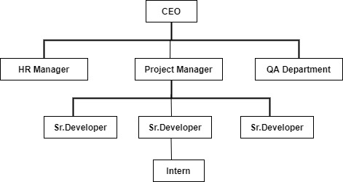

Figure 1. 1 : Organization Hierarchy

### 1.6.4 Internship Information

Table 1. 2 : Duration of Internship

|  |  |
| --- | --- |
| Position |  |
| Start Date of Internship | 20th of November |
| End Date of Internship | 20th of February |
| Total Duration | 3 months |
| Office Hour | 10 am to 6 pm |
| Working Hour | 8 hours per day |
| Working Days | 6 days per week |
| Mentor | Sumit Pradhan |
| Project | Web development |

### 1.6.5 Responsibility Assigned

All these task were done using Php framework (Laravel Framework). The responsibilities of individual were not specified only to complete project, along with phases of software development life cycle, the responsibilities were varied. I worked as a Web Developer and was assigned to create dynamic website and perform related database operations and validations for the project.

I was responsible to perform the following task as an intern:

* To be familiar with the workflow of the project.
* To understand the requirement of the project and collect entities and attributes required for building the effective database.
* To develop the employee valued skills like communication inside and outside the organization.
* To perform the testing like unit testing, System testing

# **CHAPTER-2**

# **LITERATURE REVIEW**

## 2.1 Literature review

A Website is one of the fundamental platforms for an online business.Whether people are a manufacturer, retailer or service provider, they are going to need a website to showcase the products and services in the digital world. A website acts as an online store for the business and a dynamic website makes it even more convenient.Everything has become online.It’s no surprise that everything will be soon be transformed digitally even in Nepal in coming few years. So why not prepare from today.More than 70% Nepalese youth use facebook and other internet applications daily. From this data itself, we can imagine how the online market has transformed over the years.A website is an All-in-one solution for providing useful information to the visitors.Whether, it want to provide any information on latest products or service or if it wanna communicate with the visitors, a website is a perfect place to get started from.A website can act as an effective customer relationship management if done correctly.It can communicate with the users regarding their problems and provide them the solution. These all can be performed through a single website.Gone are the days when people had to pay thousands and tens of thousands of dollars to get the product/service/business in front of prospective clients through different advertising mediums like newspapers, magazines and Tv commercials.People’s behaviour has changed with the change in technology. People hangout more on their mobile phones than on TV or Newspapers these days.This is the main reason, the business needs a website in this digital world.In today’s economy, website is becoming increasingly important for customers researching a small business. They want to be assured that it is stable enough to have a dedicated professional web presence.All of this builds authority for the business.Without a website, they’re at a huge disadvantage as a small business trying to communicate with the customers.

In today's technology dominated world, there are tons of websites doing business on the web. However, it takes a lot of efforts and right approach to make a website professional and fit for web standards. A web design is the most crucial part of a site. In today's hyper competitive market, there is a need for a [business web design](http://web.pixelcrayons.com/) that easily conveys the internet information to the users. This is where the role of a dynamic web design comes into play.A dynamic web design provides stylish and sophisticated websites that attract the visitors. Also, as integrated with high-end programming it also provide easy navigation through the site. Gone are the days when the static medium for dissemination of information was used. This is the age of dynamic websites that are more concerned about selling their products and making it interactive for the user by providing options such as live chats, videos, advanced graphics and many other things. Realizing the importance of dynamic web designs, most of the [custom web design](http://web.pixelcrayons.com/) services are offering a dynamic web design to the clients. The layouts has been made simple and attractive in order to made more comfort in reading and navigating the site.

## 2.2 Similar System that exists

There are plenty of options when it comes to picking a content management system for a development project. CMSs come in all shapes and sizes, each with its own set of features and benefits. Some are ideally suited for blogging; others may be tailored to ecommerce sites with features for pricing and accounting functionality. Specifics will vary based on company’s needs and resources.

### 2.2.1 Wordpress

WordPress is an open-source software and it’s free and available to download from the WordPress.org website. All you need to purchase is a [domain name and WordPress hosting](https://www.isitwp.com/get-free-domain-off-bluehost-web-hosting/) in order to run the website and make it available to users online.WordPress is beginner-friendly; you can easily [make a website](https://www.isitwp.com/how-to-make-a-website-step-by-step/), blog, or online store with this CMS. Plus, customizing your WordPress site is easy and affordable since WordPress offers thousands of free themes and plugins to choose from.

### 2.2.2 Joomla

[Joomla](https://launch.joomla.org/) is the second most popular CMS by market share coming in at 5.2%. Joomla is also a free and open-sourced software, like WordPress. Downloading Joomla is easy and many hosting providers offer 1-click installations. With Joomla, you can quickly [start a blog](https://www.isitwp.com/how-to-start-a-blog-step-by-step/), business website, community website, and more using their themes and extensions.

## 2.3 System Development Methodology

It is a methodology for systematically organizing the best ways to develop systems efficiently. It includes, for example, descriptions of work to be performed at each stage of the development process and drafted documents. Multiple methodologies—which differ according to viewpoint—are available. In terms of the development process, some example methodologies are "water-fall development," "spiral development," and "agile-software development" . For the Development of this CMS, I preferred the prototyping method.

### 2.3.1 Study of System Development Methodology

#### 2.3.1.1 Prototyping Model

The basic idea in **Prototype model** is that instead of freezing the requirements before a design or coding can proceed, a throwaway prototype is built to understand the requirements. This prototype is developed based on the currently known requirements. Prototype model is a [software development model](http://tryqa.com/what-are-the-software-development-models/). By using this prototype, the client can get an “actual feel” of the system, since the interactions with prototype can enable the client to better understand the requirements of the desired system.  Prototyping is an attractive idea for complicated and large systems for which there is no manual process or existing system to help determining the requirements.

Here, in the project we have used prototyping model as software development methodology. First a sample prototype was made according to the client’s base requirements. All the necessary requirements were gathered. A working model was provided to the clients. Taking responses to the working model from the clients, a new prototype was again developed. This methodology has made the work easier as the clients were actively involved in the development and missing functionality was identified in the earlier stages of development.

## 2.4 Tools for dynamic website

Creation of database-driven websites used to be complex and time consuming before server-scripting tools were invented to make it easier. To generate the content from their database instead of manually coding in HTML.PHP has been choosed for the development of this CMS.

### 2.4.1 Php

PHP is a very popular scripting language used by most of the website developers to enhance the functions and appearance of the website. It is mainly known to create dynamic pages. As it can be integrated with HTML, most of the **web** developers prefer to use this programming language.PHP is a widely-used, free, and efficient alternative to competitors such as Microsoft's ASP. PHP is a popular general-purpose scripting language that is especially suited to web development.

# **CHAPTER-3**

# **SYSTEM ANALYSIS**

## 3.1 Requirement Collection

Requirements are the most fundamental information for any project. A project is undertaken to create a new product or service or results which will fulfil the requirements of the stakeholders. Requirements are the expectations of the stakeholders which they have from the final outcome of the project. Hence it becomes the most important aspect of project management to first understand the requirements and then ensure that the requirements are finally fulfilled. Requirements gathering techniques used for this project are interviewing, use cases , and observation.

### 3.1.1 Interviewing

Users were interviewed using a set of open-ended questions, and then more probing questions were asked that helped to uncover requirements. These interviews were planned ahead of time.The interview were conducted over phone. Even though this technique proved to be time-consuming, it was good for exploring many important issues of the system.

### 3.1.2 Prototyping

Requirements collected by interactions are always prone to misinterpretation. In order to reduce such misinterpretation prototypes are often made. A prototype provides an opportunity to validate the common understanding of the requirements by all parties.

### 3.1.3 Use case

Use cases helps to describe the functional requirements of the system. It explains the dynamic behavior of the system. It also shows the interactions between the actor and the system.

### 3.1.3 Observation

This technique involved observing users by watching their behaviors in the clients/users natural settings. This techniques helped to identify process flows, opportunities for improvements and uncover implicit requirements.

## 3.2 System Requirements

### 3.2.1 Functional Requirements

Functional Requirements defines what the system must do. It defines the behaviors or functions of a system, flows, business rules and other requirements of a system along with its output.The functional requirements are discussed below:

* Admin can manages all the functionalities of the system.
* Admin can add or delete the site moderator.

#### 3.2.1.1 Use case diagram

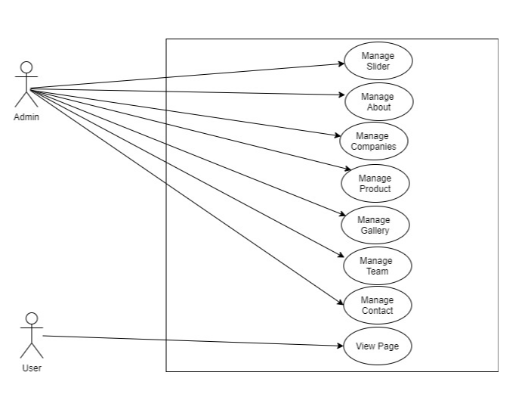

Figure 3. 1 : Use-case Diagram

#### 3.2.1.2 Expanded Use case diagram

Table 3. 1 : Usecase for managing slider

|  |  |
| --- | --- |
| **Use Case Identifier** | **UC-1 Manage Slider** |
| **Primary Actor** | Admin |
| **Secondary Actor** | None |
| **Description** | The admin should be able to add new slider, modify the slider and delete the slider . |
| **Pre-condition** | The user must logged in as admin. |
| **Post-condition** | Slider details is updated in the database. An appropriate success message is displayed on the screen. |
| **Failure scenario** | The database is not updated. Success or error message is not displayed on the screen. |

Table 3. 2 : Usecase for managing about

|  |  |
| --- | --- |
| **Use Case Identifier** | **UC-2 Manage About** |
| **Primary Actor** | Admin |
| **Secondary Actor** | None |
| **Description** | The admin should be able to add details of about, modify the details and delete the details . |
| **Pre-condition** | The user must logged in as admin. |
| **Post-condition** | About details is updated in the database. An appropriate success message is displayed on the screen. |
| **Failure scenario** | The database is not updated. Success or error message is not displayed on the screen. |

Table 3. 3 : Usecase for managing company

|  |  |
| --- | --- |
| **Use Case Identifier** | **UC-3 Manage Companies** |
| **Primary Actor** | Admin |
| **Secondary Actor** | None |
| **Description** | The admin should be able to add detail about the companies and modify it . |
| **Pre-condition** | The user must logged in as admin. |
| **Post-condition** | Companies details is updated in the database. An appropriate success message is displayed on the screen. |
| **Failure scenario** | The database is not updated. Success or error message is not displayed on the screen. |

Table 3. 4 : Usecase for managing product

|  |  |
| --- | --- |
| **Use Case Identifier** | **UC-4 Manage Product** |
| **Primary Actor** | Admin |
| **Secondary Actor** | None |
| **Description** | The admin should be able to add detail about the product and modify it . |
| **Pre-condition** | The user must logged in as admin. |
| **Post-condition** | Product details is updated in the database. An appropriate success message is displayed on the screen. |
| **Failure scenario** | The database is not updated. Success or error message is not displayed on the screen. |

Table 3. 5 : Usecase for managing gallery

|  |  |
| --- | --- |
| **Use Case Identifier** | **UC-5 Manage Gallery** |
| **Primary Actor** | Admin |
| **Secondary Actor** | None |
| **Description** | The admin should be able to add photos in the gallery and modify it . |
| **Pre-condition** | The user must logged in as admin. |
| **Post-condition** | Photos in Gallery is updated in the database. An appropriate success message is displayed on the screen. |
| **Failure scenario** | The database is not updated. Success or error message is not displayed on the screen. |

Table 3. 6 : Usecase for managing team

|  |  |
| --- | --- |
| **Use Case Identifier** | **UC-6 Manage Team** |
| **Primary Actor** | Admin |
| **Secondary Actor** | None |
| **Description** | The admin should be able to add detail about the team and modify it . |
| **Pre-condition** | The user must logged in as admin. |
| **Post-condition** | Team details is updated in the database. An appropriate success message is displayed on the screen. |
| **Failure scenario** | The database is not updated. Success or error message is not displayed on the screen. |

### 3.2.2 Non-functional requirement

Non-functional requirements define how the system should be. It covers all the remaining requirements which are not covered by functional requirements. This website is easy to use and works without downgrading the performance. It follows some of the properties like scalability, reliability, user-friendly, maintainability and usability. Website is secure because the user without login can only view the system but cannot change the feature of system.

## 3.3 Feasibility Analysis

Feasibility Study is used to determine the viability of an idea. It is often used before the actual implementation of the project. The objective of such a study is to ensure a project is legally and technically feasible and economically justifiable. It tells us whether a project is worth the investment.

### 3.3.1 Technical Feasibility

Technical feasibility involves evaluation of the hardware and the software requirements of the proposed system. This application is developed using Sublime text editor , XAMPP, and MYSQL for database. Google Chrome and Mozilla Firefox are used to run the application for facilitating user interface. So this system is technically feasible. All the necessary hardware and software required for developing and installing the system are available.

### 3.3.2 Operational Feasibility

Operational feasibility is dependent on human resources available for the project and involves projecting whether the system will be used if it is developed and implemented. Our system makes the maximum use of available resources including people, time and flow of forms. Our system provides reliable services to the potential users and the user needs to be familiar with using the application. This will enhance reduction in cost and increase in benefits for the learners.

### 3.3.3 Economic Feasibility

Economic feasibility is the cost and logistical outlook for a business project or endeavor. We considered various factors affecting the systems economic value and performance and implemented the best one. The system is economically feasible which means we can make the use of it at feasible cost and get much more benefit from it. It requires not many resources except what we already have along with our knowledge.

### 3.3.4 Schedule Feasibility

The project fails if it takes too long to be completed before it is useful. Typically, this means estimating how long the system will take it to develop. Although this site can be enlarge as required but it was developed with functionalities that were enough for the institute. So, it reduces the time cost for its development and had enough time to complete it.

## 3.4 Data model Design

### 3.4.1 Er diagram

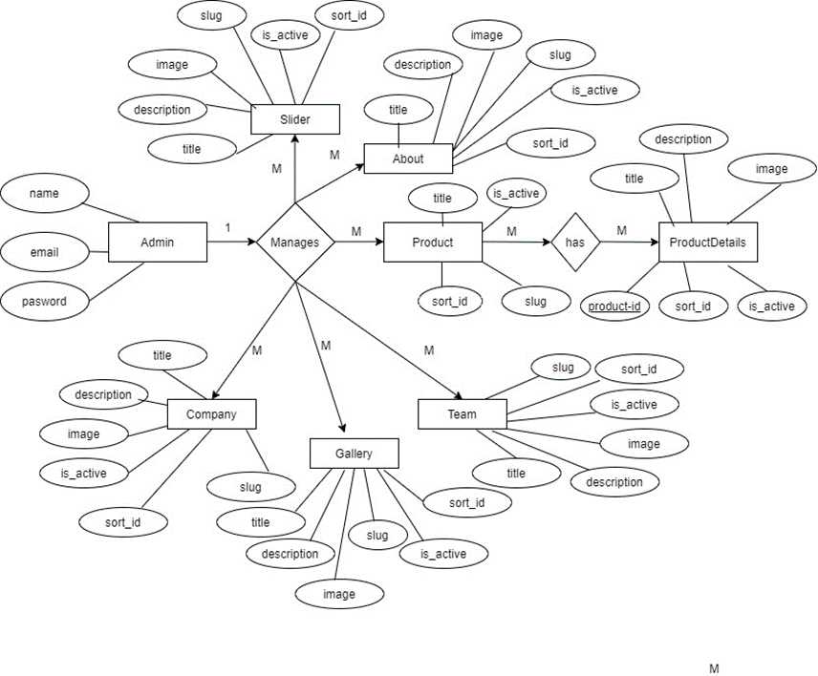

Figure 3. 2 : Er Diagram

# **CHAPTER-4**

# **SYSTEM DESIGN**

## 4.1 Architectural design

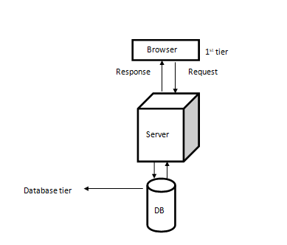

Figure 4. 1 : Architectural Design

## 4.2 Activity Diagram

It is a behavioral diagram which depicts the behavior of a system.It portrays the control flow from a start point to a finish point showing the various decision paths that exist while the activity is being executed. An activity diagram visually presents a series of actions or flow of control in a system similar to a [flowchart](https://www.smartdraw.com/flowchart/) or a [data flow diagram](https://www.smartdraw.com/data-flow-diagram/). It shows the operations(actions)involved in performing some use-cases.

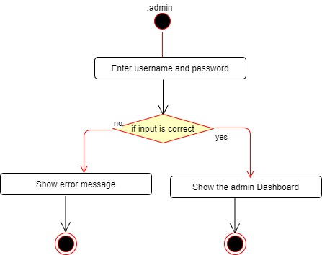

Figure 4. 2 : Activity Diagram for Login

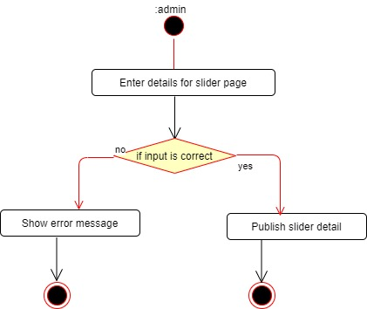

Figure 4. 3 : Activity Diagram for Managing Slider Page

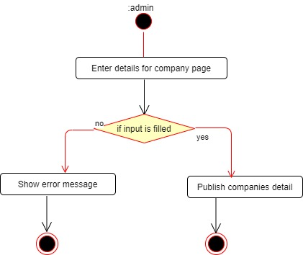

Figure 4. 4 : Activity Diagram for Managing Company Page

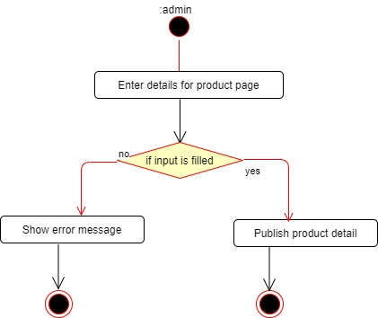

Figure 4. 5 : Activity Diagram for Managing Product Page

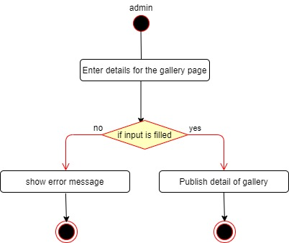

Figure 4. 6 : Activity Diagram for Managing Gallery Page

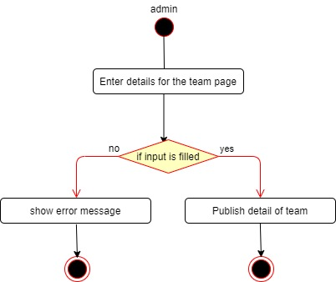

Figure 4. 7 : Activity Diagram for Managing Team Page

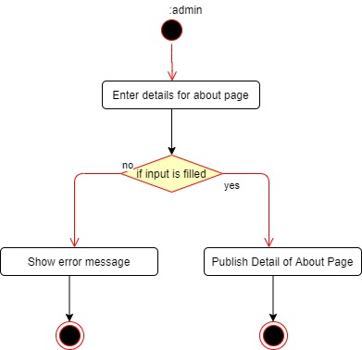

Figure 4. 8 : Activity Diagram for Managing About Page

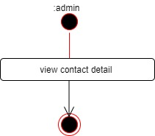

Figure 4. 9 : Activity Diagram for Managing Contact Detail

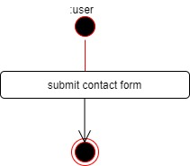

Figure 4. 10 : Activity Diagram for Filling Contact form

## 4.3 Sequence Diagram

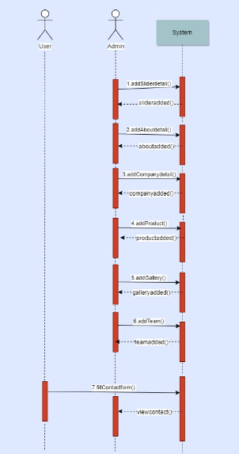

Figure 4. 11 : Sequence Diagram

# **CHAPTER-5**

# **IMPLEMENTATION AND TESTING**

## 5.1 Implementation Methodology

There are five major tasks in this phase; coding, testing, installation, documentation and training. The purpose of this phase is to convert the physical system specifications into working and reliable software and hardware, document the work that have been done and provide help for current and future users.

## 5.2 Implementation tools

### 5.2.1 Sublime Text

Sublime text has been used as a text editor for creating the website.

### 5.2.2 Draw.io

Draw.io was used as design tool for creating use-case, activity diagram , sequence diagram and other required diagram.

### 5.2.3 Frontend Tools

* **Html**

In this project, the HTML is used to create forms for users, profile, organization and usergroup, its edition and update.

* **Css**

In this project, the navigation, header and footer sections are given the custom designs using different CSS class and its properties.

* **Bootstrap**

In this project Bootstrap is used to make the website responsive to run on all type of devices.

### 5.2.4 Backend Tools

The back end of a website consists of a server, an application, and a database. A back-end developer builds and maintains the technology that powers those components which, together, enable the user-facing side of the website to even exist in the first place.

* **PHP**

It has been used for backend development in the project

* **Laravel**

Laravel is free, open-source and one of the more popular PHP web framework based on model–view–controller (MVC) architectural pattern. It was used as a framework for creating website.

* **MySQL**

MySQL was used as a database.

* **XAMPP**

XAMPP is an open source cross-platform solution stack released by Apache.The Website is completely tested using XAMPP server. The demonstration of the website is done through XAMPP server.

## 5.3 Testing

Testing is the process of validating and verifying the program or application. System testing begins with initial testing by the developer himself/herself. It helps to ensure that the system meets the given specifications. Different test data are provided and tested to know about the correctness of the system. The system is tested in series by different individuals developing the system with different sets of test data. After a successful completion of testing from the individuals it has been deployed in the existing system.

### 5.3.1 Objectives and goals

The main goal of testing are:

* To discover the cause of these errors.
* To force a program to run efficiently.
* To revise the program code to eliminate errors.
* To identify unhandled exceptions such as input of invalid/unexpected types.
* To gain the confidence of the customers by providing them a quality product.

### 5.3.2 Unit Testing

The basic unit of software that is testable is known as a module or unit. After the coding of modules, they were tested, made error free and debugged. In this way we carried out the unit test.

#### 5.3.2.1 Test 1

The objective of test 1 is to check, if any user wants login then only valid members (email and password) can login.

Table 5. 1 : Testing for login

|  |  |
| --- | --- |
| **Objective** | **Check Login Process** |
| Input | Email and Password |
| Expected Output | Login Page if user is valid |
| Original Output | Wrong Email Or Password |
| Error output | - |

**Solution**

The error was resolved by entering correct email and password for a given user.

|  |  |
| --- | --- |
| **Objective** | **Check Login Process** |
| Input | Email and Password |
| Expected Output | Login Page if user is valid or else displays error message |
| Original Output | User was successfully Logged in |
| Error output | - |

#### 5.3.2.2 Test 2

The objective of test 2 is to check, if image is successfully added or not.

Table 5. 2 : Testing for image

|  |  |
| --- | --- |
| **Objective** | **Check Login Process** |
| Input | Image Upload |
| Expected Output | Image uploaded in database |
| Original Output | Invalid image format |
| Error output | - |

**Solution**

The error was resolved by entering correct format of image.

|  |  |
| --- | --- |
| **Objective** | **Check Login Process** |
| Input | Image Upload |
| Expected Output | Image uploaded in database or else displays error message |
| Original Output | Image was successfully updated in database |
| Error output | - |

### 5.3.3 System Testing

System testing is performed to ensure that all modules and programs work together without error. Entire system test has been done and the results have been verified to see if all the modules are working.

Table 5. 3 : System testing

|  |  |  |  |  |  |
| --- | --- | --- | --- | --- | --- |
| **Test cases-Id** | **Module name** | **Test data** | **Expected result** | **Actual result** | **Remarks** |
| 1. | Admin login | Enter username and password | Enters to the admin dashboard | Enters to the admin dashboard | Pass |
| 2. | Manage slider | Admin adds images and details for the slider | New slider details must be added | New slider details has been added | Pass |
| 3. | Manage About | Admin adds title, detail, image for the clients | About details must be added | About details has been added | Pass |
| 4. | Manage Companies | Admin adds name, detail, image, link for the company page | New Company details must be added | New company details has been added | Pass |
| 5. | Manage Team | Admin adds name, details, and images for the staff | New details must be added | New details has been added | Pass |
| 6. | Manage Gallery | Admin adds images, title, content for the pages | New pages must be added | New pages has been added | Pass |
| 7. | Manage products | Admin adds name, details, images for the products | New products must be added | New products has been added | Pass |

# **CHAPTER-6**

# **CONCLUSION**

## 6.1 Summary

The technical tasks that were undertaken during the internship period have helped the intern in improving software development and debugging skills. It has helped in gaining knowledge about various technical tools and frameworks used in website developement and the process that should be followed for proper development completion. Working as an intern in one of the popular IT companies of Nepal, has boosted the confidence and has polished the professional as well as soft skills of the intern in the IT sector. As whole, this report includes project and the internship experiences, findings, knowledge and the technical skills. By the development of the project , the project was a complete dynamic website for Global saas Trading Company which allows to manage the day to day operations of the product and main it aims to have a good interactions with the customers who visits the websites. The system has been developed with much care that it is free of errors and it is efficient and less time consuming.The advantage is that this build website can be enhanced, modified or changed to the growing requirements of the users in the future.

## 6.2 Lesson Learnt

Through the internship from Techware, the lessons learnt were:

* Importance of time management and working with multiple features under pressure to meet deadlines.
* Immediate handling of urgent bugs and fixing them.
* Understanding the differences between theoretical and practical knowledge.
* Working in team with coordination and cooperation to make quality decisions.

# **REFERENCES**

This Is Why You Need A Dynamic Website For Your Business In 2018?. (2020). Retrieved 29 February 2020, from <https://blog.usejournal.com/this-is-why-you-need-a-dynamic-website-for-your-business-in-2018-f4d9e75fbfaa>

(2020). Retrieved 29 February 2020, from https://business.wikinut.com/Importance-of-a-Dynamic-Web-Design/47smzl-y/

# **SNAPSHOTS**

