1.What is the key differences between guided and unguided transmission medium;

The signal energy communicates through wires in guided media whereas The signal energy communicates through air in unguided media.

Guided media is used for point to point communication whereas Unguided media is generally suited for radio transmitting in all directions.

The guided media provides direction to the signal whereas the unguided media doesnot provides signal

Examples of guided media are twisted pair wires, coaxial cables, optical fiber cables,phone lines.

Examples of unguided media are microwave, radio or infrared.

9

Advantage of low orbit

It reduces the transmission delay

Low price for satellite and equipment.

Low transmission power is required.

Disadvantage

IT covers small area and has shorter life span.

Advantage

Requires less ground-based infrastructure required than with terrestrial.

Rapid deployment

The geostationary orbit has the advantage that the satellite remains in the same position throughout the day, and antennas can be directed towards the satellite and stay on track.

4.

**Power Line Communication** (PLC) is a communication technology that enables sending data over existing power cables.

PLC comprises of a sender who adjusts the information that is sent through a communication medium, and after that the receipient will get the information,isolates it for encourage utilize.PlC moreover permits the client to control and screen all the associated devices to the power line since it is actualized within the same wiring framework.The transmission of data is more accurate & more stable with good output signals.

5.

**Optical fibre** is made of thin wire and is usually like a human hair.It is used for sending data from one place to another through the help of light with high speed.when light is incident on glass light travels through glass or it will reflect but when we put light in a particular angle in a incident then all light are reflected through it this is called total internal reflection .we use total internal reflection phenomena in optical fibre.so when we put light in particular angle with incident then this phenomena occurs.

6

The usual bands that are used for optical communication are o-band ,E-band ,S-band ,C-band ,L-band and u-band.

The wavelength ranges are as follows:

|  |  |
| --- | --- |
| Band Name | Wavelengths |
| O-band | 1260 – 1360 nm |
| E-band | 1360 – 1460 nm |
| S-band | 1460 – 1530 nm |
| C-band | 1530 – 1565 nm |
| L-band | 1565 – 1625 nm |
| U-band | 1625 – 1675 nm |

8

Radio waves, microwaves, infrared and visible light can be used for communication

Radio waves are used for transmitting television and radio programs.

Microwaves are used for transmitting satellite television and for mobile phones.

Infrared are used for transmitting information from remote controls and are used as night-vision cameras.

Visible light are used for photography.

2

The color codes used in twisted pair cable are:

Blue

Orange

Green

Brown

Slate.

7

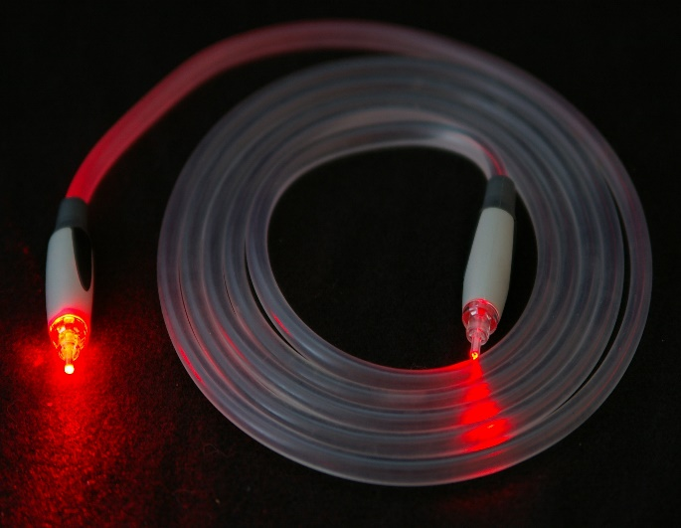

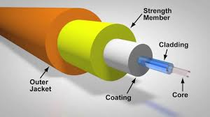

3.

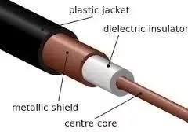

The **centre core** carries the signal.

The ‘**dielectric insulator**’ provides the core with a consistent impedance between core and shield.

The ‘**metallic shield**’ serves multiple purposes prevent signal from escaping from the core conductor and also prevent unwanted external noise or signals from impinging on the signal carried by the core conductor.The shield works bi-directionally.

The ‘**plastic jacket**’ protects the overall coaxial cable from its environment.