# MENTOR’S RECOMMENDATION

I hereby recommend that this report has been prepared under my supervision by **Binita Niroula** on **“Inventory Management System”**in partial fulfillment of the requirements for the degree of BSc. in Computer Science and Information Technology, be processed for evaluation.

……………………………….

**Mr. Kapil Dahal**

Technical Director

Internship Mentor

Techware Pvt. Ltd., Biratnagar

# SUPERVISOR’S RECOMMENDATION

I hereby recommend that this report has been prepared under my supervision by **Binita Niroula** on **“Inventory Management System”**in partial fulfillment of the requirements for the degree of BSc. in Computer Science and Information Technology, be processed for evaluation.

**……………..…….**

**Er. Dhiraj Kumar Jha**

Project Supervisor

# CERTIFICATE OF APPROVAL

This is to certify that this project prepared by **Binita Niroula** (8171/072) entitled “**Inventory Management System**” in partial fulfillment of the requirements for the degree of B.Sc. in Computer Science and Information Technology has been well studied. In our opinion, it is satisfactory in the scope and quality as a project for the required degree.

|  |  |
| --- | --- |
| -------------------------  **Er. Dhiraj Kumar Jha**  Project Supervisor | -----------------  **Er. Sumit Kr. Shah**  Head of Department,  Department of Computer Science and IT  Himalaya Darshan College,  Biratnagar, Nepal |
| -------------------------  **External Examiner**  Central Department of Computer Science and IT  Tribhuvan University  Kirtipur, Nepal | -----------------------------  **Bharat Sapkota**  Campus Chief,  Himalaya Darshan College,  Biratnagar, Nepal |

# ACKNOWLEDGEMENTS

The success and final outcome of this project required a lot of guidance and assistance from many people and I am extremely privileged to have got this all along the completion of my project. All that I have done is only due to such supervision and assistance and I would not forget to thank them.

I would like to express my gratitude to Er. Dhiraj k. Jha, project coordinator of Orchid International College, Kathmandu, supervisor of this internship for his ever inspiring suggestions, scholarly guidance and continuous encouragement. It would be a matter of proud in extending my heartly thanks to Mr. Sumit Babu Shah (HOD, BSc.CSIT, Himalaya Darshan College) for his profound assistance and advice during the report formation period.

I equally give heartly thanks to Mr. kapil Dahal, chief executive officer of Techware Pvt. Ltd. for and guiding me and helping me during the research and overall coding of my project and express my sincere gratitude to the Techware Pvt. Ltd.of Nepal, for providing me the environment for the research and development facilitysuccessfully. Special thanks to my project supervisor Mr. Sumit Pradhanfor his valuable suggestions and feedbacks, guidance, encouragement and support in this project. It adds value to boost up my ability to hang on my designation.

At last, I would like to express my gratitude towards every lecturer of Himalaya Darshan College who share their knowledge to make me able to come on this position.

Binita Niroula

TU Roll No: 8171/072

# ABSTRACT

The world is changing every second due to the enormous growth of information and communications technology, everything is at our fingertips. Even a little effort of technology can make huge difference new heights can be reached and new standards can be set. Inventory Management System is a small innovation that aims to bring about effective outcomes on an organization which have to manage their goods and items through the use of technology.

This project is aimed at developing a desktop based application named Inventory Management System for managing the inventory system of any organization. The Inventory Management System (IMS) refers to the system and processes to manage the stock of organization with the involvement of Technology system.

It is a PHP project designed in laravel-5.5 framework. It uses MVC framework for the rapid development of the project. It uses HTML, CSS, JavaScript, Bootstrap, Jquery for the frontend of the system and for the backend, it uses PHP, Ajax and MYSQL. This document contains all the information of project starting from project design to testing.

# TABLE OF CONTENTS

MENTOR’S RECOMMENDATION i

SUPERVISOR’S RECOMMENDATION ii

CERTIFICATE OF APPROVAL iii

ACKNOWLEDGEMENTS iv

ABSTRACT v

TABLE OF CONTENTS vi

LIST OF TABLES viii

LIST OF FIGURES ix

CHAPTER-1 1

INTRODUCTION 1

1.1 Introduction 1

1.2 Project Summary 1

1.3 Problem Statement 2

1.4 Scope and Limitations 2

1.4.1 Scope 2

1.4.2 Limitations 2

1.5 Objectives 2

1.6 Introduction to Company 2

1.6.1 Company Background 3

1.6.2 Contact Details 3

1.6.3 Organization Hierarchy 4

1.7 Internship Information 4

1.8 Responsibility Assigned 4

CHAPTER-2 6

LITERATURE REVIEW 6

2.1 Literature Review 6

2.2 System Development Methodology 7

2.2.1 Water Fall Model 7

CHAPTER 3 9

SYSTEM ANALYSIS 9

3.1 Requirement Analysis 9

3.1.1 Functional Requirements 9

3.1.2 Non Functional Requirement 12

3.1.3 Software and Hardware Requirement 12

3.2 Feasibility Analysis 12

3.2.1 Technical Feasibility 12

3.2.2 Operational Feasibility 13

3.2.3 Economic Feasibility 13

3.2.4 Schedule Feasibility 13

3.3 Data Modeling 13

3.3.1 ER Diagram 13

CHAPTER 4 15

SYSTEM DESIGN 15

4.1 Architectural Design 15

4.2 Activity Diagram 15

4.3 Sequence Diagram 20

CHAPTER 5 22

IMPLEMENTATION AND TESTING 22

5.1 Implementation Methodology 22

5.2 Implementation Tools 22

5.2.1 Front end 22

5.2.2 Back end 22

5.2.3 Documentation tools 22

5.3 Testing 23

5.3.1 Objective/goals 23

5.3.2 Test Case 23

CHAPTER 6 25

CONCLUSION 25

6.1 Summary 25

6.2 Lessons learnt 25

REFERENCES 26

SNAPSHOTS 27

# LIST OF TABLES

Table 1.1 : Contact Details of the Company…………………………………………..3

Table 1.2 : Internship Duration and Description ……………………………………..4

Table 3.1 : Manage category…………………………………………………………10

Table 3.2 : Manage items………………….…………………………………………11

Table 3.3 : Manage customers……………..…………………………………………11

Table 5.1 : Test cases……………………...…………………………………………23

# LIST OF FIGURES

Figure 1.1 : Organizational Hierarchy…………………………………………………4

Figure 2.1 : Waterfall Model ………………………………………………………….8

Figure 3.1 : Use-case Diagram……………………………………………………….10

Figure 3.2 : ER Diagram……………………………………………………………..14

Figure 4.1 : Architectural design diagram……………………………………………15

Figure 4.2 : Activity Diagram for Login……………………………………………..16

Figure 4.3 : Activity Diagram to add category……………………………………….17

Figure 4.4 : Activity Diagram to add items…………………………………………..18

Figure 4.5 : Activity Diagram to add customers……………………………………..19

Figure 4.6 : Activity Diagram to add sales…………………………………………...20

Figure 4. 7 : Sequence Diagram……………………………………………………...21

# CHAPTER-1

# INTRODUCTION

## 1.1 Introduction

An internship consists of an exchange of services for experience between the student and an organization. Students can also use an internship to determine if they have an interest in a particular career, create a network of contacts. Some interns find permanent, paid employment with the organizations for which they worked. This can be a significant benefit to the employer as experienced interns often need little or no training when they begin regular employment.

## 1.2 Project Summary

The project Inventory Management System is a complete desktop based application designed on Laravel using Sublime Software. The main aim of the project is to develop Inventory Management System Model software in which all the information regarding the stock of the organization will be presented. It is an intranet based desktop application which has admin component to manage the inventory and maintenance of the inventory system.

This desktop application is based on the management of stock of an organization. The application contains general organization profile, sales details, Purchase details and the remaining stock that are presented in the organization. There is a provision of updating the inventory also. This application also provides the remaining balance of the stock as well as the details of the balance of transaction. Each new stock is created and entitled with the named and the entry date of that stock and it can also be update any time when required as per the transaction or the sales is returned in case. Here the login page is created in order to protect the management of the stock of organization in order to prevent it from the threads and misuse of the inventory.

## 1.3 Problem Statement

The existing Inventory Management System website is only for the big organization like retail industry. Small organization also needs inventory management system to maintain their goods and manage their sales. This application helps to prevent the organization from the goods leakage. Small organization like retail industries difficult to keep their records in the paper. So this web based application help them to run their business smoothly.

## 1.4 Scope and Limitations

### 1.4.1 Scope

1. Provide a user friendly interface to the user to work with application.
2. Add new goods and manage the entire item in the store.
3. Generation of reports related to all the store problems.
4. Demand Management.

### 1.4.2 Limitations

1. The control of inventories is complex because it performs many function.
2. Cost may be high for implementation and maintenance.

## 1.5 Objectives

1. To develop an application that deals with the day to day requirement of any production organization
2. To develop the easy management of the inventory.
3. To handle the inventory details like sales details, purchase details and balance stock details.
4. To provide competitive advantage to the organization
5. To provide details information about the stock balance.
6. To make the stock manageable and simplify the use of inventory in the organization.

## 1.6 Introduction to Company

### 1.6.1 Company Background

Techware is a Software development organization as well as provide quality IT training at affordable rate in Biratnagar, so student don't have to run out of Biratnagar for the top IT training center. It provides its services to the clients of Nepal. It also provides training to the interns and assigns the intern with the real world projects related to their fields. It is an organization that promotes web applications and Apps development. This organization emphasizes on creating quality products where the clients' values are well understood and transformed to user-friendly solutions. With the team of technical personnel’s, highest level of expertise in the field of software and web development and the best mentors for the trainners and interns, Techware hopes to become best in the Nepalese market.

### 1.6.2 Contact Details

Table 1. 1 : Contact Details of the Company

|  |  |
| --- | --- |
| Organization Name | Techware Pvt. Ltd. |
| Address | Bhupi Marg, Biratnagar-3, Morang, Nepal |
| Telephone no. | +(977)9851196943, +(977)9805310618 |
| Email | info@techware.com.np |
| Website | www.techware.com |

### 1.6.3 Organization Hierarchy

CEO

QA Development

Project Manager

HR Manager

Sr. Developer

Developer

Sr. Developer

Developer

Sr. Developer

Developer

…

Me/Intern

Figure 1. 1 : Organizational Hierarchy

## 1.7 Internship Information

Table 1. 2 : Internship Duration and Description

|  |  |
| --- | --- |
| Position |  |
| Start Date of Internship | 20th of December |
| End Date of Internship | 20th of February |
| Total Duration | 2 months |
| Office Hour | 10 am to 6 pm |
| Working Hour | 8 hours per day |
| Working Days | 6 days per week |
| Mentor | Kapil Dahal |
| Project | Web development |

## 1.8 Responsibility Assigned

I was assigned to build up a web development including the frontend and backend activities along with the coding of each and every functionalities of the project.

I was responsible to perform the following task as an intern:

1. To be familiar with the workflow of the project.
2. To understand the requirement of the project and collect entities and attributes required for building the effective database.
3. To develop the employee valued skills like communication inside and outside the organization.
4. To perform the testing like unit testing, System testing.

# CHAPTER-2

# LITERATURE REVIEW

## 2.1 Literature Review

Web applications have become an essential component of business in today's world. By using the web applications, businesses can now develop and become simpler, and achieve its objectives much faster. These applications can help target numerous client and customers at a time. Organizations are rapidly embracing this aspect of the internet by creating web applications with the help of developers to meet their business demands. Web applications are important for a number of reasons. It is no longer possible for the businesses to see a growth in their market share unless they have a proper web application. While bigger businesses may be able to afford their own development teams for such purposes, smaller companies outsource the work to web development companies to get the same advantage at a reduced cost. It helps organizations reach new customers and let them know about the organization and the services provided by it. Web applications also provide options for an enhanced customer support. Good applications can become the first line of contact between potential customers and the business. The beauty of such applications is that they can be accessed at any time. Even location is no longer a limitation with their help. Of course, only a high quality web development company can ensure such a facility in their application.

Products are considered as the business resources for the organization. This includes managing the product with appropriate way to review any time as per the requirement. Therefore it is important to have a computer based IMS which has the ability to generate reports, maintain the balance of the stock, details about the purchase and sales in the organization.

Inventory management are the backbone of any business operations. Inventory or stocks are the lifeline and constitute brand image of any company or business. Beginning from the manufacturing stage to the tracking of products and parts during their transportation from vendor to warehouse, between the warehouses and then to retail location or directly to the customer. An Inventory Management Software is a computer based system software to keep track on inventory levels, orders, sales and deliveries. The Manufacturing industry can utilize it to generate work orders and bills of materials. Regular usage of inventory management software can keep check on overstocking of product and outages. Inventory data can be organized in an ‘easy to access and operate way’ and the old method of maintaining data in the form of lengthy spreadsheets can be shunned completely. Inventory management is a systematic approach to sourcing, storing, and selling inventory both raw materials and finished goods.

Before developing this application we came up with many Inventory Management System existing in the market, which helps to give the knowledge for the development of our project. These application software are only used by the large organization but so we came up with the application which can be used by the small company for the management of their stock in the production houses. After analyzing the other inventory management system we decided to include some of common and key features that should be included in every inventory management system. So we decided to include those things that help the small organization in away or other.

## 2.2 System Development Methodology

Software Development Life Cycle Consists of various stages that are necessary for developers like planning, analysis, design and implementation. There are many SDLC model, among them waterfall model is used in this project. There are various activities involved in Software Development Life Cycle including

* Problem Identification and System Analysis
* System Designing and System Development
* System Testing and Implementations

### 2.2.1 Water Fall Model

The Waterfall Model was the first Process Model to be introduced. It is also referred to as a linear-sequential life cycle model. It is very simple to understand and use. In a waterfall model, each phase must be completed before the next phase can begin and there is no overlapping in the phases. The advantages of waterfall development are that it allows for departmentalization and control. A schedule can be set with deadlines for each stage of development and a product can proceed through the development process model phases one by one.

The first phase of this model is requirement gathering. After gathering the requirements feasibility of the system was studied. After the Feasibility study the system design was performed. When the design was ready, creating the module of the component was started. Once the coding was done, testing each module one by one known as Unit testing was performed. After testing was done, the system was ready to be deployed.

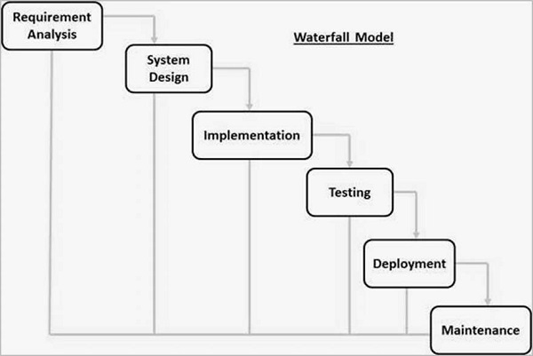

Figure 2.1 : Waterfall Model

# CHAPTER 3

# SYSTEM ANALYSIS

## 3.1 Requirement Analysis

Requirements analysis encompasses those tasks that go into determining the needs or conditions to meet for a new or altered product or project. Requirement specification provides a detailed view of the requirement needed by the programmer for developing a project. The software requirement specification provides the description of a software system to be developed. There are many things to consider while developing a well-functioning system. Requirement analysis of system points out the most essential necessity and fundamental functionality of the system. There are two types of requirement:

### 3.1.1 Functional Requirements

Functional requirement defines a function of a system or its component. A function is described as a set of inputs, the behavior, and outputs. These are statements of services the system should provide, how the system should react to particular inputs and how the system should behave in particular situations and also concerns with who should interact with the system.

• **Use-case Diagram**

The following use case diagram describes a set of action for a system, and the interaction between the actors and system.

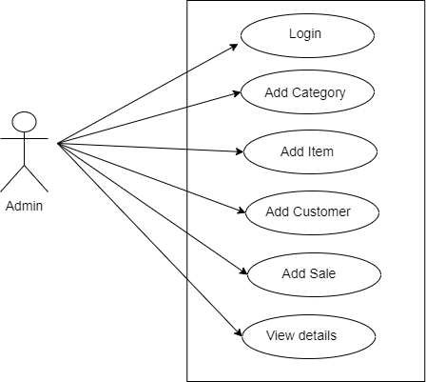

Figure 3. 1 : Use-case Diagram

Table 3. 1 : Manage category

|  |  |
| --- | --- |
| **Use Case Diagram** | **UC-1 Manage Category** |
| **Primary Actor** | Admin |
| **Secondary Actor** | None |
| **Description** | The admin should be able to add new category and manage the category. |
| **Pre-condition** | The admin must be logged in. |
| **Post-condition** | Category is updated in the database. An appropriate success message is shown on the screen. |
| **Failure scenario** | The database is not updated. Success or error message is not displayed on the screen. |

Table 3. 2 : Manage items

|  |  |
| --- | --- |
| **Use Case Diagram** | **UC-1 Manage Item** |
| **Primary Actor** | Admin |
| **Secondary Actor** | None |
| **Description** | The admin should be able to add new items related to the category and manage the items. |
| **Pre-condition** | The admin must be logged in. |
| **Post-condition** | Item is updated in the database. An appropriate success message is shown on the screen. |
| **Failure scenario** | The database is not updated. Success or error message is not displayed on the screen. |

Table 3. 3 : Manage customers

|  |  |
| --- | --- |
| **Use Case Diagram** | **UC-1 Manage Customers** |
| **Primary Actor** | Admin |
| **Secondary Actor** | None |
| **Description** | The admin should be able to add new customers and manage the customers. |
| **Pre-condition** | The admin must be logged in. |
| **Post-condition** | Customers is updated in the database. An appropriate success message is shown on the screen. |
| **Failure scenario** | The database is not updated. Success or error message is not displayed on the screen. |

### 3.1.2 Non Functional Requirement

Non-functional requirements are requirements that are not directly concerned with the specific functions delivered by the system. They may relate to emergent system properties such as reliability, response time, and storage occupancy. They may specify system performance, security, availability, and other emergent properties. Non-functional Requirements are often called “qualities attributes” of a system. Other terms for non-functional requirement are ‘qualities’, ’qualities of services’, Non-functional requirement are:-

* Security: Data like personal detail of clients should be kept confidential. To keep the data secure, system do not share these with others
* Availability: System works 24 hours, so user can use it anytime.
* Backup: As system mainly deals with client’s personal information, backup of data and personal information is prioritized.
* Correct information: The information provided by our system is genuine and correct.

### 3.1.3 Software and Hardware Requirement

* Back end: MySQL, Laravel 5.5
* Host: Apache server
* Operating System: Windows
* System: Multimedia PC

## 3.2 Feasibility Analysis

Before starting the project, feasibility study had been carried out to measure the viability of the system. Feasibility study determines if creating a new or improved system is user friendly, within the cost, and within the stipulated time or not. Following are the feasibility that has been performed for this project.

### 3.2.1 Technical Feasibility

Technical feasibility was analyzed by specifying equipment and application that satisfy the user requirements. It includes the hardware and software device requirements. For using the system there is no need of advanced technological knowledge. It has simple user interface which can be easily understood. During technical feasibility analysis, technological issues regarding the system was studied. The major emphasis was on identification of the specifications of the hardware and the software that will be used, in order to satisfy the end-user’s requirements.

### 3.2.2 Operational Feasibility

It is the measure of how well a developed system solves the problems and how it satisfies the requirement identified during the requirement analysis phase. The system is device compatible and easy to use. This application is very user friendly and does not require any technical knowledge to operate.

### 3.2.3 Economic Feasibility

Economic feasibility analysis is the most commonly used method for determining the efficiency of a new project. The required resources were freely available for the purposed system. There will be only use of internet and the computer to use the system Therefore, it was assured that the system is economically feasible. Cost and time are the most essential factors involved in this field of study.

### 3.2.4 Schedule Feasibility

Schedule Feasibility is the probability of a project to be completed within its schedule time limits, by a planned due date. If a project has a high probability to be completed on- time, then its schedule feasibility is appraised as high.

## 3.3 Data Modeling

Data modelling is a process used to define and analyze data requirements needed to support the business process within the scope of corresponding information systems in organizations.

### 3.3.1 ER Diagram

An entity-relationship model (ER model) describes inter-related things of interest in a specific domain of knowledge. The following ER model shows the entities, their attributes and relationships between them in our application.

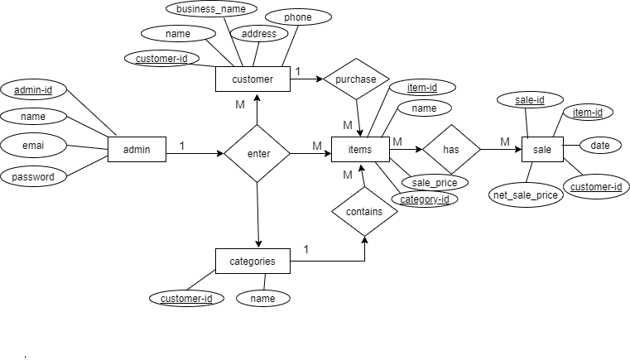

Figure 3. 2 : ER Diagram

# CHAPTER 4

# SYSTEM DESIGN

## 4.1 Architectural Design

Browser

1st tier

Request Response

Server

Middle tier

Request Response

DB

Database tier

Figure 4. 1 : Architectural design diagram

## 4.2 Activity Diagram

It shows the operations (actions) involved in performing some use-cases. It shows the step-wise decomposition/transition and control flows while implementing a certain use-case. It also shows the alternative path, concurrent path to execute a particular use-case.

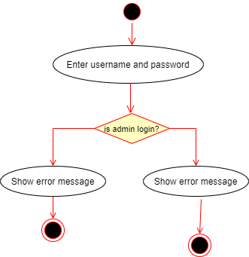

Figure 4. 2 : Activity Diagram for Login

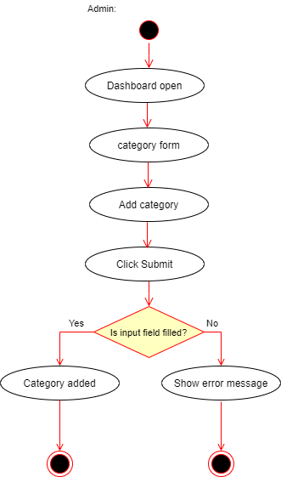

Figure 4. 3 : Activity Diagram to add category

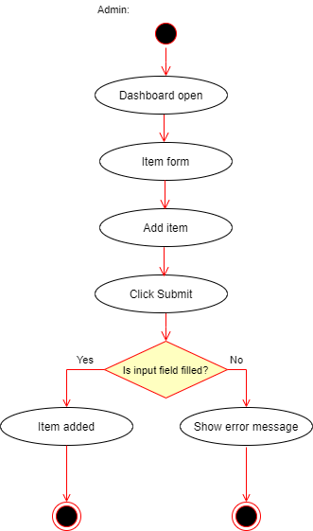

Figure 4.4 : Activity Diagram to add items

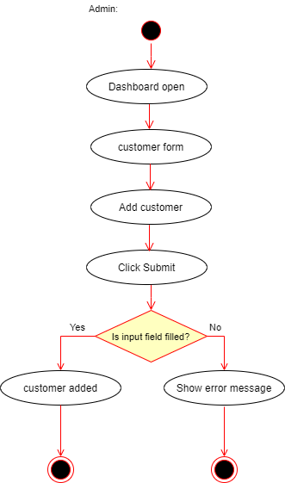

Figure 4. 5 Activity Diagram to add customers

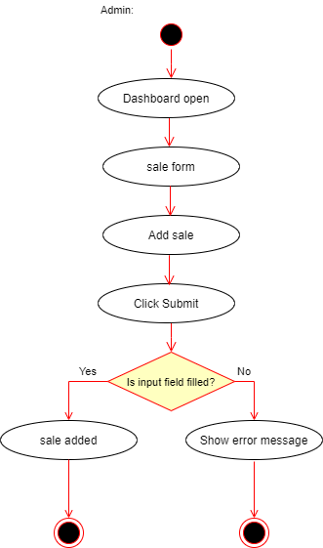

Figure 4. 6 : Activity Diagram to add sales

## 4.3 Sequence Diagram

A sequence diagram simply depicts interaction between objects in a sequential order i.e. the order in which these interactions take place. We can also use the terms event diagrams or event scenarios to refer to a sequence diagram. Sequence diagrams describe how and in what order the objects in a system function. These diagrams are widely used by businessmen and software developers to document and understand requirements for new and existing systems.

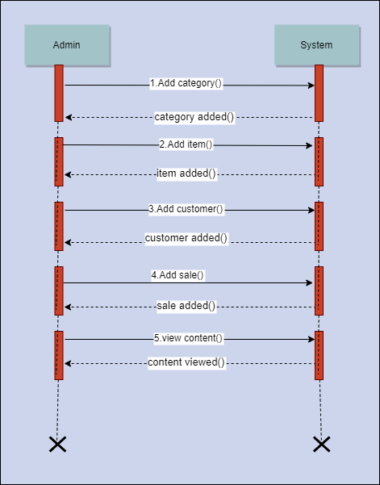

Figure 4. 7 : Sequence Diagram

# CHAPTER 5

# IMPLEMENTATION AND TESTING

## 5.1 Implementation Methodology

System Implementation specifies how the system is installed, operated and maintained. System implementation is also known as the test program that perform the complete system in its actual environment to determine its capabilities and limitations.

The project began with the analysis of the requirements and the conceptual pattern was design. After the overall analysis of the system, designing of the database, tables and user interface was started. After that coding and debugging, the system was implemented.

There are generally two different types of Implementation. They are Direct Implementation and Parallel Implementation .Parallel Implementation is used. In this Implementation method, before completely changing over to new system, existing system and new system was to be used simultaneously until the users are well trained to ready to roll out the system.

## 5.2 Implementation Tools

### 5.2.1 Front end

* Bootstrap 3.4.1 was used for designing admin dashboard of inventory
* Sublime Text 3 was used for handling code
* Jquery

### 5.2.2 Back end

* Laravel 5.5 framework was used for development
* For database, MySQL was used
* Ajax

### 5.2.3 Documentation tools

* Draw.io was used for creating ER diagram, use-case diagram etc.
* Ms Word was used as a text editor for documentation process.

**5.2.4 Extra tools**

* Git Bash
* Sublime Merge

## 5.3 Testing

Testing is the process for executing a program with the intent to cause and discovers errors. Upon accomplishment of each use case, the system is fully tested using the following strategies (unit testing, integration testing).

### 5.3.1 Objective/goals

The main goals of testing are:

1. To force a program to run efficiently.
2. To discover the cause of these errors.
3. To revise the program code to eliminate errors.

### 5.3.2 Test Case

Table 5. 1 : Test cases

|  |  |  |  |  |  |
| --- | --- | --- | --- | --- | --- |
| Test cases-Id | Module name | Test data | Expected result | Actual result | Remarks |
| 1 | Admin Login | Enter user name and password | Must enter to the admin page | Invalid user name/password | Fail |
| 2 | Admin Login | Enter username and password | Enters to the admin page | Enters to the admin page | Pass |
| 3 | Add new category | Admin adds new category | New category is created | New category is created | Pass |
| 4 | Delete category | Admin deletes the category | Category should not be deleted if items falls on that category is used | Error can be seen | Pass |
| 5 | Add new items | Admin add and delete new items | New items is added and does not deleted if it is used in sale | Item added | Pass |
| 6 | Add new customers | Admin can add new customers | Customers should be added in the table | Customers added. | Pass |
| 7 | Add sales | Admin can sale to the register customers | Sale details should be viewed in the table | Shows error. | fail |
| 8 | Add sales | Admin can sale to the register customers | Sale details should be viewed in the table | Details added | Pass |
| 9 | Delete sales | Admin can delete the sale. | Sale should be deleted from the table | Sale deleted | Pass |
| 10 | Add dates in sales | Admin can add dates in sale . | Purchase date should be added. | Date doesnot seen | fail |

# CHAPTER 6

# CONCLUSION

## 6.1 Summary

This project was done as a part of internship project for Bachelors of Science in Computer Science and Information Technology (Bsc.CSIT) program offered by Tribhuvan University , Nepal. It was undertaken to plan, design and develop a Inventory Management System for small organization This system helps to manage the goods and sales the items easily. This system also helps in stock management. With the aim of performing every tasks of the shops or organization digitally, which includes tasks like keeping records of items which contains details like which category does this items falls; what items does customers purchase; in what date does the customers buy the items, etc. With the increase in the number of shops and other retail industries, they have to keep all records which was difficult in tradition way. So this application was developed to overcome all the problems in inventory.

## 6.2 Lessons learnt

Being in the internship program and handling the designation of PHP developer , I learned a lot of employee valued skills. I learned about the good personal presentation. I learned developer’ skills and also learned how to use the developer’s tools. The internship has taught me time management, as working in a company means you have to take care of the deadlines and milestones. This internship has been an excellent and rewarding experience. It has been a great opportunity to improve personal and professional skills. This valuable skills have boosted my professional skills to higher level and prepare me for better future in this career.

# REFERENCES

("What is Inventory Management? 10 guides to mastering commerce", 2020)

Inventory Management System - Charis Blueweb® | Stock Management Software | Database Software | Best Inventory Software company in Ibadan. (2020). Retrieved 18 February 2020, from https://www.charisblueweb.com/inventory-management-system/

Setiyani, L. (2018). Simple Method For Designing Inventory Management System. *Faktor Exacta*, *11*(3). doi: 10.30998/faktorexacta.v11i3.2780

Inventory Management System, Inventory Management Application Software. (2020). Retrieved 18 February 2020, from https://webtechnepal.com/applications/inventory-management-system/

# SNAPSHOTS

