# ACKNOWLEDGEMENTS

The success and final outcome of this project required a lot of guidance and assistance from many people and I am extremely privileged to have got this all along the completion of my project. All that I have done is only due to such supervision and assistance and I would not forget to thank them.

I would like to express my gratitude to Er. Dhiraj k. Jha, project coordinator of Orchid International College, Kathmandu, supervisor of this internship for his ever inspiring suggestions, scholarly guidance and continuous encouragement. It would be a matter of proud in extending my heartly thanks to Mr. Sumit Babu Shah (HOD, BSc.CSIT, Himalaya Darshan College) for his profound assistance and advice during the report formation period.

I equally give heartly thanks to Mr. Bidur Dahal, principal of Orchid International College for and guiding me during the research of my project and express my sincere gratitude to the Broadways Infosysof Nepal, for providing me the environment for the research and development facilitysuccessfully. Special thanks to my project supervisor Mr. Sagun Shiwakotifor his valuable suggestions and feedbacks, guidance, encouragement and support in this project. It adds value to boost up my ability to hang on my designation.

At last, I would like to express my gratitude towards every lecturer of Himalaya Darshan College who share their knowledge to make me able to come on this position.

Gunjana Karki

TU Roll No: 6089/071

# ABSTRACT

“Website on Herbal Tea Collection” is literally a human resource management designed particularly for users to collect, store, manipulate and relay on the website features. It is a PHP project designed in YII2.0 framework. It uses MVC framework for the rapid development of the project. It uses HTML, CSS and JavaScript for the frontend of the system and for the backend, it uses PHP and MYSQL. This document contains all the information of project starting from project design to testing and most importantly the scrum framework for the agile project development method.

# TABLE OF CONTENTS

ACKNOWLEDGEMENTS i

ABSTRACT ii

TABLE OF CONTENTS iii

LIST OF TABLES vi

LIST OF FIGURES vii

LIST OF ABBREVATIONS viii

CHAPTER- 1 INTRODUCTION 1

1.1 Project Summary 1

1.2 Scope and Limitations 1

1.2.1 Scope 1

1.2.2 Limitations 2

1.3 Problem Statement 2

1.4 Objectives 2

1.5 Introduction to Company 3

1.5.1 Company Background 3

1.5.2 Contact Details 3

1.5.3 Organization Hierarchy 4

1.6 Internship Information 5

1.7 Responsibility Assigned 5

CHAPTER-2 LITERATURE REVIEW 6

2.1 Introduction 6

2.2 Importance of HTC 7

2.3 Development Tools 9

2.3.1. Word press 9

2.3.2. Joomla 9

2.3.3. Drupal 9

2.3.4. Expression engine 10

2.4 System Development Methodology 10

2.5 Tools for Dynamic Website 10

2.5.1 PHP 11

CHAPTER-3 SYSTEM ANALYSIS 12

3.1 Requirement analysis 12

3.1.1 Preliminary Analysis 12

3.1.2 Functional Requirement 12

3.1.2.1 Use Case Diagram 13

3.1.3 Non-Functional Requirements 17

3.1.4 Software Requirement 17

3.1.5 Hardware Requirement 17

3.2 Feasibility Analysis 17

3.2.1 Technical Feasibility 18

3.2.2 Economic Feasibility 18

3.2.3 Operational Feasibility 18

3.3 Database Design 19

3.3.1 Database Diagram 19

CHAPTER-4 SYSTEM DESIGN 20

4.1 Architectural Design 20

4.2 Activity Diagram 21

4.3 Process Design 30

4.3.1 Sequence Diagram 30

CHAPTER-5 IMPLEMENTATION AND TESTING 35

5.1 Implementation Methodology 35

5.2 Implementation Tools 35

5.2.1. Sublime Text 35

5.2.2. Microsoft Visio 35

5.2.3. Frontend and Backend Tools 36

5.3. Testing 36

5.3.1. Testing Objective 36

5.3.2. Test Cases 37

CHAPTER-6 CONCLUSION 39

REFERENCES 40

APPENDICES 41

# 

# LIST OF TABLES

Table 1.1: Contact Details of the Organization……………………………………..…3

Table 1.2: Internship Duration and Description…………………………………....…5

Table 3.1: Use Case Table for Managing Products…………………………………..14

Table 3.2: Use Case Table for Managing Client……………......……………………14

Table 3.3: Use Case Table for Managing Staff…………………...……….…………15

Table 3.4: Use Case Table for Managing Page...……...…………..…………………15

Table 3.5: Use Case Table for Managing Slider……………………..………………16

Table 3.6: Use Case Table for Managing Portfolio……………...….………………16

Table 5.1: Frontend and Backend Tools……………………………..………………36

Table 5.2: Test Cases for HTC……………………………………………...………..37

# 

# LIST OF FIGURES

Figure 1.1: Organizational Hierarchy………………………………………...……….4

Figure 3.1: Use Case Diagram…………………………………………………….....13

Figure 3.2: Database Diagram…………………………….……………………...….19

Figure 4.1: Architectural Design……………………………………………….……20

Figure 4.2: Activity Diagram for login………………………………………………21

Figure 4.3: Activity Diagram to Create User…………………………………..……22

Figure 4.4: Activity Diagram to Change Password…………………………….…...23

Figure 4.5: Activity Diagram of Slider……………………………………….….…..24

Figure 4.6: Activity Diagram of Page………………………………………………..25

Figure 4.7: Activity Diagram for Managing Portfolio……………………………….26

Figure 4.8: Activity Diagram of Clients……………………………………...………27

Figure 4.9: Activity Diagram of Staff………………………………………..….…...28

Figure 4.10: Activity Diagram for Deleting Image…………………………………..29

Figure 4.11: Sequence Diagram for Admin…………………………………...…..…30

Figure 4.12: Sequence Diagram for Creating New User………………………….….31

Figure 4.13: Sequence Diagram of Client…………………………………………...31

Figure 4.14: Sequence Diagram of Page…………………………………………......32

Figure 4.15: Sequence Diagram of Portfolio…………………………………...…....32

Figure 4.16: Sequence Diagram of Slider…………………………………………....33

Figure 4.17: Sequence Diagram of Staff………………………………..……………33

Figure 4.18: Sequence Diagram for Changing Password………………………….…34

# LIST OF ABBREVATIONS

BSC.CSIT Bachelor of Science and Computer Science and Information Technology

CMS Content Management System

HTC Herbal Tea Collection

PDS Pervasive Display System

SDLC System Development Life Cycle

# CHAPTER- 1 INTRODUCTION

## 1.1 Project Summary

“Website on Herbal Tea Collection” is literally a human resource management designed particularly for users to collect, store, manipulate and relay on the website features. The purpose of this document is to show results and outcomes of this project. This document is a part of series of documents and its purpose is to consolidate all of them and present an overview of the whole project.

Herbal teas utilize a class of herbs known for their high amounts of minerals and certain vitamins. When these plant materials are infused in hot water they naturally provide a nutritious broth-like liquid that is easy to digest and assimilate.

Herbal tea has several health benefits and is available in a variety of flavors such as orange and apple, which are not only delicious but are a perfect alternative to unhealthy sodas. Moreover, herbal tea is rich in antioxidants, minerals, and vitamins. Some of the most popular herbal teas include peppermint tea, chamomile tea, and hibiscus tea. While peppermint tea aids in digestion and has antiviral and antimicrobial properties, chamomile tea has antiplatelet-clumping activity and plays a vital role in reducing the occurrence of blood clots. Also, hibiscus tea lowers the blood pressure and is ideal for pre-hypersensitive and mildly hypersensitive people. The increasing awareness about preventive healthcare and stressful lifestyle is encouraging consumers to opt for products with health benefits like herbal tea.

## 1.2 Scope and Limitations

### 1.2.1 Scope

1. It helps in effective management of the products.
2. This report focuses on the Herbal Tea in global market.
3. This report categorizes the market based on manufacturers, regions, type and application.

### 

### 1.2.2 Limitations

1. It is likely to be insecure.
2. Planning of activities is not easy in this website.

## 1.3 Problem Statement

The plant extracts appear to be relatively safe, although headache, dizziness, restlessness, nausea, vomiting, diarrhea, and dermal sensitivity are the most common side effects that have been observe.

The use of herbal products and supplements has increased tremendously over the past three decades with not less than 80% of people worldwide relying on them for some part of primary healthcare. Although therapies involving these agents have shown promising potential with the efficacy of a good number of herbal products clearly established, many of them remain untested and their use are either poorly monitored or not even monitored at all. The consequence of this is an inadequate knowledge of their mode of action, potential adverse reactions, contraindications, and interactions with existing orthodox pharmaceuticals and functional foods to promote both safe and rational use of these agents. Since safety continues to be a major issue with the use of herbal remedies, it becomes imperative, therefore, that relevant regulatory authorities put in place appropriate measures to protect public health by ensuring that all herbal products are safe and of suitable quality. This review discusses toxicity-related issues and major safety concerns arising from the use of herbal tea products and also highlights some important challenges associated with effective monitoring of their safety.

## 1.4 Objectives

The objectives of this project are listed below:

* To collect the user requirement.
* To write and test HTML5, CSS3 to prepare front end design.
* To design the database for implementing website.
* To write PHP code to handle static website to dynamic website.

## 1.5 Introduction to Company

### 1.5.1 Company Background

Broadway Infosys is a Software development organization. It provides its services to the clients of Nepal. It assigns the intern with the real world projects related to their software. It is an organization that promotes web applications and Apps development. This organization emphasizes on creating quality products where the clients’ values are well understood and transformed to user-friendly solutions. With the team of technical personnel’s, highest level of expertise in the field of software and web development, Broadway Infosys Nepal hopes to become best in the Nepalese market.

### 1.5.2 Contact Details

Table 1.1: Contact Details of the Organization

|  |  |
| --- | --- |
| Organization Name | Broadway Infosys Nepal |
| Address | Sriganesh Marg, Tinkune, Subidhanagar, Kathmandu Nepal. |
| Telephone No. | + 977-1-4117578, 4111849, 4111583 |
| Email | info@ broadwayinfosys.com |
| Website | [www.broadwayinfosys.com](http://www.broadwayinfosys.com) |

### 

### 1.5.3 Organization Hierarchy

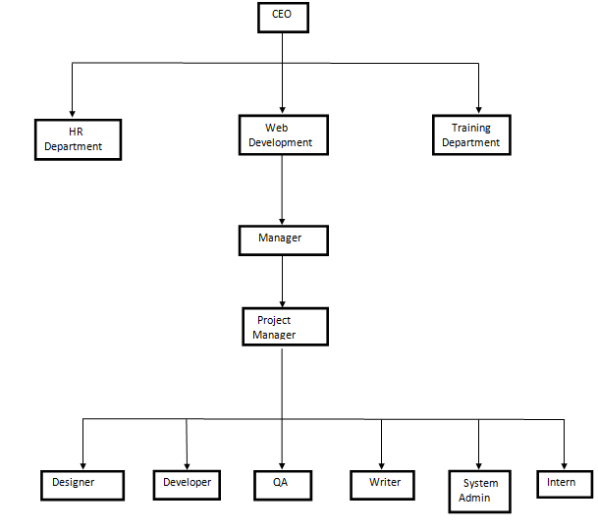

Figure 1.1: Organizational Hierarchy

## 1.6 Internship Information

Table 1.2: Internship Duration and Description

|  |  |
| --- | --- |
| **Position** | **Associate Software Engineer** |
| Start Date of the Internship | 20th of November |
| End Date of the Internship | 20th of February |
| Total Duration | 3 months |
| Office Hour | 10 am to 6 pm |
| Working Hour | 8 hours per day |
| Working Days | 5 days per week |
| Mentor | Sagun Shiwakoti |
| Project | Web development |

## 1.7 Responsibility Assigned

I was assigned to build up a dynamic website named “Herbal Tea collection” including the frontend and backend activities along with the coding of each and every functionalities of the project.

I was responsible to perform the following task as an intern:

1. To be familiar with the workflow of the project.
2. To understand the requirement of the project and collect entities and attributes required for building the effective database.
3. To implement MVC framework using Yii 2.0 framework.

# CHAPTER-2 LITERATURE REVIEW

## 2.1 Introduction

Herbal ‘renaissance’ is occurring all over the world today. Every one realized that herbal medicines do not produce any side effects and hence started to use many herbal products instead of synthetic products. Minerals, vitamins, amino acid and enzymes which are available in the herbal plants can be used for various medicinal purposes. From various reports collected worldwide, it is evident that the peoples have been using herbal plants for medicinal purposes right from ancient times. Traditionally India, Japan and China used several herbal plants for medicinal and other purposes. This practice was later transformed to western countries and America. Wide ranges of herbs were used as flavoring agents, aromatic compounds and medicinal purposes (Thomas, 1997; Shaw, 1998). Factors attributed for the increasing usage of herbal products are

1. ease of accessibility
2. desire for self-medication
3. Perceptions that herbs are safer, gentler and less costly than conventional drugs.

Now-a-days people have realized that use of natural products helped them to avoid excess usage of conventional western medicine (Allison et al., 2001). Tyler (2000) had mentioned that the people in the Europe and United States gained interest in the use of herbal medicines, as they believe that the usage of herbal drugs did not give any ill effects which are often associated with the usage of modern chemical drugs. The people in developed countries have started to use natural products for their healthy life style, and also many herbal products are commercially available. As the people in US started to use herbal products to the greater extent, some concern have become apparent regarding safety of these products.

## 2.2 Importance of HTC

Despite the name, herbal teas are not actually made from the tea plant. Instead, they are made by steeping herbs, flowers, or roots. The origins of herbal tea date back to Ancient Egypt and Ancient China, used for thousands of years for its great taste and medicinal properties. There are hundreds of different herbal teas you can drink, all with varying tastes and benefits. These benefits can range from treating a cold to relieving stress, to anti-aging properties. In addition, unlike other teas, herbal teas do not contain any caffeine.

Health Benefits of Herbal Tea

1. Fights the Cold

Herbal teas are great for treating a cold. The elder tree herb is one of the best for fighting a cold as it has properties that clear the nasal passages and stops heavy coughs. It can also reduce the symptoms of asthma.

1. Improves Digestion

Many herbal teas help with the breakdown of fats and speed up the emptying of the stomach. Doing so, they can reduce symptoms of indigestion, bloating, and vomiting. Some of the best teas for these symptoms are dandelion, chamomile, cinnamon, peppermint, and ginger tea.

1. Boosts Immune System

The antioxidants and vitamins found in herbal teas are great for helping fight disease and infections. They can protect against oxidative stress and lower the risk of chronic disease. Some of the best herbal teas for boosting your immune system are elderberry, echinacea, ginger, and licorice root tea.

1. Reduces Inflammation

Daily drinking of herbal tea can greatly help those that suffer from arthritis. Herbal tea can reduce pain, swelling, and tiredness in joints. Ginger is actually one of the best herbs to relieve inflammation, due to its main component, gingerol. This makes the tea an ideal treatment for joint and muscle pain.

1. Anti-Aging

Doesn’t everyone wish they could look and feel younger? Well, the antioxidants found in herbal teas have shown to aid in slowing down the aging process. They prevent free radical damage and reduce the aging of cells in the body. This makes your skin and hair look and feel younger.

1. Relieve Stress and Anxiety

Herbal teas calm and relax the mind, relieving stress and anxiety. Since it calms the mind, drinking herbal tea before going to sleep also helps people who suffer from insomnia. Chamomile tea is one of the best teas for stress relief and difficulty sleeping. The comforting effect may also act as a mild anti-depressant for some as it stimulates the brain to reduce feelings of depression.

1. Lower Blood Pressure

Instead of taking pills, try drinking herbal tea to lower your blood pressure instead. Herbal teas such as Hibiscus can decrease blood pressure without any negative side. There are plenty of options when it comes to picking a content management system for a development project. Depending on how advanced you need the CMS to be, what language it's built in, and who is going to be using it, it can be a nightmare trying to find the "perfect" CMS for a project.

Effects due to the chemicals it contains. High blood pressure can negatively affect the heart and kidney, so if you’re looking for a natural treatment, Hibiscus tea is the way to go.

1. Great for Skin Health

Herbal tea is a useful treatment for acne, without the side effects that some medications cause. The tea can either be drunk normally or by directly applying the tea onto the skin. Rooibos and chamomile tea are some of best teas for treating the skin due to their antioxidants and antibacterial properties. Spearmint tea may also work as it reduces the breakout of acne.

## 2.3 Development Tools

### 2.3.1. Word press

WordPress is an [Open Source](http://en.wikipedia.org/wiki/Open_source) software system used by millions of people around the world to create beautiful websites and blogs. It is completely customisable by the use of [themes](http://wordpress.org/themes/) and [plugins](http://wordpress.org/plugins/). WordPress is both free and priceless at the same time. The most important features of WordPress are that you can create a dynamic website without any programming and design knowledge ([Matt Mullenweg](https://codex.wordpress.org/User:Matt)and [Mike Little](http://mikelittle.org/), 2003).

### 2.3.2. Joomla

Joomla is a platform based on PHP and MySQL which was created in 2005 by a team of open source developers. It currently has 200,000 community users and contributors. Joomla is free to anyone who wants to download it and use it to create a website. Joomla is a free and open source content management system (CMS) to build websites and powerful online applications. Joomla was the result of fork of Manboo on August 17, 2005.

### 2.3.3. Drupal

Drupal is free and open source and reside on a web server. It is written in a php programming language. Drupal is flexible enough to create something as simple as small personal blog to something as complex as a large corporate or political website.

### 2.3.4. Expression engine

Expression Engine (EE) is an elegant, flexible CMS solution for any type of project. Designed to be extensible and easy to modify, EE sets itself apart in how clean and intuitive their user administration area is. It takes only a matter of minutes to understand the layout of the backend and to start creating content or modify the look.

The features of EE that is the global search and replace functionality. Anyone who's ever managed a site or blog knows how useful it is to change lots of data without having to manually search and open each page or post to modify it.

## 2.4 System Development Methodology

A Software development Life Cycle binds to the important stages that are necessary for developers like planning, analysis, design and implementation. It is a well defined process by which a system is planned, developed and implemented. There are following activities involves in SDLC. They are:

* Preliminary Investigation (Problem Identification)
* System analysis
* System designing
* Development of software
* System testing
* Implementation & Evaluation Maintenance

Several SDLC models in use include Waterfall, Agile, v-model, Rapid prototyping, Spiral, etc. I have used waterfall model.

## 2.5 Tools for Dynamic Website

Creation of database-driven websites used to be complex and time consuming before server-scripting tools were invented to make it easier. To generate the content from their database instead of manually coding in HTML.PHP has been choosed for the development of this CMS.

### 2.5.1 PHP

PHP is widely used and popular in Web development community, following the proliferation of Apache on Linux and UNIX servers and Windows servers too.

Advantage of PHP

PHP is designed specifically as a web scripting language, hence it is very efficient to learn and implement. PHP is an open source code and works with a multitude of servers on many different operating systems including Microsoft’s.

Disadvantage of PHP

PHP has no formal error handling mechanism and the programmers have to put some time and effort to learn the PHP framework. It is flexible but scatterbrained.

# CHAPTER-3 SYSTEM ANALYSIS

## 3.1 Requirement analysis

Every system needs some requirement for their development process. Requirement analysis holds the process of reviewing and determining the proposed system needs, functional requirements, non-functional requirements that a system must meet. For requirement analysis, following approaches were followed.

### 3.1.1 Preliminary Analysis

* Problem analysis had been done and title as problem statement.
* Studied previous related works to know about the working and applicability of the system.
* Analysis of system planning and design.

### 3.1.2 Functional Requirement

Functional requirement identified the provision of the system and the system’s reaction to certain input and how the system should behave in day to day basis. This tea collection system is focused on collecting the suitable herbs that are necessary for the health benefits and also alert the inhabitants of the locality. The functional requirements of Herbal Tea Collection include the following:

1. Admin
2. Admin can manage all the functionalities of the system.
3. Admin can manage the portfolio, manages the pages, manage the products, manage the clients.
4. User
5. A user can manage the product.
6. A user cannot manage the other users.

### 3.1.2.1 Use Case Diagram

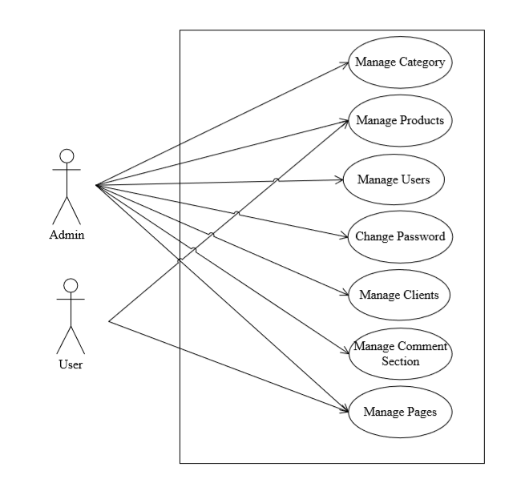

Figure 3.1: Use Case Diagram

Table 3.1: Use Case Table for Managing Products

|  |  |
| --- | --- |
| **Use Case Identifier** | **UC1-Manage Products** |
| **Primary Actor** | Admin |
| **Secondary Actor** | None |
| **Description** | The admin should be able to add new products, modify the products, edit and delete any particular products. |
| **Pre-Condition** | The user must be logged in as admin. The product should not be present if new products are being added. |
| **Post-Condition** | Te product list is updated in the database. An appropriate success message is shown on the screen. |
| **Full Scenario** | The database is not updated; success or error message is not displayed on the screen. |

Table 3.2: Use Case Table for Managing Clients

|  |  |
| --- | --- |
| **Use Case Identifier** | **UC2-Manage Clients** |
| **Primary Actor** | Admin |
| **Secondary Actor** | None |
| **Description** | The admin should be able to add new products, modify the clients, edit and delete any particular clients. |
| **Pre-Condition** | The user must be logged in as client. The client should not be present if new clients are being added. |
| **Post-Condition** | The client list is updated in the database. An appropriate success message is shown on the screen. |
| **Full Scenario** | The database is not updated; success or error message is not displayed on the screen. |

Table 3.3: Use Case Table for Managing Staff

|  |  |
| --- | --- |
| **Use Case Identifier** | **UC3-Manage Staff** |
| **Primary Actor** | Admin |
| **Secondary Actor** | None |
| **Description** | The admin should be able to add new staffs, modify the staffs, edit and delete any particular staffs. |
| **Pre-Condition** | The user must be logged in as admin. The staffs should not be present if new staffs are being added. |
| **Post-Condition** | The staffs list is updated in the database. An appropriate success message is shown on the screen. |
| **Full Scenario** | The database is not updated; success or error message is not displayed on the screen. |

Table 3.4: Use Case Table for Managing Page

|  |  |
| --- | --- |
| **Use Case Identifier** | **UC4-Manage Pages** |
| **Primary Actor** | Admin |
| **Secondary Actor** | None |
| **Description** | The admin should be able to add new pages, modify the pages, edit and delete any particular pages. |
| **Pre-Condition** | The user must be logged in as admin. The pages should not be present if new staffs are being added. |
| **Post-Condition** | The pages list is updated in the database. An appropriate success message is shown on the screen. |
| **Full Scenario** | The database is not updated; success or error message is not displayed on the screen. |

Table 3.5: Use Case Table for Managing Slider

|  |  |
| --- | --- |
| **Use Case Identifier** | **UC5-Manage Slider** |
| **Primary Actor** | Admin |
| **Secondary Actor** | None |
| **Description** | The admin should be able to add new slider, modify the slider, edit and delete any particular slider. |
| **Pre-Condition** | The user must be logged in as admin. The slider should not be present if new sliders are being added. |
| **Post-Condition** | The slider list is updated in the database. An appropriate success message is shown on the screen. |
| **Full Scenario** | The database is not updated; success or error message is not displayed on the screen. |

Table 3.6: Use Case Table for Managing Portfolio

|  |  |
| --- | --- |
| **Use Case Identifier** | **UC6-Manage Portfolio** |
| **Primary Actor** | Admin |
| **Secondary Actor** | None |
| **Description** | The admin should be able to add new portfolio, modify the portfolio, edit and delete any particular portfolio. |
| **Pre-Condition** | The user must be logged in as admin. The portfolio should not be present if new portfolio is being added. |
| **Post-Condition** | The portfolio list is updated in the database. An appropriate success message is shown on the screen. |
| **Full Scenario** | The database is not updated; success or error message is not displayed on the screen. |

### 

### 3.1.3 Non-Functional Requirements

Non-Functional requirement deals with the quality and performance of the system. It focuses on security, advancements, and performance mechanisms of the system. The non functional requirement of this project includes:

Our system is accessible to the user who is login to the system. Website is secure because the user without login can only view the system but cannot change the feature of system.

### 3.1.4 Software Requirement

* Front end: PHP, HTML
* Back end: MYSQL
* Host: Apache server
* Operating System: Windows, LINUX, MAC

### 3.1.5 Hardware Requirement

* System: Multimedia PC
* Processor: Pentium 4 or above
* Memory: 512MB RAM
* Hard Disk: 80GB or above
* Keyboard: 104 standards

## 3.2 Feasibility Analysis

Feasibility analysis helps to identify whether the system is technically, economically, legally, operationally, and securely feasible in the targeted locality or not.

### 3.2.1 Technical Feasibility

This system can be made technically feasible by making the system user friendly and maintainable by creating easy interface for users to operate.Finding alternatives for cellular communication whenever there is feasible like cloud based sharing or low range communication modules like RF modules, Lora, Zig-bee etc.

The system offers greater levels of user friendliness combined with greater processing speed. Therefore, the cost of maintenance can be reduced. Since, processing speed is very high and the work is reduced in the maintenance point of view management convince that the project is operationally feasible.

### 3.2.2 Economic Feasibility

The use of low range of communication modules might increase onetime cost but will be economical in case of operating cost. Economic feasibility can be achieved through alternative components or a trade-off between features like complexity, performance and reliability.

In the system, the organization is most satisfied by economic feasibility. Because, if the organization implements this system, it need not require any additional hardware resources as well as it will be saving lot of time.

### 3.2.3 Operational Feasibility

It is Operational feasible, since the system is providing an attractive user interface to the operator/end user, so he feels very easy to work onto it. Response to operator/end user is very fast and very good. Since, as we mentioned above that it requires much less amount of cost, it uses computer work so it is very fast to operate and it is very easy for user to work on it.

## 3.3 Database Design

### 3.3.1 Database Diagram

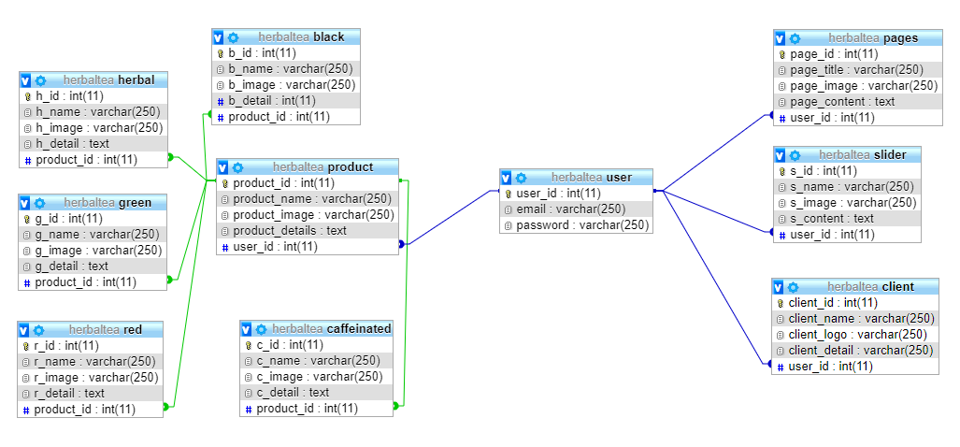

Figure 3.2: Database Diagram

# CHAPTER-4 SYSTEM DESIGN

The system design develops the architectural detail required to build a system or product. As in the case of any systematic approach, this software too has undergone the best possible design phase fine tuning all efficiency, performance and accuracy levels. The first step in system designing is to determine how the output is to be produced and in what format. Samples of the output and input are also presented. In the second step, input data and master files are to be designed to meet requirement of the proposed output. The processing phases are handled through program construction and testing, including a list of the programs needed to meet the system’s objectives and complete documentation. The system designs used for building this project include activity diagram, module diagram, sequence diagram, database diagrams and class diagram.

## 4.1 Architectural Design

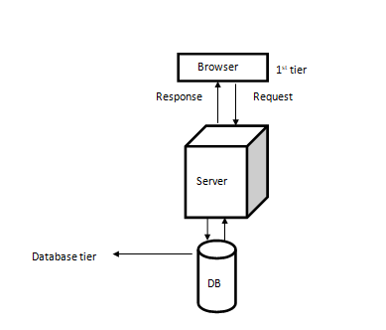 Figure 4.1: Architectural Design

It shows the operations (actions) involved in performing some use-cases. It shows the step-wise decomposition/transition and control flows while implementing a certain use-case. It also shows the alternative path, concurrent path to execute a particular use-case.

## 4.2 Activity Diagram

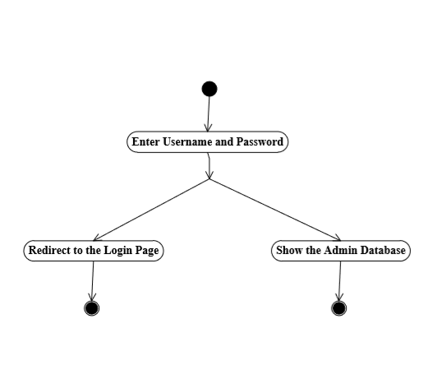Figure 4.2: Activity Diagram for Login

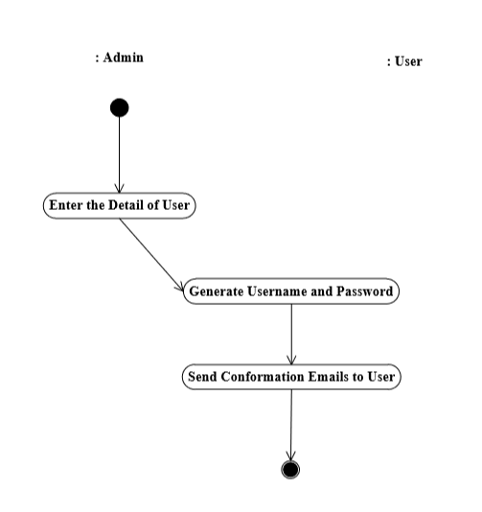Figure 4.3: Activity diagram to create user

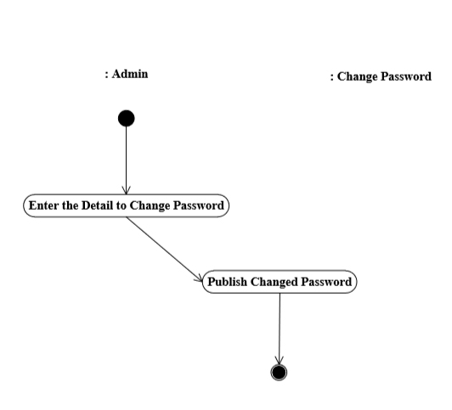

Figure 4.4: Activity Diagram to Change Password

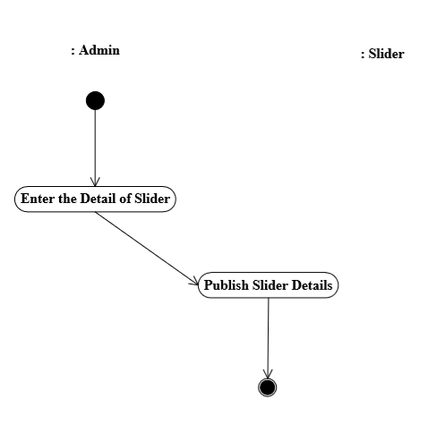

Figure 4.5: Activity Diagram of Slider

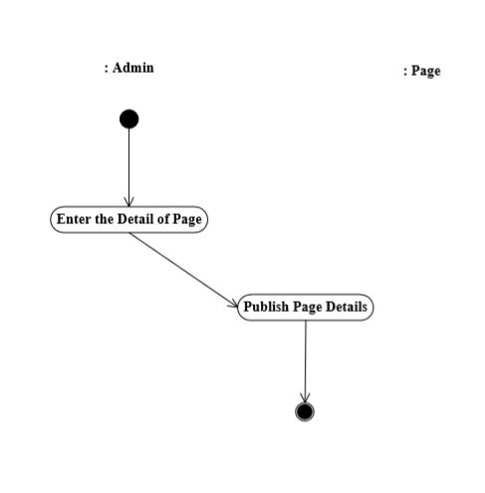

Figure 4.6: Activity Diagram of Page

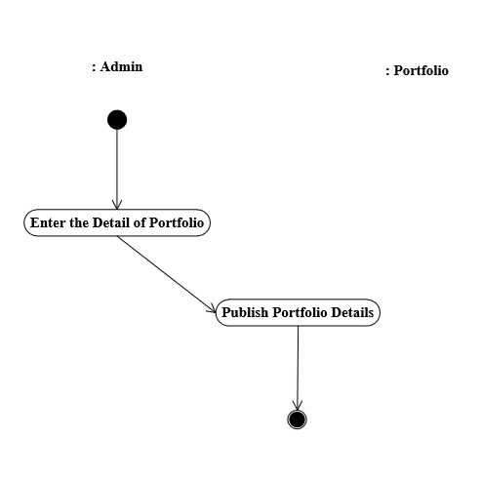

Figure 4.7: Activity diagram of Portfolio

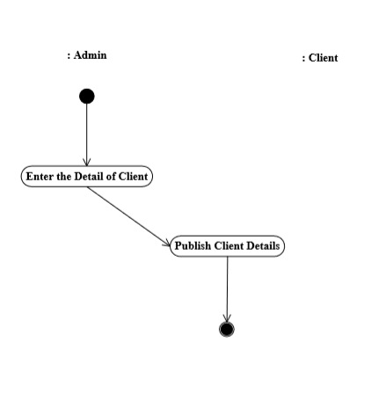

Figure 4.8: Activity diagram of Client

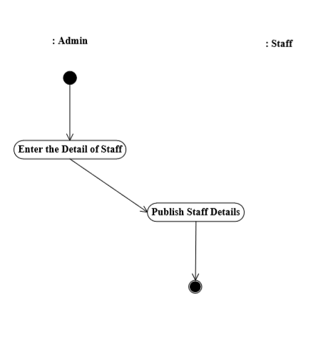

Figure 4.9: Activity diagram of Staff

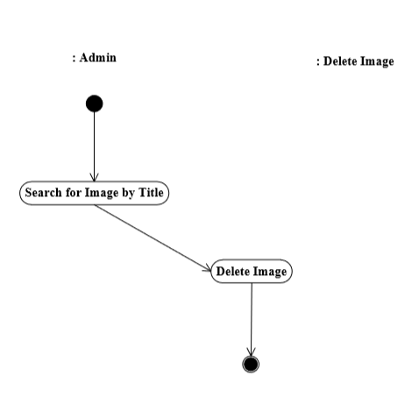

Figure 4.10: Activity diagram for Deleting Image

## 

## 4.3 Process Design

### 4.3.1 Sequence Diagram

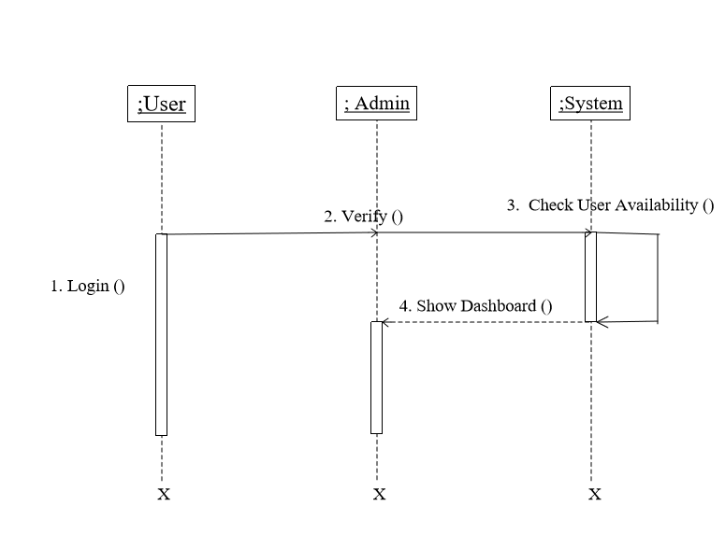

Figure 4.11: Sequence Diagram of Admin

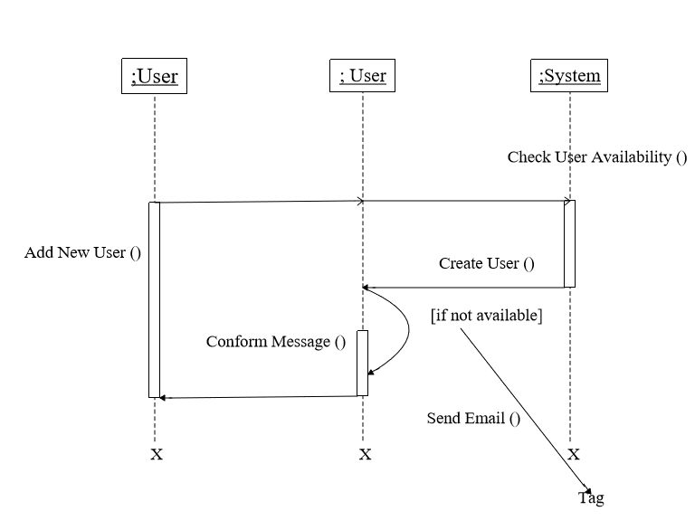

Figure 4.12: Sequence Diagram for Creating New User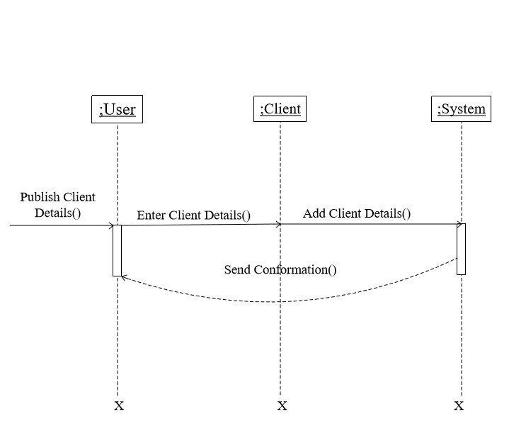 Figure 4.13: Sequence Diagram of Client

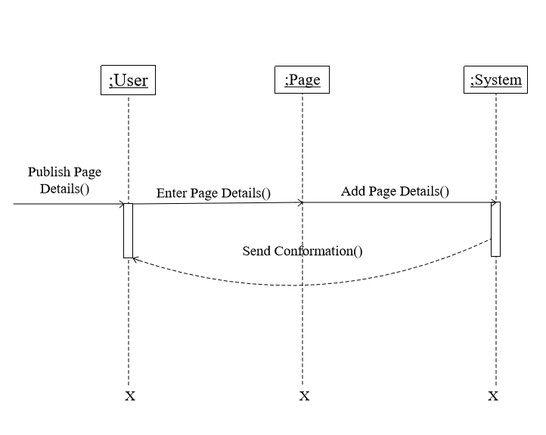

Figure 4.14: Sequence Diagram of Page

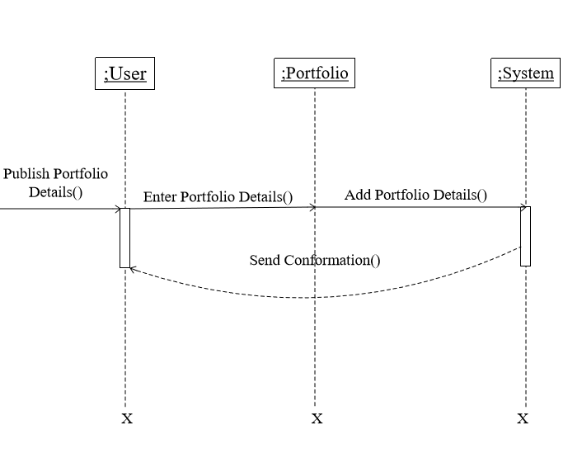Figure 4.15: Sequence Diagram of Portfolio

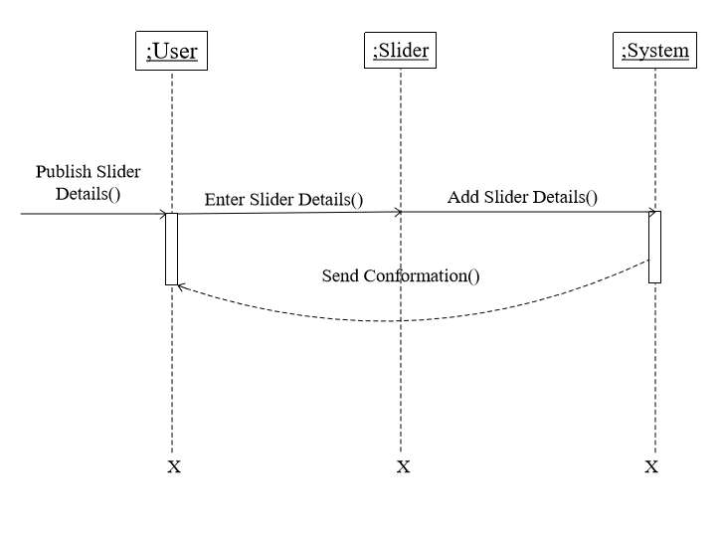Figure 4.16: Sequence Diagram of Slider

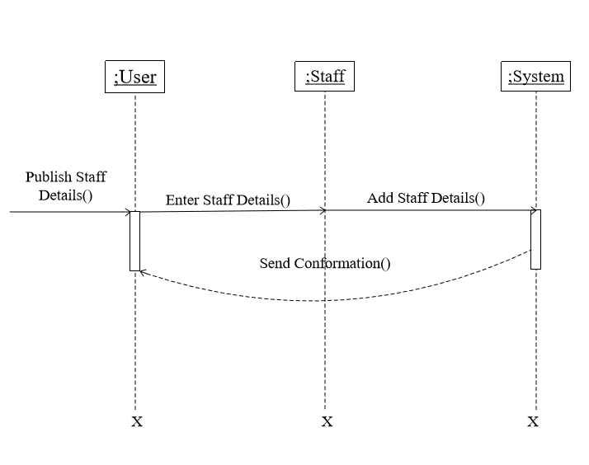Figure 4.17: Sequence Diagram of Staff

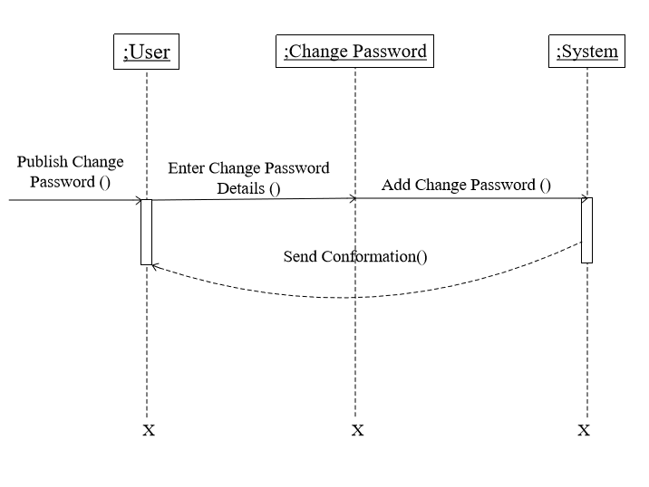

Figure 4.18: Sequence Diagram for Changing Password

# CHAPTER-5 IMPLEMENTATION AND TESTING

## 5.1 Implementation Methodology

System Implementation specifies how the system is installed operated and maintained. System implementation is also known as the test program that performs the complete system in its actual environment to determine its capabilities and limitations. Testing early in the system life cycle will reduce risks such as schedule delays or cost overruns due to incomplete or unacceptable.

Following a proper implementation method and testing of the system will prove that the system meets all its requirements, including those for performance and security.

There are two types of implementation direct implementation and parallel implementation. In this method, before completely changing over to new system, existing system and new system was to be used simultaneously until the user are well trained to ready to roll out the system.

## 5.2 Implementation Tools

### 5.2.1. Sublime Text

In our website Sublime Text has been used as a Text editor for editing the code. Sublime Text is a proprietary cross-platform source code editor with a Python application programming interface. It natively supports many programming languages and markup languages, and functions can be added by users with plugins, typically community-built and maintained under free-software licenses.

### 5.2.2. Microsoft Visio

Microsoft Vision along with draw.io was used as design tool for creating use-case, activity diagram, and sequence diagram. Microsoft Visio is a diagramming and vector graphics application and is part of the Microsoft Office family. The product was first introduced in 1992, made by the Shapeware Corporation. It was acquired by Microsoft in 2000.

### 5.2.3. Frontend and Backend Tools

Table 5.1: Frontend and Backend Tools

|  |  |
| --- | --- |
| **Front End Tools** | ● HTML  ● CSS  ● JQuery |
| **Back End Tools** | ● Apache  ● PHP  ● MY SQL |

## 5.3. Testing

Testing is used at key checkpoints in overall process to determine whether objectives are being met. Upon accomplishment of each use case, the system is fully tested using the following strategies: unit testing and integration testing.

Unit Testing

In this website development, I have used unit testing to make sure that the numbers of bugs must be solved in the development process. This can be done to increase speed, make higher probability of bug free code and easy to understand the inherited code.

Integration Testing

Here we use a variety of tools (such as HTTP unit, J unit, DB unit) and manage data in a variety of formats (HTML, Java, SQL) in order to verify web application state at different points in the architecture of a web application.

### 5.3.1. Testing Objective

1. To discover the cause of these errors.
2. To force a program to run efficiently.
3. To revise the program code to eliminate errors.
4. To identify unhandled exceptions such as input of invalid/unexpected types.
5. To gain the confidence of the customers by providing them a quality product.

### 5.3.2. Test Cases

Table 5.2: Test Cases for HTC

|  |  |  |  |  |  |
| --- | --- | --- | --- | --- | --- |
| **Test cases-Id** | **Module name** | **Test data** | **Expected result** | **Actual result** | **Remarks** |
| 1. | Admin login | Enter username and password | Enters to the admin page | Enters to the admin page | Pass |
| 2. | Add new user | Admin add new user as site moderator | New user is created | New user is created | Pass |
| 3. | Delete user | Admin delete the users account | User should be deleted | Users account has been deleted | Pass |
| 4. | Manage slider | Admin/user adds images for the slider | New slider must be added | New slider has been added | Pass |
| 5. | Manage clients | Admin/user adds name, detail, logo for the clients | New client must be added | New client has been added | Pass |
| 6. | Manage portfolio | Admin/user adds name, detail, image, link for the portfolio | New portfolio must be added | New portfolio has been added | Pass |
| 7. | Manage staff | Admin/user adds name, details, link and images for the staff | New staff must be added | New staff has been added | Pass |
| 8. | Manage pages | Admin/user adds images, title, content for the pages | New pages must be added | New pages has been added | Pass |
| 9. | Manage products | Admin/user adds name, details, price, link, images for the products | New products must be added | New products has been added | Pass |

# 

# CHAPTER-6 CONCLUSION

Some new generation may even think “herbal tea collection” is old- School but the HTC is a memory to connect the old and new generation. The family secret of making herbal tea is full of history. Although each herbal tea shop has different herbal tea making methods, we convinced that the herbal tea is a memory machine to reflect the past. Nowadays, when we feel thirsty, we may tend to choose the soft drinks instead of herbal tea, that we forget that our ancestors have inherited the treasure to us. In order to coordinate with the economic development, some herbal tea shops become commercialize. It is not too much bad but it should keep the originality. Since Good Spring Company Limited is located in the Central and near tourism spot, in a great concern, it attracts the tourists which help to spread the herbal tea culture to all over the world. To safeguard the treasure, the government should make vigorous efforts to promote herbal tea. It goes without saying that the success of herbal tea requires the devotion and cooperation of the triumvirate- business, the public and the government. Herbal tea is worth to be cultural heritage. Perhaps the herbal tea can nominate as intangible cultural heritage remain to be seen in future.

# REFERENCES

Shafik, D. (2019). *Upgrading to PHP7*. O'Reilly Media, INC, pp.40-50.

Prettyman, S. (2015). *Learn PHP7*. Apress, pp.35-50.

Carr, D. (2013). *Beginning of PHP*. 5th ed. Packt, pp.35-40.

Beighley, L. (2009). *Head First PHP & MySQL*. O’Reilly Media, pp.50-60.

Ullman, L. (2010). *PHP for web*. Pearson, pp.35-50.

# APPENDICES

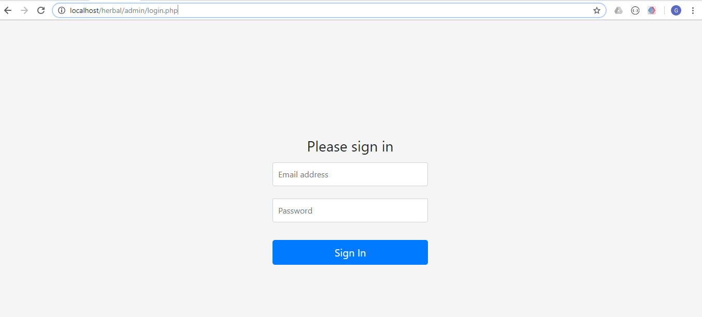

Figure: Login Panel

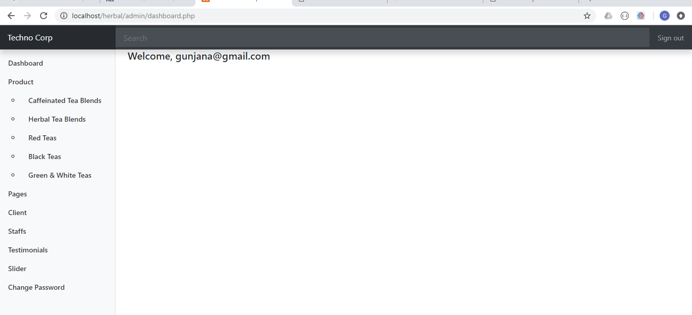

Figure: Dashboard

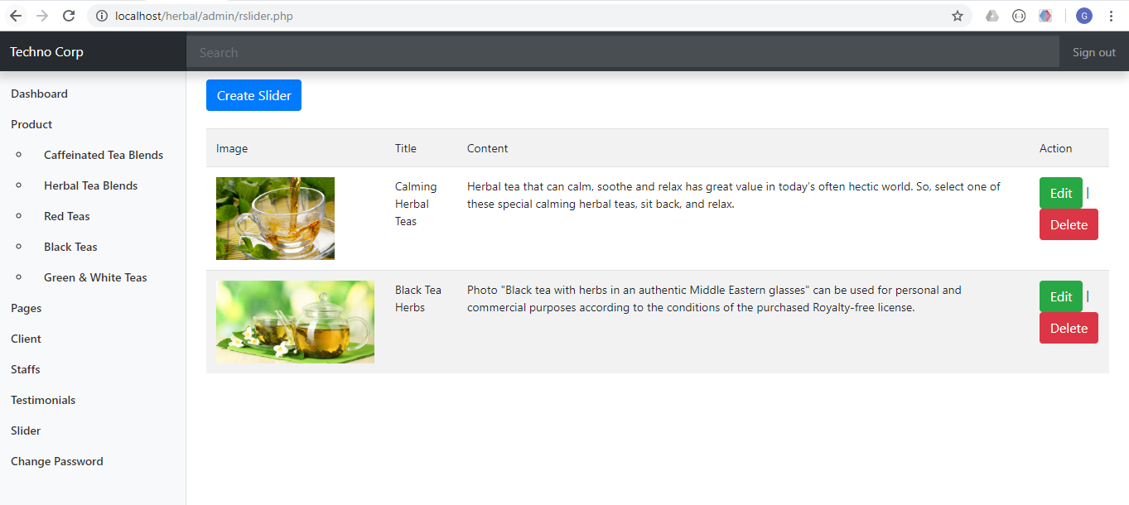

Figure: Slider Admin Page

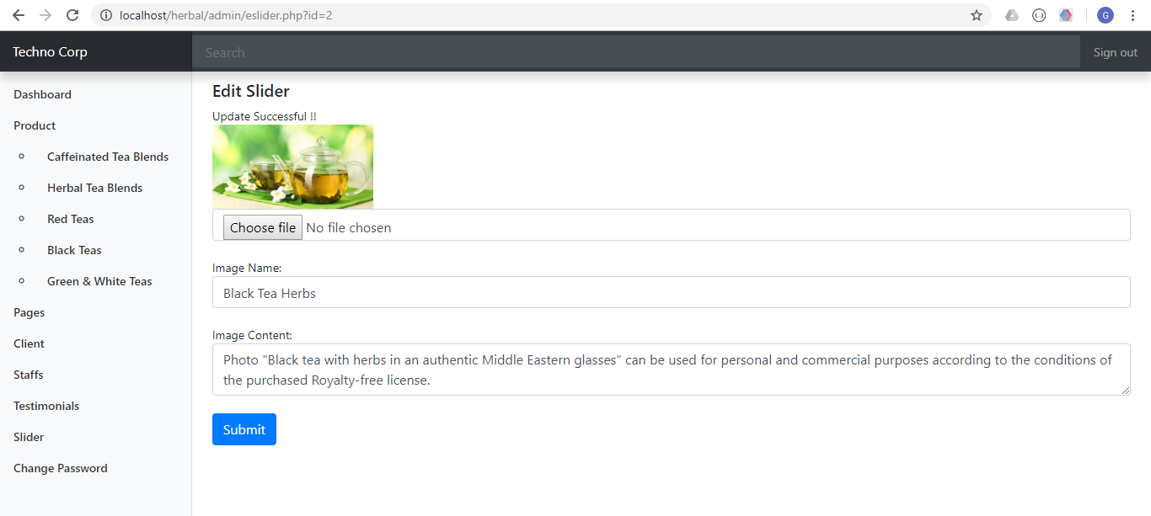

Figure: Slider Edit Page

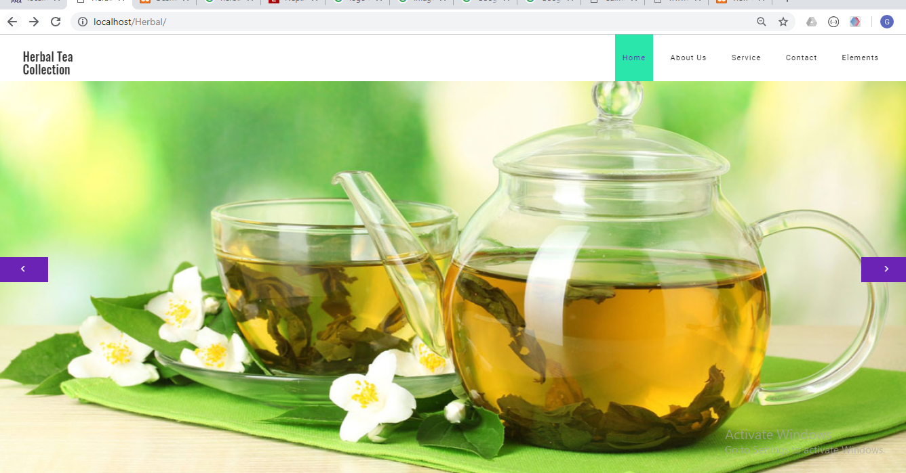

Figure: Front Page of Website

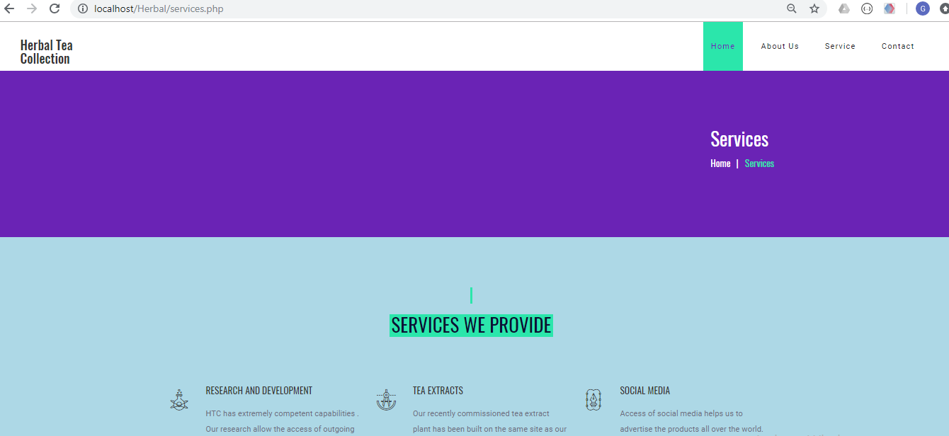

Figure: Service Page

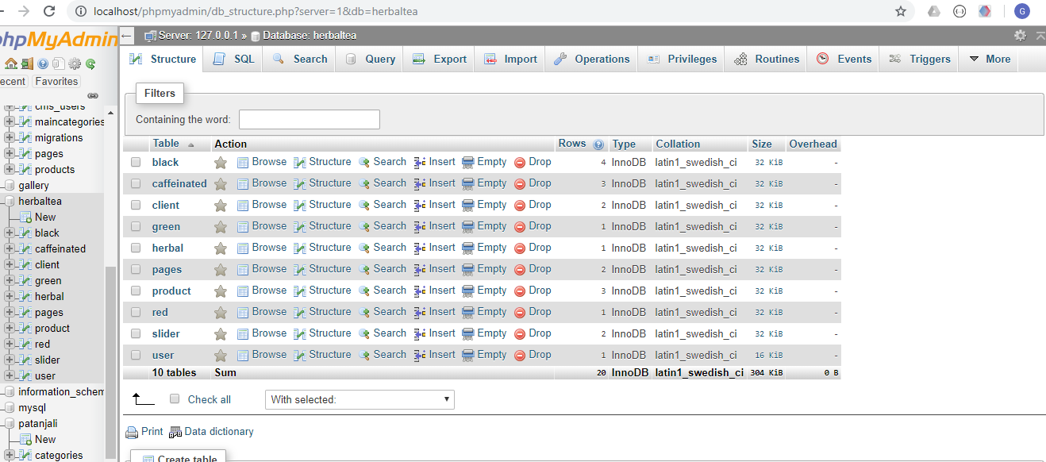

Figure: Database table used in website