### 3.1.2.1 Use Case Diagram

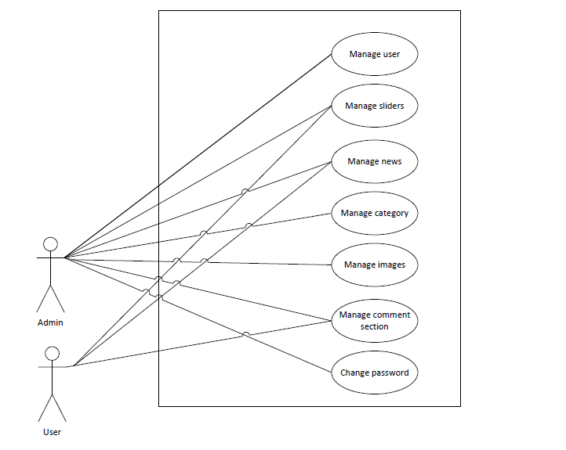

Figure 3.1: Use Case Diagram