TABLE OF CONTENT

CHAPTER-1 INTRODUCTION 1

1.1 Project Summary 1

1.2 Scope and Limitations 1

1.2.1 Scope 1

1.2.2 Limitations 1

1.3 Problem Statement 2

The existing college website is static which makes it less inattractive .It does not have database connectivity. So, Record keeping and Notice publishing is very time consuming and tiresome activity in the manual system. Moreover, the students couldnot interact properly to the details of the college through the website. Hence , they were not updated about any notices, any other information about the college. 2

1.4 Objectives 2

1.5 Introduction To Company 2

1.5.1 Company Background 2

1.5.2 Contact Details 2

1.5.3 Organization Hierarchy 3

3

1.6 Internship Information 3

1.7 Responsibility Assigned 4

CHAPTER-2 LITERATURE REVIEW 5

2.1 Similar system that exists 5

2.1.1 Wordpress 5

2.1.2 Drupal 5

2.1.3 Expression engine 5

2.1.4 Joomla 6

2.2 Introduction 6

This document is a review of some of the relevant and recent scholarly work on web development, website making, types of methodologies for the development of website and on programming methods. 6

2.3 System Development Methodology 7

2.3.1 Study of Development Methodology 7

2.3.1.1 Prototyping Model 7

Prototype model should be used when the desired system needs to have a lot of interaction with the end users. Typically, online systems, web interfaces have a very high amount of interaction with end users, are best suited for Prototype model. It might take a while for a system to be built that allows ease of use and needs minimal training for the end user. 7

2.4 Tools for Dynamic Website 7

2.4.1 PHP 8

CHAPTER-3 SYSTEM ANALYSIS 9

3.1 Requirement Collection 9

Gathering requirements is a critical step for every project. By gathering up front, enables better planning, accurate cost estimates, and mostly improved client satisfaction . Hence , a great importance was given on gathering correct requirements. Requirements gathering techniques used for this project are interviewing, use cases , and observation. 9

3.1.1 Interviewing 9

3.1.2 Use Cases 9

3.1.3 Observation 9

3.2 System Requirements 9

3.2.1 Functional Requirements 10

3.2.2 Non-functional Requirements 15

3.3 Feasibility Study 15

3.3.1 Technical Feasibility 15

3.3.2 Operational Feasibility 15

3.3.3 Economic Feasibility 16

3.3.4 Schedule Feasibility 16

3.4 Data Model of System 16

3.4.1 EER Diagram 17

CHAPTER-4 SYSTEM DESIGN 18

4.1 Architectural Design 18

4.2 Activity Diagram 18

4.3 Sequence Diagram 22

CHAPTER-5 IMPLEMENTATION AND TESTING 27

5.1 Implementation Methodology 27

5.2 Implementation Tools 27

5.2.1 Sublime Text: 27

Sublime text has been used as an text editor. 27

5.2.2 Microsoft Visio 2008 27

5.2.3 Frontend Tools 28

HTML has been used for structuring the website. 28

5.2.4 Backend Tools 28

5.2.5 Server 28

5.2.6 Database 28

5.3 Testing 28

Testing is the process for executing a program with the intent to cause and discovers errors. Upon accomplishment of each use case, the system is fully tested using the following strategies(unit testing ,integration testing). 28

5.3.1 Objective/goals 28

5.3.2 Test Case 28

CHAPTER-6 CONCLUSION 31

6.1 Summary 31

6.2 Lessons Learnt 31

REFERENCES 32

Nixon, R. (2015). *Learning PHP, MySQL, JavaScript, and CSS: A Step-by-Step Guide to Creating Dynamic Websites – by Robin Nixon*. 4th ed. Gravenstein HighwayNorth, Sebastopol: O’Reilly Media, Inc, pp.123-127,298-303. 32

SNAPSHOTS 33

APPENDIX A 35

Interviewing questions 35

**APPENDIX A**…………………………………………………………………….…35

Interviewing Questions…………………………………………………...………..35

# CHAPTER-1 INTRODUCTION

## 1.1 Project Summary

Web applications have become an essential component of business in today's world. By using the web applications, businesses can now develop and become simpler, and achieve its objectives much faster. These applications can help target numerous clientele and customers at a time. Organizations are rapidly embracing this aspect of the internet by creating web applications with the help of developers to meet their business demands. Web applications are important for a number of reasons. It is no longer possible for the businesses to see a growth in their market share unless they have a proper web application. While bigger businesses may be able to afford their own development teams for such purposes, smaller companies outsource the work to web development companies to get the same advantage at a reduced cost. It helps organisations reach new customers and let them know about the organization and the services provided by it. Web applications also provide options for an enhanced customer support. Good applications can become the first line of contact between potential customers and the business. The beauty of such applications is that they can be accessed at any time. Even location is no longer a limitation with their help. Of course, only a high quality web development company can ensure such a facility in their application.

An inventory management system is a tool that allows to track goods across the business’s supply chain. It optimizes the entire spectrum spanning from order placement with vendor to order delivery to the customer, mapping the complete journey of a product.It has been developed to override the problems in the prevailing in the manual system. Moreover, this application is designed for the particular need of the organisation to carry out operations in a smooth and effective manner.

## 1.2 Scope and Limitations

### 1.2.1 Scope

* Registration of new client/user and authentication of existing client.
* Provide a user friendly interface to the user to work with application.
* Add new goods and manage the entire item in the store.
* Generation of reports related to all the store problems.
* Demand Management.

### 1.2.2 Limitations

* The control of inventories is complex because it performs many function.
* Cost may be high for implementation and maintenance.

## 1.3 Problem Statement

## The existing college website is static which makes it less inattractive .It does not have database connectivity. So, Record keeping and Notice publishing is very time consuming and tiresome activity in the manual system. Moreover, the students couldnot interact properly to the details of the college through the website. Hence , they were not updated about any notices, any other information about the college.

## 1.4 Objectives

1. To minimize the inventory investment.
2. To provide desired level of customer service.
3. To overcome the problem faced during manual system.
4. To allow cost-efficient operations.

## 1.5 Introduction To Company

### 1.5.1 Company Background

Techware Pvt. Ltd. is an Information Technology company incorporated on March 28, 2017. The company has been established with the main aim to apply and leverage computing power as well as Information Technology solves the complex business, social and economic problems. The company segments include cognitive solution, technology services, solution and training. Since its establishment the company has been steadily moving forward to achieve its goal by applying the emerging technologies to various domains and provide unique and cost-effective solution. It also provides training to the interns and assigns the intern with the real world projects related to their fields. It is an organization that promotes web applications and Apps development. Techware mission is to provide a digital solution for website, CMS, e-commerce, web application and SEO. For each of the solution the Techware focuses on making it efficient, user friendly as well as cost effective. Techware works with languages and technologies like Angular, Node.js, .net, PHP with Laravel, MySQL and some other development tools.

### 1.5.2 Contact Details

Table-1.1 Contact Details of the Company

|  |  |
| --- | --- |
| Organization Name | Techware Pvt.Lmt. |
| Address | Bhupimarga,Biratnagar-03 |
| Mobile no. | 9851196943, 9805310618 |
| Email | [info@techware.com.np](mailto:info@techware.com.np) |
| Website | Techware.com.np |

### 1.5.3 Organization Hierarchy

### 

CEO

Training Department

Web Development

HR Department

Training Director

Manager

Project Manager

Trainer

Counselor

Intern

System Admin

Writer

QA

Developer

Designerr

Figure 1.1 Organizational Hierarchy

## 1.6 Internship Information

Table- 1.2 Internship Duration and Description

|  |  |
| --- | --- |
| Position |  |
| Start Date of Internship | 20th of November |
| End Date of Internship | 20th of February |
| Total Duration | 3 months |
| Office Hour | 10 am to 5 pm |
| Working Hour | 7 hours per day |
| Working Days | 6 days per week |
| Mentor | Kapil Dahal |
| Project | Web development |

## 1.7 Responsibility Assigned

As an intern I have got to learn basics about many web development frameworks and languages. Various responsibilities had been assigned to us such as designing forms, components and modules and perform necessary modifications and upgrades, and small bug fixing. All these task were done using Php framework (Laravel Framework). I worked as a Web Developer and was assigned to create category,item part, and perform related database operations and validations in creation for the project.

I was responsible to perform the following task as an intern:

a)To be familiar with the workflow of the project.

b)To understand the requirement of the project and collect entities and attributes required for building the effective database.

c)To develop the employee valued skills like communication inside and outside the organization.

d) To perform the testing like unit testing, System testing.

# CHAPTER-2 LITERATURE REVIEW

## 2.1 Similar system that exists

Some of the currently running systems include K12 Online Education and Virtual SC. Both of them are quite similar to the Virtual School but both of them are unreachable for common Nepali students as they demand certain cha.

### 2.1.1 Wordpress

Wordpress is a free and open-source content management system (CMS) based on PHP & MySQL Features include a plugin architecture and a template system. It is most associated with blogging but supports other types of web content including more traditional mailing lists and forums, media galleries, and online stores. Used by more than 60 million websites, including 30.6% of the top 10 million websites as of April 2018,

### 2.1.2 Drupal

Drupal is another CMS that has a very large, active community. Instead of focusing on blogging as a platform, Drupal is more of a pure CMS. A plain installation comes with a ton of optional modules that can add lots of interesting features like forums, user blogs, OpenID, profiles and more. It's trivial to create a site with social features with a simple install of Drupal.

One of Drupal's most popular features is the Taxonomy module, a feature that allows for multiple levels and types of categories for content types.

### 2.1.3 Expression engine

Expression Engine(EE)is an elegant, flexible CMS solution for any type of project. Designed to be extensible and easy to modify, EE sets itself apart in how clean and intuitive their user administration area is. It takes only a matter of minutes to understand the layout of the backend and to start creating content or modify the look. It's fantastic for creating websites for less-than-savvy clients that need to use the backend without getting confused.

One of my favorite features of EE that is the global search and replace functionality. Anyone who's ever managed a site or blog knows how useful it is to change lots of data without having to manually search and open each page or post to modify it.

### 2.1.4 Joomla

Joomla is a very advanced CMS in terms of functionality. The Joomla site hosts more than 3,200 extensions, so you know the developer community behind the popular CMS is alive and kicking. Like Wordpress, you can add just about any needed functionality with an extension. However, the Joomla theme and extension community relies more on paid resources.

## 2.2 Introduction

Inventory or stocks are the lifeline and constitute brand image of any company or business. Beginning from the manufacturing stage to the tracking of products and parts during their transportation from vendor to warehouse, between the warehouses and then to retail location or directly to the customer. An Inventory Management Software is a computer based system software to keep track on inventory levels, orders, sales and deliveries. The Manufacturing industry can utilize it to generate work orders and bills of materials. Regular usage of inventory management software can keep check on overstocking of product and outages. Inventory data can be organized in an ‘easy to access and operate way’ and the old method of maintaining data in the form of lengthy spreadsheets can be shunned completely

## 2.3 System Development Methodology

A Software Development life cycle binds to the important stages that are necessary for developers like planning, analysis, design and implementation. Several SDLC models in use include Waterfall models, Agile, Spirals ,Prototyping etc. For the Development of this CMS, I preferred the prototyping method.

### 2.3.1 Study of Development Methodology

### 2.3.1.1 Prototyping Model

### Prototype model should be used when the desired system needs to have a lot of interaction with the end users. Typically, online systems, web interfaces have a very high amount of interaction with end users, are best suited for Prototype model. It might take a while for a system to be built that allows ease of use and needs minimal training for the end user.

Here, in the project we have used prototyping model as software development methodology. First a sample prototype was made according to the client’s base requirements. All the necessary requirements were gathered. A working model was provided to the clients. Taking responses to the working model from the clients, a new prototype was again developed. This methodology has made the work easier as the clients were actively involved in the development and missing functionality was identified in the earlier stages of development.

## 

## 2.4 Tools Used

Creation of database-driven websites used to be complex and time consuming before server-scripting tools were invented to make it easier.to generate the content from their databases instead of manually coding in HTML. The two most popular and competing technologies for creating database-driven websites are open source PHP and Microsoft’s ASP. PHP has been chosed for the development of this CMS.

### 2.4.1 PHP

PHP is widely used and popular in Web development community, following the proliferation of Apache on Linux and UNIX servers and Windows servers too.

Advantages of PHP

PHP is an open source code and works with a multitude of servers on many different operating systems including Microsoft’s . PHP is designed specifically as a web scripting language, hence it is very efficient to learn and implement.

Disadvantages of PHP

PHP is not suitable for making desktop applications, and error handling is traditionally considered poor when compared to other programming language.

# 

# 

# CHAPTER-3 SYSTEM ANALYSIS

## 3.1 Requirement Collection

## Gathering requirements is a critical step for every project. By gathering up front, enables better planning, accurate cost estimates, and mostly improved client satisfaction . Hence , a great importance was given on gathering correct requirements. Requirements gathering techniques used for this project are interviewing, use cases , and observation.

## 3.1.1 Interviewing

Users were interviewed using a set of open-ended questions, and then more probing questions were asked that helped to uncover requirements. These interviews were planned ahead of time.The interview were conducted over phone. Even though this technique proved to be time-consuming, it was good for exploring many important issues of the system.

### 3.1.2 Use Cases

Use cases helps to describe the functional requirements of the system. It explains the dynamic behavior of the system. It also shows the interactions between the actor and the system.

### 3.1.3 Observation

This technique involved observing users by watching their behaviors in the clients/users natural settings. This techniques helped to identify process flows, opportunities for improvements and uncover implicit requirements.

## 3.2 System Requirements

### 3.2.1 Functional Requirements

Functional Requirements defines what the system must do. It defines the behaviors or functions of a system, flows, business rules and other requirements of a system along with its output. The functional requirements are discussed below:

a. Admin

i) Admin can manages all the functionalities of the system.

ii)Admin can add or delete the product.

iii) Admin can manage the category ,manages the item part.

b. User

i)A user can manage the pages.

ii)A user can review all the functionalities and manages them except managing the notices section.

Iii A user cannot manages the other users.

3.2.1.1 Use Case Diagram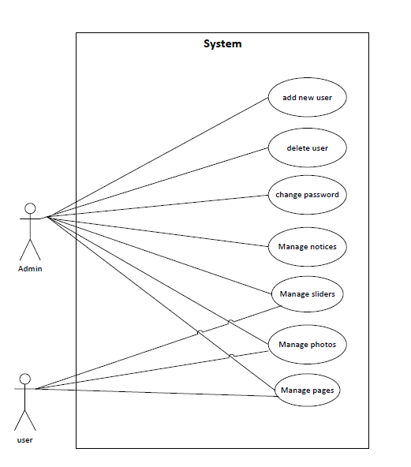

Figure-3.1 Use Case Diagram

#### 3.2.1.2 Expanded Use Case

Table-3.1 Use Case to Manage Category

|  |  |
| --- | --- |
| **Use Case Diagram** | **UC-1 Manage Category** |
| **Primary Actor** | Admin |
| **Secondary Actor** | None |
| **Description** | The admin should be able to add new product modify the category. |
| **Pre-condition** | The user must be logged in as admin. The user should not be already present within the system. |
| **Post-condition** | Category is updated in the database. An appropriate success message is shown on the screen. |
| **Failure scenario** | The database is not updated. Success or error message is not displayed on the screen. |

Table-3.2: Use Case to Manage Item

|  |  |
| --- | --- |
| **Use Case Identifiers** | **UC-2 Manage Items** |
| **Primary Actor** | Admin |
| **Secondary Actor** | None |
| **Description** | The admin should be able to add items, modify the items, delete any items. |
| **Pre-condition** | The user must logged in as admin. |
| **Post-condition** | The items is updated in the database. An appropriate success message is displayed on the screen. |
| **Failure scenario** | The database is not updated. Success or error message is not displayed on the screen |

Table-3.3: Use case to View Detail

|  |  |
| --- | --- |
| **Use Case Identifier** | **UC-3 Manage Pages** |
| **Primary Actor** | Admin |
| **Secondary Actor** | None |
| **Description** | The admin should be able to view category, modify the pages and delete the pages. |
| **Pre-condition** | The user must logged in as admin. The view page should not be present already within the system. |
| **Post-condition** | Pages list is updated in the database. An appropriate success message is displayed on the screen. |
| **Failure scenario** | The database is not updated. Success or error message is not displayed on the screen. |

Table-3.4: Use Case to Manage Sliders

|  |  |
| --- | --- |
| **Use Case Identifier** | **UC-4 Manage Sliders** |
| **Primary Actor** | Admin |
| **Secondary Actor** | None |
| **Description** | The admin should be able to add new slider photo, modify the slider photo and delete the slider photo. |
| **Pre-condition** | The user must logged in as admin. The slider category should not be present already within the system. |
| **Post-condition** | Slider photo is updated in the database. An appropriate success message is displayed on the screen. |
| **Failure scenario** | The database is not updated. Success or error message is not displayed on the screen. |

Table-3.5: Use Case to Manage Photos

|  |  |
| --- | --- |
| **Use Case Identifiers** | **UC-5 Manage Photos** |
| **Primary Actor** | Admin |
| **Secondary Actor** | None |
| **Description** | The admin should be able to add new photo for gallery, modify the photo for the gallery and delete the photo for the gallery. |
| **Pre-condition** | The user must logged in as admin. The photo category should not be present already within the system. |
| **Post-condition** | Photo for gallery is updated in the database. An appropriate success message is displayed on the screen. |
| **Failure scenario** | The database is not updated. Success or error message is not displayed on the screen. |

### 3.2.2 Non-functional Requirements

Non-functional requirements define how the system should be. This requirements are the backbone of the any system. It covers all the remaining requirements which are not covered by functional requirements.

#### 3.2.2.1 Performance

It requires minimal hardware features. It stores the information of the notices, pages and detailed information of the institute. So, it requires more than 1 GB hard disk.

#### 3.2.2.2 Hardware

It is a web based CMS and it requires internet and browser to run. Different browser that supports PHP, JavaScript can operate this website.

#### 3.2.2.3 Software

Admin can monitor the user easily through the system. Creating and managing the contents does not require more effort. Large numbers of data can be added in the system easily.

## 3.3 Feasibility Study

The feasibility study is an analysis of how successfully a project can be completed accounting for factors that affect it such as economic, technological, operational and scheduling factors.

The different analysis of the system is carried out below:

### 3.3.1 Technical Feasibility

Technical feasibility involves evaluation of the hardware and the software requirements of the proposed system. This application is developed using Sublime text editor , XAMPP, and MYSQL for database. Google Chrome and Mozilla Firefox are used to run the application for facilitating user interface. So this system is technically feasible. All the necessary hardware and software required for developing and installing the system are available.

### 3.3.2 Operational Feasibility

Operational Feasibility is a measure of how well a proposed system solves the problems. The requirements for the system are feasible to operate and translate them into the system. Use of different technology like PHP laravel for backend to interact with database and HTML, CSS, Bootstrap for the UI design made the system operationally feasible to build.

### 3.3.3 Economic Feasibility

User’s requirements can be accumulated and is economically feasible to work upon. We used PHP as server script and HTML, CSS and JavaScript to develop the frontend of the site. Apache is used as a backend server and as a database server we used MySQL Server.

### 3.3.4 Schedule Feasibility

The project fails if it takes too long to be completed before it is useful. Typically, this means estimating how long the system will take it to develop. Although this site can be enlarge as required but it was developed with functionalities that were enough for the institute. So, it reduces the time cost for its development and had enough time to complete it.

## 3.4 Data Model of System

### 3.4.1 EER Diagram

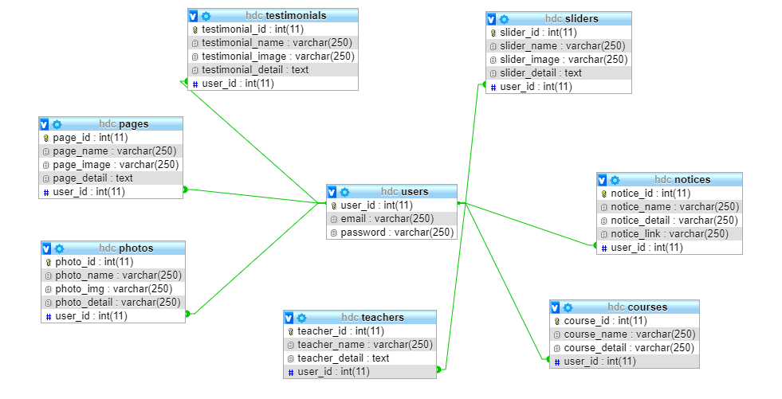

Figure-3.2 EER Digram

# 

# CHAPTER-4 SYSTEM DESIGN

# 

## 4.1 Architectural Design

Browser

1st tier

Request Response

Server

Middle tier

Request Response

DB

Database tier

Figure-4.1 : Architectural design diagram

## 4.2 Activity Diagram

It shows the operations(actions)involved in performing some use-cases. It shows the step-wise decomposition/transition and control flows while implementing a certain use-case. It also shows the alternative path, concurrent path to execute a particular use-case.

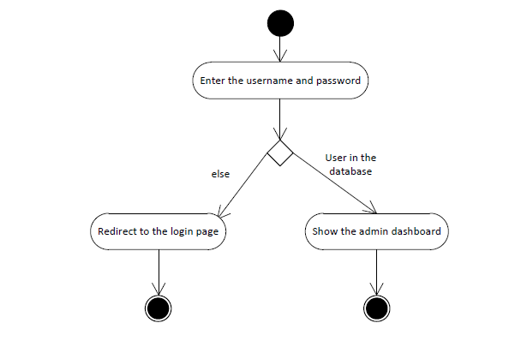

Figure-4.2 : Activity Diagram for Login

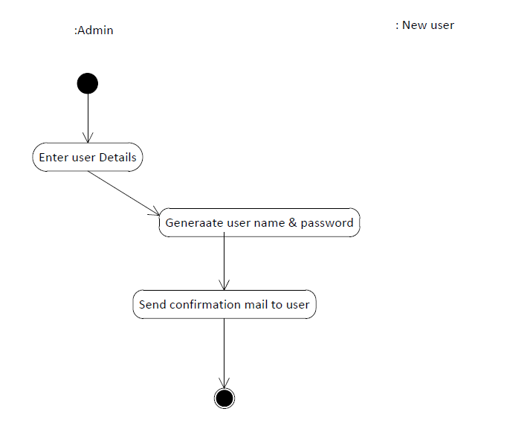

Figure-4.3 : Activity Diagram to create new user.

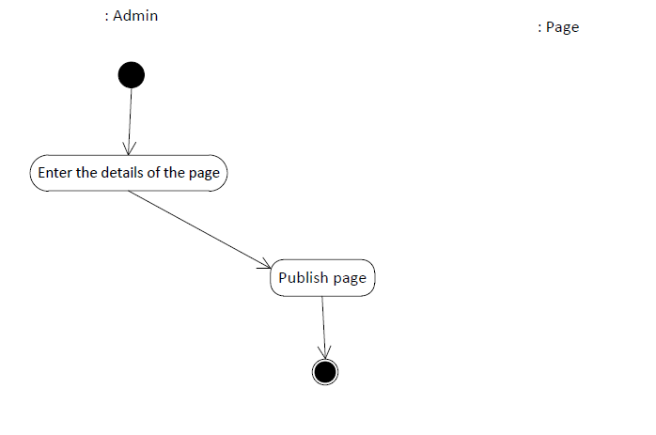

Figure-4.4 : Activity Diagram to publish pages

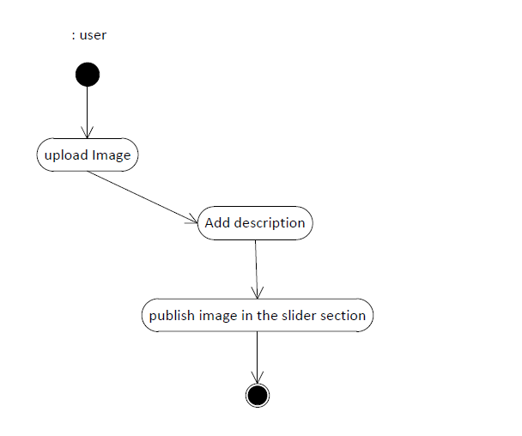

Figure -4.5: Activity diagram to publish image for slider/gallery

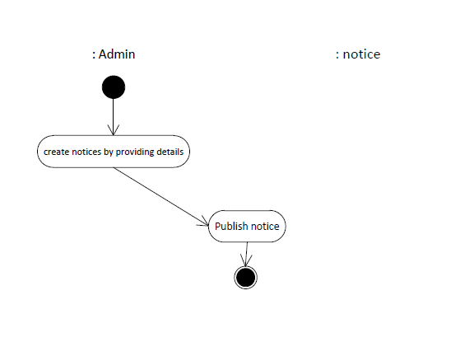

Figure-4.6 : Activity Diagram to publish notices

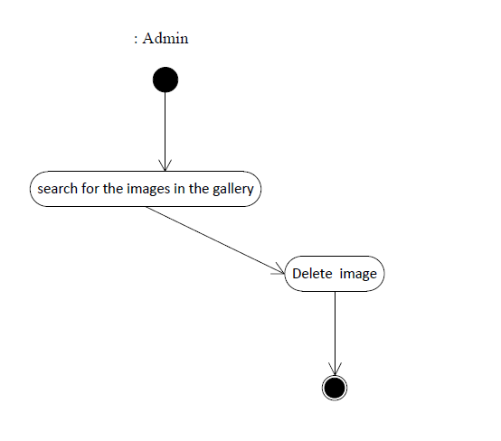

Figure-4.7: Activity Diagram For deleting Images

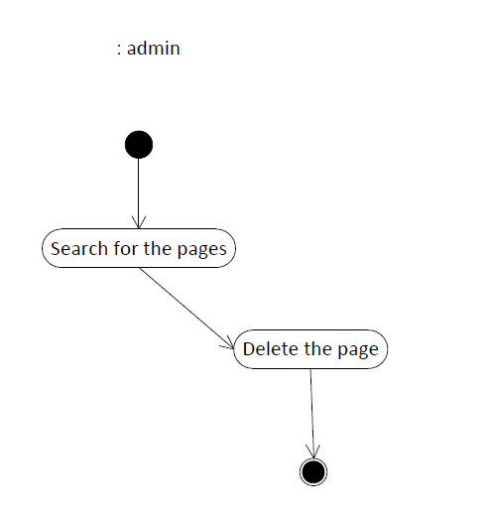

Figure-4.8 : Activity diagram for deleting the pages

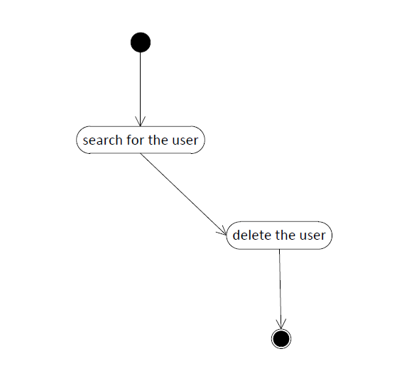

Figure-4.9: Activity Diagram for deleting the user

## 4.3 Sequence Diagram

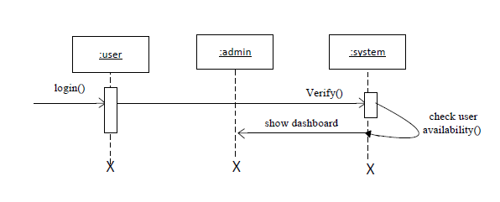

Figure-4.10 : Sequence diagram for user login

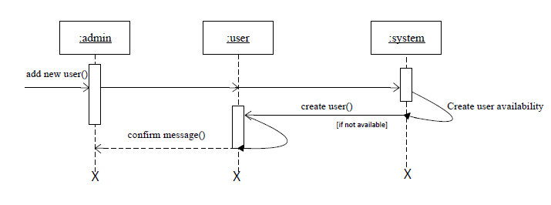

Figure-4.11 : Sequence diagram for creating new user

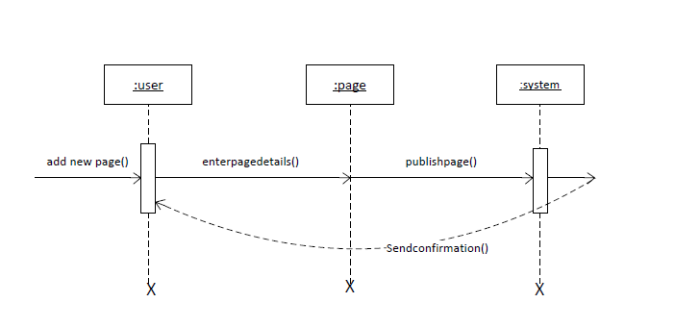

Figure-4.12 : Sequence diagram for creating new pages

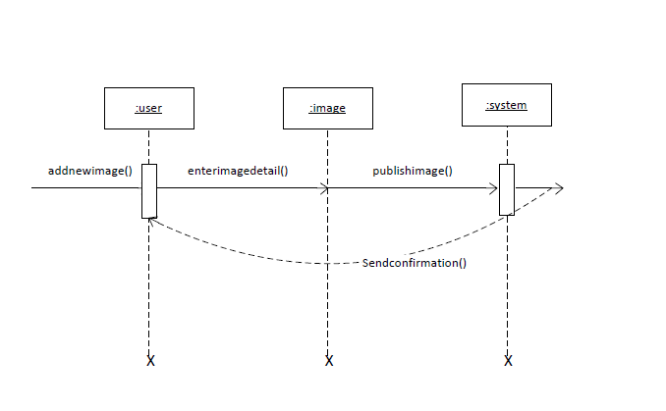

Figure-4.13 : Sequence Diagram for creating new image

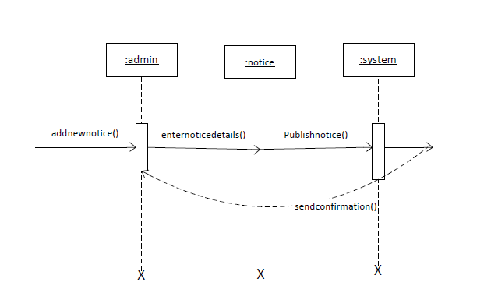Figure-4.14 : Sequence diagram for creating notice

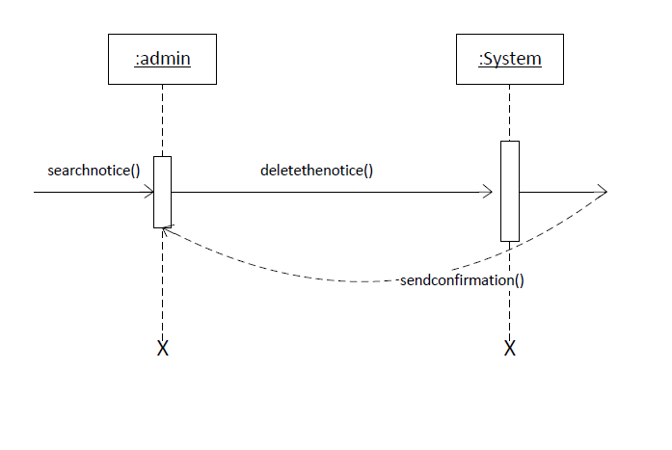

Figure-4.15: Sequence diagram for deleting the notice

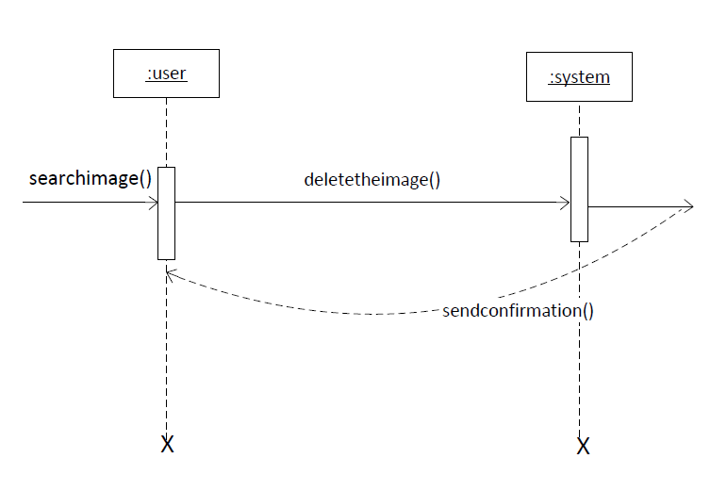

Figure-4.16:Sequence diagram for deleting the image

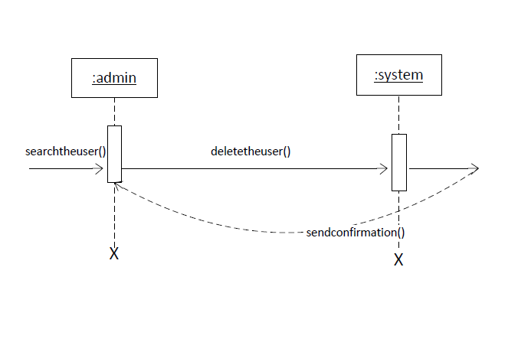Figure-4.17 : Sequence diagram for deleting the user

# 

# CHAPTER-5 IMPLEMENTATION AND TESTING

## 5.1 Implementation Methodology

System Implementation specifies how the system is installed, operated and maintained. System implementation is also known as the test program that perform the complete system in its actual environment to determine its capabilities and limitations.

The project began with the analysis of the requirements and the conceptual pattern was design. After the overall analysis of the system, designing of the database, tables and user interface was started. After that coding and debugging, the system was implemented.

There are generally two different types of Implementation. They are Direct Implementation and Parallel Implementation .Parallel Implementation is used. In this Implementation method, before completely changing over to new system, existing system and new system was to be used simultaneously until the users are well trained to ready to roll out the system .

## 5.2 Implementation Tools

## **5.2.1 Sublime Text**:

## Sublime text 3 has been used as an text editor.

### 5.2.2 Microsoft Visio 2008

Microsoft visio 2008 was used as design tool for creating use-case, activity diagram , sequence diagram and other required diagram.

### 5.2.3 Frontend Tools

### HTML has been used for structuring the website.

CSS has been used for styling the website.

JQuery like languages has been used for handling the events in the website.

### 5.2.4 Backend Tools

PHP has been used for backend development in the project

### 5.2.5 Server

Apache has been used as web server.

### 5.2.6 Database

MySQL 5.7 has been used as database and performing the database operations in this project.

## 5.3 Testing

## Testing is the process for executing a program with the intent to cause and discovers errors. Upon accomplishment of each use case, the system is fully tested using the following strategies(unit testing ,integration testing).

### 5.3.1 Objective/goals

The main goals of testing are:

i)To force a program to run efficiently.

ii) To discover the cause of these errors.

iii) To revise the program code to eliminate errors.

### 5.3.2 Test Case

Figure-5.1 Testcases

|  |  |  |  |  |  |
| --- | --- | --- | --- | --- | --- |
| Test cases-Id | Module name | Test data | Expected result | Actual result | Remarks |
| 1 | Admin Login | Enter user name and password | Must enter to the admin page | Invalid user name/password | Fail |
| 2 | Admin Login | Enter username and password | Enters to the admin page | Enters to the admin page | Pass |
| 3 | Add new user | Admin adds new user as site moderator | New user is created | New user is created | Pass |
| 4 | Delete user | Admin deletes the user’s account | User should be deleted. | User’s account has been deleted | Pass |
| 5 | Delete user | Admin deletes the user’s account | User’s should be deleted | User not found | Fail |
| 6 | Manage notices | Admin can add,delete,update the notices | Notices should be added, updated and deleted. | Notices is added, updated and deleted. | Pass |
| 7 | Manage sliders | Admin/user adds images for the slider | New slider must be added | New slider has been added. | Pass |
| 8 | Manage photos | Admin/user adds and deletes the photos for the gallery | New photos should be added and deleted if necessary and a message should be displayed on the screen | New photos has been added and deleted and message is successfully displayed on the screen. | Pass |
| 9 | Manage Courses | Admin/user adds the courses. | Courses should be added and message should be displayed on the screen | Courses has been added and successfully message is displayed on the screen. | Pass |
| 10 | Manage faculty members | Admin/users can adds the faculty members | Faculty members must be added and a message should be displayed on the screen | Faculty members has been added and successfully message is displayed on the screen. | Pass |
| 11. | Manage user’s site | None | Guests or people who visit the site must be accessible to all the pages. | Guests are accessible to the pages of the site | Pass |

# CHAPTER-6 CONCLUSION

## 

## 6.1 Summary

This project was done as a part of internship project for Bachelors of Science in Computer Science and Information Technology (Bsc.CSIT) program offered by Tribhuvan University , Nepal. It was undertaken to plan , design and develop a CMS for Himalaya Darshan College.

By the development of the project , the project was a complete dynamic website for Himalaya Darshan college which allows to manage the day to day operations of the college and main it aims to have a good interactions with the students and guests who visits the websites. The system has been developed with much care that it is free of errors and it is efficient and less time consuming.

The advantage is that this build website can be enhanced, modified or changed to the growing requirements of the users in the future.

## 6.2 Lessons Learnt

Being in the internship program and handling the designation of PHP developer , I learned a lot of employee valued skills. I learned about the good personal presentation. I learned developer’ skills and also learned how to use the developer’s tools. The internship has taught me time management, as working in a company means you have to take care of the deadlines and milestones. This internship has been an excellent and rewarding experience. It has been a great opportunity to improve personal and professional skills. This valueable skills have boosted my professional skills to higher level and prepare me for better future in this career.

# REFERENCES

## Nixon, R. (2015). *Learning PHP, MySQL, JavaScript, and CSS: A Step-by-Step Guide to Creating Dynamic Websites – by Robin Nixon*. 4th ed. Gravenstein HighwayNorth, Sebastopol: O’Reilly Media, Inc, pp.123-127,298-303.

Forbes, A. (2015). *The Joy of PHP: A Beginner's Guide to Programming Interactive Web Applications with PHP and MySQL*. 3rd ed. CreateSpace Independent Publishing Platform.

Dracup, J. (2016). *Connecting to a MySQL Database & Displaying Records on a Web Page*. [video] Available at: https://www.youtube.com/watch?v=og7TtjUdogA [Accessed 14 Dec. 2018].

# SNAPSHOTS

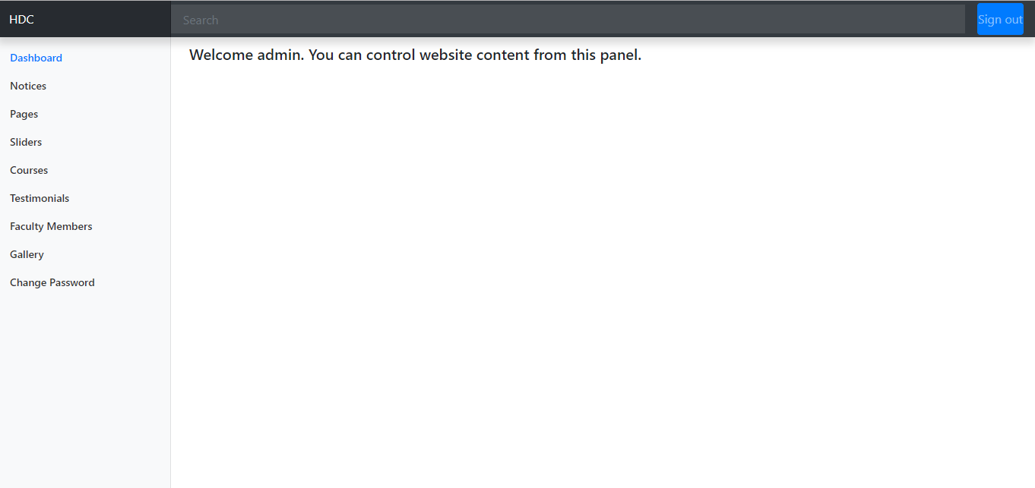

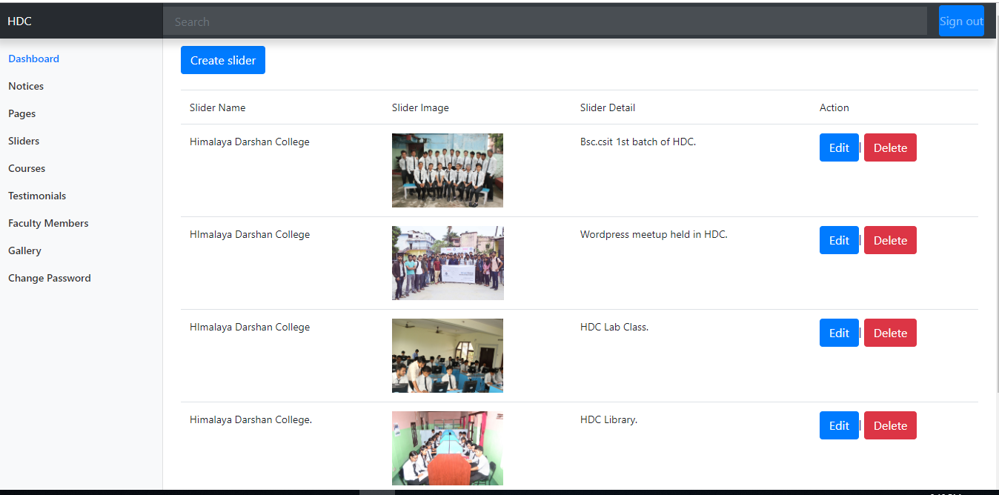

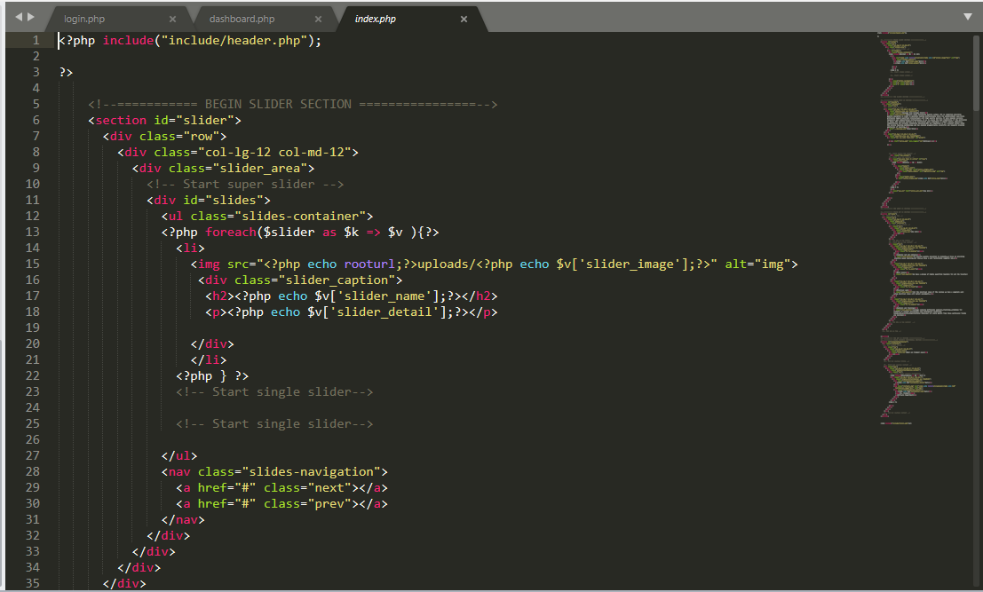

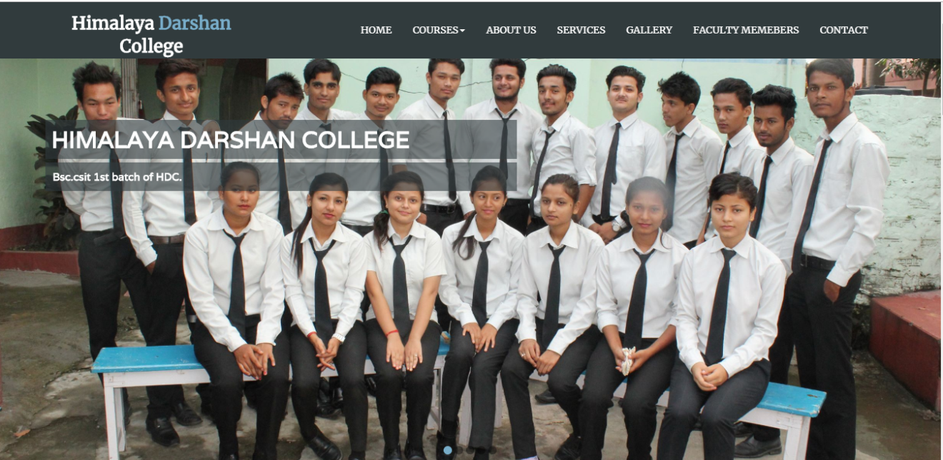

# APPENDIX A

# 

# Interviewing questions

* Describe about your institution.
* What do you want your site to accomplish?
* Do you already have a website already? If yes, why do you want a new website?
* What features do you want your website to have?
* Do you have any style guide?
* What’s your timeline?
* Do you require your site to be mobile friendly?
* Do you have any specific colors that need to be used for your website?