# CHAPTER-1

# INTRODUCTION

## 1.1 Introduction of internship

An internship is a period of work experience offered by an organization for a limited period of time. An internship gives a student the opportunity for career exploration and development, and to learn new skills. It helps the student develop and achieve learning goals. It offers the employer the opportunity to bring new ideas and energy into the workplace, develop talent and potentially build a pipeline for future full-time employees. A quality internship:

* Consists of a part-time or full-time work schedule that includes no more than 25% clerical or administrative duties.
* Provides a clear job/project description for the work experience.
* Helps the student develop and achieve learning goals.
* Offers regular feedback to the student intern.

As a part of the BSC CSIT program, the college under Tribhuvan University authorizes this internship program with the motive of blending theoretical knowledge to practical experience. I accomplished this internship program at Techware Pvt.Ltd,biratnagar. As stipulated by the University, the duration of internship was two months..

## 1.2 Project summery

## A website is a collection of publicly accessible, interlinked Web pages that share a single domain name. Websites can be created and maintained by an individual, group, business or organization to serve a variety of purposes. Together, all publicly accessible websites constitute the World Wide Web.

## The project is based on web development for GLOBAL SAS TRADING COMPANY. This website allows a platform for trading company to tender their products regarding trade types that is their products. The project provides customers to view the products detail according to their requirements.

## The objective behind the project, GLOBAL SAS TRADING is to make the access of information regarding trading company and their products a lot easier

### 1.2.1 Scope

1. Access to be able to content manage the web site from any laptop, anyplace in the world (that has web connection)
2. It is mobile responsive
3. This report focuses on the global market.
4. International trade helps in many other ways such as benefits to consumers, international peace and better standard of living.

### 1.2.2 Limitations

1. Cost of implementing training of Content management system to Client.
2. For smaller firms a Dynamic web site might be too expensive or seen as unnecessary that the investment may not be even
3. Slightly longer initial development time

## 1.3 Problem Statement

## A study was done of the existing site to understand about the flaws and functionalities of the system. The main goal of the project was to enhance and develop a new website for trading company that features and rectify the problems faced in the existing website. So, understanding and analyzing the issues carefully was very important. In this case, the existing website of the company was hardly user friendly and interactive. All the task from searching till getting the complete details include manual labor.

## More specific problems are listed as follows:

* UI/ UX design is outdated and less user friendly.

## Less availability of all the information in the existing website

## Website is not fully functional.

## After understanding the problems, it led to the conclusion that a new web application which is easily accessible and convenient to use should be developed.

## Objectives

1. To provide peoples to be updated about trading company.
2. To allow users to access that information via the website.
3. To develop a website which will represent trading company in internet.
4. To develop an interactive and responsive web site which contains information about trading company and their products.
5. To provide user-friendly interface.

## 1.5 Introduction To Company

### 1.5.1 Company Background

Techware Pvt.Ltd is a Software development organization as well as the IT Training Center. It provides its services to the clients of Nepal. It also provides training to the interns and assigns the intern with the real world projects related to their fields. It is an organization that promotes web applications and Apps development. This organization emphasizes on creating quality products where the clients values are well understood and transformed to user-friendly solutions. With the team of technical personnel’s, highest level of expertise in the field of software and web development and the best mentors for the trainnes and interns, Techware Pvt.Ltd hopes to become best in the Nepalese market.

### 1.5.2 Contact Details

Table-1.1 Contact Details of the Company

|  |  |
| --- | --- |
| Organization Name | Techware Pvt.Ltd |
| Address | Bhupi Marg, Biratnagar-3, Morang, Nepal |
| Telephone no. | +(977)9851196943, +(977)9805310618 |
| Email | info@techware.com.np |
| Website | www.techware.com |

### 1.5.3 Organization Hierarchy

CEO

HR Manager

Project Manager

QA Development

Sr. Developer

Developer

Sr. Developer

Developer

Sr. Developer

Developer

…

Me/Intern

Figure 1.1 Organizational Hierarchy

## 1.6 Internship Information

Table- 1.2 Internship Duration and Description

|  |  |
| --- | --- |
| Position |  |
| Start Date of Internship | 20th of November |
| End Date of Internship | 20th of February |
| Total Duration | 3 months |
| Office Hour | 10 am to 6 pm |
| Working Hour | 8 hours per day |
| Working Days | 5 days per week |
| Mentor | Sagun Siwakoti |
| Project | Web development |

## 1.7 Responsibility Assigned

I was assigned to build up a dynamic trading website including the frontend and backend activities along with the coding of each and every functionalities of the project.

I was responsible to perform the following task as an intern:

a)To be familiar with the workflow of the project.

b)To understand the requirement of the project and collect entities and attributes required for building the effective database.

c)To develop the employee valued skills like communication inside and outside the organization.

d) To perform the testing like unit testing, System testing.

# CHAPTER-2

# LITERATURE REVIEW

## 2.1 Similar system that exists

There are plenty of options when it comes to picking a content management system for a development project. Depending on how advanced you need the CMS to be, what language it's built in, and who is going to be using it, it can be a nightmare trying to find the "perfect" CMS for a project.

### 2.1.1 Wordpress

Wordpress is a free and open-source content management system (CMS) based on PHP & MySQL Features include a plugin architecture and a template system. It is most associated with blogging but supports other types of web content including more traditional mailing lists and forums, media galleries, and online stores. Used by more than 60 million websites, including 30.6% of the top 10 million websites as of April 2018,

### 2.1.2 Drupal

Drupal is another CMS that has a very large, active community. Instead of focusing on blogging as a platform, Drupal is more of a pure CMS. A plain installation comes with a ton of optional modules that can add lots of interesting features like forums, user blogs, OpenID, profiles and more. It's trivial to create a site with social features with a simple install of Drupal.One of Drupal's most popular features is the Taxonomy module, a feature that allows for multiple levels and types of categories for content types.

## 2.2 Introduction

## This document is a review of some of the relevant and recent scholarly work on web development, website making, types of methodologies for the development of website and on programming methods.

This literature review shows that for the development of the website , prototyping is the most appropriate development methodology and PHP is the ideal tool for developing this website.

With the advent in web technologies and its embracement by people, Website has made a significant transition from simple and static websites to dynamic ,multimedia rich websites , capable of interacting with visitors in a sophisticated way. Web development is an ever-changing phenomenon, highly sensitive to all the expectations and requirements of the modern user. The layouts has been made simple and attractive in order to made more comfort in reading and navigating the site.

## 2.3 System Development Methodology

A Software Development life cycle binds to the important stages that are necessary for developers like planning, analysis, design and implementation. Several SDLC models in use include Waterfall models, Agile, Spirals ,Prototyping etc. For the Development of this CMS, I preferred the prototyping method.

### 2.3.1 Study of Development Methodology

### 2.3.1.1 Prototyping Model

### Prototype model should be used when the desired system needs to have a lot of interaction with the end users. Typically, online systems, web interfaces have a very high amount of interaction with end users, are best suited for Prototype model. It might take a while for a system to be built that allows ease of use and needs minimal training for the end user.

Here, in the project we have used prototyping model as software development methodology. First a sample prototype was made according to the client’s base requirements. All the necessary requirements were gathered. A working model was provided to the clients. Taking responses to the working model from the clients, a new prototype was again developed. This methodology has made the work easier as the clients were actively involved in the development and missing functionality was identified in the earlier stages of development.

## 

## 2.4 Tools for Dynamic Website

Creation of database-driven websites used to be complex and time consuming before server-scripting tools were invented to make it easier.to generate the content from their databases instead of manually coding in HTML. The two most popular and competing technologies for creating database-driven websites are open source PHP and Microsoft’s ASP. PHP has been chosed for the development of this CMS.

### 2.4.1 PHP

PHP is widely used and popular in Web development community, following the proliferation of Apache on Linux and UNIX servers and Windows servers too.PHP is an open source code and works with a multitude of servers on many different operating systems including Microsoft’s . PHP is designed specifically as a web scripting language, hence it is very efficient to learn and implement.

# 

# CHAPTER-3 SYSTEM ANALYSIS

## 3.1 Requirement Collection

## Gathering requirements is a critical step for every project. By gathering up front, enables better planning, accurate cost estimates, and mostly improved client satisfaction . Hence , a great importance was given on gathering correct requirements. Requirements gathering techniques used for this project are interviewing, use cases , and observation.

## 3.1.1 Interviewing

Users were interviewed using a set of open-ended questions, and then more probing questions were asked that helped to uncover requirements. These interviews were planned ahead of time.The interview were conducted over phone. Even though this technique proved to be time-consuming, it was good for exploring many important issues of the system.

### 3.1.2 Use Cases

Use cases helps to describe the functional requirements of the system. It explains the dynamic behavior of the system. It also shows the interactions between the actor and the system.

### 3.1.3 Observation

This technique involved observing users by watching their behaviors in the clients/users natural settings. This techniques helped to identify process flows, opportunities for improvements and uncover implicit requirements.

## 3.2 System Requirements

### 3.2.1 Functional Requirements

Functional requirements specifies a function that a system or system components must be able to perform .Functional requirements are the major requirements of the system, which helps system to perform with the minimal functionalities.

A. Users

a. Admin

i) Admin can manages all the functionalities of the system.

ii)Admin can add or delete the site moderator.

iii) Admin can manage the notice ,manages the pages.

b. User

i)A user can manage the pages.

ii)A user can review all the functionalities and manages them except managing the notices section.

Iii A user cannot manages the other users.

3.2.1.1 Use Case Diagram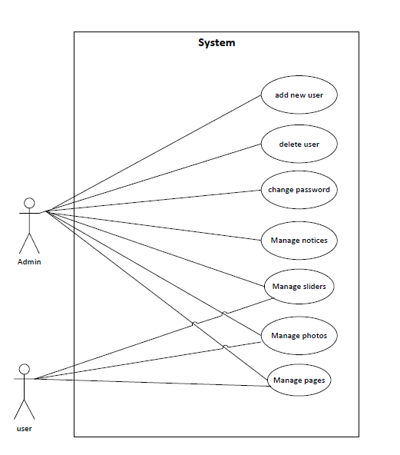

Figure-3.1 Use Case Diagram

#### 3.2.1.2 Expanded Use Case

|  |  |
| --- | --- |
| **Use Case Identifier** | **UC-1 Manage About** |
| **Primary Actor** | Admin |
| **Secondary Actor** | None |
| **Description** | The admin should be able to add details of about, modify the details and delete the details . |
| **Pre-condition** | The user must logged in as admin. |
| **Post-condition** | Details is updated in the database.Success message is displayed on the screen. |
| **Failure scenario** | The database is not updated.and error message is not displayed on the screen. |

|  |  |
| --- | --- |
| **Use Case Identifier** | **UC-2 Manage Product** |
| **Primary Actor** | Admin |
| **Secondary Actor** | None |
| **Description** | The admin should be able to add detail about the product and modify it . |
| **Pre-condition** | The user must logged in as admin. |
| **Post-condition** | Details is updated in the database.Success message is displayed on the screen. |
| **Failure scenario** | The database is not updated.and error message is not displayed on the screen. |

|  |  |
| --- | --- |
| **Use Case Identifier** | **UC-3 Manage Sliders** |
| **Primary Actor** | Admin |
| **Secondary Actor** | None |
| **Description** | The admin should be able to add new slider photo, modify the slider photo and delete the slider photo. |
| **Pre-condition** | The user must logged in as admin. The slider category should not be present already within the system. |
| **Post-condition** | Slider is updated in the database.Success message is displayed on the screen. |
| **Failure scenario** | The database is not updated.and error message is not displayed on the screen. |

|  |  |
| --- | --- |
| **Use Case Identifier** | **UC-4 Manage Companies** |
| **Primary Actor** | Admin |
| **Secondary Actor** | None |
| **Description** | The admin should be able to add detail about the companies and modify it . |
| **Pre-condition** | The user must logged in as admin. |
| **Post-condition** | Details is updated in the database.Success message is displayed on the screen.on the screen. |
| **Failure scenario** | The database is not updated.and error message is not displayed on the screen. |

|  |  |
| --- | --- |
| **Use Case Identifier** | **UC-5 Manage Gallery** |
| **Primary Actor** | Admin |
| **Secondary Actor** | None |
| **Description** | The admin should be able to add photos in the gallery and modify it . |
| **Pre-condition** | The user must logged in as admin. |
| **Post-condition** | Details is updated in the database.Success message is displayed on the screen. |
| **Failure scenario** | The database is not updated.and error message is not displayed on the screen. |

|  |  |
| --- | --- |
| **Use Case Identifier** | **UC-6 Manage Team** |
| **Primary Actor** | Admin |
| **Secondary Actor** | None |
| **Description** | The admin should be able to add detail about the team and modify it . |
| **Pre-condition** | The user must logged in as admin. |
| **Post-condition** | Details is updated in the database.Success message is displayed on the screen. |
| **Failure scenario** | The database is not updated.and error message is not displayed on the screen. |

### 3.2.2 Non-functional Requirements

Non-functional requirements are those requirements other than the functional requirements. This requirements are the backbone of the any system. Non- functional requirement helps to boost the performance, characteristics and speed of the system.

#### 3.2.2.1 Performance

It requires minimal hardware features. It stores the information of the notices, pages and detailed information of the institute. So, it requires more than 1 GB hard disk.

#### 3.2.2.2 Hardware

It is a web based CMS and it requires internet and browser to run. Different browser that supports PHP, JavaScript can operate this website.

#### 3.2.2.3 Software

Admin can monitor the user easily through the system. Creating and managing the contents does not require more effort. Large numbers of data can be added in the system easily.

## 3.3 Feasibility Study

The feasibility study is an analysis of how successfully a project can be completed accounting for factors that affect it such as economic, technological, operational and scheduling factors.

The different analysis of the system is carried out below:

### 3.3.1 Technical Feasibility

User’s requirements can be easily accumulated and is technically feasible to work upon. The requirement for the system either Hardware or Software are easily available which made the system technically feasible to build.

### 3.3.2 Operational Feasibility

Operational Feasibility is a measure of how well a proposed system solves the problems. The requirements for the system are feasible to operate and translate them into the system. Use of different technology like PHP for backend to interact with database and HTML, CSS, JavaScript for the UI design made the system operationally feasible to build.

### 3.3.3 Economic Feasibility

User’s requirements can be accumulated and is economically feasible to work upon. We used PHP as server script and HTML, CSS and JavaScript to develop the frontend of the site. Apache is used as a backend server and as a database server we used MySQL Server.

### 3.3.4 Schedule Feasibility

The project fails if it takes too long to be completed before it is useful. Typically, this means estimating how long the system will take it to develop. Although this site can be enlarge as required but it was developed with functionalities that were enough for the institute. So, it reduces the time cost for its development and had enough time to complete it.

## 3.4 Data Model of System

### 3.4.1 EER Diagram

# CHAPTER-4 SYSTEM DESIGN

# 

## 4.1 Architectural Design

Browser

1st tier

Request Response

Server

Middle tier

Request Response

DB

Database tier

Figure-4.1 : Architectural design diagram

## 4.2 Activity Diagram

It shows the operations(actions)involved in performing some use-cases. It shows the step-wise decomposition/transition and control flows while implementing a certain use-case. It also shows the alternative path, concurrent path to execute a particular use-case.

## 4.3 Sequence Diagram

# CHAPTER-5 IMPLEMENTATION AND TESTING

## 5.1 Implementation Methodology

System Implementation specifies how the system is installed, operated and maintained. System implementation is also known as the test program that perform the complete system in its actual environment to determine its capabilities and limitations.

The project began with the analysis of the requirements and the conceptual pattern was design. After the overall analysis of the system, designing of the database, tables and user interface was started. After that coding and debugging, the system was implemented.

There are generally two different types of Implementation. They are Direct Implementation and Parallel Implementation .Parallel Implementation is used. In this Implementation method, before completely changing over to new system, existing system and new system was to be used simultaneously until the users are well trained to ready to roll out the system .

## 5.2 Implementation Tools

## **5.2.1 Sublime Text**:

## Sublime text has been used as an text editor.

### 5.2.2 Draw.io

Draw.io was used as design tool for creating use-case, activity diagram ,sequence diagram and other required diagram.

### 5.2.3 Frontend Tools

### HTML has been used for structuring the website.

CSS has been used for styling the website.

Bootstrap has been used to make the website responsive to run on all type of devices.

JQuery like languages has been used for handling the events in the website.

### 5.2.4 Backend Tools

PHP has been used for backend development in the project

### 5.2.5 Server

Apache has been used as web server.

### 5.2.6 Database

MySQL 5.7 has been used as database and performing the database operations in this project.

## 5.3 Testing

## Testing is the process for executing a program with the intent to cause and discovers errors. Upon accomplishment of each use case, the system is fully tested using the following strategies(unit testing ,integration testing).

### 5.3.1 Objective/goals

The main goals of testing are:

i)To force a program to run efficiently.

ii) To discover the cause of these errors.

iii) To revise the program code to eliminate errors.

### 5.3.2 Test Case

|  |  |  |  |  |  |
| --- | --- | --- | --- | --- | --- |
| Test cases-Id | Module name | Test data | Expected result | Actual result | Remarks |
| 1 | Admin Login | Enter user name and password | Enters to the admin dashboard | Enters to the admin dashboard | Pass |
| 2 | Manage About | Admin adds title, detail, image for the clients | About details must be added | About details has been added | Pass |
| 3 | Manage Product | Admin adds, details, for the products | Details must be added | Details has been added | Pass |
| 4 | Manage slider | Admin adds images and details for the slider | Details must be added | Details has been added | Pass |
| 5 | Manage Companies | Admin adds images and details for the company | Details must be added | Details has been added | Pass |
| 6 | Manage Gallery | Admin adds details for the gallery | Details must be added | Details has been added | Pass |
| 7 | Manage Team | Admin adds images and details for the team | Details must be added | Details has been added | Pass |

# 

# CHAPTER-6 CONCLUSION

## 

## 6.1 Summary

This project was done as a part of internship project for Bachelors of Science in Computer Science and Information Technology (Bsc.CSIT) program offered by Tribhuvan University , Nepal. It was undertaken to plan , design and develop a Website for Global Saas Trading company.

By the development of the project , the project was a complete dynamic website for Global Saas Trading company which allows to manage the day to day operations of the company and main it aims to have a good interactions with the users who visits the websites. The system has been developed with much care that it is free of errors and it is efficient and less time consuming.

The advantage is that this build website can be enhanced, modified or changed to the growing requirements of the users in the future.

## 6.2 Lessons Learnt

Being in the internship program and handling the designation of PHP developer , I learned a lot of employee valued skills. I learned about the good personal presentation. I learned developer’ skills and also learned how to use the developer’s tools. The internship has taught me time management, as working in a company means you have to take care of the deadlines and milestones. This internship has been an excellent and rewarding experience. It has been a great opportunity to improve personal and professional skills. This valueable skills have boosted my professional skills to higher level and prepare me for better future in this career.

# REFERENCES

## Nixon, R. (2015). *Learning PHP, MySQL, JavaScript, and CSS: A Step-by-Step Guide to Creating Dynamic Websites – by Robin Nixon*. 4th ed. Gravenstein HighwayNorth, Sebastopol: O’Reilly Media, Inc, pp.123-127,298-303.

Forbes, A. (2015). *The Joy of PHP: A Beginner's Guide to Programming Interactive Web Applications with PHP and MySQL*. 3rd ed. CreateSpace Independent Publishing Platform.

Dracup, J. (2016). *Connecting to a MySQL Database & Displaying Records on a Web Page*. [video] Available at: https://www.youtube.com/watch?v=og7TtjUdogA [Accessed 14 Dec. 2018].

# SNAPSHOTS

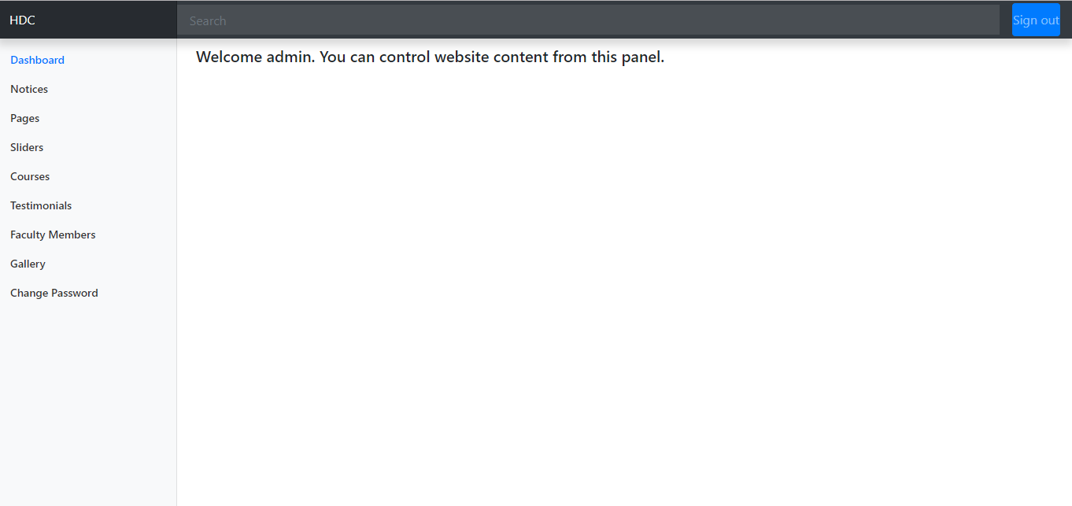

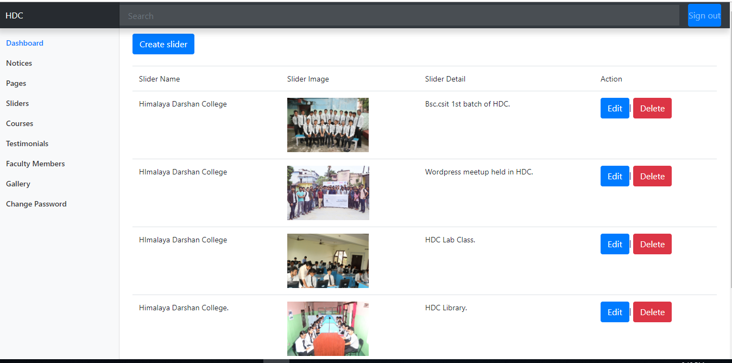

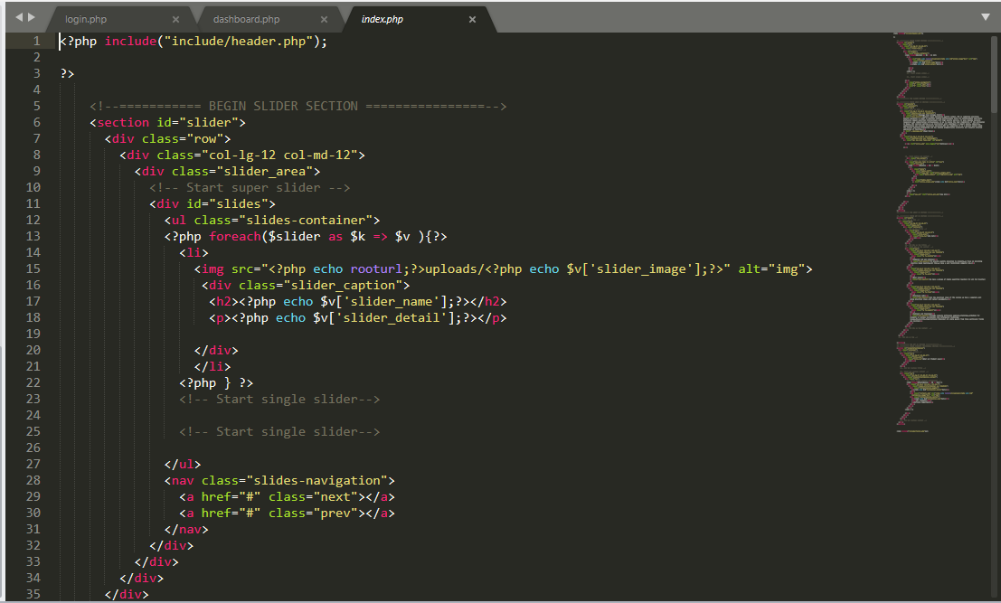

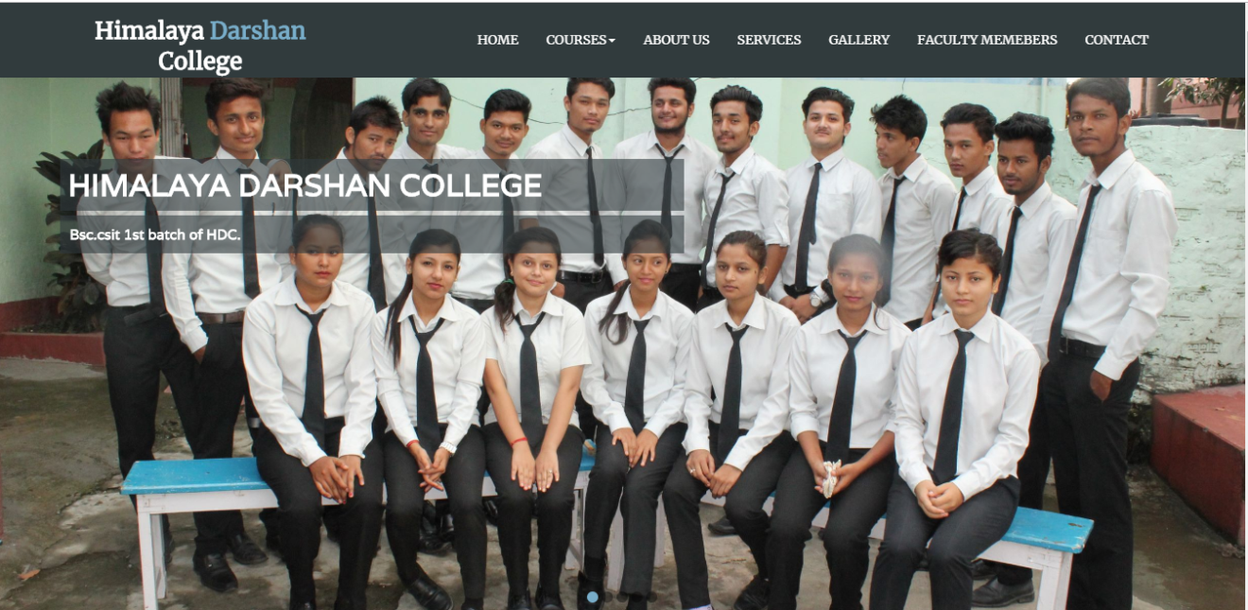

# APPENDIX A