Laxmikant Shingare  608 207 8721  laxmikant.shingare@gmail.com |  | 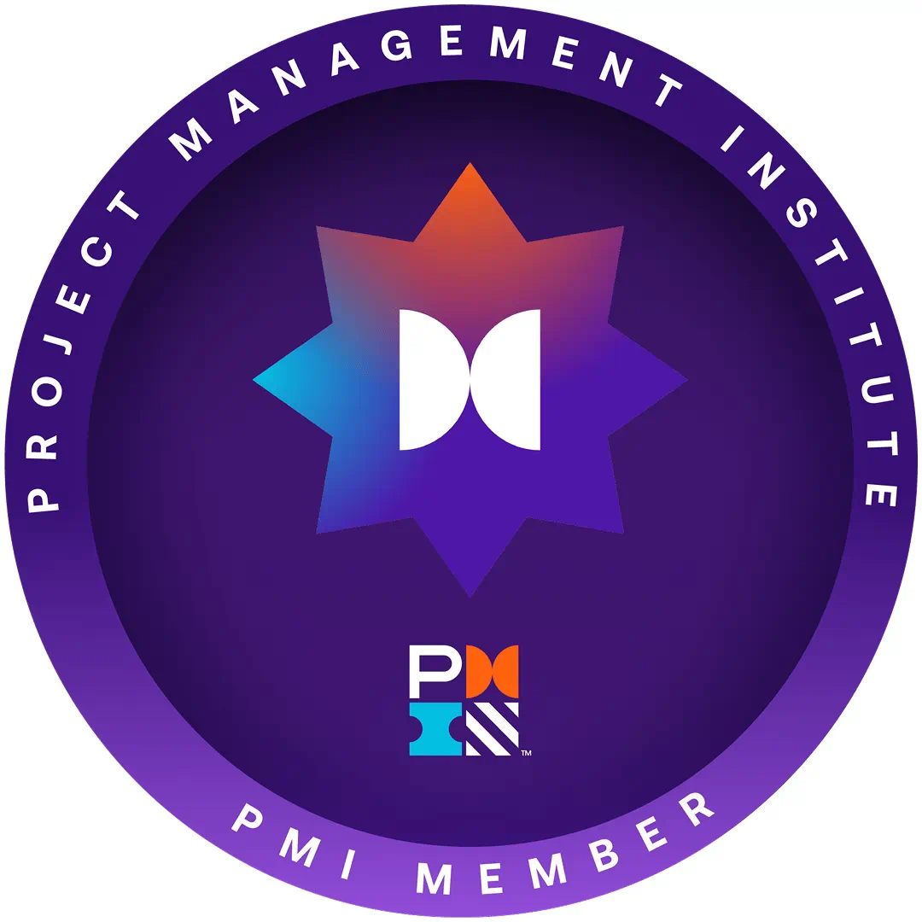
https://www.linkedin.com/in/laxmikant-shingare-4a82751a/

TECHNICAL / PROGRAMMING -

- Microsoft Technologies:
- Framework: .NET 8.0 & ADO.NET Framework (4.7/3.5/2.0/1.1), Entity Framework (EF6, 3.5)
- Web Languages: ASP.NET Core, MVC, Blazor.NET, MAUI, Copilot
- Programming Languages: C#.NET, VB.NET, JAVA, XAML (WPF) & XSLT.
- APIs: RESTful and SOAP services, WCF, Windows Services. Service Fabrics
- Front-end/UI Technologies: ReactJS, Redux, React Native, Context API, JavaScript (ES6+),
Bootstrap, Angular, Tailwind CSS, Node.js, Axios, NPM
- Database: SQL Server, Oracle, Azure SQL, MongoDB,
- Versioning using VSS, TFS, SVN, GitHub
- Modelling using UML, Visio, Microsoft Project.
- Cloud: Microsoft Azure DevOps, AWS
- Operating System: Windows, Mac, iOS and Android
- MS Office Products: Microsoft Office 365, Word, Excel, PowerPoint, Visio.
- Tool Used: Postman, SOAP UI, NUnit, Oracle SQL Developer, Telerik, Infragistics Controls, Dundas Charting Tool, Win Merge, Voltage SDK, Jenkins, Facets, Visual Studio (old to latest 2022), NPM, YARN, Swagger
- Domain Worked: Logistics, HealthCare, Banking, Insurance, Airlines

SUMMARY -
- Sound Knowledge on Project Management / Client Interaction / Resource Management / Risk Analysis / Business / Scope / Design Specification / Kanban / Scrum Master delivering in Agile way.
- Over 4 years of experience in Azure PaaS Solutions like Azure Web Apps, Application Insights, Azure Functions, Azure SQL Database, Azure Blob and File Storage.
- Worked directly with Client for requirement analysis, Creating Product Backlogs and Estimations.
- Involved in Team Building Activity at Offshore and Onsite, was also part of Technical Panel.
- Strong experience in End to End Managing of Microsoft based Projects mostly Web, Windows and Cloud based applications using Microsoft .NET technology.
- Extensive knowledge in Object Oriented Programming (OOPS).
- A good team handling experience with excellent technical, communication and interpersonal skills
- Over 17 years of significant experience in SDLC (Software Development Life Cycle) using agile (SCRUM) methodologies, focusing on Mobile, Web and Windows applications.
- Over 6 years of experience in UX/UI developing web applications, and interactive software products using ReactJS Library, Syncfusion React library, NPM Packages, Webpack, HTML, SASS, Redux
- Experienced in design and development of various applications using Microsoft .NET Framework, Visual Studio, ASP.NET, ASP.NET MVC, C#, VB.NET, ADO.NET, LINQ, WPF, JavaScript, HTML5, CSS AJAX, JSON, and XML with SOLID Principles
- Experience on Web API to create HTTP RESTful services to communicate with UI objects and JSON.
- • Proficient in Database design, Normalization, Queries, Joins, T-SQL, PL-SQL (Stored Procedures, Functions, Views, Materialized views, Triggers, Indexes, and Cursor) in MS SQL Server and Oracle.
- Extensive knowledge in Object Oriented Programming (OOPS).
- Exceptional ability in problem solving techniques, investigating, debugging& fixing the issues.
- Good communication skills, systematic approach, and ability to adopt new technologies faster

PROFESSIONAL EXPERIENCE:

VHLTec Consuting Jan 2021 – Till Date

Client: United Airlines, Illinois and Texas Mar 2022 – till date
Senior Application Developer
Description: Working with EPS (Engine Planning System) and APS (Airline Print Solution) Projects for enhancing the existing system for United airlines

Roles and Responsibilities:
- Implementing secured protocols for APS Application using .Net , ReactJS UI and https configurations by removing code vulnerabilities
- Developing UI Pages in ReactJS for EPS and Managing Engine status manually when required using DB Scripts on Production Server’s
- Designing and Developing API's in C#.Net using Visual Studio 2022, Business Layer Objects, Data Layer Objects and interacting with Database based on role and permissions.
- Collaborated with the UI team to implement reusable REACT components aligned with EPS and APS application workflows.
- Involved in TDD and coding in C#.Net, creating Branches on Master, PR reviews using Azure DevOps.
- Participated in code reviews and coordinated version control between .NET backend and React frontend using Azure DevOps and Git.
- Working with 5 team members for Server Migration for NextGen from NDC.

Environment: Visual Studio 2022, ASP.NET 4.7, ReactJS, API development, JSON, API’s, SQL Server 2016, GIT, Azure DevOps, Veracode, F5 Servers Load Balancing

Client: Agfirst Farm Credit Bank, Columbia, SC Jan 2021 – Jan 2022
Lead API Developer
Description: Migrated .Net Based and other old Web services into API's (.Net based Web API) targeting to new
OutSystems UI/UX platform.

Roles and Responsibilities:
- Lead Developer for API development in .Net and Client Interaction on daily basis for the type of output from API
- Team handling of 3 members at Offshore for developing UI Components in ReactJS for AgDocs, AgVue, Docuphase Applications
- Dealing with UC4 tool for scheduling SSIS nightly cycle jobs.
- Involved in TDD and coding in C#.Net, creating Branches on Master, PR reviews using Azure DevOps
- Worked closely with the UI team to integrate newly developed .NET APIs with Angular components on the OutSystems platform, managing API’s in Mulesoft platform
- Implemented Azure DevOps for Implementation and CICD Pipelines for deployments.
- Tools used like Visio for API flow and system specifications, Axiom Assyst for Prod turns, Azure DevOps Change Management Board, Citrix for UC4 UI Interaction and RDP.

Environment: C#.NET 4.7, UC4 ETL Tool for SSIS jobs, ASP.NET 4.7 API development, OutSystems, ReactJS, WCF Services, SQL Server 2016, GIT, TFS, Azure DevOps with CICD Pipelines, MuleSoft APIM

CitiusTech, Navi Mumbai March 2019 – Dec 2019
Client: Verge Health, Charleston, SC
Senior Software Engineer
Description: V-Credentialing Provider Reference Management is a Web Based Application, which provides Use
Interface to Higher Authority of Verge Health to verify the Authenticity of Providers. e.g. Licensee, the devices
used and Address etc. Produce EXCEL / PDF detailed Report.

Roles and Responsibilities:
- Project Management, Client Interaction / Product Owner on daily basis
- Supporting Old VB 6.0 Application
- Converting some VB.net objects into C#.Net with Blazor
- Involved in the coding in Asp.Net Core with C#.Net and Code reviews, used Microsoft Service Frabics
- Used SCRUM Framework / Agile Methodology for developing and maintaining the Application.
- Adhering HIPAA compliance
Environment: ASP.NET CORE 3.0, AJAX, Java Script, JSON, Web API, SQL Server 2014, TFS Rally, DICOM Tool,
Microsoft Service Fabrics for Microservice, DevOps CI/CD

Atos SYNTEL April 2010 – Feb 2019
Played multiple roles when working with Atos Syntel
Client: CDPHP, Albany, NY Mar 2018 – Feb 2019
Senior Software Engineer
Description: These are .Net Based Job's Applications, which facilitates Enrolment and provides Claims
processing solutions to CDPHP and collaborated insurance companies CDPHP serves Health insurance
throughout New York state but is limited to Counties of New York state.

Roles and Responsibilities:
- Project Management with End to End delivery and Client Interaction on daily basis.
- Prepare technical documentation of business requirements, system specifications
- Dealing with EHR, EDI X12 830, 832 etc transaction records through ETL and .NET Jobs.
- Design and Develop C#.Net Jobs, Business Layer Objects, Data Layer Objects.
- Implemented WCF Service for migrating it from Web Service.

Environment: C#.NET 4.5, Console Applications, Power BI ETL Tool, ASP.NET 4.5, AJAX, Java Script, JSON, WCF
Services, SQL Server 2014, GIT, JIRA, Service Now, FACETS, Power BI

Client: Claim Force Insurance, Chicago, IL Sep 2017 – Feb 2018
Technical Lead
Description: This is a Web Based Application, which provides claims processing software solutions for insurance
companies which facilitates the claims process by controlling resources, processes, and vendor relationships

Roles and Responsibilities:
- Prepare technical documentation of business requirements, system specifications discussing with client on daily basis.
- Design and Develop ASPX UI objects in Visual Studio 2013.
- Involved in the coding in C#.Net and Code reviews.
- Design and Develop Business Layer Objects, Data Layer Objects in C#.net
- Implemented WCF Service
- Created C# based Tool to convert Fox Pro Data into XML format.
- Used SCRUM Framework / Agile Methodology for developing and maintaining the Application.
Environment: C#.NET 4.5, ASP.NET 4.5, AJAX, Java Script, JSON, WCF Services, SQL Server 2014, GIT, JIRA, Rally.

Client: American Express, Phoenix, AZ Aug 2016 – June 2017
Scrum Master
Description: This is Web based Application for managing and maintaining Customer information where Higher
authorities of Amex has access to it, specific data was not in encrypted form, so I was working for Encryption /
Decryption on it using Voltage Security SDK. Incorporating with Globe star internal Tool for international cards
Data.

Roles and Responsibilities:
- Facilitating Daily scrum meetings, sprint planning, sprint review, and sprint retrospective.
- Architected and developed an solution development infrastructure for multiple Internet developers.
- g ASPX UI objects, Business Layer Objects, Data Layer Objects accordingly worked with Object Framework
- Involved in the coding in Asp.net code behind i.e. in C#.Net, using Kafka tool for streaming.
- Used Visual Studio 2013, SQL Server 2014, AZURE CLOUD for deployment
- Used Voltage Security SDK for Encryption / Decryption Cards data
- Domain : Banking and Finance.

Environment: C#.NET 4.5, ASP.NET 4.5, BLOB, AJAX, Java Script, JSON, WCF Services, Azure SQL, Azure App and
API Services, Kafka, Designing Database, TFS, GIT, Service Now, JIRA, Rally, Jenkins, Power BI

Client: Moody’s, New York Nov 2015 – Jun 2016
Associate Consultant
Description: This is Web based Application for managing and maintaining resources from various Vendors,
which provides User Interface to Moody’s Managers and Super users who can Onboard new resources single or
in Bulk against specific project with specific duration, billing amount etc. Onboarding process gets completed
after in between approvals and HR Connect generates Moody’s ID for those resources. Reports can be exported
Based on criteria.

Roles and Responsibilities:
- Project Management with End to End delivery and Client Interaction on daily basis,
- This was Water Falls Model based application development.
- Involved in the coding in C#.Net and Code reviews.
- Design and Develop C#.Net Jobs, Business Layer Objects, Data Layer Objects, Power BI, Oracle
- Implemented WCF Service for migrating it from Web Service.
- Involved in requirement phase documentation with Client on daily basis.
- Domain : Banking and Finance.
Environment: C#.NET 4.5, ASP.NET 4.5, TDD, AJAX, Java Script, JSON, WCF Services, SQL Server 2014, TFS, JIRA,
Rally.

Client: HUMANA, Louisville, KY April 2014 – Oct 2015
Associate Consultant
Description: Medicare Advantage Paperless Application (MAPA) Windows Based Enrolment Application, which
provides User Interface to Agents Captive or delegated agents who enrols Customers against specific plans
which customer wish to, once all information is gathered customers signature is taken using Signature Pad, and
ultimately the Application is uploaded to OEDB (Online Enrolment Database) using private Web Service.

Roles and Responsibilities:
- Project Management with End-to-End delivery, Client Interaction on daily basis
- Prepare technical documentation of business requirements, system specifications, operation and installation of software.
- Design and Develop Win Forms UI objects, Business Layer Objects, Data Layer Objects accordingly worked with Object Framework
- Using Visual Studio 2010. SQL Server 2008 R2.
- Involved in the coding in C#.Net and Code reviews.
- Involved in creation of Win Forms and coding in C#.Net.
Environment: Win Forms, C#.NET 4.5, ASP.NET 4.5, MVC 5 AJAX, Java Script, JSON, WCF Services, SQL Server 2014,
TFS, Version One, FACETS

Physician Finder Plus (PFP) Jan 2011 – Mar 2014
HUMANA, Louisville, KY
Associate Consultant
Description: This is a Web Based Application, which provides User Interface to search the Physician for their
urgent needs based on Zip Code, Disease, Member ID, Physician Name, Network, Service Types and Specialty.
PFP Application uses PFP Shared Service WCF Service.

Roles and Responsibilities:
- Leading a Project with Client Interaction on daily basis
- Involved in requirement phase documentation and system architecture.
- Design and Develop MVC 3.0 objects, Business Layer Objects, Data Layer Objects accordingly worked with Object Framework
- Developed complex web forms using MVC and Controller Action Results with C#, .NET Framework 4.0
- Using Visual Studio 2010. SQL Server 2008 R2, FACETS
- Involved in the coding Model and View designing C#.Net and HTML 5 helper functions.
Environment: C# 3.5, MVC 4 , ASP.NET, WCF Service, AJAX, Java Script, JSON, SQL Server 2010, TFS, Version One

Medicare Sales Reporting (MSR) Apr 2010 – Dec 2010
HUMANA, Louisville, KY, USA.
Associate Consultant
Description: This is a Web Based Application, which provides User Interface to Higher Authority of HUMANA to
know the daily, monthly, yearly Sales of the Insurance Plans and to Produce EXCEL or PDF detailed Report.

Roles and Responsibilities:
- Being a Team Player did major coding in ASP.NET and C#.Net using Telerik Controls
- Design and Develop ASPX UI objects, Business Layer Objects, Data Layer Objects according to work with Object Framework, FACETS
- Creating tables its relationship schema and developing Stored Procedures.
- Domain : Health Care
- Adhering HIPAA compliance

WebWorx Pune Apr 2009 – Nov 2009
Client: Lodging World, 26 York St, London, UK
.Net Developer
Description: The Objective of system is to maintain Hotel Information from Booking.com and Lodging World

Roles and Responsibilities:

- Design and Developing pages for Booking.com using ASPX UI objects in Visual Studio 2005.
- Developed complex web forms using ASP.Net server-side scripting with C# .NET Framework
- Implemented Ajax in Asp.net
- Involved in the coding in C#.Net and Code reviews.
- Design and Develop Business Layer Objects, Data Layer Objects in C#.net
- Implemented Web Service
- Resolving production Issue tickets as mentioned by the client.
Environment: C# 2.0, ASP.NET 2.0, Web Service, AJAX, SQL Server 2008 R2, DB Backup and Restore Plans, SVN,
VSS.

WinSoft, PUNE Mar 2008 – Dec 2008
Client: Datamatics, Portsmouth, NH, USA
Software Engineer
Description: Madison Resource Funding (MRF) is Role based Staffing Firm application which includes Branches,
Customers, Departments, Worksites and employees and different Tax masters. Placing order by Customers and
assignment of employees for Order and define pay rates for Assignment is also the function of the system.

Roles and Responsibilities:
- Involved in discussion and creation of requirement documentation with Client.
- Developed complex web forms using ASP.Net server-side scripting with C#, .NET Framework 4.0
- Involved in the coding in Asp.net with code behind in C#.Net
Environment: C# 2.0, ASP.NET 2.0, AJAX, Java Script, Web Services, SQL Server 2008, SVN, Visual Source Safe, MS
Visio, Windows Service, Microsoft Application Blocks 2.0

Reltronics Tech, Pune Sep 2006 – Dec 2007
Software Engineer
Description: Asset Management System is asset-tracking system, which is generic software for all kind of the
business, which helps to track movable assets in the premises of the company.

Roles and Responsibilities:
- Involved in discussion and creation of requirement documentation with Client.
- Involved in the coding in Asp.net with code behind in C#.Net
- Involved in the coding in Win Forms code behind in C#.Net
- Worked with MC9090-G Mobile device, distributed modules
- Coding modules and various Master Win Forms UI in project.
- Creating SQL Stored Procedures, Functions, Triggers.
Environment: WinForms, C# 2.0, ASP.NET 2.0, AJAX, Web Services, Java Script, SQL Server 2005, Symbol RDIF SDK,
Psion RFID SDK

EDUCATIONAL QUALIFICATION -
- MCS - Master's in Computer Science (University of Pune)
- BCS - Bachelor's in Computer Science (University of Pune)

CERTIFICATIONS -
- PMP Certified from pmi.org (Certificate ID: 4189555)
- Certified Scrum Master from scrumalliance.org (Certificate ID: 798555)
- Application Development Foundation (70-536)
- .NET Framework 3.5, WCF App Development (70-503)
- Asp.Net MVC Web Application (70 - 486)

