TECHNOFRIDAY.COM WEB PORTAL

TechnoFriday web portal is just like the others online shopping web portal like www.ebay.in , www.ezone.futurebazaar.com ,www.shopping.indiatimes.com etc.

We would like this Portal having all features just like online shopping portal www.next.co.in.

Online shopping is the process whereby consumers directly buy goods or services from a seller in real-time, without an intermediary service, over the Internet. It is a form of electronic commerce.

Technofriday web-portal will have limited items and products to shop on it. It covers the all electronic gadgets and lifestyle products.

We will give best deals and offers on every product for the limited time but according to our website name TechnoFriday, Friday will be the special day where we will give very special offer on a few selective products for FRIDAY only.

For many people, electronic gadgets are essential in their daily lives. If you are one of these individuals, perhaps you would like to know a few tips when it comes to shopping for these devices. After all, many electronic products and appliances cost quite a lot, and you would surely like to get good value for your investment.

Mainly we have following categories of our products and items:
- Laptops
- Mobiles
- Desktop PCs
- Mobile Accessories
- Computer Accessories
- Lifestyle Prodcuts

All the above will have Sub-categories.

Also on the home page of the website we would like to have a Flash Link where they will have the options to create their own website like Do-It-Youself Online Presence format.

We should have following Search Option:
- Category Wise
- Product Wise
- Specific Model Wise
- Price Range Wise

Option for comparison of products with pre-defined heads/Specifications

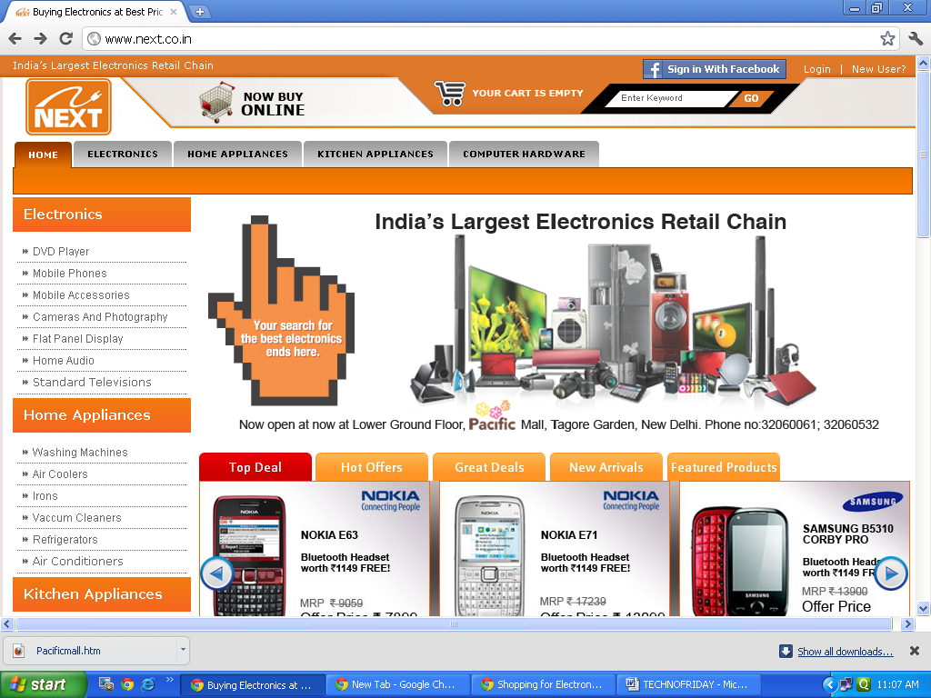

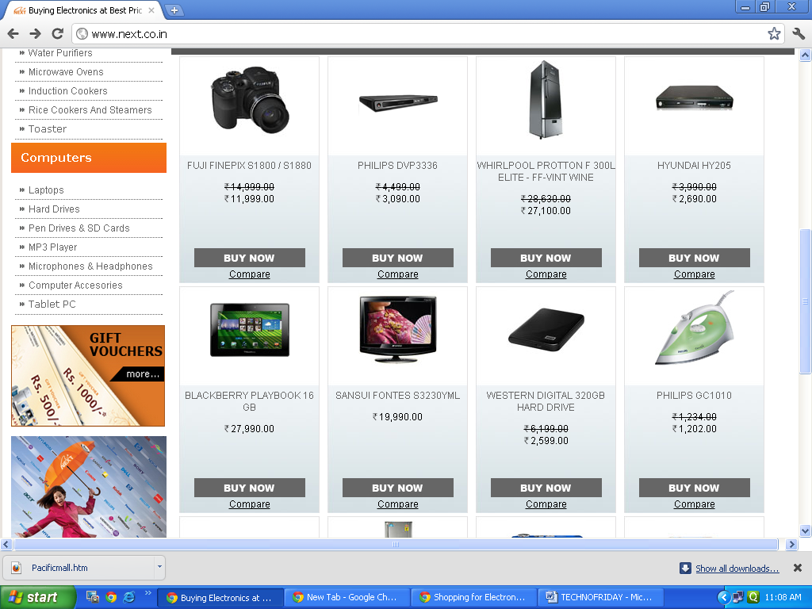

When customer clicks on BUY NOW tab he would be redirected at the product details page. There are different tabs like Features, Description, Offers, Review, Product experience, Payment Shipping & Tax Info. By clicking on the specific tab the user can get the desired information about the product.

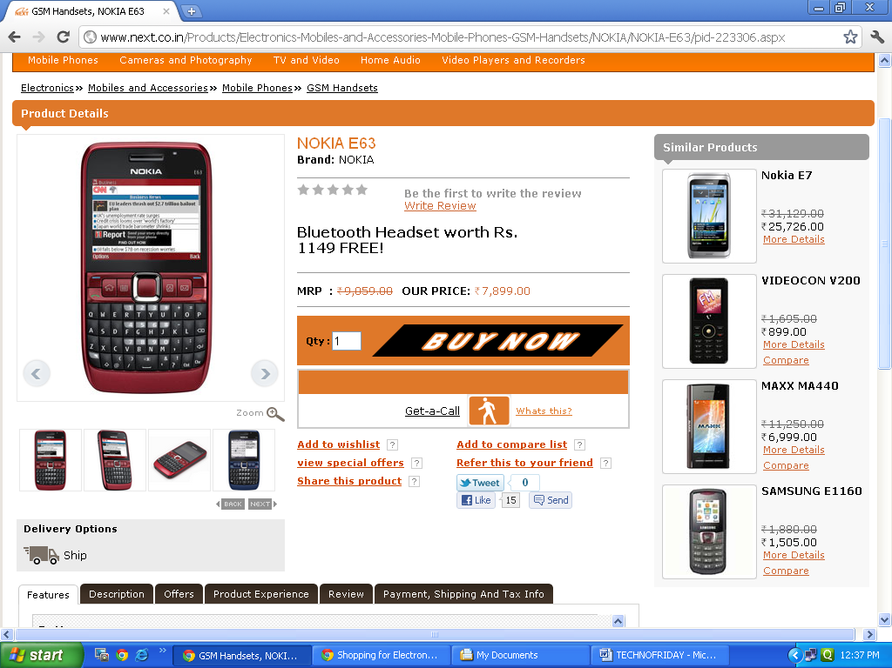

When customer click on BUY NOW button again, he would be redirected to the log-in/ Sign up Page. If the customer does not want to get registered, then he has another option of shopping “BUY AS A GUEST”. When he clicks on “BUY AS A GUEST” then he has to follow the following steps to complete his shopping:

- Step1: The Customer will have to provide his valid email-id so that the details of the products being bought can be sent on his Email_Id.

- Step2:Billing & Shipping Information: The Customer has to provide his billing & shipping address, contact details to receive their product.

- Step3: Order Summary & Logistics: On this step we will give order summary to customer and ask for reconfirmation of buying products. After confirmation the customer is redirected to the payment page.

- Step4: Payment Options: In this step customer has the following choices for making the payments to complete the order.

  - Credit Card/Debit Card
  - Net Banking
  - Cash On Delivery
  - EMI option.

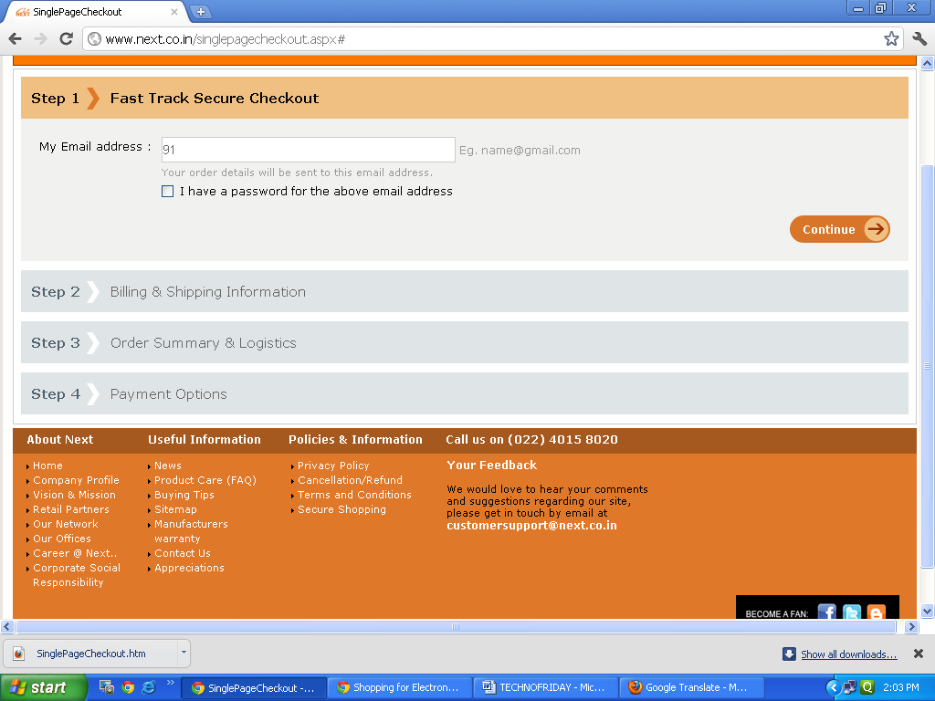

Login Module:

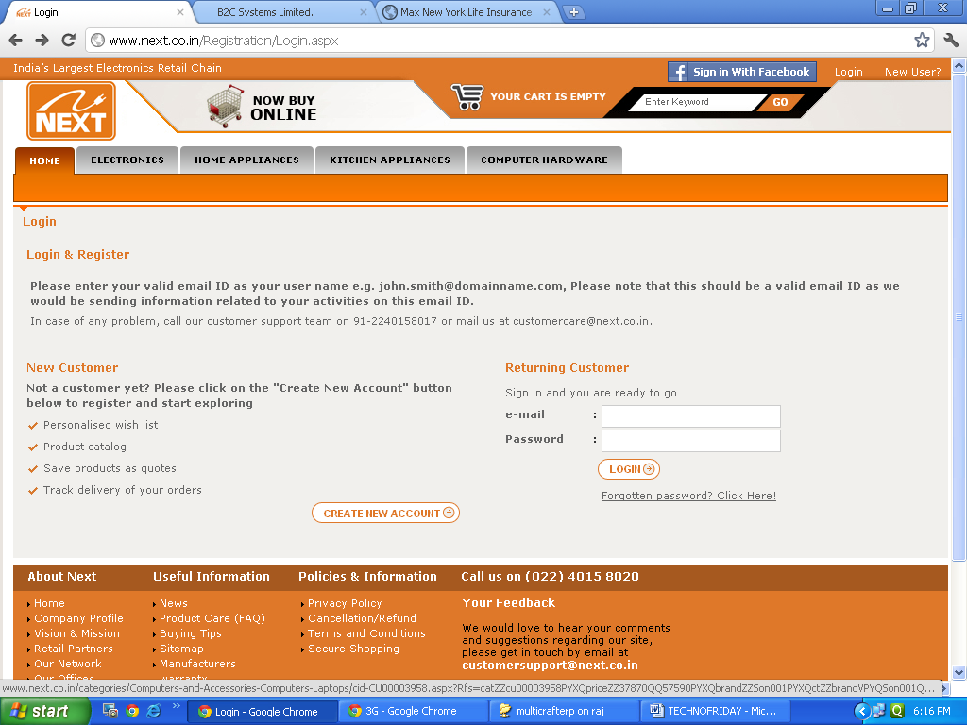

Registration/Sign Up Module:

