What is HTML ?
*HTML – Hyper Text Markup Language. It is a language used to create web pages.
* It is case insensitive.
* The compiler and runtime machine of HTML is embedded inside the BROWSER
* HTML uses various Tags whih are also called as Elements. And these tags will have attributes which
alter or over-ride the default/implicit behaviour.
* Languages similar to HTML are -> XML, CSS.
================================================================

Understand the structure of an HTML page

Evolution of HTML
HTML 1.0
1990’s
HTML 2.0
1994
HTML 3.2
1997
HTML 4.0
1999
HTML 5
2014
================================================

what is the latest version of html?
The concept of “latest version of HTML” has changed a bit from old school numbered versions.
What’s the latest HTML standard?
HTML is now a Living Standard — meaning there is no fixed version number like HTML4 or HTML6 anymore. Instead, the specification is continuously updated with new features and improvements by the Web Hypertext Application Technology Working Group (WHATWG).
In the past, we used versions like:
- HTML4 (late 1990s)
- HTML5 (released around 2014)
Today, the official specification is just called HTML (Living Standard) and is kept continuously updated — that is the latest form of HTML.
So what does that mean?
- When people say HTML5, they usually mean the modern version of HTML used today — but technically, HTML doesn’t have a numbered version anymore.
- The recommended and current HTML spec is the HTML Living Standard, which evolves over time instead of having a “HTML6” or similar numbered release.
======================================================
TEMPLATE OF A HTML CODE/PROGRAM

<doctype html!> <! It defines the document type. This is optional in most of the cases -->
<! THIS IS A HTML COMMENT. Comments do not get compiled nor run -->
<HTML type = "text/html">
<! type is an attribute of many a tags -->
<HEAD>
<! All info and data (meta data) and the source files or scripts can be added here -->
</HEAD>
<BODY> <!
<! All the elements/tags of the web page are added in to the body tag -->
</BODY>
</HTML>

What is Emmet?

Emmet is one of those tools that feels like a cheat code once you use it .
It lets you write HTML/CSS super fast using short shortcuts inside VS Code.
Emmet = shorthand → full HTML/CSS code
How to Generates full HTML template with help of “Emmet”

- Crate new html file with name test.html
- Press Shift + ! + Tab kyes together to insert HTML template.

Generates full HTML template:

<!DOCTYPE html>
<html lang="en">
<head>
<meta charset="UTF-8">
<title>Document</title>
</head>
<body>

</body>
</html>

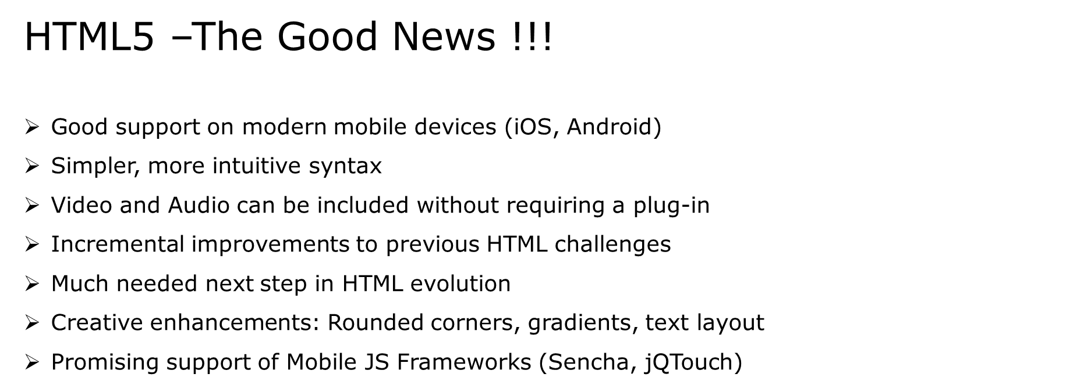

HTML Elements

Most Web documents are created using HTML.
Documents are saved with extension .html or .htm.
Tags are strings in the language surrounded by a less-than (<) and a greater-than (>) sign.
Opening tag: <html> Ending tag: </html>
Can have Attributes
Attributes are Name-Value pairs added to HTML start tags.

Program:1
<!DOCTYPE html>
<html lang="en">
<head>
<meta charset="UTF-8">
<meta name="viewport" content="width=device-width, initial-scale=1.0">
<title>Document</title>
</head>
<body>
This is my first homepage. <b>This text is bold</b>
</body>
</html>

HTML Document Sections
HTML Head Section:
<head>…</head>

•Page Title, Base URL, Meta Information
HTML Body Section:
<body>…</body>
•Text, Images, Tables Colors, etc.

Head Section: Page Title (Code)

Document Title is displayed using <title>…..</title> tag.
<!DOCTYPE HTML>
<html>
<head>
< title>
My First Page
</ title>
</head>
</html>

=========================================

