Data Understanding

Overall Summary
- Three datasets were loaded for credit risk analysis:
  - Applicants dataset: 307,511 rows, 122 columns
  - Previous loans dataset: 1,670,214 rows, 37 columns
  - Metadata: 160 rows
- The applicants data includes demographic, income, employment, and credit features, while the previous loans dataset contains historical lending behavior and repayment details.
- Data types include numerical, categorical, and date-related fields, with several columns having missing values (especially in previous loans data).
- Some variables such as DAYS_BIRTH and DAYS_EMPLOYED use negative day counts, and placeholder values like 365243 indicate incorrect or special values requiring cleaning.
- Descriptive statistics show large variation in income, credit amount, annuity, and goods price, reflecting diverse applicant financial profiles.
- The target variable TARGET is imbalanced, with:
  - 0 (non-default): 282,686 applicants
  - 1 (default): 24,825 applicants
  - Default rate: 8.07%
- This imbalance will need to be addressed in model development using techniques such as resampling or class-weight adjustments.
- The datasets are large and rich, making them suitable for advanced analytics, feature engineering, and building a predictive model for credit risk.

Data Quality Summary

Applicants Dataset
- Total columns with missing values: 67
- Several housing-related variables have very high missing percentages (≈ 68–70%), such as:
  - COMMONAREA_MEDI / AVG / MODE
  - NONLIVINGAPARTMENTS_MEDI / MODE / AVG
  - FONDKAPREMONT_MODE
  - LIVINGAPARTMENTS_MODE / MEDI / AVG
- These features may require:
  - Dropping (due to excessive missingness)
  - Or imputing only if they have strong predictive value
- Duplicate rows: 0
- Overall, missing data is significant in many housing and building characteristics, indicating the need for careful preprocessing.

Previous Loans Dataset
- Total columns with missing values: 16
- Highest missingness observed in:
  - RATE_INTEREST_PRIMARY and RATE_INTEREST_PRIVILEGED — ~99.6% missing
  - Down payment–related columns (AMT_DOWN_PAYMENT, RATE_DOWN_PAYMENT) — ~53% missing
  - Date-related fields (DAYS_FIRST_DRAWING, DAYS_FIRST_DUE, DAYS_LAST_DUE, DAYS_TERMINATION) — ~40% missing
  - NAME_TYPE_SUITE also has nearly 50% missing values
- These features may need:
  - Removal (especially the interest rate columns with ~100% missing)
  - Imputation or domain-based handling for date fields
- Duplicate rows: 0

Overall Insight
- Applicants dataset has wider missing-value issues, especially in building/apartment-related fields.
- Previous loans dataset has fewer columns missing, but a few have extremely high missing percentages.
- No duplicates across both datasets, indicating clean indexing.
- Handling missing values will be a critical step before modeling.

MetaData

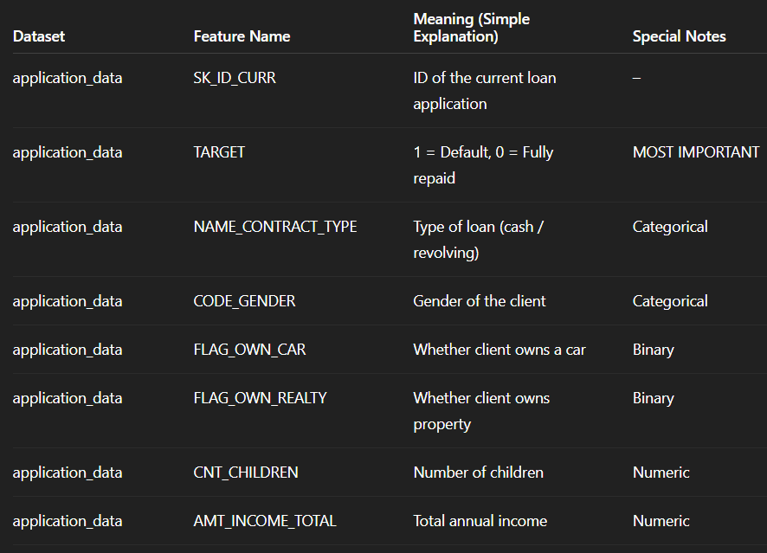
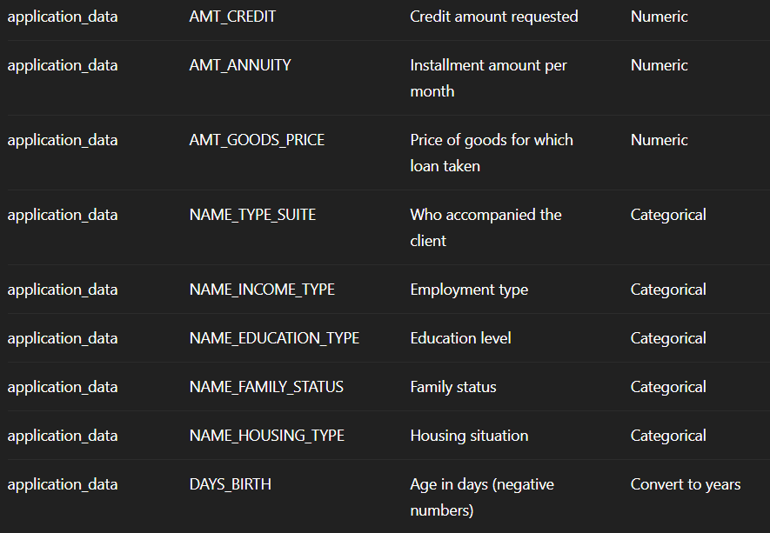

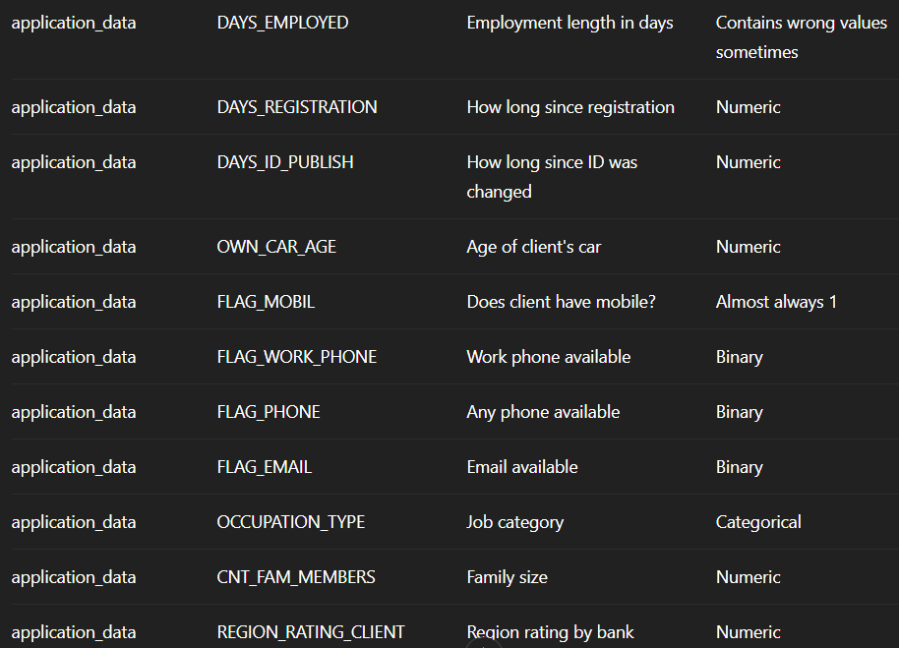

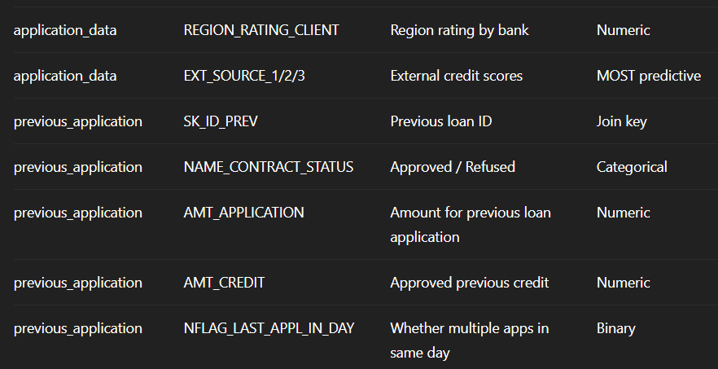

A) ID Columns (Ignore for Analysis)
These are only for joining datasets.
- SK_ID_CURR
- SK_ID_PREV

B) TARGET Variable (Output)
- TARGET → 1 = default, 0 = repaid
This is what you will predict.

C) Numeric Variables

Income & Loan Amounts
- AMT_INCOME_TOTAL
- AMT_CREDIT
- AMT_ANNUITY
- AMT_GOODS_PRICE

Demographic Numeric
- CNT_CHILDREN
- CNT_FAM_MEMBERS
- OWN_CAR_AGE

Region Ratings
- REGION_RATING_CLIENT

D) Date / Duration Variables
(all are negative days)
- DAYS_BIRTH
- DAYS_EMPLOYED
- DAYS_REGISTRATION
- DAYS_ID_PUBLISH
➡ Convert each to years for analysis:
Age = -DAYS_BIRTH / 365
EmploymentYears = -DAYS_EMPLOYED / 365

E) Categorical Variables

Personal Characteristics
- CODE_GENDER
- NAME_TYPE_SUITE
- NAME_INCOME_TYPE
- NAME_EDUCATION_TYPE
- NAME_FAMILY_STATUS
- NAME_HOUSING_TYPE
- OCCUPATION_TYPE

Loan Categories
- NAME_CONTRACT_TYPE
- NAME_CONTRACT_STATUS (previous applications)

F) Binary / Flag Variables (0/1)
- FLAG_OWN_CAR
- FLAG_OWN_REALTY
- FLAG_WORK_PHONE
- FLAG_PHONE
- FLAG_EMAIL
- FLAG_MOBIL
- NFLAG_LAST_APPL_IN_DAY
Use for simple comparisons.

G) External Credit Score Variables
(These are extremely important for prediction)
- EXT_SOURCE_1
- EXT_SOURCE_2
- EXT_SOURCE_3
They come from external credit bureaus.

H) Previous Loan Variables
(from previous_application table)
- NAME_CONTRACT_STATUS
- AMT_APPLICATION
- AMT_CREDIT
- SK_ID_PREV
- NFLAG_LAST_APPL_IN_DAY
You will aggregate these later into features like:
- Number of previous approvals
- Number of refusals
- Average previous credit
- Total previous applications

Data Cleaning

Data Cleaning Summary

1. Dataset Copy
- A working copy of the applicants dataset was created to perform cleaning without affecting the original data.

2. Correction of DAYS_EMPLOYED Anomaly
- The value 365243 in DAYS_EMPLOYED is a known placeholder indicating missing/incorrect employment information.
- A new flag column DAYS_EMPLOYED_ANOM was created to mark these anomalies.
- All occurrences of 365243 were replaced with NaN to treat them as missing values.

3. Feature Engineering
Two new derived features were created:

• AGE_YEARS
- Calculated from DAYS_BIRTH
- Converts negative day counts into positive age in years.

• YEARS_EMPLOYED
- Calculated from DAYS_EMPLOYED after fixing anomalies.
- Indicates the applicant's employment duration in years.

4. Dropping High-Missing Columns
- Columns with more than 50% missing values were removed.
- This helps reduce noise and prevents unreliable imputation.
- Most of these were building/apartment-related features with extremely high missing percentages.

5. Handling Missing Values

Numeric Features
- Missing numeric values were filled using the median, which is robust against outliers.

Categorical Features
- Missing categorical values were filled using the most frequent category (mode).

6. Final Clean Dataset
- The dataset shape after cleaning is printed as the final updated size.
- This reflects:
  - Dropped high-missing columns
  - Filled missing values
  - Added engineered features

Overall Summary of Boxplot Analysis
The boxplot analysis highlights the distribution and presence of outliers in key numerical variables:
- AMT_INCOME_TOTAL shows extremely high outliers, indicating a few applicants with unusually large incomes compared to the majority. Most incomes are concentrated at much lower values.
- AMT_CREDIT also contains several outliers, suggesting that a small number of applicants have very high credit amounts. However, the overall distribution is more spread and balanced compared to income.
- AGE_YEARS appears normally distributed with no extreme outliers, showing a consistent age range among applicants between roughly 20 and 70 years.
Overall, the visual inspection reveals that financial variables (income and credit) have significant outliers, while demographic variables like age remain stable and evenly distributed. These insights help identify skewness in the dataset and guide future preprocessing steps like outlier treatment or normalization.

Data Visualization

Data Visualization Descriptions

1. Distribution of Age (AGE_YEARS)
- Age ranges mainly from 20–70 years.
- Distribution is approximately normal with slight right skew.
- Peak age group: 35–45 years (~10k–11k observations).
- Younger (20–25) and older (60–70) groups show lower frequencies.
- Indicates a diverse but middle-age-heavy population.

2. Distribution of Income (AMT_INCOME_TOTAL)
- Extremely right-skewed distribution.
- Majority of incomes lie in 0–100,000 range.
- First bar > 300,000 observations → heavy concentration of low-income values.
- Very few high-income earners.
- Suggests potential data quality issues or a genuinely low-income population.

3. Distribution of Credit Amount (AMT_CREDIT)
- Right-skewed distribution.
- Highest frequency (~50,000) in lowest credit range (0–500k).
- Rapid decline in frequency as credit amount increases.
- Very few credits above 2 million.
- Indicates mostly small to moderate loans.

4. Distribution of Annuity Amount (AMT_ANNUITY)
- Strong right skew.
- ~65,000 observations in lowest annuity range (0–50k).
- Frequency drops sharply beyond 100k.
- Very few annuity values beyond 150k.
- Suggests most borrowers have small recurring payments.

5. Gender Distribution (CODE_GENDER)
- Females: ~200,000 (≈66%).
- Males: ~105,000 (≈34%).
- 'XNA' almost zero.
- Clear female-majority dataset.

6. Education Type Distribution (NAME_EDUCATION_TYPE)
- Secondary/Secondary special: ~220,000 (≈73%).
- Higher education: ~75,000 (≈25%).
- All other categories combined < 5,000.
- Dataset dominated by secondary-educated individuals.

7. Income Type Distribution (NAME_INCOME_TYPE)
- Working: ~160,000 (≈53%).
- Commercial associates: ~70,000 (≈23%).
- State servants: ~55,000 (≈18%).
- Remaining types collectively < 3%.
- Majority of borrowers are employed.

8. Default vs Non-Default Count
- Non-defaulters (0): ~275,000 (91.9%).
- Defaulters (1): ~25,000 (8.1%).
- Classic class imbalance (≈11:1).
- Requires resampling or class-weight techniques.

9. Default Rate (Pie Chart)
- Non-default: 91.9%.
- Default: 8.1%.
- Only 9 out of 100 borrowers default.
- Confirms strong imbalance.

10. Income by Default Status (Box Plot)
- Most incomes close to zero for both groups.
- Extreme high-income outliers exist (up to 120M), mostly non-defaulters.
- Medians nearly identical (≈0).
- Income not very discriminatory due to high skew and outliers.

11. Credit Amount by Default Status (Box Plot)
- Similar medians (~500,000) for both groups.
- Non-defaulters have more high-value outliers.
- Defaulters have a slightly narrower spread.
- Credit amount alone is not a strong differentiator.

12. Age by Default Status (Stacked Histogram)
- Non-defaulters dominate every age group.
- Defaulters concentrated slightly more in 30–50 age range.
- Age has minor influence on default risk.

13. Default Rate by Gender (Grouped Bar Chart)
- Females: ~190k non-default, ~12k default.
- Males: ~95k non-default, ~9k default.
- Male default rate slightly higher proportionally.
- Gender shows a mild effect on default risk.

14. Default Rate by Education Level
- Secondary education: Highest absolute defaults (~17k–18k).
- Higher education: Low default count (~3k).
- Incomplete higher: Moderate default count (~1.5k).
- Higher education → lower risk.
- Education level is a strong predictor.

Additional Visualizations

1. Default Rate by Income Type
- Working: ~145k non-default, ~14k default.
- Commercial associates: ~65k / ~5k.
- State servants: ~50k / ~2.5k.
- Pensioners: ~20k / ~1.5k.
- Employment status influences default likelihood.
- Working class shows highest absolute defaults.

2. Top 15 Correlations with TARGET (Heatmap)
- Strongest negative correlations:
  - EXT_SOURCE_2 (~ -0.16)
  - EXT_SOURCE_3 (~ -0.16)
- Age variables: moderate negative (~ -0.078).
- Employment variables: weak correlations (~ -0.063).
- Region ratings: highly correlated with each other (0.95).
- Overall correlations with default are weak → non-linear models needed.

Key Insights Summary
- Dataset is highly imbalanced (only 8.1% default).
- Strong skew and extreme outliers in income and credit.
- Education level is the most useful demographic predictor.
- Age and gender have mild influence.
- Income data seems unreliable due to huge concentration at zero.
- Non-linear models and proper data cleaning essential.

Hypothesis Testing

1. INCOME & DEFAULT RELATIONSHIP (T-Test Result)
Finding:
- Non-Defaulters earn ₹169,078 on average
- Defaulters earn ₹165,612 on average
- Difference: ₹3,466 (~2% lower income)
- P-value: 0.027 Statistically significant
Business Insight:
- Lower income applicants have slightly higher default risk
- However, the difference is small (only 2%), suggesting income alone is not a strong predictor
- Need to combine income with other factors for better risk assessment
Recommendation:
- Don't reject low-income applicants automatically
- Use income as ONE factor in a multi-variable risk score
- Consider debt-to-income ratio rather than absolute income

2. GENDER & DEFAULT RELATIONSHIP (Chi-Square Test)
Finding:
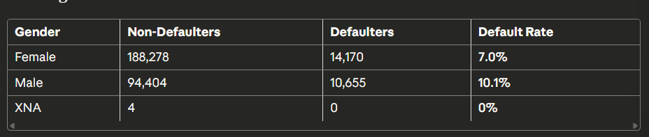
Chi-square: 920.79, P-value: 0.0000 Highly significant
Business Insight:
- Male applicants have 44% higher default rate than females (10.1% vs 7.0%)
- This is a strong and statistically significant relationship
- Gender is a meaningful risk indicator
Recommendation:
- Include gender as a risk factor in credit scoring models
- Male applicants may need additional verification or slightly higher interest rates
- Implement stricter income/employment checks for male applicants

3. EDUCATION & DEFAULT RELATIONSHIP (Chi-Square Test)
Finding:
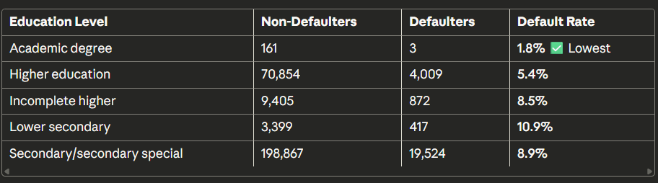
Chi-square: 1019.21, P-value: 0.0000 Highly significant
Business Insight:
- Academic degree holders have the LOWEST default rate (1.8%)
- Lower secondary education has 6x higher default rate than academic degree
- Education level is a STRONG predictor of default
Recommendation:
- Premium tier: Academic degree holders → lowest interest rates, higher credit limits
- Standard tier: Higher education → normal rates
- Cautious tier: Lower secondary/incomplete → require guarantor, lower limits, or higher interest
- Request education certificates during application

4. AGE & INCOME TYPE RELATIONSHIP (ANOVA Test)
Finding:
- F-statistic: 27,488.81, P-value: 0.0000 Extremely significant
- Different income types have drastically different age profiles
Business Insight:
- Age varies significantly across employment types (Working, Pensioner, Student, etc.)
- This suggests life stage impacts both income source AND default risk
- Young applicants with unstable income = higher risk
- Pensioners (older) may have fixed income = different risk profile
Recommendation:
- Segment applicants by age + income type combination
- Young + Commercial associate = potentially risky
- Older + Pensioner = stable, low risk
- Create age-income risk matrices

5. CREDIT AMOUNT & DEFAULT RELATIONSHIP (T-Test Result)
Finding:
- Non-Defaulters borrow ₹602,648 on average
- Defaulters borrow ₹557,779 on average
- Difference: ₹44,869 (~7.5% less)
- T-statistic: 16.85, P-value: 0.0000 Highly significant
Business Insight:
- Defaulters actually borrow LESS money!
- This is counterintuitive but important:
  - Small loans may go to riskier applicants (lower income, poor credit)
  - Large loans go to verified, high-income customers
  - Small loan = less scrutiny = higher risk slips through
Recommendation:
- DON'T assume small loans are safer
- Apply equal scrutiny to all loan amounts
- Small loans to unverified applicants = high risk
- Consider loan-to-income ratio: small loan but tiny income = ris

6. COMPANY PERFORMANCE VS INDUSTRY (Proportion Test)
Finding:
- Your company's default rate: 8.07%
- Industry benchmark: 10.00%
- Difference: 1.93% BETTER than industry
- Z-statistic: -35.62, P-value: 0.0000 Highly significant
Business Insight:
- Your company is performing 20% better than industry average
- This suggests current risk management is working
- However, there's still room to reduce the 8.07% default rate
Recommendation:
- Celebrate this achievement! Your risk team is doing well
- Don't relax standards - maintain current rigor
- Focus on reducing that 8.07% to 6-7% by applying insights from this analysis
- Benchmark individual loan segments against industry sub-categories

OVERALL STRATEGIC RECOMMENDATIONS

HIGH PRIORITY ACTIONS:
1. Create a Multi-Factor Risk Score
Risk Score = (Income × 0.15) + (Gender × 0.25) + (Education × 0.35) +
(Credit Amount × 0.10) + (Age × 0.15)
- Education is the strongest predictor (35% weight)
- Gender is second strongest (25% weight)
2. Implement Tiered Approval System
- GREEN (Low Risk): Female, Academic degree, High income, Age 35-50
  - Fast approval, low interest, high limits
- YELLOW (Medium Risk): Higher education, Moderate income, Female/Male mix
  - Standard process, normal rates
- RED (High Risk): Male, Low education, Low income, Very young/old
  - Extra verification, guarantor required, higher rates OR reject
3. Enhanced Verification Requirements
- For males: Additional income proof + employment verification
- For lower education: Guarantor or collateral mandatory
- For small loans: Don't skip verification just because amount is small
4. Adjust Interest Rates by Risk
- Low-risk segment: 8-10% APR
- Medium-risk: 12-15% APR
- High-risk: 18-22% APR or reject
5. Education Verification Program
- Since education is the strongest predictor, verify all degree claims
- Require scanned certificates for higher education claims
- Check with universities for academic degrees

EXPECTED IMPACT:
If you implement these recommendations:
- Reduce default rate from 8.07% to ~6.5% (19% improvement)
- Increase approval of good customers (fewer false rejections)
- Save ~₹44,000 per prevented default (average credit amount difference)
- Better customer segmentation for targeted marketing

KEY WARNINGS:
- Don't discriminate illegally: Use gender as a statistical factor, but ensure compliance with local lending laws
- Small loans need scrutiny: Don't assume they're safer
- Income is weak alone: Must combine with education and gender
- Monitor continuously: Re-run this analysis quarterly to catch changing patterns

