**Uploading CSV File into S3 bucket, reading the csv data in Lambda function and inserting CSV data into RDS database table and creating reports**

**Object in S3 Bucket**

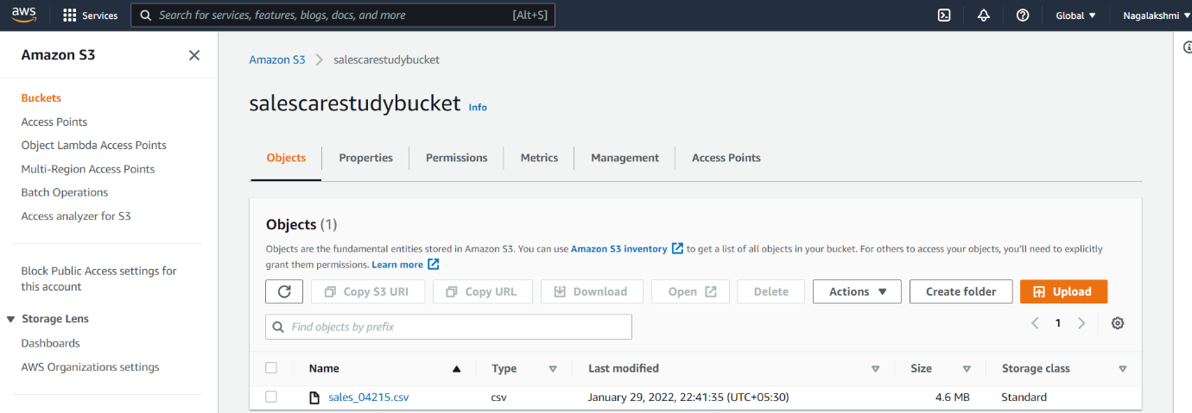

**Event Notification in S3 bucket**

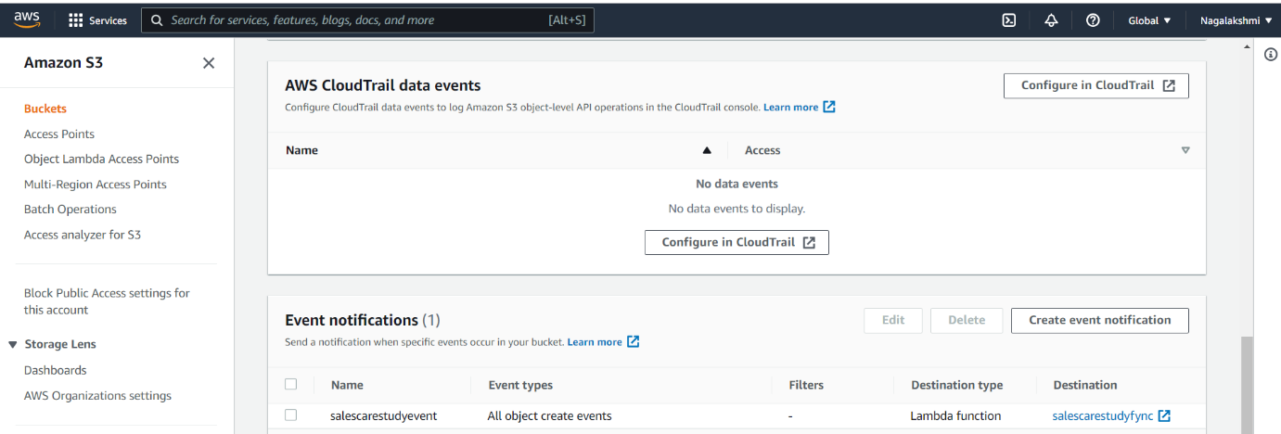

**Lambda function triggered to S3**

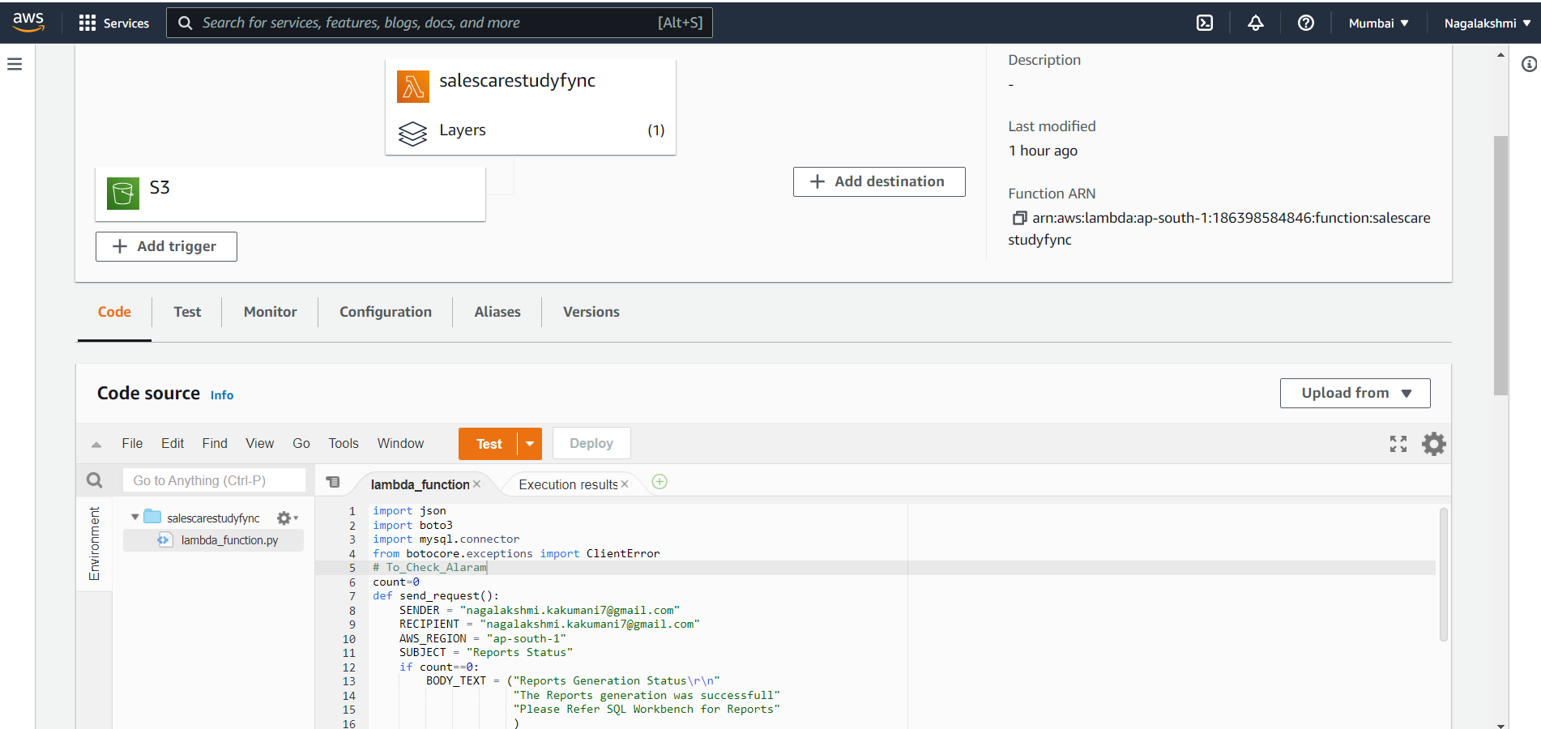

**RDS database creation**

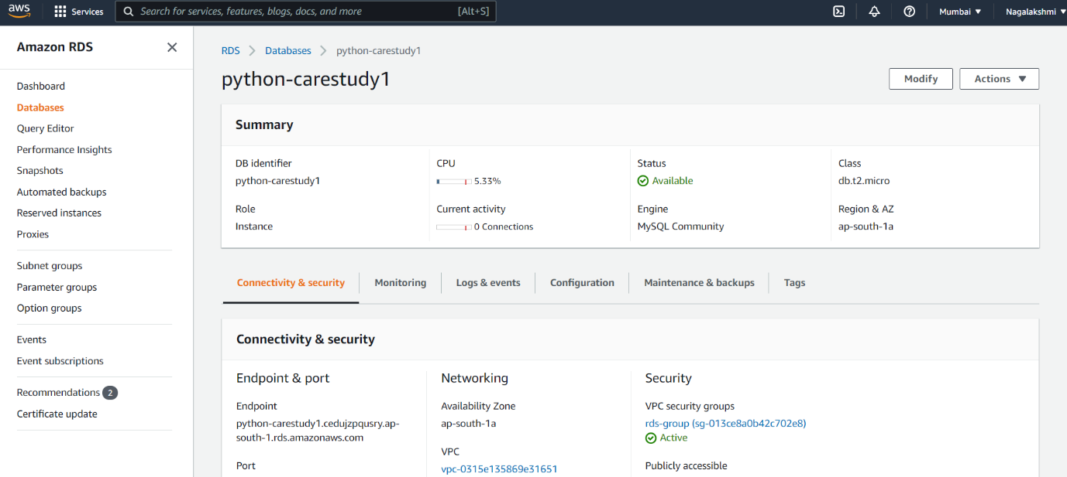

**RDS Database Configurations**

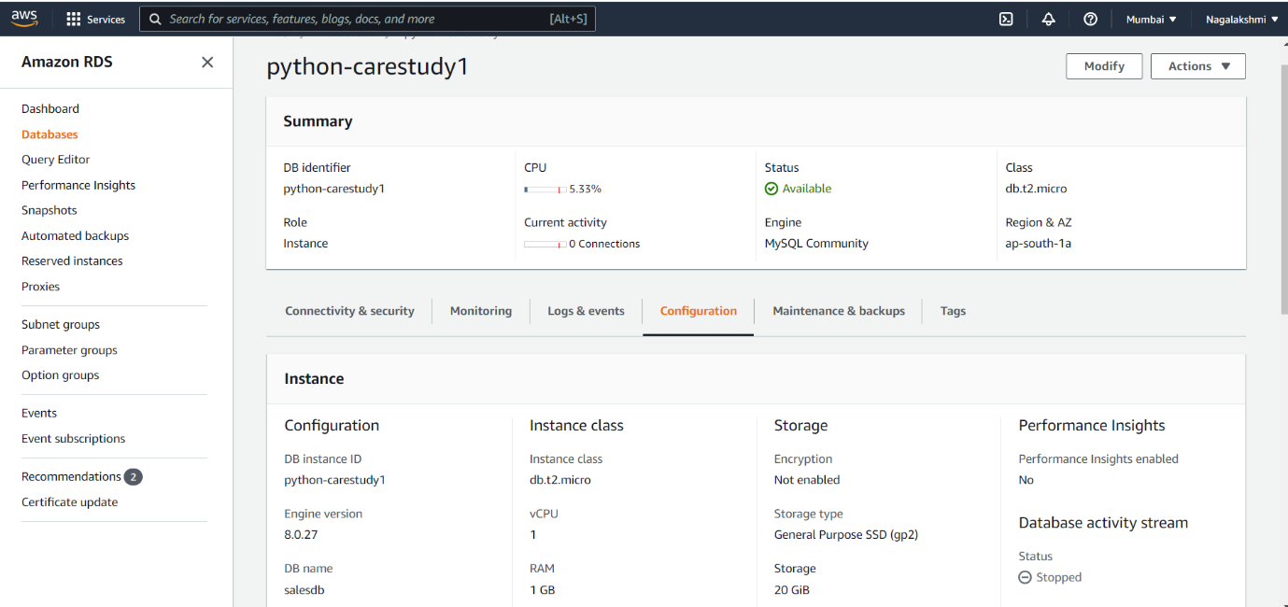

**Table In MYSQL Workbench**

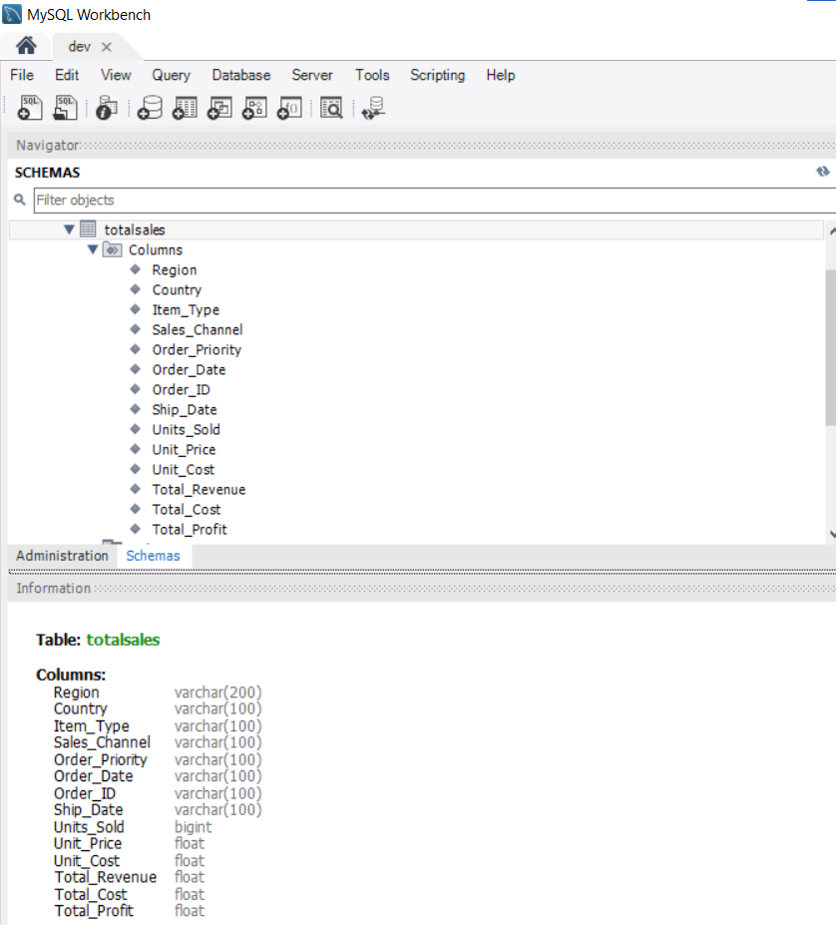

**Report1 generated as View in RDS database**

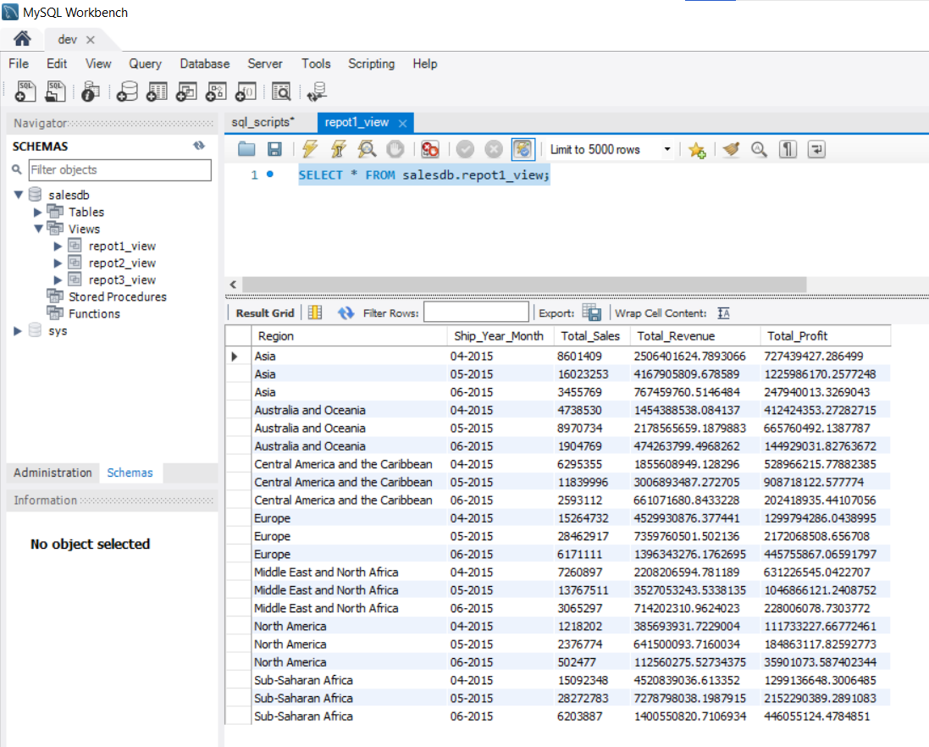

**Report2 generated as view in RDS database**

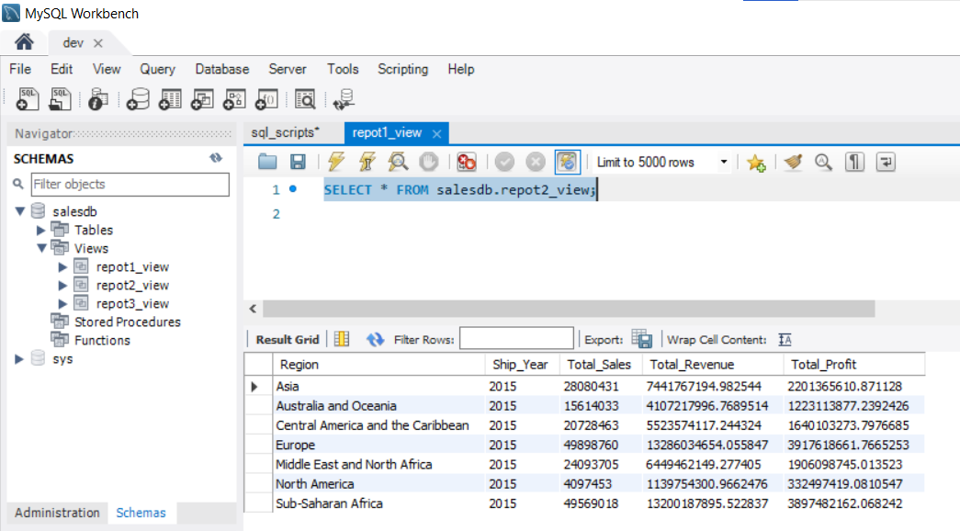

**Report3 generated as view in RDS database**

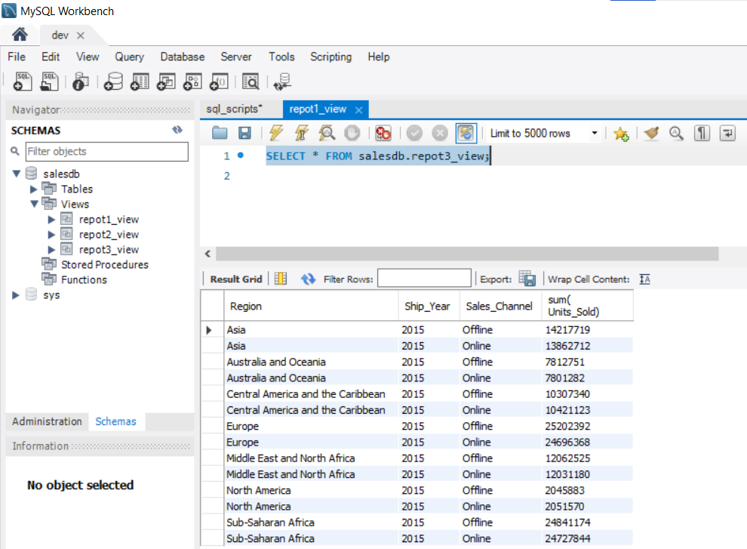

**SES Email verification Configuration**

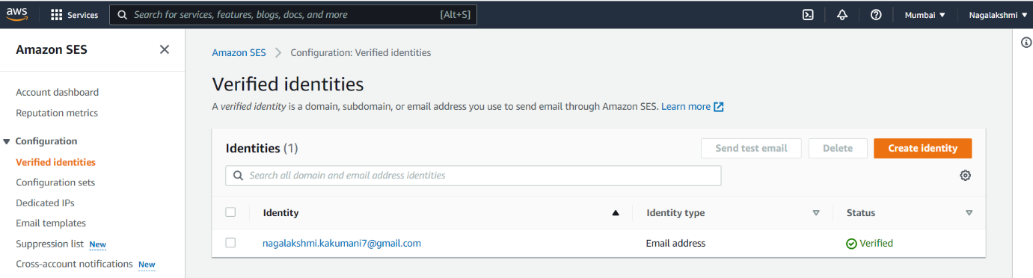

**Email sent through SES on Success**

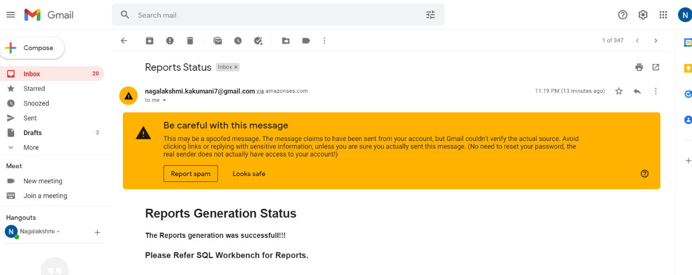

**Email sent through SES on Failure**

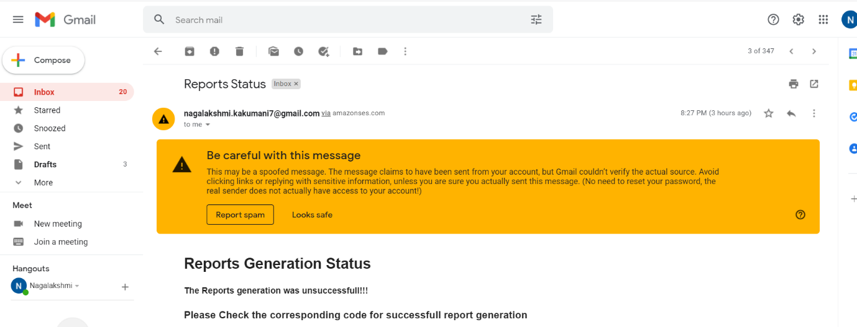

**SNS topic created for Cloud Alarm**

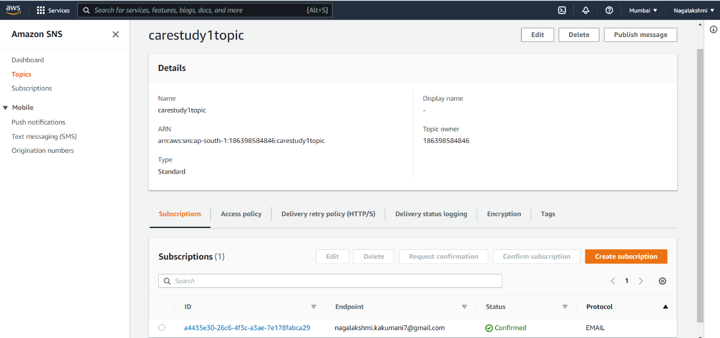

**Cloud Watch Alarm**

