**Inserting json data by using AWS Glue and S3 bucket into RDS database tables**

**AWS CDK Component code for generating S3 bucket and resources**

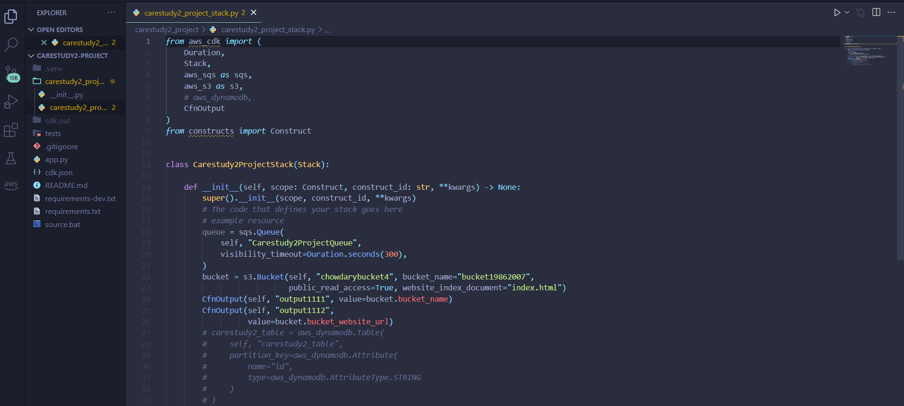

**Created S3 bucket by using AWS CDK**

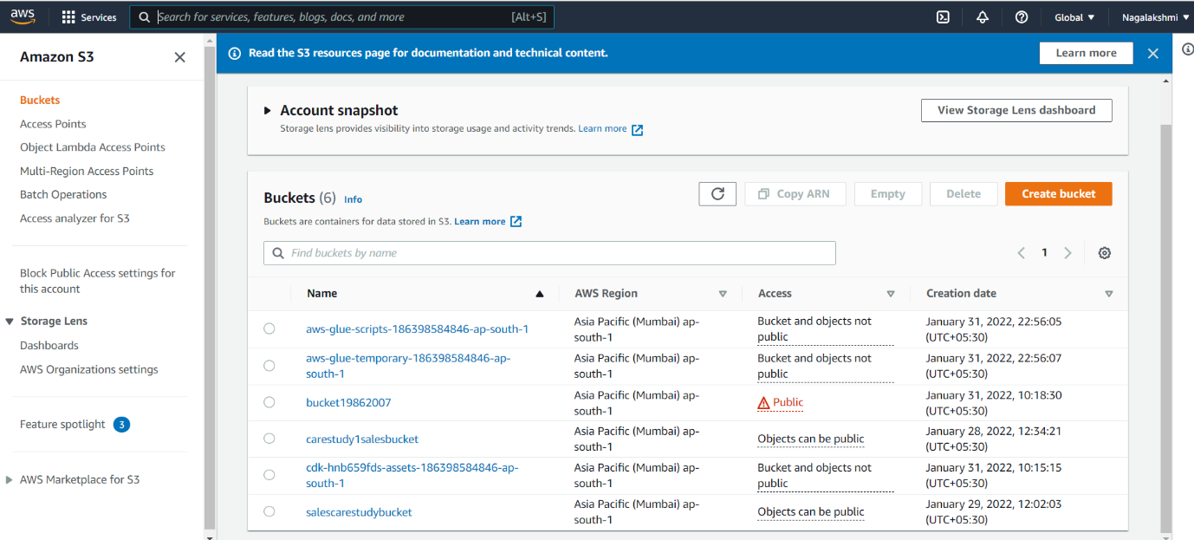

**AWS RDS Configurations**

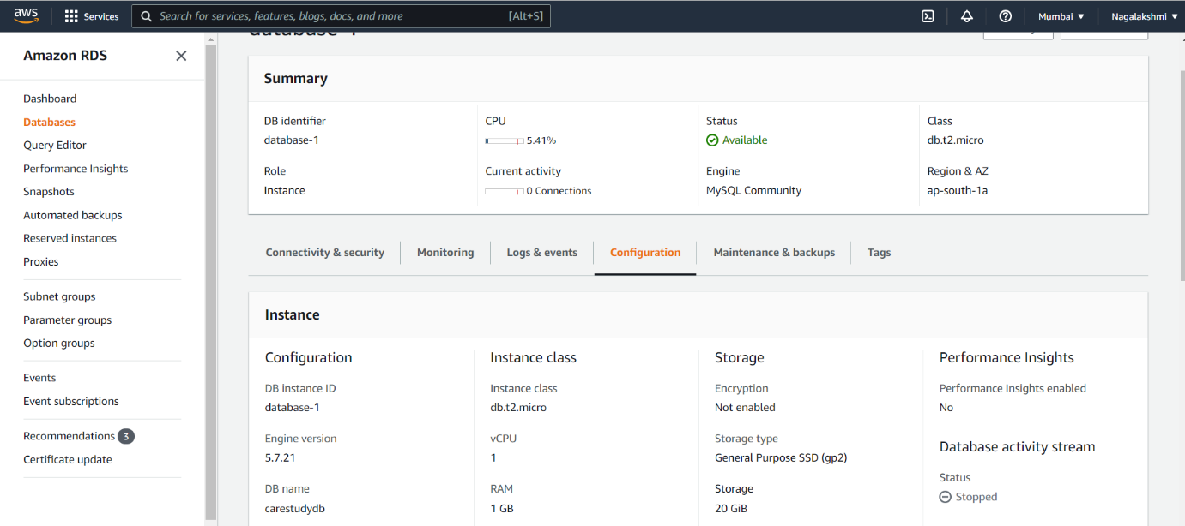

**Table Creation in RDS dtabase**

**Buildings table**



**Tenents Table**

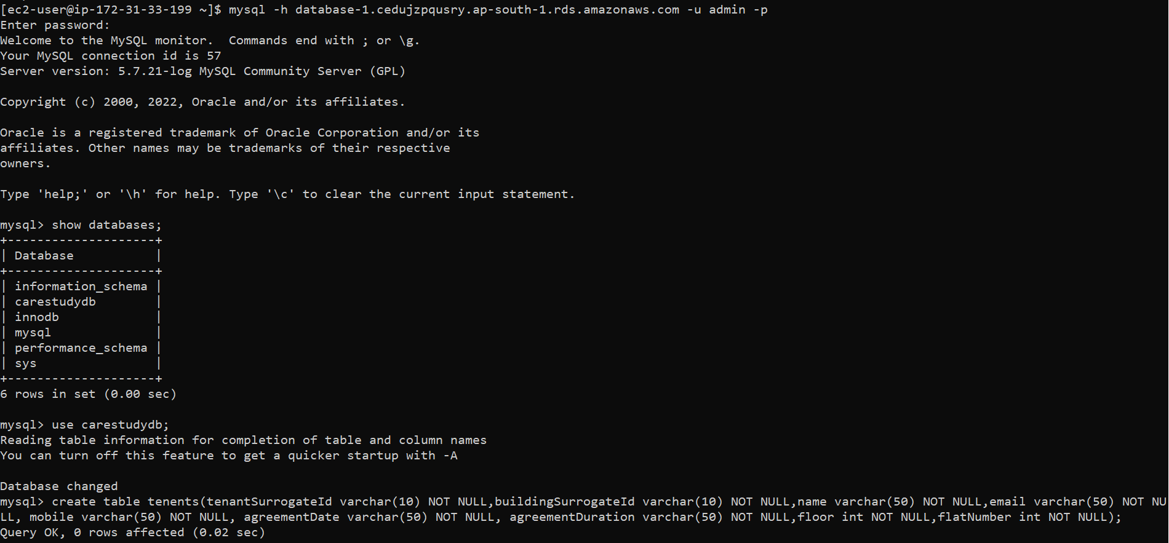

**AWS Glue Classifier for Json data**

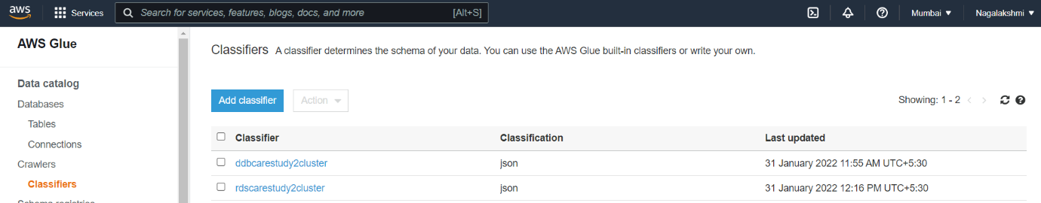

**AWS Glue Connections**

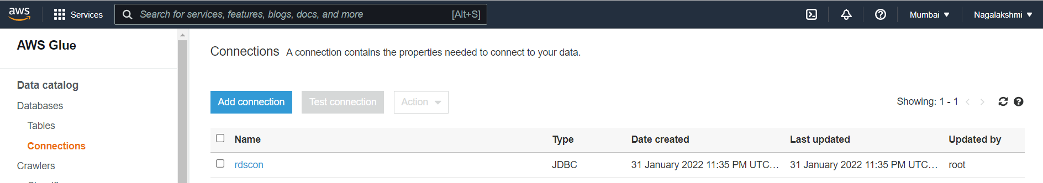

**AWS Glue Dev endpoint**

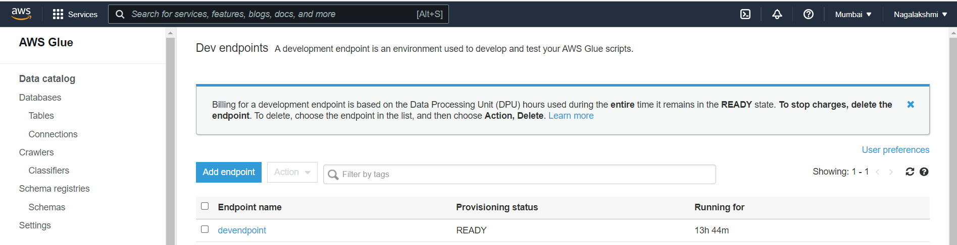

**AWS Glue Notebook**

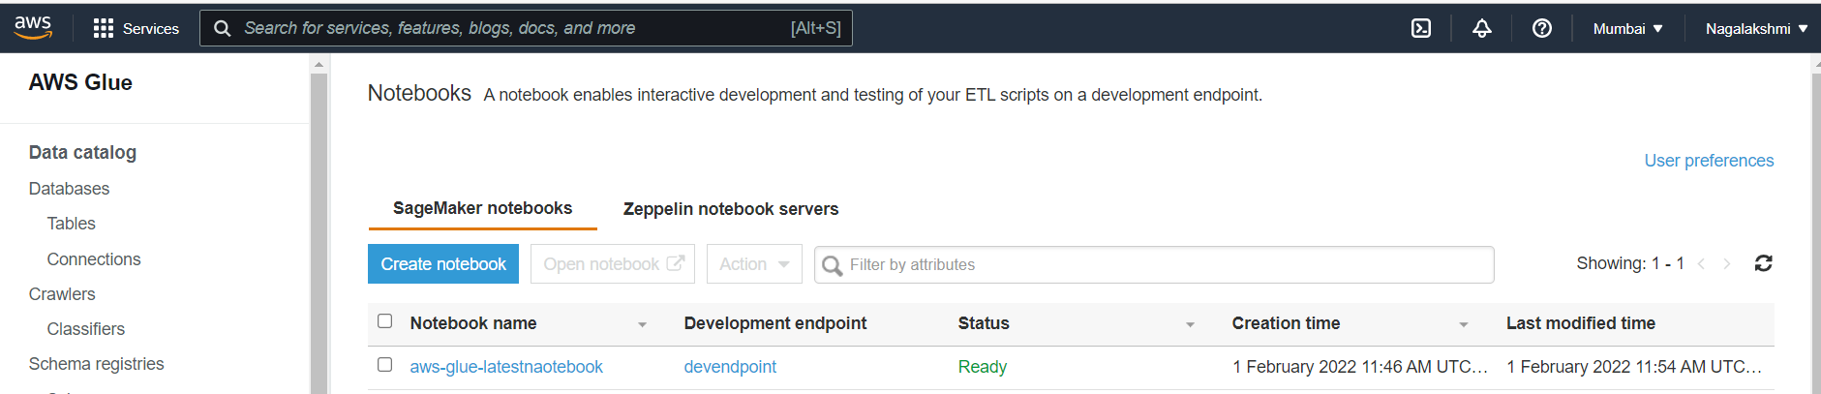

**Notebook Code**

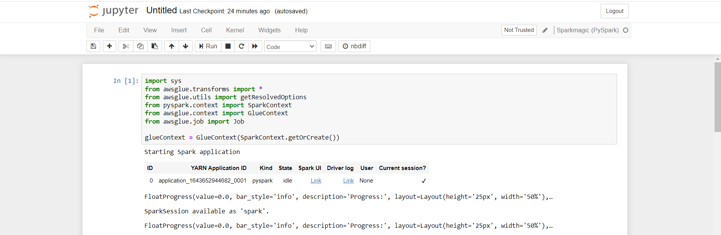



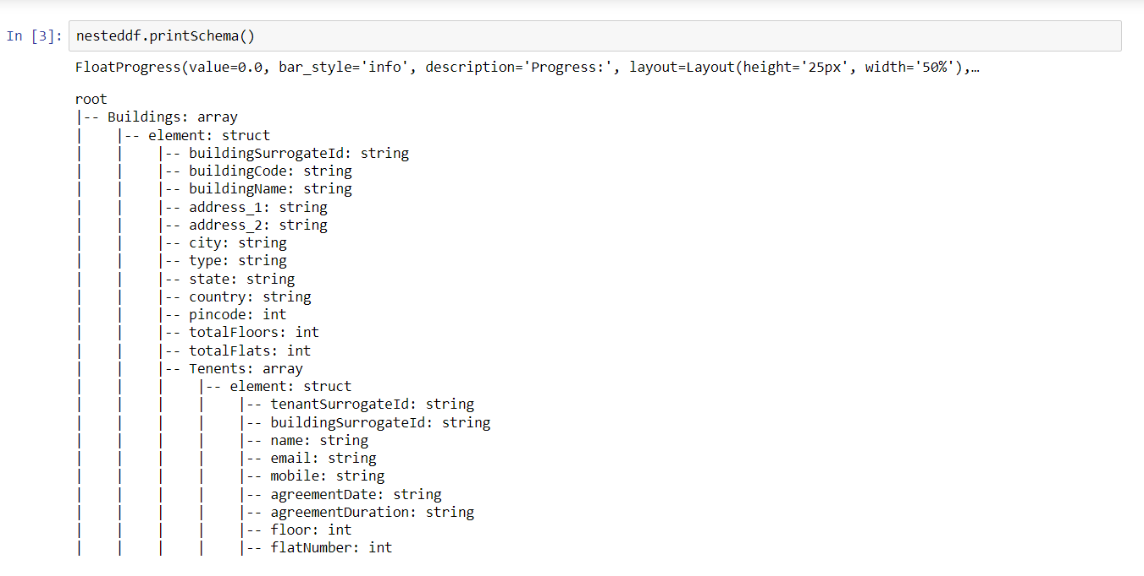

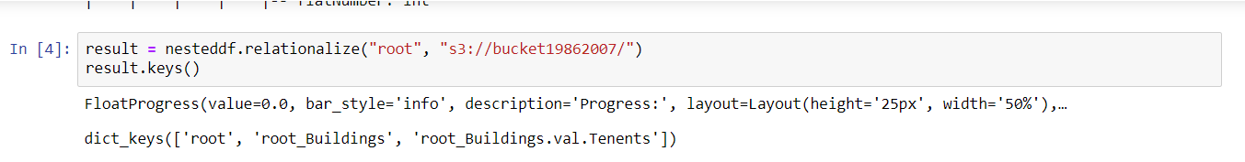

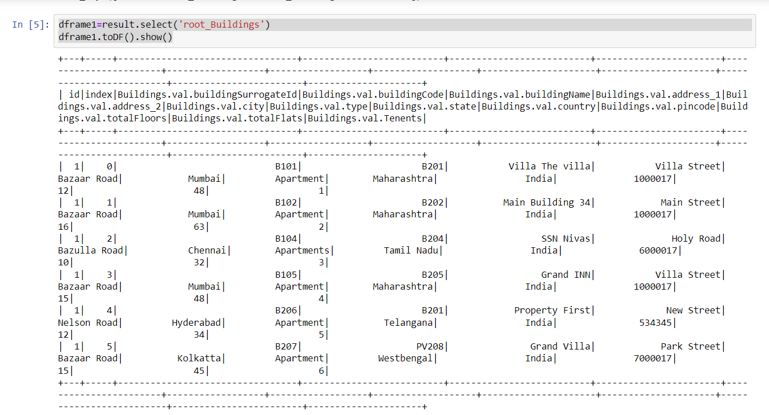

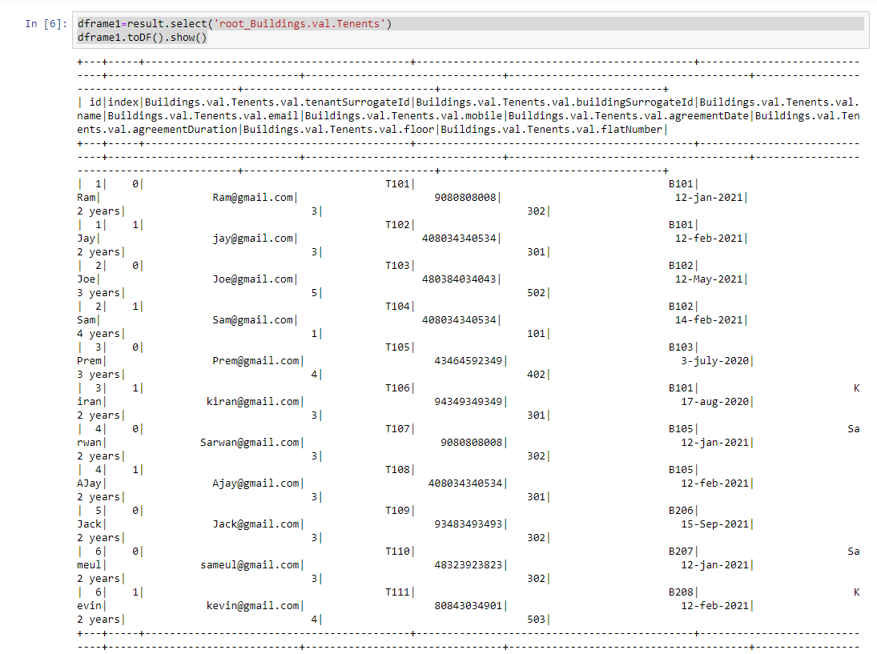

**New file created in S3 bucket after running commands in Notebook**

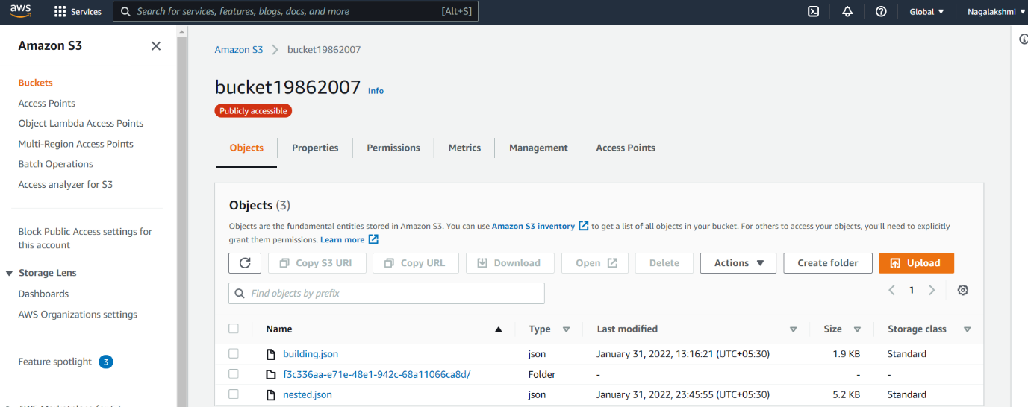

**AWS Glue Crawlers created by using S3 bucket , database table**

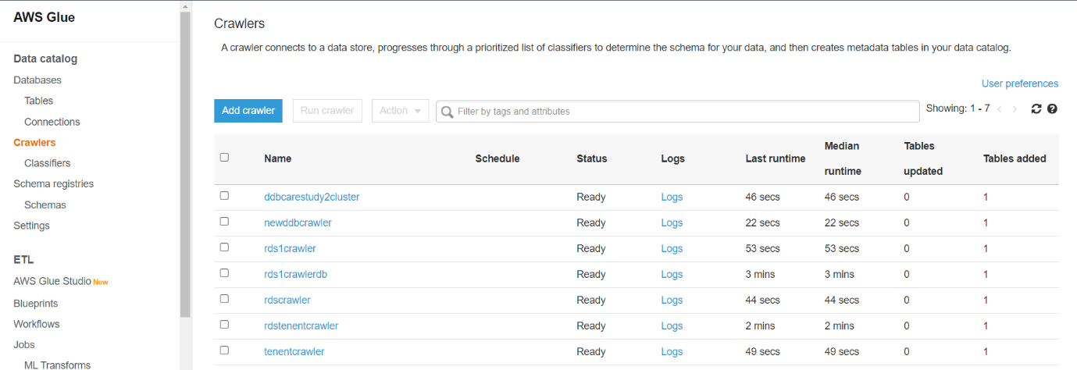

**AWS Glue Tables created after running Crawler**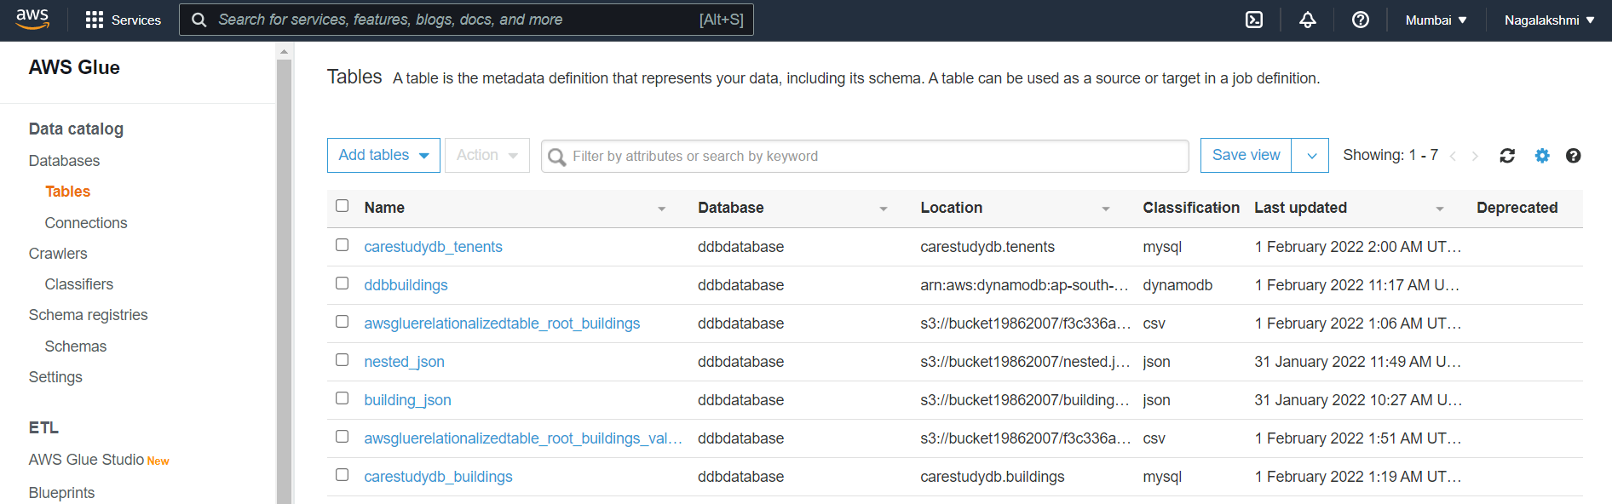

**AWS Glue Job for dynamodb**

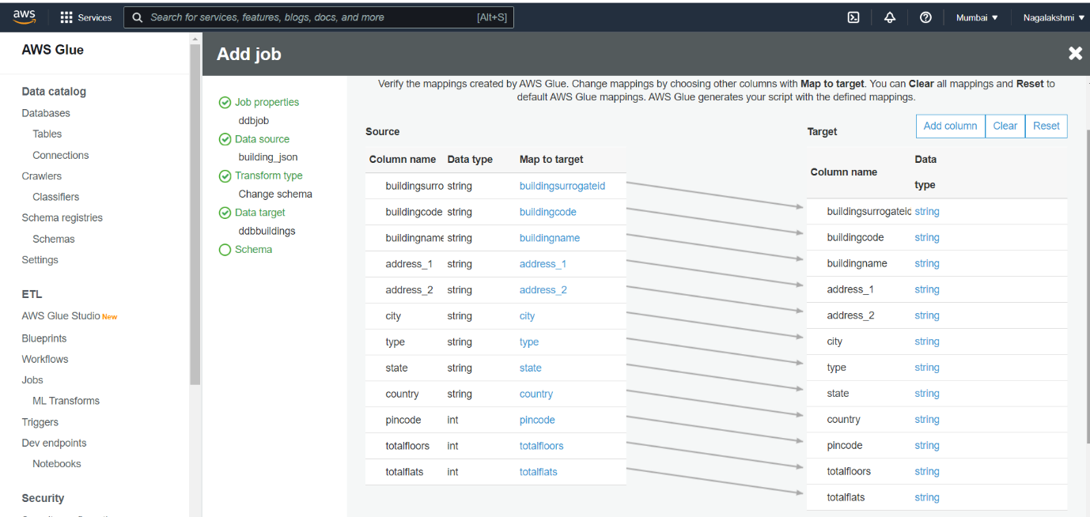

**AWS Glue job for creating building table content in RDS database**

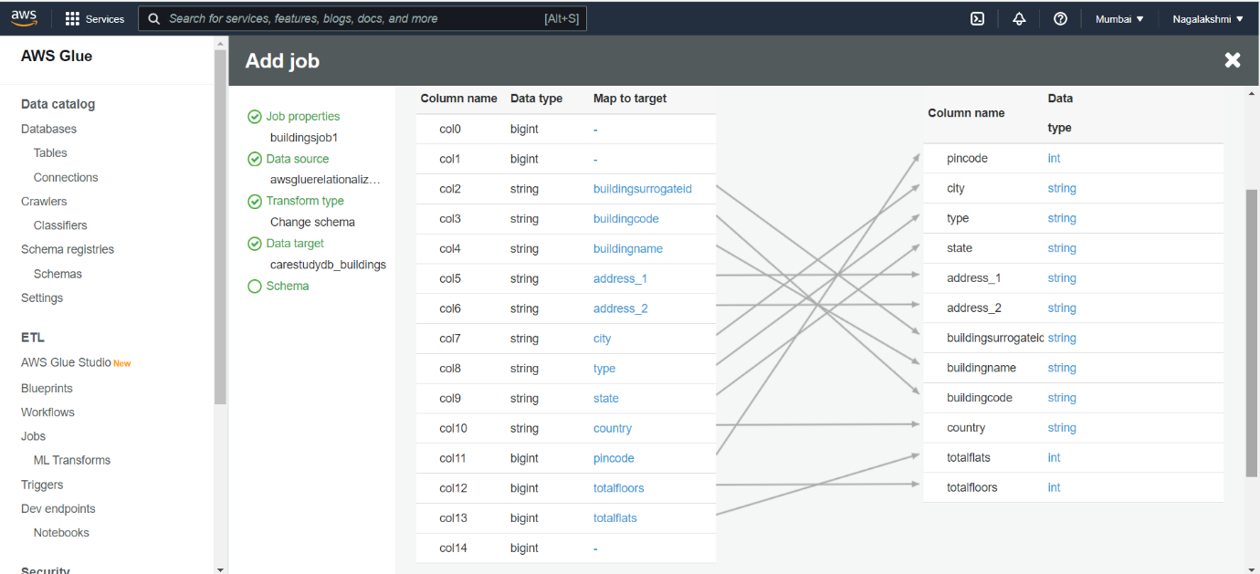

**Job Status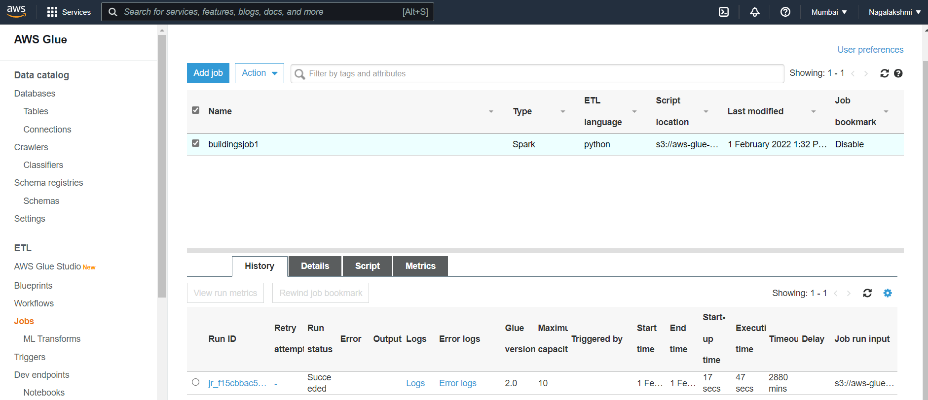AWS Glue job for creating tenants table content in RDS database**

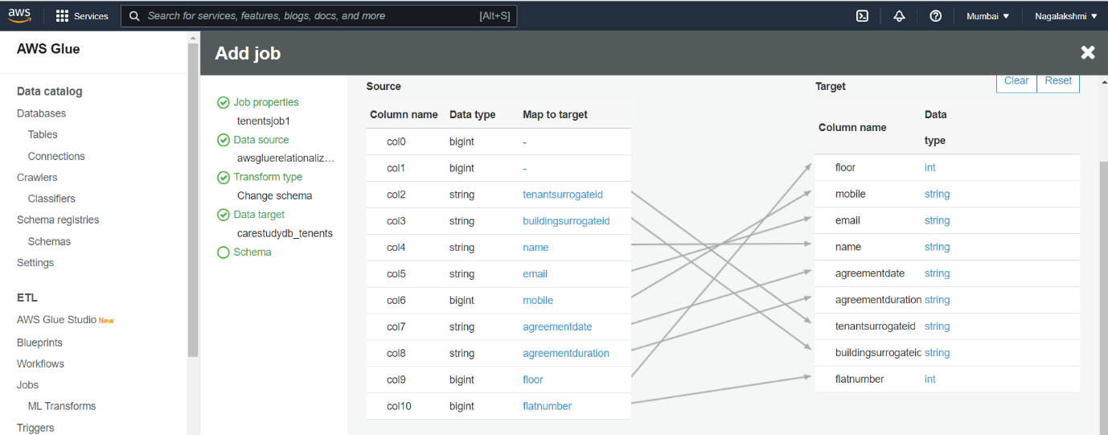

**Job Status**

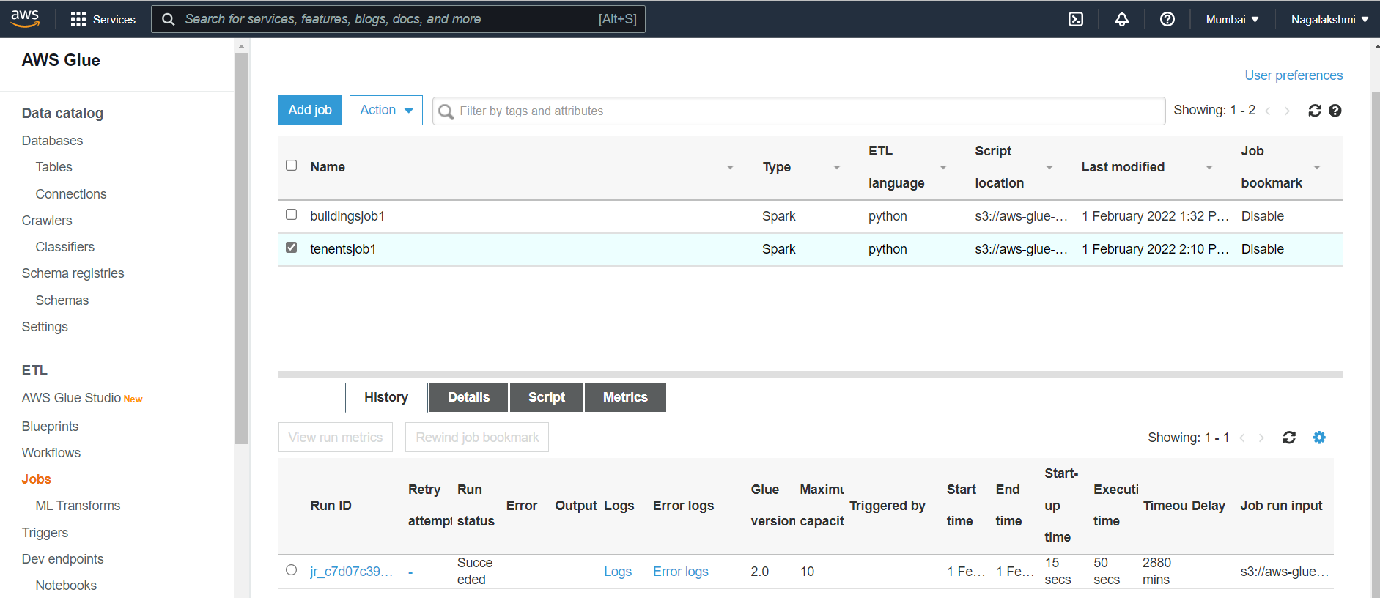

**Data inserted in RDS database after jobs success**

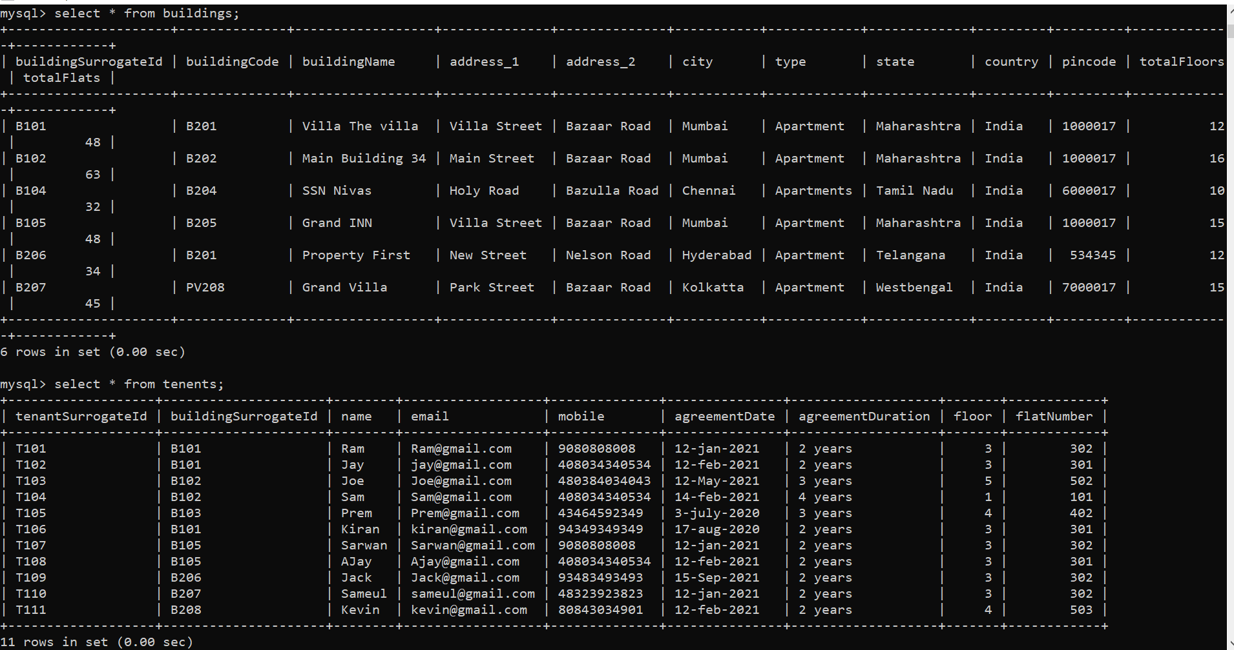

**Quick site for buildings table data**

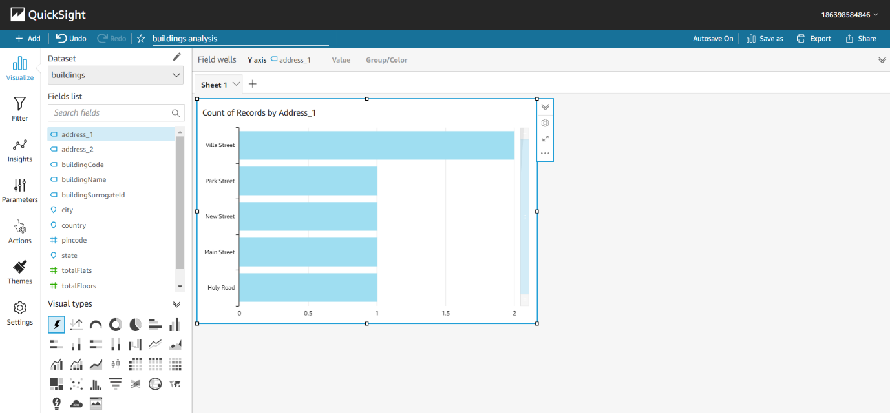

**Quick site for tenents table data**

