Auto Scaling group

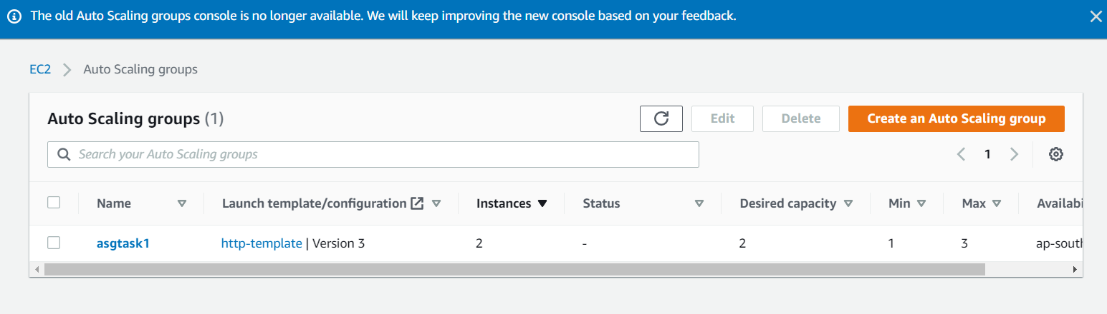

Alarm

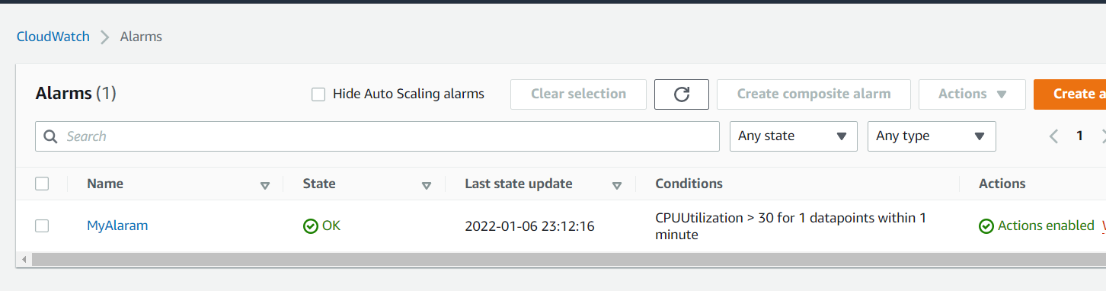

CloudWatch

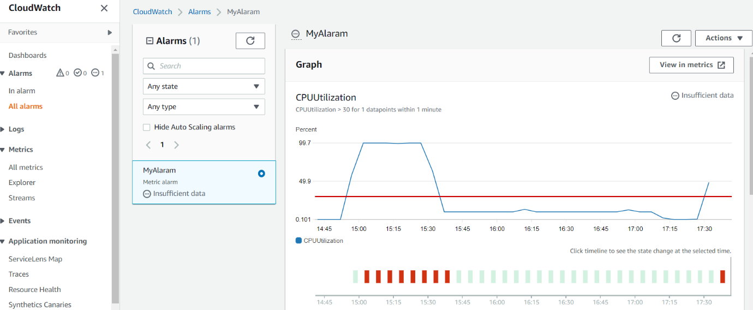

Command in cmd

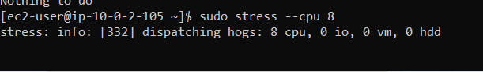

Instances

