**Launch Template**

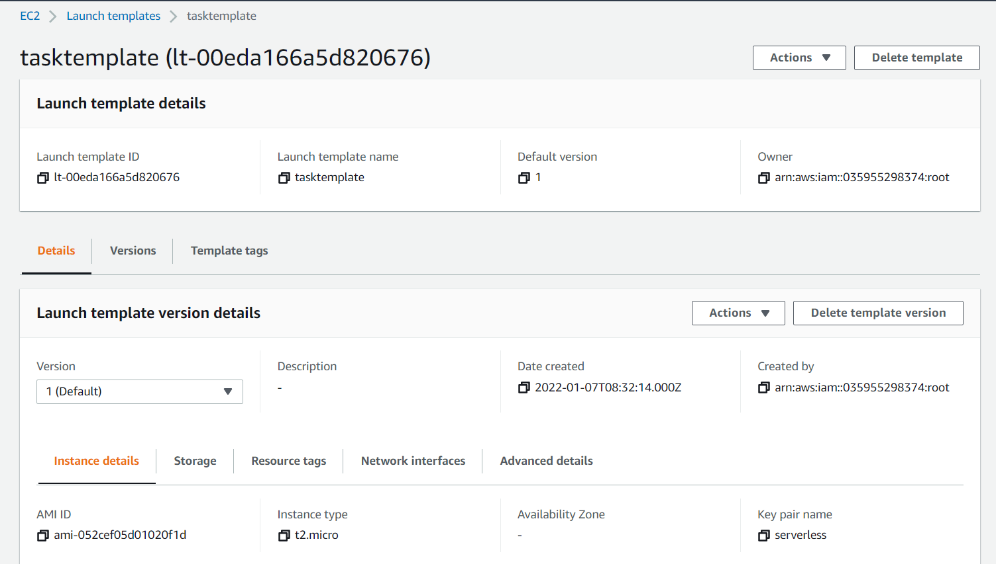

**Load Balancer**

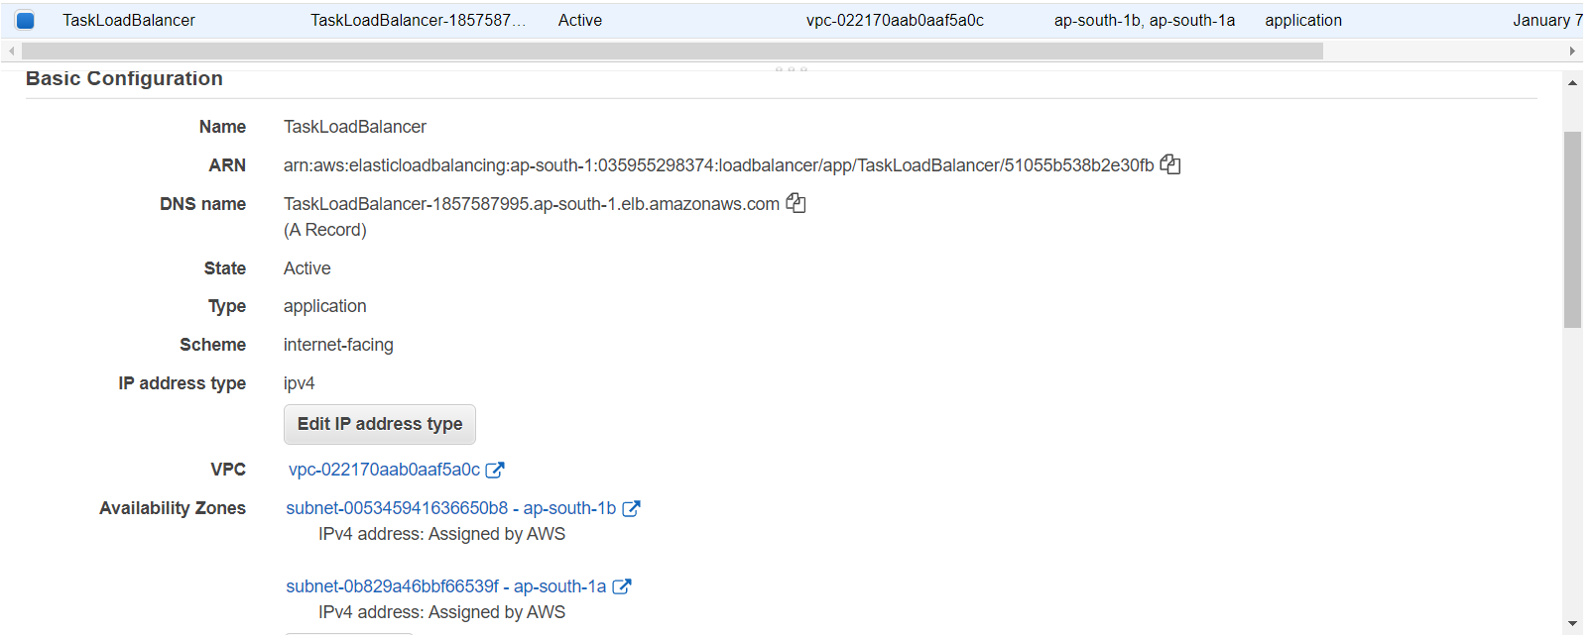

**Auto Scaling Group**

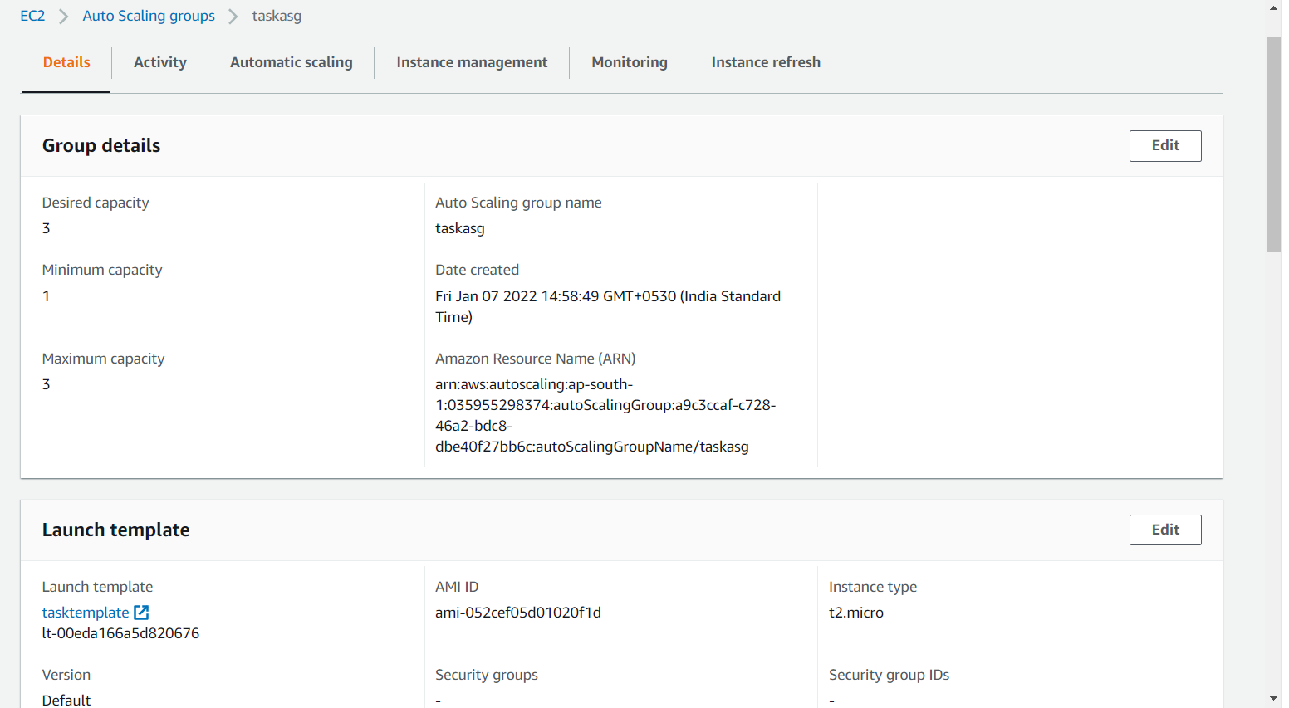

**Scaling Policy**

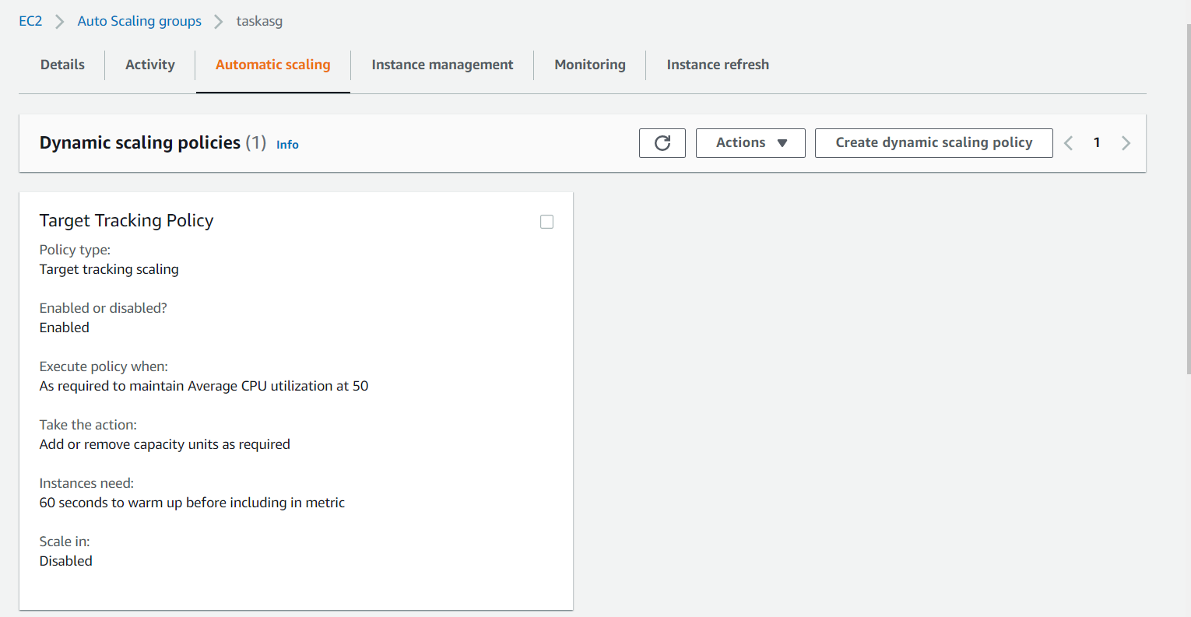

**Outcomes expected**

1. **Instance1 of ASG**

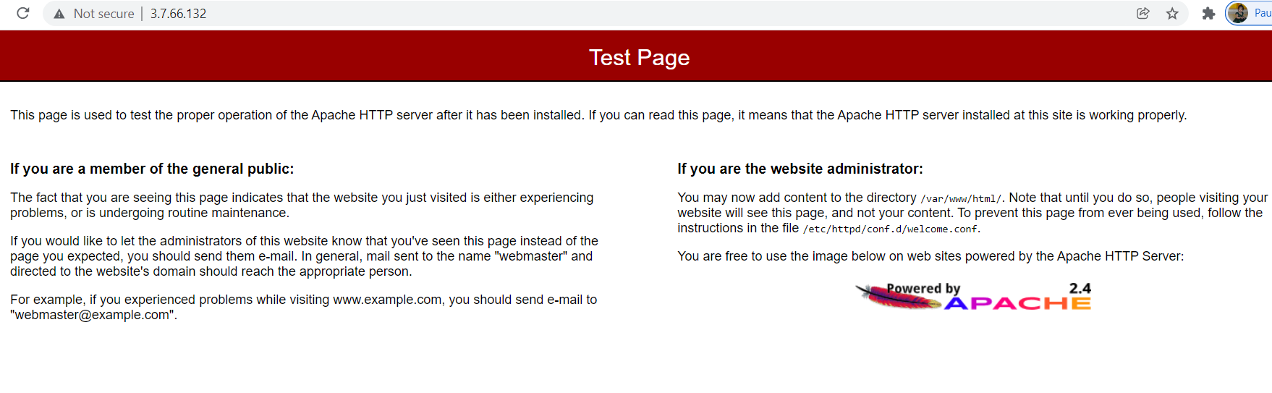

1. **Instance2 ASG**

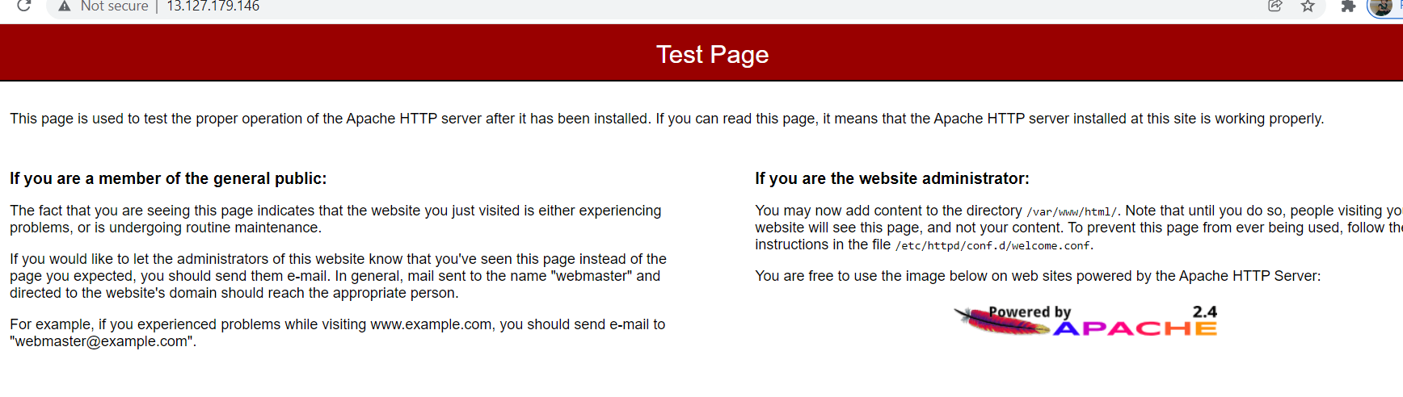

1. **Instance3 ASG**

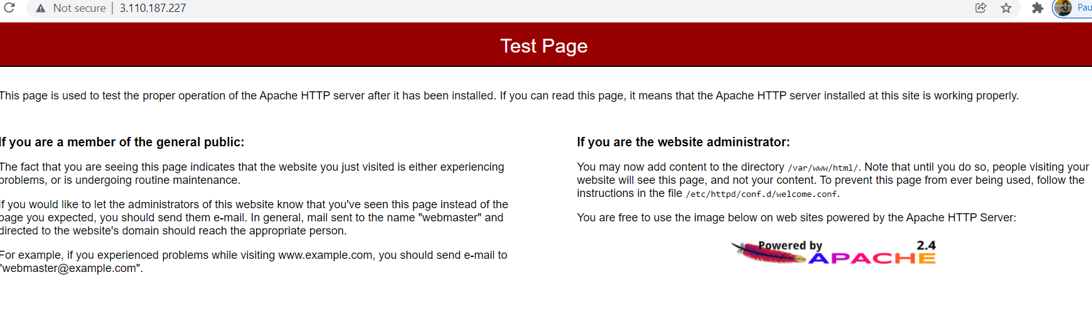

1. **Load balancer DNS**

