**Pulling Docker Image**

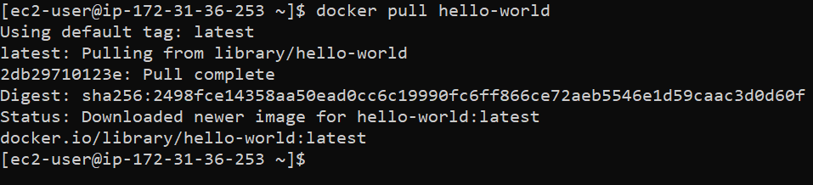

**Tagging**



**Pushing Tagged Image to Docker hub**

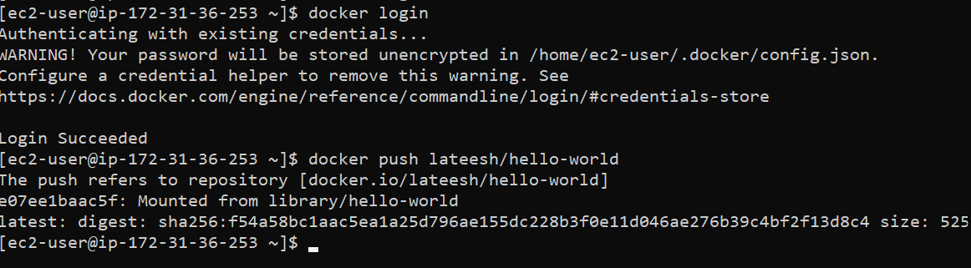

**Image in Docker hub**

