**Uploading data from s3 bucket to DynamoDB, GET/PUT/DELETE(object deletion in s3 bucket) operations through API and Lambda function**

**DynamoDB filelist table**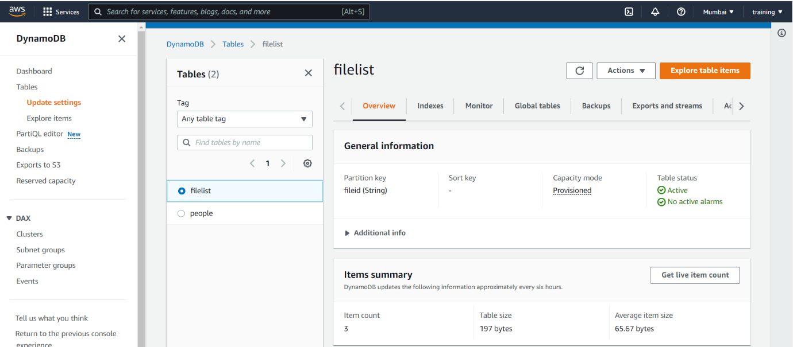

**S3 Bucket policy**

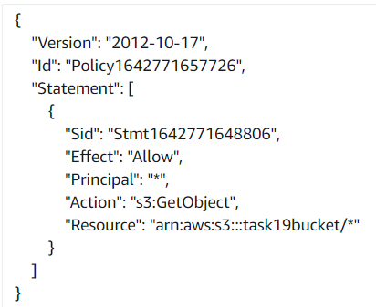

**Event notification in S3 Bucket**

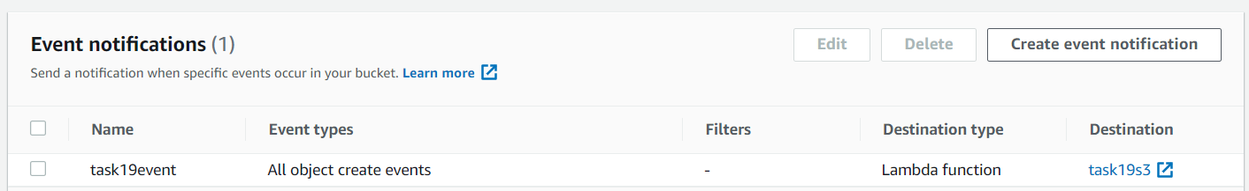

**Uploaded files in S3 Bucket**

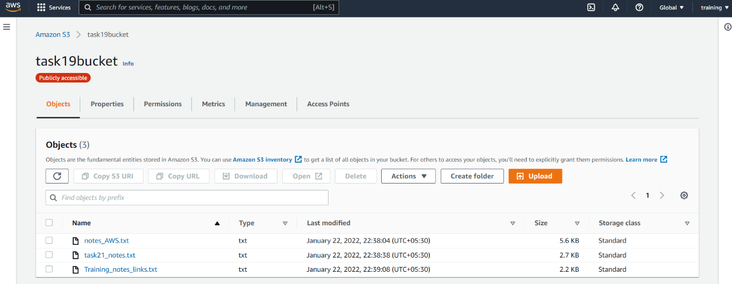

**Lambda function to insert data into DynamoDB from S3 Bucket**

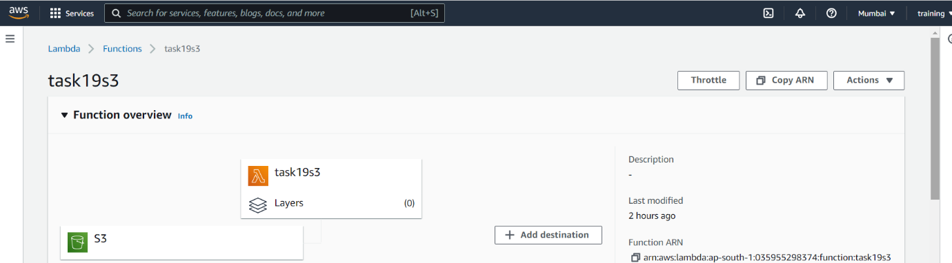

**Lambda function code to insert data into DynamoDB from S3 Bucket**

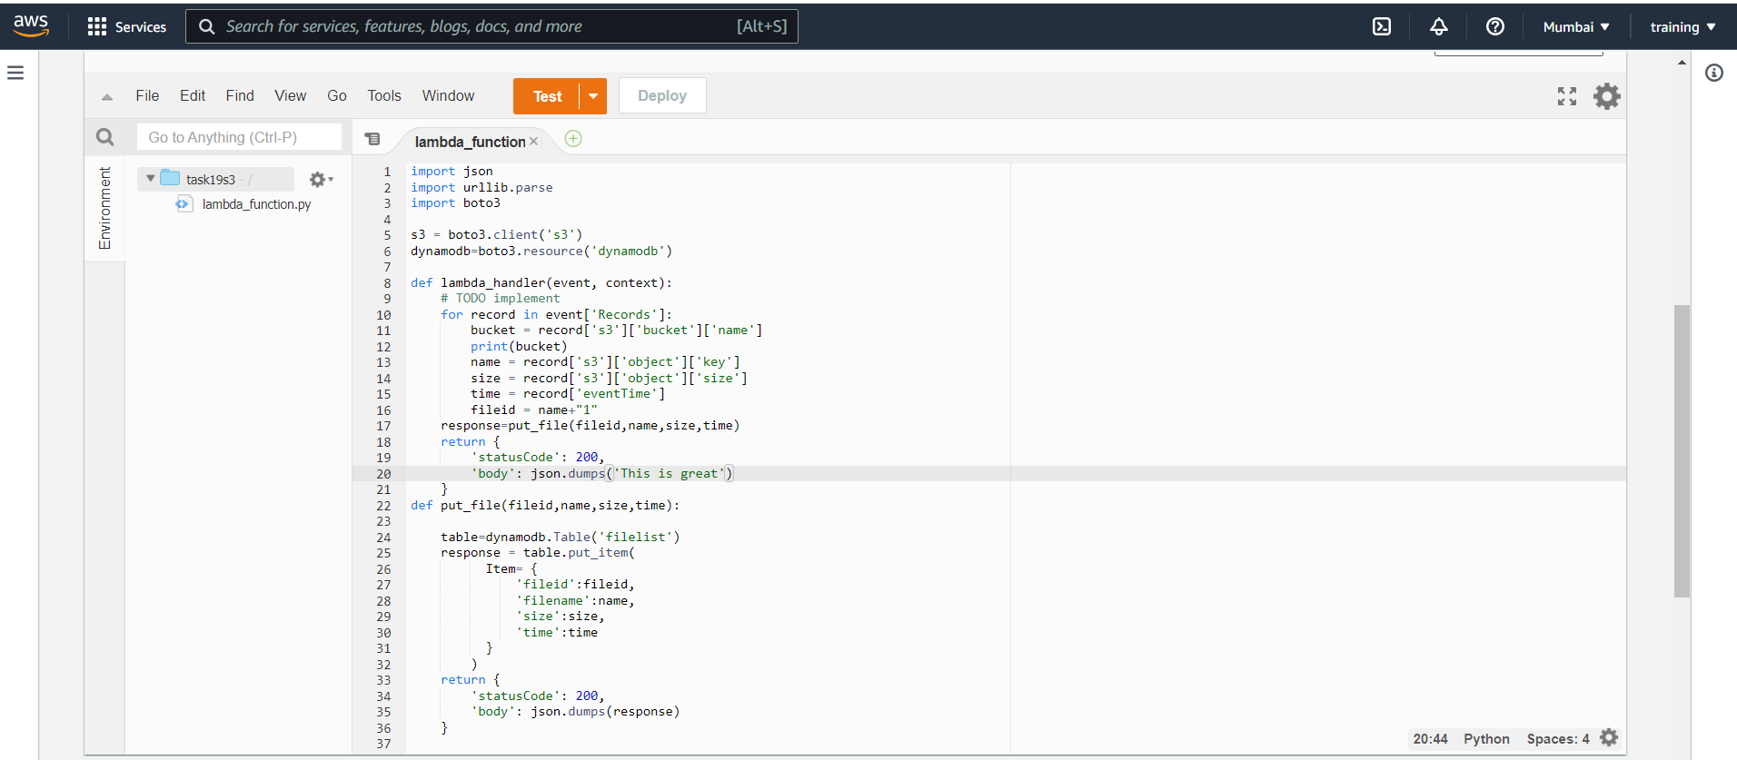

**Lambda function permission roles**

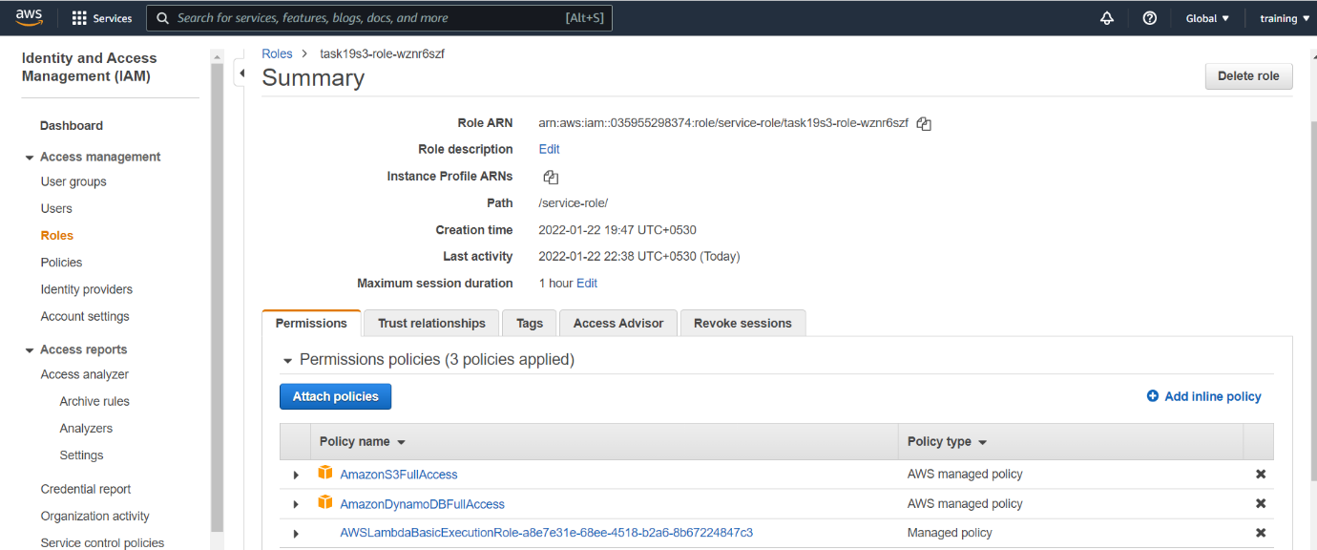

**Data in DynamoDB filelist table after uploading files into S3 Bucket**

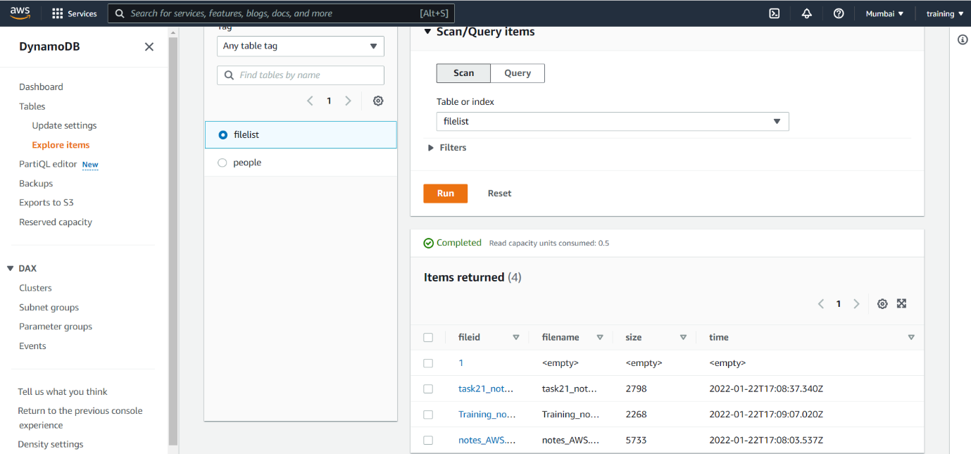

**Lambda function for get ,get single record, put and delete**

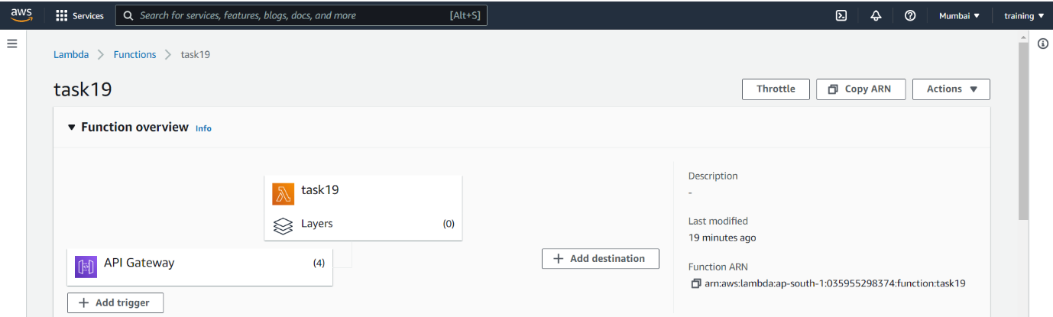

**Lambda function code for get ,get single record, put and delete**

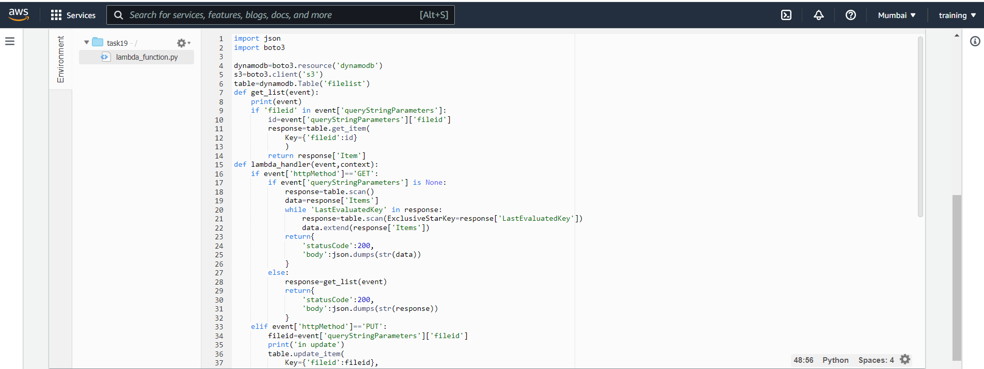

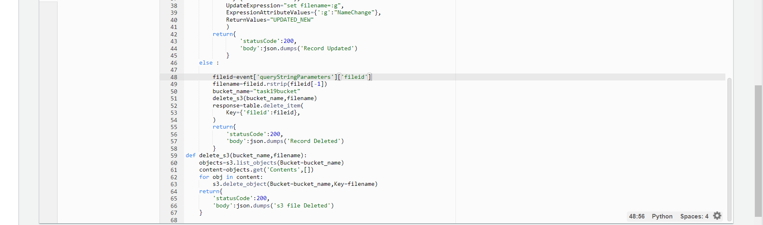

**Lambda function permission roles**

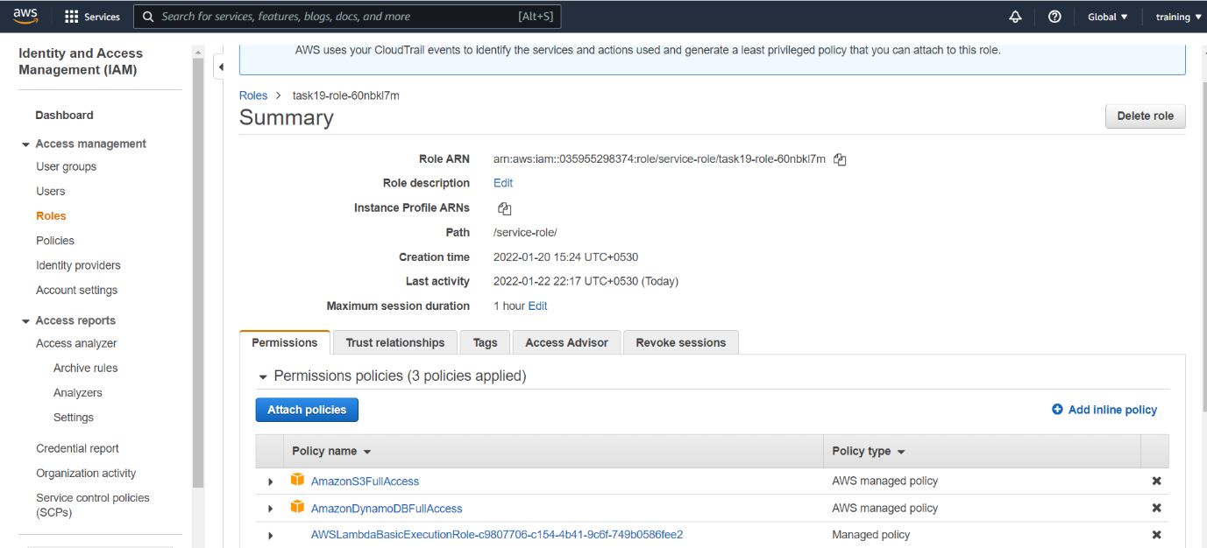

**API gateway**

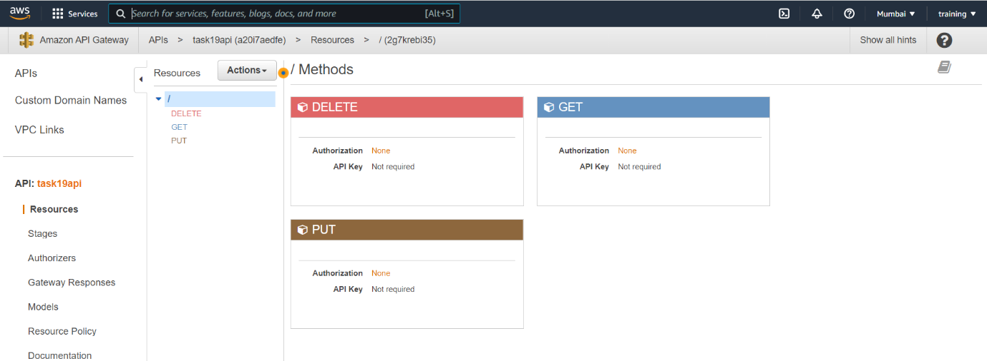

**Get response**

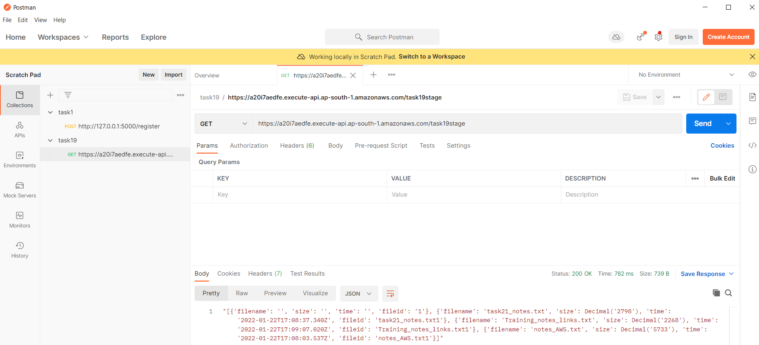

**Get single record**

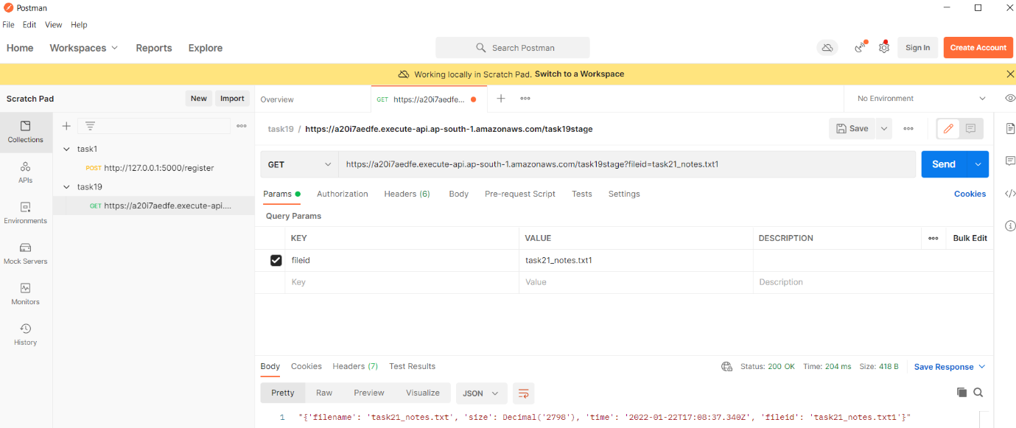

**PUT response**

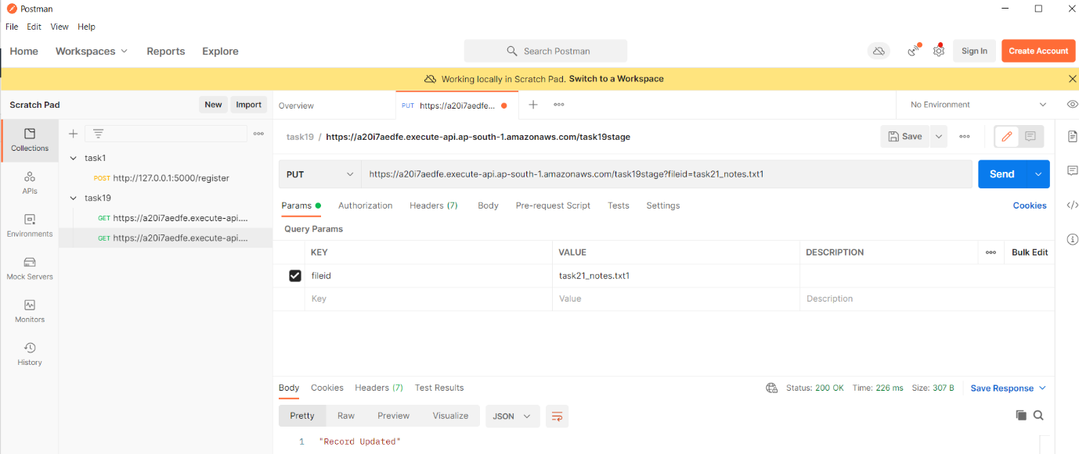

**DynamoDB filelist table data after PUT**

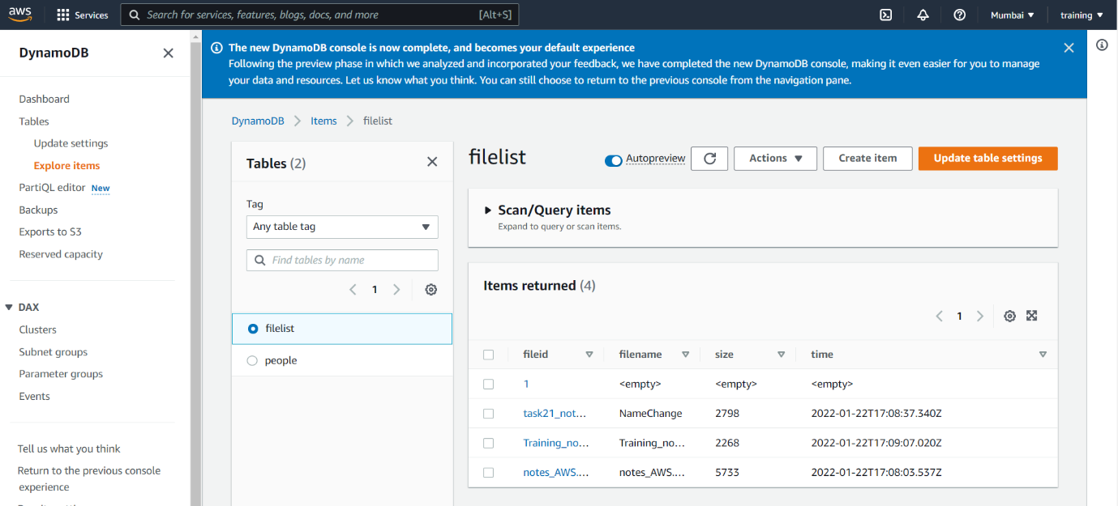

**DELETE response**

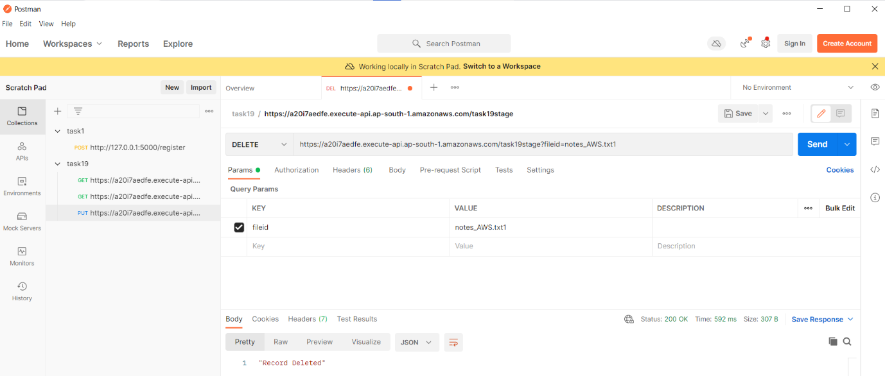

**Objects in S3 Bucket after DELETE**

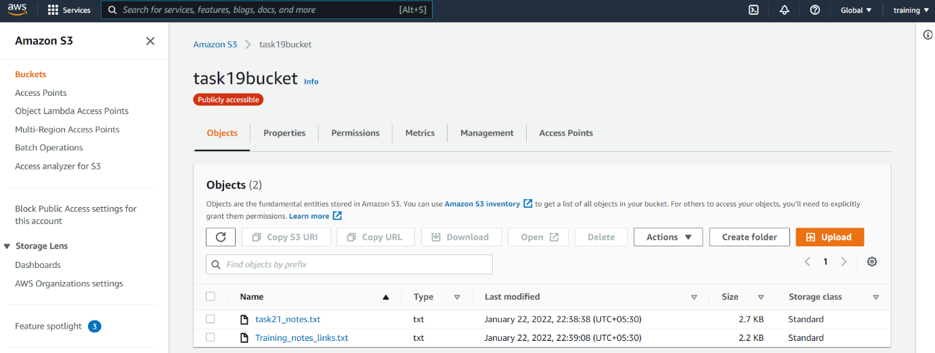

**DynamoDB filelist table items after DELETE**

