**Creating Countries table in sql workbench and uploading json data from S3 bucket to the countries table through AWS Glue**

**Countries table in SQL Workbench**

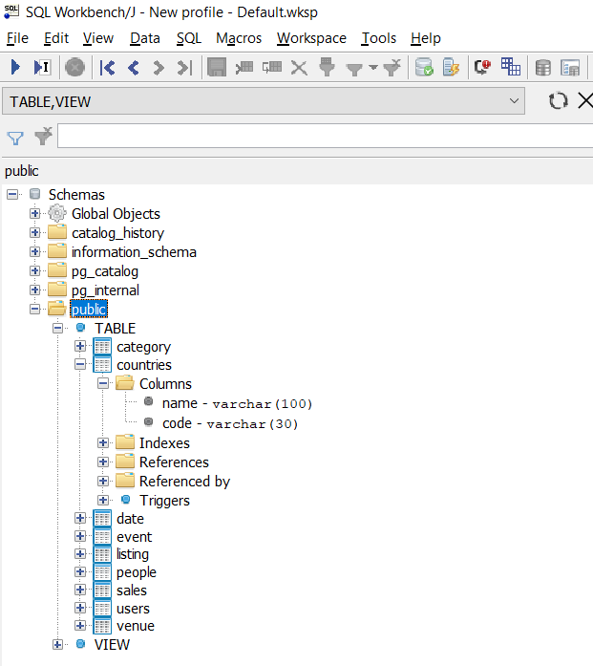

**Countries Table reflected from SQL Workbench to Redshift**

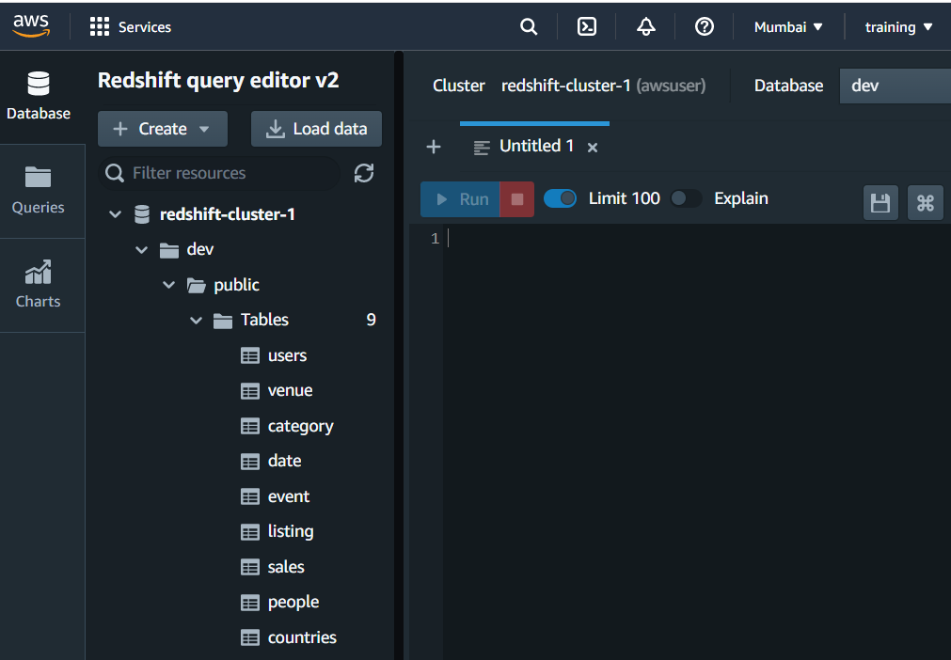

**Classifier named jsonclassifier created inside AWS Glue classifiers**

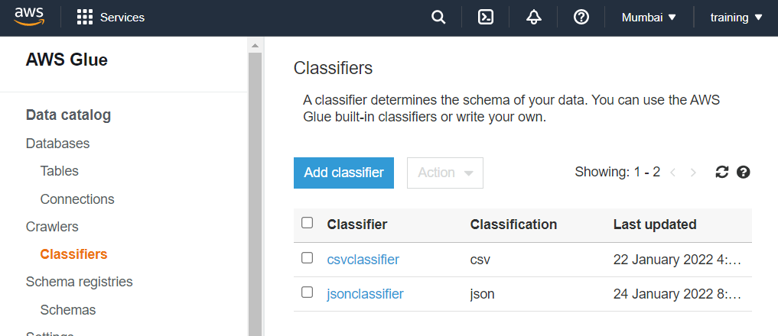

**Crawler named jsoncrawler created inside AWS Glue Crawlers**

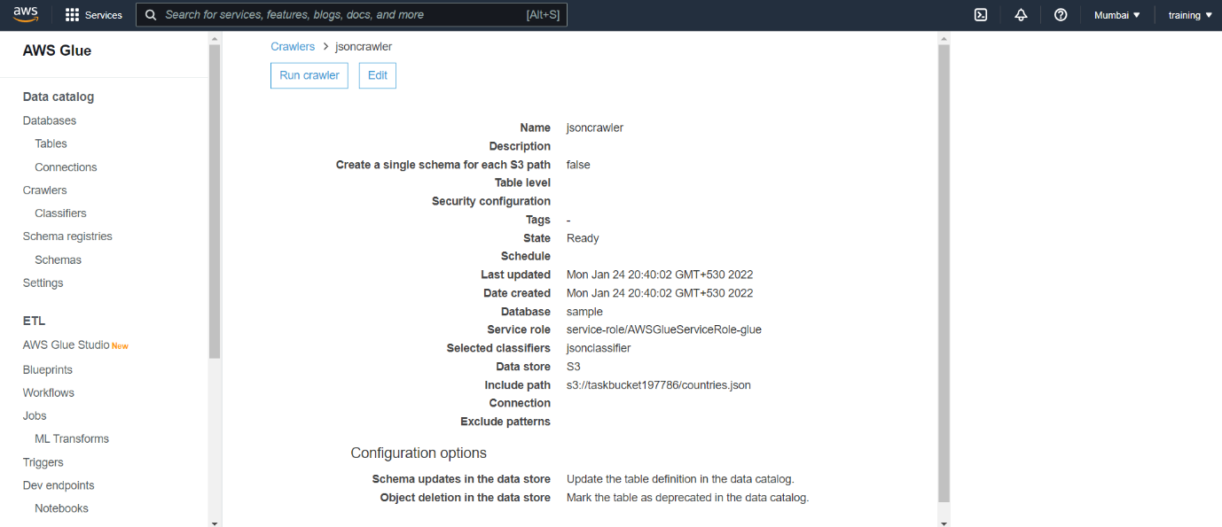

**countries_json table created automatically after running jsoncrawler**

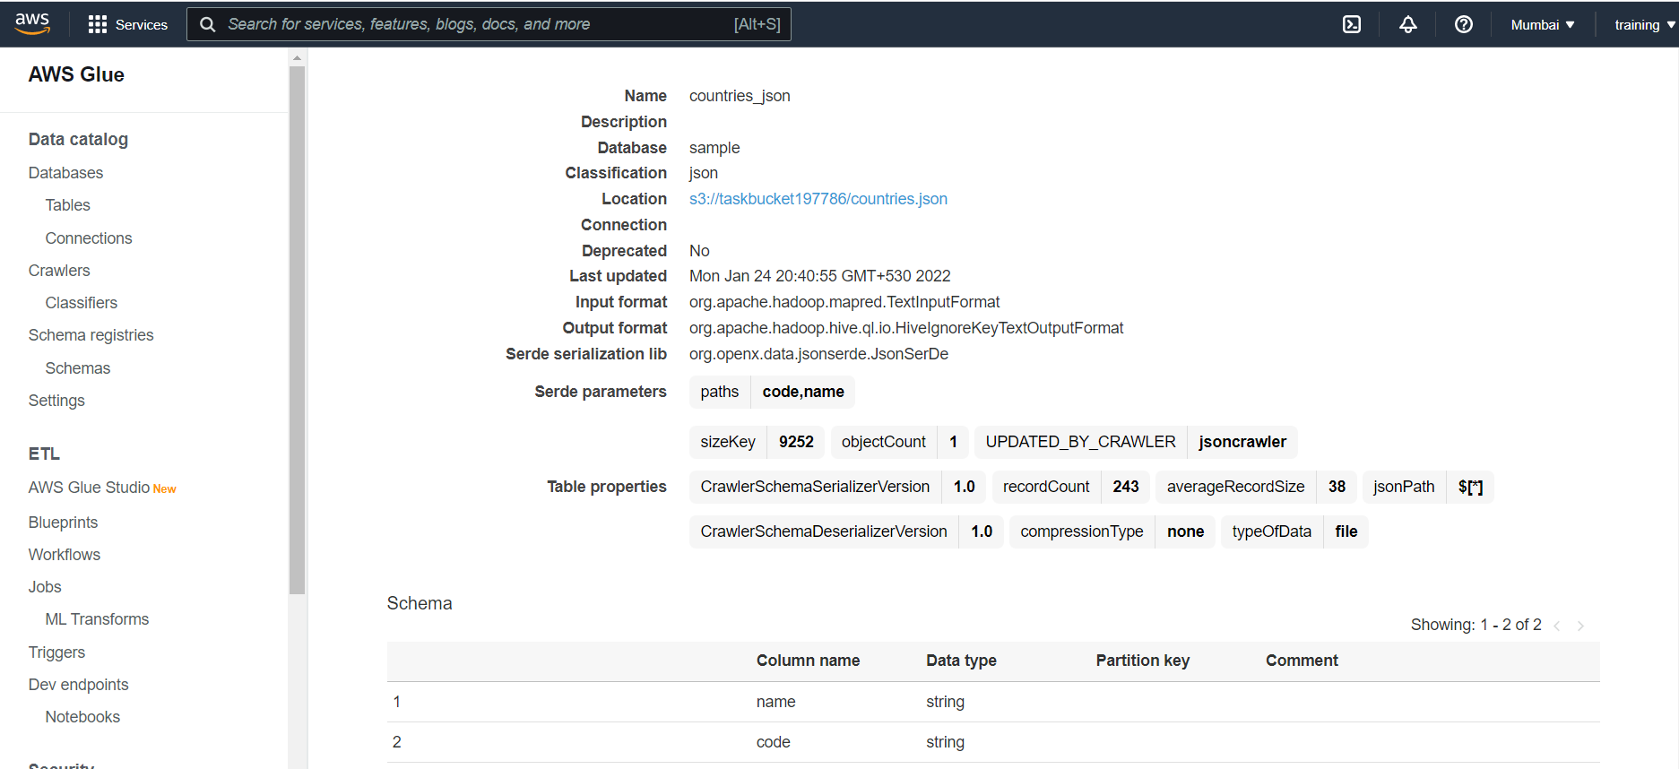

**Crawler named redshift1crawler created inside AWS Glue Crawlers**

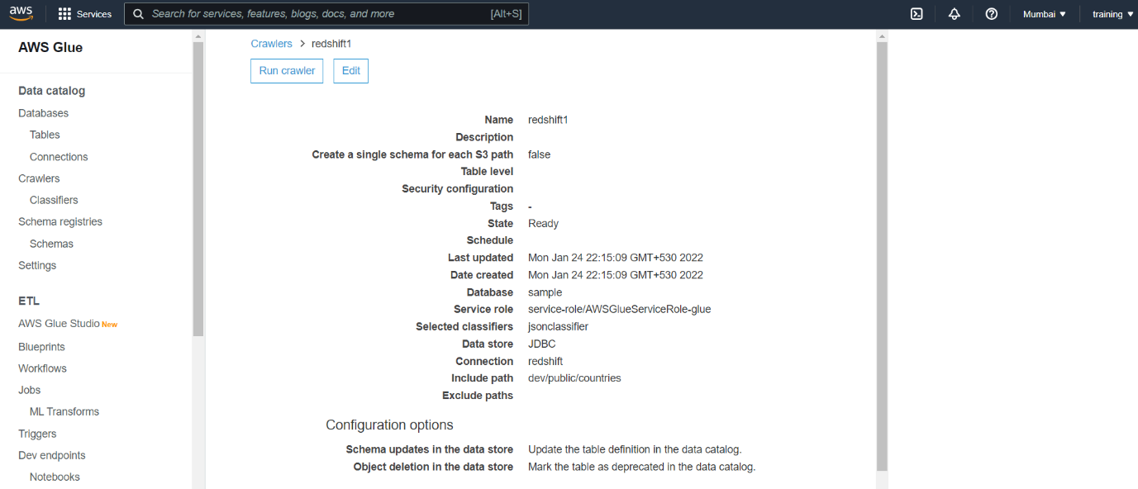

**dev_public_countries table created automatically after running redshift1crawler**

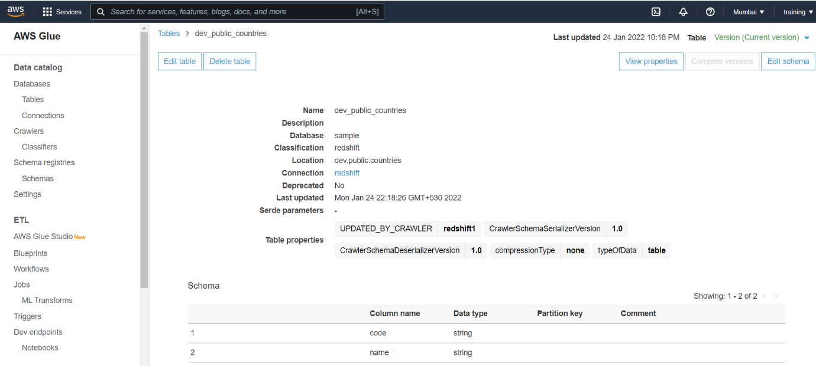

**Created and run a job named secondjob inside AWS Glue to reflect data from S3 bucket countries.json file to SQL Workbench countries table**

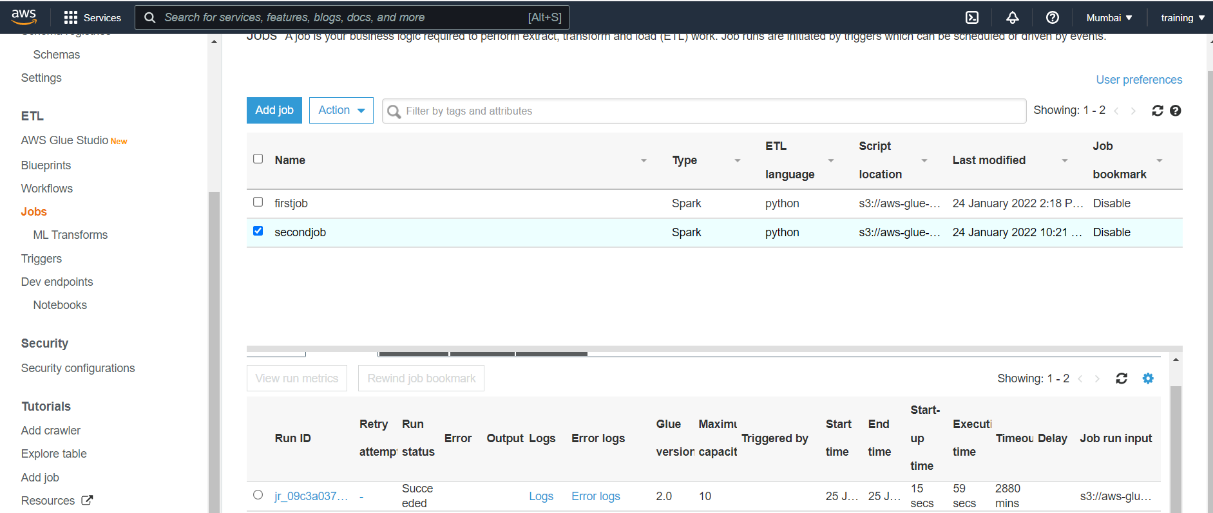

**Reflected data in SQL Workbench countries table**

