**Flask Application Deployment using Cloud Formation and Elastic Beanstalk**

**Bucket Creation**

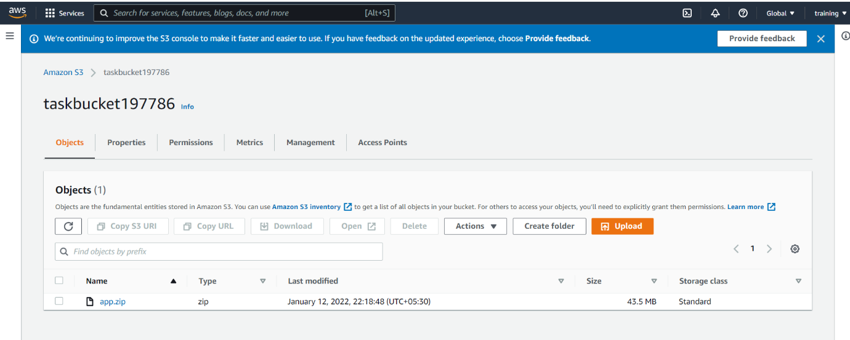

**YML File Picture**

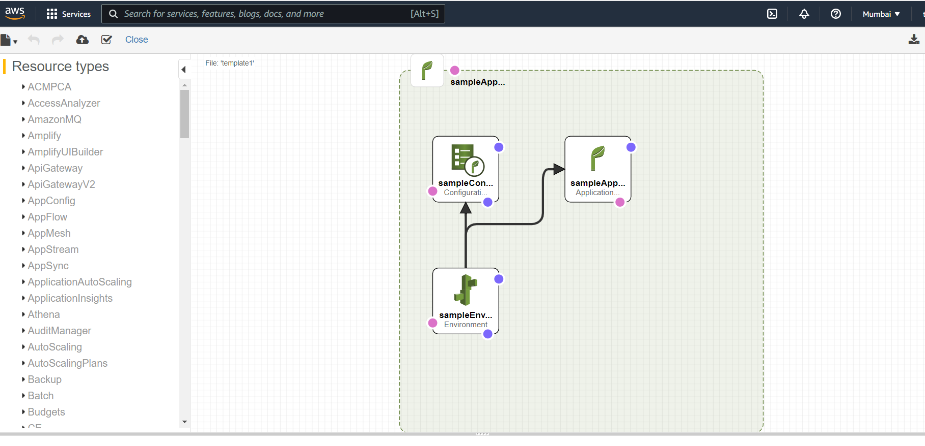

**Stack**

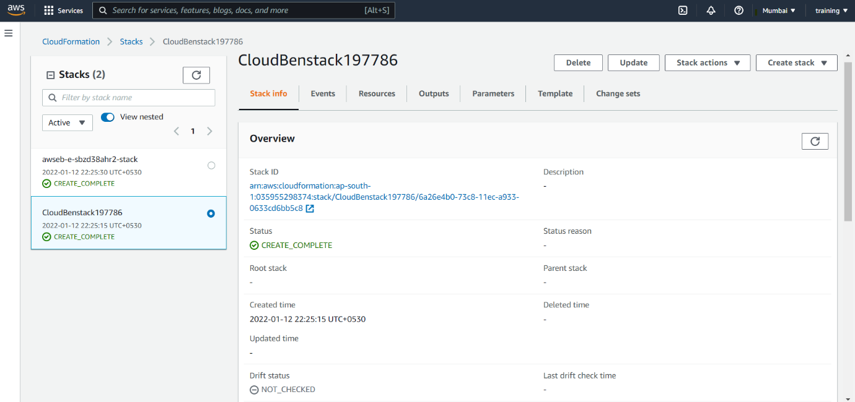

**Stack Events**

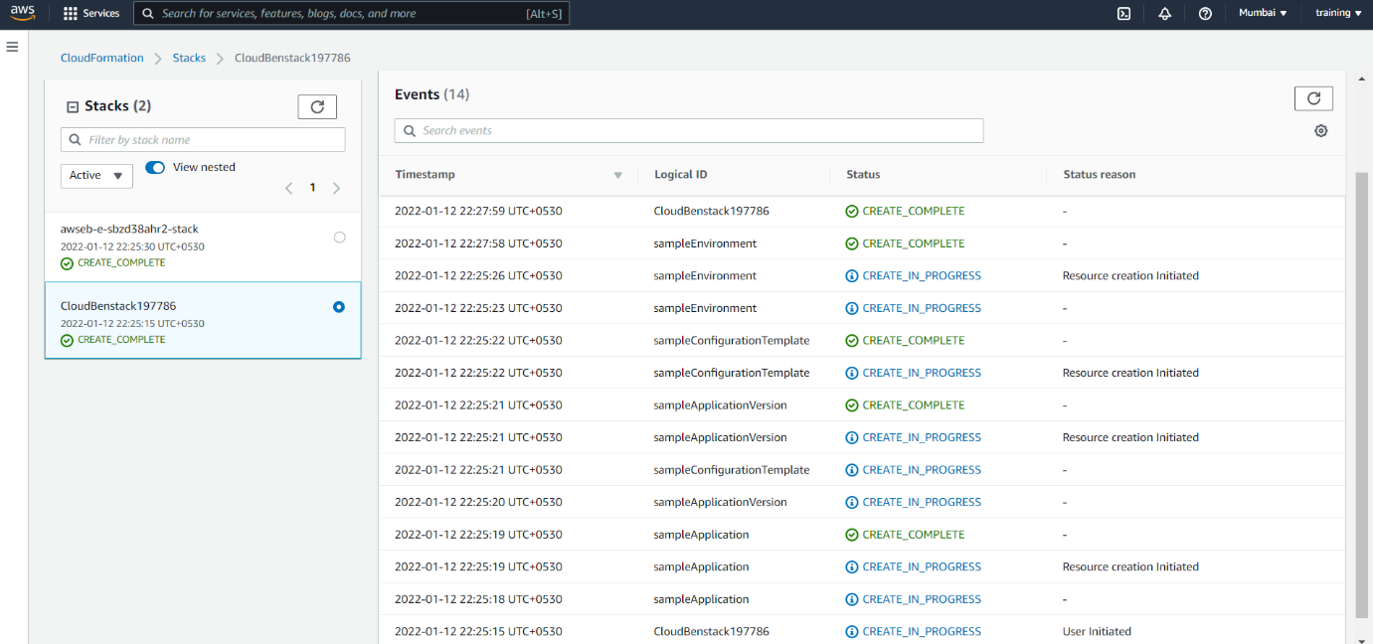

**Stack Resources**

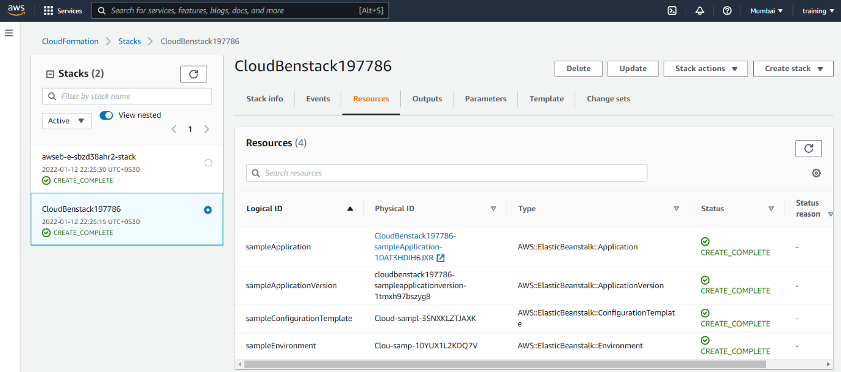

**Elastic Beanstalk Application**

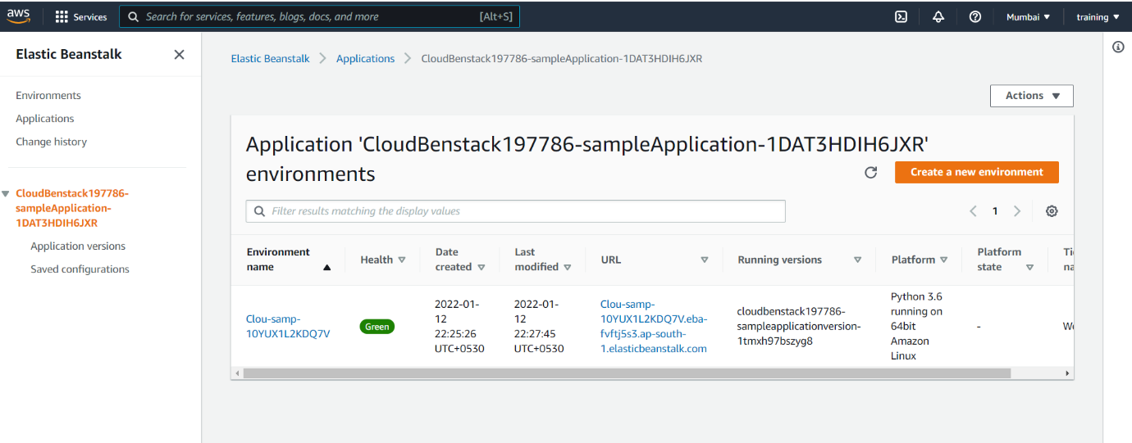

**Environment**

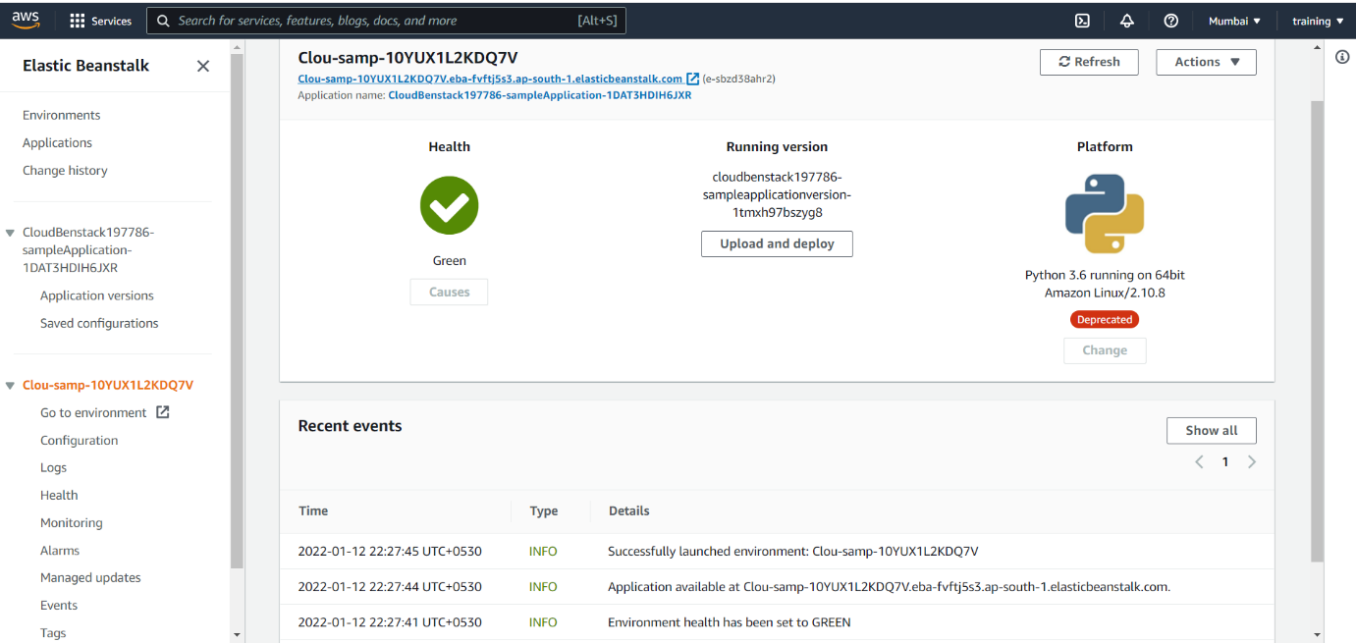

**Application**

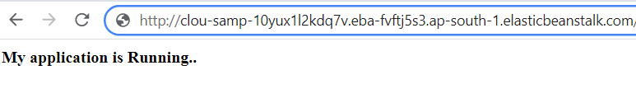

**Load Balancer**

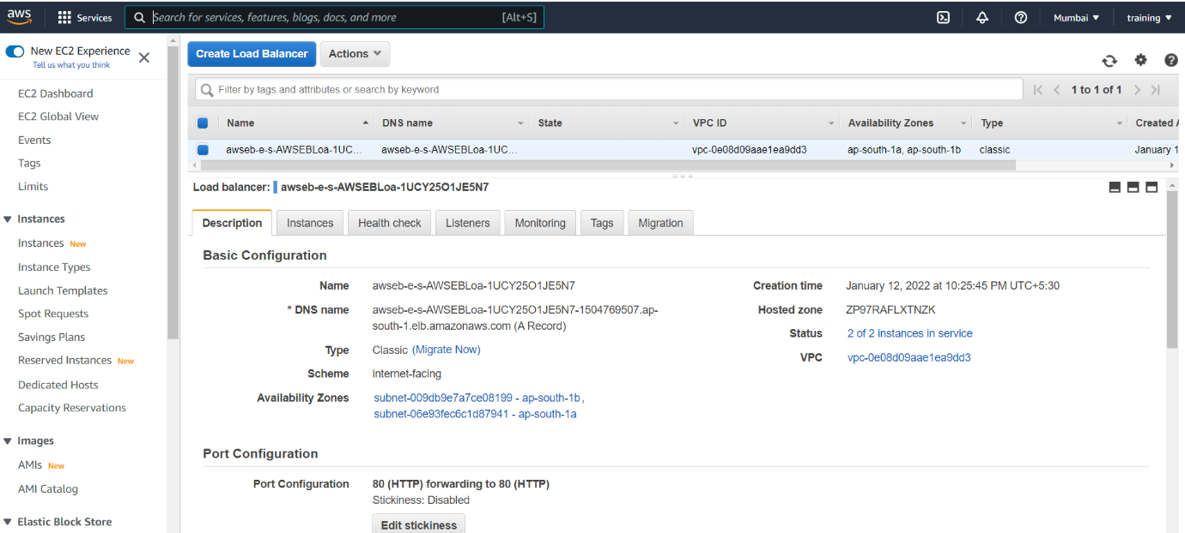

**Auto Scaling Group Instances**

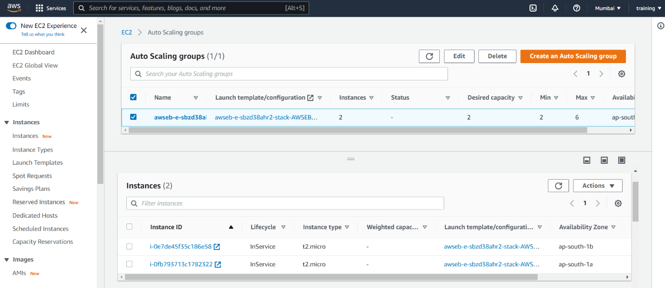

**Installing awsebcli**

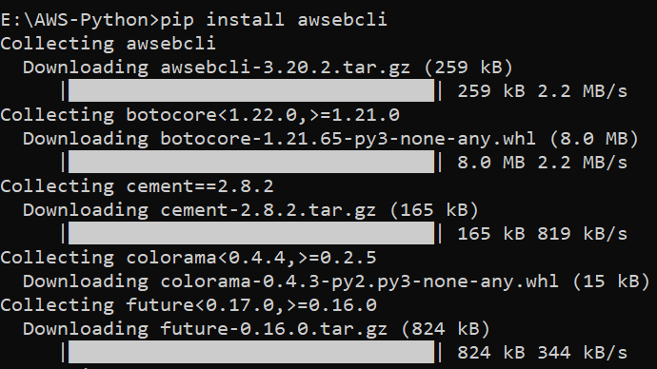

**Creating Flask Application**



**To Connect EC2 Instance**

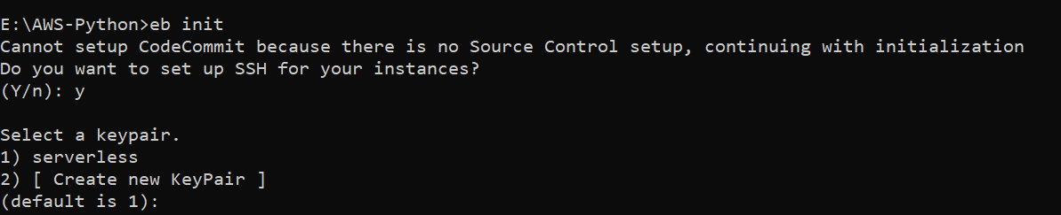

**Environment Creation and Deployment**

