**Attaching EBS Volume to Multiple Instances**

**Nitro Instances**

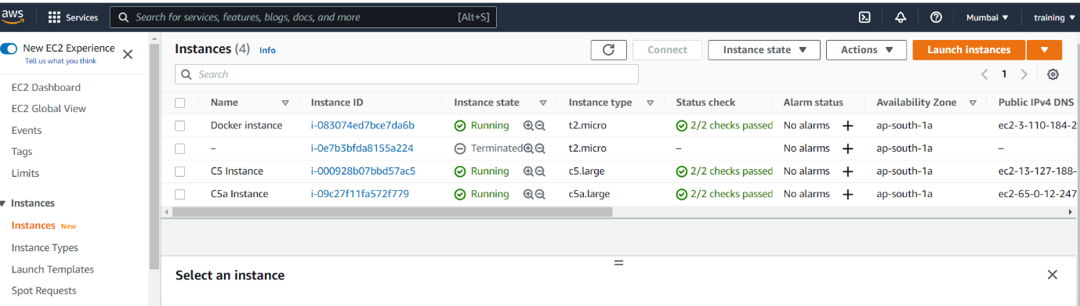

**Volume attached to 2 nitro instances**

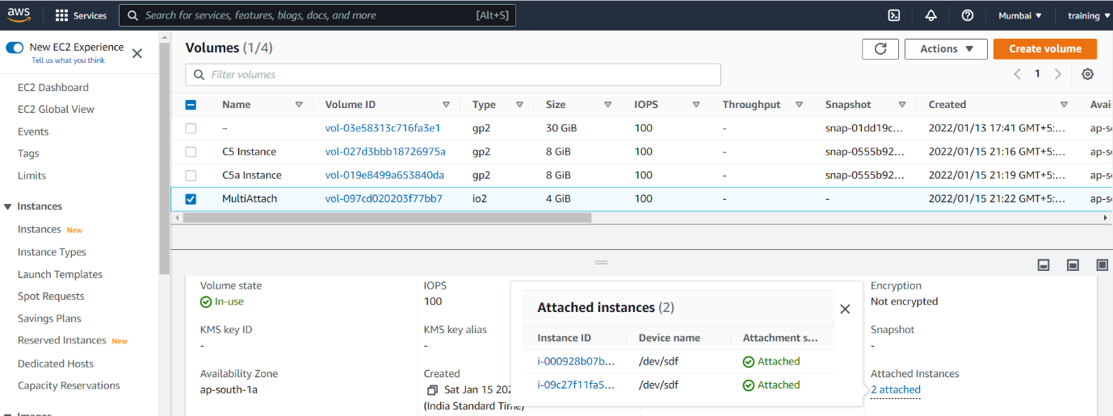

**C5 Instance Console**

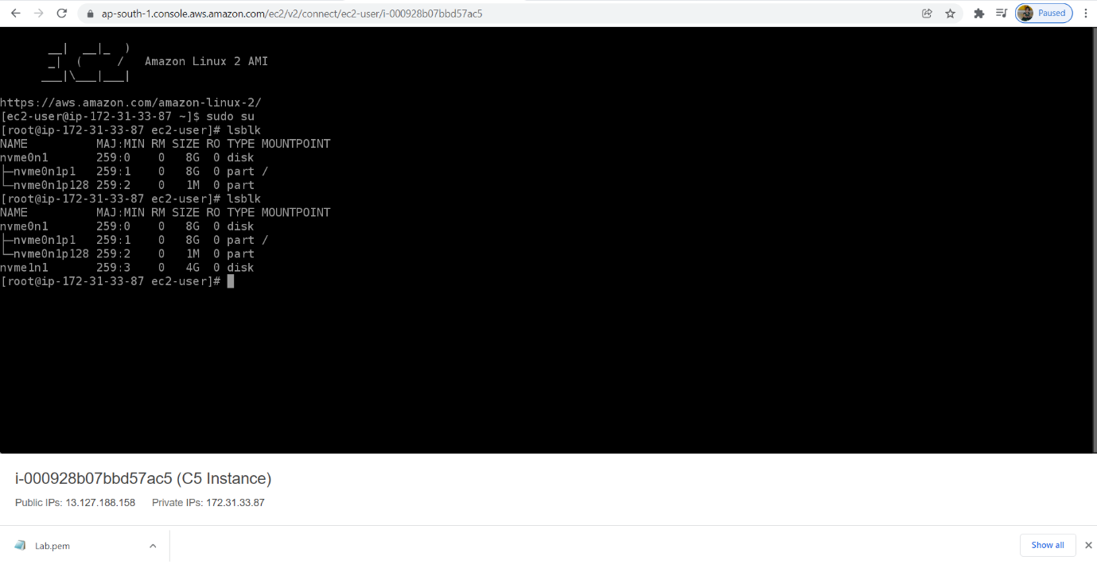

**C5a Instance Console**

