**Html Form**

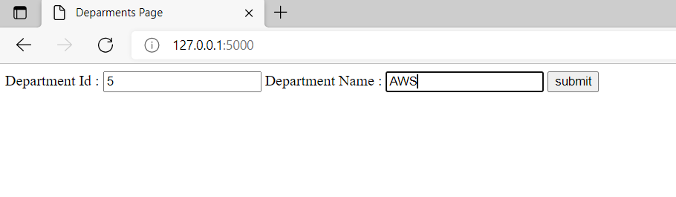

**Displaying Form data (inserted into database)**

