**URL for GET and POST**

[**https://zhmhxq75pf.execute-api.ap-south-1.amazonaws.com/taskstage/**](https://zhmhxq75pf.execute-api.ap-south-1.amazonaws.com/taskstage/)

**GET Request**

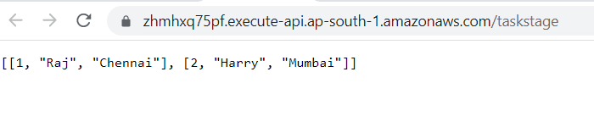

**Post Request**

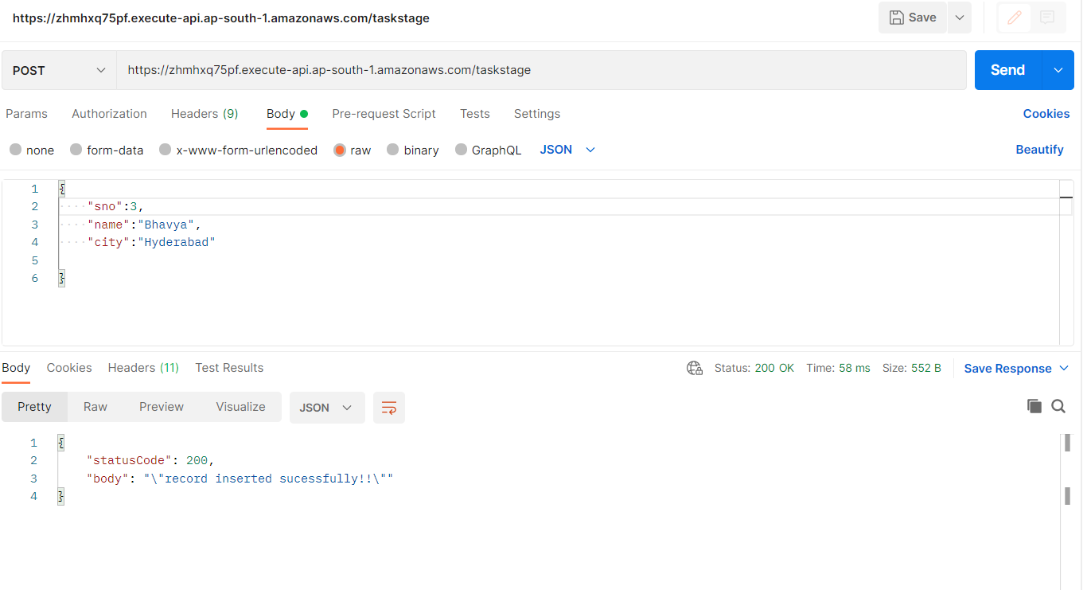

**Lambda Function (thirdfunc)**

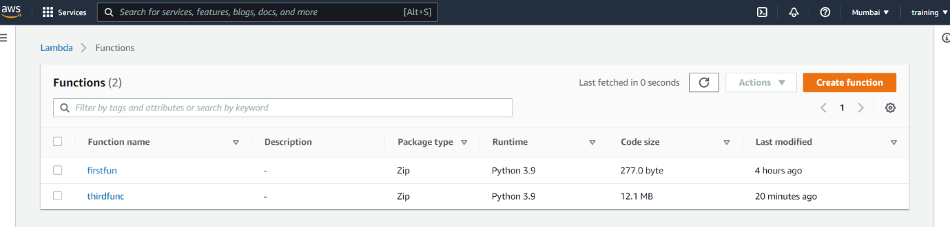

**API**

