**Form Output:**

1. Project Of Event(Home):

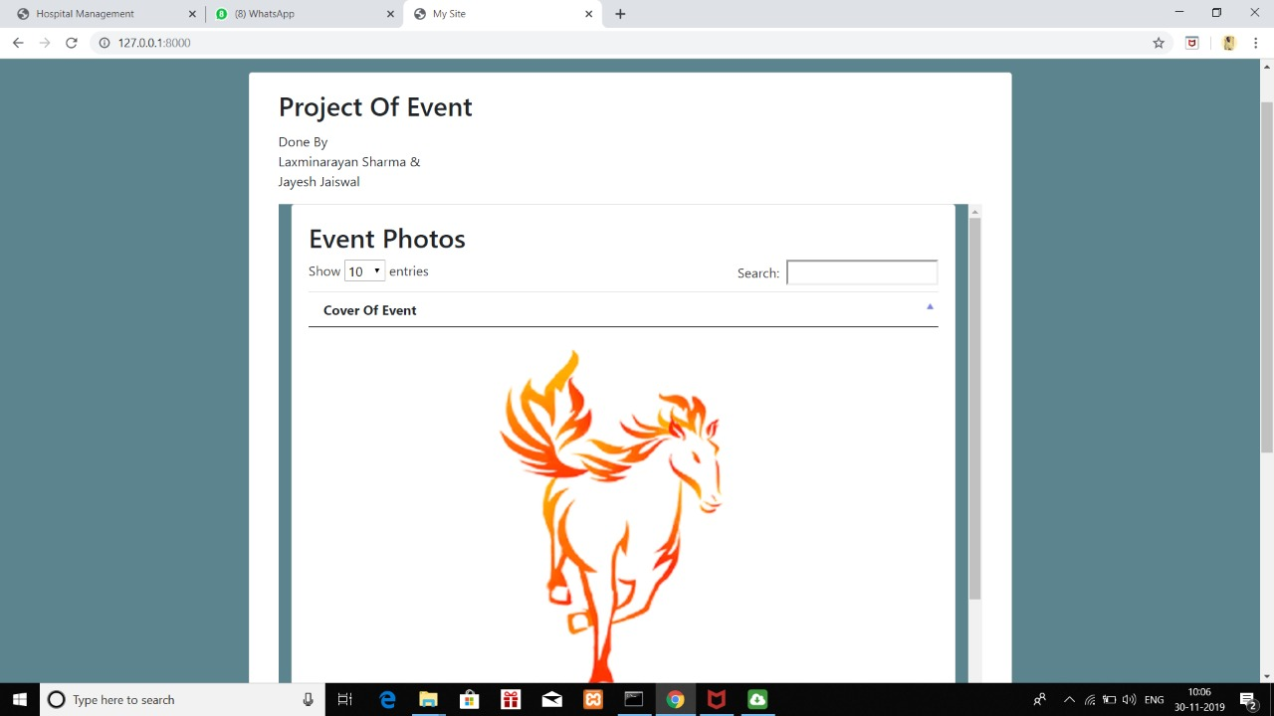

1. Event Photos And Entries: (Before deletion of a record)

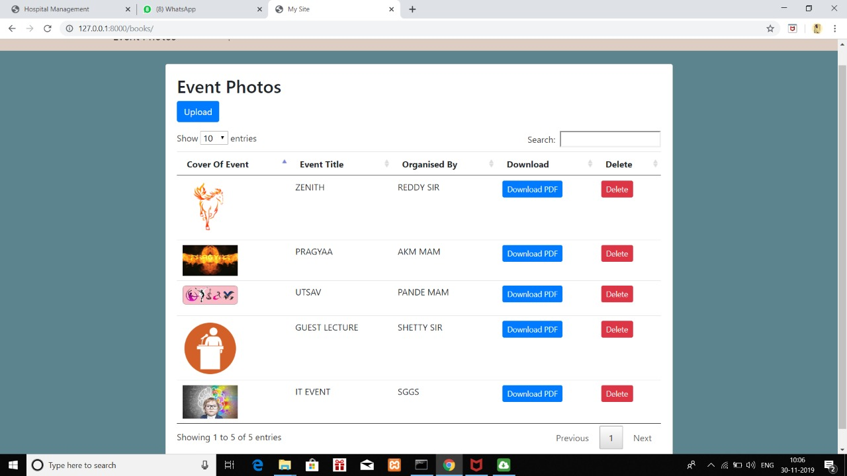

1. Event Photos And Entries: (After deletion of a record)

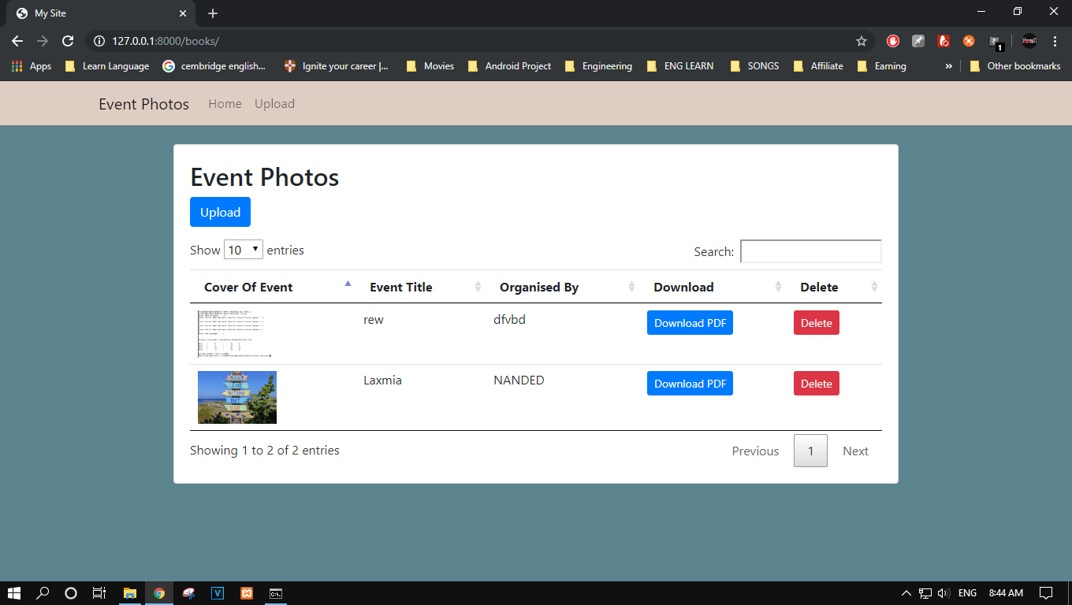

1. Upload Details Of the Event:

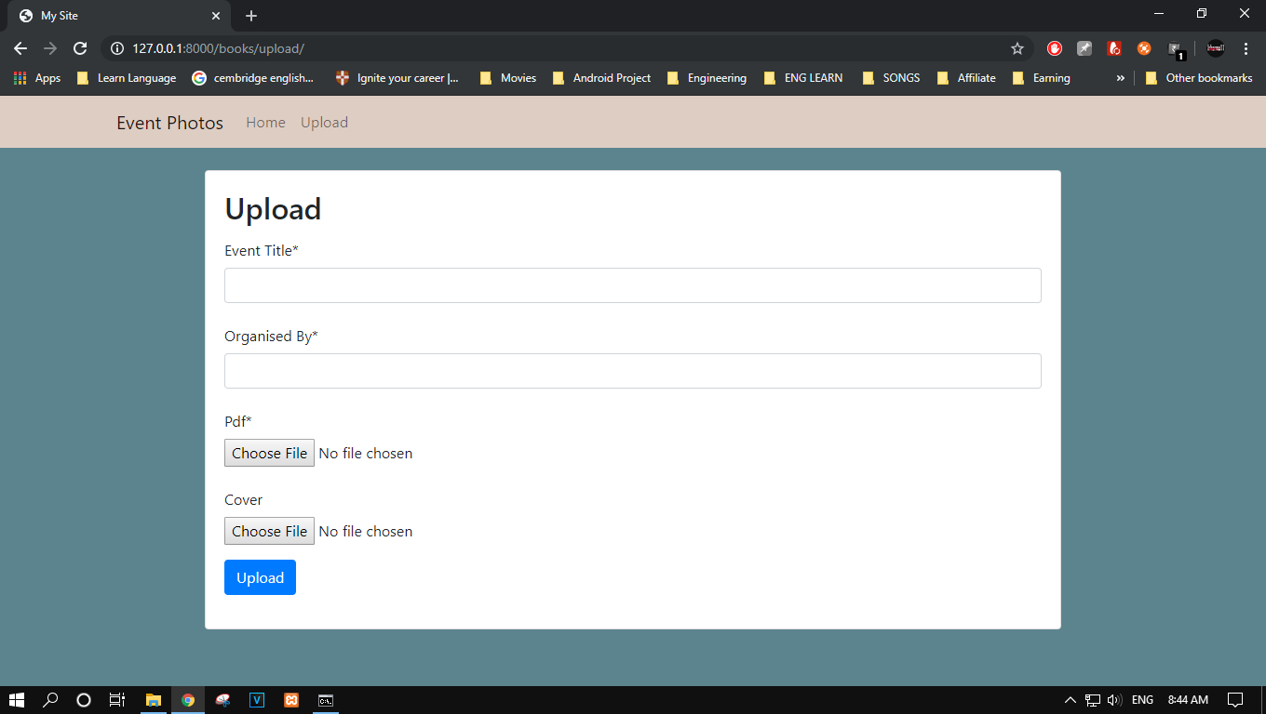

**Printout Of Code:**

1. **Forms.py**

from django import forms

from .models import Book

class BookForm(forms.ModelForm):

class Meta:

model = Book

fields = ('Event_Title', 'Organised_By', 'pdf', 'cover')

1. **Models.py**

from django.db import models

# Create your models here.

class Book(models.Model):

Event_Title = models.CharField(max_length=100)

Organised_By = models.CharField(max_length=100)

pdf = models.FileField(upload_to='books/pdfs/')

cover = models.ImageField(upload_to='books/covers/', null=True, blank=True)

def __str__(self):

return self.Event_Title

def delete(self, *args, **kwargs):

self.pdf.delete()

self.cover.delete()

super().delete(*args, **kwargs)

1. **Views.py**

from django.shortcuts import render, redirect

# Create your views here.

from django.views.generic import TemplateView, ListView, CreateView

from django.core.files.storage import FileSystemStorage

from django.urls import reverse_lazy

from .forms import BookForm

from .models import Book

class Home(TemplateView):

template_name = 'home.html'

def upload(request):

context = {}

if request.method == 'POST':

uploaded_file = request.FILES['document']

fs = FileSystemStorage()

name = fs.save(uploaded_file.name, uploaded_file)

context['url'] = fs.url(name)

return render(request, 'upload.html', context)

def book_list(request):

books = Book.objects.all()

return render(request, 'book_list.html', {

'books': books

})

def book_cover_list(request):

books = Book.objects.all()

return render(request, 'book_cover_list.html', {

'books': books

})

def upload_book(request):

if request.method == 'POST':

form = BookForm(request.POST, request.FILES)

if form.is_valid():

form.save()

return redirect('book_list')

else:

form = BookForm()

return render(request, 'upload_book.html', {

'form': form

})

def delete_book(request, pk):

if request.method == 'POST':

book = Book.objects.get(pk=pk)

book.delete()

return redirect('book_list')

class UploadBookView(CreateView):

model = Book

form_class = BookForm

success_url = reverse_lazy('class_book_list')

template_name = 'upload_book.html'

1. **Base.html**

{% load static %}

<html lang="en">

<head>

<meta charset="utf-8">

<meta name="viewport" content="width=device-width, initial-scale=1, shrink-to-fit=no">

<link rel="stylesheet" href="https://stackpath.bootstrapcdn.com/bootstrap/4.1.3/css/bootstrap.min.css" integrity="sha384-MCw98/SFnGE8fJT3GXwEOngsV7Zt27NXFoaoApmYm81iuXoPkFOJwJ8ERdknLPMO" crossorigin="anonymous">

<link rel="stylesheet" type="text/css" href="{% static 'css/app.css' %}">

<title>{% block title %}My Site{% endblock %}</title>

</head>

<body>

<nav class="navbar navbar-expand-lg navbar-light mb-4" style="background-color:#decdc3">

<div class="container">

<a class="navbar-brand" href="{% url 'home' %}">Event Photos</a>

<button class="navbar-toggler" type="button" data-toggle="collapse" data-target="#navbarSupportedContent" aria-controls="navbarSupportedContent" aria-expanded="false" aria-label="Toggle navigation">

<span class="navbar-toggler-icon"></span>

</button>

<div class="collapse navbar-collapse" id="navbarSupportedContent">

<ul class="navbar-nav">

<li class="nav-item">

<a class="nav-link" href="{% url 'home' %}">Home</a>

</li>

<li class="nav-item">

<a class="nav-link" href="{% url 'book_list' %}">Upload</a>

</li>

</ul>

</div>

</div>

</nav>

<div class="container">

<div class="row justify-content-center">

<div class="col-lg-10 col-md-12">

<div class="card mb-4">

<div class="card-body">

{% block content %}

{% endblock %}

</div>

</div>

</div>

</div>

</div>

<script src="https://code.jquery.com/jquery-3.3.1.slim.min.js" integrity="sha384-q8i/X+965DzO0rT7abK41JStQIAqVgRVzpbzo5smXKp4YfRvH+8abtTE1Pi6jizo" crossorigin="anonymous"></script>

<script src="https://cdnjs.cloudflare.com/ajax/libs/popper.js/1.14.3/umd/popper.min.js" integrity="sha384-ZMP7rVo3mIykV+2+9J3UJ46jBk0WLaUAdn689aCwoqbBJiSnjAK/l8WvCWPIPm49" crossorigin="anonymous"></script>

<script src="https://stackpath.bootstrapcdn.com/bootstrap/4.1.3/js/bootstrap.min.js" integrity="sha384-ChfqqxuZUCnJSK3+MXmPNIyE6ZbWh2IMqE241rYiqJxyMiZ6OW/JmZQ5stwEULTy" crossorigin="anonymous"></script>

</body>

</html>

1. **Book_cover_list.html**

{% load static %}

<head>

<meta charset="utf-8">

<meta name="viewport" content="width=device-width, initial-scale=1, shrink-to-fit=no">

<link rel="stylesheet" href="https://stackpath.bootstrapcdn.com/bootstrap/4.1.3/css/bootstrap.min.css" integrity="sha384-MCw98/SFnGE8fJT3GXwEOngsV7Zt27NXFoaoApmYm81iuXoPkFOJwJ8ERdknLPMO" crossorigin="anonymous">

<link rel="stylesheet" type="text/css" href="{% static 'css/app.css' %}">

<title>{% block title %}My Site{% endblock %}</title>

<link rel="stylesheet" href="http://cdn.datatables.net/1.10.11/css/jquery.dataTables.min.css">

<script src="https://ajax.googleapis.com/ajax/libs/jquery/2.2.2/jquery.min.js"></script>

<script src="http://cdn.datatables.net/1.10.11/js/jquery.dataTables.min.js"></script>

<script>

$(document).ready( function () {

$('#luckytable').DataTable();

} );

</script>

</head>

<div class="col-lg-10 col-md-12">

<div class="card mb-4">

<div class="card-body">

{% block content %}

{% block content_header %}

<h2>Event Photos</h2>

{% endblock %}

<table id="luckytable" class="table mb-0">

<thead>

<tr>

<th>Cover Of Event</th>

</tr>

</thead>

<tbody>

{% for book in books %}

<tr>

<td align="center">

{% if book.cover %}

<img src="{{ book.cover.url }}" alt="{{ book.title }}" style="width:500px;" border="1">

{% else %}

<span class="text-muted">No cover</span>

{% endif %}

</td>

</tr>

{% endfor %}

</tbody>

</table>

</div>

</div>

</div>

{% endblock %}

1. **Book_list.html**

{% load static %}

<head>

<meta charset="utf-8">

<meta name="viewport" content="width=device-width, initial-scale=1, shrink-to-fit=no">

<link rel="stylesheet" href="https://stackpath.bootstrapcdn.com/bootstrap/4.1.3/css/bootstrap.min.css" integrity="sha384-MCw98/SFnGE8fJT3GXwEOngsV7Zt27NXFoaoApmYm81iuXoPkFOJwJ8ERdknLPMO" crossorigin="anonymous">

<link rel="stylesheet" type="text/css" href="{% static 'css/app.css' %}">

<title>{% block title %}My Site{% endblock %}</title>

<link rel="stylesheet" href="http://cdn.datatables.net/1.10.11/css/jquery.dataTables.min.css">

<script src="https://ajax.googleapis.com/ajax/libs/jquery/2.2.2/jquery.min.js"></script>

<script src="http://cdn.datatables.net/1.10.11/js/jquery.dataTables.min.js"></script>

<script>

$(document).ready( function () {

$('#lucky').DataTable();

} );

</script>

</head>

<nav class="navbar navbar-expand-lg navbar-light mb-4" style="background-color:#decdc3">

<div class="container">

<a class="navbar-brand" href="{% url 'home' %}">Event Photos</a>

<button class="navbar-toggler" type="button" data-toggle="collapse" data-target="#navbarSupportedContent" aria-controls="navbarSupportedContent" aria-expanded="false" aria-label="Toggle navigation">

<span class="navbar-toggler-icon"></span>

</button>

<div class="collapse navbar-collapse" id="navbarSupportedContent">

<ul class="navbar-nav">

<li class="nav-item">

<a class="nav-link" href="{% url 'home' %}">Home</a>

</li>

<li class="nav-item">

<a class="nav-link" href="{% url 'book_list' %}">Upload</a>

</li>

</ul>

</div>

</div>

</nav>

<div class="container">

<div class="row justify-content-center">

<div class="col-lg-10 col-md-12">

<div class="card mb-4">

<div class="card-body">

{% block content %}

{% block content_header %}

<h2>Event Photos</h2>

<p>

<a href="{% url 'upload_book' %}" class="btn btn-primary">Upload</a>

</p>

{% endblock %}

<table id="lucky" class="table mb-0">

<thead>

<tr>

<th>Cover Of Event</th>

<th>Event Title</th>

<th>Organised By</th>

<th>Download</th>

<th>Delete</th>

</tr>

</thead>

<tbody>

{% for book in books %}

<tr>

<td>

{% if book.cover %}

<img src="{{ book.cover.url }}" alt="{{ book.title }}" style="width:100px;">

{% else %}

<span class="text-muted">No cover</span>

{% endif %}

</td>

<td>{{ book.Event_Title }}</td>

<td>{{ book.Organised_By }}</td>

<td>

<a href="{{ book.pdf.url }}" class="btn btn-primary btn-sm" target="_blank">

Download PDF

</a>

</td>

<td>

<form method="post" action="{% url 'delete_book' book.pk %}">

{% csrf_token %}

<button type="submit" class="btn btn-danger btn-sm">Delete</button>

</form>

</td>

</tr>

{% endfor %}

</tbody>

</table>

</div>

</div>

</div>

</div>

</div>

{% endblock %}

1. **Class_Book_list.html**

{% extends 'book_list.html' %}

{% block content_header %}

<h2>Books (Class-Based View)</h2>

<p>

<a href="{% url 'class_upload_book' %}" class="btn btn-primary">Upload</a>

</p>

{% endblock %}

1. **Home.html**

{% extends 'base.html' %}

{% block content %}

<div class="container">

<h2 class="card-title">Project Of Event </h2>

<p class="card-text">Done By <br> Laxminarayan Sharma & <br> Jayesh Jaiswal</p>

<p class="card-text">

</p>

<p class="card-text">

</p>

</div>

<div class="container" >

<iframe src="{% url 'book_cover_list' %}" height="1000px" frameborder="0" width="100%" >

</iframe>

</div>

{% endblock %}

1. **Upload.html**

{% extends 'base.html' %}

{% block content %}

<h2>Upload</h2>

<form method="post" enctype="multipart/form-data">

{% csrf_token %}

<input type="file" name="document">

<button type="submit">Upload file</button>

</form>

{% if url %}

<p>Uploaded file: <a href="{{ url }}">{{ url }}</a></p>

{% endif %}

{% endblock %}

1. **Upload_book.html**

{% extends 'base.html' %}

{% load crispy_forms_tags %}

{% block content %}

<h2>Upload</h2>

<form method="post" enctype="multipart/form-data">

{% csrf_token %}

{{ form|crispy }}

<button type="submit" class="btn btn-primary">Upload</button>

</form>

{% endblock %}

**Tree Structure:**

Folder PATH listing

Volume serial number is 8EEC-D08D

D:.

│ CL3.docx

│ db.sqlite3

│ django-upload-example.rar

│ LICENSE

│ manage.py

│ tree.docx

│ tree.txt

│

├───.idea

│ │ lucky.iml

│ │ misc.xml

│ │ modules.xml

│ │ vcs.xml

│ │ workspace.xml

│ │

│ └───inspectionProfiles

│ profiles_settings.xml

│

├───.vs

│ │ slnx.sqlite

│ │ VSWorkspaceState.json

│ │

│ └───lucky

│ └───v16

├───lucky

│ │ settings.py

│ │ urls.py

│ │ wsgi.py

│ │ __init__.py

│ │

│ └───__pycache__

│ settings.cpython-37.pyc

│ urls.cpython-37.pyc

│ wsgi.cpython-37.pyc

│ __init__.cpython-37.pyc

│

├───media

│ └───books

│ ├───covers

│ │ inscription_motivation_inspiration_paint_116653_4957x3305.jpg

│ │ rrr.png

│ │

│ └───pdfs

│ inscription_quote_motivation_127898_3840x2160.jpg

│ MOdule_1.png

│

└───mediaapp

│ admin.py

│ apps.py

│ forms.py

│ models.py

│ tests.py

│ views.py

│ __init__.py

│

├───migrations

│ │ 0001_initial.py

│ │ 0002_auto_20191110_1905.py

│ │ __init__.py

│ │

│ └───__pycache__

│ 0001_initial.cpython-37.pyc

│ 0002_auto_20191110_1905.cpython-37.pyc

│ __init__.cpython-37.pyc

│

├───static

│ └───css

│ app.css

│

├───templates

│ base.html

│ book_cover_list.html

│ book_list.html

│ class_book_list.html

│ home.html

│ upload.html

│ upload_book.html

│

└───__pycache__

admin.cpython-37.pyc

forms.cpython-37.pyc

models.cpython-37.pyc

views.cpython-37.pyc

__init__.cpython-37.pyc

**GitHub Download Link:**