LAB-3 ASSIGNMENT 6.4

ROLL NO: 2403A52091

BATCH : 4

NAME : N. LAXMI PRASANNA

TASK-1 : Start a Python class named Student with attributes name, roll_number, and marks. Prompt GitHub Copilot to complete methods for displaying details and checking if marks are above average.

PROMPT: Write a python program to start a Python class named Student with attributes name, roll_number, and marks.complete methods for displaying details and checking if marks are above average.

CODE : 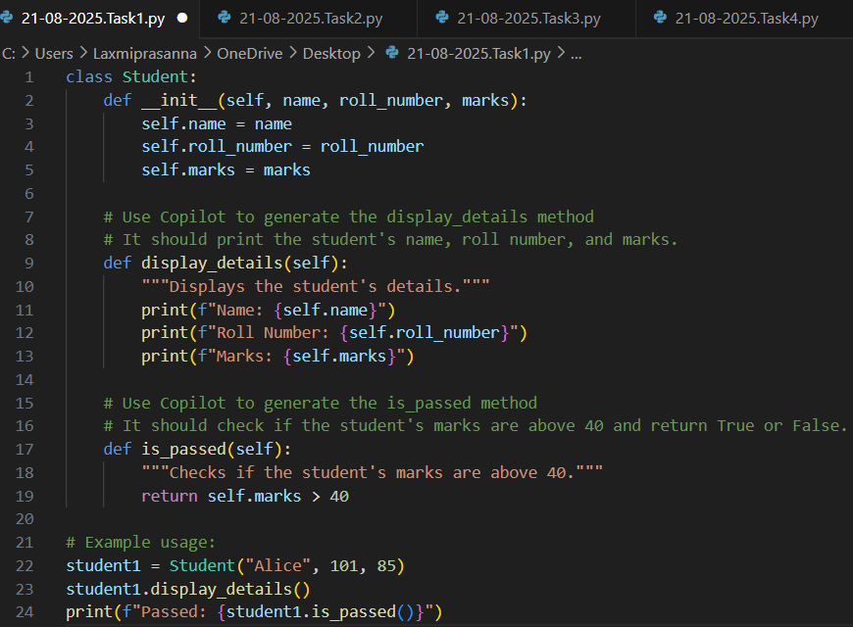

OUTPUT :

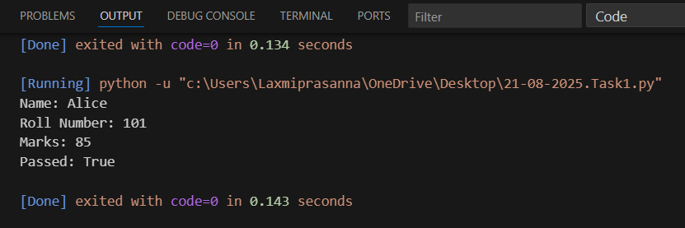

OBERSERVATIONS : Copilot-generated methods like displaying details and checking if marks are above average make the class practical and easy to use. The code is straightforward and demonstrates basic object-oriented programming and conditional checks.

TASK-2 : Write the first two lines of a for loop to iterate through a list of numbers. Use a comment prompt to let Copilot suggest how to calculate and print the square of even numbers only.

PROMPT : Write a python program to Write the first two lines of a for loop to iterate through a list of numbers. Use a comment prompt to let Copilot suggest how to calculate and print the square of even numbers only.

CODE :

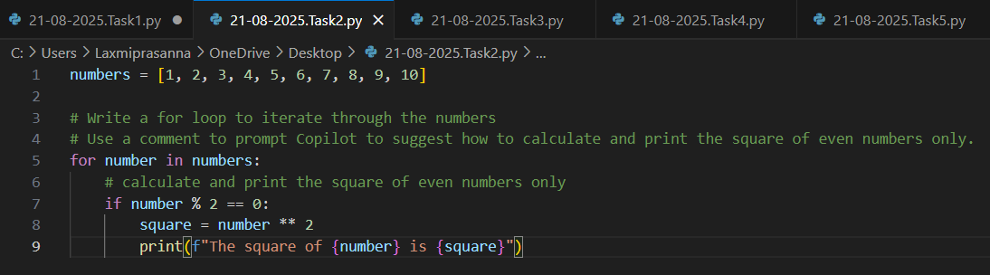

Output :

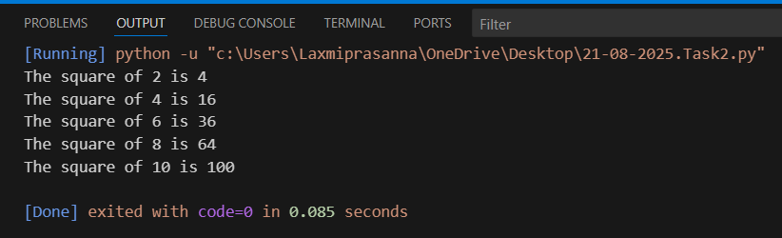

Observations : This task demonstrates how to use a for loop to iterate through a list of numbers and apply conditional logic to process only even numbers. By including a comment prompt, Copilot can suggest code to calculate and print the square of even numbers, making the code concise and easy to understand.

Task – 3 : Create a class called BankAccount with attributes account_holder and balance. Use Copilot to complete methods for deposit(), withdraw(), and check for insufficient balance.

Prompt : Write a Python program to Create a class called BankAccount with attributes account_holder and balance. Use Copilot to complete methods for deposit(), withdraw(), and check for insufficient balance.

Code :

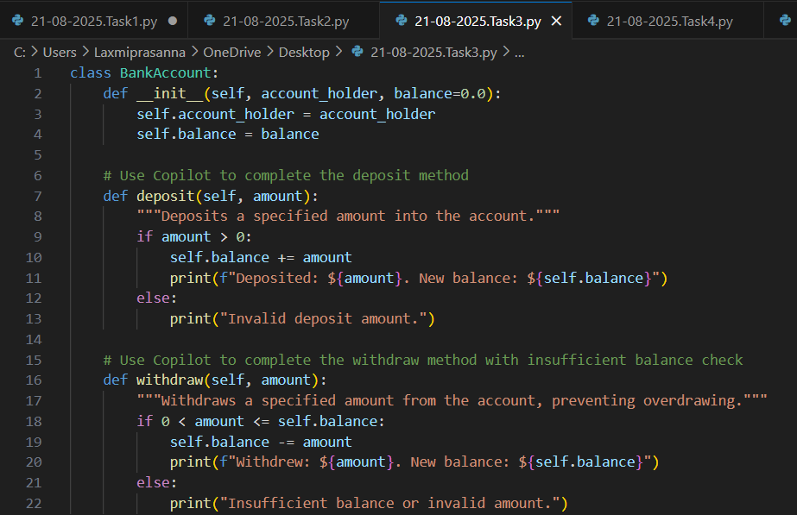

Output :

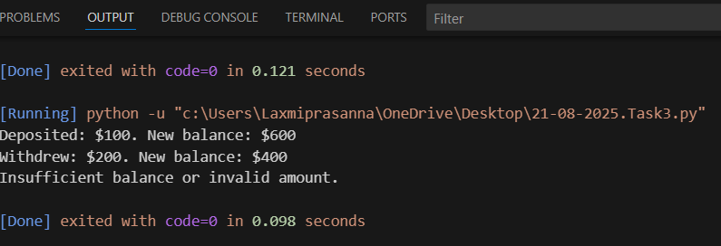

Observations : The BankAccount class lets you deposit and withdraw money, and checks for insufficient balance before withdrawing. The code is simple and easy to understand.

Task – 4 : Define a list of student dictionaries with keys name and score. Ask Copilot to write a while loop to print the names of students who scored more than 75.

Prompt : Write a python program to Define a list of student dictionaries with keys name and score. And to write a while  
loop to print the names of students who scored more than 75.

Code :

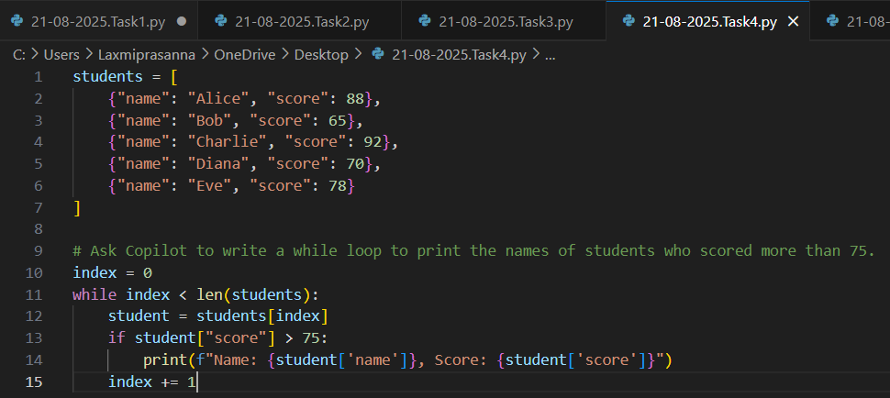

Output :

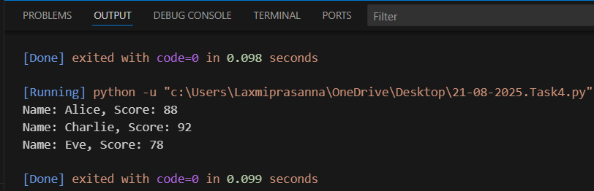

Observations : A list of student dictionaries stores each student's name and score. The while loop checks each student and prints the names of those who scored more than 75. The code is simple and uses basic list and loop concepts.

Task – 5 : Begin writing a class ShoppingCart with an empty items list. Prompt Copilot to generate methods to add_item, remove_item, and use a loop to calculate the total bill using conditional discounts.

Prompt : Write a Python program to Begin writing a class ShoppingCart with an empty items list. Prompt Copilot to generate  
methods to add_item, remove_item, and use a loop to calculate the total bill using conditional discounts.

Code :

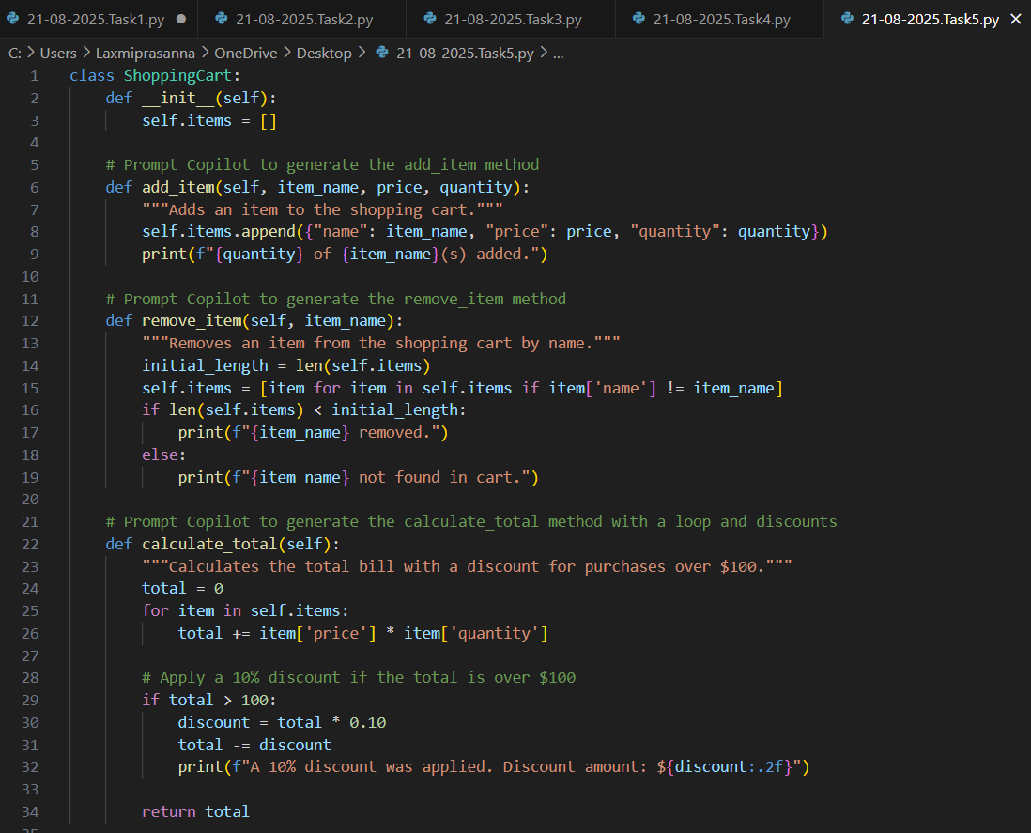

Output :

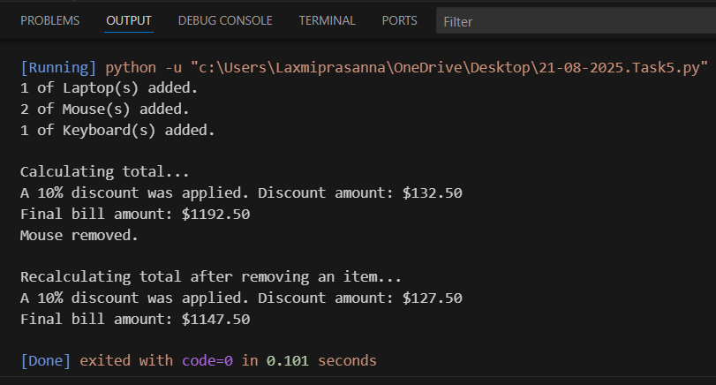

Observations : The ShoppingCart class starts with an empty items list. It has methods to add and remove items, and uses a loop to calculate the total bill. If an item costs more than 100, a discount is applied. The code is simple and shows basic class and loop usage.