FALL DETECTION FOR ELDERLY PEOPLE USING MACHINE LEARNING

If elderly peoples falls then it will put severe effect on their health and technology is helping humans in every aspect of their life and in this paper author is using machine learning algorithm to predict FALL scenarios by analysing their movements. In propose paper author has used SVM and Decision Tree algorithms to train SISFALL dataset and this trained model can be used to predict fall scenarios from new test data.

Sensors will be embedded with elderly people’s body and this sensor will record their movement such as Heart Rate, EEG and circulation and then give this input to ML model and ML model will predict current scenario or posture and alert to elderly peoples.

In propose paper Decision Tree is giving better accuracy compare to SVM and taking less time for training and testing.

We used below dataset to train both algorithms

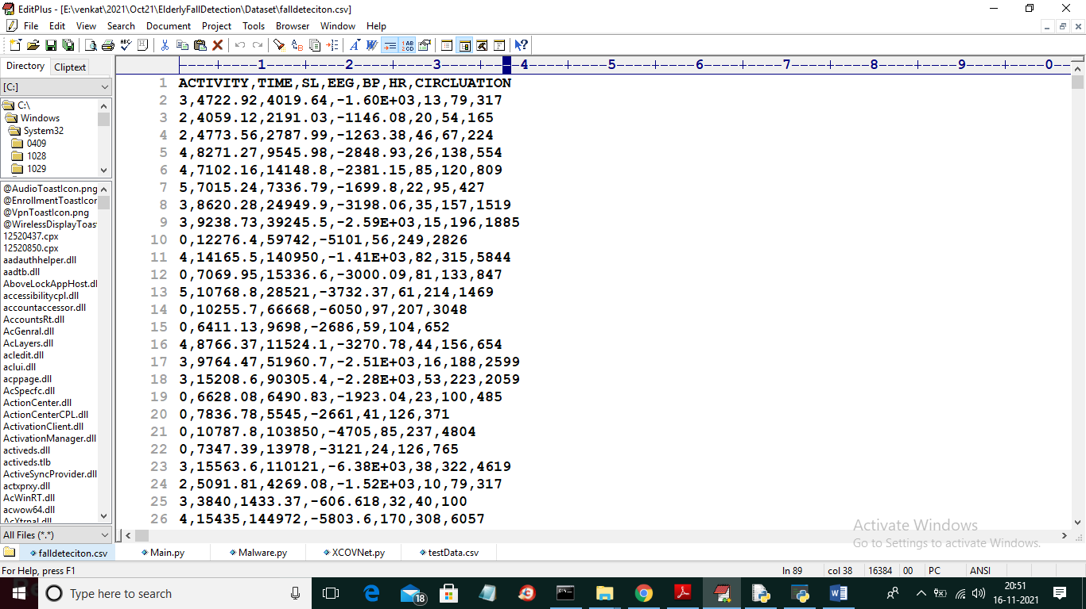

In above dataset screen first row contains dataset column names and remaining rows contains dataset values and in above dataset first column called ACTIVITY represents various positions such as 0, 1, 2, 3, 4 and 5 where each values correspond to below names

'Standing', 'Walking', 'Sitting', 'Falling', 'Cramps', 'Running'

In above names 0 means Standing and 1 means Walking etc.

Remaining values are the sensor data about elderly people movement

To implement this project we have designed following modules

1. Upload Fall Detection Dataset: using this module we will upload dataset to application
2. Features Calculation & Preprocess Dataset: using this module we will read all features from dataset and then remove missing values and then normalize dataset using MIN-MAX scaler and the split dataset into train and test and we will use 80% dataset for training and 20% for testing
3. Run SVM Algorithm: using this module we will train SVM on training dataset and then apply trained model on test data to calculate accuracy and prediction time.
4. Run Decision Tree Algorithm: using this module we will train Decision Tree on training dataset and then apply trained model on test data to calculate accuracy and prediction time.
5. Comparison Graph: using this module we will plot comparison graph between both algorithms
6. Predict Fall from Test Data: using this module we will upload new test data and then ML model predict ACTIVITY from that test data. Below is the test dataset screen shot which does not contains ACTIVITY column and ML model will predict it.

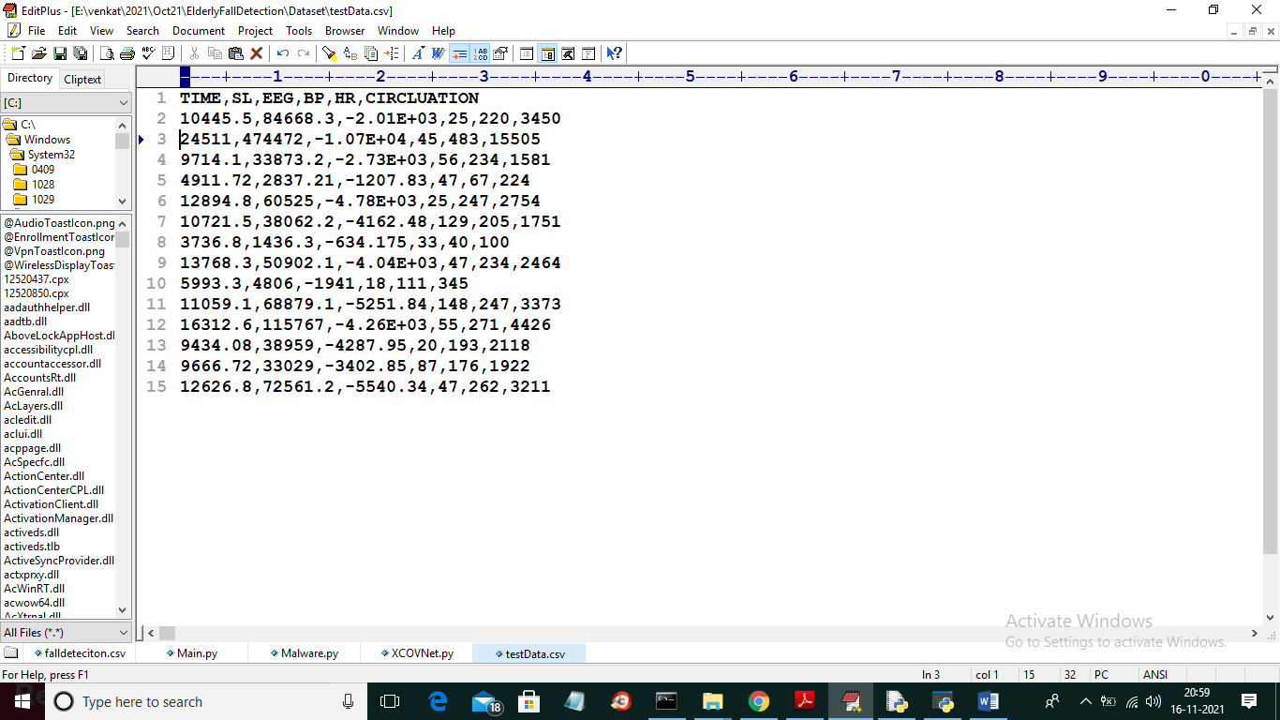

In above test data you can see we don’t have ACTIVITY column and we have only sensor data and ACTIVITY column will be predicted by ML model

SCREEN SHOTS

To run project double click on ‘run.bat’ file to get below screen

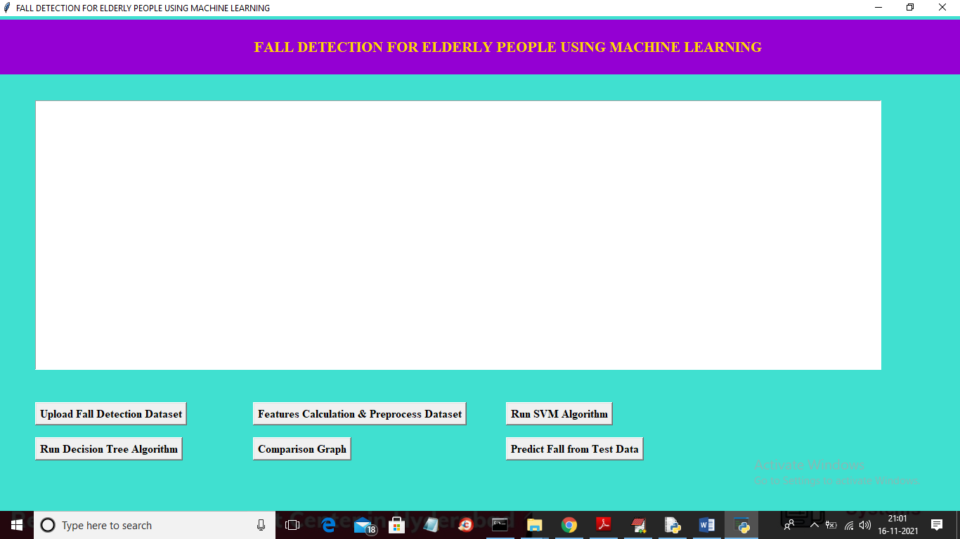

In above screen click on ‘Upload Fall Detection Dataset’ button to upload dataset

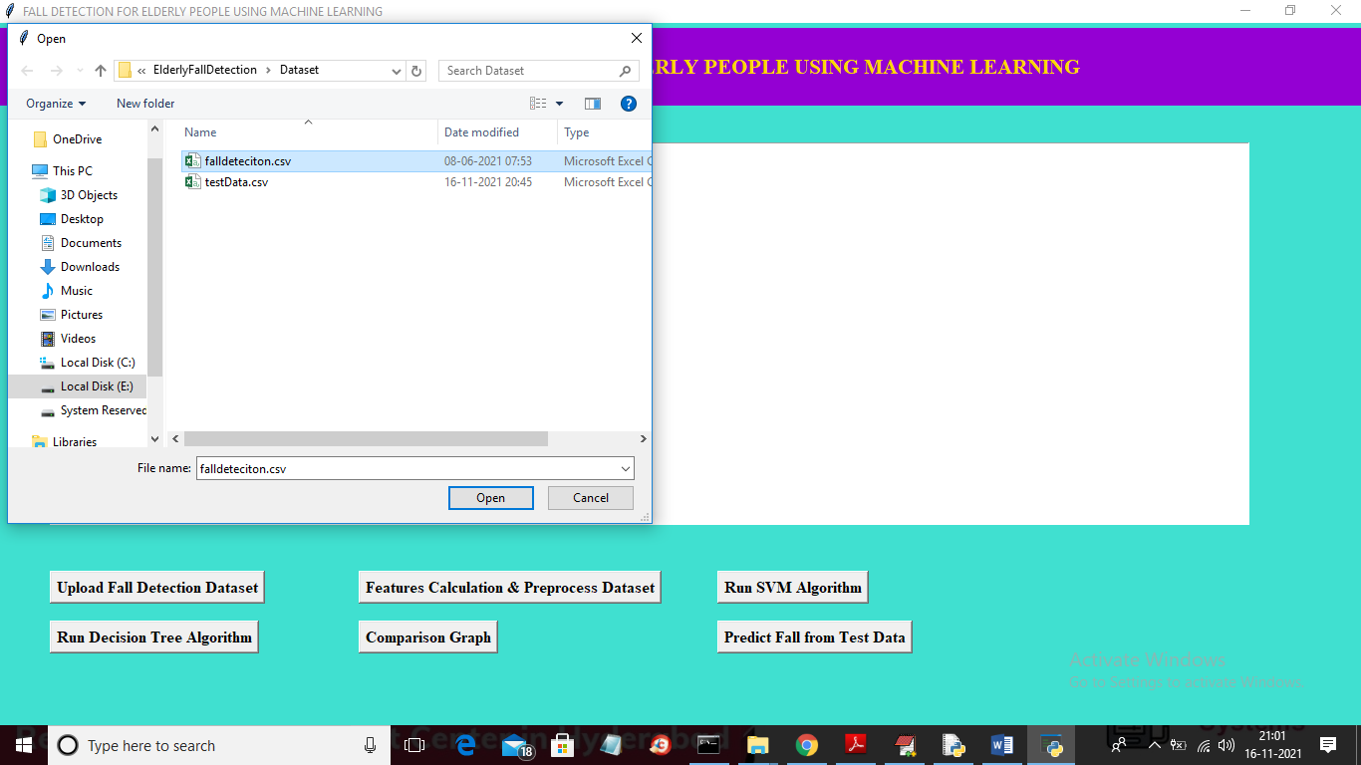

In above screen selecting and uploading ‘falldetection.csv’ dataset and then click on ‘Open’ button to load dataset and to get below screen

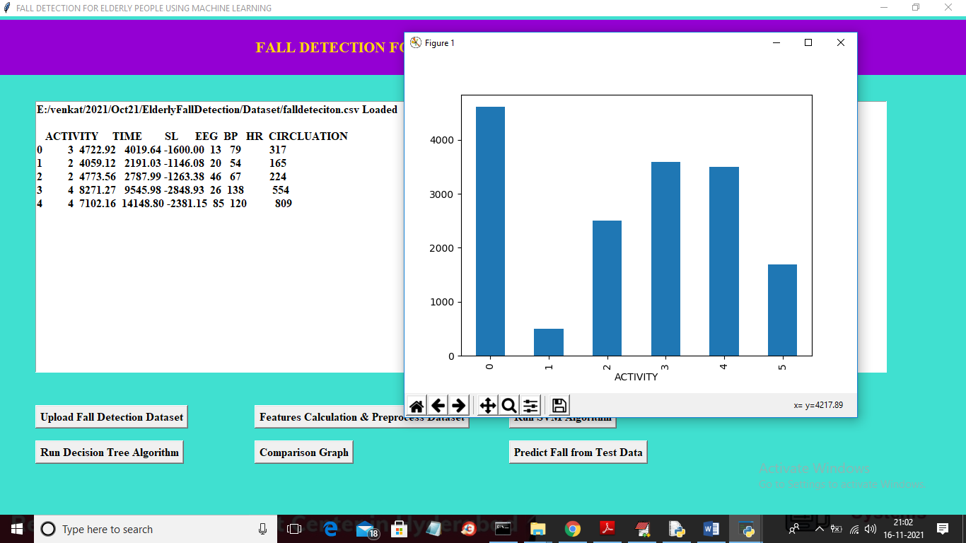

In above screen we can see dataset loaded and dataset is not in normalized format so we need to process and in above graph x-axis represents ACTIVITY such as standing, walking of falling in integer code and y-axis represents number of records available in dataset for that activity and now close above graph and then click on ‘Features Calculation & Preprocess Dataset’ button to process dataset

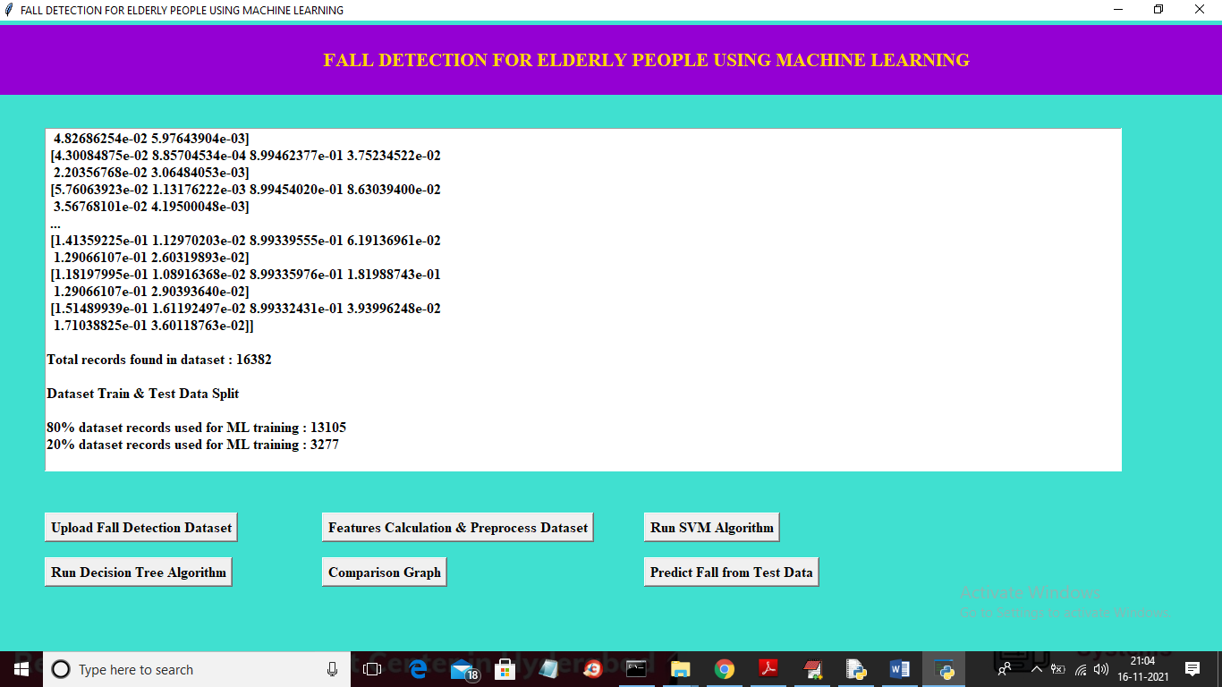

In above screen you can see dataset normalized and we can see dataset contains total 16382 records and then application split dataset into train and test where 13105 records are using for training and 3277 records for testing and now dataset is ready and now click on ‘Run SVM Algorithm’ button to train SVM and calculate accuracy

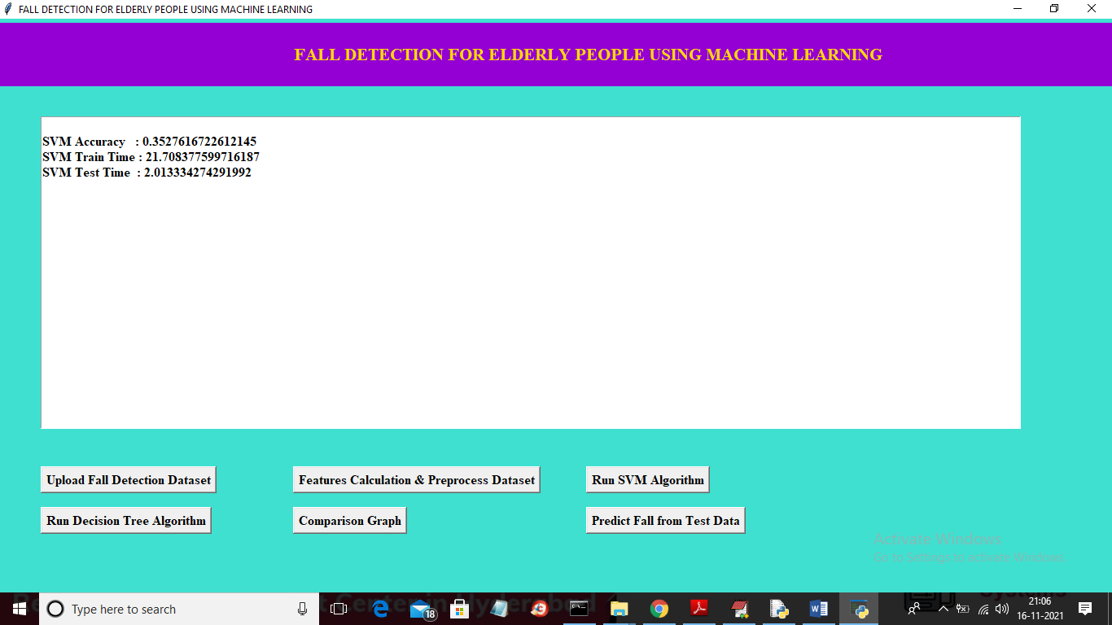

In above screen with SVM we got 0.35% accuracy and train time is 21 milli seconds and test time is 2 milli seconds and now click on ‘Run Decision Tree Algorithm’ button to train decision tree and get below result

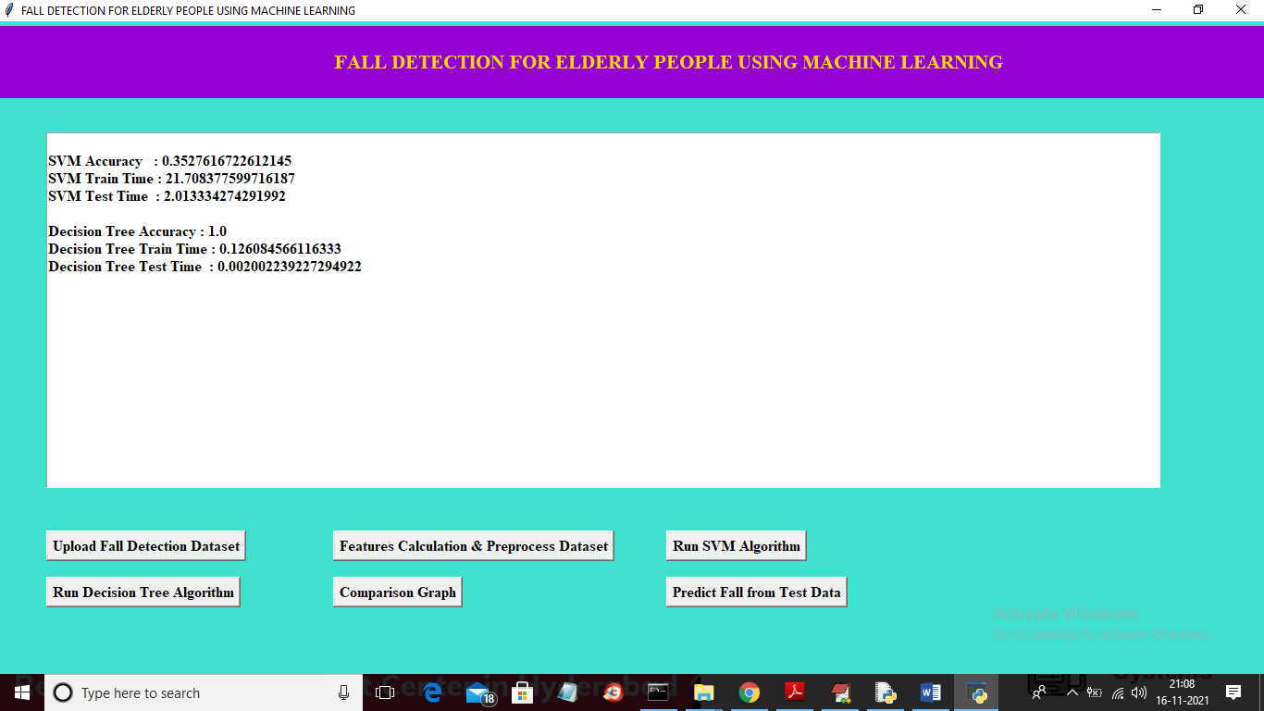

In above screen with Decision tree we got 100% accuracy and train time is 0.12 milli second and test time is 0.002 milli seconds which proofs that decision tree is better than SVM. Now click on ‘Comparison Graph’ button to get below graph

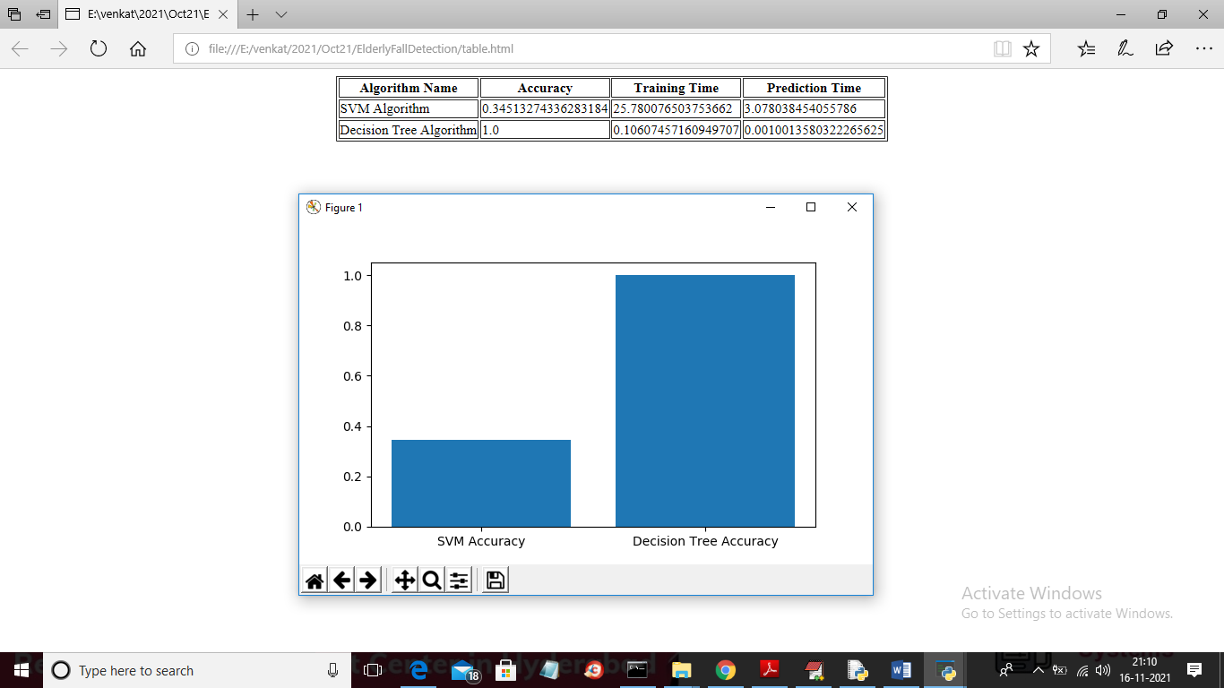

In above graph x-axis represents algorithm names and y-axis represents accuracy of those algorithms and from both Decision Tree got high accuracy and in above screen we can see comparison table of train and test time for both algorithms and now close above graph and then click on ‘Predict Fall from Test Data’ button to upload test data and get prediction

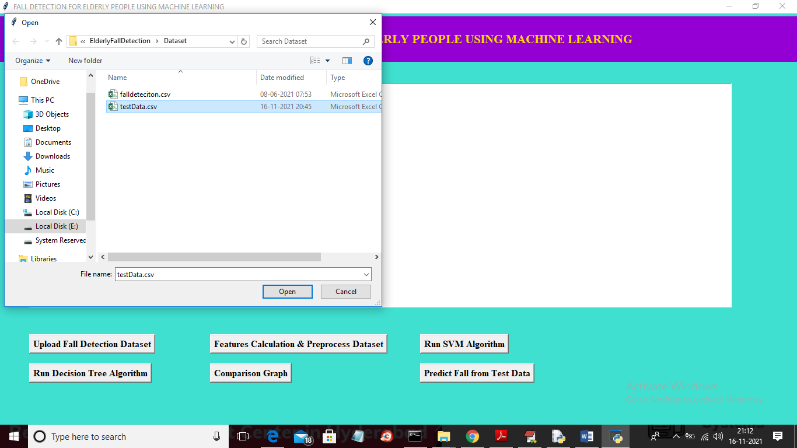

In above screen selecting and uploading ‘testData.csv’ file and then click on ‘Open’ button to get below output

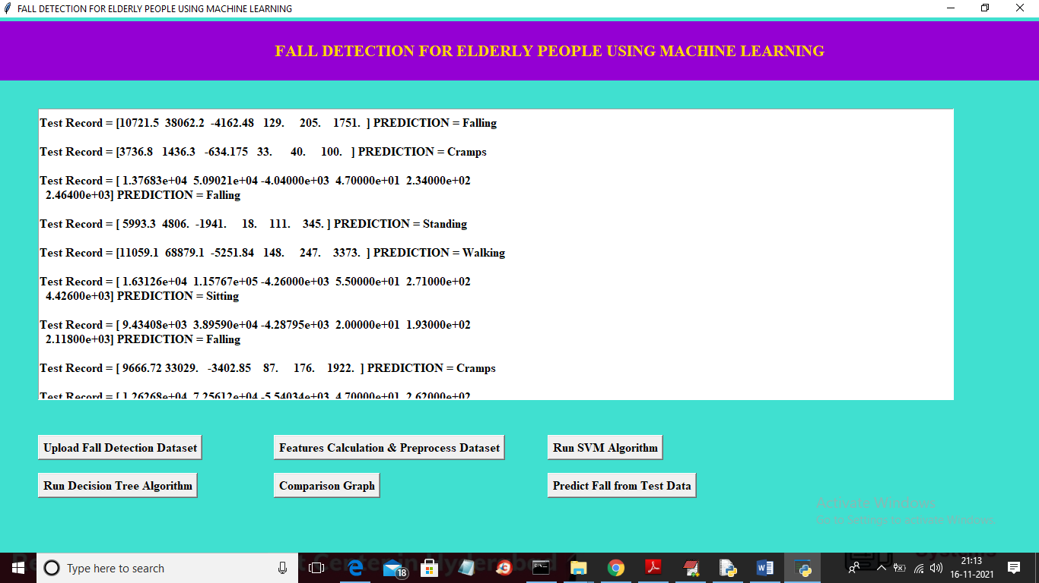

In above screen in square bracket you can see test values and after square bracket you can see PREDICTION result as ‘Standing, walking, falling etc from that test record

