Title

Page 2 content
Col 1 | Col 2 | Col 3
A | B | C
D | E | F

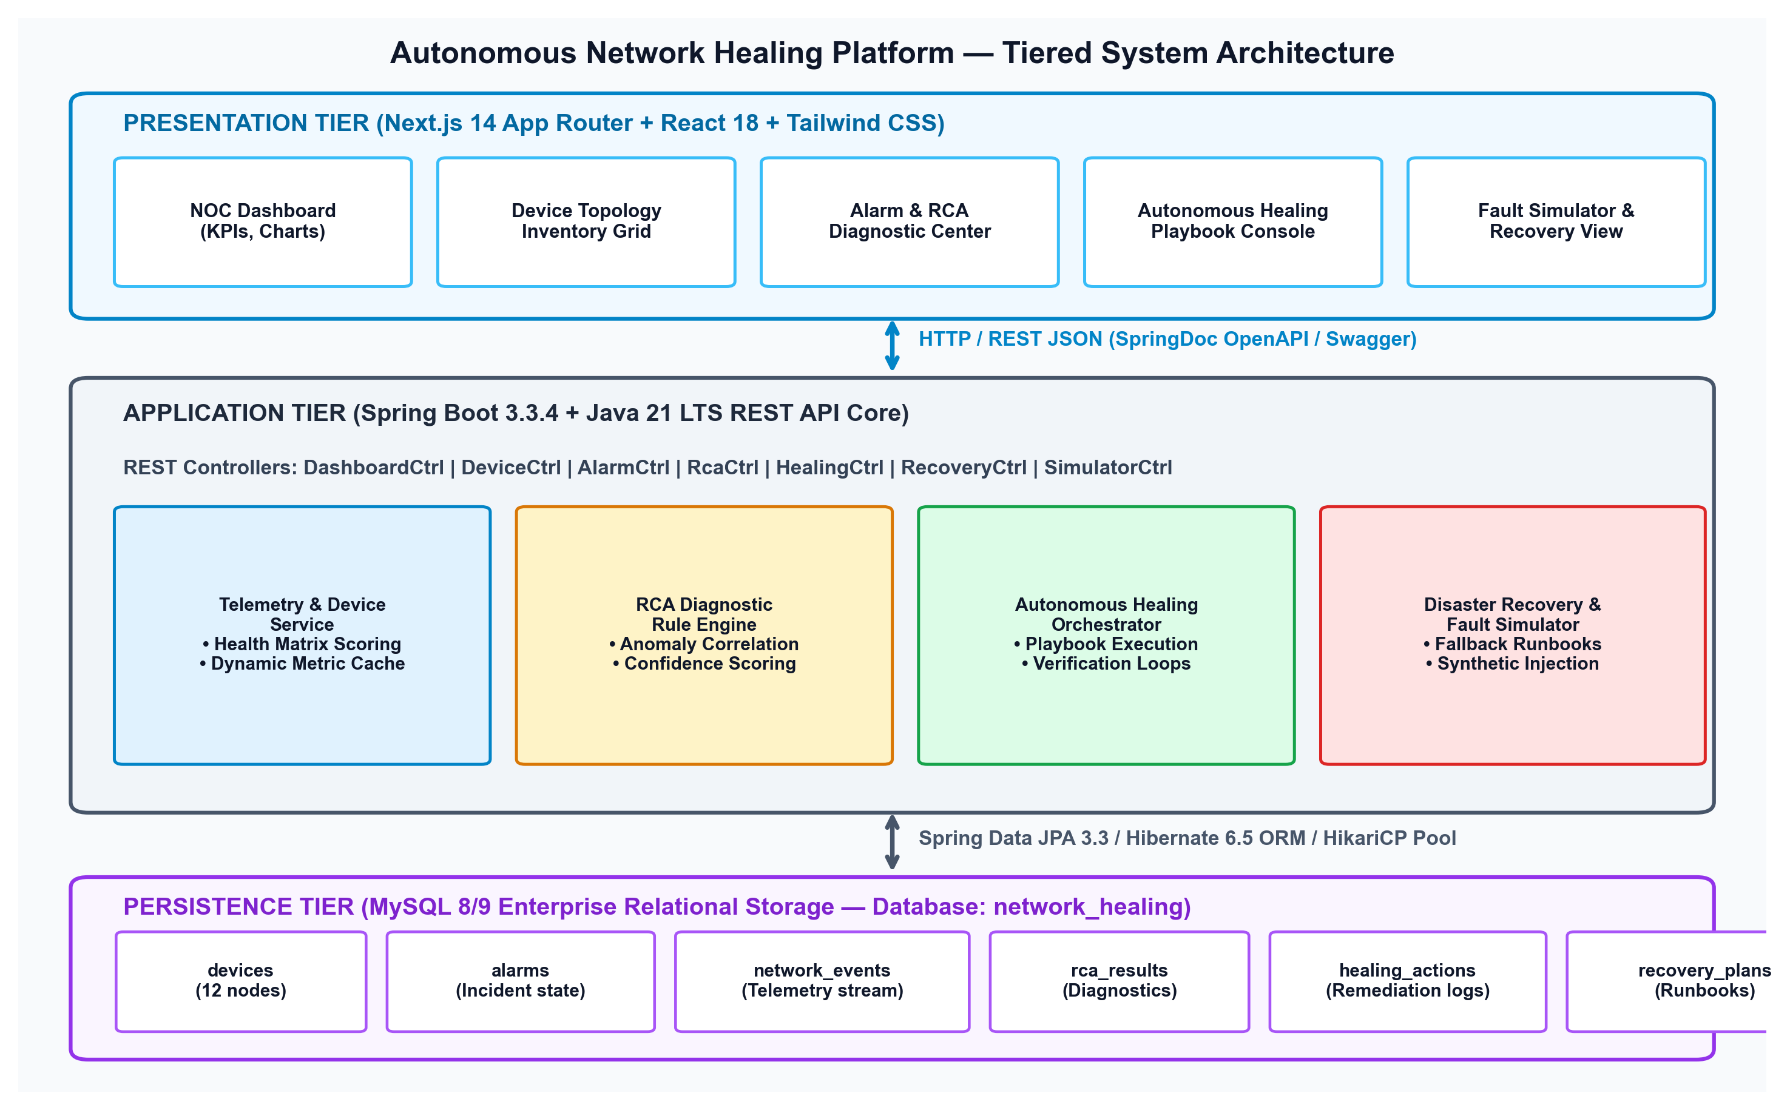
Fig 1

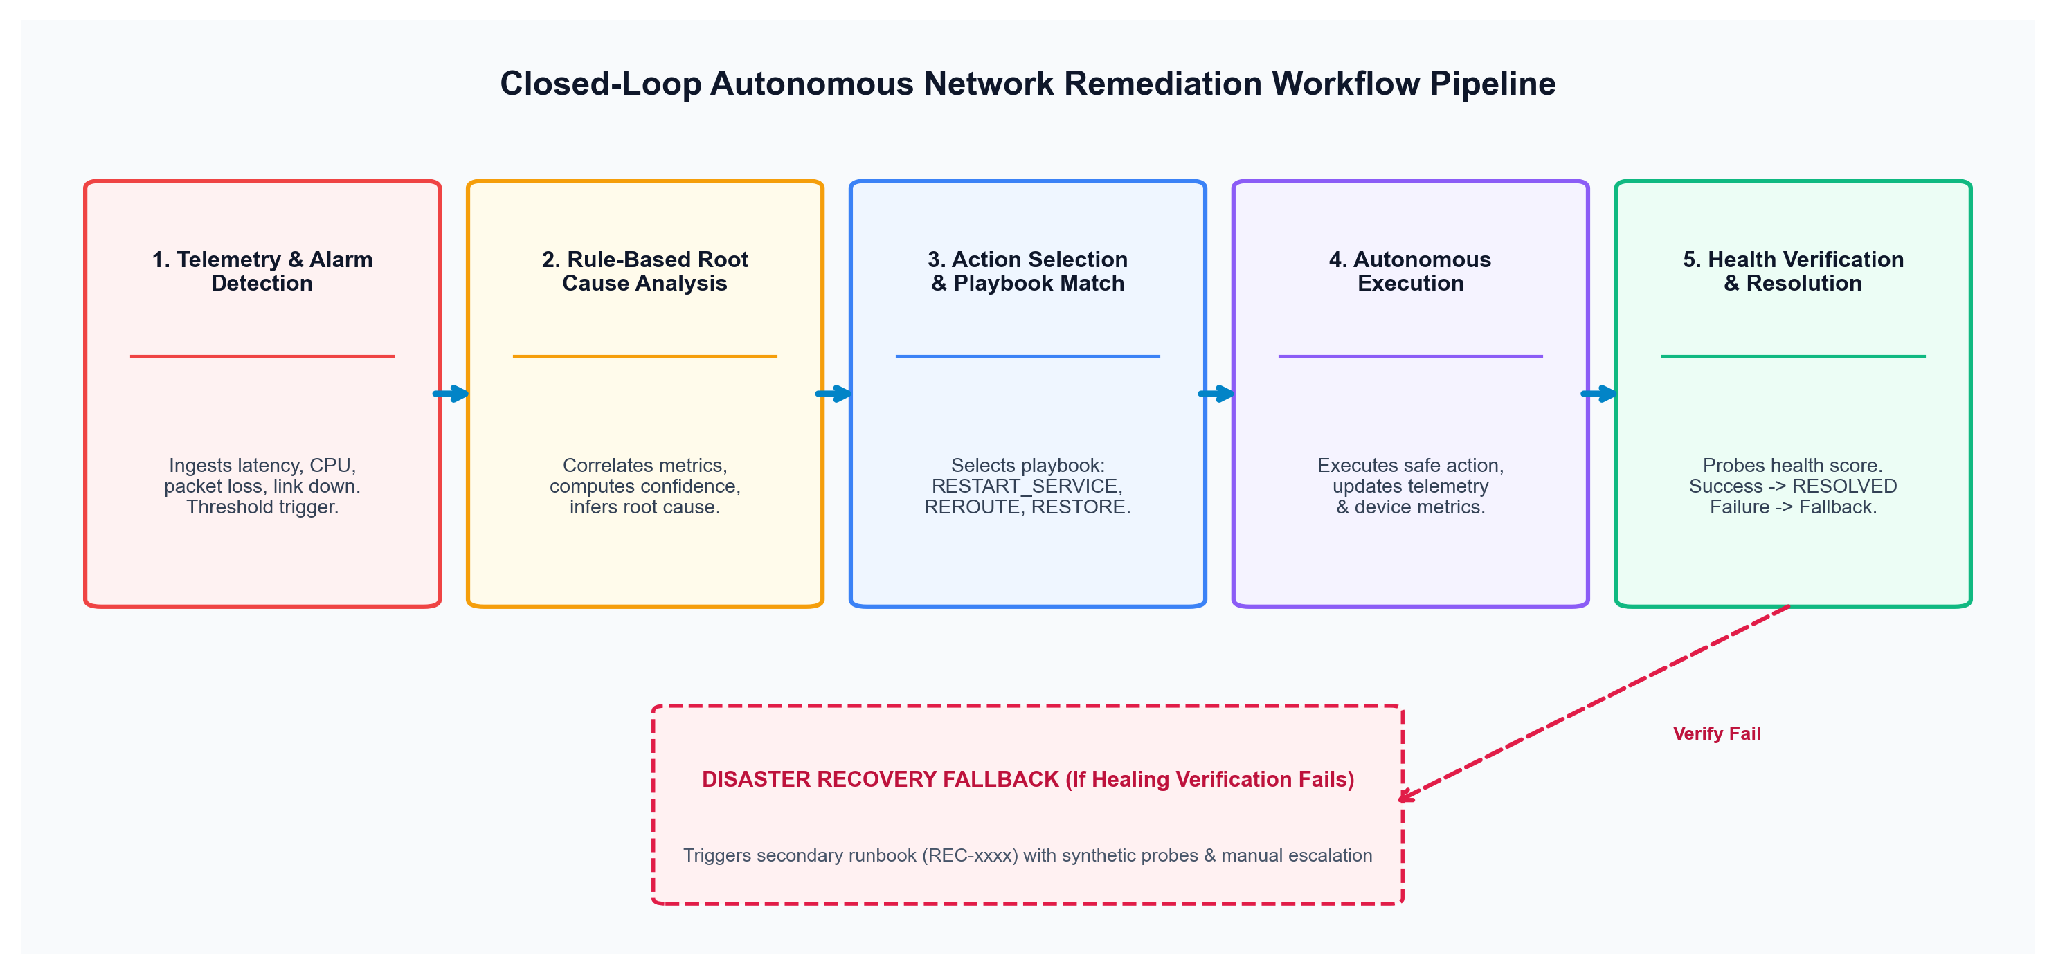
Fig 2

