Task 2:

Cryptocurrencies are systems that allow for the secure payments online which are denominated in terms of virtual "tokens," which are represented by ledger entries internal to the system.

**Cryptocurrencies** use decentralised technology to let users make secure payments and store money without the need to use their name or go through a bank. They run on a distributed public ledger called blockchain, which is a record of all transactions updated and held by currency holders

Type of cryptocurrencies:

BTC

ETH

LTC

XRP

BCH

**Advantages Cryptocurrency**

**Advantages**

Cryptocurrencies hold the promise of making it easier to transfer funds directly between two parties, without the need for a trusted third party like a bank or credit card company. These [transfers](https://www.investopedia.com/terms/t/transfer.asp) are instead secured by the use of [public keys](https://www.investopedia.com/terms/p/public-key.asp) and [private keys](https://www.investopedia.com/terms/p/private-key.asp) and different forms of incentive systems, like [Proof of Work](https://www.investopedia.com/terms/p/proof-work.asp) or [Proof of Stake](https://www.investopedia.com/terms/p/proof-stake-pos.asp).

 In modern cryptocurrency systems, a user's "[wallet](https://www.investopedia.com/terms/b/bitcoin-wallet.asp)," or account address, has a public key, while the private key is known only to the owner and is used to sign transactions. Fund transfers are completed with minimal processing fees, allowing users to avoid the steep fees charged by banks and [financial institutions](https://www.investopedia.com/terms/f/financialinstitution.asp) for [wire transfers](https://www.investopedia.com/terms/w/wiretransfer.asp).

**Disadvantages**

One of the most significant disadvantages cryptocurrencies have is the **constant fluctuation of the price**. And this makes it quite difficult for the users (and merchants) to accept and use crypto. It’s kind of a trust killer as you can never be 100% sure how much the crypto is going to be worth tomorrow.

And, along comes the next issue of cryptocurrency ‒ the **lack of merchants accepting digital money**. Why is that? The trust rate of digital money is (still) rather low. The somber reality is that even though crypto is a growing trend, a lot of companies still haven’t taken the bold enough step towards accepting digital money. There are two possible reasons for that: it may be a tendency not to be willing to take a risk with the fluctuating price, or the unawareness of what benefits cryptocurrency can bring about.

Thirdly, **not enough people know about the benefits of cryptocurrency**. The good thing is though, that more and more people gain info about digital money. The know-how is snowballing. Each day more people step into the cryptocurrency sphere by acquiring their crypto. But let’s be honest, there is still a long way to go and a lot of work to do in regards to the knowledge on cryptocurrencies. And, before the masses start using and accepting it, crypto needs years of exposure to the global system.

BITCOINS

Bitcoin is a new currency that was created in 2009 by an unknown person using the alias Satoshi Nakamoto. Transactions are made with no middle men – meaning, no banks!

## Why bitcoin?

Bitcoins can be used to buy merchandise anonymously. In addition, international payments are easy and cheap because bitcoins are not tied to any country or subject to regulation. Small businesses may like them because there are no credit card fees. Some people just buy bitcoins as an investment, hoping that they’ll go up in value.

**Transfers**

People can send bitcoins to each other using mobile apps or their computers. It’s similar to sending cash digitally.

**Mining**

People compete to “mine” bitcoins using computers to solve complex math puzzles. This is how bitcoins are created. Currently, a winner is rewarded with 12.5 bitcoins roughly every 10 minutes.

## Bitcoin wallet

## Bitcoins are stored in a “digital wallet,” which exists either in the cloud or on a user’s computer. The wallet is a kind of virtual bank account that allows users to send or receive bitcoins, pay for goods or save their money. Unlike bank accounts, bitcoin wallets are not insured by the FDIC.

## What Are Altcoins?

Altcoins are the other [cryptocurrencies](https://www.investopedia.com/terms/c/cryptocurrency.asp) launched after the success of [Bitcoin](https://www.investopedia.com/terms/b/bitcoin.asp). Generally, they sell themselves as better alternatives to Bitcoin. The term "altcoins" refers to all cryptocurrencies other than Bitcoin.

**Coins and Tokens**

Coins are any cryptocurrency that has a standalone independant blockchain (Bitcoin, Ethereum, XRP, …)  
– Altcoins are considered as coins that are not Bitcoin.  
– Tokens are cryptocurrencies that do not have their own blockchain but live on another blockchain. As they live on another blockchain, they benefit from its technology. (ERC-20 tokens…)

**Digital Wallets:**

Cryptocurrency wallets are software programs that store your public and private keys and interface with various [blockchains](https://blockgeeks.com/guides/what-is-blockchain-technology/) so users can monitor their balance, send money and conduct other operations. When a person sends you [bitcoins](https://blockgeeks.com/guides/how-to-buy-bitcoin/) or any other type of digital currency, they are essentially signing off ownership of the coins to your wallet’s address. To be able to spend those coins and unlock the funds, the private key stored in your wallet must match the public address the currency is assigned to. If the public and private keys match, the balance in your digital wallet will increase, and the senders will decrease accordingly. There is no actual exchange of real coins. The transaction is signified merely by a transaction record on the [blockchain](https://blockgeeks.com/guides/what-is-blockchain-technology/) and a change in balance in your cryptocurrency wallet.

BlockChain:

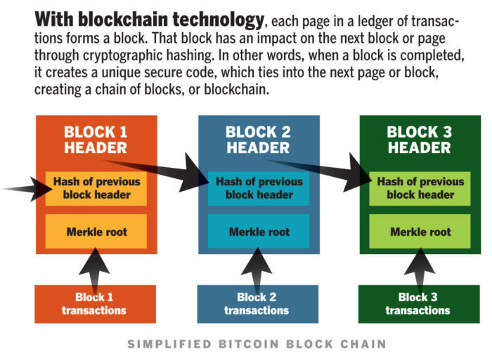

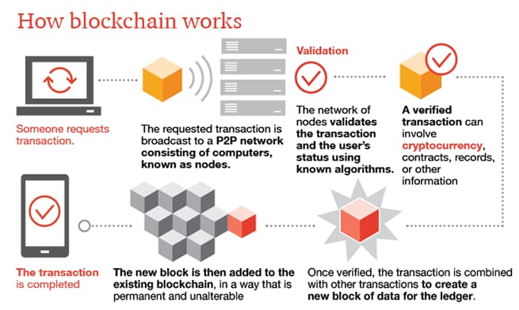

A blockchain is a [digital](https://techterms.com/definition/digital) record of transactions. The name comes from its structure, in which individual records, called blocks, are linked together in single list, called a chain. Blockchains are used for recording transactions made with cryptocurrencies, such as [Bitcoin](https://techterms.com/definition/bitcoin), and have many other application

Each transaction added to a blockchain is validated by multiple computers on the [Internet](https://techterms.com/definition/internet). These systems, which are configured to monitor specific types of blockchain transactions, form a [peer-to-peer](https://techterms.com/definition/p2p) network. They work together to ensure each transaction is valid before it is added to the blockchain. This decentralized [network](https://techterms.com/definition/network) of computers ensures a single system cannot add invalid blocks to the chain.

When a new block is added to a blockchain, it is linked to the previous block using a [cryptographic](https://techterms.com/definition/cryptography) hash generated from the contents of the previous block. This ensures the chain is never broken and that each block is permanently recorded. It is also intentionally difficult to alter past transactions in blockchain since all the subsequent blocks must be altered first.

## Ethereum

Ethereum is a technology that lets you send cryptocurrency to anyone for a small fee. It also powers applications that everyone can use and no one can take down.

**It's *the world's programmable blockchain.***

Ethereum builds on Bitcoin's innovation, with some big differences.

Both let you use digital money without payment providers or banks. But Ethereum is programmable, so you can also use it for lots of different digital assets – even Bitcoin!

This also means Ethereum is for more than payments. It's a marketplace of financial services, games and apps that can't steal your data or censor you.

**Bitcoin cash**

https://www.bitdegree.org/crypto/what-is-bitcoin-cash